Supporting information
Novel tetrahydroisoquinolines as DHFR and CDK2 inhibitors: Synthesis, characterization, anticancer activity and antioxidant properties
Eman M. Sayed,ª Etify A. Bakhite,^{b}* Reda Hassanien,ª Nasser Farhan,ª Hanan F. Aly,^{c} Salma G. Morsy,^{d} Nivin A. Hassan^{e}
ªChemistry Department, Faculty of Science, New Valley University, El-Kharja 72511, Egypt. ^{b}Chemistry Department, Faculty of Science, Assiut University, Assiut 71516, Egypt. ^{c}Department of Therapeutic Chemistry, National Research Centre, El-Behooth St., 12622 Dokki, Cairo, Egypt. ^{d}Department of Cancer Biology (Cancer Immunology and Virology), South Egypt Cancer Institute, Assiut University, Assiut, Egypt. ^{e}Pharmacology and Experimental Oncology Unit, Cancer Biology Department, South Egypt Cancer Institute, Assiut University, Assiut, Egypt.
*Corresponding author
Email: emysayed880@yahoo.com
Table of Contents
Figure S1: FT-IR spectrum of compound 1.
Figure S2: ¹H NMR spectrum of compound 1.
Figure S3: ¹³ C NMR spectrum of compound 1.
Figure S4: FT-IR spectrum of compound 3.
Figure S5: ¹H NMR spectrum of compound 3.
Figure S6: ¹³ C NMR spectrum of compound 3.
Figure S7: FT-IR spectrum of compound 4.
Figure S8: ¹H NMR spectrum of compound 4.
Figure S9: ¹³ C NMR spectrum of compound 4.
Figure S10: FT-IR spectrum of compound 5
Figure S11: ¹H NMR spectrum of compound 5.

Figure S12: ¹³ C NMR spectrum of compound 5.
Figure S13: FT-IR spectrum of compound 6.
Figure S24: ¹H NMR spectrum of compound 6.
Figure S35: ¹³ C NMR spectrum of compound 6.
Figure S46: FT-IR spectrum of compound 7a.
Figure S57: ¹H NMR spectrum of compound 7a .
Figure S18: ¹³ C NMR spectrum of compound 7a.
Figure S19: FT-IR spectrum of compound 7b.
Figure S20: ¹H NMR spectrum of compound 7b .
Figure S21: ¹³ C NMR spectrum of compound 7b.
Figure S22: FT-IR spectrum of compound 7c.
Figure S23:¹H NMR spectrum of compound 7c
Figure S24: ¹³ C NMR spectrum of compound 7c.
Figure S25: FT-IR spectrum of compound 7d.
Figure S26: ¹H NMR spectrum of compound 7d.
Figure S27: ¹³ C NMR spectrum of compound 7d.
Figure S28: FT-IR spectrum of compound 7e.
Figure S29: ¹H NMR spectrum of compound 7e.
Figure S30: ¹³ C NMR spectrum of compound 7e.
Figure S31: FT-IR spectrum of compound 8a.
Figure S32: ¹H NMR spectrum of compound 8a.
Figure S33: ¹³ C NMR spectrum of compound 8a.
Figure S34: FT-IR spectrum of compound 8b.
Figure S35: ¹H NMR spectrum of compound 8b.
Figure S36: ¹³ C NMR spectrum of compound 8b.
Figure S37: FT-IR spectrum of compound 8c.
Figure S38: ¹H NMR spectrum of compound 8c.
Figure S39: ¹³ C NMR spectrum of compound 8c.
Figure S40: FT-IR spectrum compound 8d.
Figure S41: ¹H NMR spectrum compound 8d.
Figure S42: ¹³ C NMR spectrum of compound 8d.
Figure S43: FT-IR spectrum compound 8e.
Figure S44: ¹H NMR spectrum compound 8e .
Figure S45: ¹³ C NMR spectrum of compound 8e.
Table S1: Raw date of toxicity and viability of compds 1, 3-6 against MCF7.

Table S2: Raw date of toxicity and viability of compds 7a-e against MCF7.
Table S3: Raw date of toxicity and viability of compds 8a-e against MCF7.
Table S4: Raw date of toxicity and viability of compds 1, 3- 6 against A549
Table S5: Raw date of toxicity and viability of compds 7a-e against A549
Table S6: Raw date of toxicity and viability of compds 8a-e against A549.
Table S7: CDK2 inhibitor detailed results.
Table S8: DHFR inhibitor detailed results.
Table S9: Eef2 inhibitor detailed results.
Table S10: IKB inhibitor detailed results.
Table S11: RET inhibitor detailed results.

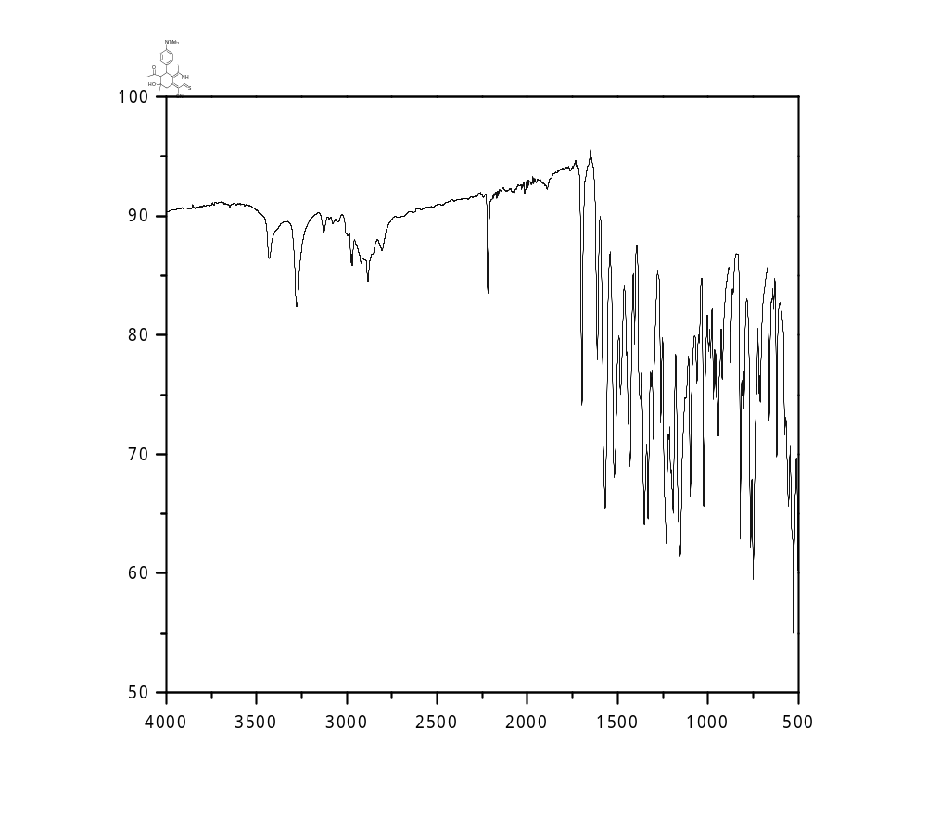

Figure S1: IR Spectrum of 7-Acetyl-4-cyano-1,6-dimethyl-6-hydroxy-8-(4-N,N-dimethylaminophenyl)-5,6,7,8-tetra-hydrosoquinoline-3(2H)-thione (1)

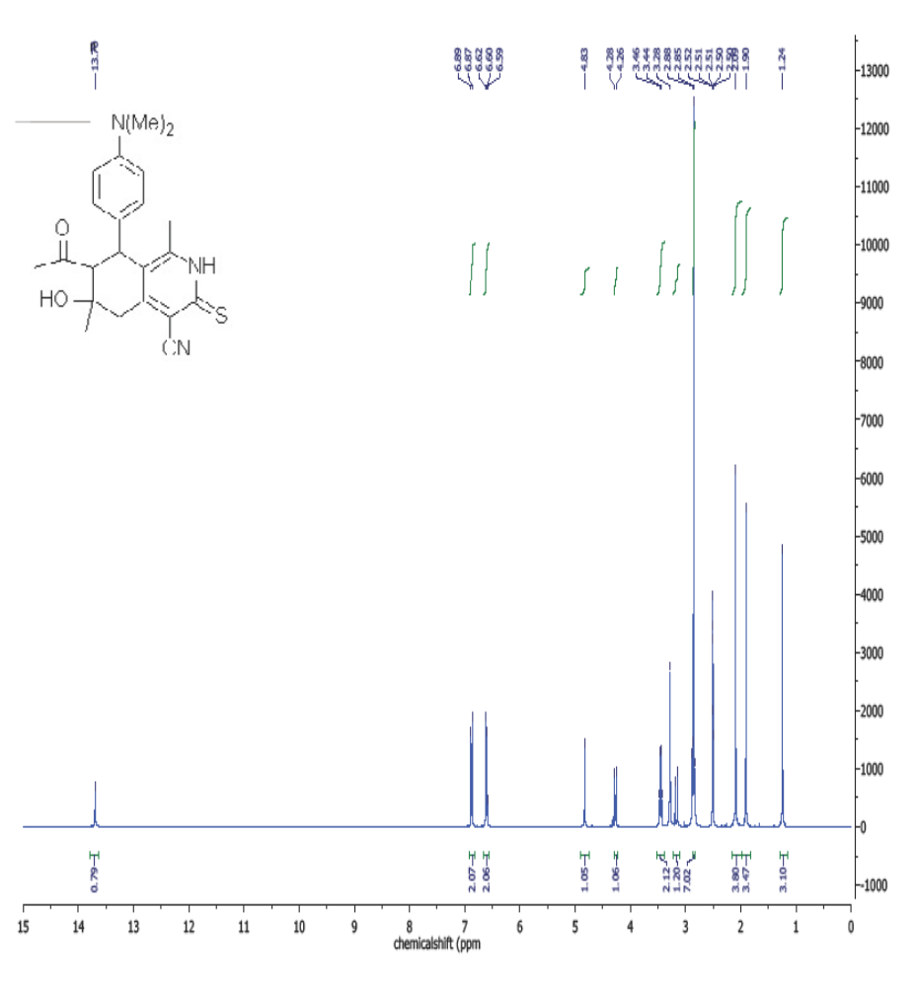
Figure S2: ¹H NMR Spectrum of 7-Acetyl-4-cyano-1,6-dimethyl-6-hydroxy-8-
.(4-N,N-dimethylaminophenyl)-5,6,7,8-tetra-hydrosoquinoline-3(2H)-thione (1)

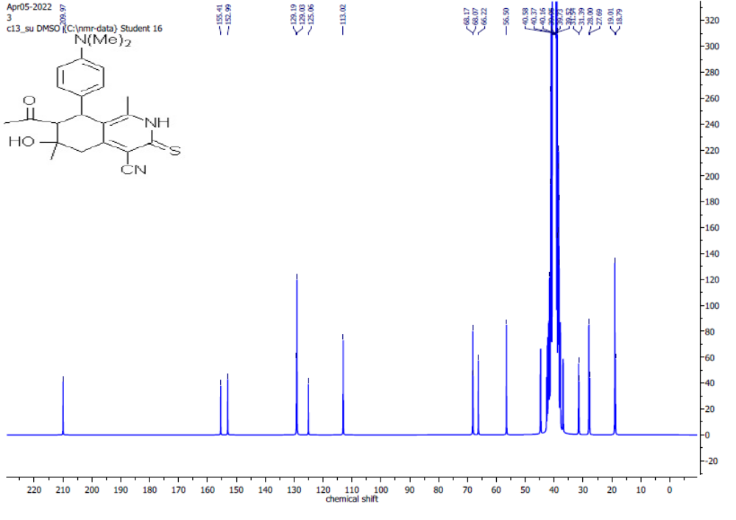

Figure S3: ¹³C NMR Spectrum of 7-Acetyl-4-cyano-1,6-dimethyl-6-hydroxy-8-(4-N,N-dimethylaminophenyl)-5,6,7,8-tetra-hydrosoquinoline-3(2H)-thione (1).
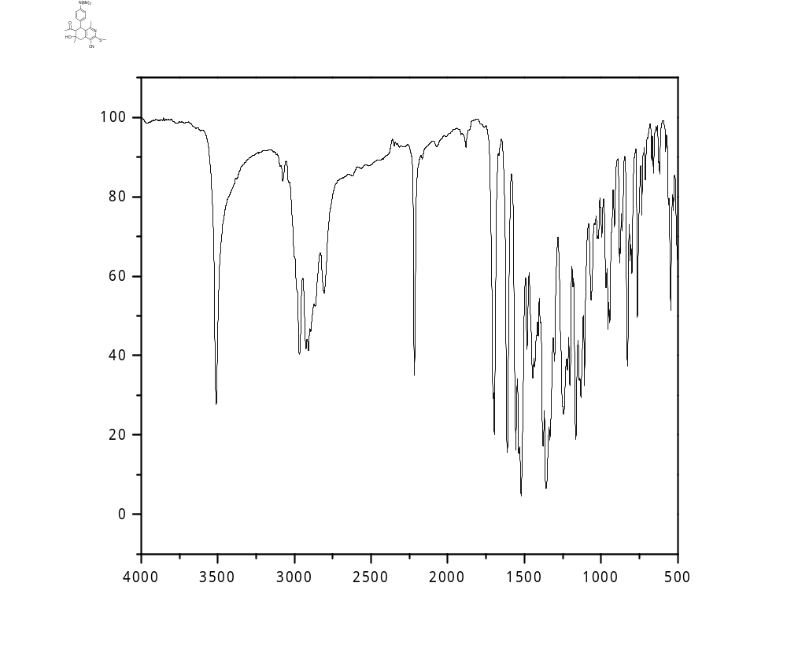

Figure S4: IR Spectrum of 7-Acetyl-4-cyano-1,6-dimethyl-3-methylthio-6-hydroxy-8-
(4-N,N-dimethylamino-phenyl)-5,6,7,8-tetrahydroisoquinoline (3).
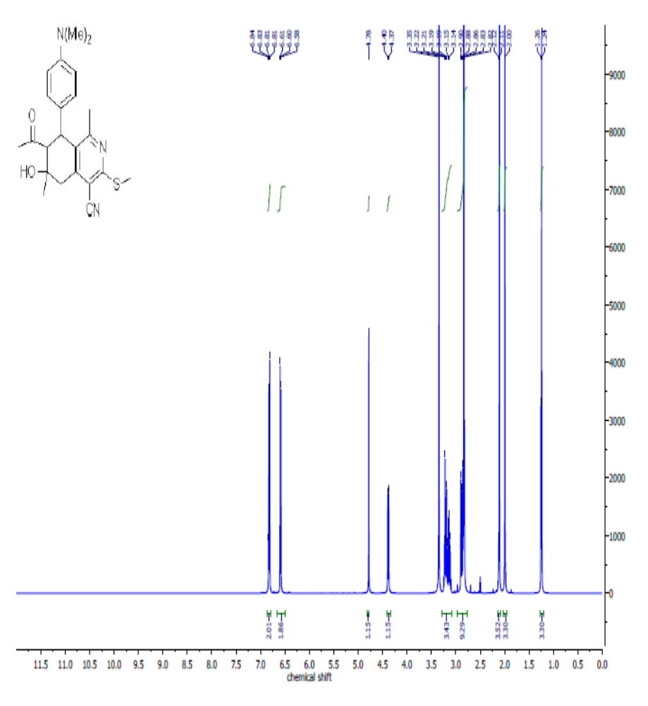

Figure S5: ¹H NMR Spectrum of 7-Acetyl-4-cyano-1,6-dimethyl-3-methylthio-6-hydroxy-8-(4-N,N-dimethylamino-phenyl)-5,6,7,8-tetrahydroisoquinoline (3).

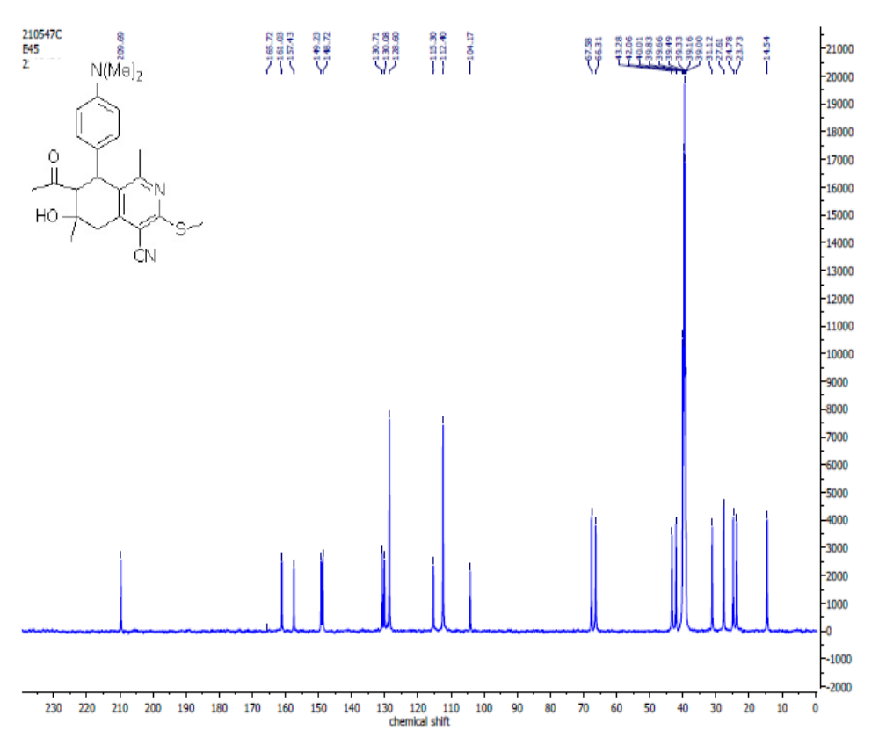
Figure S6: ¹³C NMR Spectrum of 7-Acetyl-4-cyano-1,6-dimethyl-3-methylthio-6-hydroxy-8-(4-N,N-dimethylamino-phenyl)-5,6,7,8-tetrahydroisoquinoline (3).

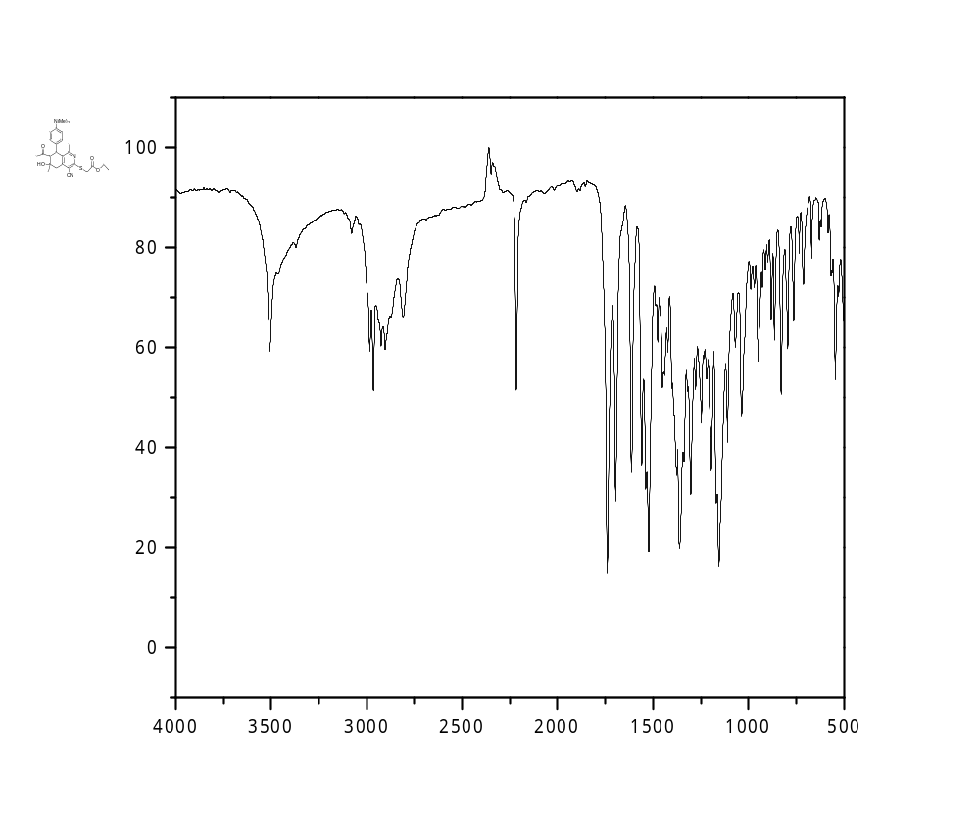
Figure S7: IR Spectrum of Ethyl 2-((7-Acetyl-4-cyano-1,6-dimethyl-6-hydroxy-8-(4-N,N-dimethylamino-phenyl)-5,6,7,8-tetrahydroisoquinolin-3-yl)thio)acetate (4).
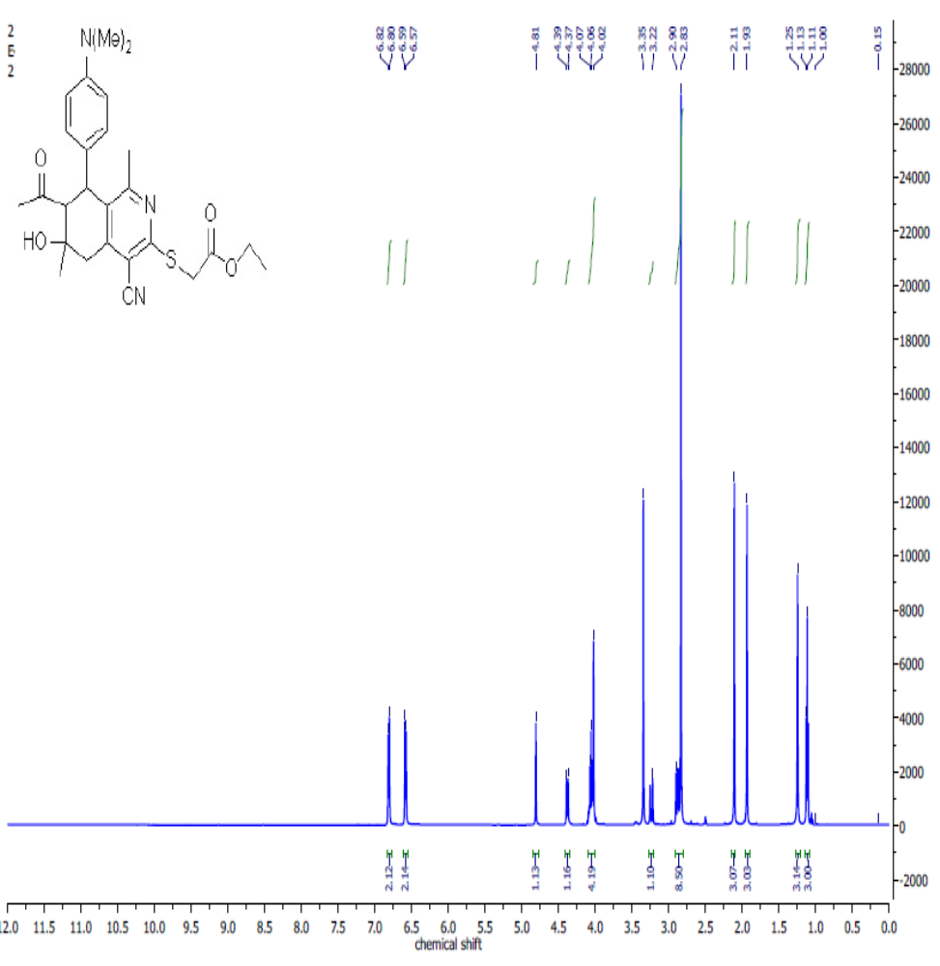
Figure S8: ¹H NMR Spectrum of Ethyl 2-((7-Acetyl-4-cyano-1,6-dimethyl-6-hydroxy-8-(4-N,N-dimethylamino-phenyl)-5,6,7,8-tetrahydroisoquinolin-3-yl)thio)acetate (4).

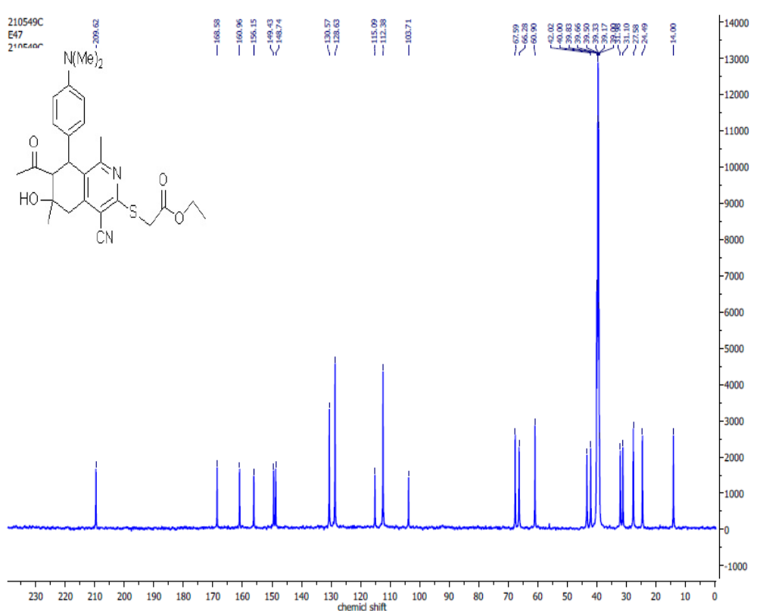

Figure S9: ¹³C NMR Spectrum of Ethyl 2-((7-Acetyl-4-cyano-1,6-dimethyl-6-hydroxy-8-(4-N,N-dimethylamino-phenyl)-5,6,7,8-tetrahydroisoquinolin-3-yl)thio)acetate (4).
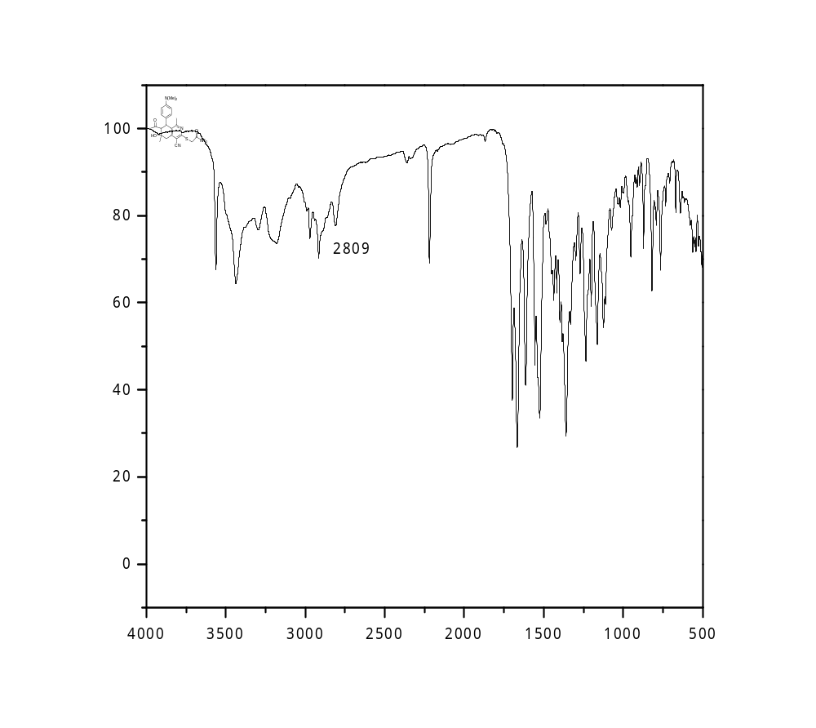
Figure S10: IR Spectrum of 2-[(7-Acetyl-4-cyano-1,6-dimethyl-6-hydroxy-8-(4-N,N-dimethylaminophenyl)-5,6,7,8-tetrahydroisoquinolin-3-yl)thio]acetamide (5).

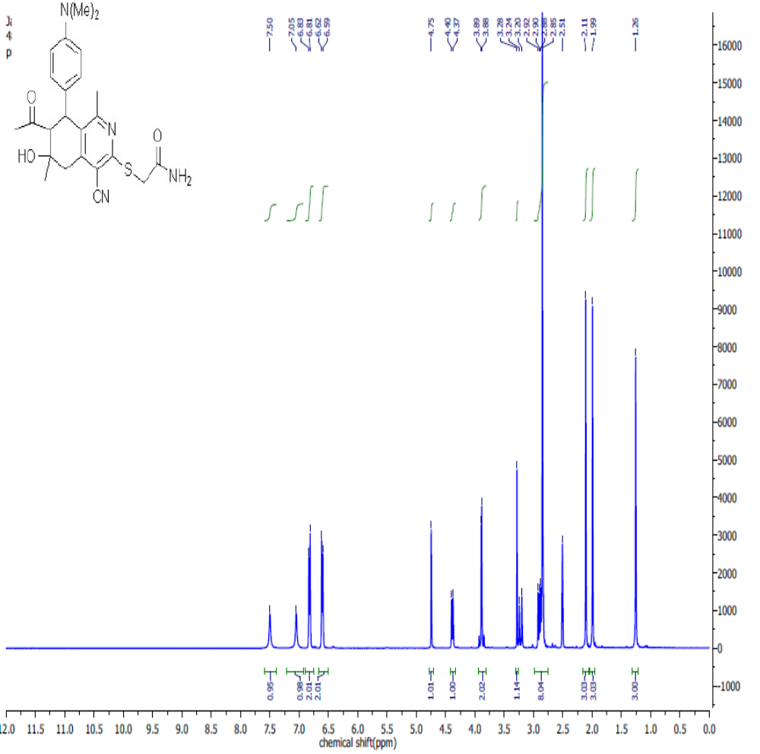

Figure S11: ¹H NMR Spectrum of 2-[(7-Acetyl-4-cyano-1,6-dimethyl-6-hydroxy-8-(4-N,N-dimethylaminophenyl)-5,6,7,8-tetrahydroisoquinolin-3-yl)thio]acetamide (5).

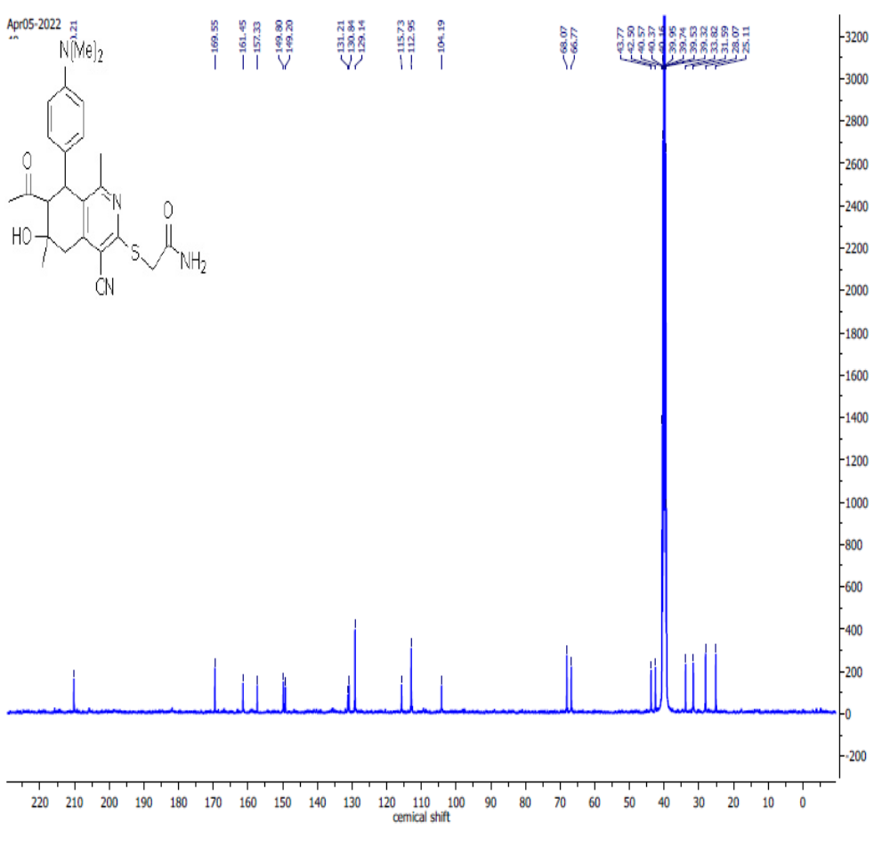

Figure S12: ¹³C NMR Spectrum 2-[(7-Acetyl-4-cyano-1,6-dimethyl-6-hydroxy-8-(4-N,N-dimethylaminophenyl)-5,6,7,8-tetrahydroisoquinolin-3-yl)thio]acetamide (5).

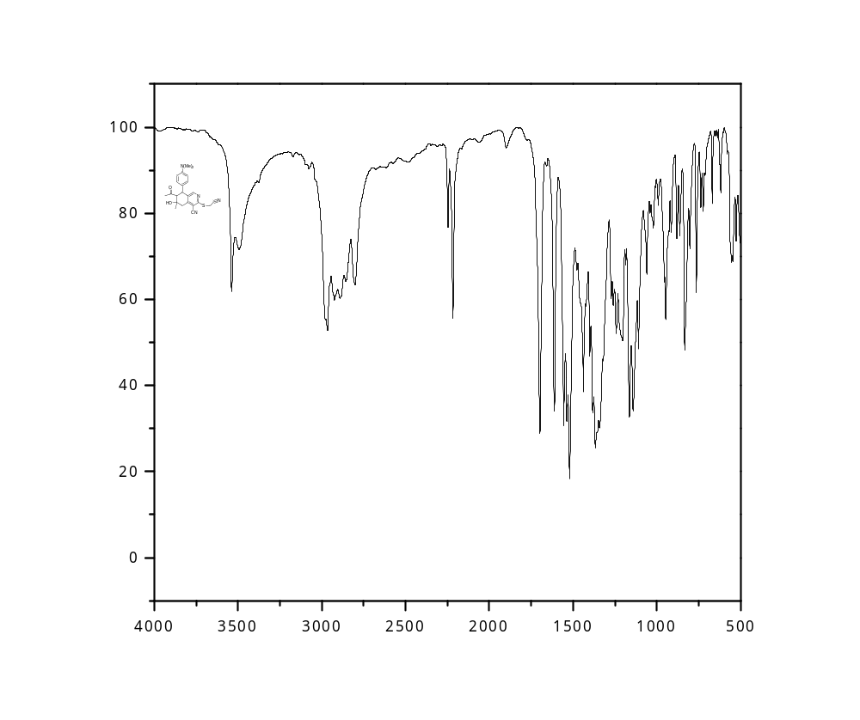
Figure S13: IR Spectrum of 2-[(7-Acetyl-4-cyano-1,6-dimethyl-6-hydroxy-8-
(4-N,N-dimethylaminophenyl)-5,6,7,8-tetrahydroisoquinolin-3-yl)thio]acetonitrile (6).

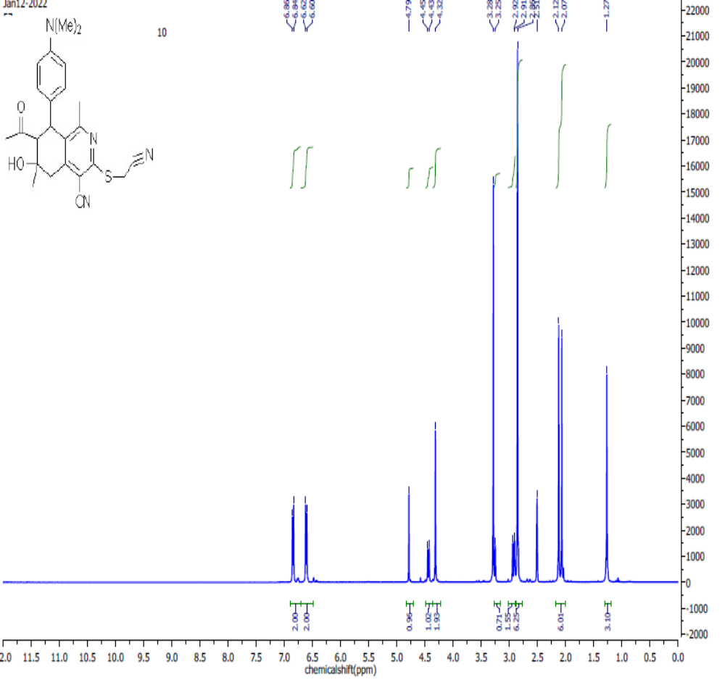
Figure S14: ¹H NMR Spectrum of 2-[(7-Acetyl-4-cyano-1,6-dimethyl-6-hydroxy-8-(4-N,N-dimethylaminophenyl)-5,6,7,8-tetrahydroisoquinolin-3-yl)thio]acetonitrile (6).

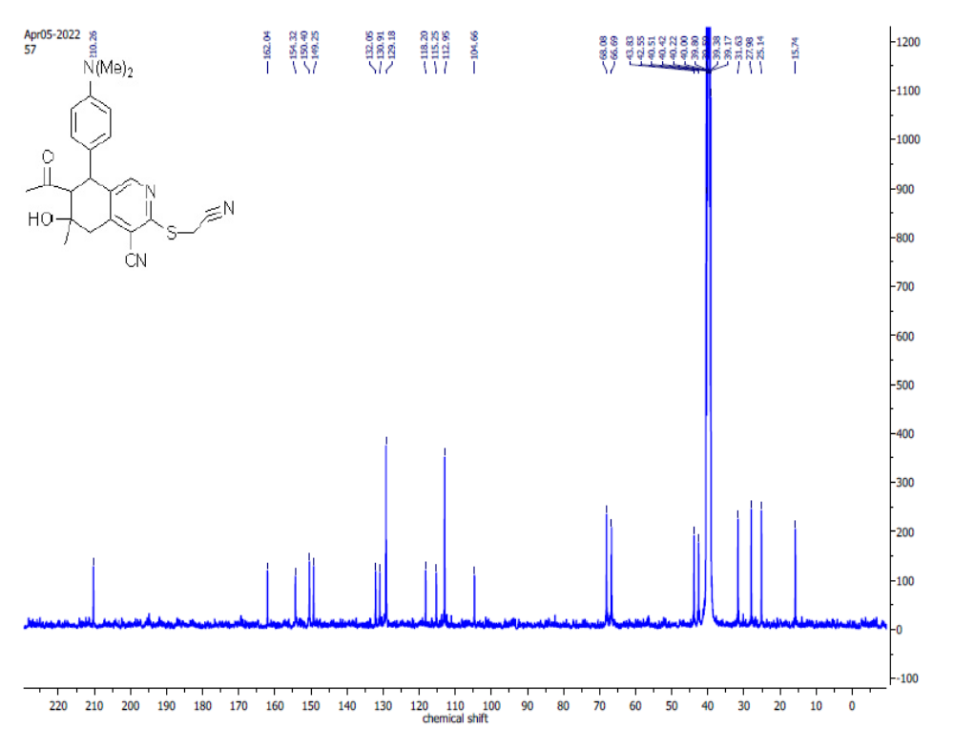Figure S15: ¹³C NMR Spectrum 2-[(7-Acetyl-4-cyano-1,6-dimethyl-6-hydroxy-8-(4-N,N-dimethylaminophenyl)-5,6,7,8-tetrahydroisoquinolin-3-yl)thio]acetonitrile (6).
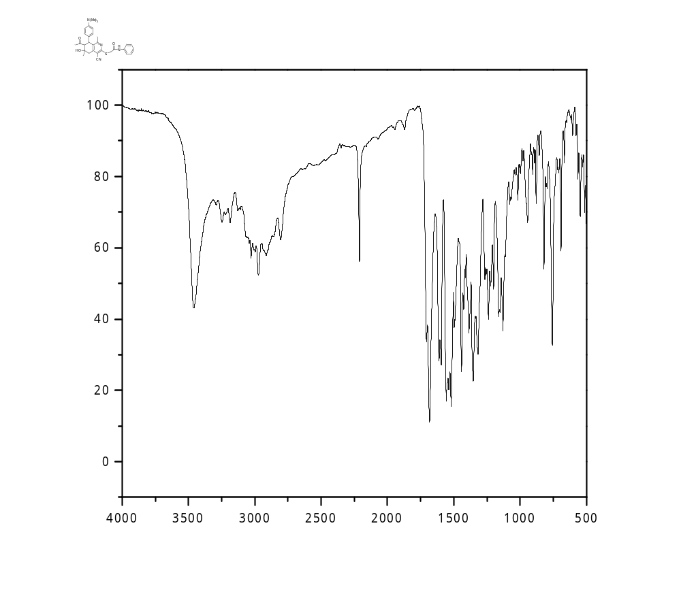
Figure S16: IR Spectrum of 2-[(7-Acetyl-4-cyano-1,6-dimethyl-6-hydroxy-8-
(4-N,N-dimethylaminophenyl)-5,6,7,8-tetra-hydroisoquinolin-3-yl)thio]-N-phenylacetamide (7a).

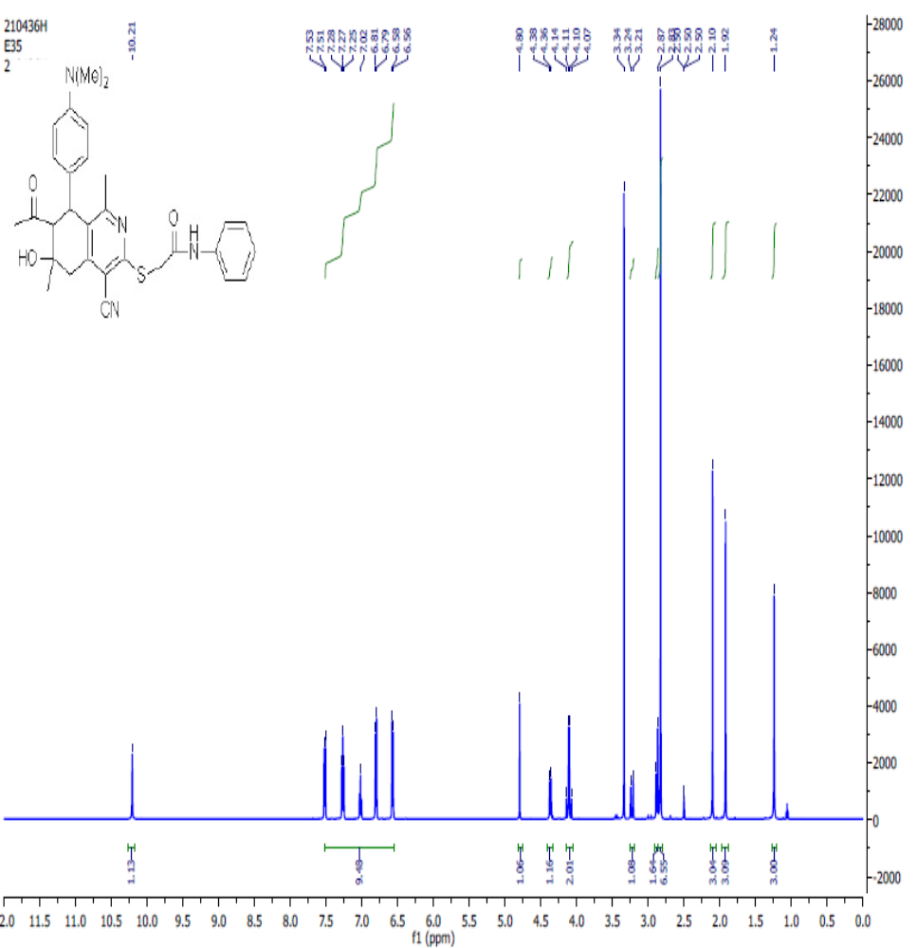
Figure S17: ¹H NMR Spectrum of 2-[(7-Acetyl-4-cyano-1,6-dimethyl-6-hydroxy-8-(4-N,N-dimethylaminophenyl)-5,6,7,8-tetra-hydroisoquinolin-3-yl)thio]-N-phenylacetamide (7a).
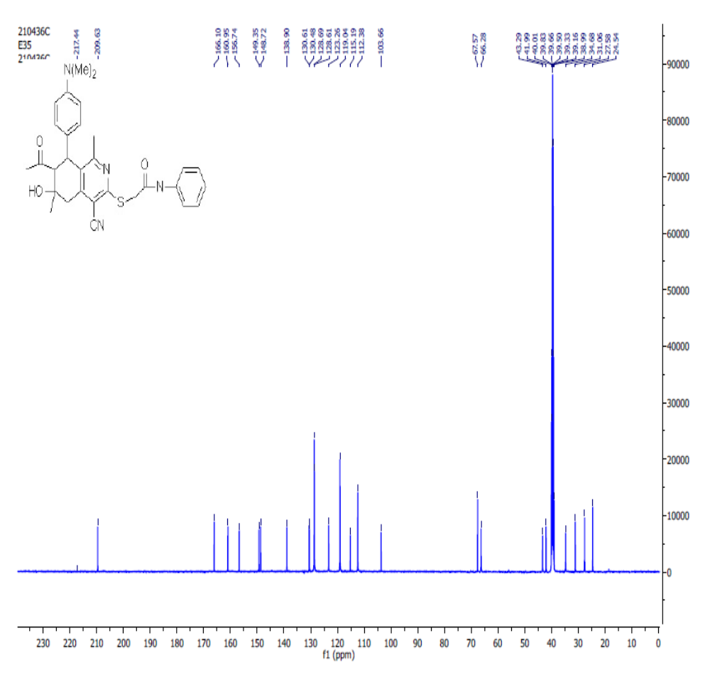
Figure S18: ¹³C NMR Spectrum of 2-[(7-Acetyl-4-cyano-1,6-dimethyl-6-hydroxy-8-(4-N,N-dimethylaminophenyl)-5,6,7,8-tetra-hydroisoquinolin-3-yl)thio]-N-phenylacetamide (7a).

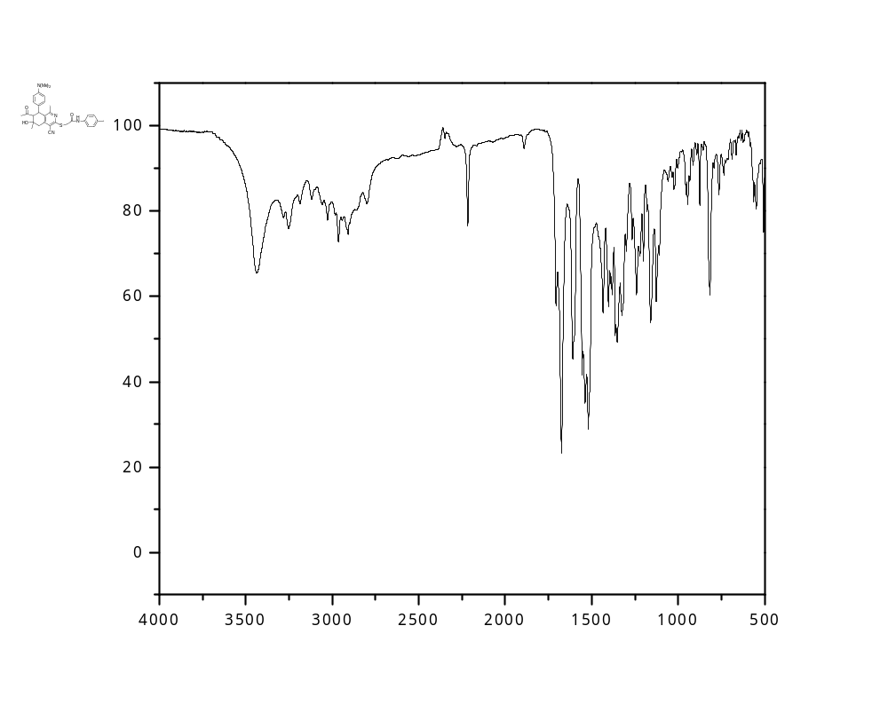
Figure S19: IR Spectrum of 2-[(7-Acetyl-4-cyano-1,6-dimethyl-6-hydroxy-8-(4-N,N-dimethylaminophenyl)-5,6,7,8-tetrahydroisoquinolin-3-yl)thio]-N-(4-tolyl)acetamide (7b).

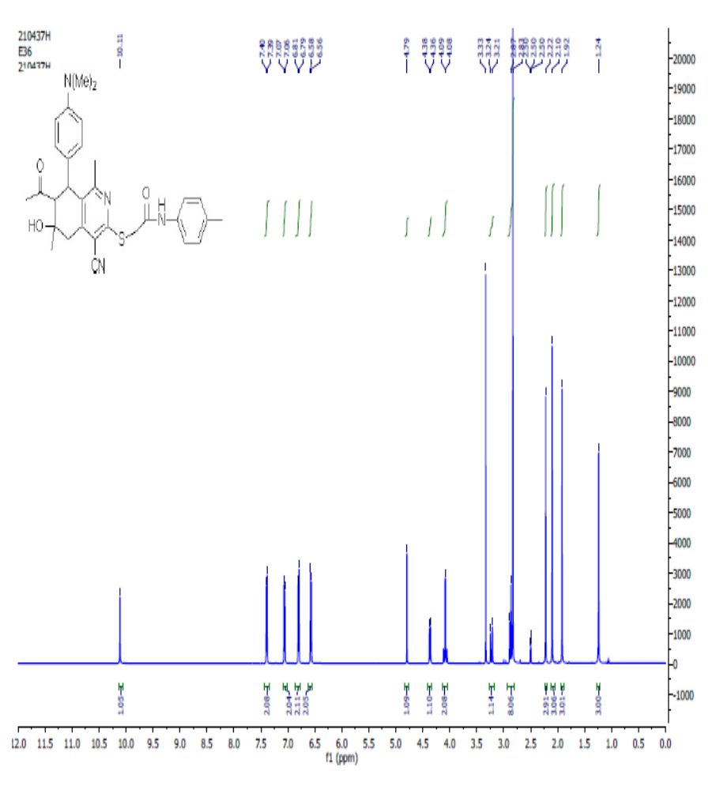
Figure S20: ¹H NMR Spectrum of 2-[(7-Acetyl-4-cyano-1,6-dimethyl-6-hydroxy-8-(4-N,N-dimethylaminophenyl)-5,6,7,8-tetrahydroisoquinolin-3-yl)thio]-N-(4-tolyl)acetamide (7b).
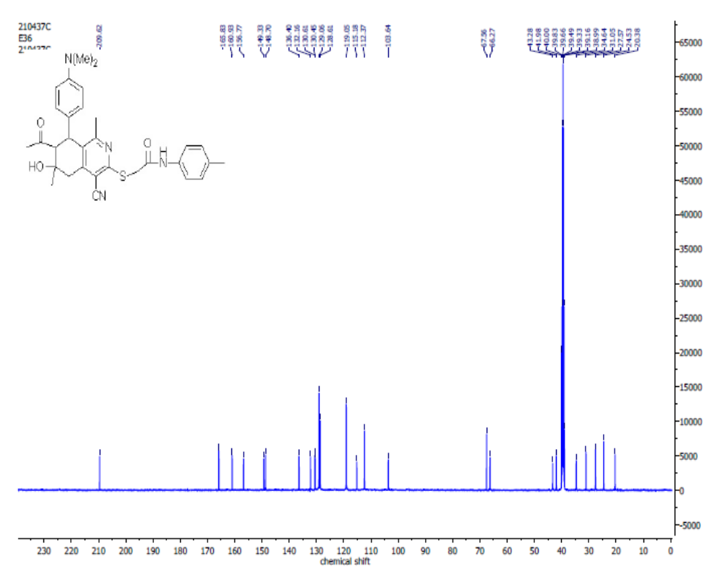
Figure S21: ¹³C NMR Spectrum of 2-[(7-Acetyl-4-cyano-1,6-dimethyl-6-hydroxy-8-(4-N,N-dimethylaminophenyl)-5,6,7,8-tetrahydroisoquinolin-3-yl)thio]-N-(4-tolyl)acetamide (7b).

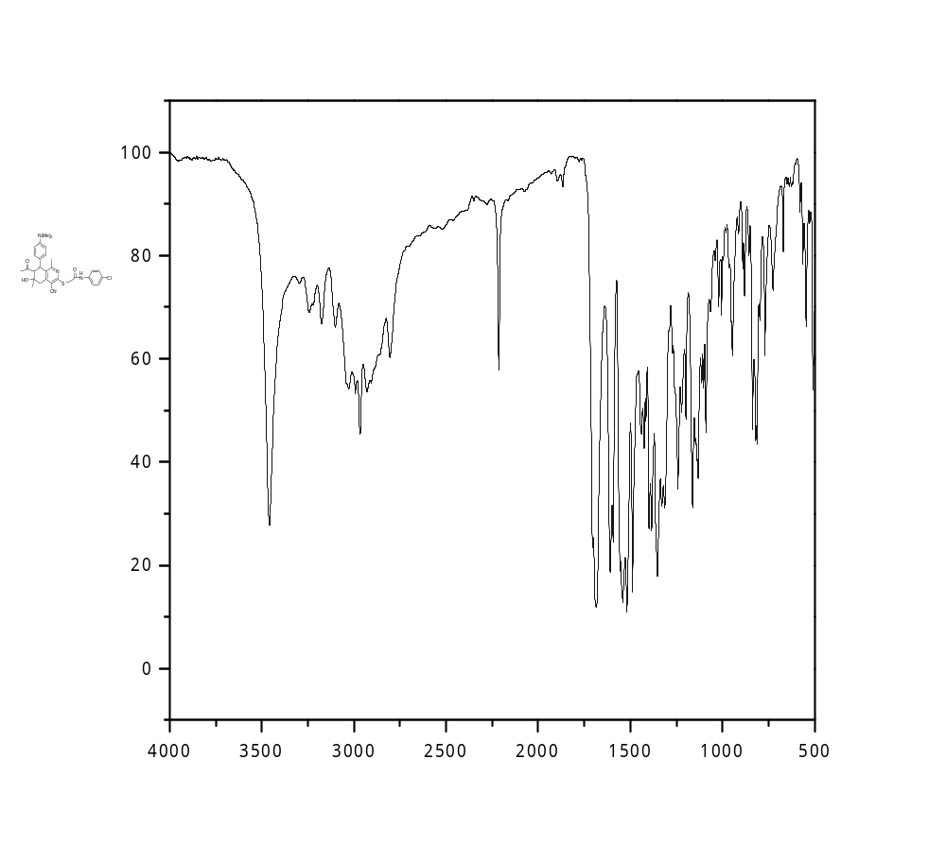

Figure S22: IR Spectrum of 2-[(7-Acetyl-4-cyano-1,6-dimethyl-6-hydroxy-8-(4-N,N-dimethylaminophenyl)-,5,6,7,8-tetrahydroisoquinolin-3-yl)thio]-N-(4-chlorophenyl)acetamide (7c).

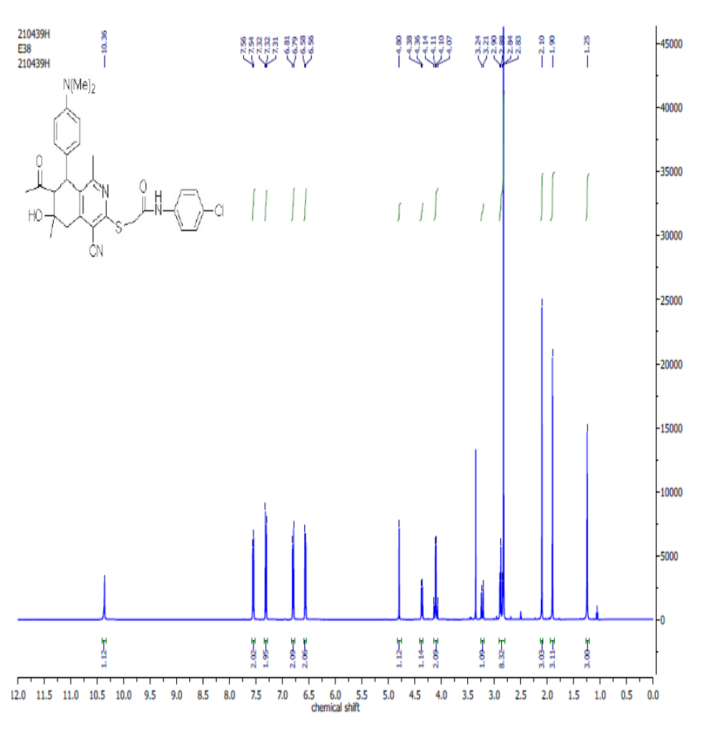
Figure S23: ¹H NMR Spectrum of 2-[(7-Acetyl-4-cyano-1,6-dimethyl-6-hydroxy-8-(4-N,N-dimethylaminophenyl)-,5,6,7,8-tetrahydroisoquinolin-3-yl)thio]-N-(4-chlorophenyl)acetamide (7c).
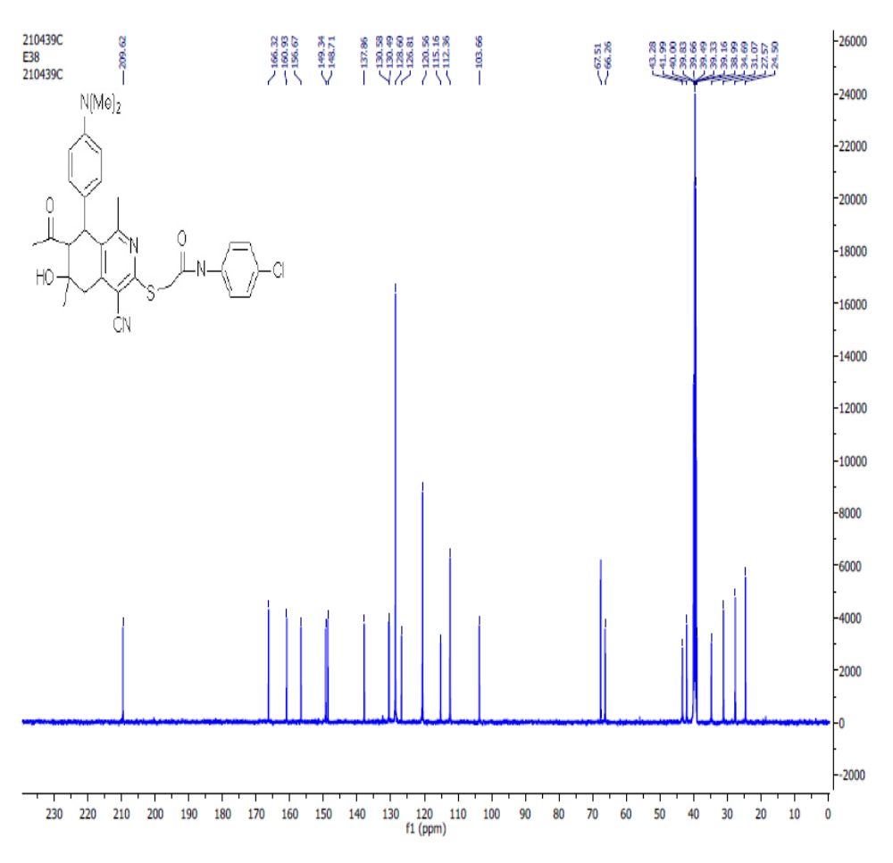

Figure S24: ¹³C NMR Spectrum of 2-[(7-Acetyl-4-cyano-1,6-dimethyl-6-hydroxy-8-(4-N,N-dimethylaminophenyl)-,5,6,7,8-tetrahydroisoquinolin-3-yl)thio]-N-(4-chlorophenyl)acetamide (7c).

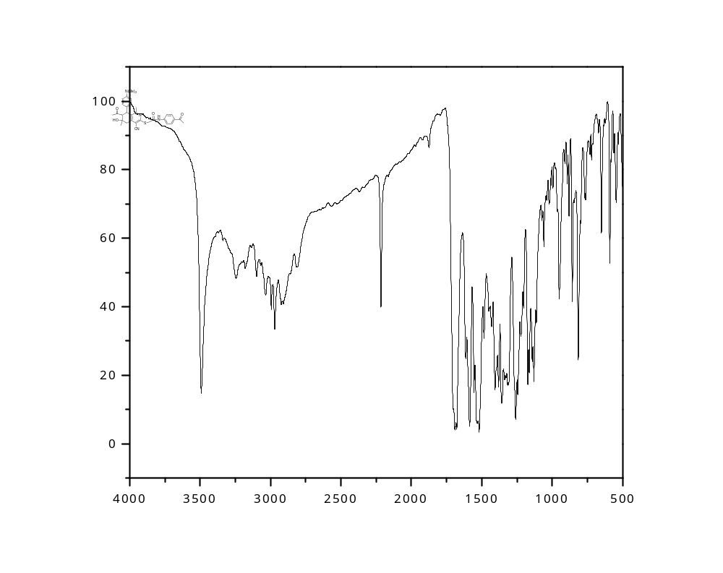
Figure S25: IR Spectrum of 2-[(7-Acetyl-4-cyano-1,6-dimethyl-6-hydroxy-8-(4-N,N-dimethylaminophenyl)-5,6,7,8-tetrahydroisoquinolin-3-yl)thio]-N-(4-acetylphenyl)acetamide (7d).

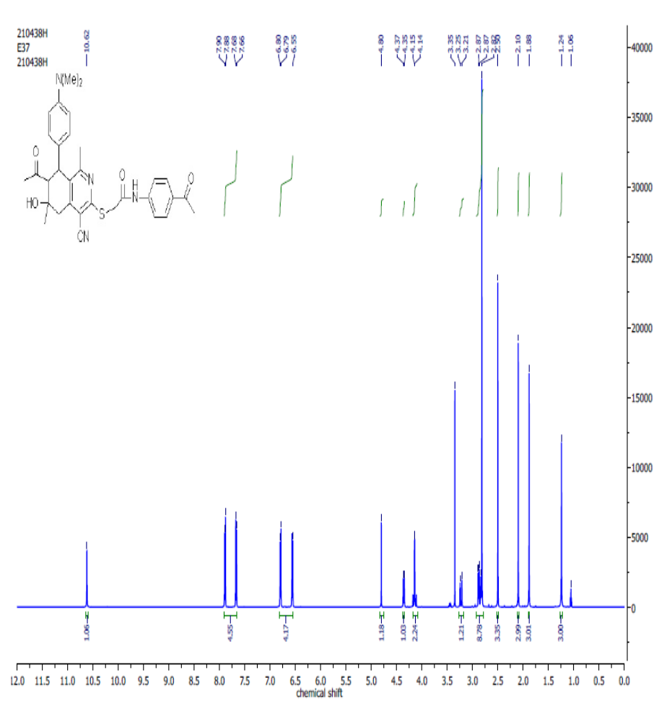
Figure S26: ¹H NMR Spectrum of 2-[(7-Acetyl-4-cyano-1,6-dimethyl-6-hydroxy-8-(4-N,N-dimethylaminophenyl)-5,6,7,8-tetrahydroisoquinolin-3-yl)thio]-N-(4-acetylphenyl)acetamide (7d)
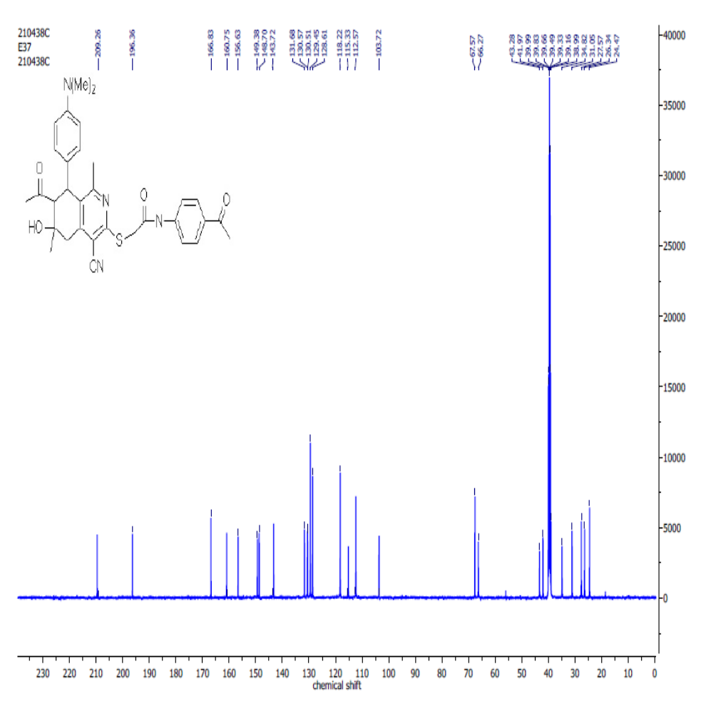
Figure S27: ¹³C NMR Spectrum 2-[(7-Acetyl-4-cyano-1,6-dimethyl-6-hydroxy-8-(4-N,N-dimethylaminophenyl)-5,6,7,8-tetrahydroisoquinolin-3-yl)thio]-N-(4-acetylphenyl)acetamide (7d)

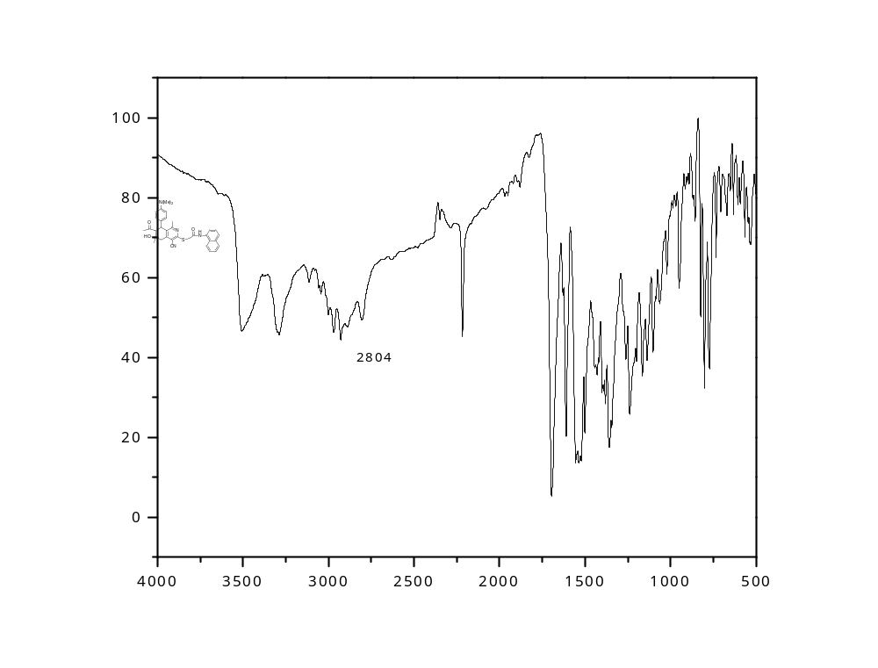

Figure S28: IR Spectrum of 2-[(7-Acetyl-4-cyano-1,6-dimethyl-6-hydroxy-8-(4-N,N-dimethylaminophenyl)-5,6,7,8-tetrahydroisoquinolin-3-yl)thio]-N CH₃-(naphthalen-1-yl)acetamide (7e).

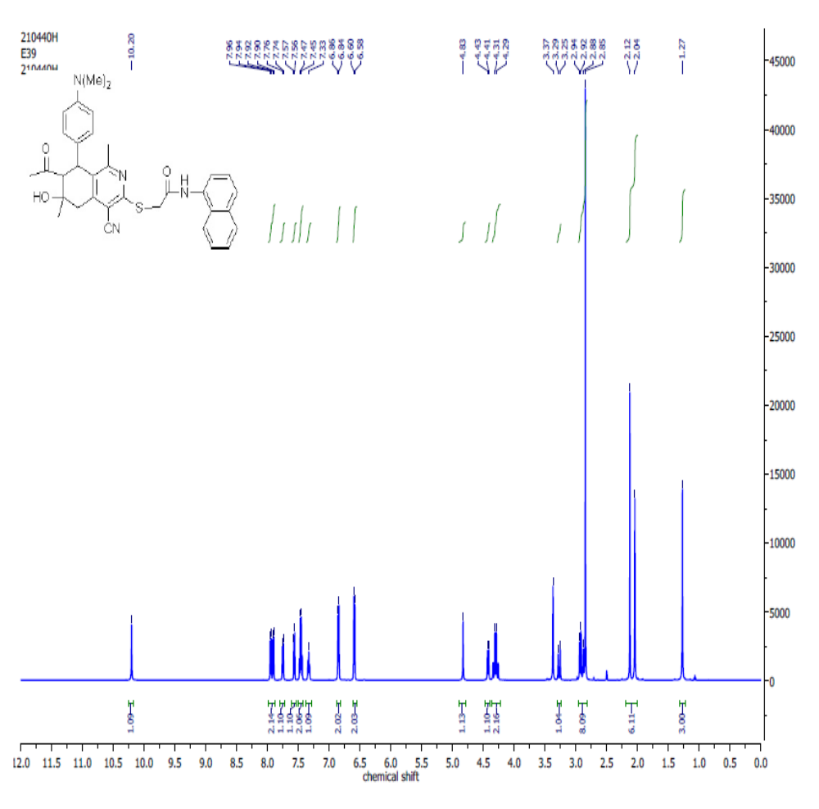Figure S29: ¹H NMR Spectrum of 2-[(7-Acetyl-4-cyano-1,6-dimethyl-6-hydroxy-8-
(4-N,N-dimethylaminophenyl)-5,6,7,8-tetrahydroisoquinolin-3-yl)thio]-N CH₃-(naphthalen-1-yl)acetamide (7e).

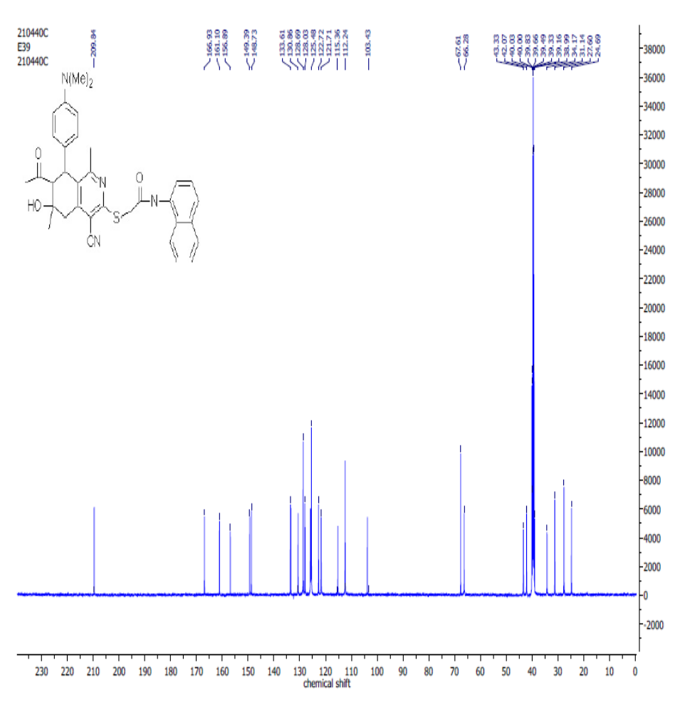
Figure S30: ¹³C NMR Spectrum of 2-[(7-Acetyl-4-cyano-1,6-dimethyl-6-hydroxy-8-(4-N,N-dimethylaminophenyl)-5,6,7,8-tetrahydroisoquinolin-3-yl)thio]-N CH₃-(naphthalen-1-yl)acetamide (7e).

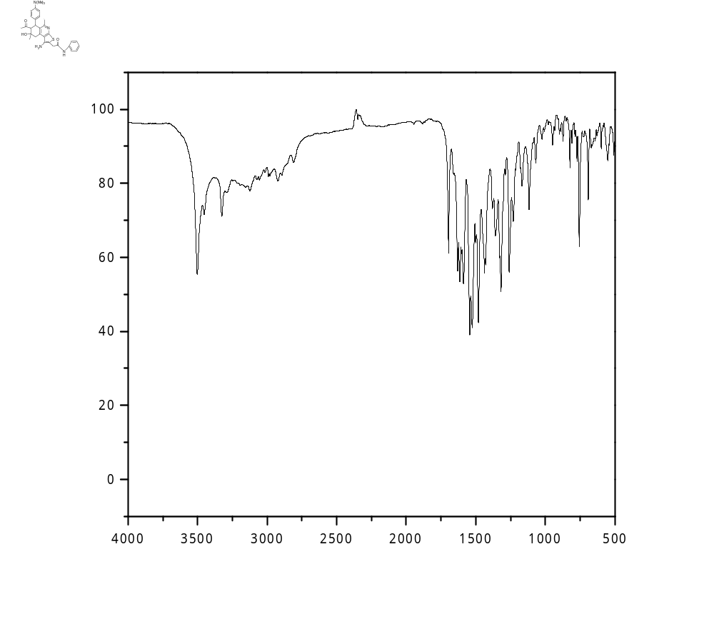

Figure S31: IR Spectrum of 7-Acetyl-1-amino-5,8-dimethyl-8-hydroxy-6-(4-N,N-dimethylaminophenyl)-N-phenyl-6,7,8,9-tetrahydrothieno[2,3-c]isoquinoline-2-carboxamide (8a).

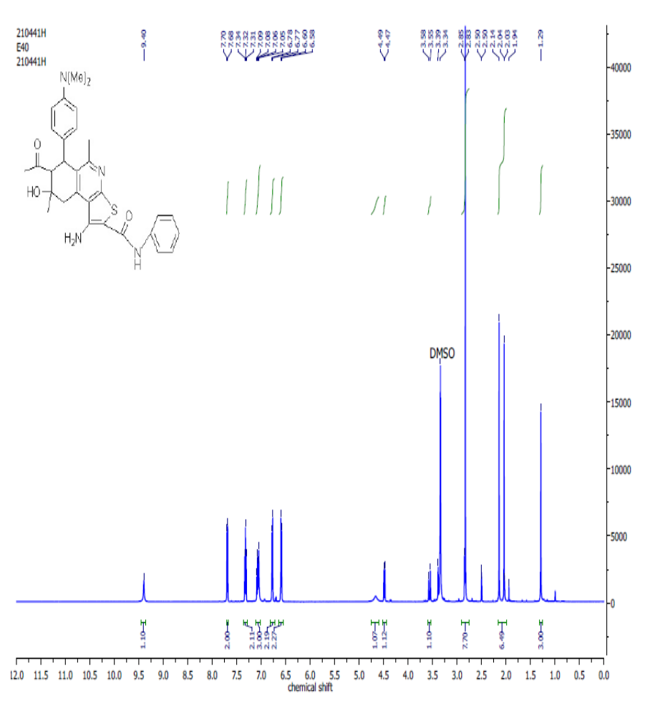
Figure S32: ¹H NMR Spectrum of 7-Acetyl-1-amino-5,8-dimethyl-8-hydroxy-6-(4-N,N-dimethylaminophenyl)-N-phenyl-6,7,8,9-tetrahydrothieno[2,3-c]isoquinoline-2-carboxamide (8a).

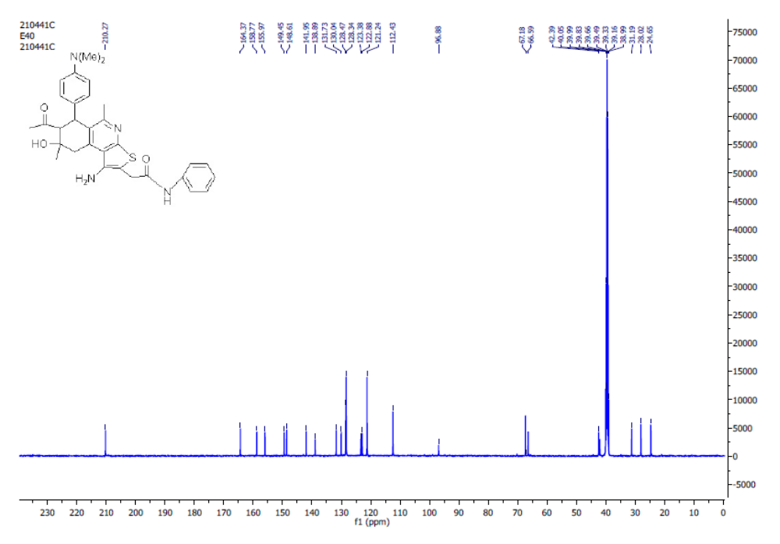
Figure S33: ¹³C NMR Spectrum of 7-Acetyl-1-amino-5,8-dimethyl-8-hydroxy-6-(4-N,N-dimethylaminophenyl)-N-phenyl-6,7,8,9-tetrahydrothieno[2,3-c]isoquinoline-2-carboxamide (8a).

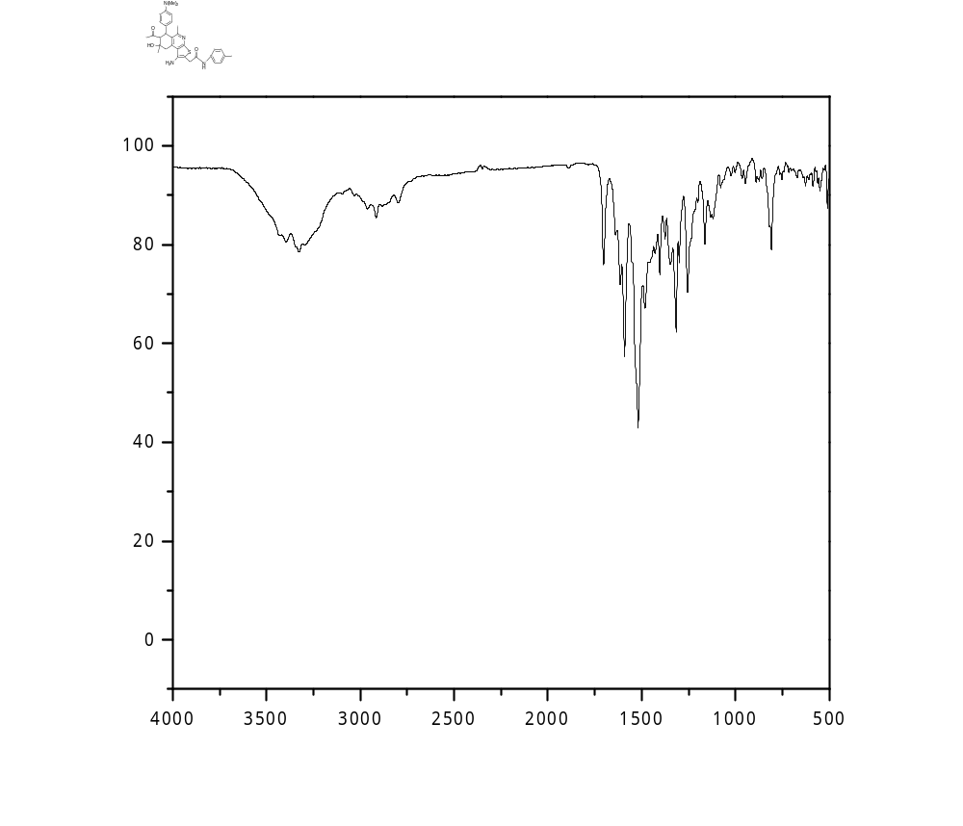
Figure S34: IR Spectrum of 7-Acetyl-1-amino-5,8-dimethyl-8-hydroxy-6-(4-N,N-dimethylaminophenyl)-N-(4-tolyl)-6,7,8,9-tetrahydrothieno[2,3-c]isoquinoline-2-carboxamide(8b).

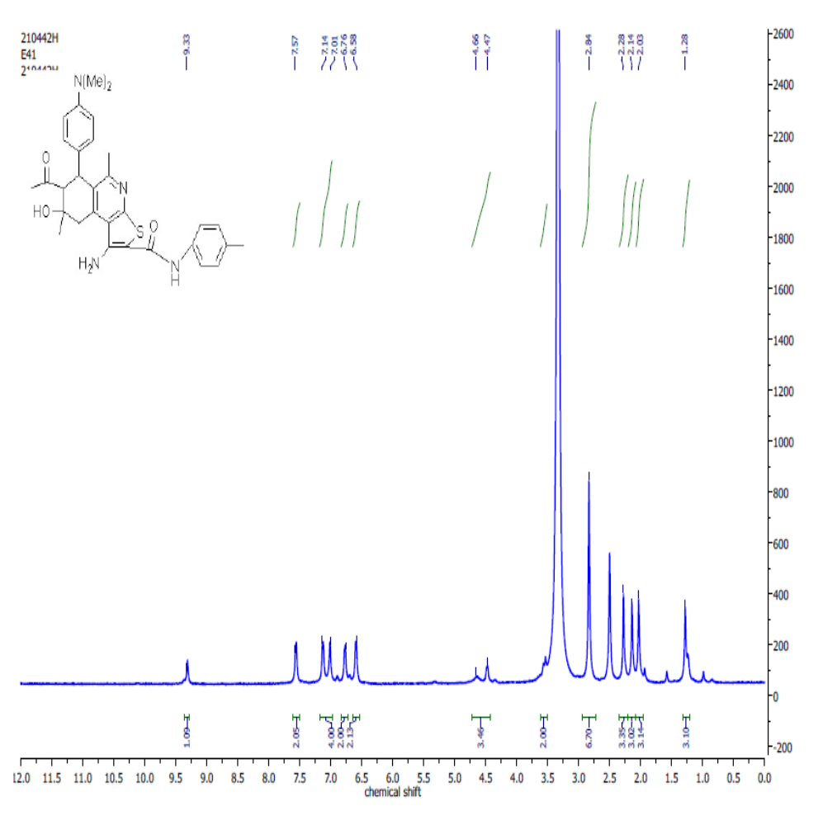Figure S35: ¹H NMR Spectrum of 7-Acetyl-1-amino-5,8-dimethyl-8-hydroxy-6-(4-N,N-dimethylaminophenyl)-N-(4-tolyl)-6,7,8,9-tetrahydrothieno[2,3-c]isoquinoline-2-carboxamide (8b).

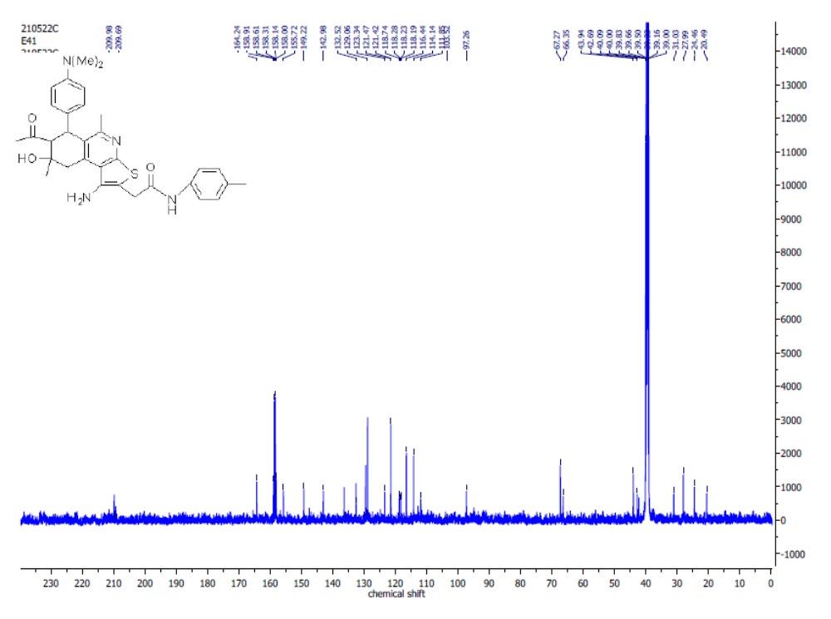
Figure S36: ¹³C NMR Spectrum of 7-Acetyl-1-amino-5,8-dimethyl-8-hydroxy-6-(4-N,N-dimethylaminophenyl)-N-(4-tolyl)-6,7,8,9-tetrahydrothieno[2,3-c]isoquinoline-2-carboxamide(8b).
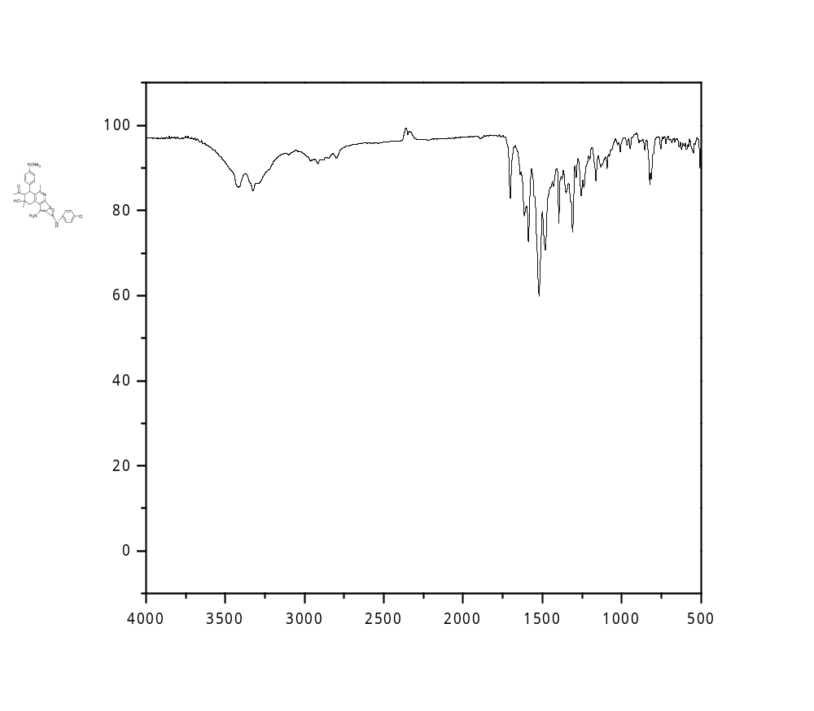

Figure S37: IR Spectrum of 7-Acetyl-1-amino-N-(4-chlorophenyl)-5,8-dimethyl-8-hydroxy-6-(4-N,N-dimethyl-aminophenyl)-6,7,8,9-tetrahydrothieno[2,3-c]isoquinoline-2-carboxamide (8c).
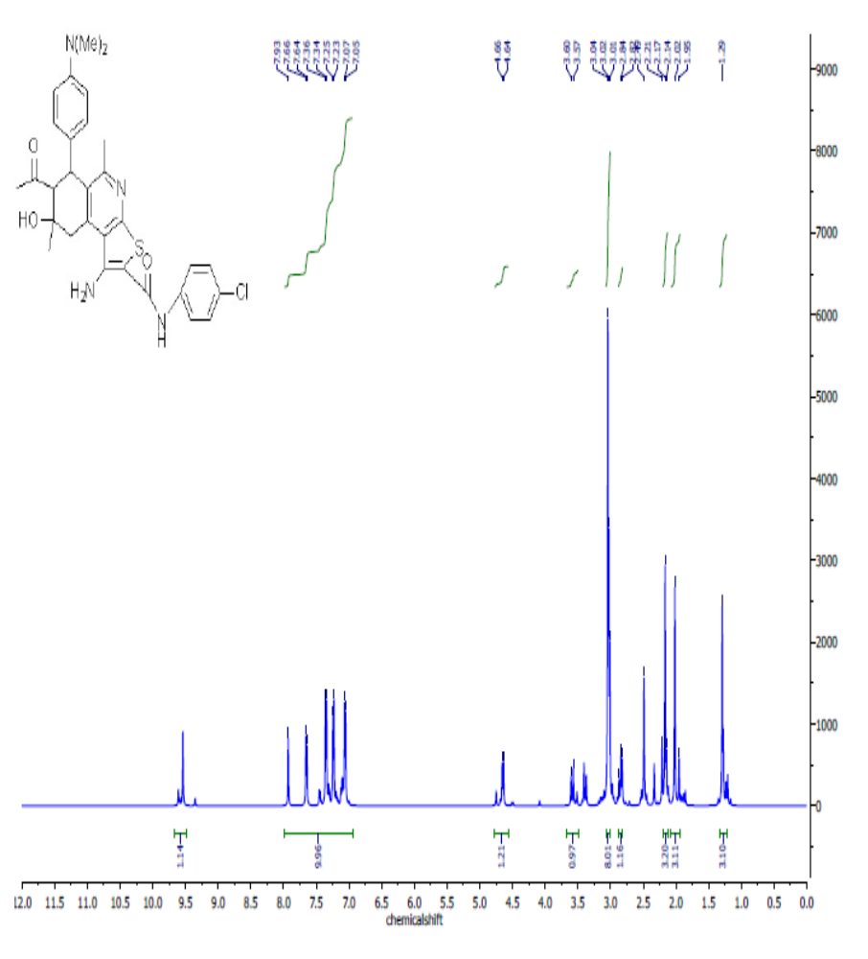Figure S38: ¹H NMR Spectrum of 7-Acetyl-1-amino-N-(4-chlorophenyl)5,8-dimethyl-8-hydroxy-6-
(4-N,N-dimethyl-aminophenyl)-6,7,8,9-tetrahydrothieno[2,3-c]isoquinoline-2-carboxamide (8c).

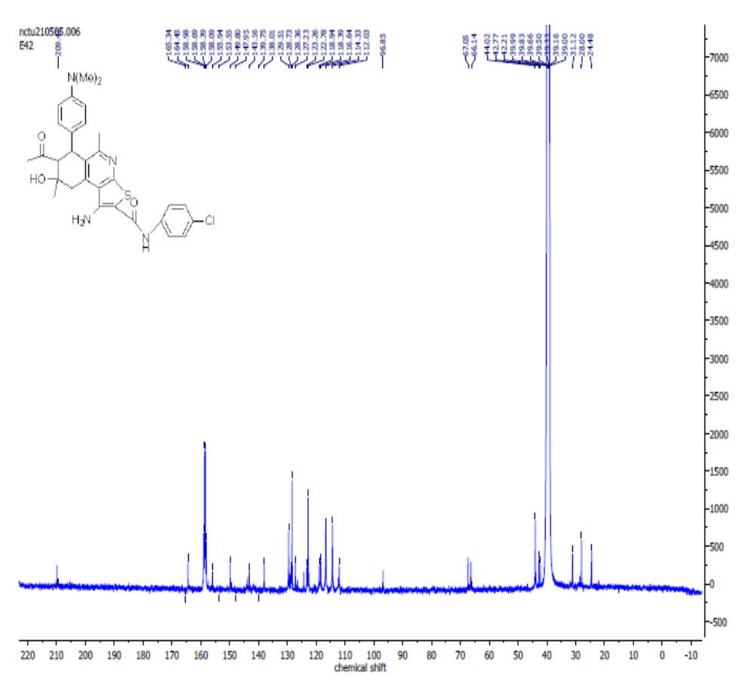
Figure S39: ¹³C NMR Spectrum of 7-Acetyl-1-amino-N-(4-chlorophenyl)-5,8-dimethyl-8-hydroxy-6-
(4-N,N-dimethyl-aminophenyl)-6,7,8,9-tetrahydrothieno[2,3-c]isoquinoline-2-carboxamide (8c).

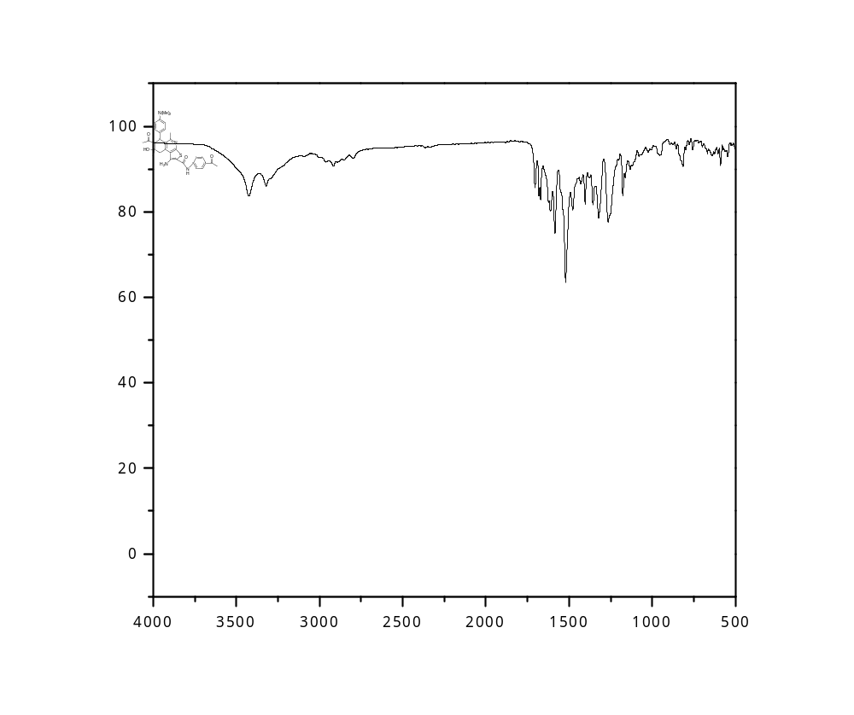Figure S40: IR Spectrum of 7-Acetyl-N-(4-acetylphenyl)-1-amino-5,8-dimethyl-8-hydroxy-6-(4-N,N-dimethyl-aminophenyl)-6,7,8,9-tetrahydrothieno[2,3-c]isoquinoline-2-carboxamide (8d).
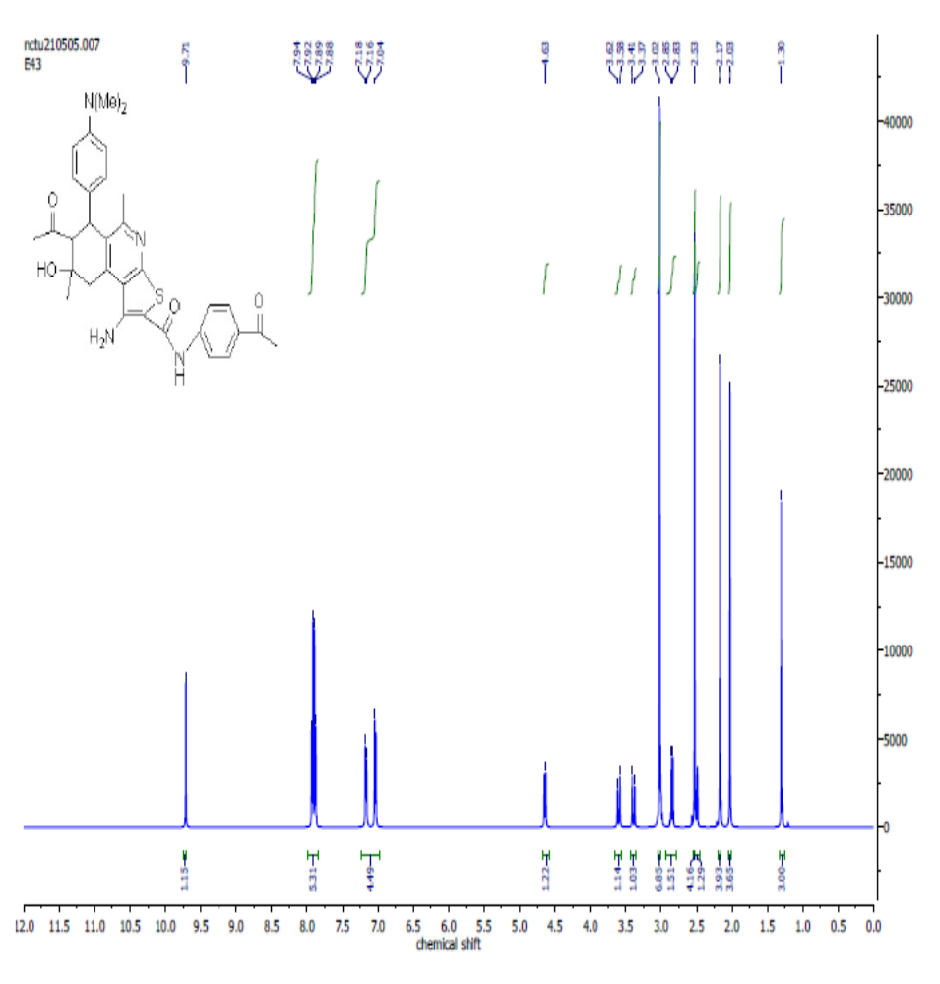
Figure S41: ¹H NMR Spectrum of 7-Acetyl-N-(4-acetylphenyl)-1-amino-5,8-dimethyl-8-hydroxy-6-(4-N,N-dimethyl-aminophenyl)-6,7,8,9-tetrahydrothieno[2,3-c]isoquinoline-2-carboxamide (8d).
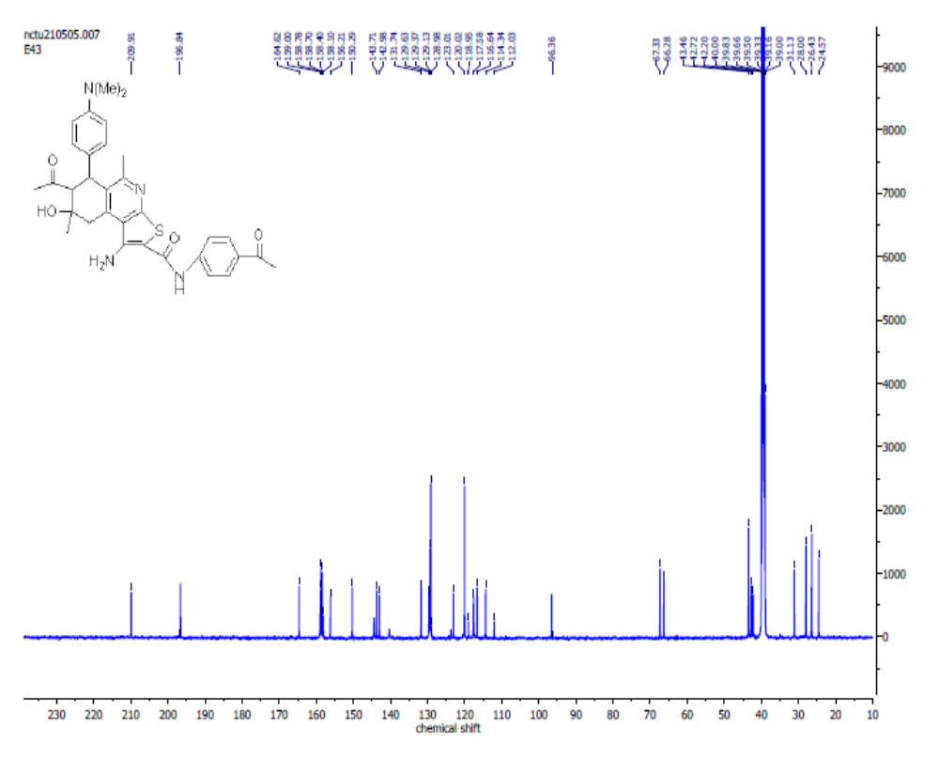
Figure S42: ¹³C NMR Spectrum of 7-Acetyl-N-(4-acetylphenyl)-1-amino-5,8-dimethyl-8-hydroxy-6-(4-N,N-dimethyl-aminophenyl)-6,7,8,9-tetrahydrothieno[2,3-c]isoquinoline-2-carboxamide (8d).
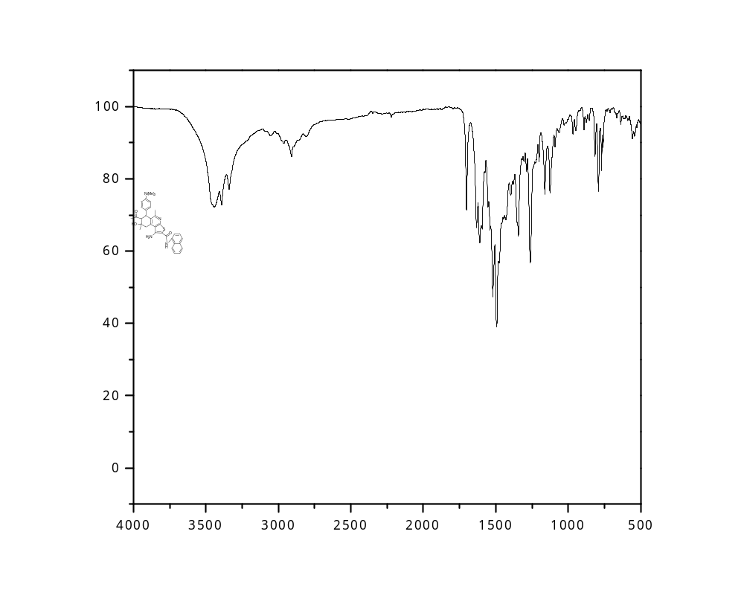
Figure S43: IR Spectrum of 7-Acetyl-1-amino-N (naphthalen-1-yl)-5,8-dimethyl-8-hydroxy-6-(4-N,N-dimethyl-aminophenyl)-6,7,8,9-tetrahydrothieno[2,3-c]isoquinoline-2-carboxamide (8e).

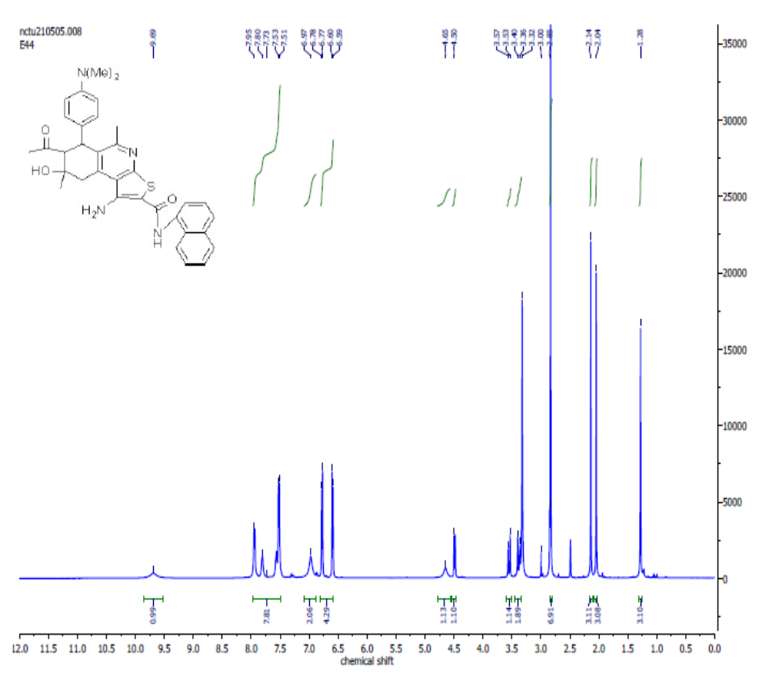
Figure S44: ¹H NMR Spectrum o7-Acetyl-1-amino-N (naphthalen-1-yl)-5,8-dimethyl-8-hydroxy-6-(4-N,N-dimethyl-aminophenyl)-6,7,8,9-tetrahydrothieno[2,3-c]isoquinoline-2-carboxamide (8e).
f

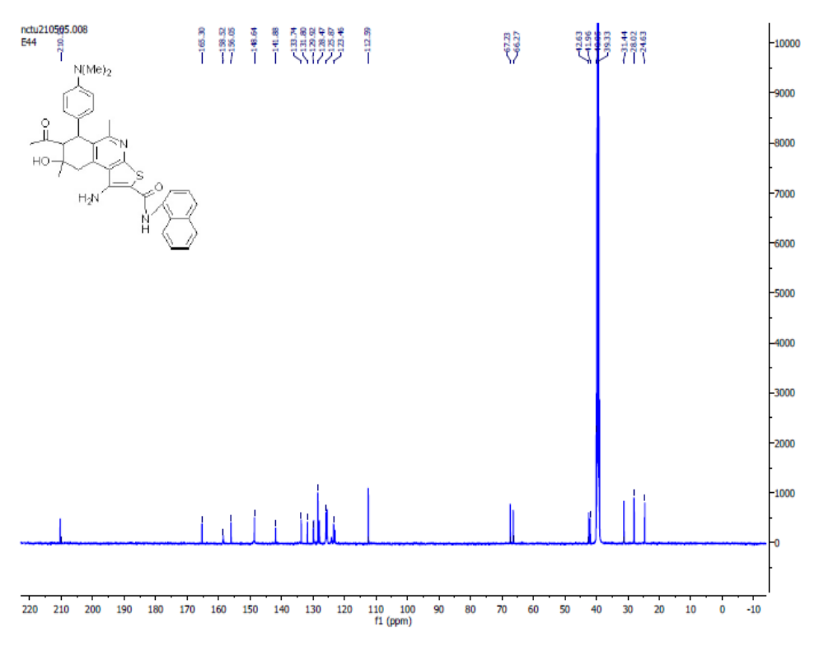Figure S45: ¹³C NMR Spectrum of 7-Acetyl-1-amino-N (naphthalen-1-yl)-5,8-dimethyl-8-hydroxy-6
-(4-N,N-dimethyl-aminophenyl)-6,7,8,9-tetrahydrothieno[2,3-c]isoquinoline-2-carboxamide (8e).

Table S1. Raw date of toxicity and viability of compds 1,3,4,5 and 6 against MCF7.
ID | Conc. | O.D |  |  | Mean O.D | ST.E | Viability % | Toxicity % | IC₅₀
ID | µMol |  |  |  |  |  |  |  | µMol
MCF7 | dilution | 0.815 | 0.81 | 0.823 | 0.816 | 0.003786 | 100 | 0
doxorubicin | 25 | 0.021 | 0.024 | 0.018 | 0.021 | 0.001732 | 1.555500 | 98.45 | 0.053
doxorubicin | 12.5 | 0.023 | 0.034 | 0.028 | 0.028333 | 0.00318 | 2.542311 | 97.46 | 0.053
doxorubicin | 6.25 | 0.043 | 0.059 | 0.051 | 0.051 | 0.004619 | 6.5503501 | 93.45 | 0.053
doxorubicin | 3.125 | 0.081 | 0.092 | 0.088 | 0.087 | 0.003215 | 9.13000 | 90.87 | 0.053
doxorubicin | 1.562 | 0.118 | 0.119 | 0.107 | 0.114667 | 0.003844 | 19.771212 | 80.23 | 0.053
doxorubicin | 0.781 | 0.284 | 0.279 | 0.286 | 0.283 | 0.002082 | 26.44000 | 73.56 | 0.053
doxorubicin | 0.391 | 0.498 | 0.492 | 0.487 | 0.492333 | 0.00318 | 37.131112 | 62.87 | 0.053
doxorubicin | 0.195 | 0.654 | 0.651 | 0.663 | 0.656 | 0.003606 | 43.660011 | 56.34 | 0.053
doxorubicin | 0.0975 | 0.756 | 0.753 | 0.760 | 0.756 | 0.003200 | 47.34 | 52.667 | 0.053
doxorubicin | 0.0487 | 0.8498 | 0.850 | 0.848 | 0.849 | 0.00246 | 51.88 | 48.12 | 0.053
 | 25 | 0.025 | 0.019 | 0.022 | 0.022 | 0.001732 | 2.6960784 | 97.303922
 | 12.5 | 0.049 | 0.055 | 0.052 | 0.052 | 0.001732 | 6.372549 | 93.627451
 | 6.25 | 0.111 | 0.103 | 0.106 | 0.106667 | 0.002333 | 13.071895 | 86.928105 | 1.857
1 | 3.125 | 0.194 | 0.187 | 0.198 | 0.193 | 0.003215 | 23.651961 | 76.348039
 | 1.562 | 0.431 | 0.446 | 0.443 | 0.44 | 0.004583 | 53.921569 | 46.078431
 | 0.781 | 0.621 | 0.624 | 0.627 | 0.624 | 0.001732 | 76.470588 | 23.529412
 | 0.391 | 0.745 | 0.755 | 0.751 | 0.750 | 0.002906 | 91.952614 | 8.473856
 | 0.195 | 0.817 | 0.809 | 0.811 | 0.812 | 0.002404 | 99.550654 | 0.4493464
 | 0.0975 | 0.878 | 0.893 | 0.892 | 0.887 | 0.00345 | 99.67632 | 0.3245666
 | 0.0487 | 0.923 | 0.913 | 0.932 | 0.915 | 0.920 | 99.725246 | 0.2744643
 | 25 | 0.028 | 0.025 | 0.019 | 0.024 | 0.002646 | 2.9411765 | 97.058824
 | 12.5 | 0.018 | 0.023 | 0.022 | 0.021 | 0.001528 | 2.5735294 | 97.426471
 | 6.25 | 0.042 | 0.034 | 0.043 | 0.039667 | 0.002848 | 4.8611111 | 95.138889
3 | 3.125 | 0.064 | 0.075 | 0.076 | 0.071667 | 0.003844 | 8.7826797 | 91.21732 | 0.562
 | 1.562 | 0.136 | 0.141 | 0.144 | 0.140333 | 0.002333 | 17.197712 | 82.802288
 | 0.781 | 0.262 | 0.278 | 0.274 | 0.271333 | 0.004807 | 33.251634 | 66.748366
 | 0.391 | 0.505 | 0.493 | 0.5 | 0.499333 | 0.00348 | 61.19281 | 38.80719
 | 0.195 | 0.745 | 0.751 | 0.748 | 0.748 | 0.001732 | 91.666667 | 8.3333333
 | 0.0975 | 0.792 | 0.782 | 0.7912 | 0.788 | 0.003455 | 92.876 | 7.124
 | 0.0487 | 0.923 | 0.892 | 0.9123 | 0.909 | 0.001344 | 94.876 | 5.124
 | 25 | 0.029 | 0.027 | 0.022 | 0.026 | 0.002082 | 3.1862745 | 96.813725
 | 12.5 | 0.062 | 0.069 | 0.071 | 0.067333 | 0.002728 | 8.251634 | 91.748366
 | 6.25 | 0.146 | 0.142 | 0.151 | 0.146333 | 0.002603 | 17.933007 | 82.066993 | 3.074
4 | 3.125 | 0.515 | 0.514 | 0.516 | 0.515 | 0.000577 | 63.112745 | 36.887255
 | 1.562 | 0.621 | 0.628 | 0.626 | 0.625 | 0.002082 | 76.593137 | 23.406863
 | 0.781 | 0.742 | 0.745 | 0.767 | 0.751333 | 0.007881 | 92.075163 | 7.9248366
 | 0.391 | 0.818 | 0.812 | 0.819 | 0.816333 | 0.002186 | 100.04085 | 0.04085
 | 0.195 | 0.819 | 0.817 | 0.81 | 0.815333 | 0.002728 | 99.918301 | 0.0816993
 | 0.0975 | 0.927 | 0.921 | 0.912 | 0.93 | 0.002445 | 99.936676 | 0.064345
 | 0.0487 | 0.941 | 0.993 | 0.978 | 0.9766 | 0.00244 | 99.938212 | 0.034667
 | 25 | 0.027 | 0.021 | 0.02 | 0.022667 | 0.002186 | 2.7777778 | 97.222222
 | 12.5 | 0.024 | 0.032 | 0.021 | 0.025667 | 0.003283 | 3.1454248 | 96.854575
 | 6.25 | 0.055 | 0.051 | 0.043 | 0.049667 | 0.003528 | 6.0866013 | 93.913399 | 0.924
5 | 3.125 | 0.092 | 0.096 | 0.084 | 0.090667 | 0.003528 | 11.111111 | 88.888889
 | 1.562 | 0.189 | 0.176 | 0.185 | 0.183333 | 0.003844 | 22.46732 | 77.53268
 | 0.781 | 0.529 | 0.523 | 0.528 | 0.526667 | 0.001856 | 64.542484 | 35.457516
 | 0.391 | 0.784 | 0.779 | 0.782 | 0.781667 | 0.001453 | 95.792484 | 4.2075163
 | 0.195 | 0.834 | 0.846 | 0.838 | 0.839333 | 0.003528 | 102.85948 | -2.859477
 | 0.0975 | 0.892 | 0.895 | 0.896 | 0.8945 | 0.00456 | 103.56655 | -3.54455
 | 0.0487 | 0.923 | 0.956 | 0.9678 | 0.96578 | 0.00234 | 104.54433 | -4.56677
 | 25 | 0.019 | 0.022 | 0.024 | 0.021667 | 0.001453 | 2.6552288 | 97.344771
 | 12.5 | 0.023 | 0.025 | 0.022 | 0.023333 | 0.000882 | 2.8594771 | 97.140523
 | 6.25 | 0.053 | 0.054 | 0.055 | 0.054 | 0.000577 | 6.6176471 | 93.382353
6 | 3.125 | 0.116 | 0.11 | 0.124 | 0.116667 | 0.004055 | 14.297386 | 85.702614 | 0.329
 | 1.562 | 0.189 | 0.198 | 0.192 | 0.193 | 0.002646 | 23.651961 | 76.348039
 | 0.781 | 0.234 | 0.241 | 0.242 | 0.239 | 0.002517 | 29.289216 | 70.710784
 | 0.391 | 0.335 | 0.324 | 0.328 | 0.329 | 0.003215 | 40.318627 | 59.681373
 | 0.195 | 0.507 | 0.5 | 0.505 | 0.504 | 0.002082 | 61.764706 | 38.235294
 | 0.0975 | 0.591 | 0.596 | 0.582 | 0.589 | 0.00435 | 74.5543 | 25.5567
 | 0.0487 | 0.674 | 0.635 | 0.634 | 0.647 | 0.00466 | 80.118 | 18.992
Table S2. Raw date of toxicity and viability of compounds 7a,7b,7c,7d, and 7e against MCF7.
ID | Conc. | O.D |  |  | Mean O.D | ST.E | Viability % | Toxicity % | IC₅₀
ID | µMol |  |  |  |  |  |  |  | µMol
MCF7 | dilution | 0.815 | 0.81 | 0.823 | 0.816 | 0.003786 | 100 | 0
 | 25 | 0.024 | 0.021 | 0.019 | 0.021333 | 0.001453 | 2.6143791 | 97.385621
 | 12.5 | 0.064 | 0.061 | 0.072 | 0.065667 | 0.003283 | 8.0473856 | 91.952614
 | 6.25 | 0.23 | 0.233 | 0.226 | 0.229667 | 0.002028 | 28.145425 | 71.854575 | 2.218
7a | 3.125 | 0.384 | 0.379 | 0.388 | 0.383667 | 0.002603 | 47.017974 | 52.982026
 | 1.562 | 0.541 | 0.536 | 0.543 | 0.54 | 0.002082 | 66.176471 | 33.823529
 | 0.781 | 0.631 | 0.624 | 0.627 | 0.627333 | 0.002028 | 76.879085 | 23.120915
 | 0.391 | 0.745 | 0.755 | 0.751 | 0.750333 | 0.002906 | 91.952614 | 8.0473856
 | 0.195 | 0.837 | 0.839 | 0.842 | 0.839333 | 0.001453 | 102.85948 | -2.859477
 | 0.0975 | 0.895 | 0.894 | 0.896 | 0.895 | 0.00455 | 103.45566 | -3.455666
 | 0.0487 | 0.945 | 0.9678 | 0.958 | 0.95666 | 0.0223445 | 105.76544 | -5.345662
 | 25 | 0.028 | 0.025 | 0.031 | 0.028 | 0.001732 | 3.4313725 | 96.568627
 | 12.5 | 0.027 | 0.034 | 0.022 | 0.027667 | 0.00348 | 3.3905229 | 96.609477
 | 6.25 | 0.052 | 0.054 | 0.063 | 0.056333 | 0.003383 | 6.9035948 | 93.096405 | 0.474
7b | 3.125 | 0.111 | 0.115 | 0.106 | 0.110667 | 0.002603 | 13.562092 | 86.437908
 | 1.562 | 0.146 | 0.141 | 0.144 | 0.143667 | 0.001453 | 17.606209 | 82.393791
 | 0.781 | 0.162 | 0.178 | 0.274 | 0.204667 | 0.034973 | 25.081699 | 74.918301
 | 0.391 | 0.485 | 0.499 | 0.494 | 0.492667 | 0.004096 | 60.375817 | 39.624183
 | 0.195 | 0.745 | 0.751 | 0.748 | 0.748 | 0.001732 | 91.666667 | 8.3333333
 | 0.0975 | 0.853 | 0.834 | 0.846 | 0.833 | 0.00494 | 93.77455 | 6.2344568
 | 0.0487 | 0.921 | 0.923 | 926 | 0.9333 | 0.004566 | 95.4311 | 4.56888
 | 25 | 0.029 | 0.023 | 0.027 | 0.026333 | 0.001764 | 3.2271242 | 96.772876
 | 12.5 | 0.042 | 0.034 | 0.41 | 0.162 | 0.124022 | 19.852941 | 80.147059
 | 6.25 | 0.109 | 0.114 | 0.111 | 0.111333 | 0.001453 | 13.643791 | 86.356209 | 1.491
7c | 3.125 | 0.275 | 0.284 | 0.286 | 0.281667 | 0.003383 | 34.517974 | 65.482026
 | 1.562 | 0.522 | 0.512 | 0.516 | 0.516667 | 0.002906 | 63.316993 | 36.683007
 | 0.781 | 0.742 | 0.745 | 0.757 | 0.748 | 0.004583 | 91.666667 | 8.3333333
 | 0.391 | 0.819 | 0.819 | 0.814 | 0.817333 | 0.001667 | 100.1634 | 0.5333987
 | 0.195 | 0.817 | 0.81 | 0.808 | 0.811667 | 0.002728 | 99.468954 | 0.1610458
 | 0.0975 | 0.921 | 0.933 | 0.923 | 0.925 | 0.00778 | 100.57755 | -0.53355
 | 0.0487 | 0.966 | 0.976 | 0.686 | 0.976 | 0.00345 | 100.43345 | -0.67765
 | 25 | 0.028 | 0.03 | 0.022 | 0.026667 | 0.002404 | 3.2679739 | 96.732026
 | 12.5 | 0.024 | 0.027 | 0.031 | 0.027333 | 0.002028 | 3.3496732 | 96.650327
 | 6.25 | 0.045 | 0.048 | 0.053 | 0.048667 | 0.002333 | 5.9640523 | 94.035948 | 0.495
7d | 3.125 | 0.192 | 0.186 | 0.194 | 0.190667 | 0.002404 | 23.366013 | 76.633987
 | 1.562 | 0.279 | 0.276 | 0.285 | 0.28 | 0.002646 | 34.313725 | 65.686275
 | 0.781 | 0.389 | 0.385 | 0.388 | 0.387333 | 0.001202 | 47.46732 | 52.53268
 | 0.391 | 0.584 | 0.579 | 0.582 | 0.581667 | 0.001453 | 71.28268 | 28.71732
 | 0.195 | 0.778 | 0.766 | 0.779 | 0.774333 | 0.004177 | 94.893791 | 5.1062092
 | 0.0975 | 0.812 | 0.8243 | 0.834 | 0.823 | 0.0016754 | 96.5544 | 3.5566
 | 0.0487 | 0.953 | 0.9656 | 0.964 | 0.9 | 0.0034556 | 98.2255 | 1.8855
 | 25 | 0.02 | 0.022 | 0.024 | 0.022 | 0.001155 | 2.6960784 | 97.303922
 | 12.5 | 0.023 | 0.025 | 0.027 | 0.025 | 0.001155 | 3.0637255 | 96.936275
 | 6.25 | 0.053 | 0.054 | 0.055 | 0.054 | 0.000577 | 6.6176471 | 93.382353 | 0.211
7e | 3.125 | 0.093 | 0.1 | 0.094 | 0.095667 | 0.002186 | 11.723856 | 88.276144
 | 1.562 | 0.179 | 0.178 | 0.172 | 0.176333 | 0.002186 | 21.609477 | 78.390523
 | 0.781 | 0.234 | 0.241 | 0.242 | 0.239 | 0.002517 | 29.289216 | 70.710784
 | 0.391 | 0.31 | 0.314 | 0.318 | 0.314 | 0.002309 | 38.480392 | 61.519608
 | 0.195 | 0.547 | 0.543 | 0.542 | 0.544 | 0.001528 | 66.666667 | 33.333333
 | 0.0975 | 0.647 | 0.674 | 0.678 | 0.666 | 0.003456 | 73.554457 | 27.556667
 | 0.0487 | 0.75 | 0.746 | 0.746 | 0.747 | 0.005868 | 79.234669 | 20.876446

Tables S3. Raw date of toxicity and viability of compounds 8a, 8b, 8c, 8d, and 8e against MCF7.
ID | Conc.  µMol | O.D |  |  | Mean O.D | ST.E | Viability % | Toxicity % | IC₅₀  µMol
MCF7 | dilution | 0.815 | 0.810 | 0.823 | 0.816 | 0.003786 | 100 | 0
8a | 25 | 0.025 | 0.018 | 0.020 | 0.021 | 0.002082 | 2.573529412 | 97.426470588 | 0.872
8a | 12.5 | 0.028 | 0.025 | 0.023 | 0.025333 | 0.001453 | 3.104575163 | 96.895424837 | 0.872
8a | 6.25 | 0.044 | 0.053 | 0.046 | 0.047667 | 0.002728 | 5.841503268 | 94.158496732 | 0.872
8a | 3.125 | 0.104 | 0.101 | 0.108 | 0.104333 | 0.002028 | 12.785947712 | 87.214052288 | 0.872
8a | 1.562 | 0.281 | 0.286 | 0.283 | 0.283333 | 0.001453 | 34.722222222 | 65.277777778 | 0.872
8a | 0.781 | 0.531 | 0.534 | 0.537 | 0.534 | 0.001732 | 65.44117647 | 34.558823529 | 0.872
8a | 0.391 | 0.745 | 0.755 | 0.751 | 0.750333 | 0.002906 | 91.95261438 | 8.047385621 | 0.872
8a | 0.195 | 0.817 | 0.819 | 0.822 | 0.819333 | 0.001453 | 100.40849673 | -0.408496732 | 0.872
8a | 0.0975 | 0.894 | 0.8934 | 0.893 | 0.8953 | 0.00345 | 100.57788655 | -0.53322455 | 0.872
8a | 0.0487 | 0.956 | 0.9465 | 0.945 | 0.949 | 0.00231 | 101.54432 | -1.566678 | 0.872
8b | 25 | 0.028 | 0.022 | 0.031 | 0.027 | 0.002646 | 3.308823529 | 96.691176471 | 3.800
8b | 12.5 | 0.097 | 0.093 | 0.102 | 0.097333 | 0.002603 | 11.928104575 | 88.071895425 | 3.800
8b | 6.25 | 0.322 | 0.326 | 0.328 | 0.325333 | 0.001764 | 39.869281046 | 60.130718954 | 3.800
8b | 3.125 | 0.614 | 0.615 | 0.616 | 0.615 | 0.000577 | 75.367647059 | 24.632352941 | 3.800
8b | 1.562 | 0.706 | 0.711 | 0.704 | 0.707 | 0.002082 | 86.642156863 | 13.357843137 | 3.800
8b | 0.781 | 0.792 | 0.800 | 0.804 | 0.798667 | 0.003528 | 97.87581699 | 2.124183007 | 3.800
8b | 0.391 | 0.824 | 0.811 | 0.818 | 0.817667 | 0.003756 | 100.20424837 | -0.204248366 | 3.800
8b | 0.195 | 0.813 | 0.811 | 0.819 | 0.814333 | 0.002404 | 99.79575163 | 0.204248366 | 3.800
8b | 0.0975 | 0.889 | 0.883 | 0.878 | 0.886 | 0.003423 | 99.8766 | 0.1234 | 3.800
8b | 0.0487 | 0.945 | 0.956 | 0.935 | 0.945 | 0.00233 | 99.9322 | 0.0678 | 3.800
8c | 25 | 0.029 | 0.027 | 0.019 | 0.025 | 0.003055 | 3.063725490 | 96.936274510 | 0.215
8c | 12.5 | 0.026 | 0.024 | 0.021 | 0.023667 | 0.001453 | 2.900326797 | 97.099673203 | 0.215
8c | 6.25 | 0.025 | 0.028 | 0.031 | 0.028 | 0.001732 | 3.431372549 | 96.568627451 | 0.215
8c | 3.125 | 0.027 | 0.024 | 0.036 | 0.029 | 0.003606 | 3.553921569 | 96.446078431 | 0.215
8c | 1.562 | 0.114 | 0.120 | 0.116 | 0.116667 | 0.001764 | 14.297385621 | 85.702614379 | 0.215
8c | 0.781 | 0.242 | 0.245 | 0.247 | 0.244667 | 0.001453 | 29.98366013 | 70.016339869 | 0.215
8c | 0.391 | 0.324 | 0.320 | 0.329 | 0.324333 | 0.002603 | 39.74673203 | 60.253267974 | 0.215
8c | 0.195 | 0.492 | 0.487 | 0.481 | 0.486667 | 0.00318 | 59.64052288 | 40.359477124 | 0.215
8c | 0.0975 | 0.564 | 0.546 | 0.567 | 0.559 | 0.00342 | 69.5434 | 30.4566 | 0.215
8c | 0.0487 | 0.646 | 0.678 | 0.648 | 0.657 | 0.00124 | 73.3223 | 26.67777 | 0.215
8d | 25 | 0.022 | 0.018 | 0.020 | 0.02 | 0.001155 | 2.450980392 | 97.549019608 | 0.117
8d | 12.5 | 0.024 | 0.022 | 0.026 | 0.024 | 0.001155 | 2.941176471 | 97.058823529 | 0.117
8d | 6.25 | 0.025 | 0.033 | 0.030 | 0.029333 | 0.002333 | 3.594771242 | 96.405228758 | 0.117
8d | 3.125 | 0.042 | 0.046 | 0.044 | 0.044 | 0.001155 | 5.392156863 | 94.607843137 | 0.117
8d | 1.562 | 0.050 | 0.056 | 0.045 | 0.050333 | 0.00318 | 6.168300654 | 93.831699346 | 0.117
8d | 0.781 | 0.097 | 0.093 | 0.089 | 0.093 | 0.002309 | 11.39705882 | 88.602941176 | 0.117
8d | 0.391 | 0.284 | 0.279 | 0.282 | 0.281667 | 0.001453 | 34.51797386 | 65.482026144 | 0.117
8d | 0.195 | 0.378 | 0.366 | 0.379 | 0.374333 | 0.004177 | 45.87418301 | 54.125816993 | 0.117
 | 0.0975 | 0.456 | 0.425 | 0.467 | 0.449 | 0.002343 | 54.4424 | 45.6686 | 0.117
 | 0.0487 | 0.578 | 0.567 | 0.578 | 0.574 | 0.00235 | 78.2125 | 21.78754 | 0.117
8e | 25 | 0.027 | 0.020 | 0.024 | 0.023667 | 0.002028 | 2.900326797 | 97.099673203 | 0.461
8e | 12.5 | 0.023 | 0.025 | 0.028 | 0.025333 | 0.001453 | 3.104575163 | 96.895424837 | 0.461
8e | 6.25 | 0.053 | 0.054 | 0.055 | 0.054 | 0.000577 | 6.617647059 | 93.382352941 | 0.461
8e | 3.125 | 0.117 | 0.114 | 0.121 | 0.117333 | 0.002028 | 14.379084967 | 85.620915033 | 0.461
8e | 1.562 | 0.289 | 0.298 | 0.292 | 0.293 | 0.002646 | 35.906862745 | 64.093137255 | 0.461
8e | 0.781 | 0.334 | 0.341 | 0.342 | 0.339 | 0.002517 | 41.54411765 | 58.455882353 | 0.461
8e | 0.391 | 0.645 | 0.644 | 0.648 | 0.645667 | 0.001202 | 79.12581699 | 20.874183007 | 0.461
8e | 0.195 | 0.779 | 0.780 | 0.772 | 0.777 | 0.002517 | 95.22058824 | 4.779411765 | 0.461
8e | 0.0975 | 0.823 | 0.845 | 0.823 | 0.83033 | 0.003239 | 97.37795 | 2.67546788 | 0.461
8e | 0.0487 | 0.923 | 0.945 | 0.914 | 0.92733 | 0.002349 | 98.423 | 1.5778654 | 0.461

Table S4. Raw date of toxicity and viability of compounds 1,3,4,5, and 6 against A549.
ID | Conc. | O.D |  |  | Mean O.D | ST.E | Viability % | Toxicity % | IC₅₀
ID | µMol |  |  |  |  |  |  |  | µMol
A549 | dilution | 0.842 | 0.855 | 0.838 | 0.845 | 0.005132 | 100 | 0
Douxrbicin aganist A549 | 25 | 0.021 | 0.024 | 0.021 | 0.022 | 0.001 | 1.10011044 | 98.9 | 0.218
Douxrbicin aganist A549 | 12.5 | 0.073 | 0.084 | 0.083 | 0.08 | 0.003512 | 2.10001433 | 97.9 | 0.218
Douxrbicin aganist A549 | 6.25 | 0.183 | 0.191 | 0.196 | 0.19 | 0.003786 | 4.65133122 | 95.35 | 0.218
Douxrbicin aganist A549 | 3.125 | 0.489 | 0.487 | 0.478 | 0.484667 | 0.003383 | 6.44046566 | 93.56 | 0.218
Douxrbicin aganist A549 | 1.562 | 0.668 | 0.679 | 0.677 | 0.674667 | 0.003383 | 10.1609787 | 89.84 | 0.218
Douxrbicin aganist A549 | 0.781 | 0.714 | 0.707 | 0.716 | 0.712333 | 0.002728 | 20.260977 | 79.34 | 0.218
Douxrbicin aganist A549 | 0.391 | 0.848 | 0.842 | 0.837 | 0.842333 | 0.00318 | 37.551247 | 62.45 | 0.218
Douxrbicin aganist A549 | 0.195 | 0.984 | 0.991 | 0.973 | 0.982667 | 0.005239 | 63.670356 | 36.33 | 0.218
Douxrbicin aganist A549 | 0.0975 | 0.99 | 0.998 | 0.989 | 0.99 | 0.00673 | 73.2 | 27.8 | 0.218
Douxrbicin aganist A549 | 0.0487 | 0.996 | 0.997 | 0.995 | 0.99 | 0.00734 | 80 | 20 | 0.218
 | 25 | 0.023 | 0.025 | 0.032 | 0.026667 | 0.002728 | 3.1558185 | 96.844181
 | 12.5 | 0.078 | 0.076 | 0.08 | 0.078 | 0.001155 | 9.2307692 | 90.769231
1 | 6.25 | 0.2 | 0.205 | 0.198 | 0.201 | 0.002082 | 23.786982 | 76.213018 | 2.219
 | 3.125 | 0.342 | 0.34 | 0.338 | 0.34 | 0.001155 | 40.236686 | 59.763314
 | 1.562 | 0.55 | 0.545 | 0.553 | 0.549333 | 0.002333 | 65.009862 | 34.990138
 | 0.781 | 0.663 | 0.66 | 0.658 | 0.660333 | 0.001453 | 78.145957 | 21.854043
 | 0.391 | 0.782 | 0.776 | 0.777 | 0.778333 | 0.001856 | 92.110454 | 7.8895464
 | 0.195 | 0.839 | 0.849 | 0.847 | 0.845 | 0.002055 | 97 | 3
 | 0.0975 | 0.910 | 0.900 | 0.905 | 0.907 | 0.00377 | 98.2 | 2.8
 | 0.0487 | 0.97 | 0.975 | 0.973 | 0.974 | 0.0043 | 99 | 1
 | 25 | 0.03 | 0.026 | 0.034 | 0.03 | 0.002309 | 3.5502959 | 96.449704
 | 12.5 | 0.09 | 0.086 | 0.092 | 0.089333 | 0.001764 | 10.571992 | 89.428008
3 | 6.25 | 0.244 | 0.25 | 0.248 | 0.247333 | 0.001764 | 29.270217 | 70.729783 | 2.469
 | 3.125 | 0.401 | 0.389 | 0.397 | 0.395667 | 0.003528 | 46.824458 | 53.175542
 | 1.562 | 0.52 | 0.522 | 0.525 | 0.522333 | 0.001453 | 61.814596 | 38.185404
 | 0.781 | 0.644 | 0.645 | 0.648 | 0.645667 | 0.001202 | 76.410256 | 23.589744
 | 0.391 | 0.799 | 0.805 | 0.802 | 0.802 | 0.001732 | 94.911243 | 5.0887574
 | 0.195 | 0.837 | 0.838 | 0.84 | 0.838333 | 0.001882 | 99.211045 | 0.7889546
 | 0.0975 | 0.897 | 0.895 | 0.893 | 0.895 | 0.00202 | 99.50 | 0.50
 | 0.0487 | 0.900 | 0.92 | 0.94 | 0.920 | 0.00240 | 99.700 | 0.30
 | 25 | 0.023 | 0.026 | 0.02 | 0.023 | 0.001732 | 2.7218935 | 97.278107
 | 12.5 | 0.037 | 0.034 | 0.032 | 0.034333 | 0.001453 | 4.0631164 | 95.936884
4 | 6.25 | 0.088 | 0.092 | 0.094 | 0.091333 | 0.001764 | 10.808679 | 89.191321 | 0.918
 | 3.125 | 0.243 | 0.247 | 0.246 | 0.245333 | 0.001202 | 29.033531 | 70.966469
 | 1.562 | 0.32 | 0.322 | 0.318 | 0.32 | 0.001155 | 37.869822 | 62.130178
 | 0.781 | 0.57 | 0.572 | 0.568 | 0.57 | 0.001155 | 67.455621 | 32.544379
 | 0.391 | 0.661 | 0.668 | 0.67 | 0.666333 | 0.002728 | 78.856016 | 21.143984
 | 0.195 | 0.807 | 0.816 | 0.812 | 0.811667 | 0.002803 | 96.055227 | 3.9447732
 | 0.0975 | 0.820 | 0.843 | 0.876 | 0.843012 | 0.003955 | 98 | 2
 | 0.0487 | 0.900 | 0.893 | 0.884 | 0.89688 | 0.004566 | 98.2 | 1.8
 | 25 | 0.03 | 0.034 | 0.028 | 0.030667 | 0.001764 | 3.6291913 | 96.370809
 | 12.5 | 0.067 | 0.072 | 0.074 | 0.071 | 0.002082 | 8.4023669 | 91.597633
5 | 6.25 | 0.144 | 0.139 | 0.141 | 0.141333 | 0.001453 | 16.725838 | 83.274162 | 1.247
 | 3.125 | 0.258 | 0.259 | 0.252 | 0.256333 | 0.002186 | 30.335306 | 69.664694
 | 1.562 | 0.388 | 0.386 | 0.39 | 0.388 | 0.001155 | 45.91716 | 54.08284
 | 0.781 | 0.533 | 0.53 | 0.535 | 0.532667 | 0.001453 | 63.037475 | 36.962525
 | 0.391 | 0.768 | 0.763 | 0.76 | 0.763667 | 0.002333 | 90.374753 | 9.6252465
 | 0.195 | 0.848 | 0.84 | 0.839 | 0.842333 | 0.002848 | 99.684418 | 0.3155819
 | 0.0975 | 0.8933 | 0.904 | 0.912 | 0.9003 | 0.00322 | 99.87 | 0.13
 | 0.0487 | 0.9100 | 0.9232 | 0.921 | 0.91800 | 0.0012 | 100 | 0
 | 25 | 0.032 | 0.028 | 0.034 | 0.031333 | 0.001764 | 3.7080868 | 96.291913
 | 12.5 | 0.097 | 0.099 | 0.095 | 0.097 | 0.001155 | 11.47929 | 88.52071
6 | 6.25 | 0.211 | 0.214 | 0.216 | 0.213667 | 0.001453 | 25.285996 | 74.714004 | 3.736
 | 3.125 | 0.478 | 0.472 | 0.474 | 0.474667 | 0.001764 | 56.17357 | 43.82643
 | 1.562 | 0.591 | 0.597 | 0.594 | 0.594 | 0.001732 | 70.295858 | 29.704142
 | 0.781 | 0.711 | 0.718 | 0.714 | 0.714333 | 0.002028 | 84.536489 | 15.463511
 | 0.391 | 0.833 | 0.835 | 0.83 | 0.832667 | 0.001453 | 98.540434 | 1.4595661
 | 0.195 | 0.839 | 0.836 | 0.844 | 0.839667 | 0.002333 | 99.368836 | 0.6311637
 | 0.0975 | 0.8588 | 0.867 | 0.8723 | 0.8643 | 0.00321 | 99.5 | 0.50
 |  |  |  |  |  | 0.00356 |  | 0.4
 | 0.0487 | 0.899 | 0.896 | 0.897 | 0.897 |  | 99.7

Table S5. Raw date of toxicity and viability of compounds 7a,7b,7c,7d, and 7e against A549.
ID | Conc. | O.D |  |  | Mean O.D | ST.E | Viability % | Toxicity % | IC₅₀
ID | µMol |  |  |  |  |  |  |  | µMol
A549 | dilution | 0.842 | 0.855 | 0.838 | 0.845 | 0.005132 | 100 | 0
 | 25 | 0.033 | 0.027 | 0.03 | 0.03 | 0.001732 | 3.0241935 | 96.975806
 | 12.5 | 0.087 | 0.082 | 0.089 | 0.086 | 0.002082 | 8.6693548 | 91.330645
7a | 6.25 | 0.2 | 0.194 | 0.198 | 0.1973 | 0.001764 | 19.892473 | 80.107527 | 1.586
 | 3.125 | 0.463 | 0.46 | 0.466 | 0.463 | 0.001732 | 46.673387 | 53.326613
 | 1.562 | 0.584 | 0.58 | 0.582 | 0.582 | 0.001155 | 58.669355 | 41.330645
 | 0.781 | 0.699 | 0.691 | 0.695 | 0.695 | 0.002309 | 70.060484 | 29.939516
 | 0.391 | 0.855 | 0.851 | 0.856 | 0.854 | 0.001528 | 86.08871 | 13.91129
 | 0.195 | 0.989 | 0.992 | 0.99 | 0.9903 | 0.000882 | 99.831989 | 0.1680108
 | 0.0975 | 0.995 | 0.993 | 0.996 | 0.99466 | 0.001234 | 99.86545 | 0.134556
 | 0.04875 | 0.998 | 0.997 | 0.998 | 0.99766 | 0.001453 | 99.90118 | 0.09882
 | 25 | 0.033 | 0.03 | 0.028 | 0.030333 | 0.001453 | 3.5897436 | 96.410256
 | 12.5 | 0.05 | 0.054 | 0.052 | 0.052 | 0.001155 | 6.1538462 | 93.846154
7b | 6.25 | 0.112 | 0.118 | 0.115 | 0.115 | 0.001732 | 13.609467 | 86.390533 | 0.987
 | 3.125 | 0.234 | 0.23 | 0.236 | 0.233333 | 0.001764 | 27.613412 | 72.386588
 | 1.562 | 0.39 | 0.393 | 0.388 | 0.390333 | 0.001453 | 46.193294 | 53.806706
 | 0.781 | 0.542 | 0.54 | 0.545 | 0.542333 | 0.001453 | 64.18146 | 35.81854
 | 0.391 | 0.722 | 0.728 | 0.725 | 0.725 | 0.001732 | 85.798817 | 14.201183
 | 0.195 | 0.846 | 0.836 | 0.84 | 0.840667 | 0.002906 | 99.487179 | 0.5128205
 | 0.0975 | 0.889 | 0.888 | 0.89 | 0.889 | 0.00345 | 99.6534 | 0.3466567
 | 0.04875 | 0.956 | 0.976 | 0.959 | 0.974 | 0.012545 | 99.7534 | 0.246666
 | 25 | 0.018 | 0.022 | 0.025 | 0.021667 | 0.002028 | 2.5641026 | 97.435897
 | 12.5 | 0.035 | 0.036 | 0.032 | 0.034333 | 0.001202 | 4.0631164 | 95.936884
7c | 6.25 | 0.077 | 0.082 | 0.08 | 0.079667 | 0.001453 | 9.4280079 | 90.571992 | 0.496
 | 3.125 | 0.19 | 0.193 | 0.195 | 0.192667 | 0.001453 | 22.800789 | 77.199211
 | 1.562 | 0.266 | 0.271 | 0.273 | 0.27 | 0.002082 | 31.952663 | 68.047337
 | 0.781 | 0.41 | 0.408 | 0.412 | 0.41 | 0.001155 | 48.52071 | 51.47929
 | 0.391 | 0.56 | 0.566 | 0.562 | 0.562667 | 0.001764 | 66.587771 | 33.412229
 | 0.195 | 0.789 | 0.793 | 0.796 | 0.792667 | 0.002028 | 93.806706 | 6.1932939
 | 0.0975 | 0.8332 | 0.845 | 0.846 | 0.8414 | 0.002135 | 95.3422 | 4.6578766
 | 0.04875 | 0.956 | 0.964 | 0.958 | 0.9593 | 0.001847 | 96.54323 | 3.456777
 | 25 | 0.032 | 0.028 | 0.026 | 0.028667 | 0.001764 | 3.3925049 | 96.607495
 | 12.5 | 0.056 | 0.062 | 0.06 | 0.059333 | 0.001764 | 7.0216963 | 92.978304
7d | 6.25 | 0.112 | 0.109 | 0.114 | 0.111667 | 0.001453 | 13.21499 | 86.78501 | 0.446
 | 3.125 | 0.19 | 0.198 | 0.193 | 0.193667 | 0.002333 | 22.919132 | 77.080868
 | 1.562 | 0.247 | 0.249 | 0.253 | 0.249667 | 0.001764 | 29.546351 | 70.453649
 | 0.781 | 0.389 | 0.393 | 0.387 | 0.389667 | 0.001764 | 46.114398 | 53.885602
 | 0.391 | 0.53 | 0.538 | 0.534 | 0.534 | 0.002309 | 63.195266 | 36.804734
 | 0.195 | 0.81 | 0.815 | 0.816 | 0.813667 | 0.001856 | 96.291913 | 3.7080868
 | 0.0975 | 0.901 | 0.91 | 0.906 | 0.90566 | 0.001456 | 97.5431 | 2.4569
 | 0.04875 | 0.978 | 0.976 | 0.965 | 0.973 | 0.001345 | 98.01817 | 1.9818378
 | 25 | 0.02 | 0.024 | 0.018 | 0.020667 | 0.001764 | 2.4457594 | 97.554241
 | 12.5 | 0.023 | 0.016 | 0.019 | 0.019333 | 0.002028 | 2.2879684 | 97.712032
7e | 6.25 | 0.013 | 0.028 | 0.022 | 0.021 | 0.004359 | 2.4852071 | 97.514793 | 0.155
 | 3.125 | 0.042 | 0.038 | 0.044 | 0.041333 | 0.001764 | 4.8915187 | 95.108481
 | 1.562 | 0.09 | 0.086 | 0.092 | 0.089333 | 0.001764 | 10.571992 | 89.428008
 | 0.781 | 0.15 | 0.158 | 0.157 | 0.155 | 0.002517 | 18.343195 | 81.656805
 | 0.391 | 0.29 | 0.285 | 0.288 | 0.287667 | 0.001453 | 34.043393 | 65.956607
 | 0.195 | 0.52 | 0.524 | 0.518 | 0.520667 | 0.001764 | 61.617357 | 38.382643
 | 0.0975 | 0.634 | 0.621 | 0.623 | 0.626 | 0.00168 | 70.5142 | 29.4858
 | 0.04875 | 0.732 | 0.734 | 0.745 | 0.737 | 0.001895 | 76.8061 | 23.193943

Tables S6. Raw date of toxicity and viability of compounds 8a, 8b, 8c, 8d, and 8e against A549.

ID | Conc.  µMol | O.D |  |  | Mean O.D | ST.E | Viability % | Toxicity % | IC₅₀  µMol
A549 | dilution | 0.842 | 0.855 | 0.838 | 0.845 | 0.005132 | 100 | 0
8a | 25 | 0.017 | 0.015 | 0.020 | 0.017333 | 0.001453 | 2.051282051 | 97.948717949 | 1.045
8a | 12.5 | 0.030 | 0.026 | 0.028 | 0.028 | 0.001155 | 3.313609467 | 96.686390533 | 1.045
8a | 6.25 | 0.099 | 0.102 | 0.097 | 0.099333 | 0.001453 | 11.755424063 | 88.244575937 | 1.045
8a | 3.125 | 0.211 | 0.217 | 0.214 | 0.214 | 0.001732 | 25.325443787 | 74.674556213 | 1.045
8a | 1.562 | 0.392 | 0.390 | 0.395 | 0.392333 | 0.001453 | 46.429980276 | 53.570019724 | 1.045
8a | 0.781 | 0.510 | 0.508 | 0.513 | 0.510333 | 0.001453 | 60.394477318 | 39.605522682 | 1.045
8a | 0.391 | 0.750 | 0.755 | 0.757 | 0.754 | 0.002082 | 89.23076923 | 10.769230769 | 1.045
8a | 0.195 | 0.809 | 0.813 | 0.806 | 0.809333 | 0.002028 | 95.77909270 | 4.220907298 | 1.045
 | 0.0975 | 0.893 | 0.874 | 0.879 | 0.88213 | 0.002145 | 96.3211224 | 3.6788776 | 1.045
 | 0.04875 | 0.956 | 0.965 | 0.976 | 0.9656 | 0.002095 | 96.8654434 | 3.1345566 | 1.045
8b | 25 | 0.030 | 0.034 | 0.036 | 0.033333 | 0.001764 | 3.944773176 | 96.055226824 | 0.527
8b | 12.5 | 0.050 | 0.067 | 0.054 | 0.057 | 0.005132 | 6.745562130 | 93.254437870 | 0.527
8b | 6.25 | 0.133 | 0.136 | 0.129 | 0.132667 | 0.002028 | 15.700197239 | 84.299802761 | 0.527
8b | 3.125 | 0.250 | 0.245 | 0.248 | 0.247667 | 0.001453 | 29.309664694 | 70.690335306 | 0.527
8b | 1.562 | 0.320 | 0.326 | 0.332 | 0.326 | 0.003464 | 38.579881657 | 61.420118343 | 0.527
8b | 0.781 | 0.408 | 0.407 | 0.403 | 0.406 | 0.001528 | 48.047337278 | 51.952662722 | 0.527
8b | 0.391 | 0.666 | 0.664 | 0.662 | 0.664 | 0.001155 | 78.57988166 | 21.420118343 | 0.527
8b | 0.195 | 0.731 | 0.736 | 0.749 | 0.738667 | 0.005364 | 87.41617357 | 12.583826430 | 0.527
8b | 0.0975 | 0.798 | 0.792 | 0.79 | 0.7933 | 0.003212 | 89.51415 | 10.4858548 | 0.527
8b | 0.04875 | 0.854 | 0.842 | 0.844 | 0.84666 | 0.002145 | 91.0766 | 8.9293384 | 0.527
8c | 25 | 0.020 | 0.030 | 0.026 | 0.025333 | 0.002906 | 2.998027613 | 97.001972387 | 0.332
8c | 12.5 | 0.023 | 0.027 | 0.034 | 0.028 | 0.003215 | 3.313609467 | 96.686390533 | 0.332
8c | 6.25 | 0.088 | 0.090 | 0.092 | 0.09 | 0.001155 | 10.650887574 | 89.349112426 | 0.332
8c | 3.125 | 0.134 | 0.141 | 0.126 | 0.133667 | 0.004333 | 15.818540434 | 84.181459566 | 0.332
8c | 1.562 | 0.210 | 0.200 | 0.205 | 0.205 | 0.002887 | 24.260355030 | 75.739644970 | 0.332
8c | 0.781 | 0.303 | 0.290 | 0.293 | 0.295333 | 0.00393 | 34.950690335 | 65.049309665 | 0.332
8c | 0.391 | 0.443 | 0.447 | 0.450 | 0.446667 | 0.002028 | 52.85996055 | 47.140039448 | 0.332
8c | 0.195 | 0.690 | 0.687 | 0.683 | 0.686667 | 0.002028 | 81.26232742 | 18.737672584 | 0.332
8c | 0.0975 | 0.734 | 0.735 | 0.743 | 0.73733 | 0.002148 | 85.74305 | 14.2569595 | 0.332
8c | 0.04875 | 0.823 | 0.843 | 0.831 | 0.83233 | 0.0020459 | 89.7605152 | 10.2394848 | 0.332
8d | 25 | 0.022 | 0.030 | 0.033 | 0.028333 | 0.003283 | 3.353057199 | 96.646942801 | 0.515
8d | 12.5 | 0.027 | 0.029 | 0.035 | 0.030333 | 0.002404 | 3.589743590 | 96.410256410 | 0.515
8d | 6.25 | 0.097 | 0.104 | 0.093 | 0.098 | 0.003215 | 11.597633136 | 88.402366864 | 0.515
8d | 3.125 | 0.144 | 0.149 | 0.146 | 0.146333 | 0.001453 | 17.317554241 | 82.682445759 | 0.515
8d | 1.562 | 0.265 | 0.269 | 0.267 | 0.267 | 0.001155 | 31.597633136 | 68.402366864 | 0.515
8d | 0.781 | 0.390 | 0.396 | 0.394 | 0.393333 | 0.001764 | 46.548323471 | 53.451676529 | 0.515
8d | 0.391 | 0.477 | 0.472 | 0.474 | 0.474333 | 0.001453 | 56.13412229 | 43.865877712 | 0.515
8d | 0.195 | 0.686 | 0.680 | 0.683 | 0.683 | 0.001732 | 80.82840237 | 19.171597633 | 0.515
8d | 0.0975 | 0.721 | 0.723 | 0.731 | 0.725 | 0.001456 | 84.60513456 | 15.39493982 | 0.515
8d | 0.04875 | 0.832 | 0.821 | 0.834 | 0.829 | 0.001234 | 86.5050687 | 13.49494848 | 0.515
8e | 25 | 0.022 | 0.017 | 0.020 | 0.019667 | 0.001453 | 2.327416174 | 97.672583826 | 1.329
8e | 12.5 | 0.030 | 0.028 | 0.022 | 0.026667 | 0.002404 | 3.155818540 | 96.844181460 | 1.329
8e | 6.25 | 0.098 | 0.095 | 0.100 | 0.097667 | 0.001453 | 11.558185404 | 88.441814596 | 1.329
8e | 3.125 | 0.266 | 0.262 | 0.260 | 0.262667 | 0.001764 | 31.084812623 | 68.915187377 | 1.329
8e | 1.562 | 0.478 | 0.472 | 0.470 | 0.473333 | 0.002404 | 56.015779093 | 43.984220907 | 1.329
8e | 0.781 | 0.540 | 0.538 | 0.542 | 0.540 | 0.001155 | 63.905325444 | 36.094674556 | 1.329
8e | 0.391 | 0.776 | 0.780 | 0.773 | 0.776333 | 0.002028 | 91.87376726 | 8.126232742 | 1.329
8e | 0.195 | 0.833 | 0.840 | 0.846 | 0.839667 | 0.003756 | 99.36883629 | 0.631163708 | 1.329
8e | 0.0975 | 0.893 | 0.892 | 0.887 | 0.89066 | 0.003459 | 99.65436 | 0.34564356 | 1.329
8e | 0.04875 | 0.923 | 0.931 | 0.924 | 0.926 | 0.00432 | 99.7606 | 0.2394855 | 1.329

Table S6a: cytotoxicity of compound 7e, 8d on WI38 cell line
 | Blank | CC | Sample No. 7e/WI38 |  |  |  |  | Sample No. 8d/WI38
 | 1 | 2 | 3 | 4 | 5 | 6 | 7 | 8 | 9 | 10 | 11 | 12
A | B | C | 25uM | 12.5uM | 6.25uM | 3.25uM | 1.55uM | 25uM | 12.5uM | 6.25uM | 3.25uM | 1.55uM
B | B | C | 25uM | 12.5uM | 6.25uM | 3.25uM | 1.55uM | 25uM | 12.5uM | 6.25uM | 3.25uM | 1.55uM
C | B | C | 25uM | 12.5uM | 6.25uM | 3.25uM | 1.55uM | 25uM | 12.5uM | 6.25uM | 3.25uM | 1.55uM
ROBONIK P2000 Eia reader
Wave length: 450 nm
Reference: 630 nm
 | 1 | 2 | 3 | 4 | 5 | 6 | 7 | 8 | 9 | 10 | 11 | 12
A | 0.001 | 0.495 | 0.216 | 0.284 | 0.354 | 0.416 | 0.477 | 0.231 | 0.311 | 0.379 | 0.428 | 0.487
B | 0.003 | 0.509 | 0.222 | 0.292 | 0.349 | 0.422 | 0.481 | 0.229 | 0.305 | 0.364 | 0.439 | 0.484
C | 0.001 | 0.483 | 0.231 | 0.307 | 0.341 | 0.405 | 0.464 | 0.237 | 0.318 | 0.357 | 0.416 | 0.467
mean | 0.002 | 0.496 | 0.223 | 0.29433 | 0.348 | 0.41433 | 0.474 | 0.2323 | 0.31133 | 0.366667 | 0.42767 | 0.47933
% viability |  |  | 44.9899 | 59.3813 | 70.208 | 83.5911 | 95.6288 | 46.873 | 62.811 | 73.97445 | 86.2811 | 96.7048
7e/WI38 |  | 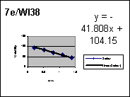 |  |  |  |  |  | 8d/WI38 |  | 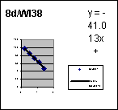
1.4 | 44.99 |  |  |  |  |  |  | 1.3979 | 46.8729
1.1 | 59.38 |  |  |  |  |  |  | 1.0969 | 62.811
0.8 | 70.21 |  |  |  |  |  |  | 0.7959 | 73.9744
0.51 | 83.59 |  |  |  |  |  |  | 0.5119 | 86.2811
0.19 | 95.63 |  |  |  |  |  |  | 0.1903 | 96.7048
IC50= |  |  |  |  |  |  |  | IC50=
 | Blank | CC | Sample No. Dox/WI38 |  |  |  |  | Sample No.
 | 1 | 2 | 3 | 4 | 5 | 6 | 7 | 8 | 9 | 10 | 11 | 12
A | B | C | 25uM | 12.5uM | 6.25uM | 3.25uM | 1.55uM
B | B | C | 25uM | 12.5uM | 6.25uM | 3.25uM | 1.55uM
C | B | C | 25uM | 12.5uM | 6.25uM | 3.25uM | 1.55uM
ROBONIK P2000 Eia reader
Wave length: 450 nm
Reference: 630 nm
 | 1 | 2 | 3 | 4 | 5 | 6 | 7 | 8 | 9 | 10 | 11 | 12
A | 0.001 | 0.486 | 0.166 | 0.227 | 0.311 | 0.354 | 0.397
B | 0.001 | 0.505 | 0.153 | 0.281 | 0.324 | 0.349 | 0.422
C | 0.001 | 0.479 | 0.138 | 0.262 | 0.313 | 0.363 | 0.417
mean | 0.001 | 0.49 | 0.15233 | 0.25667 | 0.316 | 0.35533 | 0.412 | 0 | 0 | 0 | 0 | 0
% viability |  |  | 31.0884 | 52.381 | 64.49 | 72.517 | 84.0816 | 0 | 0 | 0 | 0 | 0
Dox/WI38 |  | 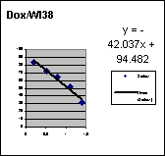 |  |  |  |  |  |  |  | 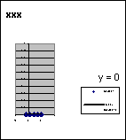
log conc. | % viability |  |  |  |  |  |  | log conc. | % viability
1.4 | 31.09 |  |  |  |  |  |  | 2 | 0
1.1 | 52.38 |  |  |  |  |  |  | 1.3979 | 0
0.8 | 64.49 |  |  |  |  |  |  | 0.7959 | 0
0.51 | 72.52 |  |  |  |  |  |  | 0.1931 | 0
0.19 | 84.08 |  |  |  |  |  |  | -0.4089 | 0
IC50= |  |  |  |  |  |  |  | IC50=

Table S7. CDK2 inhibitor detailed results.
CDK2
code | IC50 | conc | log | %inh | T2 | T1 | ∆T | RFU2 | RFU1 | ∆RFU | slope | K.Activity
7e |  | 100 | 2 | 92.7 | 30 | 0 | 30 | 7.26 | 0 | 7.26 | 3.333 | 8.712
 |  | 10 | 1 | 86.1 | 30 | 0 | 30 | 13.88 | 0 | 13.88 | 3.333 | 16.656
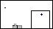 |  | 1 | 0 | 68.1 | 30 | 0 | 30 | 31.91 | 0 | 31.91 | 3.333 | 38.292
 |  | 0.1 | -1 | 48.2 | 30 | 0 | 30 | 51.79 | 0 | 51.79 | 3.333 | 62.148
 |  | 0.01 | -2 | 25.8 | 30 | 0 | 30 | 74.15 | 0 | 74.15 | 3.333 | 88.98
EC |  |  |  | 0 | 30 | 0 | 30 | 100 | 0 | 100 | 3.333 | 120
code | IC50 | conc | log | %inh | T2 | T1 | ∆T | RFU2 | RFU1 | ∆RFU | slope | K.Activity
roscovitine |  | 100 | 2 | 90.8 | 30 | 0 | 30 | 9.2 | 0 | 9.23 | 3.333 | 11.234
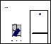 |  | 10 | 1 | 85 | 30 | 0 | 30 | 15 | 0 | 15.02 | 3.333 | 16.648
 |  | 1 | 0 | 66.34 | 30 | 0 | 30 | 34.66 | 0 | 34.53 | 3.333 | 35.096
 |  | 0.1 | -1 | 40.8 | 30 | 0 | 30 | 60.2 | 0 | 60.23 | 3.333 | 60.892
 |  | 0.01 | -2 | 25.7 | 30 | 0 | 30 | 74.3 | 0 | 74.3 | 3.333 | 76.006
EC |  |  |  | 0 | 30 | 0 | 30 | 100 | 0 | 100 | 3.333 | 120

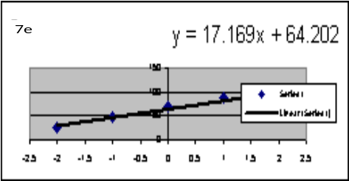 | 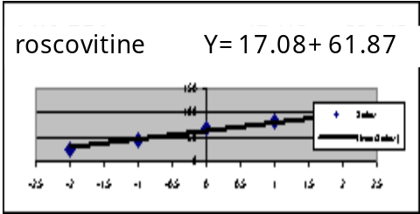
Table S8. DHFR inhibitor Detailed Result.
DHFR
code | IC50 | conc | log | %inh | T2 | T1 | ∆T | RFU2 | RFU1 | ∆RFU | slope | K.Activity
8d |  | 100 | 2 | 93 | 30 | 0 | 30 | 6.96 | 0 | 6.96 | 3.333 | 8.352
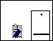 |  | 10 | 1 | 85.7 | 30 | 0 | 30 | 14.32 | 0 | 14.32 | 3.333 | 17.184
 |  | 1 | 0 | 67.1 | 30 | 0 | 30 | 32.91 | 0 | 32.91 | 3.333 | 39.492
 |  | 0.1 | -1 | 38.9 | 30 | 0 | 30 | 61.08 | 0 | 61.08 | 3.333 | 73.296
 |  | 0.01 | -2 | 27.5 | 30 | 0 | 30 | 72.54 | 0 | 72.54 | 3.333 | 87.048
EC |  |  |  | 0 | 30 | 0 | 30 | 100 | 0 | 100 | 3.333 | 120
code | IC50 | conc | log | %inh | T2 | T1 | ∆T | RFU2 | RFU1 | ∆RFU | slope | K.Activity
MTX |  | 100 | 2 | 92.7 | 30 | 0 | 30 | 7.28 | 0 | 7.28 | 3.333 | 8.736
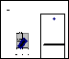 |  | 10 | 1 | 87 | 30 | 0 | 30 | 12.96 | 0 | 12.96 | 3.333 | 15.552
 |  | 1 | 0 | 71.4 | 30 | 0 | 30 | 28.55 | 0 | 28.55 | 3.333 | 34.26
 |  | 0.1 | -1 | 43.2 | 30 | 0 | 30 | 56.82 | 0 | 56.82 | 3.333 | 68.184
 |  | 0.01 | -2 | 30.2 | 30 | 0 | 30 | 69.78 | 0 | 69.78 | 3.333 | 83.736
EC |  |  |  | 0 | 30 | 0 | 30 | 100 | 0 | 100 | 3.333 | 120
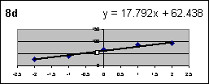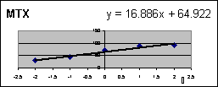

Table S9: Eef2 kinase inhibitor detailed results.
ser | compound |  | eEF2  IC50 | SD  ±
ser | code | M.W  g/mol | uM | SD  ±
1 | 8d | 670 | 0.689 | 0.036
*** | NH125 | 524.55 | 0.357 | 0.019
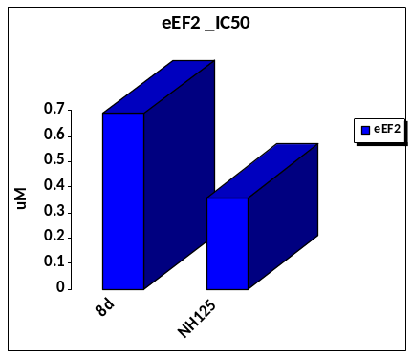

Eef2
code | IC50 | conc | log | %inh | T2 | T1 | ∆T | RFU2 | RFU1 | ∆RFU | slope | K.Activity
8d |  | 100 | 2 | 91.7 | 30 | 0 | 30 | 8.31 | 0 | 8.31 | 3.333 | 9.972
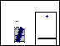 |  | 10 | 1 | 76.5 | 30 | 0 | 30 | 23.51 | 0 | 23.51 | 3.333 | 28.212
 |  | 1 | 0 | 48.2 | 30 | 0 | 30 | 51.82 | 0 | 51.82 | 3.333 | 62.184
 |  | 0.1 | -1 | 32.8 | 30 | 0 | 30 | 67.19 | 0 | 67.19 | 3.333 | 80.628
 |  | 0.01 | -2 | 16.5 | 30 | 0 | 30 | 83.51 | 0 | 83.51 | 3.333 | 100.212
EC |  |  |  | 0 | 30 | 0 | 30 | 100 | 0 | 100 | 3.333 | 120
code | IC50 | conc | log | %inh | T2 | T1 | ∆T | RFU2 | RFU1 | ∆RFU | slope | K.Activity
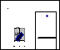NH125 |  | 100 | 2 | 92.6 | 30 | 0 | 30 | 7.42 | 0 | 7.42 | 3.333 | 8.904
 |  | 10 | 1 | 84.3 | 30 | 0 | 30 | 15.72 | 0 | 15.72 | 3.333 | 18.864
 |  | 1 | 0 | 62.7 | 30 | 0 | 30 | 37.29 | 0 | 37.29 | 3.333 | 44.748
 |  | 0.1 | -1 | 33.9 | 30 | 0 | 30 | 66.11 | 0 | 66.11 | 3.333 | 79.332
 |  | 0.01 | -2 | 20.1 | 30 | 0 | 30 | 79.86 | 0 | 79.86 | 3.333 | 95.832
EC |  |  |  | 0 | 30 | 0 | 30 | 100 | 0 | 100 | 3.333 | 120

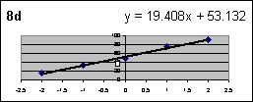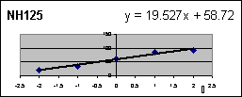
Table S10. IKB inhibitor detailed result.
ser | compound |  | IκB  IC50 | SD  ±
ser | code | M.W  g/mol | uM | SD  ±
1 | 8d | 670 | 0.240 | 0.013
*** | TPCA-1 | 279.29 | 0.072 | 0.004
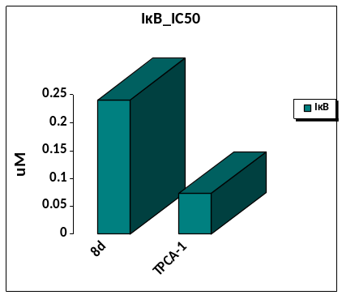

IκB
code | IC50 | conc | log | %inh | T2 | T1 | ∆T | RFU2 | RFU1 | ∆RFU | slope | K.Activity
8d |  | 100 | 2 | 93.7 | 30 | 0 | 30 | 6.26 | 0 | 6.26 | 3.333 | 7.512
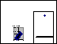 |  | 10 | 1 | 86.4 | 30 | 0 | 30 | 13.57 | 0 | 13.57 | 3.333 | 16.284
 |  | 1 | 0 | 63.9 | 30 | 0 | 30 | 36.09 | 0 | 36.09 | 3.333 | 43.308
 |  | 0.1 | -1 | 42.3 | 30 | 0 | 30 | 57.71 | 0 | 57.71 | 3.333 | 69.252
 |  | 0.01 | -2 | 21.8 | 30 | 0 | 30 | 78.19 | 0 | 78.19 | 3.333 | 93.828
EC |  |  |  | 0 | 30 | 0 | 30 | 100 | 0 | 100 | 3.333 | 120
code | IC50 | conc | log | %inh | T2 | T1 | ∆T | RFU2 | RFU1 | ∆RFU | slope | K.Activity
TPCA-1 |  | 100 | 2 | 95.2 | 30 | 0 | 30 | 4.82 | 0 | 4.82 | 3.333 | 5.784
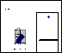 |  | 10 | 1 | 88.6 | 30 | 0 | 30 | 11.35 | 0 | 11.35 | 3.333 | 13.62
 |  | 1 | 0 | 71.3 | 30 | 0 | 30 | 28.72 | 0 | 28.72 | 3.333 | 34.464
 |  | 0.1 | -1 | 53.6 | 30 | 0 | 30 | 46.38 | 0 | 46.38 | 3.333 | 55.656
 |  | 0.01 | -2 | 32.5 | 30 | 0 | 30 | 67.52 | 0 | 67.52 | 3.333 | 81.024
EC |  |  |  | 0 | 30 | 0 | 30 | 100 | 0 | 100 | 3.333 | 120
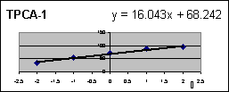
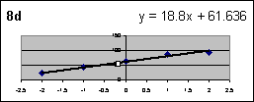
Table S11. RET inhibitor detailed results.

ser | Compound |  | RET | SD  ±
ser | CODE | MW  g/mol | IC50  uM | SD  ±
1 | 7e | 578 | 0.106 | 0.005
*** | Staurosporine | 466.5 | 0.069 | 0.003
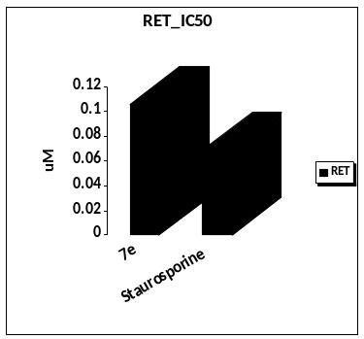

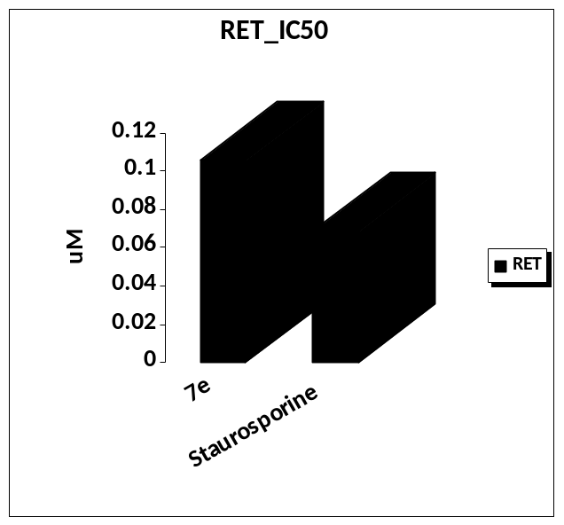

RET
code | IC50 | conc | log | %inh | T2 | T1 | ∆T | RFU2 | RFU1 | ∆RFU | slope | K.Activity
7e |  | 100 | 2 | 94.5 | 30 | 0 | 30 | 5.45 | 0 | 5.45 | 3.333 | 6.54
 |  | 10 | 1 | 88.6 | 30 | 0 | 30 | 11.38 | 0 | 11.38 | 3.333 | 13.656
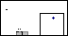 |  | 1 | 0 | 72.1 | 30 | 0 | 30 | 27.85 | 0 | 27.85 | 3.333 | 33.42
 |  | 0.1 | -1 | 45.7 | 30 | 0 | 30 | 54.29 | 0 | 54.29 | 3.333 | 65.148
 |  | 0.01 | -2 | 31.5 | 30 | 0 | 30 | 68.53 | 0 | 68.53 | 3.333 | 82.236
EC |  |  |  | 0 | 30 | 0 | 30 | 100 | 0 | 100 | 3.333 | 120
code | IC50 | conc | log | %inh | T2 | T1 | ∆T | RFU2 | RFU1 | ∆RFU | slope | K.Activity
Staurosporine |  | 100 | 2 | 94 | 30 | 0 | 30 | 6.03 | 0 | 6.03 | 3.333 | 7.236
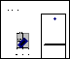 |  | 10 | 1 | 88.2 | 30 | 0 | 30 | 11.82 | 0 | 11.82 | 3.333 | 14.184
 |  | 1 | 0 | 74.6 | 30 | 0 | 30 | 25.44 | 0 | 25.44 | 3.333 | 30.528
 |  | 0.1 | -1 | 50.1 | 30 | 0 | 30 | 49.93 | 0 | 49.93 | 3.333 | 59.916
 |  | 0.01 | -2 | 34.5 | 30 | 0 | 30 | 65.48 | 0 | 65.48 | 3.333 | 78.576
EC |  |  |  | 0 | 30 | 0 | 30 | 100 | 0 | 100 | 3.333 | 120

