Supplementary table 1: Clinicopathological features of OAS1 based on ACC, BLCA, LGG, LUAD and SKCM cohorts and their distribution.
Cancer subtype | Total sample  count | Types of the clinicopathological feature
Cancer subtype | Total sample  count | Cancer stages-based distribution or Tumor Grade or Histology | Patients ages-based distribution | Patients’ genders-based distribution | Geographical distribution
ACC | 79 | Stage 1 = 9 | 21–40 years = 26 | Male = 31 | Caucasian = 66
ACC | 79 | Stage 2 = 37 | 41–60 years = 32 | Female = 48 | African–American = 1
ACC | 79 | Stage 3 = 16 | 61–80 years = 18 |  | Asian = 1
ACC | 79 | Stage 4 = 15
ACC | 79 | Sample count with missing cancer stages data = 02 | Sample count with missing patients ages data = 00 | Sample count with missing patients’ genders data = 00 | Sample count with missing geographical data = 11
ACC | 79 | Final sample count undertaken in the analysis =  77 | Final sample count undertaken in the  analysis = 79 | Final sample count undertaken in the  analysis = 79 | Final sample count undertaken in the analysis =  68
BLCA | 408 | Stage 1 = 2 | 21–40 years = 2 | Male = 297 | Caucasian = 320
BLCA | 408 | Stage 2 = 129 | 41–60 years = 105 | Female = 105 | African–American = 22
BLCA | 408 | Stage 3 = 137 | 61–80 years = 251 |  | Asian = 44
BLCA | 408 | Stage 4 = 132 | 81–100 years = 44
BLCA | 408 | Sample count with missing cancer stages data = 08 | Sample count with missing patients ages data = 06 | Sample count with missing patients’ genders data = 06 | Sample count with missing geographical data = 22
BLCA | 408 | Final sample count under taken in the analysis = 400 | Final sample count under taken in the  analysis = 402 | Final sample count undertaken in the  analysis = 402 | Final sample count undertaken in the analysis =  386
LGG | 514 | Grade 2 = 248 | 21–40 years = 243 | Male = 285 | Caucasian = 474
LGG | 514 | Grade 3 = 265 | 41–60 years = 200 | Female = 229 | African–American = 21
LGG | 514 |  | 61–80 years = 60 |  | Asian = 8
LGG | 514 |  | 81–100 years = 1
LGG | 514 | Sample count with missing cancer stages data = 01 | Sample count with missing patients ages data = 10 | Sample count with missing patients’ genders data = 00 | Sample count with missing geographical data = 11
LGG | 514 | Final sample count under taken in the analysis = 513 | Final sample count under taken in the analysis = 504 | Final sample count undertaken in the analysis = 514 | Final sample count undertaken in the analysis = 503
LUAD | 515 | Stage 1 = 277 | 21–40 years = 12 | Male = 238 | Caucasian = 387
LUAD | 515 | Stage 2 = 125 | 41–60 years = 90 | Female = 276 | African–American = 51
LUAD | 515 | Stage 3 = 85 | 61–80 years = 149 |  | Asian = 08
LUAD | 515 | Stage 4 = 28 | 81–100 years = 32
LUAD | 515 | Sample count with missing cancer stages data = 0 | Sample count with missing patients ages data = 232 | Sample count with missing patients’ genders data = 01 | Sample count with missing geographical data = 69
LUAD | 515 | Final sample count under taken in the analysis = 515 | Final sample count under taken in the  analysis = 283 | Final sample count undertaken in the  analysis = 514 | Final sample count undertaken in the analysis =  446
SKCM | 472 | Stage 1 = 77 | 21–40 years = 60 | Male = 268 | Caucasian = 438
SKCM | 472 | Stage 2 = 139 | 41–60 years = 185 | Female = 175 | African–American = 1
SKCM | 472 | Stage 3 = 170 | 61–80 years = 179 |  | Asian = 12
SKCM | 472 | Stage 4 = 23 | 81–100 years = 31
SKCM | 472 | Sample count with missing cancer stages data = 63 | Sample count with missing patients ages data = 17 | Sample count with missing patients’ genders data = 11 | Sample count with missing geographical data = 21
SKCM | 472 | Final sample count under taken in the analysis = 409 | Final sample count under taken in the analysis = 455 | Final sample count undertaken in the analysis = 461 | Final sample count undertaken in the analysis = 451

Supplementary table 2: Clinicopathological features of OAS2 based on KIRP, LGG, PAAD and SKCM cohorts and their distribution.
Cancer subtype | Total sample  count | Types of the clinicopathological feature
Cancer subtype | Total sample  count | Cancer stages-based distribution or Tumor Grade or Histology | Patients ages-based distribution | Patients’ genders-based distribution | Geographical distribution
KIRP | 290 | Stage 1 = 140 | 21–40 years = 16 | Male = 214 | Caucasian = 206
KIRP | 290 | Stage 2 = 21 | 41–60 years = 119 | Female = 76 | African–American = 61
KIRP | 290 | Stage 3 = 29 | 61–80 years = 139 |  | Asian = 06
KIRP | 290 | Stage 4 = 11 | 81–100 years = 13
KIRP | 290 | Sample count with missing cancer stages data = 89 | Sample count with missing patients ages data = 03 | Sample count with missing patients’ genders data = 00 | Sample count with missing geographical data = 17
KIRP | 290 | Final sample count undertaken in the analysis =  201 | Final sample count undertaken in the  analysis = 287 | Final sample count undertaken in the  analysis = 290 | Final sample count undertaken in the analysis =  273
LGG | 514 | Grade 2 = 248 | 21–40 years = 243 | Male = 285 | Caucasian = 474
LGG | 514 | Grade 3 = 265 | 41–60 years = 200 | Female = 229 | African–American = 21
LGG | 514 |  | 61–80 years = 60 |  | Asian = 8
LGG | 514 |  | 81–100 years = 1
LGG | 514 | Sample count with missing cancer stages data = 01 | Sample count with missing patients ages data = 10 | Sample count with missing patients’ genders data = 00 | Sample count with missing geographical data = 11
LGG | 514 | Final sample count under taken in the analysis = 513 | Final sample count under taken in the  analysis = 504 | Final sample count undertaken in the  analysis = 514 | Final sample count undertaken in the analysis =  503
PAAD | 178 | Stage 1 = 06 | 21–40 years = 03 | Male = 97 | Caucasian = 156
PAAD | 178 | Stage 2 = 146 | 41–60 years = 56 | Female = 80 | African–American = 06
PAAD | 178 | Stage 3 = 04 | 61–80 years = 106 |  | Asian = 11
PAAD | 178 | Stage 4 = 04 | 81–100 years = 12
PAAD | 178 | Sample count with missing cancer stages data = 18 | Sample count with missing patients ages data = 01 | Sample count with missing patients’ genders data = 01 | Sample count with missing geographical data = 05
PAAD | 178 | Final sample count under taken in the analysis = 160 | Final sample count under taken in the analysis = 177 | Final sample count undertaken in the analysis = 177 | Final sample count undertaken in the analysis = 173
SKCM | 515 | Stage 1 = 77 | 21–40 years = 60 | Male = 268 | Caucasian = 438
SKCM | 515 | Stage 2 = 139 | 41–60 years = 185 | Female = 175 | African–American = 1
SKCM | 515 | Stage 3 = 170 | 61–80 years = 179 |  | Asian = 12
SKCM | 515 | Stage 4 = 23 | 81–100 years = 31
SKCM | 515 | Sample count with missing cancer stages data = 63 | Sample count with missing patients ages data = 17 | Sample count with missing patients’ genders data = 11 | Sample count with missing geographical data = 21
SKCM | 515 | Final sample count under taken in the analysis = 409 | Final sample count under taken in the analysis = 455 | Final sample count undertaken in the analysis = 461 | Final sample count undertaken in the analysis = 451

Supplementary table 3: Clinicopathological features of OAS3 based on ACC, KICH, LUAD and LGG cohorts and their distribution.
Cancer subtype | Total sample  count | Types of the clinicopathological feature
Cancer subtype | Total sample  count | Cancer stages-based distribution or Tumor Grade or Histology | Patients ages-based distribution | Patients’ genders-based distribution | Geographical distribution
ACC | 85 | Stage 1 = 9 | 21–40 years = 26 | Male = 31 | Caucasian = 66
ACC | 85 | Stage 2 = 37 | 41–60 years = 32 | Female = 48 | African–American = 1
ACC | 85 | Stage 3 = 16 | 61–80 years = 18 |  | Asian = 1
ACC | 85 | Stage 4 = 15 | 81–100 years = 0
ACC | 85 | Sample count with missing cancer stages data = 08 | Sample count with missing patients ages data = 09 | Sample count with missing patients’ genders data = 0 | Sample count with missing geographical data = 17
ACC | 85 | Final sample count undertaken in the analysis = 77 | Final sample count undertaken in the  analysis = 76 | Final sample count undertaken in the  analysis = 85 | Final sample count undertaken in the analysis  = 68
KICH | 67 | Stage 1 = 20 | 21–40 years = 11 | Male = 38 | Caucasian = 57
KICH | 67 | Stage 2 = 25 | 41–60 years = 36 | Female = 27 | African–American = 04
KICH | 67 | Stage 3 = 14 | 61–80 years = 16 |  | Asian = 02
KICH | 67 | Stage 4 = 06 | 81–100 years = 1
KICH | 67 | Sample count with missing cancer stages data = 02 | Sample count with missing patients ages data = 03 | Sample count with missing patients’ genders data = 02 | Sample count with missing geographical data = 04
KICH | 67 | Final sample count under taken in the analysis = 65 | Final sample count under taken in the analysis =  64 | Final sample count undertaken in the  analysis = 65 | Final sample count undertaken in the analysis  = 63
LUAD | 515 | Stage 1 = 277 | 21–40 years = 12 | Male = 238 | Caucasian = 387
LUAD | 515 | Stage 2 = 125 | 41–60 years = 90 | Female = 276 | African–American = 51
LUAD | 515 | Stage 3 = 85 | 61–80 years = 149 |  | Asian = 08
LUAD | 515 | Stage 4 = 28 | 81–100 years = 32
LUAD | 515 | Sample count with missing cancer stages data = 0 | Sample count with missing patients ages data = 232 | Sample count with missing patients’ genders data = 01 | Sample count with missing geographical data = 69
LUAD | 515 | Final sample count under taken in the analysis = 515 | Final sample count under taken in the analysis = 283 | Final sample count undertaken in the analysis = 514 | Final sample count undertaken in the analysis  = 446
LGG | 515 | Tumor Grade 2 = 248 | 21–40 years = 243 | Male = 285 | Caucasian = 474
LGG | 515 | Tumor Grade 3= 265 | 41–60 years = 200 | Female = 229 | African–American = 21
LGG | 515 |  | 61–80 years = 60 |  | Asian = 08
LGG | 515 |  | 81–100 years = 1
LGG | 515 | Sample count with missing cancer stages data = 02 | Sample count with missing patients ages  data = 11 | Sample count with missing patients’ genders data = 01 | Sample count with missing geographical data = 12
LGG | 515 | Final sample count under taken in the analysis = 513 | Final sample count under taken in the analysis =  504 | Final sample count undertaken in the  analysis = 514 | Final sample count undertaken in the analysis =  503

OASL

Cancer subtype | Total sample count | Types of the clinicopathological feature
Cancer subtype | Total sample count | Cancer stages-based distribution or Tumor Grade or Histology | Patients ages-based distribution | Patients’ genders- based distribution | Geographical distribution
ACC | 80 | Stage 1 = 09 | 21–40 years = 26 | Male = 31 | Caucasian = 66
ACC | 80 | Stage 2 = 37 | 41–60 years = 32 | Female = 48 | African–American = 1
ACC | 80 | Stage 3 = 16 | 61–80 years = 18 |  | Asian = 1
ACC | 80 | Stage 4 = 15 | 81–100 years = 0
ACC | 80 | Sample count with  missing cancer stages data = 03 | Sample count with  missing patients ages data = 04 | Sample count with  missing patients’ genders data = 01 | Sample count with missing geographical data  = 12
ACC | 80 | Final sample count undertaken in the analysis = 77 | Final sample count undertaken in the analysis = 76 | Final sample count undertaken in the analysis = 79 | Final sample count undertaken in the analysis = 68
LGG | 515 | Tumor Grade 2 = 248 | 21–40 years = 243 | Male = 285 | Caucasian = 474
LGG | 515 | Tumor Grade 3 = 268 | 41–60 years = 200 | Female = 229 | African–American = 21
LGG | 515 |  | 61–80 years = 60 |  | Asian = 08
LGG | 515 |  | 81–100 years = 1
LGG | 515 | Sample count with  missing cancer stages data = 02 | Sample count with  missing patients ages data = 11 | Sample count with  missing patients’ genders data = 01 | Sample count with missing geographical data  = 12
LGG | 515 | Final sample count under taken in the analysis = 513 | Final sample count under taken in the analysis = 504 | Final sample count undertaken in the analysis = 514 | Final sample count undertaken in the analysis = 503
KIRC | 533 | Stage 1 = 267 | 21–40 years = 26 | Male = 345 | Caucasian = 462
KIRC | 533 | Stage 2 = 57 | 41–60 years = 238 | Female = 188 | African–American = 56
KIRC | 533 | Stage 3 = 123 | 61–80 years = 246 |  | Asian = 08
KIRC | 533 | Stage 4 = 84 | 81–100 years = 20
KIRC | 533 | Sample count with missing cancer stages  data = 02 | Sample count with missing patients  ages data = 03 | Sample count with missing patients’  genders data = 0 | Sample count with missing geographical data  = 07
KIRC | 533 | Final sample count under taken in the analysis =  531 | Final sample count under taken in the  analysis = 530 | Final sample count undertaken in the  analysis = 533 | Final sample count undertaken in the  analysis = 526
PAAD | 178 | Stage 1 = 06 | 21–40 years = 03 | Male = 97 | Caucasian = 156
PAAD | 178 | Stage 2 = 146 | 41–60 years = 56 | Female = 80 | African–American = 06
PAAD | 178 | Stage 3 =04 | 61–80 years = 106 |  | Asian = 11
PAAD | 178 | Stage 4 = 04 | 81–100 years = 12
PAAD | 178 | Sample count with missing cancer stages  data =18 | Sample count with missing patients  ages data = 177 | Sample count with missing patients’  genders data = 01 | Sample count with missing geographical data  = 05
PAAD | 178 | Final sample count under taken in the analysis =  160 | Final sample count under taken in the  analysis = 283 | Final sample count undertaken in the  analysis = 177 | Final sample count undertaken in the  analysis = 173
SKCM | 472 | Stage 1 = 77 | 21–40 years = 60 | Male = 286 | Caucasian = 438
SKCM | 472 | Stage 2 = 139 | 41–60 years = 185 | Female = 175 | African–American = 1
SKCM | 472 | Stage 3 = 170 | 61–80 years = 179 |  | Asian = 12
SKCM | 472 | Stage 4 = 23 | 81–100 years = 31
SKCM | 472 | Sample count with missing cancer stages data = 63 | Sample count with missing patients ages data =17 | Sample count with missing patients’ genders data = 11 | Sample count with missing geographical data  = 21
SKCM | 472 | Final sample count under taken in the analysis =  409 | Final sample count under taken in the  analysis = 455 | Final sample count undertaken in the  analysis = 461 | Final sample count undertaken in the analysis  = 451

THYM | 120 | Tumor histology: Type A=15  Type C=11 Type AB=35 Type B1=14 Type B2=28 Type B3=11 Type AIAB=2 Type BIB2= 1  Type B2IB3= 3 | 21–40 years = 11 | Male = 63 | Caucasian = 100
THYM | 120 |  | 41–60 years = 49 | Female = 57 | African–American = 06
THYM | 120 |  | 61–80 years = 56 |  | Asian = 12
THYM | 120 |  | 81–100 years = 2
THYM | 120 | Sample count with missing cancer stages  data = 0 | Sample count with missing patients  ages data = 02 | Sample count with missing patients’  genders data = 0 | Sample count with missing geographical data  = 02
THYM | 120 | Final sample count under taken in the analysis =  120 | Final sample count under taken in the  analysis = 118 | Final sample count undertaken in the  analysis = 120 | Final sample count undertaken in the analysis  = 118
SARC | 260 | Stage 1 = | 21–40 years = 21 | Male = 141 | Caucasian = 226
SARC | 260 | Stage 2 = | 41–60 years = 104 | Female = 118 | African–American = 18
SARC | 260 | Stage 3 = | 61–80 years = 111 |  | Asian = 06
SARC | 260 | Stage 4 = | 81–100 years = 20
SARC | 260 | Sample count with missing cancer stages  data = | Sample count with missing patients  ages data = 03 | Sample count with missing patients’  genders data = 01 | Sample count with missing geographical data  = 10
SARC | 260 | Final sample count under taken in the analysis =  Supplementary table 4: Clinicopathological features of OASL based on ACC, LGG, KIRC, PAAD, SKCM, THYM and SARC cohorts and their distribution | Final sample count under taken in the  analysis = 257 | Final sample count undertaken in the  analysis = 259 | Final sample count undertaken in the analysis  = 250

Protein Name | Cancer Name | Missense mutations | SIFT | Polyphen-2
 |  |  |  | HumDiv |  |  | HumVar
 |  |  |  | Prediction Score | Sensitivity | Specificity | Prediction Score | Sensitivity | Specificity
OAS-1 | BLCA | E322Q | 0.05 (Tolerated) | 0.971 | 0.77 | 0.96 | 0.699 | 0.78 | 0.85
OAS-1 | BLCA | E393Q | 0.00 (Intolerated) | 0.286 | 0.91 | 0.89 | 0.035 | 0.94 | 0.6
OAS-1 | BLCA | T292M | 0.04 (Intolerated) | 0.729 | 0.85 | 0.92 | 0.448 | 0.83 | 0.8
OAS-1 | BLCA | H378Y | 0.00 (Intolerated) | 0.003 | 0.98 | 0.44 | 0.012 | 0.96 | 0.52
OAS-1 | BLCA | E97K | 0.35 (Tolerated) | 0.129 | 0.93 | 0.86 | 0.109 | 0.91 | 0.69
OAS-1 | LUAD | D358N | 0.00 (Intolerated) | 0.096 | 0.93 | 0.85 | 0.009 | 0.96 | 0.49
OAS-1 | LUAD | D394N | 0.00 (Intolerated) | 0 | 1 | 0 | 0 | 1 | 0
OAS-1 | LUAD | S49T | 0.71 (Tolerated) | 0 | 1 | 0 | 0.001 | 0.99 | 0.09
OAS-1 | LUAD | P202S | 0.00 (Intolerated) | 0.997 | 0.41 | 0.98 | 0.947 | 0.65 | 0.92
OAS-1 | LUAD | E372K | 0.00 (Intolerated) | 0.022 | 0.95 | 0.8 | 0.026 | 0.94 | 0.58
OAS-1 | LUAD | T251K | 0.06 (Tolerated) | 0.999 | 0.14 | 0.99 | 0.971 | 0.6 | 0.93
OAS-1 | SKCM | G369E | 0.00 (Intolerated) | 0 | 1 | 0 | 0.001 | 0.99 | 0.09
OAS-1 | SKCM | E260K | 0.03 (Intolerated) | 0.08 | 0.93 | 0.85 | 0.085 | 0.91 | 0.67
OAS-1 | SKCM | G369R | 0.00 (Intolerated) | 0 | 1 | 0 | 0 | 1 | 0
OAS-1 | SKCM | D358N | 0.00 (Intolerated) | 0.096 | 0.93 | 0.85 | 0.009 | 0.96 | 0.49
OAS-1 | SKCM | T7I | 0.25 (Tolerated) | 0.316 | 0.9 | 0.89 | 0.078 | 0.92 | 0.66
OAS-1 | SKCM | Q229K | 0.27 (Tolerated) | 0.972 | 0.77 | 0.96 | 0.727 | 0.78 | 0.85
OAS-1 | SKCM | D75E | 0.25 (Tolerated) | 0.826 | 0.84 | 0.93 | 0.589 | 0.81 | 0.83
OAS-1 | SKCM | D13E | 0.00 (Intolerated) | 0.956 | 0.79 | 0.95 | 0.466 | 0.83 | 0.8
OAS-1 | SKCM | E101K | 0.18 (Tolerated) | 0.951 | 0.79 | 0.95 | 0.692 | 0.78 | 0.85
OAS-1 | SKCM | Y51C | 0.18 (Tolerated) | 0.98 | 0.75 | 0.96 | 0.877 | 0.71 | 0.89
OAS-1 | SKCM | L235M | 0.00 (Intolerated) | 1 | 0 | 1 | 1 | 0 | 1
OAS-1 | SKCM | P124L | 0.33 (Tolerated) | 0.002 | 0.99 | 0.3 | 0.009 | 0.96 | 0.49
OAS-1 | SKCM | S63F | 0.00 (Intolerated) | 1 | 0 | 1 | 0.998 | 0.18 | 0.98
OAS-1 | SKCM | S377F | 0.00 (Intolerated) | 0.085 | 0.93 | 0.85 | 0.094 | 0.91 | 0.68
Supplementary Table 5A: The table illustrates missense mutations in the OAS1 gene, specifically in four cancer types. In the case of BLCA, mutations are found at E322Q, E393Q, T292M, H378Y, E97K, D358N, D394N, S49T, P202S, E372K, and T251K. LUAD exhibits mutations at G369E, E260K, G369R, D358N, T7I, Q229K, D75E, D13E, E101K, Y51C, L235M, P124L, S63F, and S377F.

Protein Name | Cancer Name | Missense mutations | SIFT | Polyphen-2
 |  |  |  | HumDiv |  |  | HumVar
 |  |  |  | Prediction Score | Sensitivity | Specificity | Prediction Score | Sensitivity | Specificity
OAS2 | LGG | P683L | 0.00 (Intolerated) | 1 | 0 | 1 | 0.999 | 0.09 | 0.99
OAS2 | PAAD | V432I | 1.00 (Tolerated) | 0.001 | 0.99 | 0.15 | 0.001 | 0.99 | 0.09
OAS2 | SKCM | R161L | 0.32 (Tolerated) | 0.986 | 0.74 | 0.96 | 0.866 | 0.72 | 0.89
OAS2 | SKCM | G591D | 0.00 (Intolerated) | 1 | 0 | 1 | 1 | 0 | 1
OAS2 | SKCM | N380H | 0.09 (Tolerated) | 0.989 | 0.72 | 0.97 | 0.911 | 0.69 | 0.9
OAS2 | SKCM | E119K | 0.29 (Tolerated) | 0.522 | 0.88 | 0.9 | 0.031 | 0.94 | 0.59
OAS2 | SKCM | G517R | 0.27 (Tolerated) | 0.993 | 0.7 | 0.97 | 0.939 | 0.66 | 0.91
OAS2 | SKCM | G102R | 0.77 (Tolerated) | 0.788 | 0.85 | 0.93 | 0.272 | 0.87 | 0.76
OAS2 | SKCM | G505W | 0.02 (Intolerated) | 0.993 | 0.7 | 0.97 | 0.907 | 0.69 | 0.9
OAS2 | SKCM | R192S | 0.00 (Intolerated) | 0.42 | 0.89 | 0.9 | 0.194 | 0.88 | 0.73
OAS2 | SKCM | S73F | 0.06 (Tolerated) | 0.982 | 0.75 | 0.96 | 0.873 | 0.71 | 0.89
OAS2 | SKCM | P667S | 0.63 (Tolerated) | 0.004 | 0.97 | 0.59 | 0.005 | 0.97 | 0.44
OAS2 | SKCM | R463M | 0.01 (Intolerated) | 1 | 0 | 1 | 0.963 | 0.62 | 0.92
OAS2 | SKCM | W158L | 0.23 (Tolerated) | 0.695 | 0.86 | 0.92 | 0.334 | 0.85 | 0.77
OAS2 | SKCM | T250I | 0.02 (Intolerated) | 0.999 | 0.14 | 0.99 | 0.974 | 0.59 | 0.93
OAS2 | SKCM | D671N | 1.00 (Tolerated) | 0.151 | 0.92 | 0.87 | 0.062 | 0.92 | 0.65
OAS2 | SKCM | S123F | 0.46 (Tolerated) | 0.001 | 0.99 | 0.15 | 0.002 | 0.99 | 0.18
OAS2 | SKCM | D541N | 0.67 (Tolerated) | 0.801 | 0.84 | 0.93 | 0.355 | 0.85 | 0.78
OAS2 | SKCM | E662K | 0.89 (Tolerated) | 0.103 | 0.93 | 0.86 | 0.062 | 0.92 | 0.65
OAS2 | SKCM | S423F | 0.01 (Intolerated) | 0.071 | 0.94 | 0.84 | 0.105 | 0.91 | 0.69

Supplementary Table 5B: The table illustrates missense mutations in the OAS2 gene. For the SKCM subtype, mutations include OAS2 gene missense mutations at P683L (LGG), V432I (PAAD), and R161L, G591D, N380H, E119K, G517R, G102R, G505W, R192S, S73F, P667S, R463M, W158L, T250I, D671N, S123F, D541N, E662K, and S423F.

Protein Name | Cancer Name | Missense mutations | SIFT | Polyphen-2
 |  |  |  | HumDiv |  |  | HumVar
 |  |  |  | Prediction Score | Sensitivity | Specificity | Prediction Score | Sensitivity | Specificity
OAS3 | LUAD | G257C | 0.01 (Intolerated) | 0.925 | 0.81 | 0.94 | 0.557 | 0.81 | 0.82
OAS3 | LUAD | W209L | 0.00 (Intolerated) | 1 | 0 | 1 | 1 | 0 | 1
OAS3 | LUAD | K941N | 0.00 (Intolerated) | 1 | 0 | 1 | 1 | 0 | 1
OAS3 | LUAD | G257C | 0.01 (Intolerated) | 0.925 | 0.81 | 0.94 | 0.557 | 0.81 | 0.82
OAS3 | LUAD | N373I | 0.00 (Intolerated) | 0.037 | 0.94 | 0.82 | 0.007 | 0.97 | 0.46
OAS3 | LUAD | T1045S | 0.00 (Intolerated) | 1 | 0 | 1 | 1 | 0 | 1
OAS3 | LUAD | S104L | 0.32 (Tolerated) | 0 | 1 | 0 | 0 | 1 | 0
OAS3 | LUAD | H1050L | 0.30 (Tolerated) | 0.002 | 0.99 | 0.3 | 0.003 | 0.98 | 0.26
OAS3 | LGG | P595H | 0.00 (Intolerated) | 1 | 0 | 1 | 1 | 0 | 1
OAS3 | LGG | R836W | 0.00 (Intolerated) | 1 | 0 | 1 | 0.995 | 0.45 | 0.96

Supplementary Table 5C: The plot reveals missense mutations in the OAS3 gene, with G257C, W209L, K941N, G257C, N373I, T1045S, S104L, and H1050L in LUAD, and P595H and R836W in LGG.

Protein Name | Cancer Name | Missense mutations | SIFT | Polyphen-2
 |  |  |  | HumDiv |  |  | HumVar
 |  |  |  | Prediction Score | Sensitivity | Specificity | Prediction Score | Sensitivity | Specificity
OASL | LGG | A314S | 0.12 (Tolerated) | 0.91 | 0.81 | 0.94 | 0.845 | 0.73 | 0.88
OASL | SKCM | V65L | 0.04 (Intolerated) | 0 | 1 | 0 | 0.001 | 0.99 | 0.09
OASL | SKCM | D485N | 0.00 (Intolerated) | 0.012 | 0.96 | 0.78 | 0.016 | 0.95 | 0.54
OASL | SKCM | S69F | 0.01 (Intolerated) | 1 | 0 | 1 | 0.937 | 0.66 | 0.91
OASL | SKCM | R143K | 1.00 (Tolerated) | 0.003 | 0.98 | 0.44 | 0.054 | 0.93 | 0.64
OASL | SKCM | P148L | 0.31 (Tolerated) | 0.057 | 0.94 | 0.84 | 0.008 | 0.96 | 0.48
OASL | SKCM | E258K | 0.04 (Intolerated) | 0.119 | 0.93 | 0.86 | 0.05 | 0.93 | 0.63
OASL | SKCM | R80K | 0.51 (Tolerated) | 0.001 | 0.99 | 0.15 | 0.017 | 0.95 | 0.54
OASL | SKCM | N253K | 0.23 (Tolerated) | 0.433 | 0.89 | 0.9 | 0.154 | 0.89 | 0.72
OASL | SKCM | G144R | 0.54 (Tolerated) | 0 | 1 | 0 | 0.001 | 0.99 | 0.09
OASL | SKCM | R384W | 0.00 (Intolerated) | 0.033 | 0.95 | 0.82 | 0.005 | 0.97 | 0.44
OASL | SKCM | G480S | 0.00 (Intolerated) | 0.898 | 0.82 | 0.94 | 0.55 | 0.82 | 0.82
OASL | SKCM | R202W | 0.00 (Intolerated) | 1 | 0 | 1 | 0.977 | 0.58 | 0.94
OASL | SKCM | G73D | 0.00 (Intolerated) | 0.999 | 0.14 | 0.99 | 0.966 | 0.61 | 0.93
OASL | SKCM | R127K | 1.00 (Tolerated) | 0.086 | 0.93 | 0.85 | 0.094 | 0.91 | 0.68
OASL | SKCM | E96D | 0.53 (Tolerated) | 0.006 | 0.97 | 0.75 | 0.002 | 0.99 | 0.18
OASL | SKCM | S167F | 0.08 (Tolerated) | 0.003 | 0.98 | 0.44 | 0.008 | 0.96 | 0.48
OASL | SARC | D320E | 1.00 (Tolerated) | 0.945 | 0.8 | 0.95 | 0.724 | 0.78 | 0.85

Supplementary Table 5D: For the OASL gene, A314S is mutated in LGG, while in SKCM, mutations include V65L, D485N, S69F, R143K, P148L, E258K, R80K, N253K, G144R, R384W, G480S, R202W, G73D, R127K, E96D, and S167F. SARC displays a mutation at D320E.

Supplementary Table 7: The datasets utilised for validating the expression of OAS1 by the GENT2 website include ACC, BLCA, LUAD, SKCM, UVM and LGG.

Sr.  No. | Cancer | Datasets | Source
1 | ACC | GSE28476,GSE15918, GSE8588, GSE76021, GSE75415 | Affymetrix U133 Plus2 and U133A microarray platforms
2 | BLCA | 1.GSE31684 series: GSE42089, GSE31684, GSE30522 2. GSE3167, series: GSE37317, GSE5287, GSE3167 | Affymetrix U133 Plus2 and U133A microarray platforms
3 | LUAD | 1.GSE10309, 2. GSE10072, series: GSE68465, GSE20189, GSE31908, GSE14108, GSE17475, GSE14107, GSE10072 | Affymetrix U133 Plus2 and U133A microarray platforms
4 | SKCM | 1.GSE4587, Series: GSE130244, GSE114445, GSE99221, GSE82105 2. GSE3189, Series: GSE46517, GSE2503, GSE3189 | Affymetrix U133 Plus2 and U133A microarray platforms
5 | UVM | 1.GSE27831, Series: GSE51880, GSE27831, GSE22138  2.GSE66048 | Affymetrix U133 Plus2 and U133A microarray platforms
6 | LGG | GSE24072 | Affymetrix U133A microarray platform

Supplementary table 8: The datasets utilised for validating the expression of OAS2 by the GENT2 website include KIRP, PAAD, SKCM, and LGG.

Sr.  No. | Cancer | Datasets | Source
1 | KIRP | GSE85258, GSE19949, GSE15641 | Affymetrix U133 Plus2 and U133A microarray platforms
2 | PAAD | GSE57728, GSE57728, GSE18670, GSE37645, GSE23952, GSE15471, GSE19281, GSE19279, GSE43288 | Affymetrix U133 Plus2 and U133A microarray platforms
3 | SKCM | 1.GSE4587, Series: GSE130244, GSE114445, GSE99221, GSE82105  2. GSE3189, Series: GSE46517, GSE2503, GSE3189 | Affymetrix U133 Plus2 and U133A microarray platforms
4 | LGG | GSE24072 | Affymetrix U133A microarray platform

Supplementary table 9: The datasets utilised for validating the expression of OAS3 by the GENT2 website include ACC, KICH, LAML, LUAD, and LGG.
Sr. No | Cancer | Datasets | Source
1 | ACC | GSE28476,GSE15918, GSE8588, GSE76021, GSE75415 | Affymetrix U133 Plus2 and U133A microarray platforms
2 | KICH | GSE12090, GSE19949, GSE6280, GSE15641 | Affymetrix U133 Plus2 and U133A microarray platforms
3 | LAML | GSE57194, GSE33223, GSE30903, GSE35159, GSE30442, GSE22845, GSE15013, GSE29883, GSE19577, GSE21261, GSE21261, GSE12417, GSE3280, GSE34860, GSE34860, GSE34044, GSE18673, GSE12417, GSE9476, GSE5007, GSE2668,  GSE1729 | Affymetrix U133 Plus2 and U133A microarray platforms
4 | LUAD | GSE10309,  GSE10072, Series:SE68465, GSE20189, GSE31908, GSE14108, GSE17475, GSE14107, GSE10072 | Affymetrix U133 Plus2 and U133A microarray platforms
5 | LGG | GSE24072 | Affymetrix U133A  microarray platform

OASL

Sr.  No. | Cancer | Datasets | Source
1 | ACC | GSE28476,GSE15918, GSE8588, GSE76021, GSE75415 | Affymetrix U133 Plus2 and U133A microarray platforms
2 | KIRC | GSE41485, GSE41137, GSE36895, GSE12090, GSE2748, GSE6344, GSE781 | Affymetrix U133 Plus2 and U133A microarray platforms
3 | PAAD | GSE57728, GSE57728, GSE18670, GSE37645, GSE23952, GSE15471, GSE19281, GSE19279, GSE43288 | Affymetrix U133 Plus2 and U133A microarray platforms
4 | SKCM | 1.GSE4587, Series: GSE130244, GSE114445, GSE99221, GSE82105  2. GSE3189, Series:GSE46517, GSE2503, GSE3189 | Affymetrix U133 Plus2 and U133A microarray platforms
5 | SARC | GSE50980, GSE37409, GSE32569, GSE37355, GSE9264, GSE2 GSE240727524, GSE12972, GSE2712, GSE2719, GSE1377 | Affymetrix U133 Plus2 and U133A microarray platforms
6 | LGG | GSE24072 | Affymetrix U133A  microarray platform
7 | THYM | GSE131027 | Affymetrix U133 Plus2 microarray platform

Supplementary table 10: The datasets utilised for validating the expression of OASL by the GENT2 website include ACC, KIRC, PAAD, SKCM, SARC, LGG, and THYM.

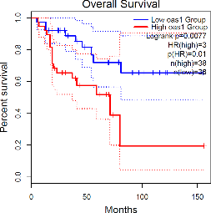
1A

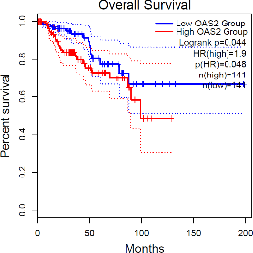
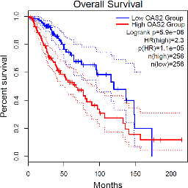
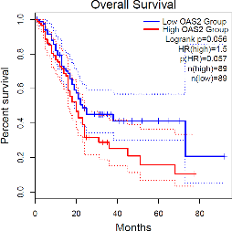
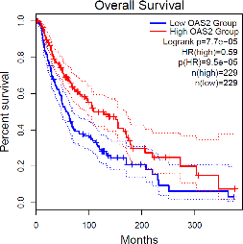
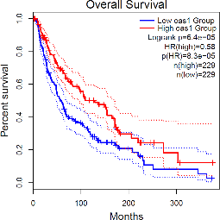
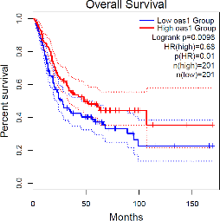
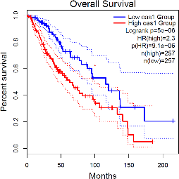
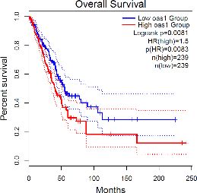
1B
1C
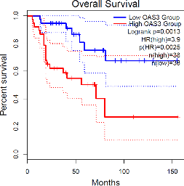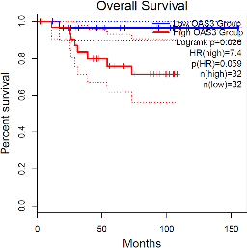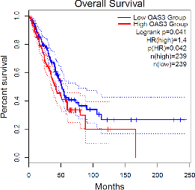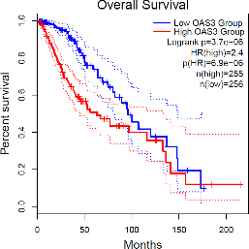

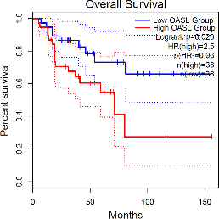
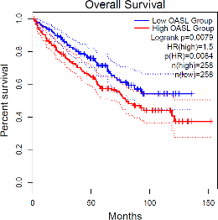
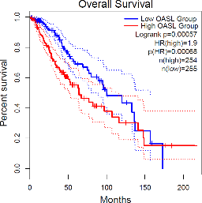
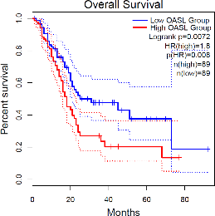
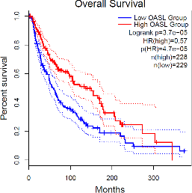
1D

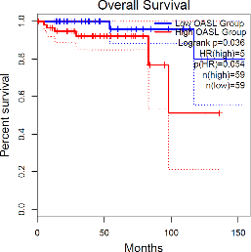
Supplementary Figure 1: Overall survival curves comparing low and high expression of OAS1, OAS2, OAS3 and OASL gene in different tumors analyzed by Gepia2, A) Correlation between OAS1 gene expression levels and patients’ survival in ACC, BLCA, LGG, LUAD and SKCM. B) Correlations between OAS2 gene expression levels and patients’ survival in KIRP, LGG, PAAD and SKCM. C) Correlations between OAS3 expression levels and patient survival in ACC, KICH, LUAD and LGG. D) Correlations between OASL gene expression levels and patient survival in ACC, LGG, KIRC, PAAD, SKCM, THYM

