Supporting Information

Efficient activation of H₂O₂ by C₆₀/MIL-101(Fe,Cu) composite for degradation of methylene blue under visible light

Zhuyou Zhou*, Yufeng Ji*, Yong Wang, Menghe Liu, Ying Xu, Ruijie Liu,
Mingjie Yang, Congyang Zou
School of Environmental Science and Engineering, Suzhou University of Science and Technology, Suzhou 215009, Jiangsu, China

----------------------------------
* Corresponding author’s E-mails: ericcongyang@126.com
Tel:+8617751098666

Catalyst characterizations
Power X-ray diffraction (XRD) analysis on a D8 Advance diffrac-tometer (Bruker, Germany) was performed to identify the structure and crystallinity of the as-prepared samples with monochromatic high-intensity Cu Kα radiation (λ=1.5406 Å). The specific surface area and pore size distribution of all samples were determined by using Brunauer-Emmett-Teller (BET) method, respectively, based on the adsorption data of N₂ adsorption-desorption isotherms collected at 77K on a NOVA4000 analyzer (Quantachrome, USA). Scanning electronic microscopy (SEM; JEOL, Japan) images were acquired on Quanta FEG 250 field emission scanning electron microscope equipped with energy dispersive spectrometer (EDS). Fourier transform infrared (FT-IR) spec-troscopy (Nicolet6700; Thermo Ltd., Japan) was carried out to detect the chemical bonds on the surface of the catalyst. UV-vis diffuse reflectance spectra (UV-vis DRS) were obtained by UV-vis spectrophotometer (UV-3600, Shimadzu Ltd., Japan). X-ray photoelectro spectroscopy (XPS; XSAM 800) was employed to characterize the elemental states. Zeta potentials and average particle size of materials were measured by a zeta potentiometer (Nano-ZS90, Malvern, UK). Electron paramagnetic resonance (EPR; Bruker, Germany) can be used to measure the free radicals produced by materials in different systems.
Photoelectrochemical and Electrochemical Measurements
The electrochemical impedance spectroscopy (EIS), transient photocurrent (TPC) and Mott-Schottky curve were recorded with a three-electrode system at the CHI660E electrochemical station. The three-electrode system used the platinum wire as the counter electrode, the photocatalyst as the working electrode and the AgCl electrode as the reference electrode. The catalysts were applied to the FTO conductive glass for testing in Na₂SO₄ (0.1 mol/L) electrolyte solution.

Fig. S1 Standard curve of MB.

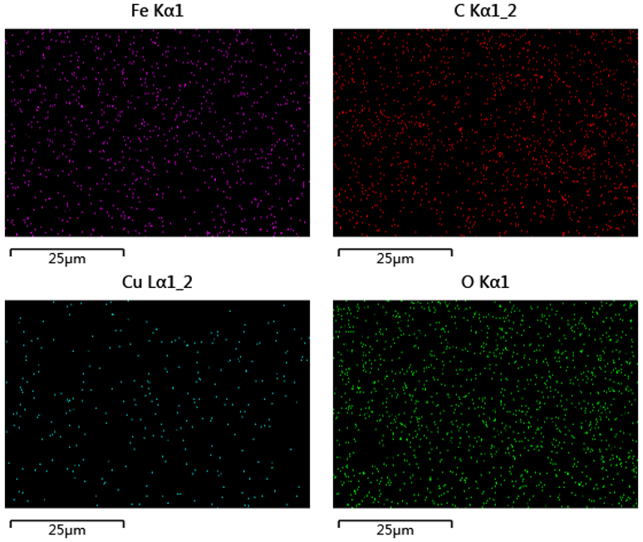
Fig. S2 EDS mapping of C₆₀/MIL-101(Fe/Cu) (25 μm).
.

