Genomic signatures of geographic isolation and paleoclimate unveil the “island-like” pattern in the glasshouse Rheum nobile
Hum Kala Rana^{1, 2}, Santosh Kumar Rana³, Hang Sun^{1, *}, Dong Luo ^{1, *}
ªKey Laboratory for Plant Diversity and Biogeography of East Asia, Kunming Institute of Botany, CAS, #132 Lanhei Road, Kunming 650201, China
^{b}University of Chinese Academy of Sciences, Beijing 100049, China
^{c}Department of Ecosystem Science and Management, Pennsylvania State University, University Park, PA 16802, United States
*Corresponding author.
E-mail address: sunhang@mail.kib.ac.cn (H. Sun), luodong@mail.kib.ac.cn (D. Luo)
Running Title: Population genomics of Rheum nobile.

Supplementary Figures

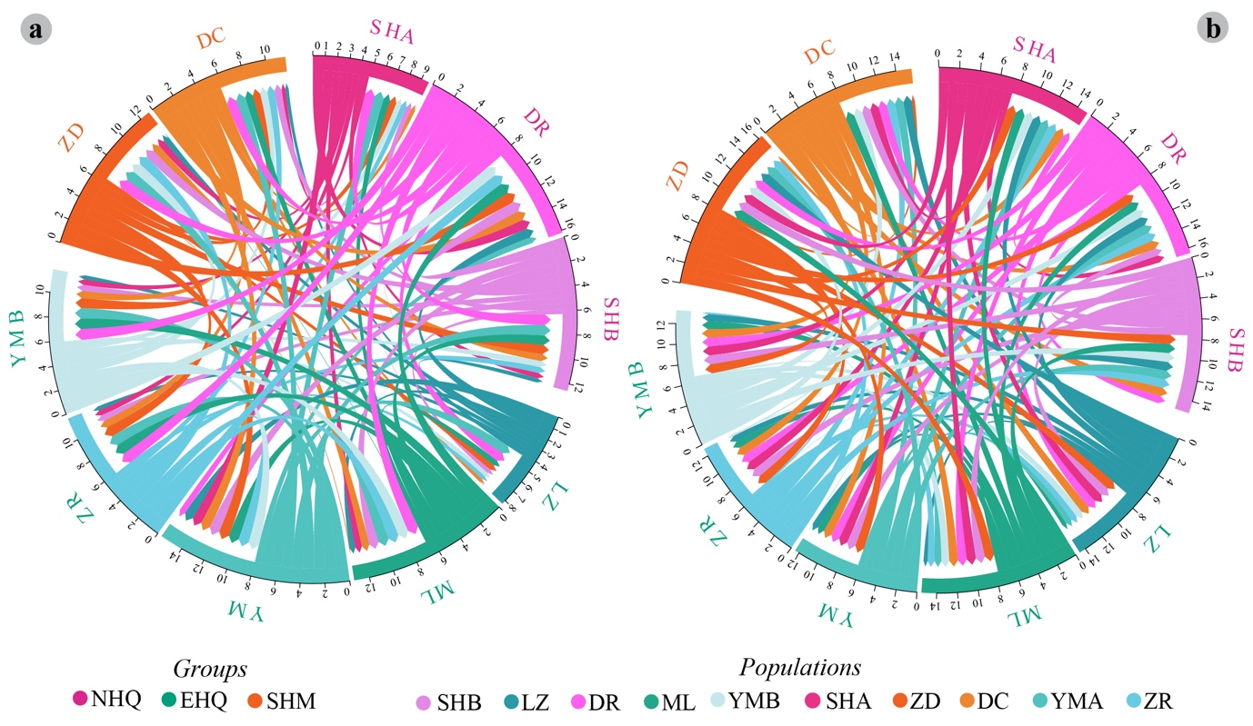
Fig. S1. Circos plots showing the paired populations level F_{ST} of (a) plastome and (b) ITS datasets for Rheum nobile.
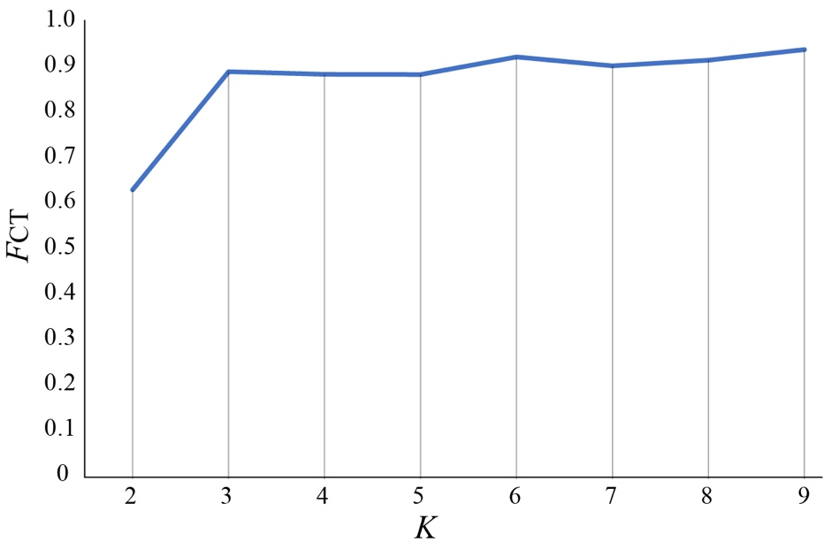
Fig. S2. Distributions of the F_{CT} values for the indicated number of groups (K) based on ITS sequences for Rheum nobile.
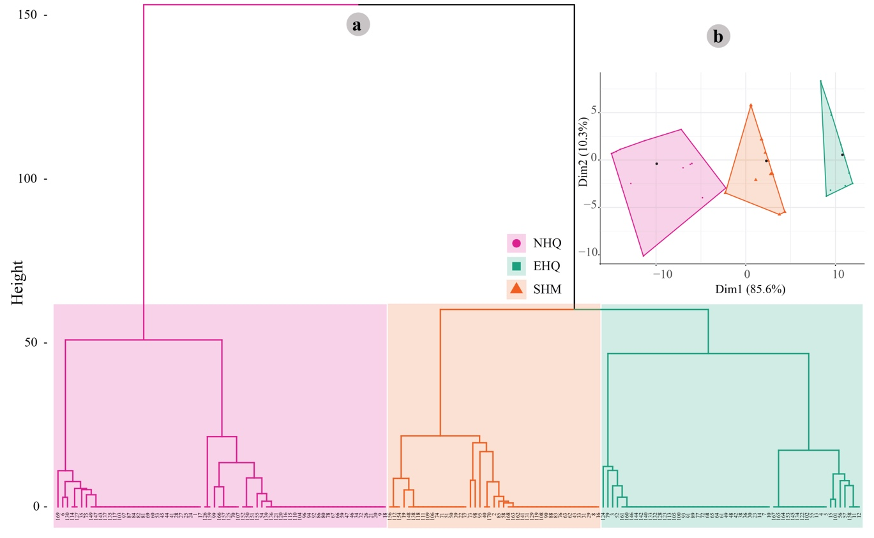
Fig. S3. (a) Hierarchical cluster dendrogram and (b) cluster factor map based on SNPs using factoextra package in R software. Colours correspond to three phylogroups of Rheum nobile.

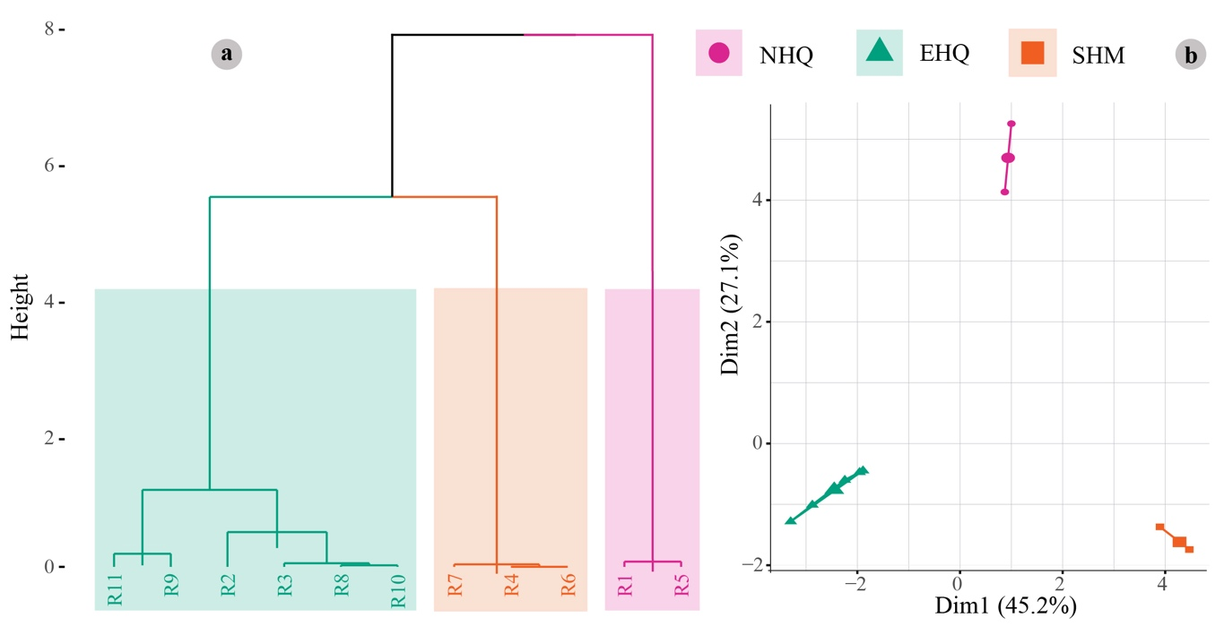
Fig. S4. ITS ribotypes variations based on (a) hierarchical cluster dendrogram and (b) cluster factor map using factoextra package in R software. Colours correspond to three phylogroups of Rheum nobile.

Fig. S5. Maximum likelihood (ML: RAxML) based phylogenetic tree of Rheum nobile inferred from (a) extracted CDS regions of plastome and (b) ITS datasets. Maximum likelihood bootstrap values and Bayesian posterior (BI) probabilities are represented at the nodes (only for major nodes).
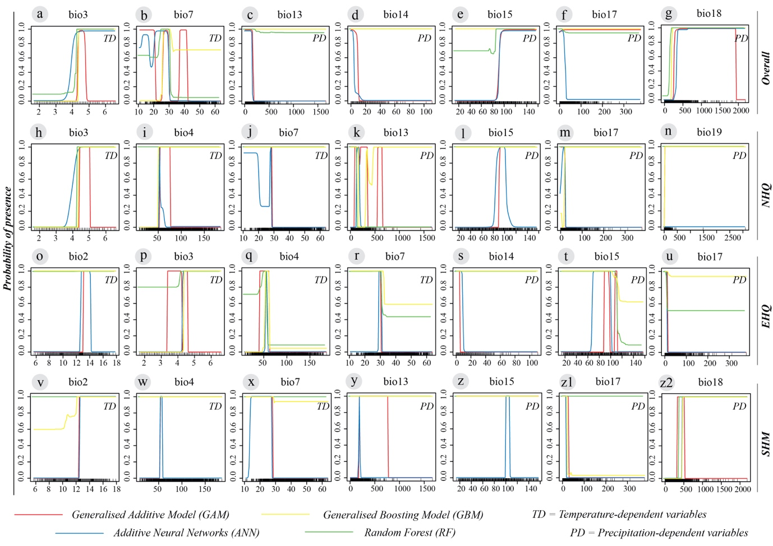
Fig. S6. Response curves of the highly predictive algorithms showing the probability of presence under the highly contributed temperature-dependent (a, b, h–j, o–r, v–x) and precipitation-dependent (c–g, k–n, s–u, y–z2) variables for the overall and three phylogroups of Rheum nobile. The predictive algorithms GAM (red line), GBM (yellow line), RF (green line), and ANN (blue line) are based on high contribution with TSS/KAPPA/AUC > 0.89. Temperatures are expressed in °C (degree Celsius), and Precipitation in mm (millimetre). Refer to Table S1 for the bioclimatic variables.

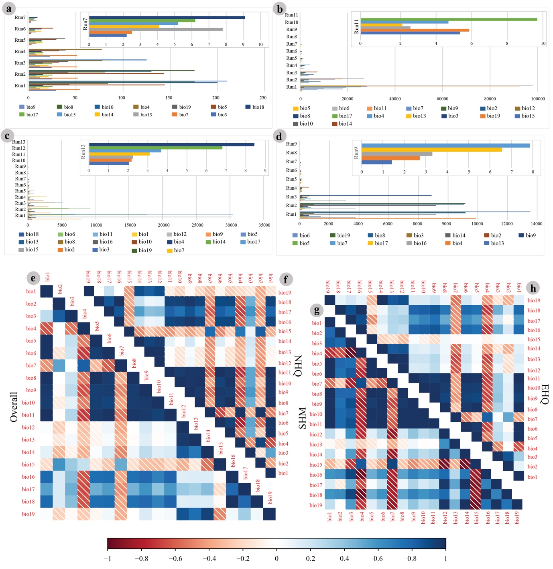
Fig. S7. Variance Inflation Factor (VIF) in different test runs for the selection of explanatory variables for (a) overall, (b) NHQ, (c) EHQ, (d) SHM of Rheum nobile and its groups. The selected subset of explanatory variables (VIF <10) was presented as the final test run. Pearson’s correlation (r) plots performed among the 19 bioclimatic variables based on: occurrence points (e) overall, (f) NHQ, (g) EHQ, (h) SHM. Lighter the colour of the squares, the lesser the correlation between variables. Refer to Table S1 for the bioclimatic variables.

