Figures

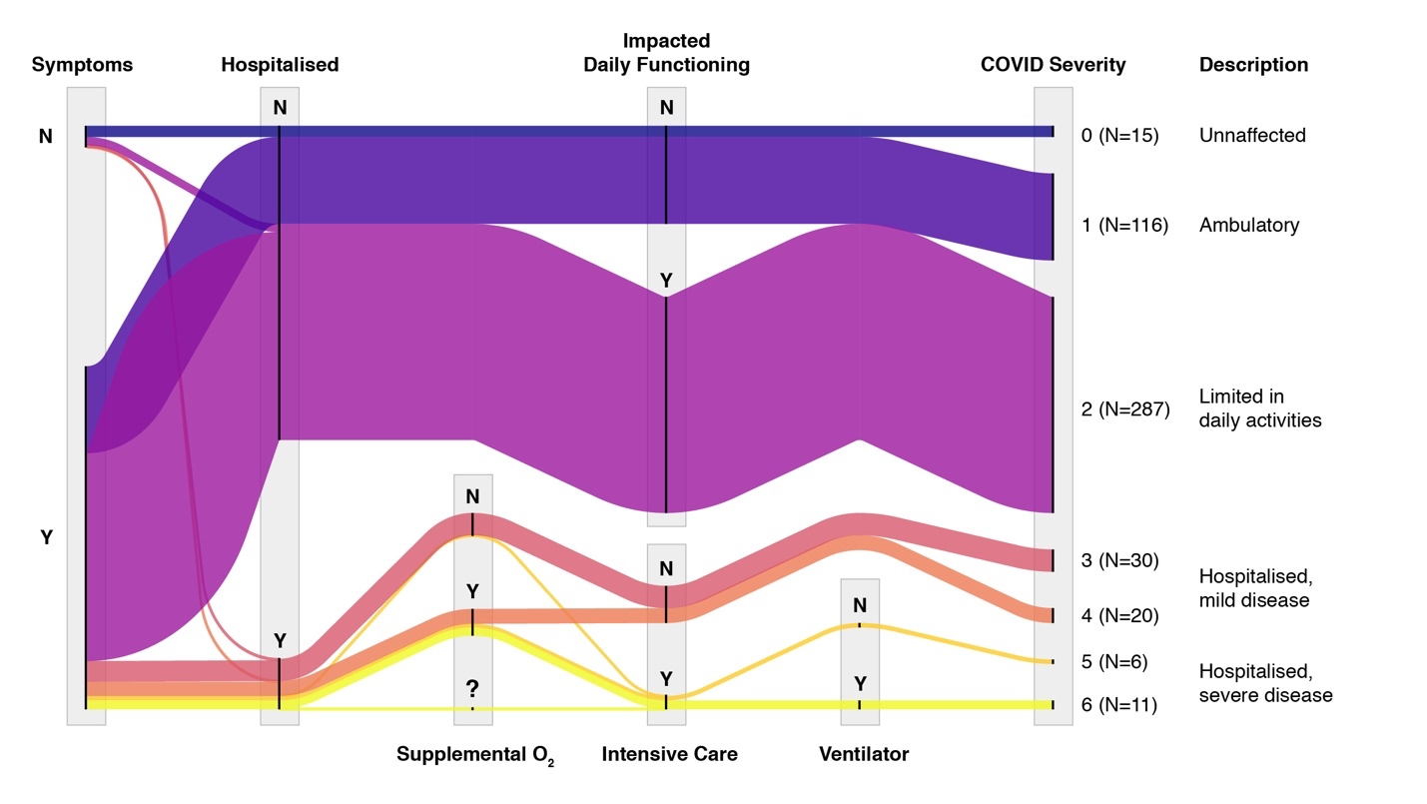
Figure S1: Response rate to each COVID-related item on the questionnaire, where the number of participants that responded “Yes” (Y), “No” (N), or “I don’t know” (?) is proportional to the height of the response node (i.e., the vertical black line). Coloured bands correspond to groups of participants that were assigned the same WHO COVID severity score (0-6) according to their responses to these questions, which can be observed by following each coloured band through the response nodes. The figure also depicts the sequence of questions that each group was asked; for example, the unaffected group (score = 0, dark blue band) selected none of the listed symptoms, were not hospitalised (and therefore not asked about ICU, etc.) and were not impacted in their daily functioning.

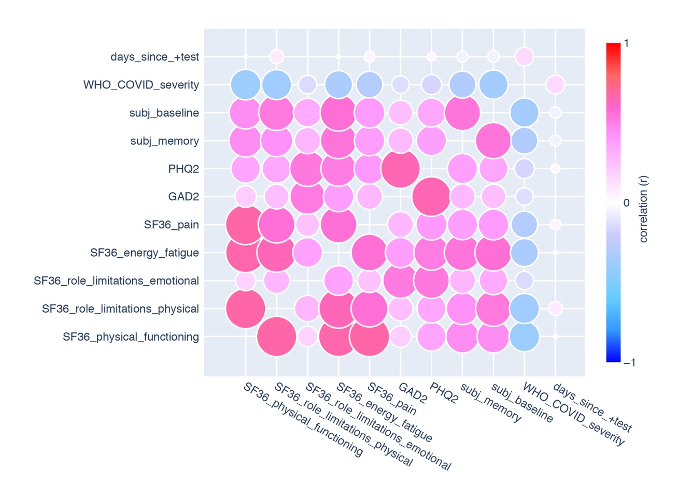
Figure S2: Pair-wise correlations between health-related measures in COVID+ participants (N=485). Correlations along the diagonal (i.e., r = 1.0) are not shown. Red and blue colours indicate positive and negative correlations, respectively. A larger node size and stronger colour intensity indicate stronger correlations.

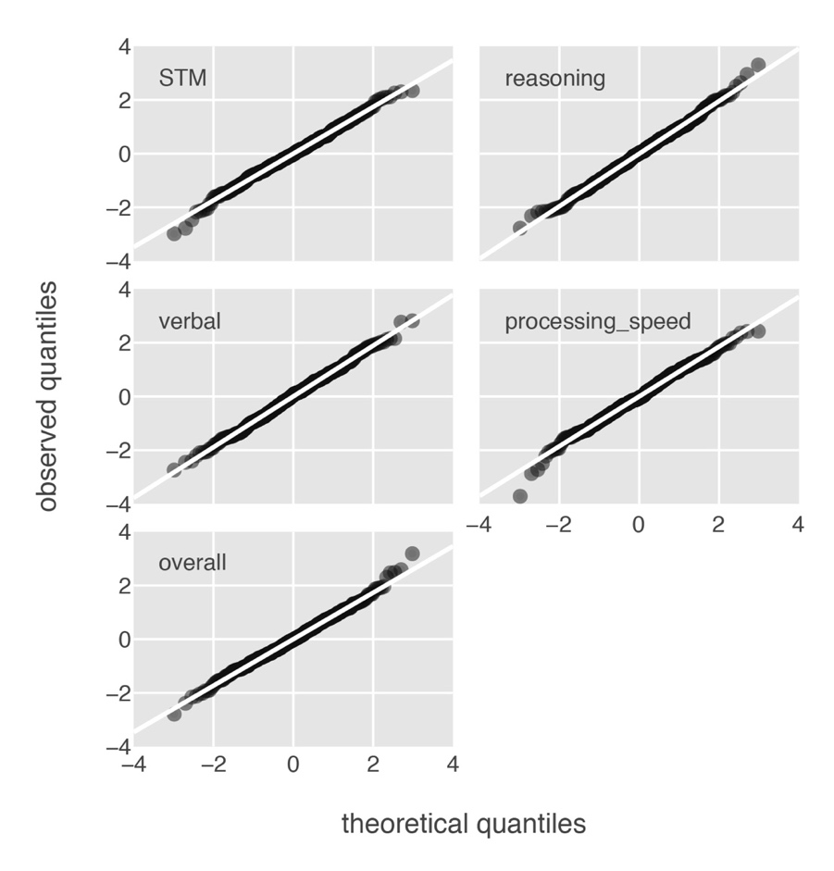
Figure S3: Quantile-quantile (“QQ”) plots of the residuals from linear regression models that predict each composite cognitive scores from the two health factors – physical (F1) and mental (F2) health – in the COVID+ sample (N=485). Statistics related to those regression models are presented in Table 3 (see main text).

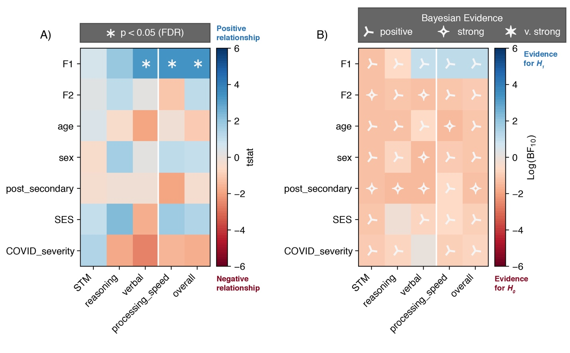

Figure S4: Pair-wise tests between variables of interest, using A) frequentist and B) Bayesian statistics. In both panels, the rows are regression parameters used to predict cognitive scores (columns). However, each variable is considered in isolation of the others – that is, the simple regression of each cognitive score on to a single predictor variable.

A) T-statistics for each parameter estimate. Blue indicates a positive t-statistic (and estimated parameter greater than 0.0) whereas red indicates the converse. Stars indicate significant effects, p < 0.05, corrected for multiple comparisons using the False Discovery Rate (FDR) across all t-tests in the panel.

B) Bayes Factors comparing the regression model that predicted each cognitive score from a single variable to a null (intercept-only) model. Blue cells indicate support for the alternative hypothesis (BF₁₀ > 1), and warm cells indicate support for the null hypothesis (BF₁₀ < 1). Symbols provide a heuristic interpretation for the given BF: positive (BF₁₀ 3-20), strong, (BF₁₀ 20-150), or very strong (BF₁₀ > 150) evidence for H₁ (labels not shown for BFs that support the null hypotheses)

Tables

Table S1: Classification criteria for the WHO COVID-19 severity scores obtainable given the questionnaire items (see Table S1) in this study. Percentages (of participants in each WHO category) are relative to the entire COVID+ sample. Y/N indicates the response “Yes” or “No”. Green indicates the option associated with better health, whereas red indicates the response associated with poorer health.

Description | Question | Yes / No | WHO Score | Count
Unaffected | Symptoms | N | 0 | 15(5.3%)
Unaffected | Hospital | N | 0 | 15(5.3%)
Ambulatory | Symptoms | Y | 1 | 116 (23.8%)
Ambulatory | Daily Routine | Y | 1 | 116 (23.8%)
Ambulatory | Hospital | N | 1 | 116 (23.8%)
Limited in activities | Symptoms | Y | 2 | 287 (57.0%)
Limited in activities | Daily Routine | N | 2 | 287 (57.0%)
Limited in activities | Hospital | N | 2 | 287 (57.0%)
Hospitalised, mild disease | Hospital | Y | 3 | 30 (6.1%)
Hospitalised, mild disease | Supplemental O₂ | N | 3 | 30 (6.1%)
Hospitalised, mild disease | Intensive Care | N | 3 | 30 (6.1%)
Hospitalised, mild disease | Hospital | Y | 4 | 20 (4.1%)
Hospitalised, mild disease | Supplemental O₂ | Y | 4 | 20 (4.1%)
Hospitalised, mild disease | Intensive Care | N | 4 | 20 (4.1%)
Hospitalised, severe disease | Hospital | Y | 5 | 6 (1.2%)
Hospitalised, severe disease | Intensive Care | Y | 5 | 6 (1.2%)
Hospitalised, severe disease | Ventilator | N | 5 | 6 (1.2%)
Hospitalised, severe disease | Hospital | Y | 6 | 11 (2.4%)
Hospitalised, severe disease | Intensive Care | Y | 6 | 11 (2.4%)
Hospitalised, severe disease | Ventilator | Y | 6 | 11 (2.4%)

Table S2: Factor loadings of health-related measures from COVID+ participants (N = 485)
 |  |  |  | Factor
variable | mean |  | (SD) | F1 |  | F2
SF36_physical_functioning | 69.70 |  | (29.03) | 0.838 |  | .
SF36_role_limitations_physical | 37.32 |  | (43.02) | 0.771 |  | .
SF36_role_limitations_emotional | 56.63 |  | (43.18) | . |  | 0.632
SF36_energy_fatigue | 34.08 |  | (24.01) | 0.754 |  | 0.357
SF36_pain | 66.91 |  | (26.04) | 0.674 |  | .
GAD2 | 2.10 |  | (1.95) | . |  | 0.773
PHQ2 | 2.00 |  | (1.86) | 0.317 |  | 0.756
“How would you rate your memory? (0-5) | 2.28 |  | (1.01) | 0.565 |  | 0.268
“…are back to your baseline level of cognitive functioning?” | 32.23% “Yes” |  |  | 0.616 |  | 0.609
WHO COVID severity | 1.92 |  | (1.08) | -0.461 |  | .
(approximate) days since most recent test | 93.30 |  | (67.68) | . |  | .
eigenvalue |  |  |  | 4.67 | 1.48
% variance explained |  |  |  | 30.78 | 17.35
Extraction method: Factor analysis with Varimax rotation.
Only coefficient values greater than 0.2 are displayed.

Table S3: Factor loadings of CBS test scores from control participants (N = 8,815)
 |  |  | factor
score | mean | (SD) | STM | reasoning | verbal
spatial_span | 5.66 | (1.06) | 0.721 | . | .
grammatical_reasoning | 17.87 | (5.18) | . | 0.475 | 0.561
double_trouble | 25.08 | (15.25) | 0.261 | 0.342 | 0.484
odd_one_out | 15.84 | (2.13) | . | 0.578 | .
monkey_ladder | 7.70 | (1.16) | 0.725 | . | .
rotations | 76.12 | (34.95) | . | 0.635 | .
feature_match | 114.06 | (29.51) | 0.289 | 0.598 | .
digit_span | 6.66 | (1.40) | . | . | 0.796
spatial_planning | 19.01 | (9.73) | 0.477 | 0.429 | .
paired_associates | 4.66 | (0.98) | 0.561 | . | 0.367
polygons | 41.06 | (21.90) | . | 0.608 | 0.263
token_search | 7.20 | (2.14) | 0.549 | . | 0.217
eigenvalue |  |  | 3.71 | 1.05 | 0.98
% variance explained |  |  | 17.93 | 17.50 | 12.38
Extraction method: Principal Component Analysis (PCA) with Varimax rotation.
Only coefficient values greater than 0.2 are displayed.

Table S4: Linear regression parameters modelling the relationship between demographic variables and physical (F1) and mental (F2) health factor scores. P-values and confidence intervals are Bonferroni-corrected (N=8). Bold entries indicate significant effects (p_{adj <} 0.05).

DV | IV | β | t | df | p_{adj} | CI | ΔR² | f² | BF₁₀
F1 | age | -0.01 | -3.17 | 480 | 0.013 | (-0.020, -0.001) | 0.019 | 0.021 | 6.86
F1 | male | 0.56 | 5.91 | 480 | < 0.001 | (0.302, 0.827) | 0.066 | 0.073 | > 1000
F1 | post_secondary | 0.07 | 0.62 | 480 | 1.000 | (-0.244, 0.386) | 0.001 | 0.001 | 0.05
F1 | SES | 0.09 | 0.56 | 480 | 1.000 | (-0.365, 0.550) | 0.001 | 0.001 | 0.05
F2 | age | 0.01 | 2.84 | 480 | 0.037 | (0.000, 0.019) | 0.016 | 0.017 | 2.60
F2 | male | 0.19 | 2.00 | 480 | 0.365 | (-0.072, 0.461) | 0.008 | 0.008 | 0.34
F2 | post_secondary | 0.38 | 3.27 | 480 | 0.009 | (0.061, 0.702) | 0.021 | 0.022 | 9.53
F2 | SES | -0.43 | -2.53 | 480 | 0.094 | (-0.893, 0.037) | 0.013 | 0.013 | 1.13
DV – dependent variable, IV – independent variable, β - estimated coefficient; t - t-statistic;
df – t-statistic degrees of freedom; p_{adj} - adjusted p-value; CI - confidence intervals; f² - Cohen’s f

Table S5: Two-sample t-test results comparing COVID+ participants, grouped into tercile bins based on F1, against the control sample; “worse”, “average”, and “better” correspond to the 0%-33%, 33%-66%, and 66%-100% percentile bins (higher F1 associated with better physical health). P-values and confidence intervals are Bonferroni corrected (N=15), and bold entries indicate significant effects (p_{adj <} 0.05).

F1_bin | score | difference | t | df | p_{adj} | CI | BF₁₀
worse | STM | 0.02 | 0.32 | 167.61 | 1.000 | (-0.201, 0.249) | 0.09
worse | reasoning | -0.34 | -3.96 | 166.13 | 0.002 | (-0.593, -0.084) | 190.87
worse | verbal | -0.34 | -4.64 | 167.92 | < 0.001 | (-0.562, -0.122) | > 1000
worse | processing_speed | -0.50 | -6.33 | 166.90 | < 0.001 | (-0.742, -0.267) | > 1000
worse | overall | -0.34 | -4.56 | 167.61 | < 0.001 | (-0.569, -0.119) | > 1000
average | STM | 0.04 | 0.60 | 167.85 | 1.000 | (-0.165, 0.247) | 0.10
average | reasoning | -0.10 | -1.31 | 166.41 | 1.000 | (-0.327, 0.128) | 0.20
average | verbal | -0.15 | -2.05 | 167.10 | 0.631 | (-0.365, 0.068) | 0.69
average | processing_speed | -0.24 | -3.35 | 167.26 | 0.015 | (-0.455, -0.027) | 21.50
average | overall | -0.10 | -1.53 | 168.94 | 1.000 | (-0.293, 0.094) | 0.28
better | STM | 0.08 | 1.30 | 170.80 | 1.000 | (-0.105, 0.267) | 0.20
better | reasoning | -0.11 | -1.61 | 168.68 | 1.000 | (-0.322, 0.096) | 0.31
better | verbal | -0.02 | -0.29 | 167.05 | 1.000 | (-0.257, 0.212) | 0.09
better | processing_speed | -0.14 | -1.99 | 168.90 | 0.719 | (-0.344, 0.068) | 0.61
better | overall | -0.02 | -0.29 | 169.85 | 1.000 | (-0.214, 0.176) | 0.09
t - t-statistic; df – degrees of freedom; p_{adj} - adjusted p-value; CI - confidence intervals

Table S6: Linear regression parameters modelling the relationship between cognitive scores and physical (F1) and mental (F2) health factor scores. P-values and confidence intervals are Bonferroni-corrected for 15 comparisons, and bold entries indicate significant effects (p_{adj <} 0.05). Nuisance variables were included as covariates of no interest.

DV | IV | b | t | df | p_{adj} | CI | DR² | f² | BF₁₀
STM | F1 | 0.03 | 0.79 | 478 | 1.000 | (-0.090, 0.156) | 0.001 | 0.001 | 0.06
STM | F2 | 0.02 | 0.42 | 478 | 1.000 | (-0.104, 0.138) | 0.000 | 0.000 | 0.05
reasoning | F1 | 0.06 | 1.28 | 478 | 1.000 | (-0.078, 0.197) | 0.003 | 0.003 | 0.10
reasoning | F2 | 0.06 | 1.23 | 478 | 1.000 | (-0.079, 0.192) | 0.003 | 0.003 | 0.10
verbal | F1 | 0.14 | 3.15 | 478 | 0.026 | (0.009, 0.275) | 0.020 | 0.021 | 6.58
verbal | F2 | 0.00 | 0.03 | 478 | 1.000 | (-0.130, 0.132) | 0.000 | 0.000 | 0.05
processing_speed | F1 | 0.15 | 3.30 | 478 | 0.016 | (0.016, 0.277) | 0.022 | 0.023 | 10.74
processing_speed | F2 | -0.04 | -1.03 | 478 | 1.000 | (-0.173, 0.084) | 0.002 | 0.002 | 0.08
overall | F1 | 0.12 | 2.97 | 478 | 0.047 | (0.001, 0.245) | 0.018 | 0.018 | 3.79
overall | F2 | 0.05 | 1.15 | 478 | 1.000 | (-0.073, 0.167) | 0.003 | 0.003 | 0.09
Covariates of no interest: age (in years), sex, post-secondary education, and SES growing up.
DV – dependent variable, IV – independent variable, β - estimated coefficient; t - t-statistic;
df – t-statistic degrees of freedom; p_{adj} - adjusted p-value; CI - confidence intervals; f² - Cohen’s f f

Table S7: Two-sample t-test results comparing non-hospitalised to hospitalised COVID+ participants. Positive differences indicate higher scores for the non-hospitalised group. Confidence intervals and p-values are Bonferroni corrected (N=7), and bold entries indicate significant effects (p_{adj <} 0.05).

score | difference | t | df | p_{adj} | CI | BF₁₀
F1 | 0.49 | 3.89 | 90.27 | 0.001 | (0.144, 0.841) | 170.87
F2 | 0.00 | -0.02 | 85.49 | 1.000 | (-0.385, 0.379) | 0.14
STM | -0.19 | -1.58 | 86.98 | 0.819 | (-0.507, 0.137) | 0.47
reasoning | 0.33 | 2.52 | 86.86 | 0.094 | (-0.030, 0.695) | 2.88
verbal | 0.11 | 0.95 | 95.71 | 1.000 | (-0.205, 0.423) | 0.22
processing_speed | 0.30 | 2.24 | 83.33 | 0.195 | (-0.070, 0.672) | 1.52
overall | 0.14 | 1.08 | 83.39 | 1.000 | (-0.211, 0.482) | 0.25
t - t-statistic; df – degrees of freedom; p_{adj} - adjusted p-value; CI - confidence intervals

Table S8: Two-sample t-test results comparing each of the COVID+ non-hospitalised and hospitalised groups to the control sample. p-values and confidence intervals are Bonferroni corrected (N=10), and bold entries indicate significant effects (p_{adj <} 0.05).

Hospital | score | difference | t | df | p_{adj} | CI | BF₁₀
No | STM | 0.02 | 0.54 | 471.71 | 1.000 | (-0.099, 0.146) | 0.07
No | reasoning | -0.14 | -2.84 | 460.01 | 0.048 | (-0.275, -0.001) | 3.01
No | verbal | -0.16 | -3.22 | 460.14 | 0.014 | (-0.293, -0.019) | 9.46
No | processing_speed | -0.25 | -5.49 | 465.32 | < 0.001 | (-0.383, -0.123) | > 1000
No | overall | -0.14 | -3.13 | 472.36 | 0.019 | (-0.258, -0.013) | 7.16
Yes | STM | 0.21 | 1.90 | 67.27 | 0.614 | (-0.109, 0.526) | 0.75
Yes | reasoning | -0.47 | -3.81 | 67.00 | 0.003 | (-0.828, -0.112) | 138.67
Yes | verbal | -0.27 | -2.54 | 67.40 | 0.134 | (-0.568, 0.038) | 2.88
Yes | processing_speed | -0.55 | -4.35 | 66.93 | < 0.001 | (-0.924, -0.185) | > 1000
Yes | overall | -0.27 | -2.28 | 67.07 | 0.259 | (-0.616, 0.074) | 1.58
t - t-statistic; df – degrees of freedom; p_{adj} - adjusted p-value; CI - confidence intervals

Table S9: Results of linear regression analyses predicting cognitive scores from: physical (F1) and mental (F2) health factor scores, and hospitalisation status (1 = hospitalised group). P-values and confidence intervals are Bonferroni corrected for 15 comparisons, and bold entries indicate significant effects (p_{adj <} 0.05).

DV | IV | b | t | df | p_{adj} | CI | DR² | f² | BF₁₀
STM | F1 | 0.04 | 0.88 | 481 | 1.000 | (-0.083, 0.154) | 0.002 | 0.002 | 0.07
STM | F2 | 0.01 | 0.28 | 481 | 1.000 | (-0.106, 0.128) | 0.000 | 0.000 | 0.05
STM | Hospital | 0.20 | 1.75 | 481 | 1.000 | (-0.139, 0.544) | 0.006 | 0.006 | 0.21
reasoning | F1 | 0.06 | 1.34 | 481 | 1.000 | (-0.073, 0.194) | 0.004 | 0.004 | 0.11
reasoning | F2 | 0.05 | 1.02 | 481 | 1.000 | (-0.086, 0.176) | 0.002 | 0.002 | 0.08
reasoning | Hospital | -0.30 | -2.33 | 481 | 0.305 | (-0.687, 0.081) | 0.011 | 0.011 | 0.69
verbal | F1 | 0.14 | 3.17 | 481 | 0.025 | (0.009, 0.268) | 0.020 | 0.021 | 6.74
verbal | F2 | 0.00 | 0.01 | 481 | 1.000 | (-0.127, 0.128) | 0.000 | 0.000 | 0.05
verbal | Hospital | -0.04 | -0.32 | 481 | 1.000 | (-0.413, 0.332) | 0.000 | 0.000 | 0.05
processing_speed | F1 | 0.14 | 3.16 | 481 | 0.025 | (0.009, 0.262) | 0.020 | 0.021 | 6.56
processing_speed | F2 | -0.06 | -1.32 | 481 | 1.000 | (-0.181, 0.069) | 0.004 | 0.004 | 0.11
processing_speed | Hospital | -0.23 | -1.89 | 481 | 0.881 | (-0.599, 0.130) | 0.007 | 0.007 | 0.28
overall | F1 | 0.12 | 3.10 | 481 | 0.031 | (0.006, 0.243) | 0.019 | 0.020 | 5.49
overall | F2 | 0.04 | 0.92 | 481 | 1.000 | (-0.080, 0.153) | 0.002 | 0.002 | 0.07
overall | Hospital | -0.07 | -0.64 | 481 | 1.000 | (-0.416, 0.267) | 0.001 | 0.001 | 0.06
DV – dependent variable, IV – independent variable, β - estimated coefficient; t - t-statistic;
df – t-statistic degrees of freedom; p_{adj} - adjusted p-value; CI - confidence intervals; f² - Cohen’s f

Table S10: Bayes factors (BF₁₀) for each variable and cognitive score that compares a model containing the predictor of interest to the null model (i.e., intercept-only model). BF₁₀ greater than 1.0 indicates support for the alternative hypothesis, such that the variable of interest adds explanatory power for that cognitive score.

variable | STM | reasoning | verbal | processing  speed | overall
F1 | 0.06 | 0.27 | 9.76 | 12.75 | 13.12
F2 | 0.05 | 0.08 | 0.05 | 0.08 | 0.09
WHO_COVID_severity | 0.12 | 0.21 | 1.15 | 0.14 | 0.17
age | 0.05 | 0.05 | 0.29 | 0.05 | 0.07
sex | 0.05 | 0.18 | 0.05 | 0.09 | 0.08
post_secondary | 0.05 | 0.05 | 0.05 | 0.29 | 0.05
SES | 0.07 | 0.73 | 0.16 | 0.23 | 0.13

