1.Materials and methods

1.1 Sample collection and preparation
Samples were taken from the Daqu-making factory of Sichuan Forgood Distillery Co., Ltd., Sichuan Province, China. In April 2022, a batch of medium and high-temperature Daqu, which was put into storage on the same day and stored in different places was randomly selected for the experiment. The production process of the distillery's Daqu involves pressing wheat with varying degrees of crushing, without adding any other starter-making materials. These samples were treated by high-energy electron beam at the doses of 0 kGy, 0.20 kGy, 1.00 kGy, 2.00 kGy, 2.5 kGy, and 3 kGy. The actual irradiation dose was determined by the measured value of the dosimeter. To prevent contamination and ensure that the detected microorganisms were the original ones affected by the irradiation treatment, samples was stored in a cool and ventilated food-grade translucent plastic box. Strict aseptic procedures were followed during the subsequent sampling. At intervals of 0, 25, 60, and 90 d after irradiation, three blocks of Daqu were randomly sampled from each irradiated Daqu block, then crushed and mixed evenly. Eight to ten grams samples were transferred to sterile 15 ml centrifuge tubes, with three samples collected from each sample. Finally, the samples were stored in a refrigerator at -80C for further analysis.

1.2 Microbial culture and enumeration
Acetobacter culture medium used in this study is 10g glucose, 10g yeast extract, 20g CaCO3, 20g agar, 1000 mL distilled water, autoclaved at 121℃ for 15 min, and then 40mL anhydrous ethanol is added at 70℃. 10g of Daqu powder was homogenized in 90 mL of sterile 0.9% sodium chloride solution at the speed of 180 rpm in a shaking incubator for 30 minutes. The homogenized sample (1.0 mL) was continuously diluted 10 times in sterile 0.9% sodium chloride solution, and the aliquot sample (0.1 mL) was coated on a plate, and cultured at 38℃ for 48 hours, and the microbial number of Daqu was determined regularly.

1.3 Determination of D10 values of different microorganisms
After the sample was irradiated, the colony number of Daqu microorganisms treated with different irradiation doses on the day of sample treatment was obtained by traditional culturable technology, and the D10 values of different microorganisms were calculated by linear fitting with spss software.

2.Results
The sample A of strong-flavor Daqu, which has just been stored in the warehouse, was irradiated by high-energy electron beam. The actual irradiation dose measured by dosimeter was 0kGy, 0.37kGy, 1.40kGy, 2.80kGy, 3.10kGy and 3.55kGy. The effects of different irradiation doses on acetic acid bacteria in Daqu during storage were studied by dilution coating plate counting method. The counting results are shown in Table 1.
As can be seen from Table 1, the counting results of 0 days after irradiation show that the number of Acetobacter decreases with the increase of irradiation dose. Except for the Daqu sample treated with 0.37 kGy radiation dose, the number of acid-producing bacteria was lower than that of the control group within 90 days, and the number of acid-producing bacteria decreased with the increase of radiation dose. After 40 days, the number of acetic acid bacteria in Daqu samples irradiated with 1.40kGy or less can be restored to the level of samples without irradiation, and the number of microorganisms can reach the same order of magnitude.
The data results in Table 1 were analyzed, and the D10 value of Acetobacter was calculated by linear fitting. D10 of Acetobacter is 1.15 kGy, and the related results are summarized in Figure 1 and Table 2.
Table 1 Total number of Acetobacter (CFU/ g) during storage of Daqu with different irradiation doses.
 | 0 kGy | 0.37 kGy | 1.4 kGy | 2.8 kGy | 3.1 kGy | 3.55 kGy
0d | $5.50×10$⁸ | $5.30×10$⁸ | $2.22×10$⁷ | 1.50$×10$⁷ | $1.10×10$⁶ | $4.30×10$⁵
5d | $6.60×10$⁷ | $2.40×10$⁷ | $1.90×10$⁷ | 1.7$0×10$⁷ | 1.10$×10$⁷ | $3.70×10$⁶
10d | $1.20×10$⁸ | $1.10×10$⁸ | $6.30×10$⁷ | $3.10×10$⁷ | $1.60×10$⁷ | 1.80$×$10⁶
15d | $7.70×10$⁷ | $3.90×10$⁷ | $1.30×10$⁷ | $6.30×10$⁶ | $1.00×10$⁵ | $9.50×10$⁴
25d | $5.60×10$⁴ | $6.80×10$⁴ | $1.40×10$⁷ | $5.10×10$⁴ | $2.00×10$³ | $5.00×10$³
40d | $2.39×10$⁴ | $2.25×10$⁴ | $1.18×10$⁴ | $7.40×10$³ | $6.00×10$³ | $7.00×10$²
60d | $1.59×10$⁴ | $1.57×10$⁴ | $1.41×10$⁴ | $3.10×10$³ | $3.10×10$³ | $4.20×10$²
90d | 1.01 $×$ 10⁴ | 1.00$×$ 10⁴ | 1.18$×10$⁴ | 2.70 $×10$³ | 1.68$×10$³ | 5.2$0×10$²

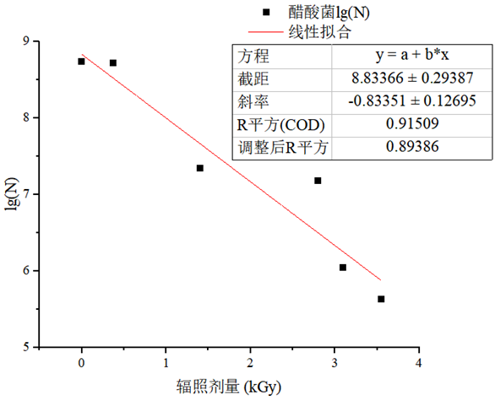

Fig. 1 Fitting curve of total viable count of Acetobacter and irradiation dose
Irradiation dose
Acetic acid bacteria(lgN)
Linear fitting

Types of microorganisms | Regression equation | D₁₀
Acetic acid bacteria | Y=－0.83351X+8.83366，R2=0.915 | 1.20 kGy
Table 2 D10 values of Acetobacte

