Supplementary Material
Table 1. Samples used in this study and the corresponding localities
Sample code | Latin name | Locality | Collected parts
H1 | Paris polyphylla var. chinensis | Dayi, Sichuan | leaf
H2 | P. polyphylla var. chinensis | Shimian, Sichuan | leaf
H3 | P. polyphylla var. chinensis | Pingwu Xiangyan, Sichuan | leaf
H4 | P. polyphylla var. chinensis | Pingwu Mupi, Sichuan | leaf
H5 | P. polyphylla var. chinensis | Pengzhou Bailu, Sichuan | leaf
H6 | P. polyphylla var. chinensis | Pengzhou Bailu, Sichuan | leaf
H7 | P. polyphylla var. chinensis | Pengzhou Bailu, Sichuan | leaf
H8 | P. polyphylla var. chinensis | Ya’an Tianquan, Sichuan | leaf
H9 | P. polyphylla var. chinensis | Xingshan Shuiyuesi, Hubei | leaf
H10 | P. polyphylla var. chinensis | PengzhouGexianshan, Sichuan | leaf
H11 | P. polyphylla var. chinensis | PengzhouGexianshan,Sichuan | leaf
H12 | P. polyphylla var. chinensis | PengzhouGexianshan,Sichuan | leaf
H13 | P. polyphylla var. chinensis | PengzhouGexianshan,Sichuan | leaf
H14 | P. polyphylla var. chinensis | Dayi Qingxia,Sichuan | leaf
H15 | P. polyphylla var. chinensis | Fengcheng,Jiangxi | leaf
H16 | P. polyphylla var. chinensis | Emeishan Zhongfeng,Sichuan | leaf
H17 | P. polyphylla var. chinensis | Emeishan Zhongfeng,Sichuan | leaf
H18 | P. polyphylla var. chinensis | Ya’an Yingjing,Sichuan | rhizome
H19 | P. polyphylla var. chinensis | Ya’an Yanqiao,Sichuan | rhizome
H20 | P. polyphylla var. chinensis | Ya’an Yanchang,Sichuan | rhizome
H21 | P. polyphylla var. chinensis | Ya’an Yanchang,Sichuan | rhizome
H22 | P. polyphylla var. chinensis | Xingshan Shuiyuesi,Hubei | rhizome
H23 | P. polyphylla var. chinensis | Dujiangyan,Sichuan | rhizome
H24 | P. polyphylla var. chinensis | Luzhou,Sichuan | rhizome
H25 | P. polyphylla var. chinensis | Luzhou,Sichuan | rhizome
H26 | P. polyphylla var. chinensis | Chongzhou Jiguanshan,Sichuan | leaf
H27 | P. polyphylla var. chinensis | Nianyang Anxian,Sichuan | leaf
H28 | P. polyphylla var. chinensis | Nianyang Anxian,Sichuan | leaf
H29 | P. polyphylla var. chinensis | Beichuan Xiaoba,Sichuan | leaf
H30 | P. polyphylla var. chinensis | Beichuan Xiaoba,Sichuan | leaf
H31 | P. polyphylla var. chinensis | Chongzhou Huanyuan,Sichuan | leaf
H32 | P. polyphylla var. chinensis | Chongzhou Huanyuan,Sichuan | leaf
H33 | P. polyphylla var. chinensis | Liping Long’e Guizhou | leaf
H34 | P. polyphylla var. chinensis | Liping Long’e Guizhou | leaf
YN1 | P. polyphylla var. yunnanensis | Dafang Shuijing,Sichuan | leaf
YN2 | P. polyphylla var. yunnanensis | Dafang Shuijing,Sichuan | leaf
YN3 | P. polyphylla var. yunnanensis | Bijie Tianbaqiao,Guizhou | leaf
YN4 | P. polyphylla var. yunnanensis | Bijie Tianbaqiao,Guizhou | leaf
YN5 | P. polyphylla var. yunnanensis | Bijie Qixingguan,Guizhou | leaf
YN6 | P. polyphylla var. yunnanensis | Bijie Qixingguan,Guizhou | leaf
*YN7 | P. polyphylla var. yunnanensis | Dafang,Guizhou | leaf
*YN8 | P. polyphylla var. yunnanensis | Dafang,Guizhou | leaf
*YN9 | P. polyphylla var. yunnanensis | Dafang,Guizhou | leaf
*YN10 | P. polyphylla var. yunnanensis | Dafang,Guizhou | leaf
*YN11 | P. polyphylla var. yunnanensis | Dafang,Guizhou | leaf
*YN12 | P. polyphylla var. yunnanensis | Pu’er,Yunnan | leaf
*YN13 | P. polyphylla var. yunnanensis | Pu’er,Yunnan | leaf
YN14 | P. polyphylla var. yunnanensis | Pu’er,Yunnan | leaf
YN15 | P. polyphylla var. yunnanensis | Pu’er,Yunnan | leaf
*YN16 | P. polyphylla var. yunnanensis | Longli,Guizhou | leaf
*YN17 | P. polyphylla var. yunnanensis | Longli,Guizhou | leaf
*YN18 | P. polyphylla var. yunnanensis | Longli,Guizhou | leaf
YN19 | P. polyphylla var. yunnanensis | Xuanwei longchang,Yunnan | leaf
YN20 | P. polyphylla var. yunnanensis | Xuanwei longchang,Yunnan | leaf
YN21 | P. polyphylla var. yunnanensis | Xuanwei longchang,Yunnan | leaf
YN22 | P. polyphylla var. yunnanensis | Xuanwei longchang,Yunnan | leaf
YN23 | P. polyphylla var. yunnanensis | Xuanwei Xize,Yunnan | leaf
YN24 | P. polyphylla var. yunnanensis | Xuanwei Xize,Yunnan | leaf
YN25 | P. polyphylla var. yunnanensis | Xuanwei Xize,Yunnan | leaf
YN26 | P. polyphylla var. yunnanensis | Xuanwei Xize,yunnan | leaf
YN27 | P. polyphylla var. yunnanensis | Xingyi,Guizhou | leaf
YN28 | P. polyphylla var. yunnanensis | Changshun Guangshun,Guizhou | leaf
YN29 | P. polyphylla var. yunnanensis | Changshun Guangshun,Guizhou | leaf
YN30 | P. polyphylla var. yunnanensis | Shimian Tianwan,Sichuan | leaf
YN31 | P. polyphylla var. yunnanensis | Shimian Tianwan,Sichuan | leaf
YN32 | P. polyphylla var. yunnanensis | Shimian Tianwan,Sichuan | leaf
YN33 | P. polyphylla var. yunnanensis | Shimian Tianwan,Sichuan | leaf
*YN34 | P. polyphylla var. yunnanensis | Gengma,Yunnan | leaf
*YN35 | P. polyphylla var. yunnanensis | Liuzhi,Guizhou | leaf
YN36 | P. polyphylla var. yunnanensis | Huili Baiji,Sichuan | leaf
*YN37 | P. polyphylla var. yunnanensis | Changshun Guangshun,Guizhou | leaf
*YN38 | P. polyphylla var. yunnanensis | Changshun Guangshun,Guizhou | leaf
*YN39 | P. polyphylla var. yunnanensis | Jinping,Yunnan | leaf
*YN40 | P. polyphylla var. yunnanensis | Dayi Huashuiwan,Sichuan | leaf
*YN41 | P. polyphylla var. yunnanensis | Dayi Huashuiwan,Sichuan | leaf
*YN42 | P. polyphylla var. yunnanensis | Dayi Huashuiwan,Sichuan | leaf
*YN43 | P. polyphylla var. yunnanensis | Anshun,Guizhou | leaf
*YN44 | P. polyphylla var. yunnanensis | Anshun,Guizhou | leaf
*YN45 | P. polyphylla var. yunnanensis | Gengma,Yunnan | leaf
*YN46 | P. polyphylla var. yunnanensis | Liuzhi,Guizhou | leaf
*YN47 | P. polyphylla var. yunnanensis | Liuzhi Langdai,Guizhou | leaf
*YN48 | P. polyphylla var. yunnanensis | Liuzhi Langdai,Guizhou | leaf
*YN49 | P. polyphylla var. yunnanensis | Liuzhi Langdai,Guizhou | leaf
*YN50 | P. polyphylla var. yunnanensis | Liuzhi,Guizhou | leaf
*YN51 | P. polyphylla var. yunnanensis | Liuzhi,Guizhou | leaf
*YN52 | P. polyphylla var. yunnanensis | Pengzhou,Sichuan | leaf
*YN53 | P. polyphylla var. yunnanensis | Pengzhou,Sichuan | leaf
*YN54 | P. polyphylla var. yunnanensis | Pengzhou,Sichuan | leaf
YN55 | P. polyphylla var. yunnanensis | Pengzhou,Sichuan | leaf
YN56 | P. polyphylla var. yunnanensis | Pengzhou,Sichuan | leaf
YN57 | P. polyphylla var. yunnanensis | Pengzhou,Sichuan | leaf
YN58 | P. polyphylla var. yunnanensis | Tengchong Mingguang,Yunnan | leaf
YN59 | P. polyphylla var. yunnanensis | Tengchong Mingguang,Yunnan | leaf
YN60 | P. polyphylla var. yunnanensis | Tengchong Jietou,Yunnan | leaf
YN61 | P. polyphylla var. yunnanensis | Tengchong Jietou,Yunnan | leaf
YN62 | P. polyphylla var. yunnanensis | Yanyuan Yantang,Sichuan | leaf
YN63 | P. polyphylla var. yunnanensis | Yanyuan Yantang,Sichuan | leaf
YN64 | P. polyphylla var. yunnanensis | Yanbian Gesala,Sichuan | leaf
YN65 | P. polyphylla var. yunnanensis | Yanbian Gesala,Sichuan | leaf
DY1 | P. polyphylla var. polyphylla | Chongzhou Goujia,Sichuan | leaf
DY2 | P. polyphylla var. polyphylla | Ya’an hanyuan,Sichuan | leaf
DY3 | P. polyphylla var. polyphylla | Liangshan Puge,Sichuan | leaf
DY4 | P. polyphylla var. polyphylla | Pingwu Xiangyan,Sichuan | leaf
DY5 | P. polyphylla var. polyphylla | Wenxian Tielou,Gansu | leaf
DY6 | P. polyphylla var. polyphylla | Beichuan Xiaoba,Sichuan | leaf
DY7 | P. polyphylla var. polyphylla | Beichuan Xiaoba,sichuan | leaf
DY8 | P. polyphylla var. polyphylla | Beichuan Xiaoba,Sichuan | leaf
DY9 | P. polyphylla var. polyphylla | Beichuan Xiaoba,Sichuan | leaf
DY10 | P. polyphylla var. polyphylla | Beichuan Xiaoba,Sichuan | leaf
DY11 | P. polyphylla var. polyphylla | Pengzhou Bailu,Sichuan | leaf
DY12 | P. polyphylla var. polyphylla | Pengzhou Bailu,Sichuan | leaf
DY13 | P. polyphylla var. polyphylla | Pengzhou Bailu,Sichuan | leaf
DY14 | P. polyphylla var. polyphylla | Pengzhou Bailu,Sichuan | leaf
DY15 | P. polyphylla var. polyphylla | Pengzhou Bailu,Sichuan | leaf
DY16 | P. polyphylla var. polyphylla | Pengzhou Bailu,Sichuan | leaf
DY17 | P. polyphylla var. polyphylla | Xingshan Shuiyuesi,Hubei | rhizome
XY1 | P. polyphylla var. stenophylla | Pengzhou Bailu,Sichuan | leaf
XY2 | P. polyphylla var. stenophylla | Dayi Xiling,Sichuan | leaf
XY3 | P. polyphylla var. stenophylla | Chongzhou,Sichuan | leaf
XY4 | P. polyphylla var. stenophylla | Gulin,Sichuan | rhizome
XY5 | P. polyphylla var. stenophylla | Ya’an,Sichuan | rhizome
XY6 | P. polyphylla var. stenophylla | Chongzhou Jiguanshan,Sichuan | leaf
XY7 | P. polyphylla var. stenophylla | Chongzhou Jiguanshan,Sichuan | leaf
XY8 | P. polyphylla var. stenophylla | Liupanshui Shuicheng,Guizhou | leaf
XY9 | P. polyphylla var. stenophylla | Liupanshui Shuicheng,Guizhou | leaf
XY10 | P. polyphylla var. stenophylla | Chongzhou Jiguanshan,Sichuan | leaf
N1 | Paris vietnamensis (Takht.) H. Li | Jinping,Yunnan | leaf
N2 | P. veitnamensis | Jinping,Yunnan | leaf
N3 | P. veitnamensis | Jinping,Yunnan | leaf
N4 | P. veitnamensis | Jinping,Yunnan | leaf
N5 | P. veitnamensis | Lao Cai,Vietnam | leaf
N6 | P. veitnamensis | Lao Cai,Vietnam | leaf
N7 | P. veitnamensis | Phôngsali,Laos | leaf
N8 | P. veitnamensis | Phôngsali,Laos | leaf
WZL1 | Paris axialis H. Li | Beichuan Xiaoba,Sichuan | leaf
WZL2 | P. axialis | Beichuan Xiaoba,Sichuan | leaf
WZL3 | P. axialis | Chongzhoiu Jiguanshan,Sichuan | leaf
WZL4 | P. axialis | Chongzhoiu Jiguanshan,Sichuan | leaf
WZL5 | P. axialis | Ya’an Yingjing,Sichuan | leaf
PF1 | Paris vaniotii H. Lév. | Chongzhou Goujia,Sichuan | leaf
PF2 | P. vaniotii | Dayi Huashuiwan,Sichuan | leaf
PF3 | P. vaniotii | Shimian,Sichuan | leaf
PF4 | P. vaniotii | Chongzhou Bailuzhen,Sichuan | leaf
PF5 | P. vaniotii | Chongzhou Bailuzhen,Sichuan | leaf
PF6 | P. vaniotii | Chongzhoiu Jiguanshan,Sichuan | leaf
PF7 | P. vaniotii | Chongzhoiu Jiguanshan,Sichuan | leaf
Q1 | Paris fargesii var. fargesii | Chongzhoiu Yulang,Sichuan | leaf
Q2 | P. fargesii var. fargesii | Chongzhou Goujia,Sichuan | leaf
Q3 | P. fargesii var. fargesii | Pingwu Mupi,Sichuan | leaf
Q4 | P. fargesii var. fargesii | Dayi Huashuiwan,Sichuan | leaf
Q5 | P. fargesii var. fargesii | Pengzhou Bailu,sichuan | leaf
Q6 | P. fargesii var. fargesii | Pengzhou Bailu,sichuan | leaf
Q7 | P. fargesii var. fargesii | Pengzhou Bailu,sichuan | leaf
Q8 | P. fargesii var. fargesii | Laifeng,Hubei | rhizome
Q9 | P. fargesii var. fargesii | Jinggangshan Huangyangjie,Jiangxi | leaf
Q10 | P. fargesii var. fargesii | Chongzhou,Sichuan | leaf
Q11 | P. fargesii var. fargesii | Chongzhou,Sichuan | leaf
Q12 | P. fargesii var. fargesii | Pengzhou Bailu,sichuan | leaf
Q13 | P. fargesii var. fargesii | Pengzhou Bailu,sichuan | leaf
Q14 | P. fargesii var. fargesii | Pengzhou Bailu,sichuan | leaf
Q15 | P. fargesii var. fargesii | Pengzhou Bailu,sichuan | leaf
Q16 | P. fargesii var. fargesii | Shuangpai,Hunan | leaf
Q17 | P. fargesii var. fargesii | Shuangpai,Hunan | leaf
Q18 | P. fargesii var. fargesii | Chongzhou,Sichuan | leaf
Q19 | P. fargesii var. fargesii | Chongzhou,Sichuan | leaf
Q20 | P. fargesii var. fargesii | Laifeng,Hubei | leaf
Q21 | P. fargesii var. fargesii | Laifeng,Hubei | leaf
Q22 | P. fargesii var. fargesii | Shuicheng,Guizhou | leaf
HZ1 | P. thibetica var. thibetica | Dayi Xiling,Sichuan | leaf
HZ2 | P. thibetica var. thibetica | Pingwu Mupi,Sichuan | leaf
HZ3 | P. thibetica var. thibetica | Wenxian Tielou,Gansu | leaf
HZ4 | P. thibetica var. thibetica | Anxian Gaochuan,Sichuan | leaf
HZ5 | P. thibetica var. thibetica | Anxian Gaochuan,Sichuan | leaf
HZ6 | P. thibetica var. thibetica | Beichuan Xiaoba,Sichuan | leaf
HZ7 | P. thibetica var. thibetica | Beichuan Xiaoba,Sichuan | leaf
HZ8 | P. thibetica var. thibetica | Pengzhou Bailu,sichuan | leaf
HZ9 | P. thibetica var. thibetica | Pengzhou Bailu,sichuan | leaf
HZ10 | P. thibetica var. thibetica | Chongzhou Jiguanshan,Sichuan | leaf
HZ11 | P. thibetica var. thibetica | Chongzhou Jiguanshan,Sichuan | leaf
HZ12 | P. thibetica var. thibetica | Emeishan,Sichuan | leaf
HZ13 | P. thibetica var. thibetica | Emeishan,Sichuan | leaf
CZ1 | Paris forrestii (Takht.) H. Li | Tengchong,Yunnan | leaf
CZ2 | P. forrestii | Tengchong,Yunnan | rhizome
CZ3 | P. forrestii | Tengchong,Yunnan | leaf
Note: The samples of PPY marked with “*” were genotype II, while those not marked were genotype I.

Table 2. PPY primer sequence
Primers category | name | sequence（5’-3’） | dsDNA | TM | GC%
Former primer  YN-I | YN-IF1 | CACTCGCCGTGTCCGTCTA | 19 | 60 | 63.2
 | YN-IF11 | CCACTCGCCGTGTCCGTCTA | 20 | 64 | 65
 | YN-IF2 | ACTTTTGACCCACGGGCA | 18 | 59.1 | 55.6
 | YN-IF21 | AACACTTTTGACCCACGAGCA | 21 | 60.5 | 47.6
 | YN-IF22 | AACACTTTTGACCAACAGGCA | 21 | 61 | 45.5
 | YN-IF23 | CAACACTTTTGACCCACAGGCA | 22 | 63.2 | 50
 | YN-IF24 | CACTTTTGACCCACGGGCA | 19 | 62.2 | 57.9
 | YN-IF3 | CACTTTTGACCCACGGGCA | 19 | 61.9 | 55
 | YN-IF31 | GTCGCAATGCTAGGCAACA | 19 | 60.2 | 57.9
 | YN-IF4 | GTCGCAATGCTAGGCACCA | 18 | 64 | 61.1
 | YN-IF5 | GCGTGCCCTTTGCCGAAT | 22 | 63.5 | 45.5
After the primer  YN-I | YN-IR1 | AAACATAAGGCGACGGCATCAT | 19 | 59.6 | 57.9
 | YN-IR11 | CAACTATGCCCGTGGGTCA | 20 | 59 | 55
 | YN-IR2 | CCAACTATGCTCGTGGGTCA | 23 | 59.9 | 47.8
 | YN-IR21 | CTGTCATTAGATGATGCAGTGGC | 23 | 59.5 | 47.8
 | YN-IR22 | CTGTCATTAGATGAAGCAGACGC | 24 | 61 | 45.8
 | YN-IR23 | ACTGTCATTAGATGATGCAGTGGC | 25 | 61.8 | 48
 | YN-IR24 | CTCTCTGATTAGATGATGTAGCGGC | 25 | 63.6 | 48
 | YN-IR3 | CACTGTCATTAGATGATGCAGTGGC | 20 | 59.6 | 55
 | YN-IR31 | GAAGAGTGGGATGCCAACGT | 21 | 61.7 | 52.4
 | YN-IR4 | TGAAGAGTGGGATGCCAAGGT | 24 | 60.7 | 41.7
 | YN-IR5 | GTAGCGAAATGCGATACTTGATGT | 21 | 62.6 | 54.5
 | YN-IR6 | GCGTCGCTCTGTGCCTACTAT | 23 | 63.2 | 43.5
Former primer  YN-II | YN-IIF1 | AACGGATGACGATTATGGTGGAA | 20 | 63 | 60
 | YN-IIF2 | CGCACAAGAACACGGGAGGT | 21 | 60.9 | 47.6
 | YN-IIF21 | GCATCGGCTAATGACAATGGA | 21 | 60.3 | 47.6
 | YN-IIF22 | GCATCGGCTAATGACAAAGGA | 23 | 60.6 | 43.5
 | YN-IIF3 | CTGCATCGGCTAATGACAATGTA | 20 | 62.4 | 60
 | YN-IIF31 | CACTCGCCGTGTTGGTCTCA | 20 | 59.2 | 60
 | YN-IIF4 | CACTCGCCGTACTGGTCTCA | 18 | 63.7 | 66.7
 | YN-IIF41 | CCTACCGCGCGCACAAGA | 18 | 62.5 | 66.7
After the primer  YN-II | YN-IIR1 | CCTACCGCCCGCACAAGA | 20 | 60.4 | 55
 | YN-IIR2 | AAGCCAAAGCCCCTACACCT | 21 | 62.6 | 57.1
 | YN-IIR21 | GCCTGGGCGTCACGTCTTATA | 23 | 62.9 | 52.2
 | YN-IIR22 | CTGCCTGTGCGACACGTCTTATA | 23 | 59.8 | 47.8
 | YN-IIR23 | CTGCCTTCGTGACACAACTTCTA | 25 | 60.1 | 44
 | YN-IIR24 | GCCTACATGGTCGTAACGTCTTATA | 21 | 63.7 | 57.1
 | YN-IIR25 | GCCTGGGGGTCACGACTTTTA | 21 | 63.1 | 61.9
 | YN-IIR26 | GCCTGGGGGTCACGACTTCTA | 20 | 60.4 | 60
 | YN-IIR3 | CCTGGGGGTCACGACTTGTA | 19 | 61.2 | 57.9

Table 3. SNP sites of two genotypes in PPY
Genotypes | Variation sites(bp)
 | 9 | 10 | 34 | 36 | 42 | 55 | 62 | 93 | 127 | 131 | 180
YN-I | T | G | C | T | C | T | A | C | G | A | T
YN-II | C | T | T | C | T | C | G | T | A | T | C
 | 183 | 193 | 197 | 201 | 211 | 212 | 223 | 395 | 411 | 412 | 413
YN-I | G | A | C | C | A | T | C | T | G | C | G
YN-II | A | G | T | T | C | C | T | C | A | T | A
 | 439 | 443 | 462 | 471 | 476 | 482 | 500 | 520 | 521 | 526 | 527
YN-I | G | A | T | G | T | C | C | G | T | G | G
YN-II | A | G | C | A | C | T | T | T | G | C | A
 | 594 | 596 | 599 | 604 | 612 | 615 | 622
YN-I | A | G | A | A | G | C | T
YN-II | G | C | G | G | T | T | C

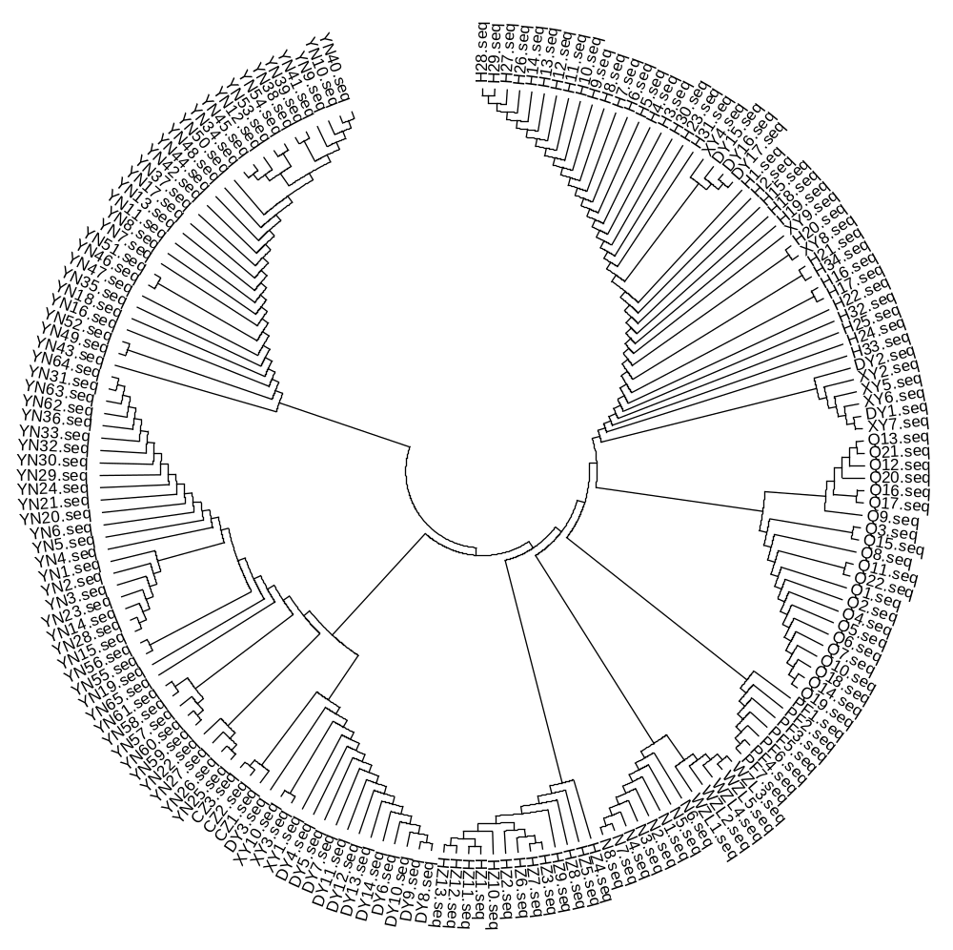
Figure 1. Phylogenetic tree of the Paris genus constructed based on ITS.

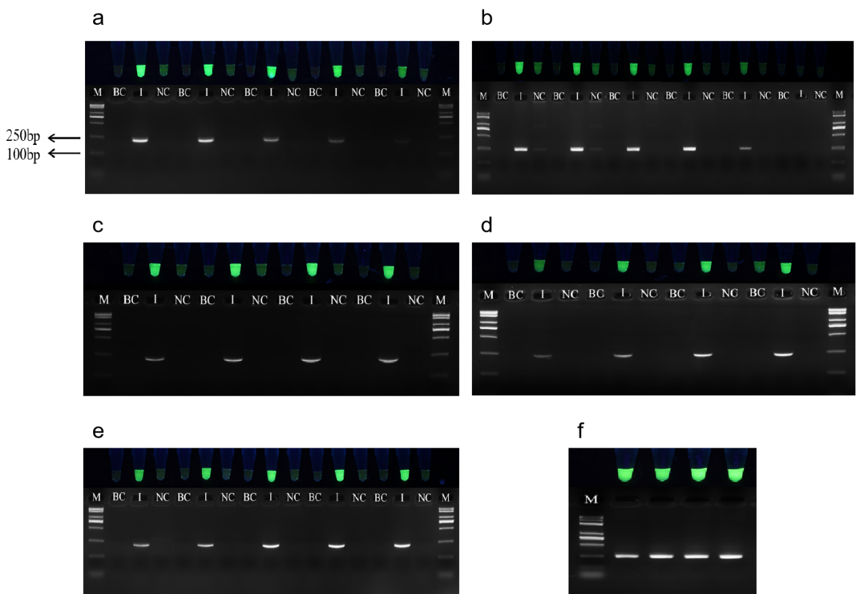
Figure 2. Optimization results of PCR reaction system of YN-I.
a.Investigate into primer concentration of specific PCR system of YN-I. M: Trans2K Plus DNA Marker. BC: blank control. I: PPY (YN-I). NC: P. polyphylla, the same as below in this chapter. In the figure, the specific primer pairs were 0.3μM, 0.25μM, 0.2μM, 0.15μM, and 0.1μM, respectively. b. Investigate into annealing temperature of specific PCR system of YN-I. The annealing temperatures were 58℃, 60.6℃, 62℃, 63.7℃, 66.2℃, and 68℃, respectively. c. Investigate into dNTP concentration of specific PCR system of YN-I. dNTP concentration was 80μM, 120μM, 200μM, and 280μM, respectively. d. Investigate into aq enzyme dosage of specific PCR system of YN-I. The Taq enzyme dosage was 1U, 1.5U, 2.5U, and 3.5U, respectively. e. Investigate into the number of cycles of specific PCR system of YN-I. The number of cycles was 26, 28, 30, 32, 34, respectively. f. Investigate into the template quantities of specific PCR system of YN-I. The template quantities were 10ng, 30ng, 60ng, and 90ng, respectively.
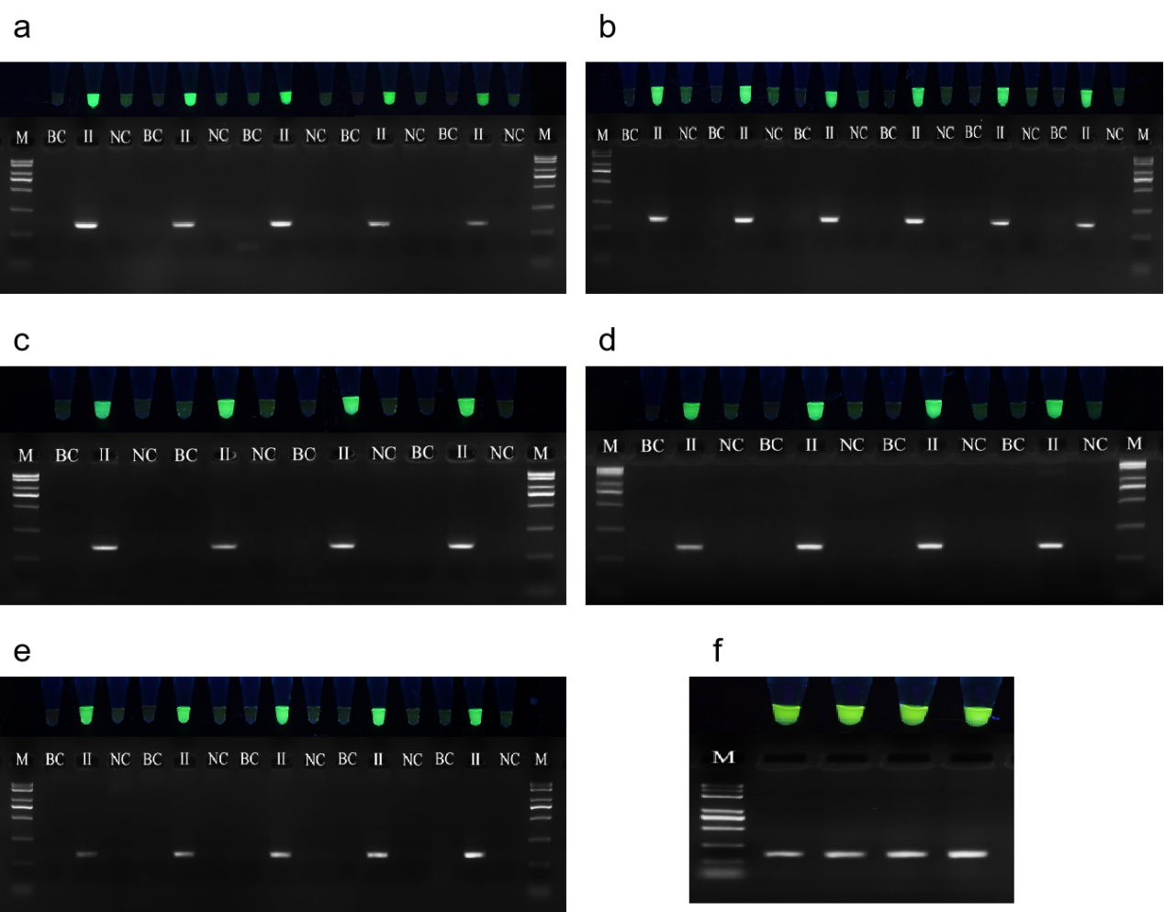
Figure 3. Optimization results of PCR reaction system of YN-II.
a.Investigate into primer concentration of specific PCR system of YN-II. The specific primer pairs were 0.3μM, 0.25μM, 0.2μM, 0.15μM, and 0.1μM, respectively. b.Investigate into annealing temperature of specific PCR system of YN-II. The annealing temperatures were 58℃, 60.6℃, 62℃, 63.7℃, 66.2℃, and 68℃, respectively. c. Investigate into dNTP concentration of specific PCR system of YN-II. dNTP concentration was 80μM, 120μM, 200μM, and 280μM, respectively. d. Investigate into aq enzyme dosage of specific PCR system of YN-II. The Taq enzyme dosage was 1U, 1.5U, 2.5U, and 3.5U, respectively. e. Investigate into the number of cycles of specific PCR system of YN-II. The number of cycles was 26, 28, 30, 32, 34, respectively. f. Investigate into the template quantities of specific PCR system of YN-II. The template quantities were 10 ng, 30 ng, 60 ng, and 90 ng, respectively.

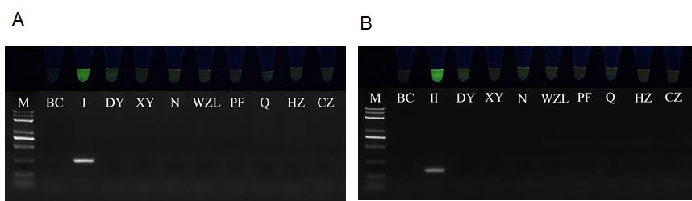
Figure 4. Fluorescent visualization identification of PPY with its common related species. (A) Specific identification of the YN-I system. (B) Specific identification of the YN-II system. M: Trans2K Plus DNA Marker. BC: blank control. I: PPY (YN-I). II: PPY (YN-II). DY: P. polyphylla. XY: P. stenophylla. N: P. vietnamensis. WZL: P. axialis. PF: P. vaniotii. Q:P. fargesii. HZ: P. thibetica. CZ:P. forrestii

Table 4. Information table of commercial medicinal materials of Paris
Sample number | Merchant-batch | Latin name | Locality
1 | KY-1 | P. polyphylla var. yunnanensis | Yun’nan
2 | KY-1 | P. polyphylla var. yunnanensis | Yun’nan
3 | KY-2 | P. polyphylla var. yunnanensis | Yun’nan
4 | DH-1 | P. polyphylla var. yunnanensis | Yun’nan
5 | DH-2 | Trillium camschatcense | Yun’nan
6 | DH-2 | Trillium camschatcense | Yun’nan
7 | DH-2 | Trillium camschatcense | Yun’nan
8 | FJ-1 | Paris forrestii | Yun’nan
9 | FJ-1 | Paris forrestii | Yun’nan
10 | FJ-1 | -- | Yun’nan
11 | FJ-2 | -- | Yun’nan
12 | FJ-2 | Trillium govanianum | Yun’nan
13 | FJ-2 | P. forrestii | Yun’nan
14 | JYK | Trillium govanianum | Yun’nan
15 | JYK | Trillium undulatum | Yun’nan
16 | JYK | Trillium govanianum | Yun’nan
17 | SST | Trillium camschatcense | Yun’nan
18 | SST | Trillium camschatcense | Yun’nan
19 | SST | Trillium camschatcense | Yun’nan
20 | YQJ | P. polyphylla var. yunnanensis | Sichuan
21 | YQJ | P. polyphylla var. yunnanensis | Sichuan
22 | YQJ | -- | Sichuan
23 | WJ | P. polyphylla | Sichuan
24 | WJ | P. polyphylla | Sichuan
25 | WJ | P. polyphylla | Sichuan

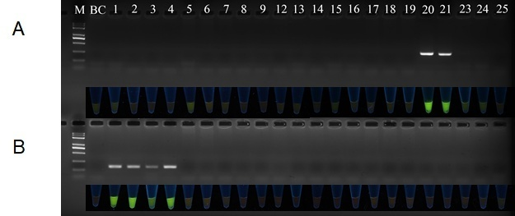
Figure 5. The specific identification of commercial medicinal materials of Paris. (A) The site-specific PCR system and fluorescence visual identification system of commercial medicinal materials of YN-I. (B) The site-specific PCR system and fluorescence visual identification system of commercial medicinal materials of YN-II.

