TABLE S1 Samples of Diaphorina citri psillids from China sequenced for mitogenome and endosymbiont de novo assembly
No. | Country | Province/ State | Region | Host plant | Sequencing method | Elevation(m) | Longitude(∘) | Latitude (∘) | References
A1 | China | Guangdong | Guangzhou (Tianhe) | Citrus reticulata | NGS | 25 | 113.3619 | 23.1246 | Wu et al.(2016)
A2 |  |  | Guangzhou (Conghua) | C. reticulata | NGS | 42 | 113.5864 | 23.5483 | This study
A3 |  |  | Foshan | Murraya paniculata | NGS | 7 | 113.1219 | 23.0218 | This study
A4 |  |  | Huizhou (Huicheng) | C. reticulata | cPCR | 21 | 114.4167 | 23.1107 | Wu et al.(2018)
A5 |  |  | Huizhou(Boluo) | C. reticulata | NGS | 23 | 114.4568 | 23.4896 | This study
A6 |  |  | Jieyang(Rongcheng) | M. paniculata | cPCR | 3 | 116.3726 | 23.5497 | Wu et al.(2018)
A7 |  |  | Jieyang(Jiedong) | M. paniculata | NGS | 12 | 116.4015 | 23.5753 | This study
A8 |  |  | Chaozhou(Chaoan) | M. paniculata | cPCR | 5 | 116.6304 | 23.4554 | Wu et al.(2018)
A9 |  |  | Chaozhou(Xiangqiao) | M. paniculata | NGS | 12 | 116.6229 | 23.6566 | This study
A10 |  |  | Shantou(Nan'ao) | M. paniculata | NGS | 125 | 117.0234 | 23.4218 | This study
A11 |  |  | Shaoguan(Zhenjiang) | C. reticulata | cPCR | 57 | 113.6075 | 24.8139 | Wu et al.(2018)
A12 |  |  | Shaoguan(Renhua) | C. reticulata | NGS | 147 | 113.7622 | 25.0433 | This study
A13 |  |  | Yunfu | M. paniculata | NGS | 44 | 112.2303 | 22.9199 | This study
A14 |  |  | Yunan | M. paniculata | NGS | 173 | 111.5352 | 23.2346 | This study
A15 |  |  | Meizhou(Meixian) | C. maxima | NGS | 131 | 116.1219 | 24.2888 | This study
A16 |  |  | Meizhou(Fengshun) | M. paniculata | NGS | 273 | 116.1822 | 23.7394 | This study
A17 |  |  | Heyuan | M. paniculata | NGS | 165 | 114.7006 | 23.7436 | This study
A18 |  |  | Jiangmen(Xinhui) | C. sinensis | NGS | 1 | 113.0322 | 22.4587 | This study
A19 |  |  | Zhaoqing | C. medica | NGS | 22 | 112.4652 | 23.0469 | This study
A20 |  |  | Qingyuan | C. reticulata | NGS | 238 | 113.0561 | 23.6820 | This study
A21 |  |  | Maoming | C. maxima | NGS | 23 | 111.6395 | 21.06639 | This study
A22 |  |  | Yangjiang(Yangchunmashui) | C. reticulata | cPCR | 8 | 111.6389 | 22.1199 | Wu et al.(2018)
A23 |  |  | Zhanjiang(Lianjiang) | C. × aurantium ‘sweet orange’ | NGS | 43 | 110.2862 | 21.6096 | This study
A24 |  | Jiangxi | Fuzhou(Nanfeng) | M. paniculata | NGS | 122 | 116.5070 | 27.1279 | This study
A25 |  |  | Pingxiang | C. sinensis | NGS | 251 | 113.8438 | 27.04879 | This study
A26 |  |  | Ganzhou(Xinfeng) | C. sinensis | NGS | 234 | 114.9289 | 25.28750 | This study
A27 |  |  | Guangchang | C. reticulata | cPCR | 128 | 116.3258 | 26.8373 | Wu et al.(2018)
A28 |  |  | Ji’an | C. reticulata | cPCR | 100 | 114.2437 | 26.9651 | Wu et al.(2018)

TABLE S1 Continued from previous page
A29 |  | Guangxi | Guilin | C. reticulata | NGS | 225 | 110.3284 | 25.2746 | This study
A30 |  |  | Qinzhou | C. reticulata | NGS | 50 | 109.5314 | 22.2514 | This study
A31 |  |  | Wuzhou | C. reticulata | NGS | 138 | 111.1376 | 23.0595 | This study
A32 |  |  | Nanning | C. reticulata | cPCR | 79 | 108.2874 | 22.7957 | Wu et al.(2018)
A33 |  |  | Yulin | C. reticulata | cPCR | 85 | 110.1818 | 22.6371 | Wu et al.(2018)
A34 |  | Fujian | Quanzhou | M. paniculata | NGS | 522 | 114.2437 | 26.9651 | This study
A35 |  |  | Fuzhou | M. paniculata | cPCR | 43 | 119.2397 | 26.0849 | Wu et al.(2018)
A36 |  |  | Xiamen | M. paniculata | cPCR | 2 | 118.0894 | 24.4795 | Wu et al.(2018)
A37 |  | Hainan | Chengmai | C. × aurantium ‘sweet orange’ | NGS | 65 | 110.0048 | 19.738 | This study
A38 |  |  | Haikou | C. × aurantium ‘sweet orange’ | cPCR | 15 | 110.1973 | 19.5703 | Wu et al.(2018)
A39 |  | Taiwan | Nantou | M. paniculata | NGS | 545 | 120.6700 | 23.9196 | This study
A40 |  |  | Xinzhu | M. paniculata | cPCR | 29 | 120.9922 | 24.8086 | Wu et al.(2018)
A41 |  | Hunan | Yongxing | C. × aurantium ‘sweet orange’ | NGS | 172 | 100.6203 | 36.2866 | This study
A42 |  |  | Yizhang | C. × aurantium ‘sweet orange’ | cPCR | 171 | 112.9488 | 25.3937 | Wu et al.(2018)
A43 |  | Zhejiang | Wenzhou | C. reticulata | NGS | 26 | 120.5692 | 28.0256 | This study
A44 |  |  | Taizhou | C. reticulata | cPCR | 14 | 121.5186 | 28.7692 | Wu et al.(2018)
A45 |  | Yunnan | Mangshi | C. limon | NGS | 976 | 98.3331 | 24.2018 | This study
A46 |  |  | Ruili | M. paniculata | cPCR | 1253 | 97.8543 | 24.0116 | Wu et al.(2018)
A47 |  |  | Baoshan | M. paniculata | cPCR | 1619 | 98.8773 | 24.9241 | Wu et al.(2018)
A48 |  |  | Binchuan | C. reticulata | cPCR | 1455 | 100.5837 | 25.8234 | Wu et al.(2018)
A49 |  |  | Jianshui | C. × aurantium ‘sweet orange’ | cPCR | 1293 | 111.5212 | 23.2385 | Wu et al.(2018)
A50 |  | Guizhou | Ceheng | C. × aurantium ‘sweet orange’ | NGS | 1002 | 105.8117 | 24.9836 | This study
A51 |  |  | Wangmo | C. × aurantium ‘sweet orange’ | cPCR | 1033 | 106.0274 | 25.2044 | Wu et al.(2018)
A52 |  | Sichuan | Leibo | C. reticulata | NGS | 1174 | 103.5645 | 28.2657 | This study
A53 |  |  | Miyi | C. reticulata | cPCR | 1099 | 102.1654 | 27.0102 | Wu et al.(2018)
A54 |  |  | Ningnan | C. × aurantium ‘sweet orange’ | cPCR | 1191 | 102.7574 | 27.0573 | Wu et al.(2018)
A55 | America | California | San Gabriel | C. japonica | NGS | – – | – – | – – | Wu et al.(2018)
A56 |  | Florida | Immokalee | C. × aurantium ‘sweet orange’ | NGS | – – | – – | – – | Wu et al.(2018)

TABLE S2 Mitochondrial and endosymbiont genome information of 34 samples of Diaphorina citri psillids from China sequenced by Next Generation Sequencing (NGS)
No. | Country | Province/ State | Region | Size(bp) and coverage(x) of each genome |  |  |  | Notes
 |  |  |  | Mitogenome | CaCr | CaPa | CaPa plasmid | Notes
B1 | China | Guangdong | Guangzhou (Tianhe) | 14,996; 4,001  (Wu et al., 2016) | 174,018; 65.05 | 457,569; 474.75  (Wu et al., 2015) | 5,458; 1,988.47  (Wu et al., 2015) | References
B2 |  |  | Guangzhou (Conghua) | 14,978; 97,058.36 | 174,018; 85.64 | 457,571; 207 | 5,460; 1,323.23 | Detection
B3 |  |  | Foshan | 14,992; 3,984.56 | 174,020; 181.81 | 457,568; 1,468.34 | 5,458; 726.52 | Detection
B4 |  |  | Huizhou (Huicheng) | 14,995; 419.32 | 174,020; 32.34 | 457,569; 595.97 | 5,458; 1,314.73 | Detection
B5 |  |  | Jieyang(Jiedong) | 14,995; 6,103.18 | 174,018; 135.99 | 457,563; 108.76 | 5,459; 349.53 | Detection
B6 |  |  | Chaozhou(Xiangqiao) | 14,999; 3,984.14 | 174,021; 68.59 | 457,573; 141.20 | 5,458; 161.30 | Detection
B7 |  |  | Shantou(Nanao) | 14,979; 67,253.18 | 174,013; 49.97 | 457,568; 43.81 | 5,458; 534.70 | Detection
B8 |  |  | Shaoguan | 14,994; 5,336.23 | 174,021; 496.67 | 457,574; 12.11 | 5,458; 22.13 | Detection
B9 |  |  | Yunfu | 14,999; 263.45 | 174,019; 32.68 | 457,570; 39.06 | 5,458; 56.96 | Detection
B10 |  |  | Yunan | 14,989; 668.72 | 174,020; 68.12 | 457,570; 16.83 | 5,459; 34.39 | Detection
B11 |  |  | Meizhou(Meixian) | 14,996; 2,961.91 | 174,018; 71.25 | 457,572; 137.26 | 5,458; 147.44 | Detection
B12 |  |  | Meizhou(Fengshun) | 14,979; 25,647.03 | 174,024; 696.50 | 457,564; 211.43 | 5,460; 668.33 | Detection
B13 |  |  | Heyuan | 14,993; 5,484.48 | 174,020; 275.03 | 457,570; 96.57 | 5,458; 130.17 | Detection
B14 |  |  | Jiangmen(Xinhui) | 14,985; 395.30 | 174,020; 3,889.82 | 457,574; 345.12 | 5,458; 433.91 | Detection
B15 |  |  | Zhaoqing | 14,979; 77,811.00 | 174,019; 28.40 | 457,572; 43.02 | 5,458; 293.93 | Detection
B16 |  |  | Qingyuan | 14,940; 455.88 | 174,023; 1.61 | 457,568; 1.88 | 5,458; 14.19 | Detection
B17 |  |  | Maoming | 14,984; 2,921.81 | 174,021; 2,366.60 | 457,571; 463.17 | 5,458; 1,644.02 | Detection
B18 |  |  | Zhanjiang | 14,990; 1,201.62 | 174,022; 19.65 | 457,571; 195.56 | 5,458; 326.52 | Detection
B19 |  | Jiangxi | Fuzhou(Nanfeng) | 14,995; 2,214.02 | 174,027; 1.32 | 457,570; 10.67 | 5,458; 51.14 | Detection
B20 |  |  | Pingxiang | 14,978; 2,550.25 | 174,016; 11.58 | 457,572; 39.91 | 5,458; 76.08 | Detection
B21 |  |  | Ganzhou(Xinfeng) | 14,979; 2,608.17 | 174,022; 441.92 | 457,574; 25.46 | 5,458; 166.03 | Detection
B22 |  | Guangxi | Guilin | 14,978; 3990.79 | 174,017; 4.13 | 457,574; 5.95 | 5,458; 9.83 | Detection
B23 |  |  | Qinzhou | 14,796; 7,153.58 | 174,018; 41.30 | 457,568; 75.21 | 5,458; 474.31 | Detection
B24 |  |  | Wuzhou | 14,993; 3,908.70 | 174,016; 434.19 | 457,568; 983.61 | 5,458; 4,867.09 | Detection
B25 |  | Fujian | Quanzhou | 14,993; 2,548.41 | 174,019; 53.71 | 457,567; 132.37 | 5,457; 183.60 | Detection
B26 |  | Hainan | Chengmai | 14,980; 2,302.39 | 174,020; 186.28 | 457,569; 73.80 | 5,458; 261.02 | Detection
B27 |  | Taiwan | Nantou | 14,978; 1,004.26 | 174,021; 29.33 | 457,570; 74.57 | 5,459; 2,408.05 | Detection
B28 |  | Hunan | Yongxing | 14,979; 2,513.92 | 174,021; 9.55 | 457,571; 304.05 | 5,458; 1,305.53 | Detection
B29 |  | Zhejiang | Wenzhou | 14,978; 56.13 | 174,025; 7.84 | 457,571; 8.34 | 5,459; 104.22 | Detection
B30 |  | Yunnan | Mangshi | 14,994; 2.128.42 | 174,022; 2.19 | 457,574; 107.22 | 5,462; 413.47 | Detection
B31 |  | Guizhou | Ceheng | 14,978; 6,620.06 | 174,022; 2.77 | 457,569; 4.48 | 5,458; 19.42 | Detection
B32 |  | Sichuan | Leibo | 14,980; 6,619.22 | 174,021; 17.95 | 457,569; 52.98 | 5,459; 748.43 | Detection
B33 | America | California | San Gabriel | 14,994; 760.08  (Wu et al., 2017) | 174,022; 58.71 | 457,569; 224.19 | 5,458; 298.31 | Outgroups
B34 |  | Florida | Immokalee | 14,996; 1,985.18  (Wu et al., 2017) | 174,025; 1.52 | 457,579; 19.60 | 5,459; 42.55 | Outgroups
Range |  |  |  | 14,940~14,999; 56.13~97,058.36 | 174,013~174,025; 1.32~3,889.82 | 457,563~457,579; 1.88~1,468.34 | 5,457~5,462; 9.83~4,867.09
Note: CaCr-“Candidatus Carsonella ruddii”, CaPa-“Ca. Profftella armature”. The citation in parentheses in the table represents a genome that was published in relevant literature, while the remaining entries are newly added samples.
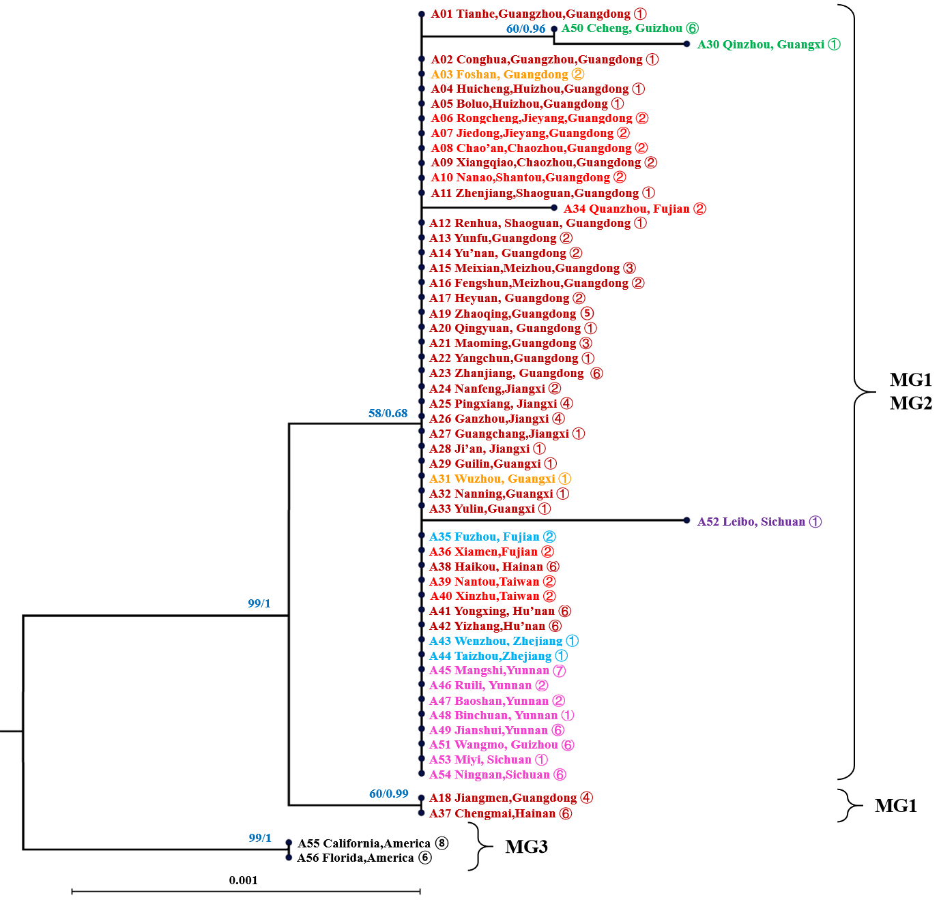
Fig. S1 Phylogenetic analyses of Diaphorina citri mitogenome sequences based on cox1 gene. Numbers at the nodes are bootstrap values from maximum likelihood /posterior probabilities from Bayesian inference analysis. Accessions from China are presented in red. Samples were identified by Mitochondrial Group (MG) subgroups matching Figure 3: MG1-1: deep red. MG1-2: blue, MG1-3: orange, MG1-4: green, MG1-5: light red, MG2-1: purple, MG2-2: magenta, MG3: black. Host plants symbols: ①Citrus reticulata, ②Murraya paniculata, ③C. maxima, ④C. sinensis, ⑤C. medica, ⑥C. × aurantium ‘sweet orange’, ⑦C. limon, ⑧C. japonica

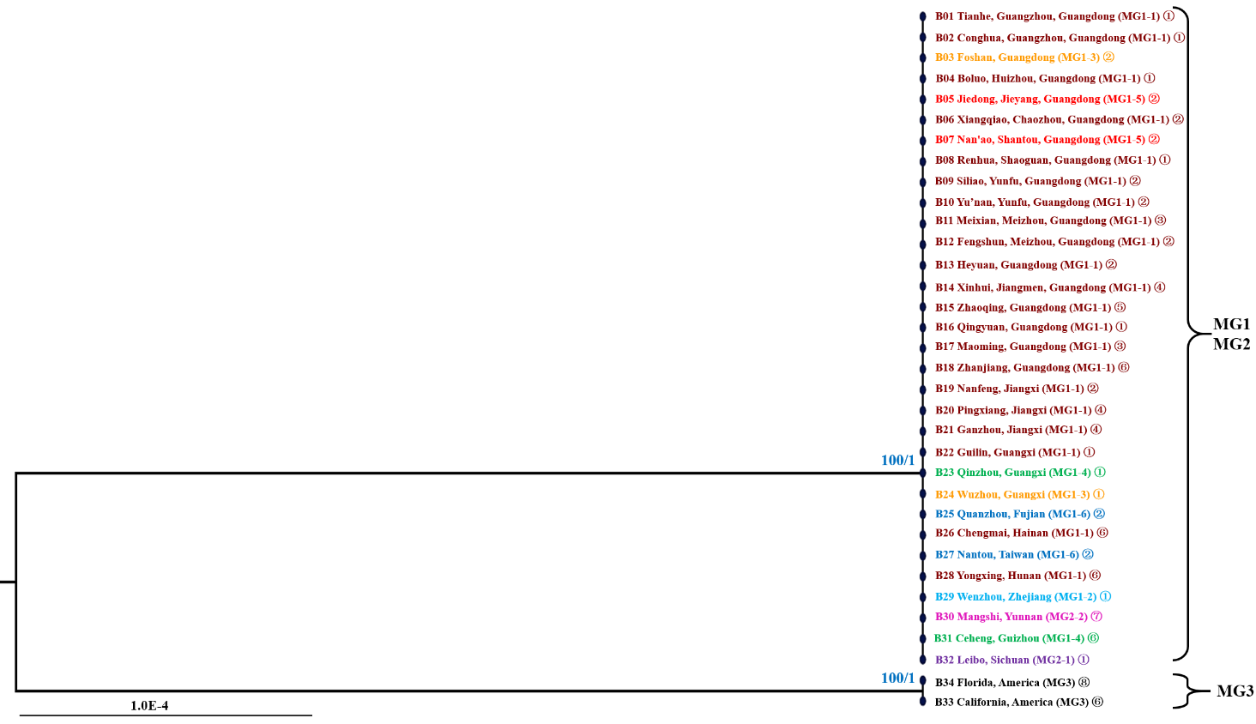
Fig. S2 Phylogenetic analyses of Diaphorina citri “Candidatus Carsonella ruddii” sequences based on the 16SrDNA gene. Numbers at the nodes are bootstrap values from maximum likelihood/ posterior probabilities from Bayesian inference analysis. Samples were identified by Mitochondrial Group (MG) subgroups matching Figure 3: MG1-1: deep red. MG1-2: blue, MG1-3: orange, MG1-4: green, MG1-5: light red, MG2-1: purple, MG2-2: magenta, MG3: black. Host plants symbols: ①Citrus reticulata, ②Murraya paniculata, ③C. maxima, ④C. sinensis, ⑤C. medica, ⑥C. × aurantium ‘sweet orange’ , ⑦C. limon, ⑧C. japonica
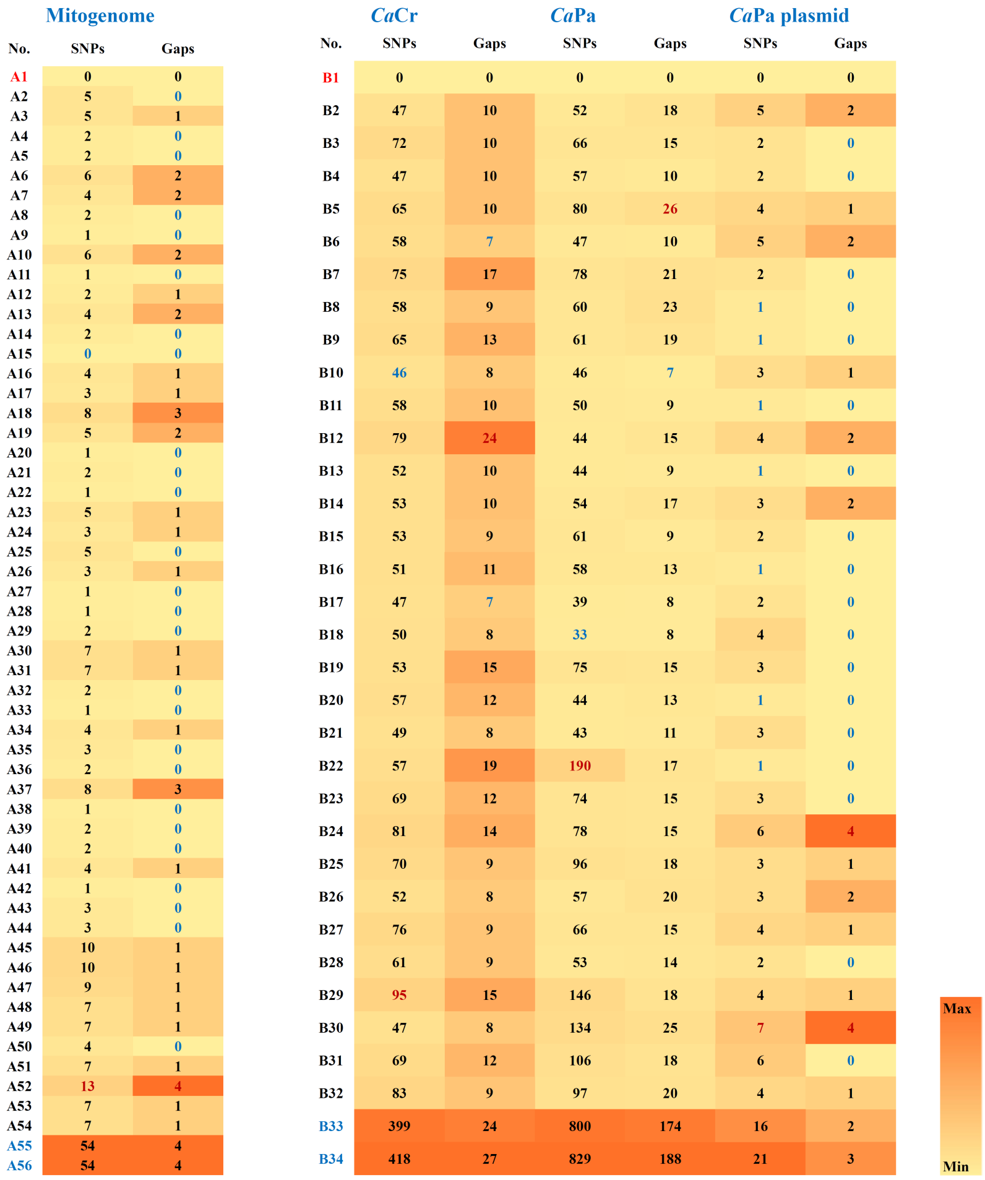
Fig. S3 Heatmap table of numbers of single nucleotide polymorphisms (SNPs) and gaps among the sampled genomes from China belonging to (i) Diaphorina citri mitogenome, (ii) “Candidatus Carsonella ruddii” (CaCr) , (iii) “Ca. Profftella armature” (CaPa) and (iv) CaPa associated plasmids. The numbers were established based on respective reference sequences from NCBI: (i) NC_030214, (ii) CP012411, (iii) CP012591, and (iv) CP012592. Numbers in red indicate values for the samples used as reference, numbers in blue indicate samples from outside of China (used as outgroups in phylogenies of Figs. 5 & 6). Samples details are given in Table S1 and Table S2

