Supplementary material
Observed plants at each sampling site.
Site No. | Photograph of sampling plot | Observed plant type (amount of each plant) | Observed plant percent cover （Braun-Blanquet method）
A1 | 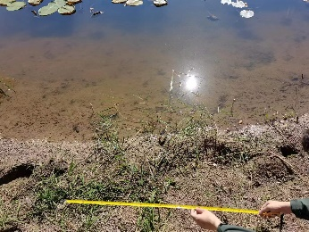 | Alternanthera philoxeroides (14)  Cynodon dactylon (56)  Paspalum dilatatum (18)  Plantago major (2)  Echinochloa crusgalli (9) | 1  4  3  R  1
A2 | 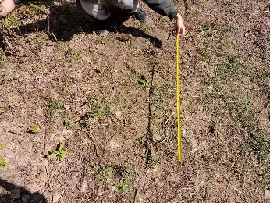 | Erigeron canadensis (8)  Duchesnea indica (29)  Camphora officinarum (2)  Stellaria media (12)  Alternanthera philoxeroides (65)  Cynodon dactylon (16)  Plantago major (14)  Rosa laevigata (4) | 1  2  R  1  4  2  1  R
A3 | 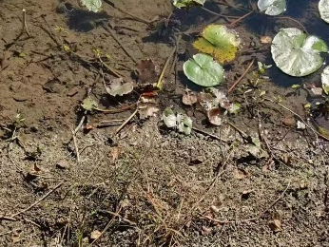 | Alternanthera philoxeroides(30)  Paspalum dilatatum (27)  Nymphaea (10)  Cynodon dactylon (13) | 2  2  3  1
A4 | 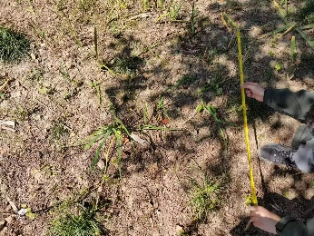 | Fatoua villosa (27)  Iris tectorum (8)  Echinochloa crusgalli (6)  Causonis japonica (16) | 2  1  1  1
A5 | 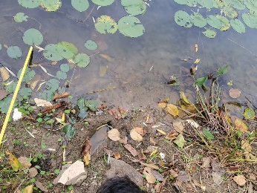 | Hydrocotyle verticillate (82)  Nymphaea (13)  Pontederia cordata (7)  Ophiopogon japonicus (3)  Duchesnea indica (16)  Narcissus tazetta (1)  Ludwigia peploides (16) | 4  3  1  R  1  R  1
A6 | 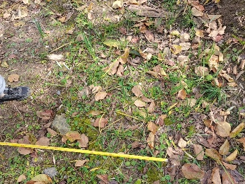 | Hydrocotyle verticillate (103)  Tulbaghia violacea(28)  Duchesnea indica (47)  Lygodium japonicum (5)  Phyllanthus urinaria (2) | 5  4  4  1  R
B1 | 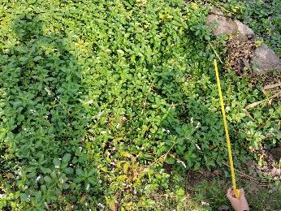 | Eichhornia crassipes (237)  Ludwigia peploides (352)  Persicaria maculosa (36)  Rumex acetosa (3)  Ludwigia palustris (82)  Cyperus rotundus (8) | 4  5  2  1  2  1
B2 | 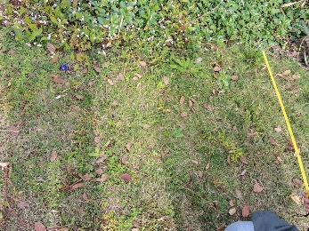 | Persicaria maculosa (24)  Cyperus rotundus (17)  Rumex acetosa (3)  Commelina diffusa (11)  Alternanthera philoxeroides (76)  Ludwigia adscendens (29)  Ludwigia peploides (13) | 2  2  1  1  3  3  1
B3 | 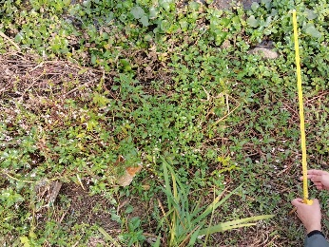 | Ludwigia peploides (273)  Eichhornia crassipes (178)  Persicaria maculosa (27)  Alternanthera philoxeroides (23)  Acorus calamus (4) | 5  4  2  1  1
B4 | 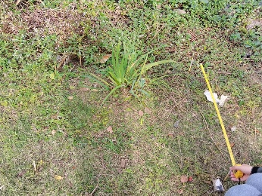 | Acorus calamus (11)  Duchesnea indica (36)  Commelina diffusa (32)  Alternanthera philoxeroides (44) | 1  3  2  3
B5 | 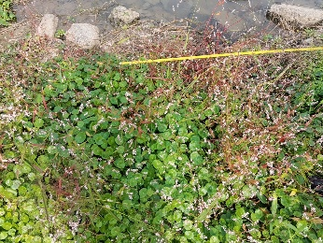 | Persicaria maculosa (114)  Hydrocotyle verticillate (438)  Thalia dealbata Fraser (26)  Acorus calamus (31)  Ludwigia peploides (57)  Pterocarya stenoptera (1) | 5  5  2  2  3  R
B6 | 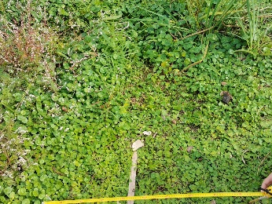 | Hydrocotyle verticillate (594)  Acorus calamus (6)  Persicaria maculosa (14)  Duchesnea indica (42)  Rumex acetosa (6) | 5  1  1  2  1
C1 | 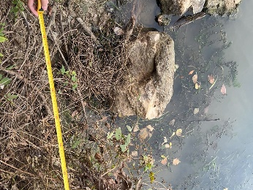 | Rumex obtusifolius (2)  Causonis japonica (15)  Humulus scandens (54)  Glycine soja Siebold (7)  Solidago decurrens (3)  Persicaria maculosa (14) | R  2  3  1  R  2
C2 | 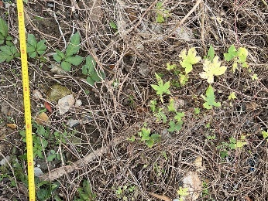 | Causonis japonica (32)  Humulus scandens (48)  Nerium oleander (3) | 3  4  R
C3 | 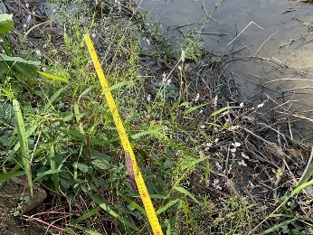 | Ludwigia peploides (30)  Rumex acetosa (35)  Eichhornia crassipes (8)  Causonis japonica (13) | 3  4  1  2
C4 | 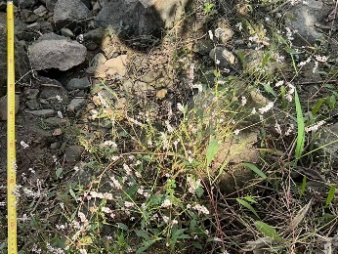 | Rumex acetosa (41)  Ludwigia peploides (22)  Humulus scandens (14) | 5  2  1
C5 | 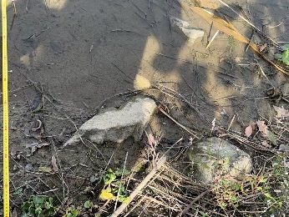 | Persicaria longiseta (10)  Rumex acetosa (42)  Ludwigia peploides (32)  Eichhornia crassipes (27) | 1  4  3  2
C6 | 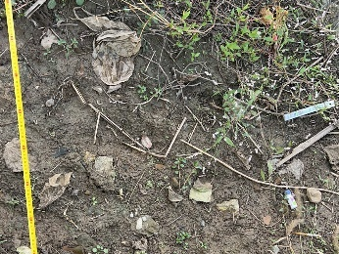 | Alternanthera philoxeroides (21)  Rumex acetosa (15)  Setaria viridis (2)  Capsella bursapastoris (7) | 3  2  R  1
D1 | 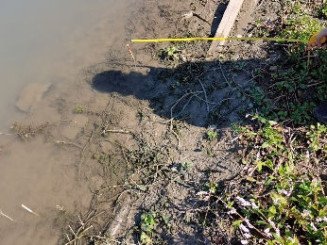 | Rumex acetosa (31)  Ludwigia peploides (84)  Eichhornia crassipes (12)  Alternanthera philoxeroides (19) | 3  4  2  2
D2 | 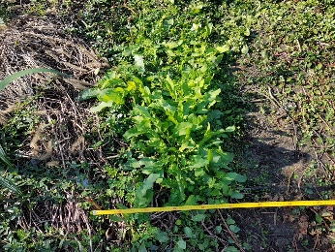 | Ludwigia peploides 223)  Duchesnea indica (43)  Rumex acetosa (15)  Daucus carota (57)  Bidens frondosa (2)  Rumex acetosa (8)  Alternanthera philoxeroides (26)  Setaria viridis. (8) | 4  3  3  3  R  1  2  1
D3 | 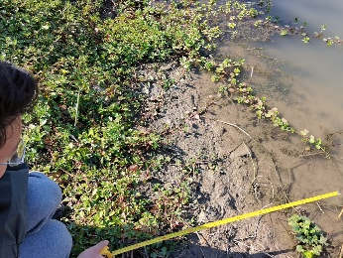 | Eichhornia crassipes (14)  Ludwigia peploides (83)  Daucus carota (16) | 1  3  1
D4 | 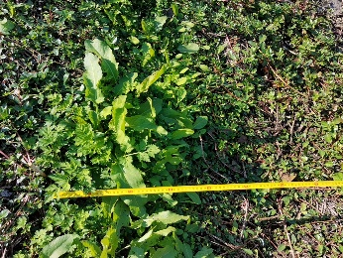 | Rumex acetosa (38)  Daucus carota (49)  Ludwigia peploides (174)  Alternanthera philoxeroides (83)  Artemisia selengensis (1) | 3  3  4  3  R
D5 | 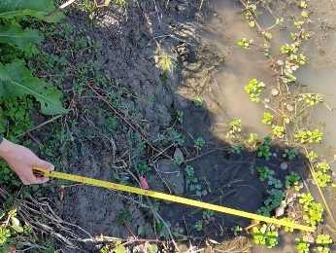 | Ludwigia peploides (26)  Alternanthera philoxeroides (39)  Eichhornia crassipes (15) | 2  3  1
D6 | 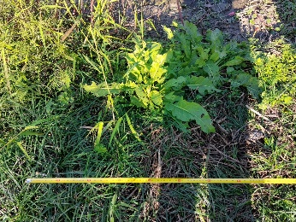 | Panicum bisulcatum (29)  Rumex acetosa (5)  Daucus carota (26)  Alternanthera philoxeroides (35)  Ophiopogon japonicus (25) | 2  4  2  2  5
E1 | 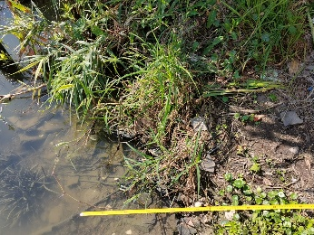 | Hydrocotyle verticillate (46)  Echinochloa crus-galli (11)  Ludwigia peploides (29) | 2  2  1
E2 | 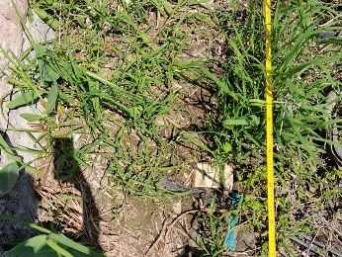 | Echinochloa crus-galli (66)  Ludwigia peploides (28)  Thalia dealbata Fraser (5)  Persicaria amphibia (24) | 5  2  2  2
E3 | 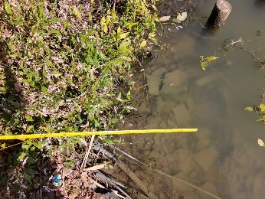 | Persicaria maculosa (24)  Ludwigia peploides (16)  Alternanthera philoxeroides (11) | 5  2  1
E4 | 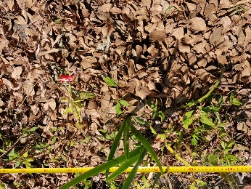 | Persicaria maculosa (32)  Thalia dealbata (3)  Hydrocotyle verticillate (6)  Ludwigia peploides (17) | 2  R  1  1
E5 | 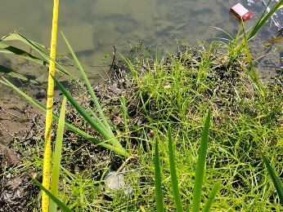 | Eichhornia crassipes (6)  Persicaria maculosa (23)  Hydrocotyle verticillate (46)  Phragmites australis (14)  Ludwigia peploides (27)  Cyperus rotundus (153) | R  1  2  3  2  5
E6 | 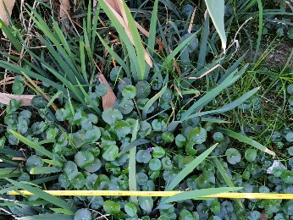 | Hydrocotyle verticillate (92)  Rumex crispus (1)  Thalia dealbata (15)  Persicaria maculosa (12)  Cyperus rotundus (17)  Alternanthera philoxeroides (13)  Ludwigia peploides (25) | 5  2  4  1  2  1  3
F1 | 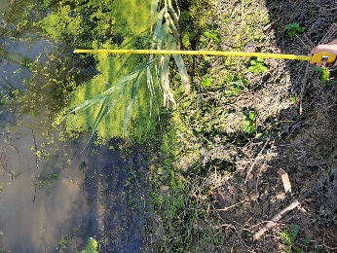 | Lemna minor (1000)  Petersianthus macrocarpus (18)  Arundo donax (1)  Ludwigia peploides (1) | 5  1  R  R
F2 | 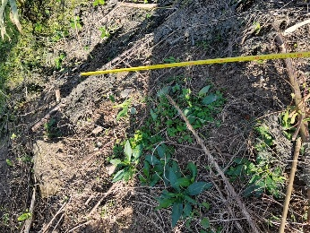 | Solidago decurrens (16)  Oenanthe javanica (28)  Lactuca indica (3) | 2  2  R
F3 | 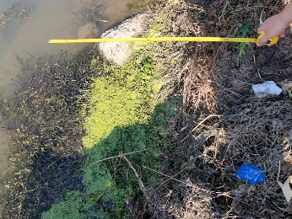 | Lemna minor (1000)  Eichhornia crassipes (7)  Taraxacum mongolicum (3)  Lactuca indica (1) | 5  1  R  R
F4 | 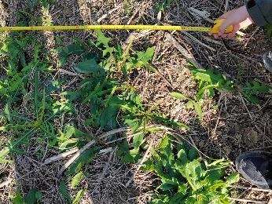 | Lactuca indica (17)  Rumex crispus (4)  Zornia gibbose (20) | 5  1  2
F5 | 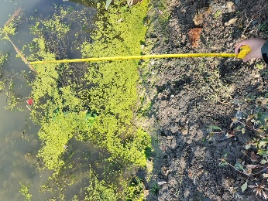 | Lemna minor (1000)  Taraxacum mongolicum (4)  Bidens frondose (3)  Eichhornia crassipes (3) | 4  1  1  1
F6 | 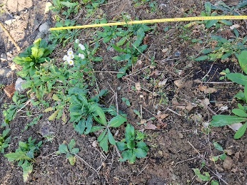 | Sonchus wightianus (38)  Erigeron philadelphicus (9)  Rumex acetosa (4)  Leguminosae (11) | 5  1  1  1
G1 | 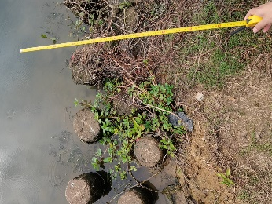 | Ludwigia peploides (26)  Persicaria maculosa (12)  Digitaria sanguinalis (7)  Pistia stratiotes (13) | 3  1  1  1
G2 | 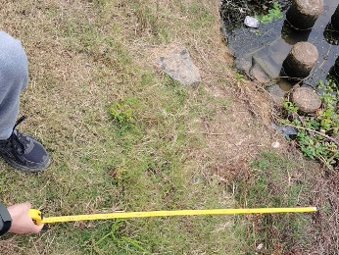 | Persicaria maculosa (19)  Symphyotrichum subulatum (33)  Euphorbia humifusa (9)  Echinochloa crusgalli (5)  Digitaria sanguinalis (6) | 2  3  1  1  1
G3 | 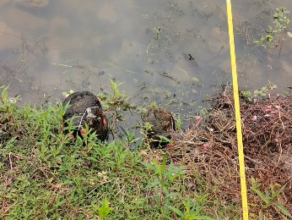 | Ludwigia peploides (75)  Persicaria maculosa (42)  Lemna minor (12)  Digitaria sanguinalis (4)  Alternanthera sessilis (24) | 4  3  1  1  2
G4 | 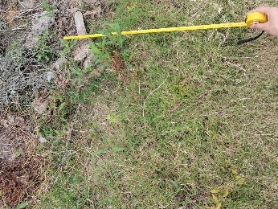 | Persicaria maculosa (29)  Symphyotrichum subulatum (4)  Rumex acetosa (4)  Ludwigia peploides (24) | 2  1  1  1
G5 | 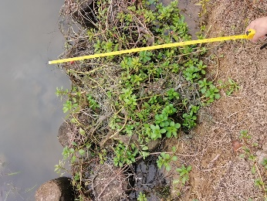 | Ludwigia peploides (58)  Lemna minor (42)  Persicaria maculosa (8) | 5  1  1
G6 | 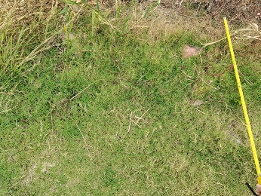 | Arundo donax (21)  Symphyotrichum subulatum (24)  Persicaria maculosa (9)  Rumex acetosa (3) | 4  2  1
H1 | 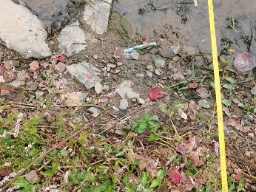 | Persicaria maculosa (43)  Ludwigia peploides (32)  Taraxacum mongolicum (4) | 4  3  1
H2 | 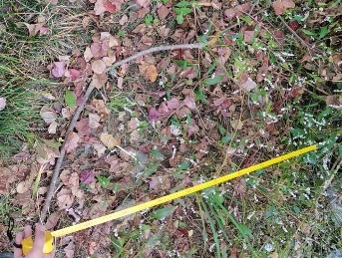 | Persicaria maculosa (52)  Thalia dealbata (7)  Ophiopogon japonicus (12)  Rumex acetosa (6)  Lactuca indica (5) | 5  1  2  2  1
H3 | 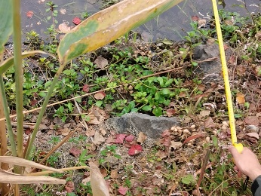 | Persicaria maculosa (21)  Eichhornia crassipes (24)  Ludwigia peploides (53)  Rumex crispus (5) | 2  2  4  1
H4 | 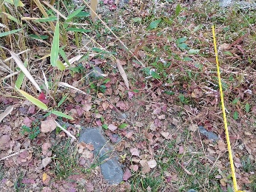 | Persicaria maculosa (53)  Ludwigia peploides (27)  Arundo donax (4)  Ophiopogon japonicus (3)  Rumex acetosa (3) | 5  2  1  1  1
H5 | 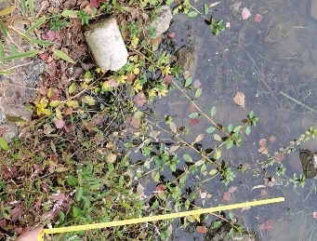 | Persicaria maculosa (43)  Ludwigia peploides (54)  Arundo donax (13) | 3  4  2
H6 | 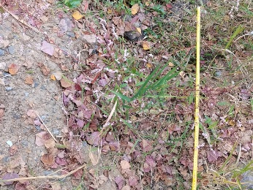 | Taraxacum mongolicum (17)  Arundo donax (22)  Persicaria maculosa (18)  Ludwigia peploides (18) | 3  4  2  1

