Part 1: Detailed search query

- Pubmed database:
Search,Query,Items found,Time
#16,"Search (English[Language]) AND ((((((((((stereotactic body radiotherapy[MeSH Terms]) OR stereotactic body radiotherap*[Title/Abstract]) OR stereotactic ablative radiotherap*[Title/Abstract]) OR Cyber*Knife[Title/Abstract]) OR Gamma*Knife[Title/Abstract]) OR SBRT[Title/Abstract]) OR SABR[Title/Abstract])) AND ((((((adenoma, hepatocellular[MeSH Terms]) OR Hepatocellular Carcinoma*[Title/Abstract]) OR hepatic malignan*[Title/Abstract]) OR liver cancer*[Title/Abstract]) OR hepatic neoplasm*[Title/Abstract]) OR liver neoplasm*[Title/Abstract])) AND ( ""2000/01/01""[PDat] : ""2020/05/01""[PDat] ) AND Humans[Mesh]) Filters: Publication date from 2000/01/01 to 2020/05/01; Humans",346,23:23:46
#15,"Search ((((((((stereotactic body radiotherapy[MeSH Terms]) OR stereotactic body radiotherap*[Title/Abstract]) OR stereotactic ablative radiotherap*[Title/Abstract]) OR Cyber*Knife[Title/Abstract]) OR Gamma*Knife[Title/Abstract]) OR SBRT[Title/Abstract]) OR SABR[Title/Abstract])) AND ((((((adenoma, hepatocellular[MeSH Terms]) OR Hepatocellular Carcinoma*[Title/Abstract]) OR hepatic malignan*[Title/Abstract]) OR liver cancer*[Title/Abstract]) OR hepatic neoplasm*[Title/Abstract]) OR liver neoplasm*[Title/Abstract]) Filters: Publication date from 2000/01/01 to 2020/05/01; Humans",373,23:22:40
#14,"Search ((((((((stereotactic body radiotherapy[MeSH Terms]) OR stereotactic body radiotherap*[Title/Abstract]) OR stereotactic ablative radiotherap*[Title/Abstract]) OR Cyber*Knife[Title/Abstract]) OR Gamma*Knife[Title/Abstract]) OR SBRT[Title/Abstract]) OR SABR[Title/Abstract])) AND ((((((adenoma, hepatocellular[MeSH Terms]) OR Hepatocellular Carcinoma*[Title/Abstract]) OR hepatic malignan*[Title/Abstract]) OR liver cancer*[Title/Abstract]) OR hepatic neoplasm*[Title/Abstract]) OR liver neoplasm*[Title/Abstract]) Filters: Publication date from 2000/01/01 to 2020/12/31; Humans",373,23:22:23
#13,"Search ((((((((stereotactic body radiotherapy[MeSH Terms]) OR stereotactic body radiotherap*[Title/Abstract]) OR stereotactic ablative radiotherap*[Title/Abstract]) OR Cyber*Knife[Title/Abstract]) OR Gamma*Knife[Title/Abstract]) OR SBRT[Title/Abstract]) OR SABR[Title/Abstract])) AND ((((((adenoma, hepatocellular[MeSH Terms]) OR Hepatocellular Carcinoma*[Title/Abstract]) OR hepatic malignan*[Title/Abstract]) OR liver cancer*[Title/Abstract]) OR hepatic neoplasm*[Title/Abstract]) OR liver neoplasm*[Title/Abstract]) Filters: Humans",375,23:21:53
#12,"Search ((((((((stereotactic body radiotherapy[MeSH Terms]) OR stereotactic body radiotherap*[Title/Abstract]) OR stereotactic ablative radiotherap*[Title/Abstract]) OR Cyber*Knife[Title/Abstract]) OR Gamma*Knife[Title/Abstract]) OR SBRT[Title/Abstract]) OR SABR[Title/Abstract])) AND ((((((adenoma, hepatocellular[MeSH Terms]) OR Hepatocellular Carcinoma*[Title/Abstract]) OR hepatic malignan*[Title/Abstract]) OR liver cancer*[Title/Abstract]) OR hepatic neoplasm*[Title/Abstract]) OR liver neoplasm*[Title/Abstract])",520,23:18:56
#11,"Search ((((((stereotactic body radiotherapy[MeSH Terms]) OR stereotactic body radiotherap*[Title/Abstract]) OR stereotactic ablative radiotherap*[Title/Abstract]) OR Cyber*Knife[Title/Abstract]) OR Gamma*Knife[Title/Abstract]) OR SBRT[Title/Abstract]) OR SABR[Title/Abstract]",18830,23:16:53
#10,"Search (((((adenoma, hepatocellular[MeSH Terms]) OR Hepatocellular Carcinoma*[Title/Abstract]) OR hepatic malignan*[Title/Abstract]) OR liver cancer*[Title/Abstract]) OR hepatic neoplasm*[Title/Abstract]) OR liver neoplasm*[Title/Abstract]",106618,23:09:40
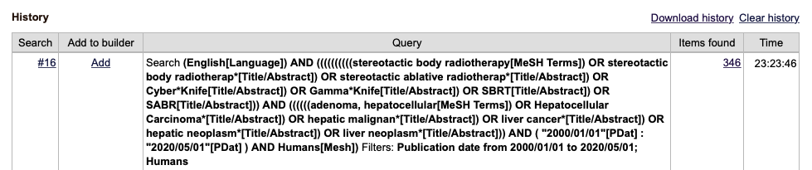

- Cochrane database
ID Search
#1 ("hepatocellular carcinoma*"):ti,ab,kw OR ("liver cancer*"):ti,ab,kw OR ("HCC"):ti,ab,kw OR ("hepatic cancer*"):ti,ab,kw OR ("liver neoplasm*"):ti,ab,kw (Word variations have been searched)
#2 MeSH descriptor: [Carcinoma, Hepatocellular] explode all trees
#3 #1 OR #2
#4 MeSH descriptor: [Radiosurgery] explode all trees
#5 ("stereotactic ablation"):ti,ab,kw OR ("stereotactic body"):ti,ab,kw OR ("Cyber Knife"):ti,ab,kw OR ("Gamma Knife"):ti,ab,kw OR (SBRT):ti,ab,kw
#6 (SABR):ti,ab,kw
#7 #4 OR #5 OR #6
#8 #3 AND #7
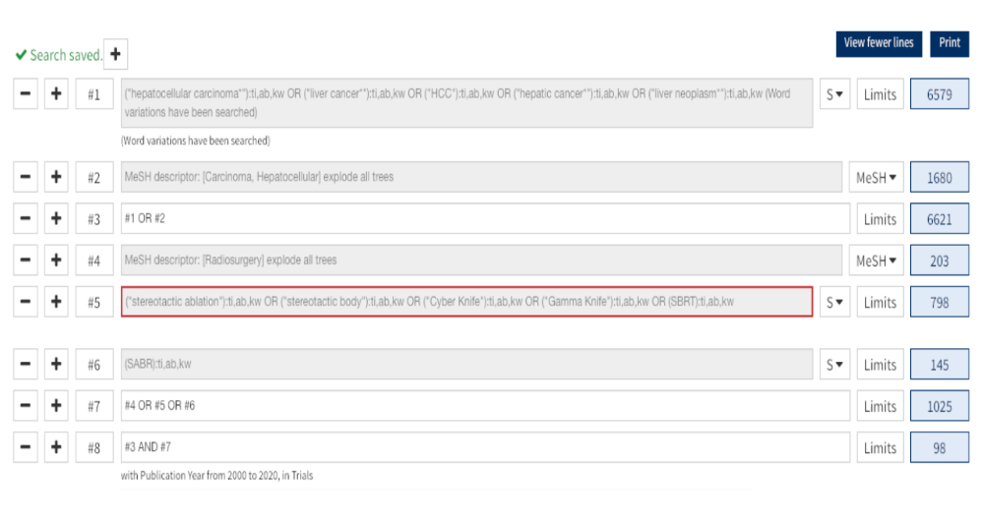
Part 2: PICO eligibility criteria

PICO | Description
Patients | Patients with small liver-confined HCC (maximum single tumor diameter≦6cm or tumor volume ≦100cc), 1-3 lesions, no lymph node or extrahepatic metastasis
Intervention | SBRT for pretreated or initial small-sized HCC
Comparisons | no intervention OR TACE OR RFA OR others
Outcome | Local control, overall survival, predictors for LC or OS, toxicity

Part 3: Normal distribution test
## L1_1_OS L1_3_OS L2_1_LC L2_3_LC L3_grade3 L3_RILD
## PRAW 0.04695441 0.7298484 0.012742599 0.01838514 0.1499892 0.3753506
## PLN 0.02924387 0.6315932 0.005084789 0.00921608 0.6505292 0.3492400
## PLOGIT 0.41294327 0.8387841 0.977341441 0.56505490 0.7248930 0.3626802
## PAS 0.42700595 0.7288792 0.209943462 0.10194077 0.9143196 0.3760822
## PFT 0.31709071 0.9292322 0.204079657 0.15433205 0.8583161 0.3412450
** p>0.05 –> normal distribution **

