Supplementary Materials for

The risk of micro/nanoplastics to human sperm and the intervention against their toxicity using magnetic Fe₃O₄ nanoparticles
Ying Chen et al.
*Corresponding author. Email: luotao@ncu.edu.cn (T. Luo); chenhouyang2007@163.com (H. Chen).

This PDF file includes:
Supplementary Materials and Methods
Figs. S1 to S10
Supplementary Materials and Methods
Main reagents
PS-MNPs with diameters of 25 nm, 50 nm, 100 nm, 500 nm, 4 μm, and 10 μm (50 mg/mL) were purchased from Beijing Zhongkeleiming Technology Co. Ltd. (Beijing, China). HTF medium was purchased from Irvine Scientific (Santa Ana, CA, USA). Chlortetracycline (CTC), P4, methylcellulose, and BPA were supplied by Sigma‒Aldrich Chemical Co. (St. Louis, MO, USA). Unused disposable paper cups were purchased from a Chinese eCommerce Platform. Nano-Fe₃O₄ (5 mg/mL) was purchased from Aladdin Biochemical Technology Co., Ltd. (Shanghai, China). 2',7'-Dichlorodihydrofluorescein diacetate (DCFH-DA) was purchased from MedchemExpress LLC. (Monmouth Junction, NJ, USA).
Py-GCMS analysis
Specifically, 4 mL of semen samples from each pool or the treated solutions from the disposable paper cups were dried and digested using 68% nitric acid (W/W) for two hours. The resulting mixture was then moderately diluted with deionized water and filtered through a 10 μm or 0.22 μm filter membrane using vacuum filtration. The filtrates were subsequently dried and pyrolyzed using an EGA/PY-3030D pyrolyzer (Frontier Laboratories Ltd., Koriyama, Japan) at 550 °C and analyzed using a Shimadzu single quadrupole GCMS-QP2020 gas chromatograph-mass spectrometer (Shimadzu Corporation, Kyoto, Japan) as described previously (Tang et al. 2023).
Sperm treatments
After liquefaction, the sperm of normozoospermic men were purified by direct swim-up in HS solution (135 mM NaCl, 5 mM KCl, 1 mM MgSO₄, 2 mM CaCl₂, 10 mM lactic acid, 5 mM glucose, 20 mM HEPES, 1 mM Na-pyruvate at pH 7.4 with NaOH).
To determine whether MNPs can be internalized by sperm, purified sperm were exposed to 0.025-, 0.05-, 0.1-, 0.5-, 4-, and 10-μm-sized green fluorescent PS-MNPs (0.5 mg/mL) in HS solution for 4 hours in a 5% CO₂ incubator at 37 °C. After washing with HS solution, the sperm were fixed with 4% paraformaldehyde and imaged using an FV1000-IX81 laser scanning confocal microscope (Olympus, Tokyo, Japan) with an M Ar laser (488 nm) for green fluorescence.
To evaluate the impact of synthetic PS-MNPs on human sperm and physiological parameters, purified sperm were exposed to PS-MNPs in HS solution in a 5% CO₂ incubator at 37 °C for 1, 60, 120, and 240 minutes, and then the viability, motility, DNA damage, ROS production, and MMP of human sperm were examined. In addition, the purified sperm were exposed to PS-MNPs in HTF medium (a capacitation buffer) in a 5% CO₂ incubator at 37 °C for 4 hours to measure the impact of synthetic PS-MPs on capacitation and capacitation-related sperm functions, such as penetration ability, hyperactivation, and acrosome reaction. Sperm exposed to HS solution or HTF medium were used as controls.
The potential risks of environmental MNPs released from disposable paper cups on human sperm were examined. Briefly, 50 mL of HS solution or HTF medium was heated to 90 °C and poured into disposable paper cups at room temperature for 1 hour. The purified sperm were then resuspended in the MPs released from disposable paper cups in either HS solution or HTF medium for 1, 60, 120, and 240 minutes or 4 hours, respectively, in a 5% CO₂ incubator at 37 ℃. Purified sperm exposed to HS solution or HTF medium served as controls. The sperm functions and physiological parameters essential for fertilization were analyzed.
To evaluate the joint effects of PS-MNPs and BPA on human sperm, purified sperm were exposed to PS-MNPs, BPA, and their combinations in HS solution for 1, 60, 120, and 240 minutes or in HTF medium for 4 hours in a 5% CO₂ incubator at 37 ℃. PS-MNPs with diameters of 25 nm (5 and 62.5 μg/mL) and 30 μM BPA were used. After exposure, sperm functions and physiological parameters essential for fertilization were analyzed. Sperm exposed to HS solution or HTF medium were used as control groups.
The alleviatory effect of nano-Fe₃O₄ on PS-NP-induced human sperm toxicity was assessed. Briefly, nano-Fe₃O₄ (1.3 mg/mL) and green fluorescent 25-nm PS-NPs (250 μg/mL) were mixed in HS solution or HTF medium for 2.5 hours on a shaker at 180 rpm at room temperature. The mixture was then placed on a magnetic stand (Merck KGaA, Darmstadt, Germany) for 30 minutes. The fluorescent intensities of the supernatants (Fs), nano-Fe₃O₄ (F_{Fe}), fluorescent 25-nm PS-NPs (F_{PS-NPs}), and HS solution (F_{HS}) or HTF medium (F_{HTF}) were measured using an EnSpire Multimode Plate Reader (PerkinElmer Inc., Shelton, CT, USA). The removal rates of PS-NPs in HS solution and HTF medium were calculated as [(F_{PS-NPs} – F_{HS}) – (Fs – F_{Fe})]/(F_{PS-NPs} – F_{HS}) × 100% and [(F_{PS-NPs} – F_{HTF}) – (Fs – F_{Fe})]/F_{PS-NPs} – F_{HTF}) × 100%, respectively. In addition, the purified sperm were resuspended in the HS solution-treated supernatants for 1, 60, 120, and 240 minutes or in the HTF medium-treated supernatants for 4 hours in a 5% CO2 incubator at 37 ℃. The sperm exposed to nano-Fe₃O₄ (1.3 mg/mL), green fluorescent PS-NPs (250 μg/mL) of 25 nm, HS solution (control), and HTF solution (control) were also examined. After exposure, sperm functions and physiological parameters were analyzed.
Assessment of sperm functions
Sperm viability was assessed using the eosin staining assay as previously described (Xu et al. 2023). Total motility and progressive motility were measured using the Laja 20-µm-deep sperm counting chamber (Laja, Luzernestraat, Netherlands) under a Zeiss Axio Lab A1 microscope equipped with a 10 × negative-phase contrast objective (Carl Zeiss Jena GmbH, Jena, Germany) by well-trained researchers. The capacitation and acrosome reaction of human sperm were detected using the CTC staining method as previously described (Xu et al. 2023). The penetration ability of human sperm was analyzed by assessing sperm permeability in a 1% (w/v) methylcellulose solution as previously reported (Luo et al. 2019). Sperm hyperactivation was evaluated using the Hamilton Thorne CEROSII computer-assisted sperm analysis system (Hamilton Thorne Biosciences, Beverly, MA, USA), as previously described (Luo et al. 2019).
Measurement of sperm DNA damage
The sperm DNA damage was measured using the OxiSelect 96-Well Comet Assay Kit (Cell Biolabs, Inc., San Diego, CA, USA) according to the manufacturer’s instructions.
Examination of sperm reactive oxygen species (ROS)
The purified sperm were stained with a cell-permeable ROS probe (10 μM DCFH-DA) in HS solution at 37 ℃ for 30 minutes in a 5% CO₂ incubator. The stained sperm were washed with HS solution to remove excess dye. MNPs and chemicals were then added and incubated for 4 hours. The fluorescence intensity was measured using an EnSpire Multimode Plate Reader (PerkinElmer Inc.) with excitation/emission wavelengths of 488 nm/525 nm at 1, 60, 120, and 240 minutes after incubation.
Evaluation of sperm mitochondrial membrane potential (MMP)
Sperm MMP was measured using a JC-1 MMP Assay Kit (MedchemExpress LLC.) according to the manufacturer’s instructions. Purified sperm were stained with 2 μM JC-1 in HS solution at 37 ℃ for 20 minutes in a 5% CO₂ incubator. The stained sperm were subsequently washed with HS solution to remove excess dye. MPs and chemicals were added and incubated for 4 hours. The fluorescence intensity was measured using an EnSpire Multimode Plate Reader (PerkinElmer Inc.) with excitation/emission wavelengths of 525 nm/590 nm (F_{red}) and 488 nm/530 nm (F_{green}). The fluorescent intensities were measured before adding the MPs and chemicals and at 1, 60, 120, and 240 minutes after incubation. The change in sperm MMP was calculated using the formula ΔR/R₀ × 100% (where R₀ represents the ratio of F_{red} and F_{green} before the application of MPs and chemicals, and R represents the ratio of F_{red} and F_{green} at 1, 60, 120, and 240 minutes after incubation; ΔR=R-R₀).
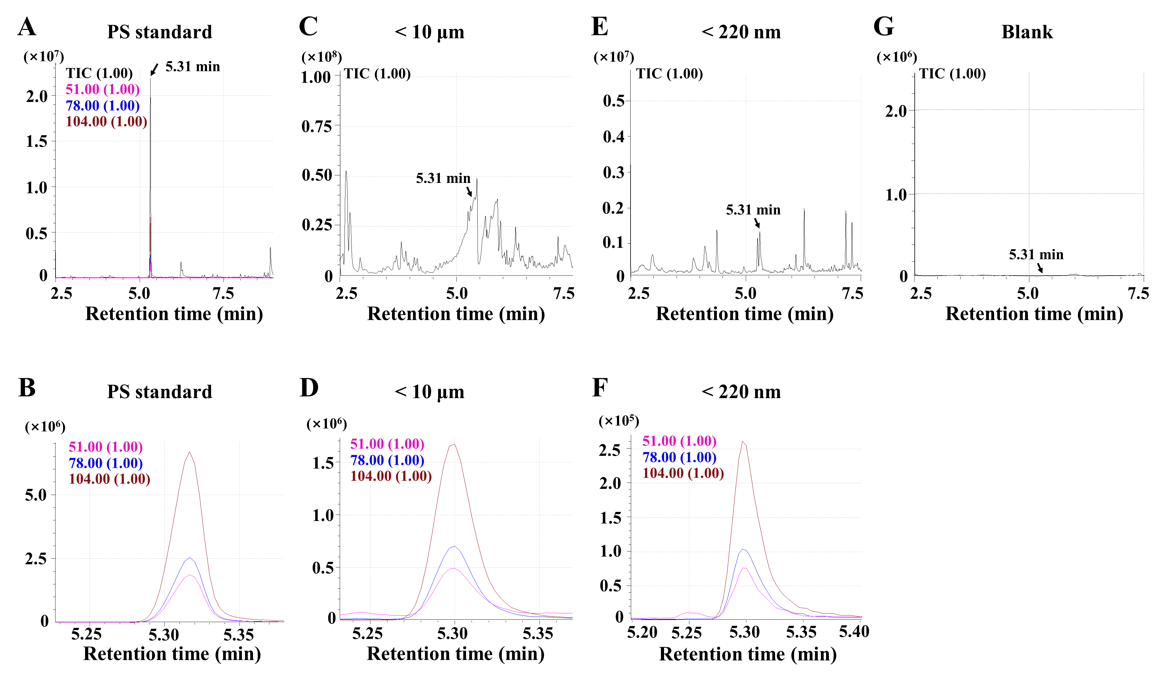
Figure S1
Fig. S1. The Polystyrene micro/nanoplastics (PS-MNPs) were detected in human semens using pyrolysis gas chromatography/mass spectrometry. (A and B) The mass spectrum of the PS standard. (C-F) The representative mass spectrum of PS-MNPs in human semen. (G) The mass spectrum of the blank.
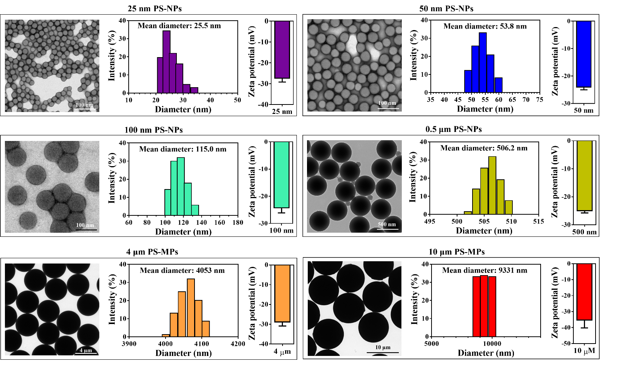
Figure S2
Fig. S2. Characteristics of PS-MNPs of different sizes. Morphological characteristics, size distribution, and ζ-potential of PS-MNPs were examined by transmission electron microscopy and dynamic light scattering in deionized water. n=3.
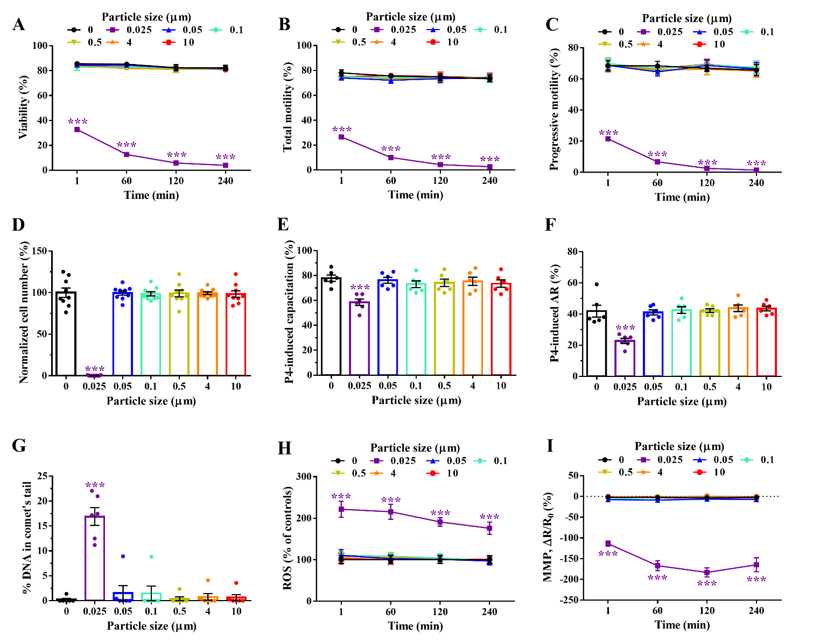
Figure S3
Fig. S3. Impacts of PS-MNPs ranging in size from 25 nm to 10 μm on viability (A), motility (B and C), penetration ability (D), progesterone (P4)-induced capacitation (E), P4-induced acrosome reaction (AR) (F), DNA damage (G), reactive oxygen species (ROS, H), and mitochondrial membrane potential (MMP, I). The experiments were repeated on 6-9 individuals. Data are presented as the mean ± standard error of the mean. Differences between the control and treatment groups were assessed by one-way ANOVA and Dunnett's test. ***p < 0.001.
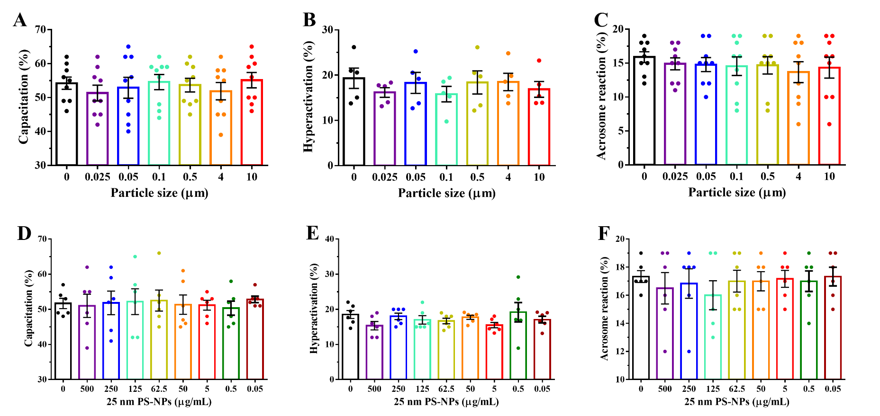
Figure S4
Fig. S4. Impacts of PS-MNPs on capacitation (A and D), hyperactivation (B and E), acrosome reaction (AR, C and F) of human sperm. The experiments were repeated on 6-9 individuals. Data are presented as the mean ± standard error of the mean. Differences between the control and treatment groups were assessed by one-way ANOVA and Dunnett's test.

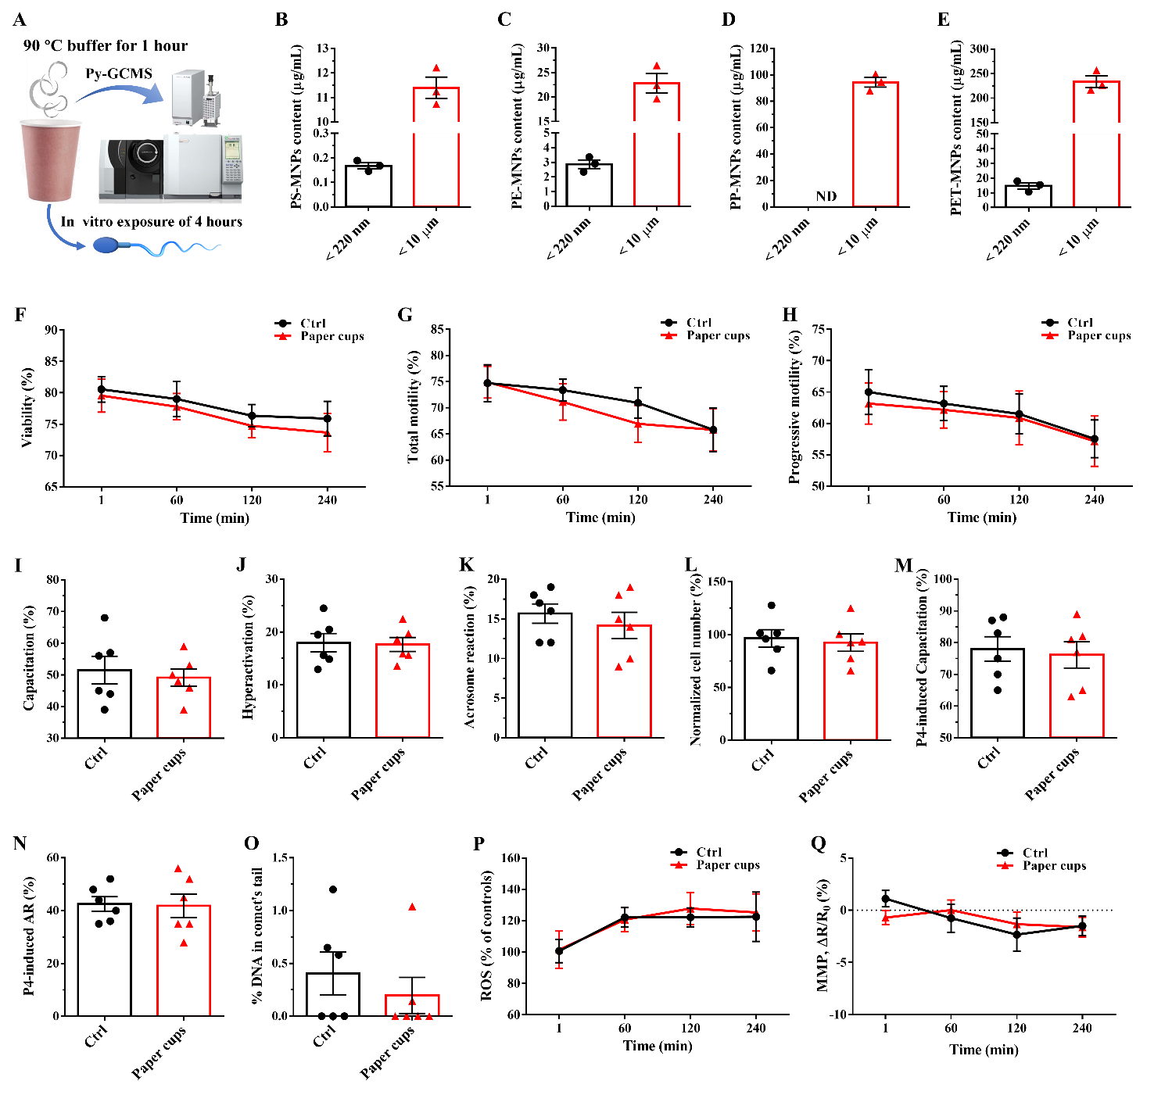
Figure S5
Fig. S5. Impacts of environmental MNPs released from disposable paper cups on human sperm. (A) The MNPs released from disposable paper cups were examined by pyrolysis gas chromatography/mass spectrometry (Py-GCMS) and exposed to human sperm. The following types of MNPs were detected: PS-MNPs (B), polyethylene (PE)-MPs (C), polypropylene (PP)-MPs (D), and polyethylene terephthalate (PET)-MPs (E). The experiments were repeated three times. Impacts of environmental MNPs on viability (F), total motility (G), progressive motility (H), capacitation (I), hyperactivation (J), acrosome reaction (AR, K), penetration ability (L), progesterone (P4)-induced capacitation (M), P4-induced AR (N), DNA damage (O), ROS (P), and MMP (Q) of human sperm were measured. The experiments were repeated on 6-9 individuals, and the data are presented as the mean ± SEM. Differences between the control and treatment groups were assessed by Student’s t test.

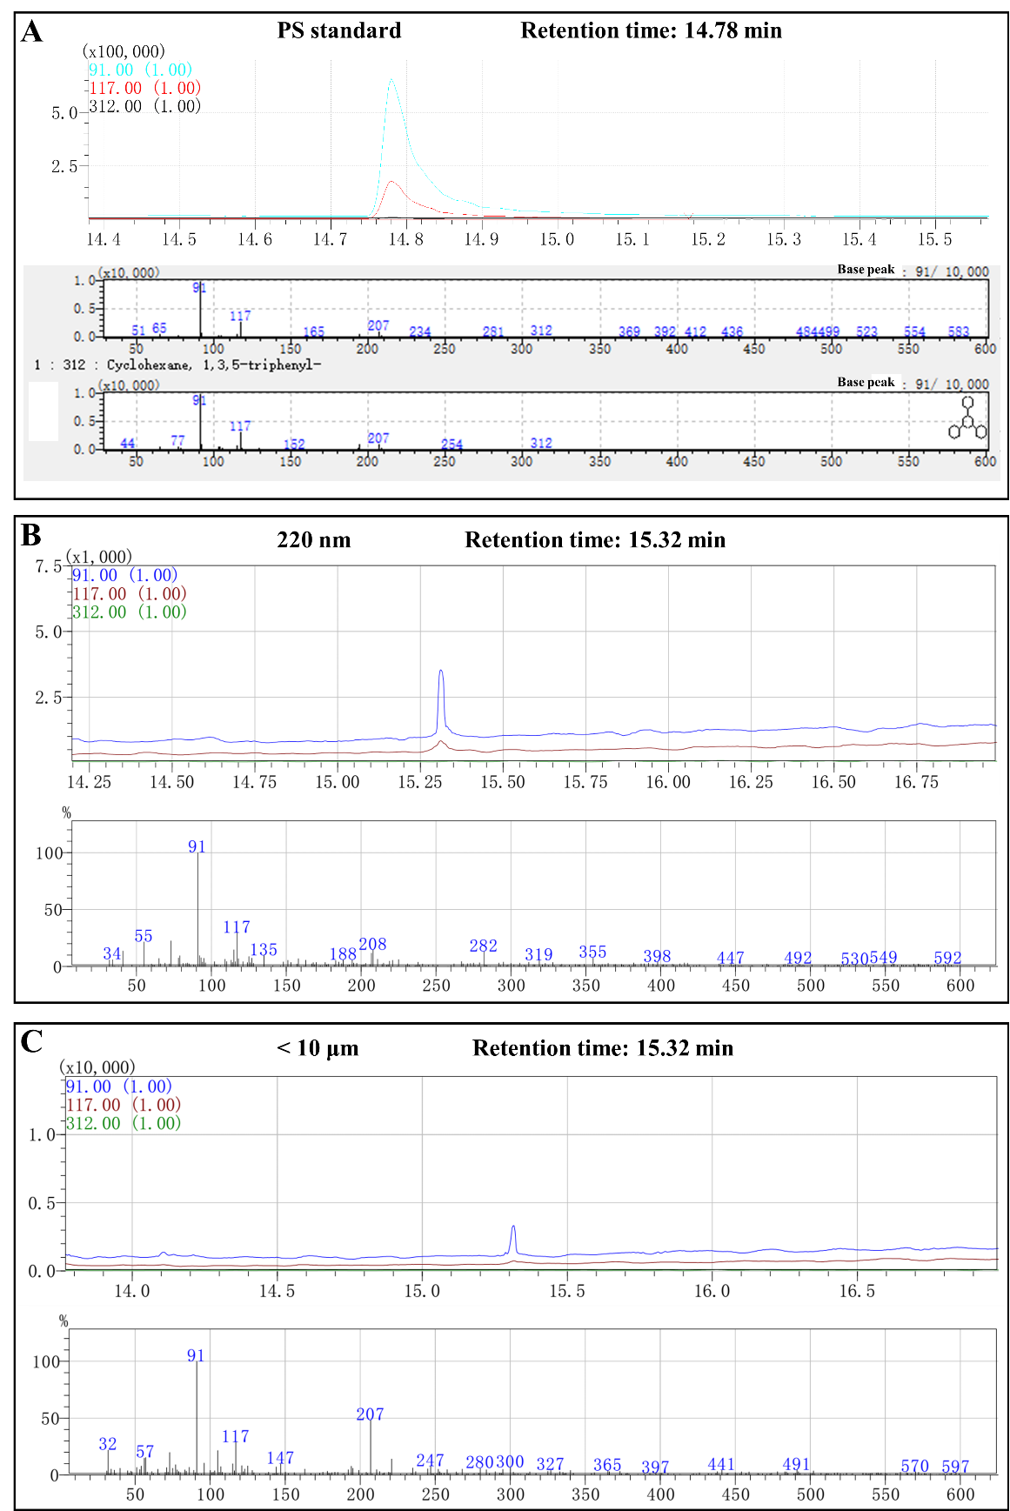
Figure S6
Fig. S6. The mass spectrum for PS-MNPs released by disposable paper cups. The representative mass spectra for polystyrene standard (A) and PS-MNPs released by disposable paper cups (B and C) were shown.

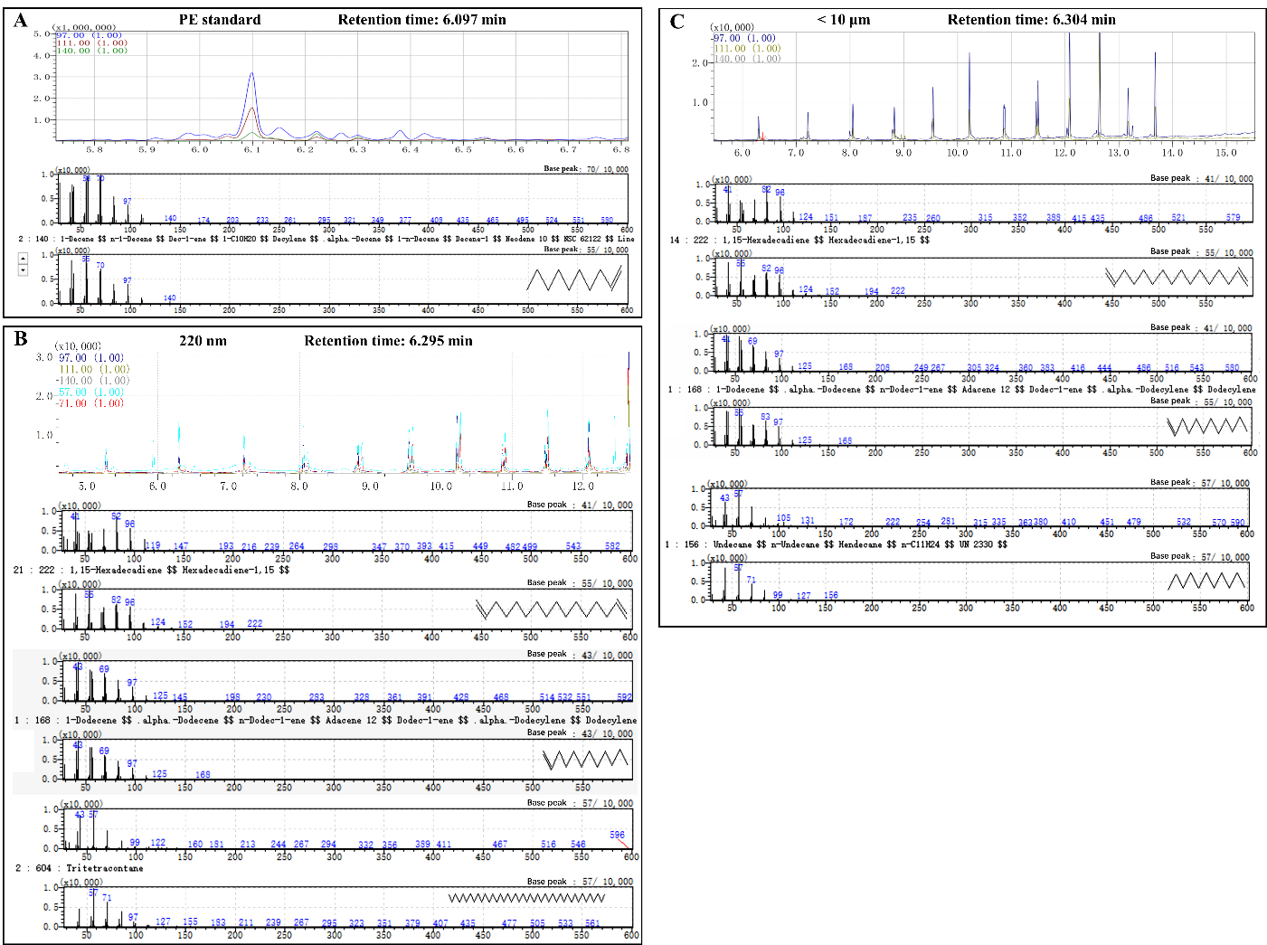
Figure S7
Fig. S7. The mass spectrum for PE-MNPs released by disposable paper cups. The representative mass spectra for polyethylene (PE) standard (A) and PE-MNPs released by disposable paper cups (B and C) were shown.

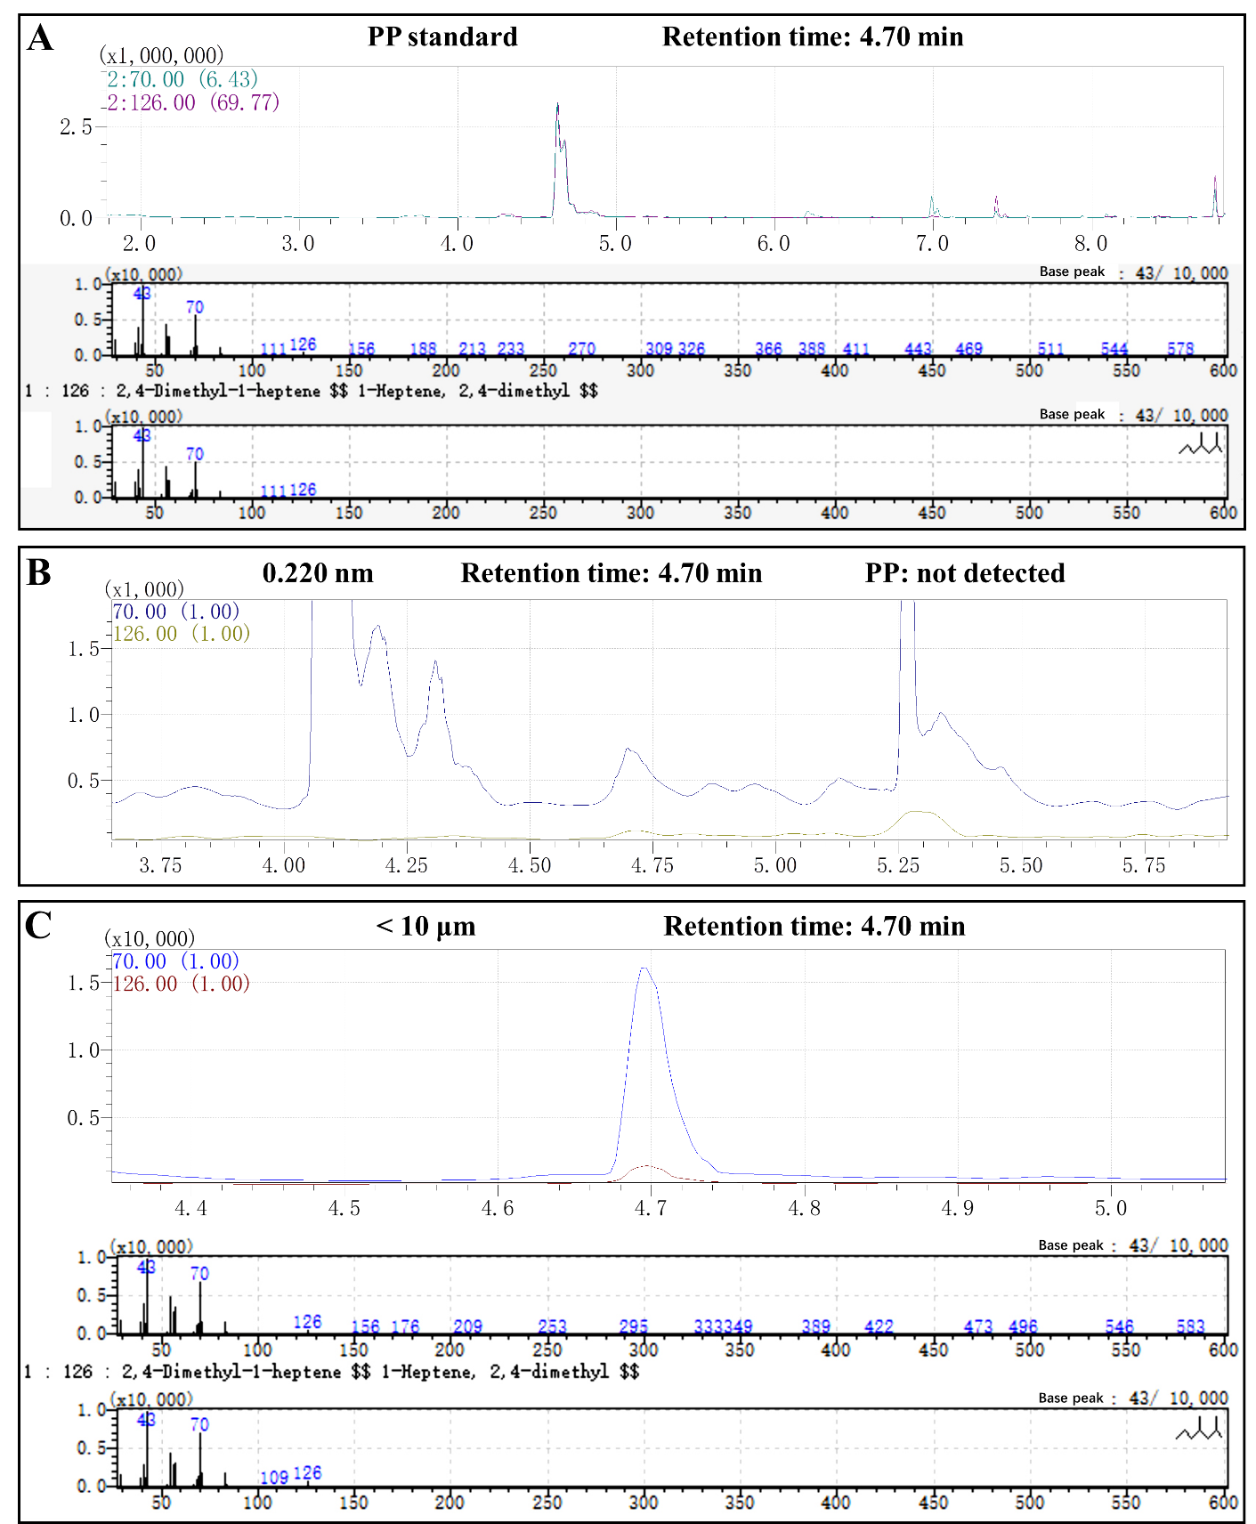
Figure S8
Fig. S8. The mass spectrum for PP-MNPs released by disposable paper cups. The representative mass spectra for polypropylene (PP) standard (A) and PP-MNPs released by disposable paper cups (B and C) were shown.

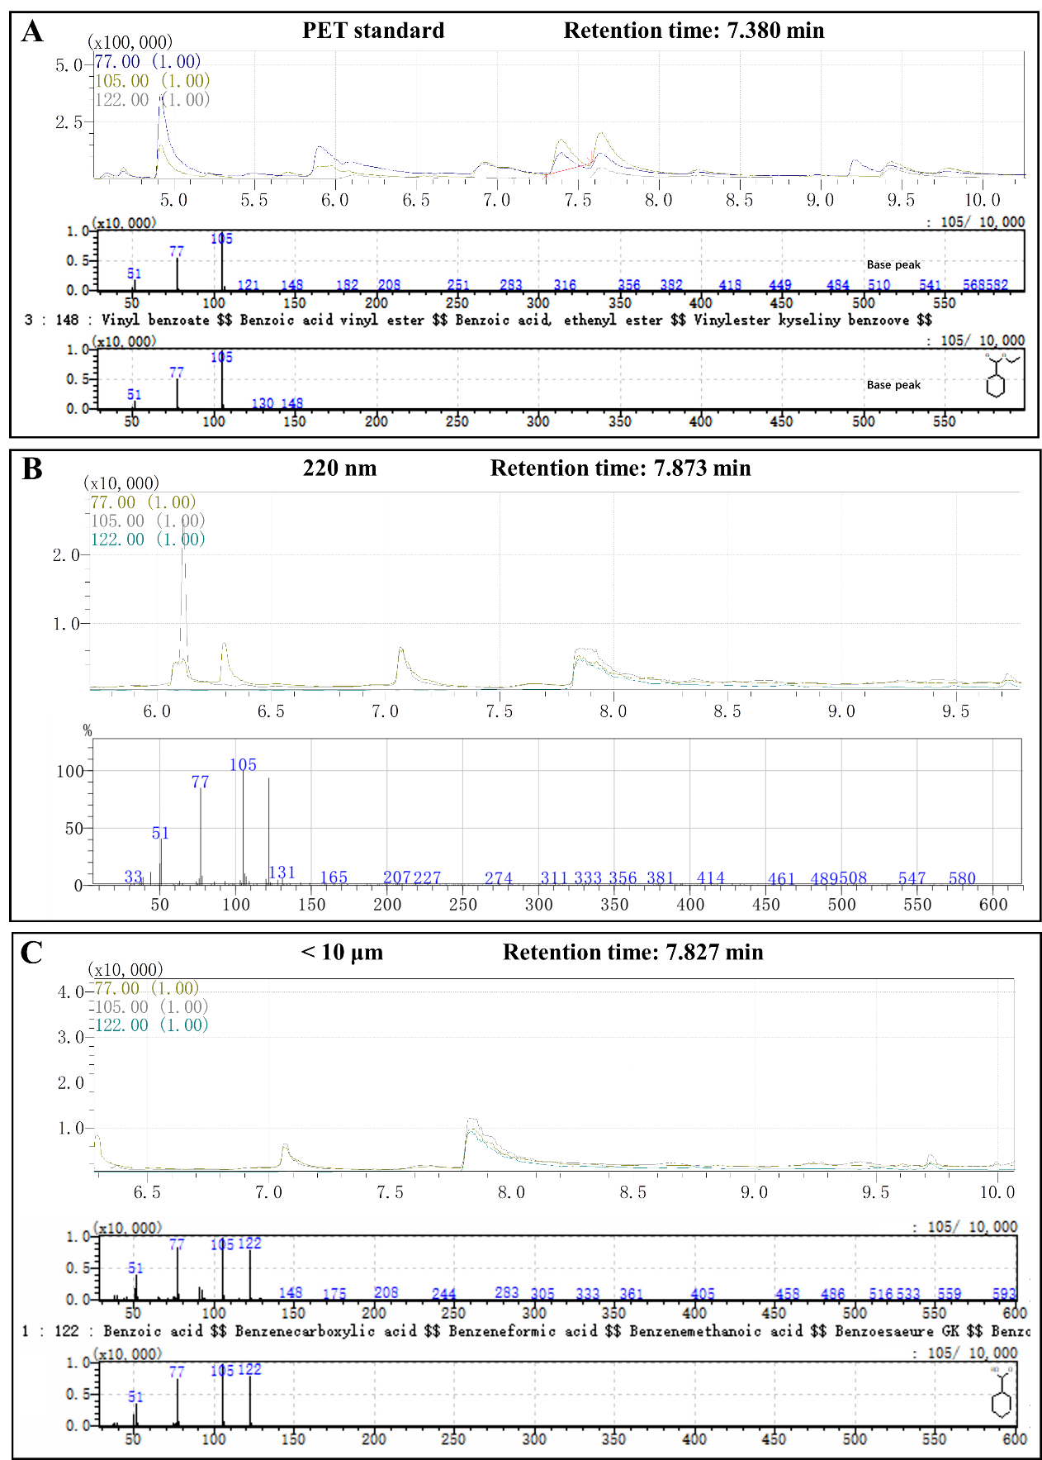
Figure S9
Fig. S9. The mass spectrum for PET-MNPs released by disposable paper cups. The representative mass spectra for polyethylene terephthalate (PET) standard (A) and PET-MNPs released by disposable paper cups (B and C) were shown.

Figure S10
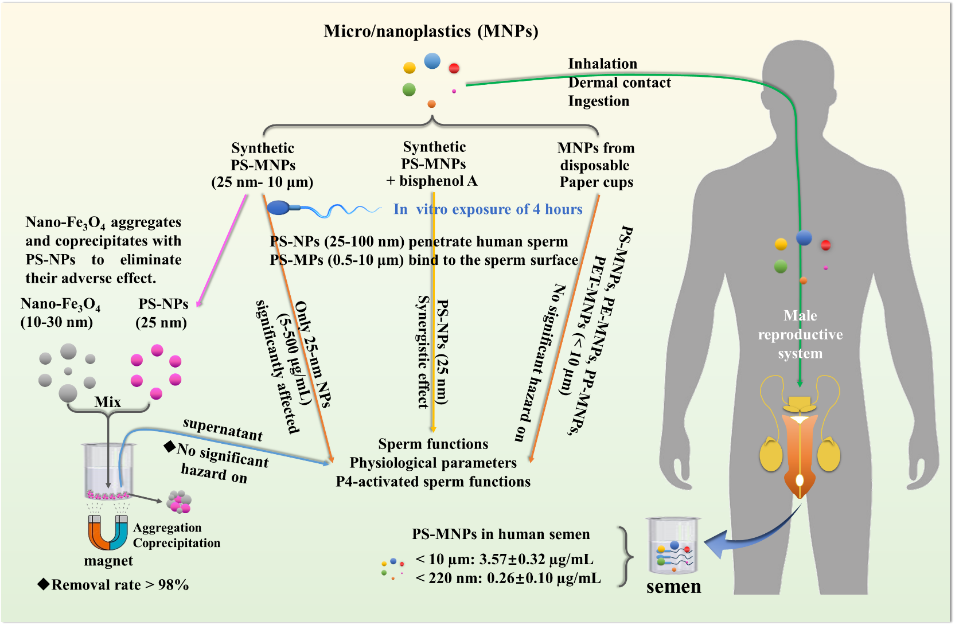
Fig. S10. A graph summarizing the new insights into the male reproductive toxicity of micro/nanoplastics (MNPs).

