A Global Invasion Risk Assessment of Spodoptera frugiperda (Lepidoptera: Noctuidae) Under Climatic Change – Supplementary Figures

Sanad H. Ragab^{1*}, Michael G. Tyshenko²

¹Department of Zoology and Entomology, Faculty of Science, Al-Azhar University, Nasr city, Cairo, Egypt
²Risk Sciences International Ottawa, Canada

* Corresponding author: Sanad H. Ragab
Email: sanadragab@azhar.edu.eg

Future prediction of Spodoptera frugiperda under different climate scenarios

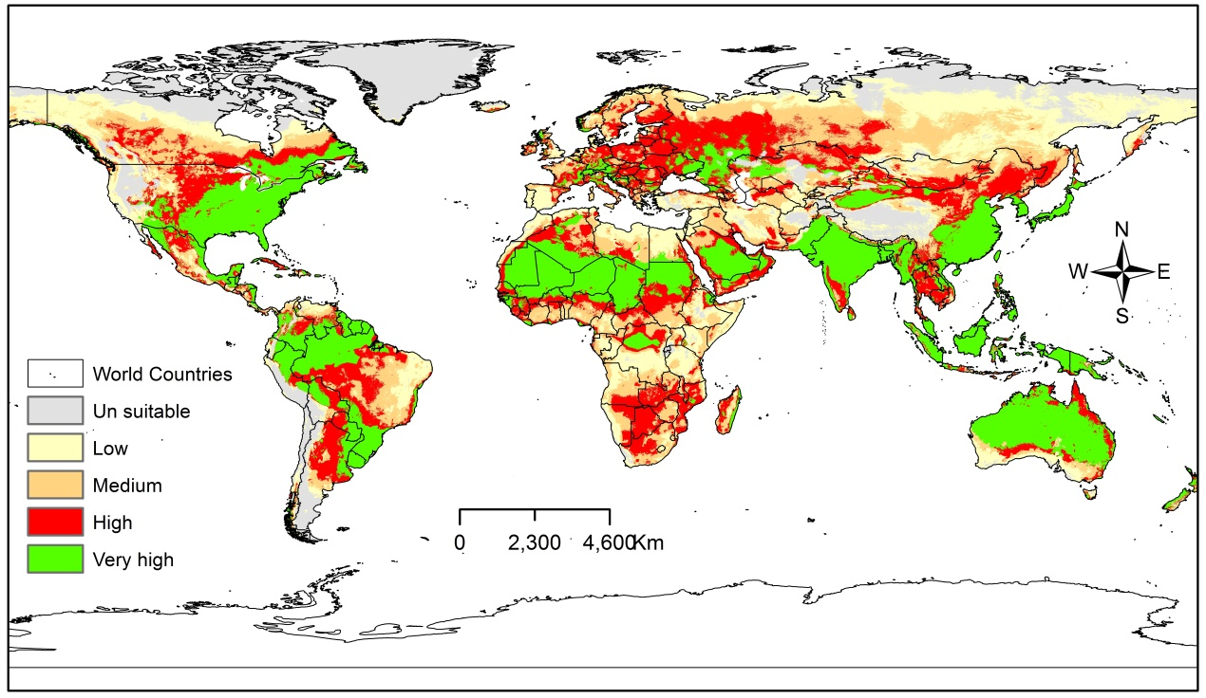The predicted future distribution range of Spodoptera frugiperda under scenario (a) BCC-CSM2MR_ssp126_2021-2040.
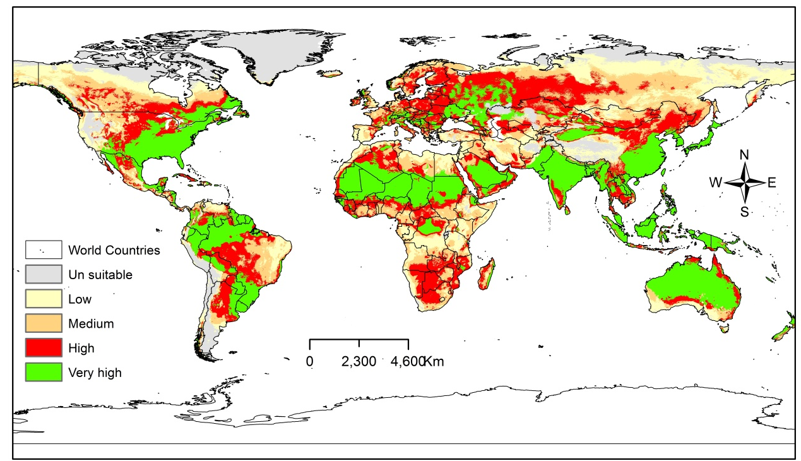The predicted future distribution range of Spodoptera frugiperda under scenario (b) BCC-CSM2-MR_ssp126_ 2080-2100
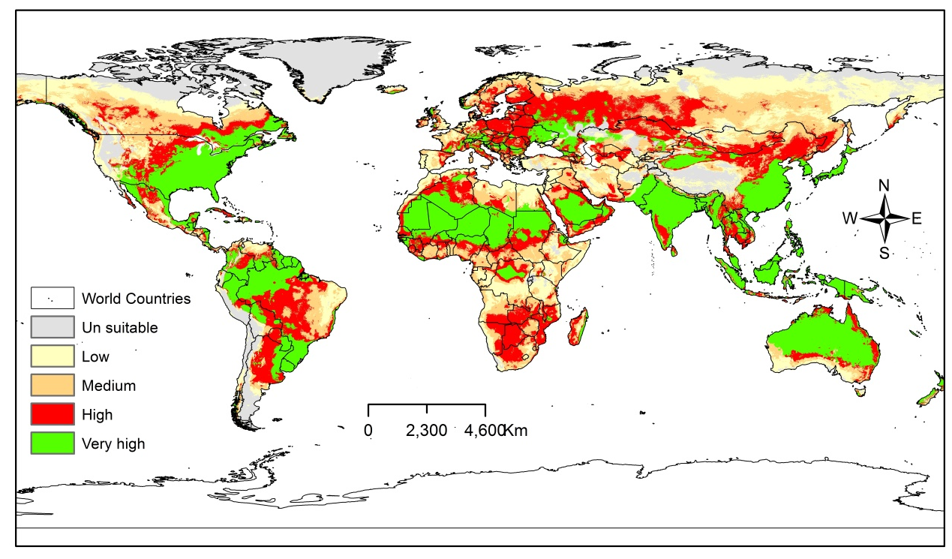The predicted future distribution range of Spodoptera frugiperda under scenario (c) BCC-CSM2MR_ssp585_ 2021-2040.
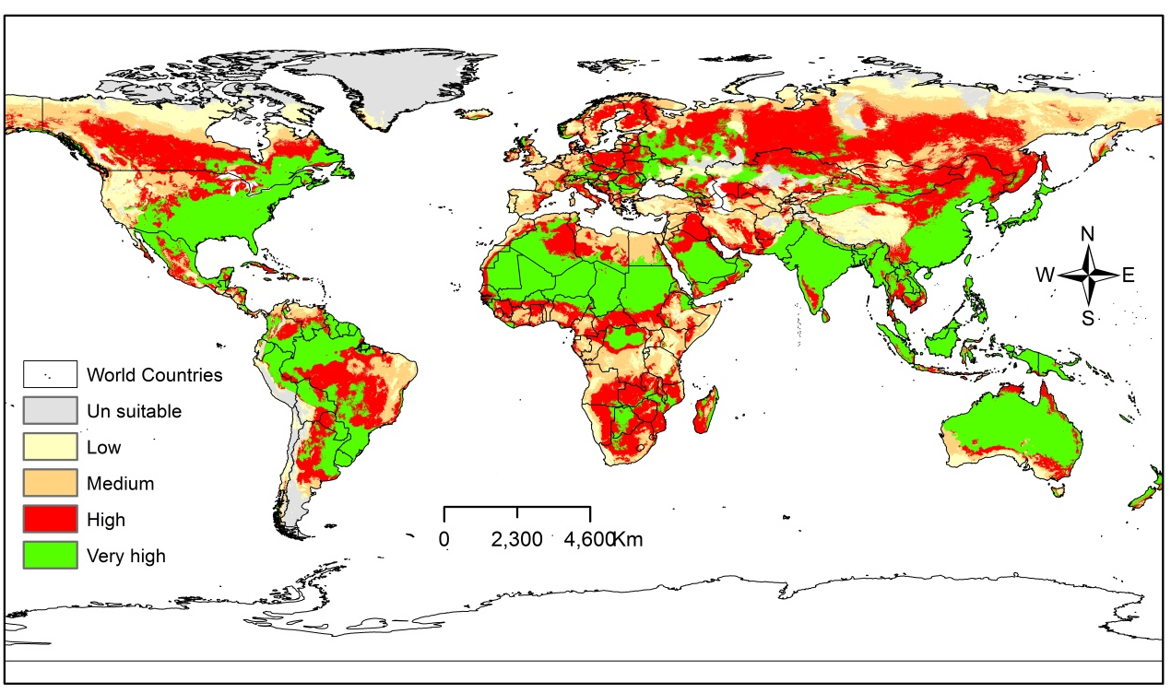The predicted future distribution range of Spodoptera frugiperda under scenario (d) BCC-CSM2-MR_ssp585_ 2080-2100.
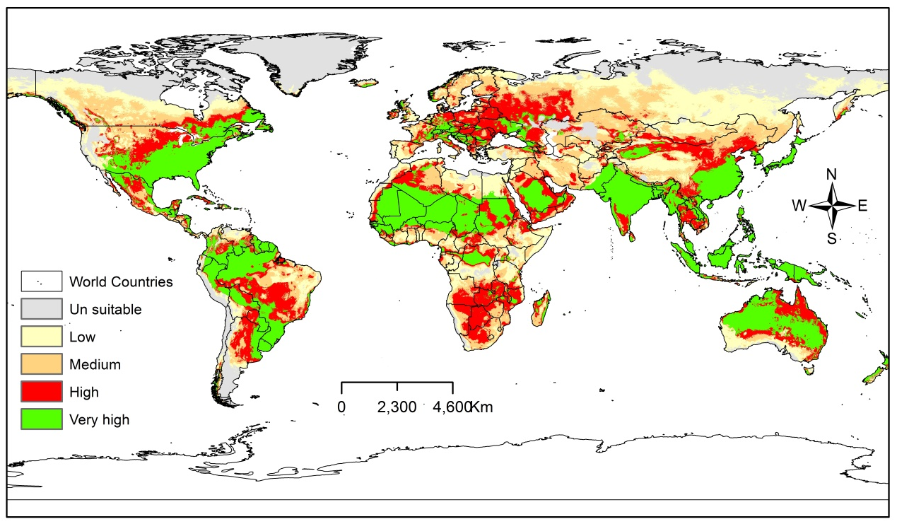The predicted future distribution range of Spodoptera frugiperda under scenario (a) IPSL-CM6ALR_ssp126_2021-2040.
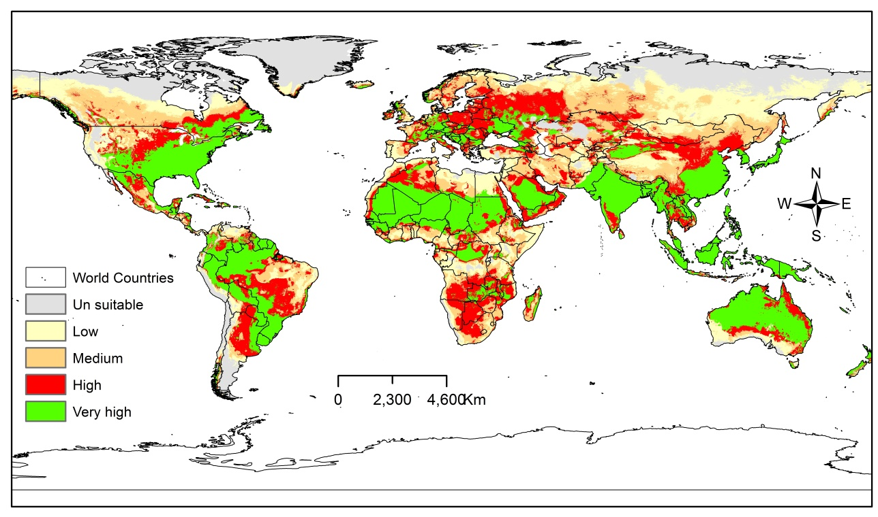The predicted future distribution range of Spodoptera frugiperda under scenario (b) IPSL-CM6A-LR_ssp126_2080-2100.
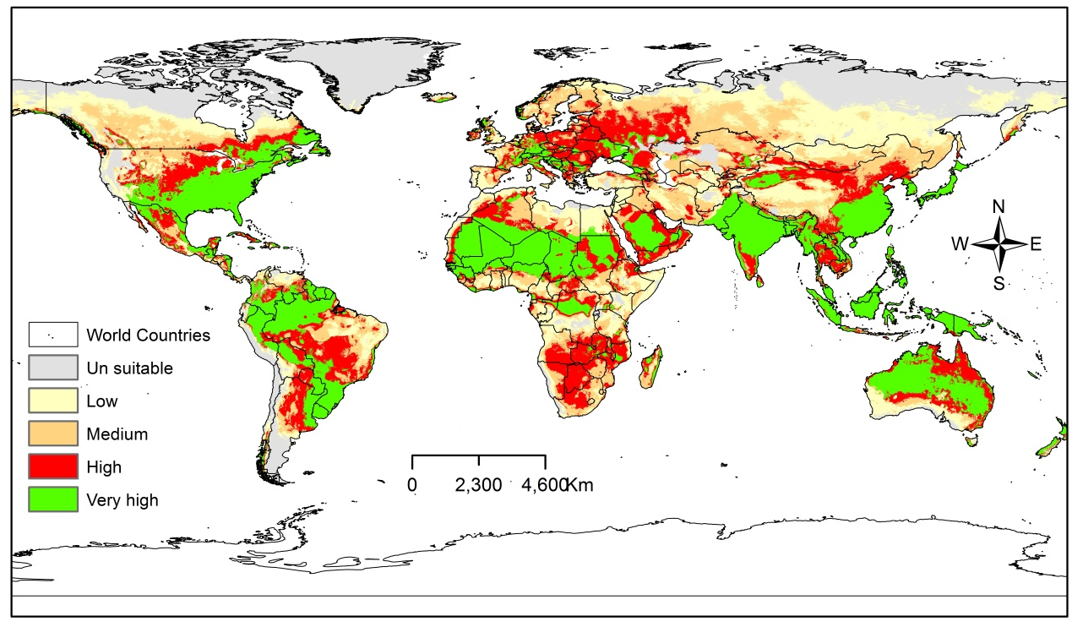The predicted future distribution range of Spodoptera frugiperda under scenario (c) IPSL-CM6ALR_ssp585_ 2021-2040.
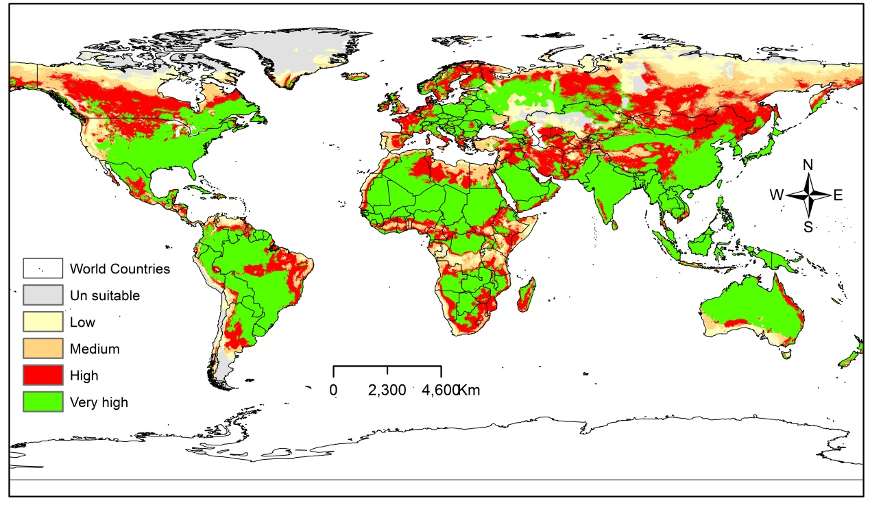The predicted future distribution range of Spodoptera frugiperda under scenario (d) IPSL-CM6A-LR_ssp585_ 2080-2100

