SUPPORTING INFORMATION

Carrier Free Delivery System of Monoacylglycerol Lipase Hydrophobic Inhibitor for Cancer Therapy
Muhammad Adeel^{1,2,3}, Gloria Saorin^{1,2}, Giacomo Boccalon¹, Andrea Augusto Sfriso⁴, Salvatore Parisi^{3,5}, Isabella Moro⁶, Stefano Palazzolo³, Isabella Caligiuri³, Carlotta Granchi*⁷, Vincenzo Canzonieri^{3,8}, Tiziano Tuccinardi^{7,9} and Flavio Rizzolio*^{1,3,9}

Figure S1. TEM images of MAGL23 (a&b) and MAGL23-F (c& d) at different magnifications. The size decreased and dispersebility increased when employed pluronic acid as surfactant, compared to as synthetized MAGL23.

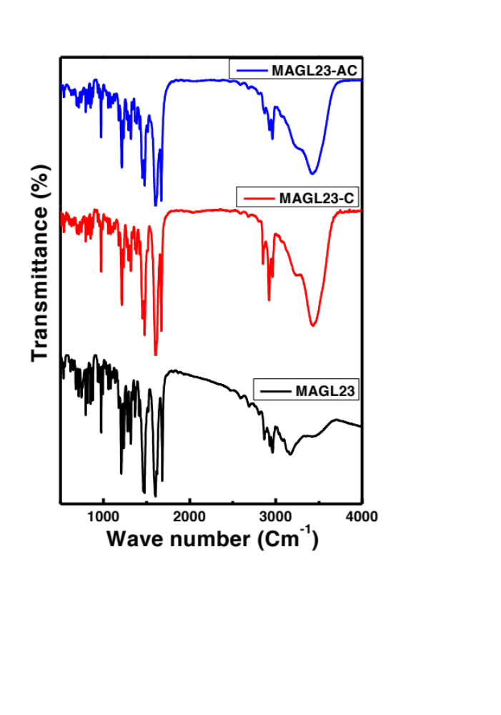
Figure S2. FTIR spectra of MAGL-C, MAGL-AC, and drug powder (MAGL)

