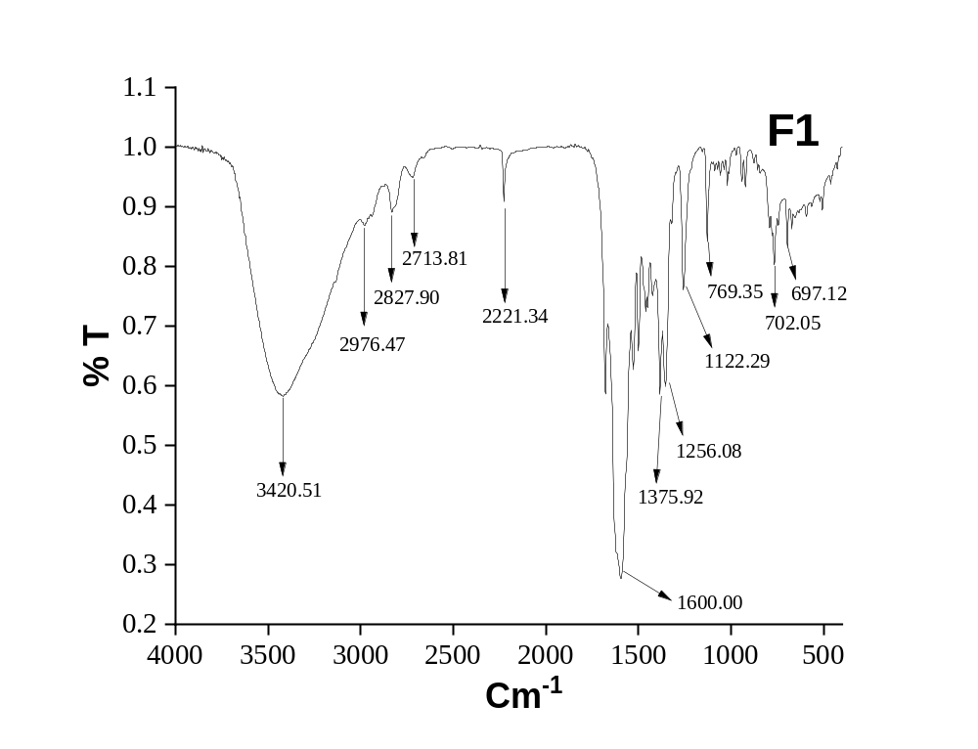
Figure s1. IR Spectrum of F1

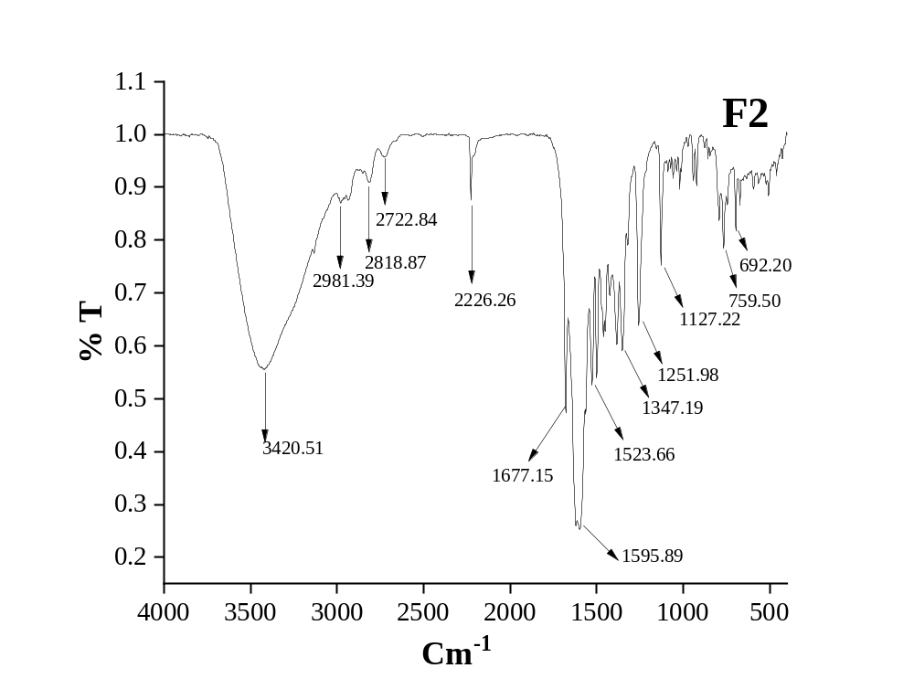
Figure s2. IR Spectrum of F2

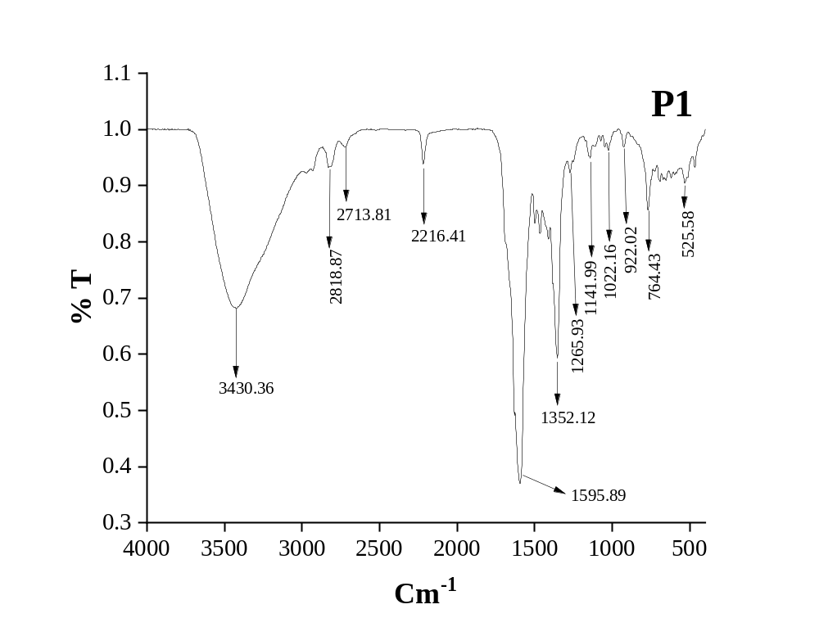
Figure s3. IR Spectrum of P1
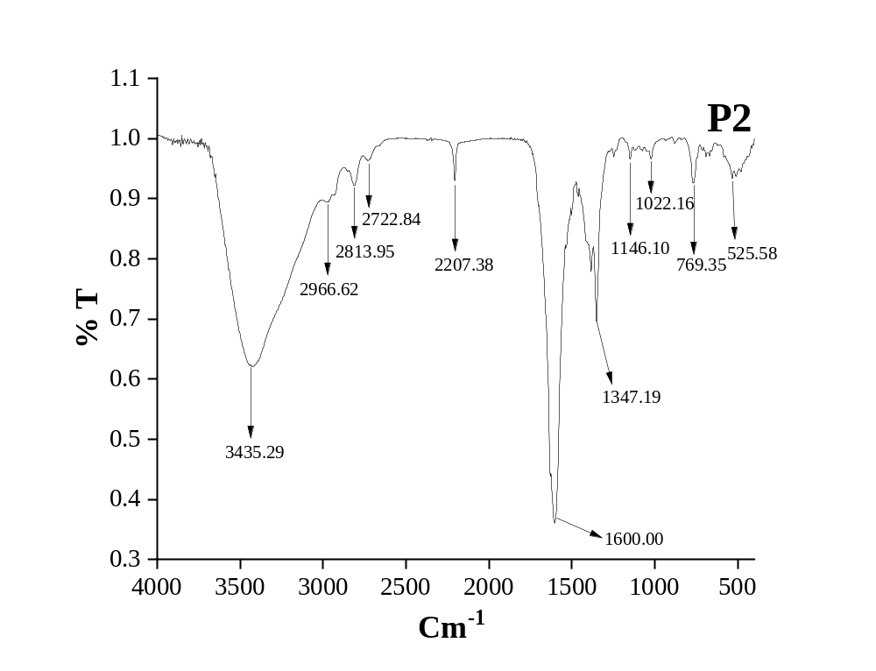

Figure s4. IR Spectrum of P2

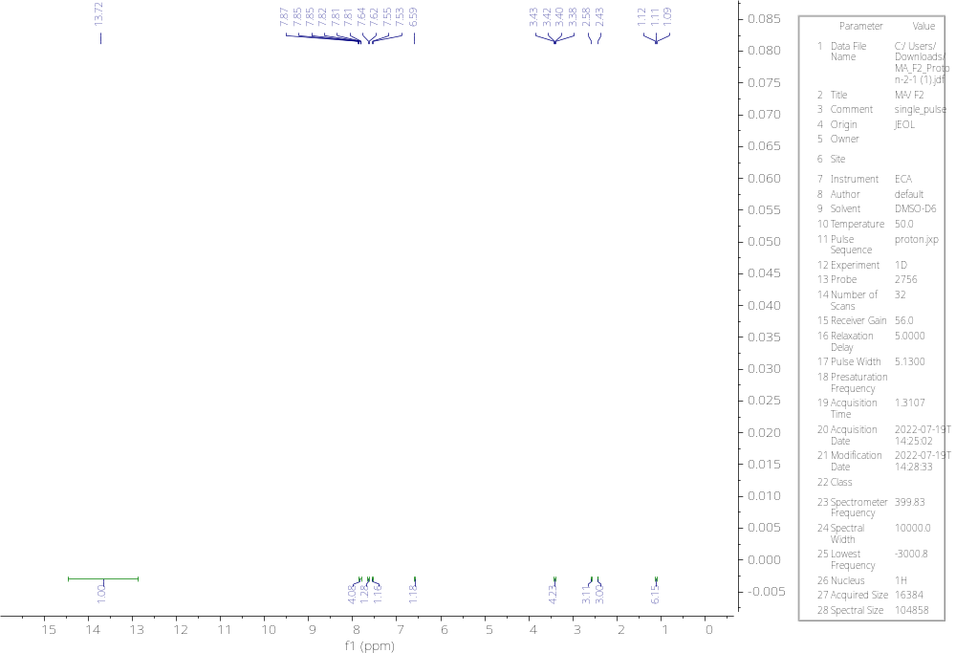
Figure s5. ¹H NMR Spectrum of F1

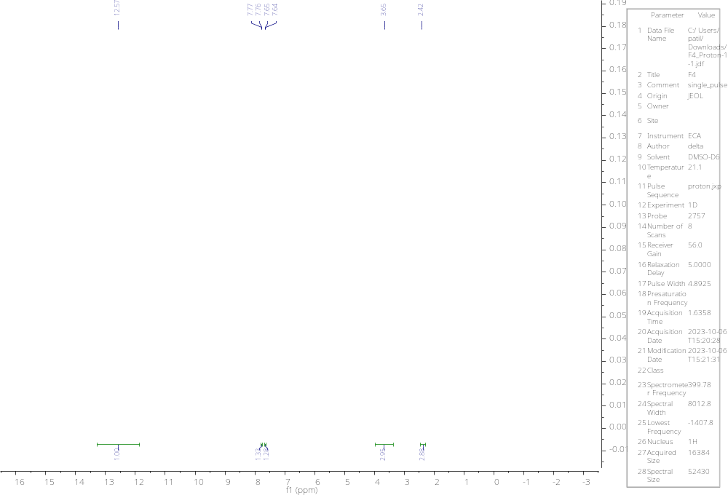
Figure s6. ¹H NMR Spectrum of F2
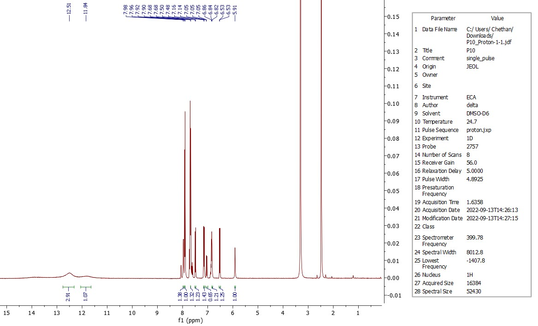

Figure s7. ¹H NMR Spectrum of P1

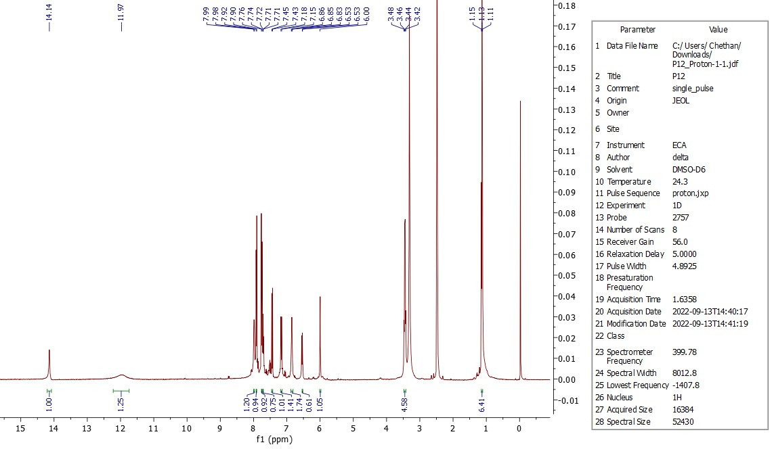
Figure s8. ¹H NMR Spectrum of P2

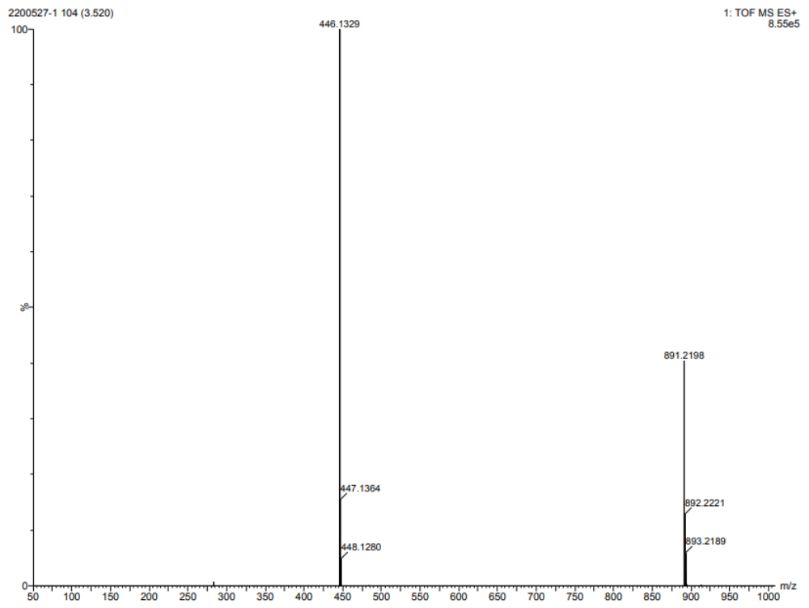
Figure s9. HRMS Spectrum of F1
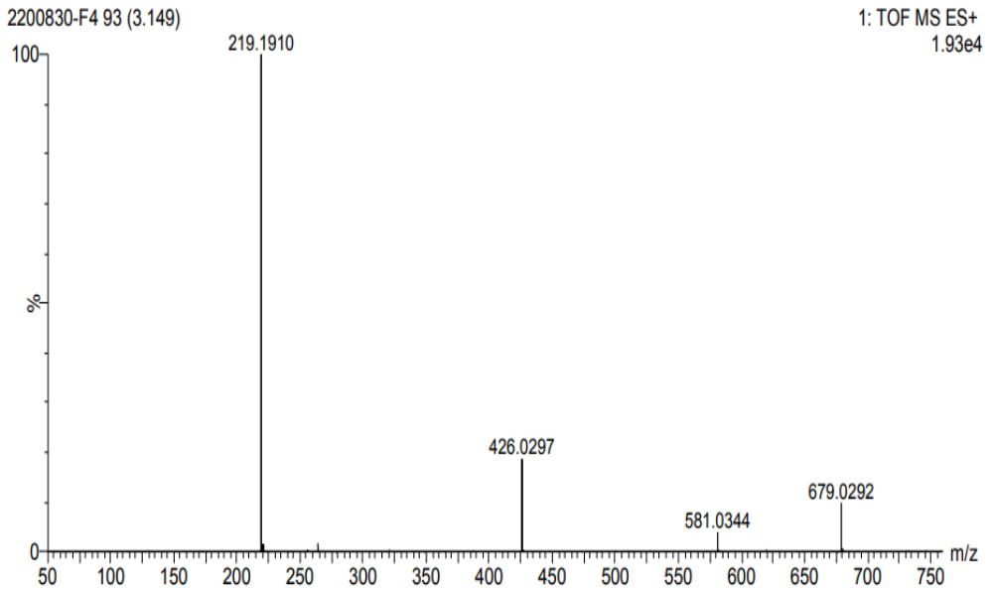
Figure s10. HRMS Spectrum of F1
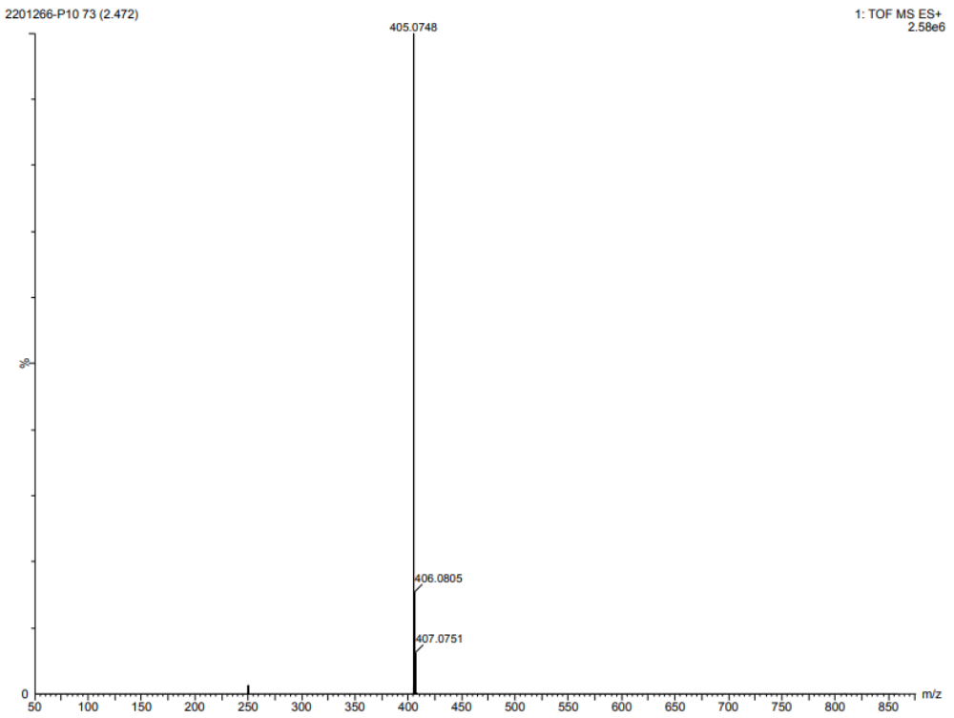

Figure s11. HRMS Spectrum of F1

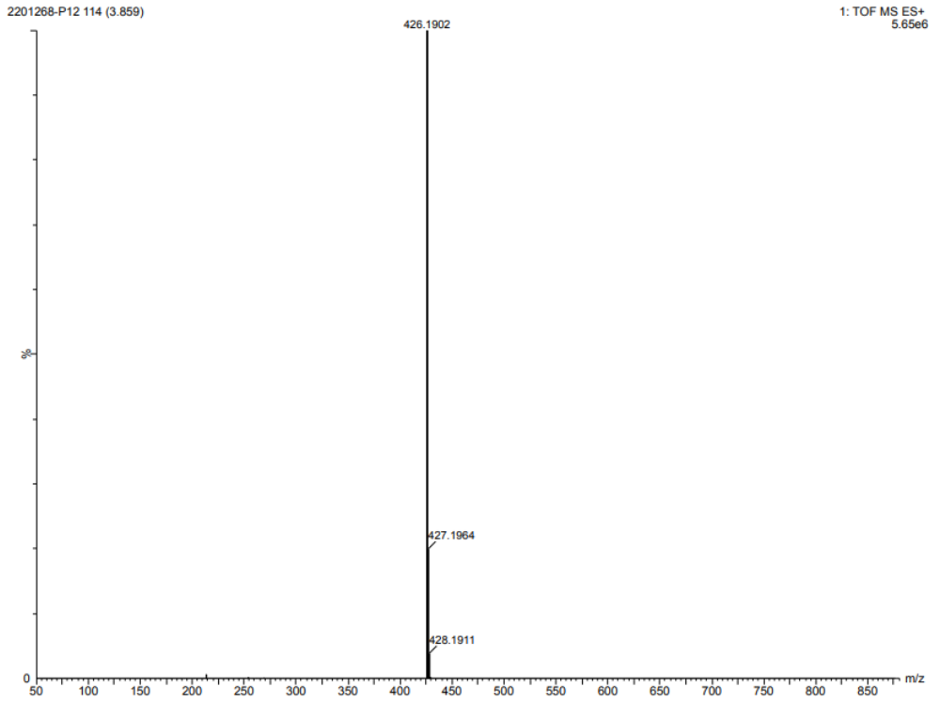

Figure s12. HRMS Spectrum of F1

