Figure S1 Stripe rust reactions of Baidatou and Huixianhong
a. Seedling reactions of Baidatou (BDT, left, IT = 0;) and Huixianhong (HXH, right, IT = 4) to Pst race CYR31 at 14 dpi (days post inoculation). b. Adult plant responses of Baidatou (IT = 0;, Maximum DS = 1%) and Huixianhong (IT = 4, Maximum DS = 100%) to mixed Pst races (CYR32, CYR33 and CYR34) in the field.

Figure S2 Phenotypic distribution of 2,476 F₂ plants derived from the cross of Huixianhong/Baidatou at the adult plant stage at Qingshui in the 2020-2021 cropping season
The horizontal axis is maximum disease severity (MDS) scored as the percentage of infected leaf area when the MDS of Huixianhong reached 90-100%. The vertical axis is the number of F₂ plants. The MDS of two parents Baidatou and Huixianhong were 0 and 100%, respectively.

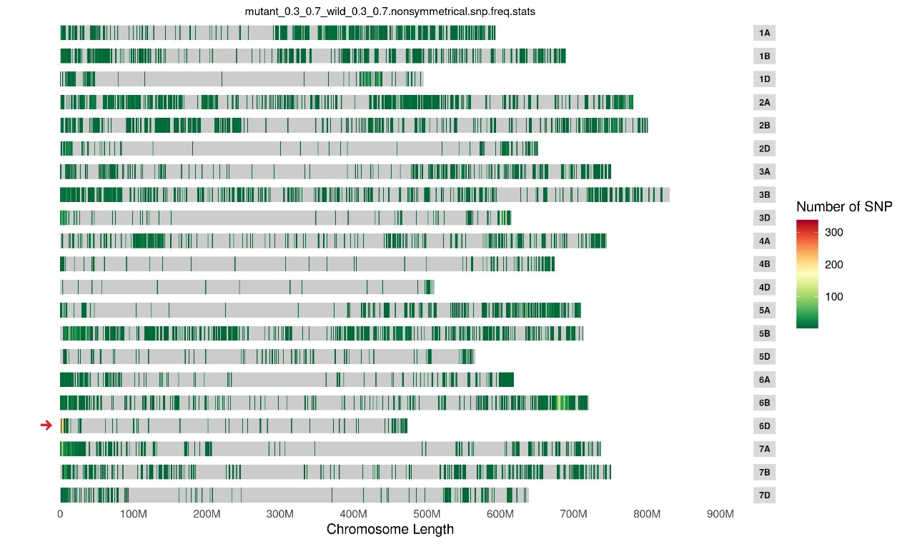
Figure S3 Distribution of 17,837 SNPs on the wheat genome estimated from BSE-seq
Gray boxes on the right show chromosome names; bottom numbers show chromosome length. The deep-green to light-yellow lines in the figure mean SNP number. The intensely yellow (arrow) lines at the distal end of chromosome arm 6DS show a higher density SNPs between the R and S pools.

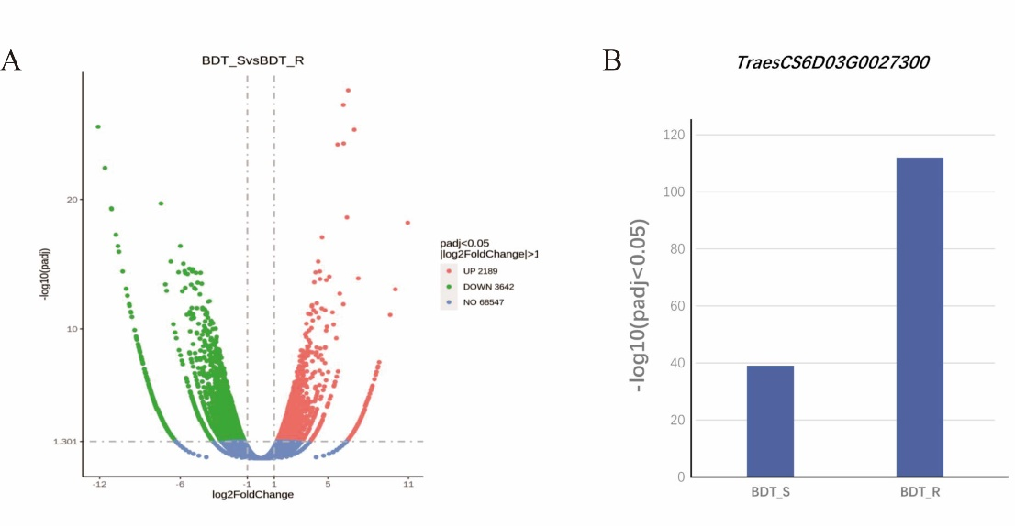
Figure S4 Relative expression of genes between the R-pool and S-pool estimated by RNA-seq
A. Volcanic map of differentially expressed genes between the R-pool and S-pool; The 2,189 genes were up-regulated and 3,642 genes were down-regulated in the S-pool compared with R-pool. B. Relative expression level of TraesCS6D03G0027300 in R-pool and S-pool estimated by RNA-seq.

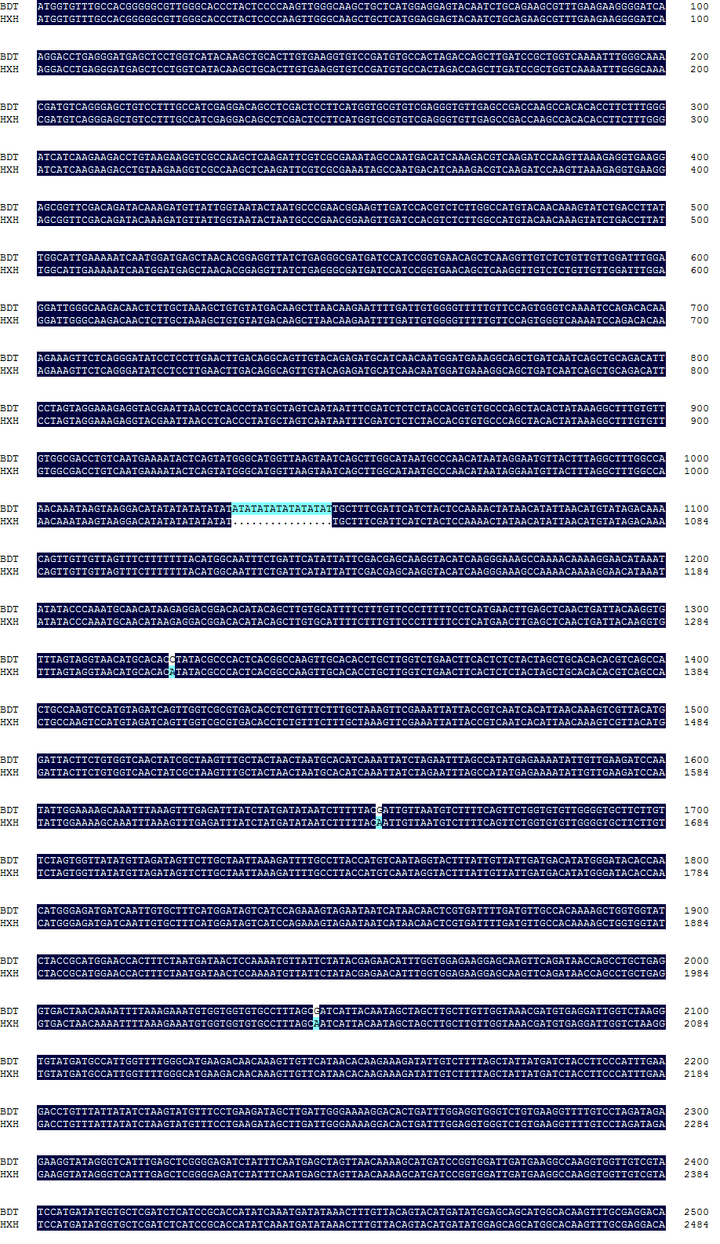
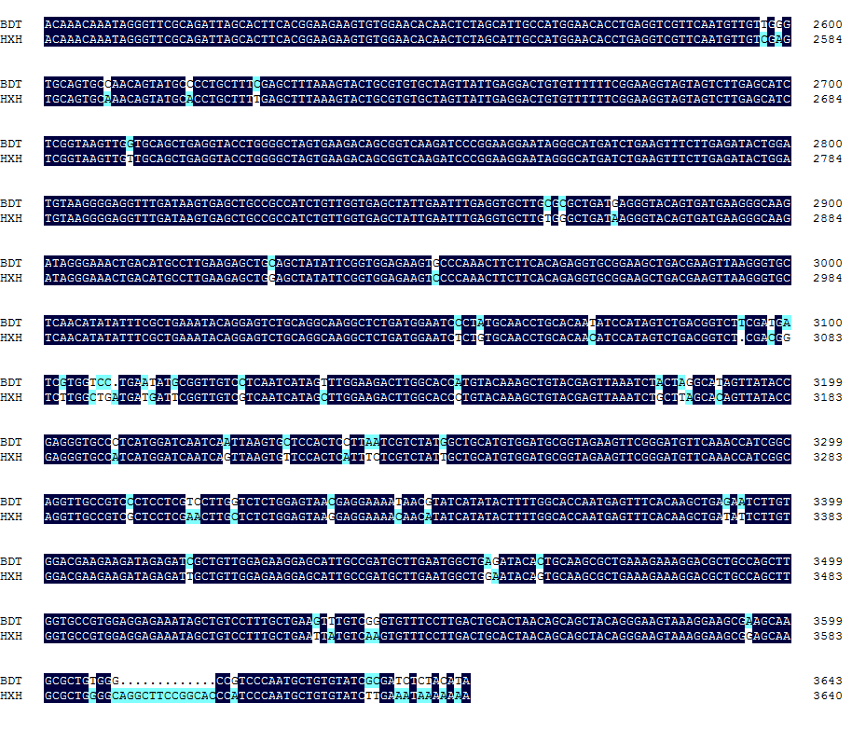
Figure S5 ORF sequences of TraesCS6D03G0027300 in Baidatou and Huixianhong
The ORF sequences of TraesCS6D03G0027300 in Baidatou (BDT) and Huixianhong (HXH) are 3,644 bp and 3,641 bp, respectively. Numbers on the right are base pair positions.

Figure S6 BSR-seq analysis of the R-pool and S-pool using Ae. tauschii ssp. strangulata accession AL8/78 as a reference D genome
Vertical scale is -log₁₀ (p). Polymorphic sites between resistant (R) and susceptible (S) pools were concentrated at the distal region of chromosome arm 6DS. The genome sequence for Ae. tauschii ssp. strangulata accession AL8/78 is from Luo et al. (2017).

Figure S7 Collinearity analysis of the 943.6-kb target interval in Chinese Spring RefSeq v2.1 with Ae. tauschii AL8/78 and Fielder according to the TGT website (http://wheat.cau.edu.cn/TGT/)
The 943.6-kb target interval in Chinese Spring shows close collinearity with the Ae. tauschii AL8/78 and Fielder genomes. Putative homologous disease resistance genes in the collinear interval of the three genomes.

Figure S8 Genetic map and physical positions of the adult-plant resistance gene YrBai (Li et al. 2018).
A. Genetic map of YrBai (cM). B. Physical distance (Mb) of YrBai and markers. (Li et al. 2018)

Figure S9 Phylogenetic analysis of TraesCS6D03G0027300 in Triticum species
Line and numbers on the lower left indicate branch length. Line and numbers at the lower right indicate ORF sequence length; 5’ to 3’ is from left to right.
Figure S10 Collinearity analysis of 943.6-kb interval in Chinese Spring RefSeq v2.1 with 15 Triticum species at TGT website (http://wheat.cau.edu.cn/TGT/)
The 943.6-kb target interval in Chinese Spring showed a high collinearity with the genomes of 14 Triticum accessions except T. aestivum cv. Julius that had an insertion of 38 genes compared with Chinese Spring in the collinear interval.

Table S1 Infection types of Baidatou and Huixianhong to 11 Pst races at the seedling stage
Pst racesª | Baidatou | Huixianhong | Mingxian 169^{b}
CYR27 | 2ª | 4 | 4
CYR29 | 0; | 4 | 4
CYR31 | 0; | 4 | 4
CYR32 | 1 | 4 | 4
CYR33 | 0; | 4 | 4
CYR34 | 0; | 4 | 4
Su-1 | 2 | 4 | 4
Su-3 | 0 | 4 | 4
Su-4 | 0; | 4 | 4
Shuiyou Ⅱ | 2- | 4 | 4
Su-35 | 2+ | 4 | 4
ª The Pst races and phenotype identifications provided by Dr. Ruiming Lin. Seedling infection types based on a 0–4 scale infection types (ITs) referred (Bariana and McIntosh 1993)
^{b} Susceptible control

Table S2 Gene-specific primers for candidate genes and the internal control ACTIN gene
Gene IDª | Primer sequence (5′–3′)^{b}
TraesCS6D03G0026700 | F1: GCACACCACCACATTTCTTTAAG  R1: CGCGCTATGATTAATCTACTTTCT
TraesCS6D03G0026700 | F2: AATAGTGCTGCACACCAGGAG  R2: GCGCGTGAATATGATGTAGTAGTT
TraesCS6D03G0026800 | F1: ATACGTCTCCCTCGAGCCTCT  R1: TTACAACAGGTCCTTGATCCGT  F2: GCAACAACATCACTGAATCAAAG  R2: GCTCCTGAGTTACTATCCACCAG
TraesCS6D03G0027300 | F1: TCTCCTTGAACTTGACAGGCAGT  R1: CCATGAAAGCACAATTGATCATC  F2: CCTGGATCTGTTGGTGAGCTAT  R2: CGTAGAGGACAACCGCATATTC
TraesCS6D03G0027400 | F1: ACTGGAGATTCACATGCCTGAC  R1: CAAGCAAGCACACTTAATCACG  F2: GCAGAGTCACAGAAACAATGGT  R2: AGCACACCACCACATTTCTTTAAG
TraesCS6D03G0027500 | F1: ACGTAACCTCACCCTATGCTAGTC  R1: ATCCTTCTCCACCAAATGTTCTC  F2: ATCGGTACCGTCGTCATCGTC  R2: ATATCGAGGATGTGGGCCGTG
ACTIN | F: ATGGAAGCTGCTGGAATCCAT  R: CCTTGCTCATACGGTCAGCAATAC
ª Gene sequences were downloaded from Chinese Spring genome sequences RefSeq v2.1 (IWGSC 2021).
^{b} F: forward primer; R: reverse primer

Table S3 Polymorphic sites on chromosome arm 6DS between resistant (R) and susceptible (S) pools based on BSE-seq
Variation type | Physical positionª | R pool^{b} | S pool | ED index
SNP | 680,760 | G | A | 1.41
SNP | 723,355 | G | A | 1.41
SNP | 723,606 | A | T | 1.41
SNP | 723,630 | G | A | 1.41
SNP | 1,410,201 | G | T | 1.41
SNP | 1,413,142 | G | T | 1.41
SNP | 1,414,825 | G | A | 1.41
SNP | 1,420,525 | T | C | 1.41
SNP | 1,517,479 | G | A | 1.41
SNP | 1,517,480 | A | T | 1.41
SNP | 1,560,260 | G | T | 1.41
SNP | 1,760,546 | G | A | 1.41
SNP | 1,769,717 | G | A | 1.41
SNP | 1,782,447 | T | A | 1.41
SNP | 1,839,982 | C | A | 1.41
SNP | 1,854,954 | C | A | 1.41
SNP | 2,051,457 | T | C | 1.41
SNP | 2,355,594 | G | A | 1.41
SNP | 3,711,397 | G | A | 1.41
SNP | 3,738,926 | T | A | 1.41
SNP | 3,824,246 | A | G | 1.41
SNP | 3,926,512 | G | C | 1.41
SNP | 3,940,496 | C | G | 1.41
SNP | 3,973,962 | C | T | 1.41
SNP | 3,973,965 | G | C | 1.41
SNP | 3,998,177 | T | A | 1.41
InDel | 4,060,286 | CT | CTTAT | 1.41
SNP | 4,060,291 | C | A | 1.41
SNP | 4,273,791 | T | A | 1.41
SNP | 4,283,189 | G | T | 1.41
SNP | 4,870,589 | A | T | 1.41
SNP | 4,870,596 | G | C | 1.41
SNP | 4,871,068 | C | T | 1.41
SNP | 5,078,288 | G | C | 1.41
SNP | 5,078,313 | C | G | 1.41
SNP | 5,149,136 | A | G | 1.41
SNP | 5,480,059 | C | A | 1.41
SNP | 5,480,062 | G | T | 1.41
SNP | 5,480,063 | A | T | 1.41
SNP | 5,480,071 | T | C | 1.41
SNP | 5,564,697 | C | A | 1.41
SNP | 5,565,083 | C | T | 1.41
SNP | 5,565,137 | C | G | 1.41
SNP | 5,845,889 | G | A | 1.41
SNP | 5,941,235 | G | A | 1.41
InDel | 5,976,451 | CA | CAA | 1.41
SNP | 5,976,691 | A | G | 1.41
SNP | 7,101,793 | T | C | 1.41
ª Physical positions refer to Chinese Spring genome RefSeq v1.1 (IWGSC 2018).
^{b} Base pair types of R and S pools at each SNP site

Table S4 Molecular markers flanking YrBDT
Marker name | Primer sequence (5′–3′)ª | Product size (bp) | Endonuclease or SNP/InDel
CAPS1 | F: AACCCAATACTCCGCCACAAGT  R: GAGCCTCCTGCCGTAATACCT | 1,285 | NcoI
CAPS2 | F: ATACGCAACGGGCAATTCAACT  R: TACTGCGAGCATGTGAAGTCAG | 608 | AseI
CAPS3 | F: AATTGGTGGTGTGCCTTTAGCG  R: ATGCCCTTCATCACTGTACCCTC | 831 | TaqI
STS1 | F: AGGCTATGGCGGCAAATTGT  R: CCACTTTGTCATGGCATAAGCTC | 920/742^{b} | InDel
STS2 | F: GTCACGAGAGCTTGGTCCAG  R: AAGGTCATGTGGCACGAATTC | 651/629^{c} | InDel
STS3 | F: CCAAACAGAACTTCAGAACCTCAT  R: CCGATGTGCTACAAGATTCCAG | 879/836^{d} | InDel
KASP75 | A: GAAGGTGACCAAGTTCATGCTtaagtcgg  ctgtctgttcgcc  B: GAAGGTCGGAGTCAACGGATTtaagtcgg  ctgtctgttcgct  C: cgtcatatagttcgctgatcccg | - | -
ª F: forward primer; R: reverse primer
^{b} 920/742: PCR products in Baidatou and Huixianhong are 928 and 742 bp, respectively
^{c} 651/629: PCR products in Baidatou and Huixianhong are 651 and 629 bp, respectively
^{d} 879/836: PCR products in Baidatou and Huixianhong are 879 and 836 bp, respectively

Table S5 Descriptions of five putative disease resistance genes in the 943.6-kb target genomic region based on Chinese Spring genome sequences
Gene IDª | Length  (bp) | Start position  (Mb) | Gene annotation^{b}
TraesCS6D03G0026700 | 8,080 | 5,190,029 | TIR-NBS-LRR
TraesCS6D03G0026800 | 5,990 | 5,209,297 | TIR-NBS-LRR
TraesCS6D03G0027300 | 3,644 | 5,279,686 | TIR-NBS-LRR
TraesCS6D03G0027400 | 7,036 | 5,306,255 | TIR-NBS-LRR
TraesCS6D03G0027500 | 4,786 | 5,323,022 | TIR-NBS-LRR
ª Sequences were downloaded from Chinese Spring genome RefSeq v2.1 (IWGSC 2021).
^{b} Gene annotations according to Chinese Spring genome RefSeq v2.1 (IWGSC 2021).

Table S6 Polymorphic SNPs on chromosome 6DS between resistant (R) and susceptible (S) pools based on BSR-seq
Variation type |  | Physical positionª | R pool^{b} | S pool | SNP-index
SNP | 1,049,925 |  | C | T | 1
SNP | 1,049,927 |  | T | T | 0
SNP | 1,049,958 |  | G | G | 0
SNP | 1,264,444 |  | T | G | 1
SNP | 1,461,289 |  | G | A | 1
SNP | 1,487,102 |  | A | C | 1
SNP | 1,833,743 |  | C | G | 1
SNP | 3,968,860 |  | T | T | 0
SNP | 4,029,104 |  | G | G | 0
SNP | 4,029,197 |  | C | T | 1
SNP | 4029230 |  | G | G | 0.05
SNP | 4,211,389 |  | G | G | 0
SNP | 4,211,392 |  | A | A | 0
SNP | 4,247,210 |  | C | G | 1
SNP | 4,336,739 |  | G | G | 0
SNP | 4,336,756 |  | A | A | 0
SNP | 4,455,047 |  | C | T | 1
SNP | 4,659,475 |  | T | T | 0
SNP | 4,659,479 |  | G | G | 0
SNP | 4,659,486 |  | C | C | 0
SNP | 4,659,517 |  | C | C | 0
SNP | 4,659,589 |  | G | A | 1
ª Physical position relative to Ae. tauschii ssp. strangulata accession AL8/78 (Luo et al., 2017)
^{b} Base pair types of R and S pools at each SNP position

Table S7 Putative disease resistance genes in the collinear interval of the 943.6-kb target region in Ae. tauschii and wheat cultivar Fielder
Gene IDª | Species/cultivar | Gene annotation^{b}
AET6Gv20022000 | Ae. tauschii | Disease resistance protein RGA5
AET6Gv20022200 | Ae. tauschii | Disease resistance protein RGA5
AET6Gv20023100 | Ae. tauschii | Disease resistance protein Piks-2
TraesFLD6D01G004600 | Fielder | Disease resistance protein RGA5
TraesFLD6D01G004700 | Fielder | Disease resistance protein RGA5
TraesFLD6D01G004800 | Fielder | NA
TraesFLD6D01G004900 | Fielder | Disease resistance protein PIK6-NP
TraesFLD6D01G005000 | Fielder | Disease resistance protein PIK6-NP
TraesFLD6D01G005100 | Fielder | Disease resistance protein RGA5
TraesFLD6D01G005200 | Fielder | Disease resistance protein RGA5
TraesFLD6D01G005300 | Fielder | Disease resistance protein RGA5
TraesFLD6D01G005400 | Fielder | Disease resistance protein RGA5
TraesFLD6D01G005500 | Fielder | Disease resistance protein RGA5
ª Gene ID refer to Ae. tauschii ssp. strangulata accession AL8/78 (Zhu et al. 2021) and T. aestivum cv. Fielder genome (Sato et al. 2021).
^{b} Gene annotations according to Ae. tauschii ssp. strangulata accession AL8/78 (Zhu et al. 2021) and T. aestivum cv. Fielder genome (Sato et al. 2021) on the TGT website (http://wheat.cau.edu.cn/TGT/)

