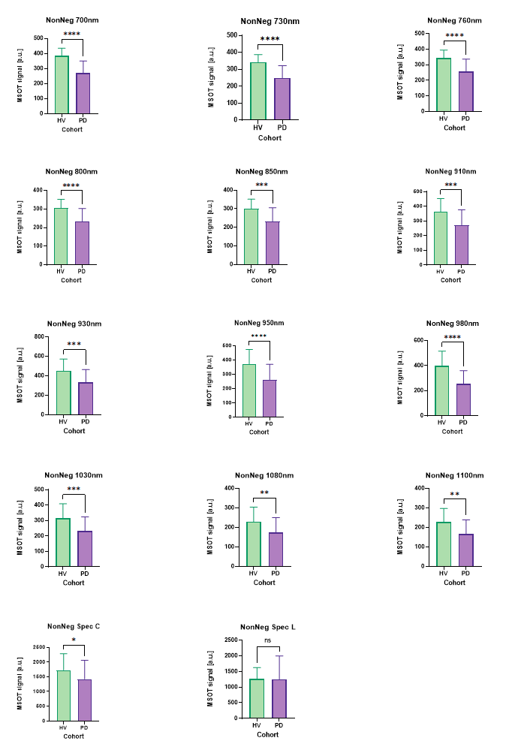
Figure S1. MSOT Quantification of biceps muscle using non-negativ signals. Comparison of signal intensity for single wavelength (700-1100m), MSOT_{col} and MSOT_{lip} between HV and PD.

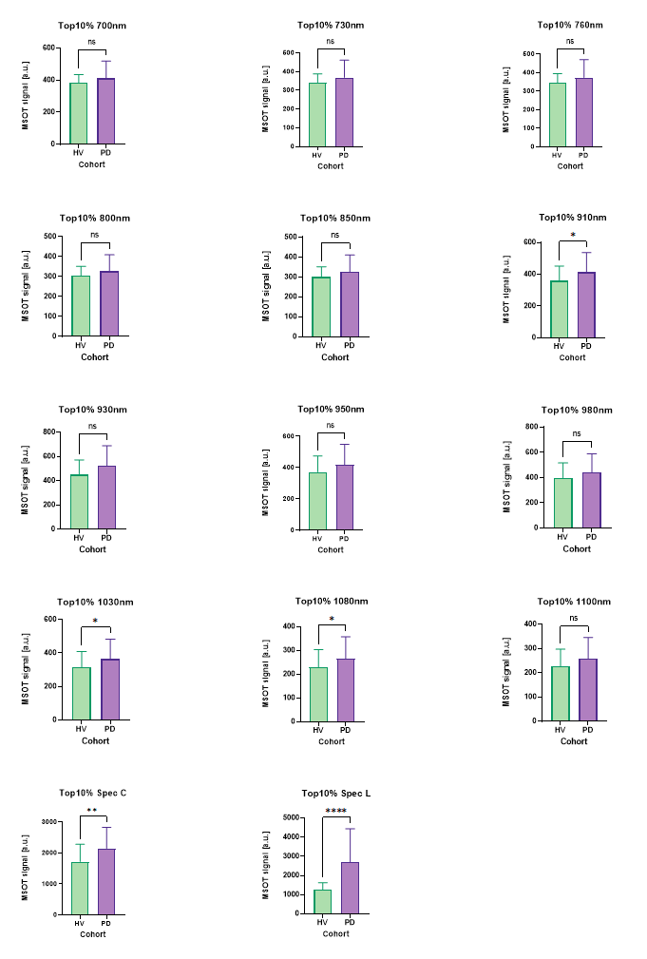
Figure S2. MSOT Quantification of biceps muscle using top 10% of total signals. Comparison of signal intensity for single wavelength (700-1100m), MSOT_{col} and MSOT_{lip} between HV and PD.
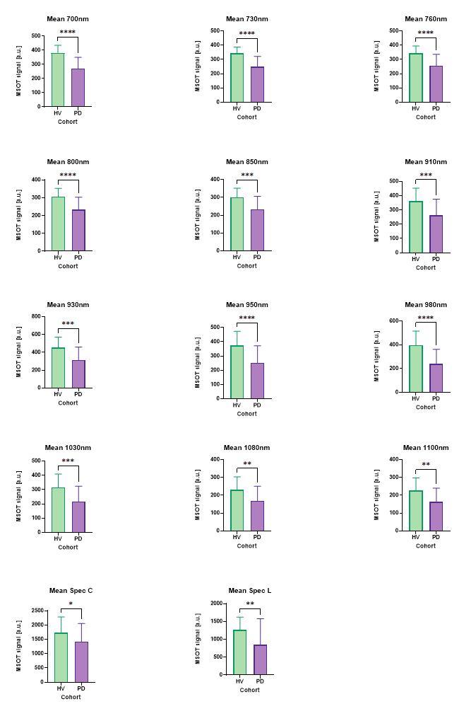
Figure S3. MSOT Quantification of biceps muscle using mean signals. Comparison of signal intensity for single wavelength (700-1100m), MSOT_{col} and MSOT_{lip} between HV and PD.

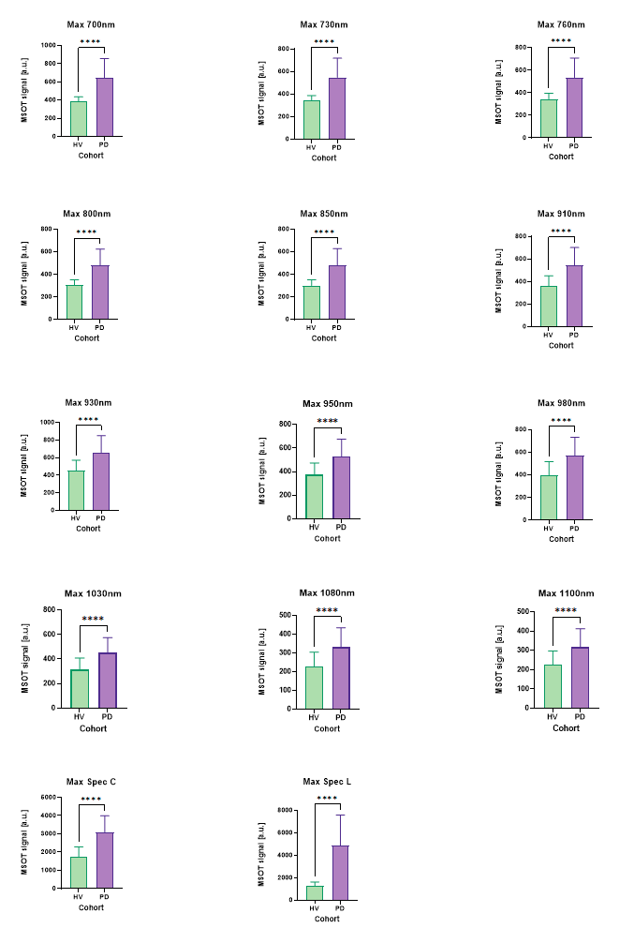
Figure S4. MSOT Quantification of biceps muscle using maximum signals. Comparison of signal intensity for single wavelength (700-1100m), MSOT_{col} and MSOT_{lip} between HV and PD.

