Supplementary Material

MODEL SETUP
Meteorological forcing. As described in Table 1SM, reference simulations for the years 2005, 2008 and 2019 used hourly experimental data from observations of pressure, wind speed (u and v), total precipitation, relative humidity, average air temperature, solar radiation at the Earth's surface, thermal radiation at the ground).
Climate scenario simulations (RCP 8.5 and RCP 4.5 2006-2100) used daily model outputs from the regional model COSMO CLM (Bucchignani et al., 2016; Zollo et al., 2016) at 8 km (0.0715°) resolution , for the same parameters. COSMO CLM is a climate model used for dynamical downscaling of global climate simulations in the Italian peninsula.
Sea level data. For the reference scenario we used observations, as described in Table2, while for the climate scenarios we calculated a linear trend of sea level rise between 2019 and 2100, derived from the median values (50th percentile) of a set of models (Zanchettin et al., 2021, Fox-Kemper et al., 2021). The value of sea level rise 0.71 m is applied for the year 2100 under the RCP 8.5 scenario (Zanchettin et al., 2021), and a value of 0.52 m by 2100 is applied for the RCP 4.5 scenario (median value for Venice of the AR6 IPCC ensemble, Fox-Kemper et al., 2021).
Marine boundary data (temperature and salinity at the inlets) for the three reference years were taken from experimental values collected by the regional protection agency and available on the agency website (www.arpaveneto.it). Marine boundary data for the climate scenario were derived from the CMCC-MFS16-NEMO the regional model of the Mediterranean Sea, used to downscale the climate global simulations (https://dds.cmcc.it/#/dataset/medsea-cmip5-projections-physics, (Lovato, 2022; Reale et al., 2022; Solidoro et al., 2022). Output of the CMCC-MFS16-NEMO model for the two scenarios RCP 4.5 and 8.5 were used to calculate average anomalies for each year in the period 2020-2100 with respect to the reference year (2019). The obtained trends of anomaly were applied to the monthly data available from field observations for present state (2019) to provide local forcings for the two scenarios RCP 4.5 and 8.5.

The regulation of MOSE closure was introduced following the procedure described in some internal reports of the Consorzio Venezia Nuova and in Umgiesser et al. 2020 and applied to the scenario simulations: every time that a tidal peak higher than 110 cm would have been reached, the closure was applied, by anticipating the incoming tide and preventing the sea level to rise above 90 cm during the considered tidal cycle. Reopening was set as soon as the decreasing tide would reach again the 90 cm threshold.

Forcing and inputs

Input and forcing |  | Source | Stations | year/ | years | Variable | Frequency
Meteo (data) | ISPRA |  | Sea inlets and Lagoon | 2005  2008  2019 |  | Pressure (Pa), wind speed (u,v) m/s  rain kg/m2  rel. humidity %  average air temperature °K  solar radiation w/m2 | hourly
Meteo (model)  Bucchignani et al., 2016  Zollo et al., 2016  RCP 8.5  RCP 4.5 | CMCC |  | Venice Lagoon domain | 2006 | 2100 | Pressure (Pa), wind speed (u,v) m/s  rain kg/m2  rel. humidity %  average air temperature °K  solar radiation w/m2 | daily
Sea level (data) | ISPRA |  | Sea inlets | 2005,  2008  2019 |  | Measured levels (m) | hourly
Sea level (model)  RCP 8.5  RCP 4.5 |  |  | Sea inlets | 2006 | 2100 | Levels (m) Model projections adjustment | hourly
Physical-chemical state of sea boundaries  (model)  RCP 8.5  RCP 4.5 | CMCC |  | Adriatic Sea data points closest to the Lagoon inlets | 2006 | 2100 | Water temperature (°C)  Salinity  Model projections adjusted with measures | daily
River runoff data | CORILA |  | Rivers | 2005, 2008, 2019 |  | Rivers runoff (m3/s) | hourly
Regression model projections | This work |  | Rivers | 2019 | 2100 | Regression model projections (m3/s) | hourly
River measurements | ARPAV |  | Rivers | 2005, 2008, 2019 | 2019-12 | Water temperature (°C) | monthly
River  projected | This work |  | Rivers | 2019 | 2100 | Water temperature (°C) | hourly
Table 1SM. List of inputs and forcing for reference and climate change scenario simulations with sources.

Scenarios
Boundary conditions and forcing
Three reference simulations for the years 2005, 2008 and 2019, characterised by different meteorological forcing conditions, were performed to test the model agreement with the measurements.
The model was then used to represent the two selected climate scenarios, RCP 4.5 and RCP 8.5, with and without MOSE closures (as summarised in Table 2SM).

Simulations | Time | Scenario | Marine boundary conditions | River inflows | Model output
Reference | 2005, 2008, 2019 | Hindcast | Temperature, Salinity, Water Levels Measures and CMEMS | Temperature, Salinity | Temperature, Salinity, Water levels, Water velocity
Clima100_4.5  Clima100_4.5_MOSE | 2019-2100 | Projection RCP 4.5 | Temperature, Salinity, Water Levels | Temperature, Salinity | Temperature, Salinity, Water levels, Water velocity
Clima100_8.5  Clima100_8.5_MOSE | 2019-2100 | Projection RCP 8.5 | Temperature, Salinity, Water Levels | Temperature, Salinity | Temperature, Salinity, Water levels, Water velocity
Table 2SM. List of the simulations. Reference simulations and climate scenarios for RCP 4.5 and RCP 8.5 projections, with and without closing the lagoon inlets.

Model calibration and data comparison

The model responses show good agreement with the observed physical and chemical values with a coefficient of determination R² between 0.97 and 0.98 for temperature, 0.6 for salinity and 0.76 and 0.97 for levels. Figure 1SM shows the comparison between simulated and observed values of water levels sampled at the 11 stations (shown in Figure 2SM of the manuscript) located in different areas of the lagoon, presenting differences in hydrodynamic conditions. The simulated curves agree well with the experimental data, both in terms of phase and intensity. The median value of the root mean square error RMSE for the predicted/observed values of the stations is 0.06 m and the bias of 0.02 m.

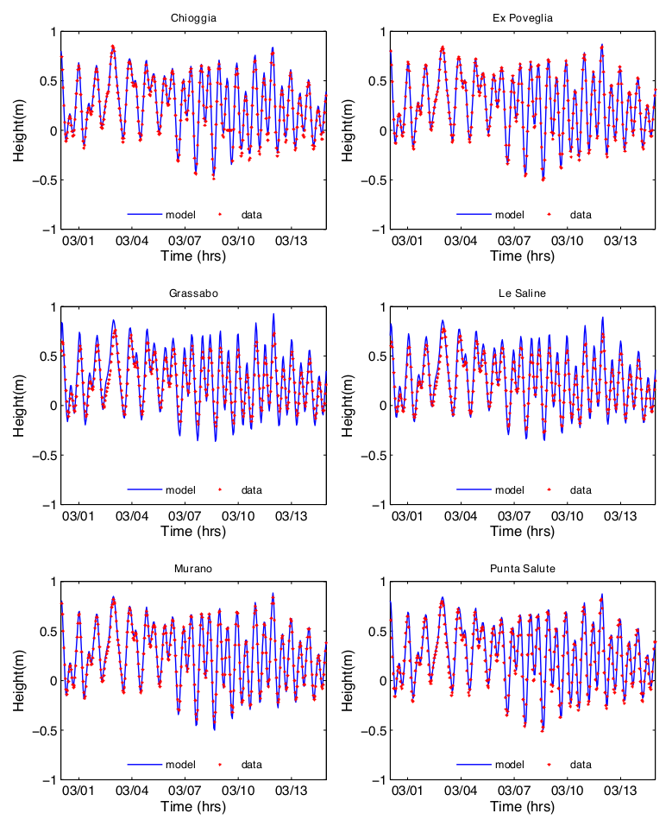
Figure 1SM. Model data comparison for the water levels in 6 sampling stations indicated in the map of Figure 1 in the manuscript.

Water residence times (WRT) The average WRT computed for the three reference (2005, 2008, and 2019) years are, respectively of 11, 7 and 9, days in agreement with Umgiesser et al. (2014) and with previous studies which, however, were based on a fewer number of simulations. Our statistics, which is robust, shows the typical variability of coastal Lagoons. As shown in Figure 5 (main text), WRT present a spatial variability, with lowest values closer to the marine boundaries and closest to the main channels and highest values toward the mainland.

Temperature and Salinity
Temperature and salinity for the years 2005, 2008 and 2019 were computed and the model was evaluated by comparing the numerical results with available hourly measurements of water temperature and salinity obtained from the multi-parameter SAMANET network probes, which are spread across different areas of the lagoon at 9 stations (VE-01 – VE-10), as shown Figure 2SM. Each SAMANET station represents a specific area of the lagoon: the variations in thermohaline properties observed at different stations are the result of differences in the local environmental conditions such as confinement, depths, relevance of freshwater inputs, exchanges with the sea and the atmosphere, and human activities. The different stations are representative of specific areas of the lagoon: station VE-01 is located near the industrial center of Marghera; station VE-02 is located north of the city of Venice, with a limited influence of the heat exchange with the sea on the water temperature; station VE-03 is located near the mouth of the harbor of Malamocco, a position where it is highly exposed to exchanges with the sea; station VE-07 is located far from the harbor mouths, but near the mouth of the Dese River, and is therefore affected by freshwater inputs; station VE-08, like station VE-02, is representative of an area far from the harbor mouths, but located at the northern end of the lagoon; finally, station VE-09 is located in an interior lowland of the central southern lagoon.
Figure 2SM Spatial discretization of the lagoon domain represented by the grid VenlagBio_20. Yellow points indicate the sampling SAMANET stations and the blue points the tide gauge ISPRA stations.

As an example Figure 3SM, 4SM, 5SM, show the comparison between the daily average of hourly water temperatures measured at the SAMANET stations and predicted by the model for the years 2005, 2008 and 2019, respectively. The comparison indicates that the model’s predictions match reasonably well with the observed temperatures.
The root mean square error (RMSE) is calculated as the difference between the modeled and observed temperatures using the formula RMSE $=\sqrt{\frac{\sum_{t=1}^{t=N}{{\left(x_{ot}-x_{mt}\right)}^{2}}}{N_{t}}}$, where $x_{ot}$ is the observation’s measured value at time t, and $x_{mt}$ is the modeled value at time t. Overall, the statistical analysis suggests that the model provides reasonably accurate predictions of water temperature in the Venice lagoon, with a RMSE of 1.91 °C (calculated as the median value) for the three years and the bias lower than ±1°C (median values for the three years, are, respectively of -0.05, -0.69 and -0.8 for the year 2005, 2008 and 2019).
Figure 3SM. Data-model comparison for water temperature for the 7 stations of the SAMANET network in the Venice lagoon during 2005. The 7 graphics on top show the model results (black lines) and measurement (red lines). The bottom figure shows the yearly statistical distribution of Δt, for every station a box-plot of the difference of water temperature between modeled and observed data is represented in blue. The rectangular box itself is drawn from the first to the third quartile (25th to 75th percentile), a red horizontal line drawn in the middle of the box denotes the median, while the upper and lower whiskers show the minimal and maximal values. The whiskers do not consider the most extreme data points considered as outliers; these outliers are represented individually by a red “+” symbol. All the median values of the difference between the model and observed data are in the range [-1,+1]°C (between the two dashed lines) except for Station 5.
Figure 4SM. Data-model comparison for water temperature for the 10 stations of the SAMANET network in the Venice lagoon during 2008. The 10 graphics on top show the model results (black lines) and measurement (red lines). The bottom figure shows the yearly statistical distribution of Δt, for every station a box-plot of the difference of water temperature between modeled and observed data is represented in blue. The rectangular box itself is drawn from the first to the third quartile (25th to 75th percentile), a red horizontal line drawn in the middle of the box denotes the median, while the upper and lower whiskers show the minimal and maximal values. The whiskers do not consider the most extreme data points considered as outliers; these outliers are represented individually by a red “+” symbol. Most of the median values of the difference between the model and observed data are in the range [-1,+1]°C (between the two dashed lines) except for Station 5.

Figure 5SM. Data-model comparison for water temperature for the 5 stations of the SAMANET network in the Venice lagoon during 2019. The top 5 figures show the model results (black lines) and measurement (red lines). The bottom figure shows the yearly statistical distribution of Δt, for every station a box-plot of the difference of water temperature between modeled and observed data is represented in blue. The rectangular box itself is drawn from the first to the third quartile (25th to 75th percentile), a red horizontal line drawn in the middle of the box denotes the median, while the upper and lower whiskers show the minimal and maximal values. The whiskers do not consider the most extreme data points considered as outliers; these outliers are represented individually by a red “+” symbol. (All the median values of the difference between the model and observed data are in the range [-1,+1]°C (between the two dashed lines)

SM 3:X RESULTS OF CLIMATE SCENARIOS

Table 3SM. Average, minimum, maximum, monthly (and yearly) lagoon, water levels (m) for 2019 and anomaly values in 2050 and 2100, relatively to the 2019 for the RCP 4.5 and 8.5, with (right hand side, identified by “_CLOSE”) and without (left hand side) lagoon closures.

Table 4SM. Average monthly lagoon basin salinity for the year 2019 and anomaly in 2050 and 2100, calculated relative to 2019, and average, maximum, and minimum values for the RCP 4.5 and 8.5, with and without lagoon closures.
Table 5SM. Average monthly lagoon water temperature (°C) for the year 2019 and anomaly in 2050 and 2100, calculated relative to 2019, and average, maximum, and minimum values for the RCP 4.5 and 8.5, with and without lagoon closures.

MHW
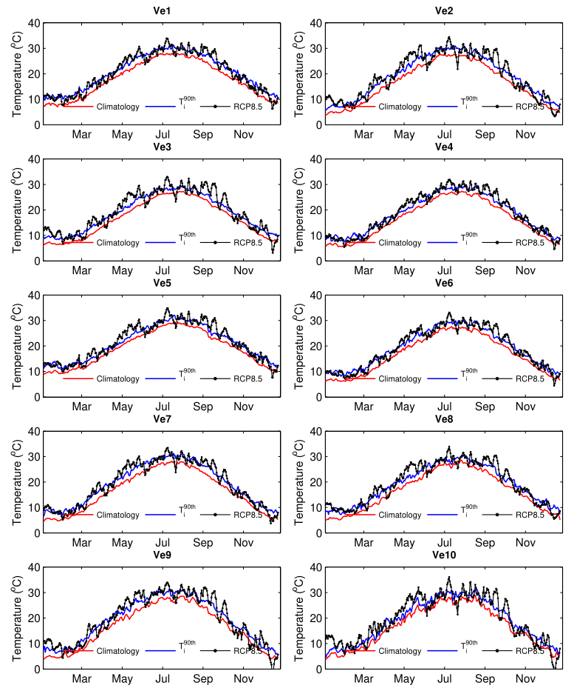
Figure 6SM. Mean 18-years climatology temperature, 90th percentile of the 18-years climatology $T_{i}^{90th}$(2005-2019) used as a threshold, and model projection for the scenario RCP 8.5 with MOSE, mid-future for each sampling station.

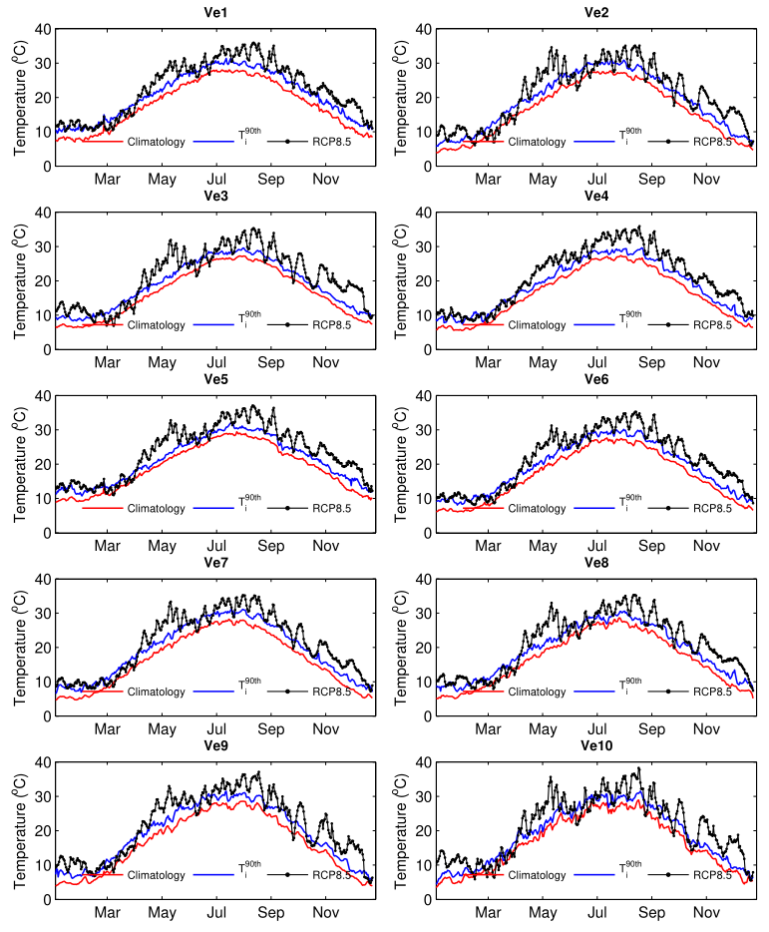Figure 7SM. Mean 18-years climatology temperature, 90th percentile of the 18-years climatology $T_{i}^{90th}$(2005-2019) used as a threshold, and model projection for the scenario RCP 8.5 with MOSE, far-future for each sampling station.

Summary table

 |  | REF | MID FUTURE |  |  |  | FAR FUTURE
 |  |  | 2050 | 2050 | 2050 | 2050 | 2100 | 2100 | 2100 | 2100
 |  |  | 4.5 | 4.5 | 8.5 | 8.5 | 4.5 | 4.5 | 8.5 | 8.5
INDOCATOR | UNIT | 2019 | NOMOSE | MOSE | NOMOSE | MOSE | NOMOSE | MOSE | NOMOSE | MOSE
Closures | [days/years] | 0 | 19 | 19 | 0 | 30 | 0 | 150 | 0 | 260
Water level rise | [m] | 0 | 0.20 | 0.19 | 0.27 | 0.25 | 0.52 | 0.42 | 0.72 | 0.48
WRT (average) | [days] | 8.8 | 9 | 9.3 | 9.6 | 10 | 10 | 13 | 11 | 17
% res time > 20 days | % lagoon area | 0.6 | 2.1 | 2.3 | 3.3 | 4.5 | 6.2 | 20.3 | 10.8 | 37.1
% res time > 30 days | % lagoon area | 0.4 | 0.4 | 0.4 | 0.4 | 0.7 | 0.4 | 2.8 | 1 | 12
% res time > 40 days | % lagoon area | 0.24 | 0.26 | 0.27 | 0.29 | 0.30 | 0.28 | 0.53 | 0.32 | 4.3
T> 30°C | % lagoon area | 1.3 | 3.8 | 3.8 | 1.9 | 1.9 | 9.4 | 8.7 | 22.3 | 21.5
MHW* | [average, days] | 65 | 217 | 216 | 193 | 189 | 252 | 251 | 280 | 268
MHW4*>4°C | [average, days] | 3.7 | 24 | 29 | 25 | 25 | 55 | 43 | 104 | 98
MHW4*>4 °C>4days | [# of events] | 2 | 6 | 6 | 5 | 5 | 6 | 7 | 12 | 10
MHW5*>5°C | [average, days] | 1,2 | 12 | 12 | 10 | 10 | 31 | 20 | 61 | 60
MHW5*>5°C>5days | [# of events] | 0 | 1 | 1 | 2 | 2 | 2 | 2 | 6 | 6

Table 6SM. Comparison among indicators computed for the different scenarios: Closures: number of days per year in which the barriers have to be closed to keep the water levels below the threshold, Water level rise: increment of the average lagoon water level compared to the reference (2019), WRT: % of the lagoon area with yearly averaged residence time > 20 days or of >30 days); T> 30 °C % of the lagoon area with T> 30 °C; MHW average number of days with T > $T_{i}^{90th}$ , the 90th percentile climatology computed over 18 years for the Samanet stations; MHW>4° average number of days with T > $T_{i}^{90th}+4°C;$MHW>4 °C>4days maximum number of events, per station, of T > $T_{i}^{90th}+4°C lasting 5 days or more$ (*: computed on SAMANET stations)

