SUPPORTING INFORMATION
Synthesis of urchin-like Au@TiO₂ nano-carriers in the drug-loading system toward cancer treatment
Anh-Thu Nguyen^{1,2}, Phuong Thi Le⁸, Thi H. Ho^{6,7}, Huong-Vy Thuy Ngo^{1,2}, Sy Van Vu^{1,2,3}, Tien Nu Hoang Lo⁴, In Park^{4,5}, Hsueh-Shin Chen⁹, Nguyet N. T. Pham^{1,2*}, Khuong Quoc Vo^{1,2*}.
¹ Faculty of Chemistry, Ho Chi Minh City University of Science, Vietnam National University, Ho Chi Minh City, 227 Nguyen Van Cu Street, Ward 4, District 5, Ho Chi Minh City 70000, Vietnam.
² Vietnam National University, Ho Chi Minh City, Vietnam.
³ Central Laboratory for Analysis, University of Science, Vietnam National University Ho Chi Minh City, Vietnam.
⁴ Research Institute of Clean Manufacturing System, Korea Institute of Industrial Technology (KITECH), 89 Yangdaegiro-gil, Ipjang-myeon, Cheonan 31056, South Korea.
⁵ KITECH school, University of Science and Technology (UST), 176 Gajeong-dong, Yuseong-gu, Daejeon 34113, South Korea.
⁶ Laboratory for Computational Physics, Institute for Computational Science and Artificial Intelligence, Van Lang University, Ho Chi Minh City, Vietnam.
⁷ Faculty of Mechanical - Electrical and Computer Engineering, School of Technology, Van Lang University, Ho Chi Minh City, Vietnam.
⁸ Institute of Applied Materials Science, Vietnam Academy of Science and Technology, Ho Chi Minh City 70000, Vietnam.
⁹ Department of Materials Science & Engineering, National Tsing Hua University, Hsinchu City 300, Taiwan
*Corresponding author
Email: ptnnguyet@hcmus.edu.vn, vqkhuong@hcmus.edu.vn

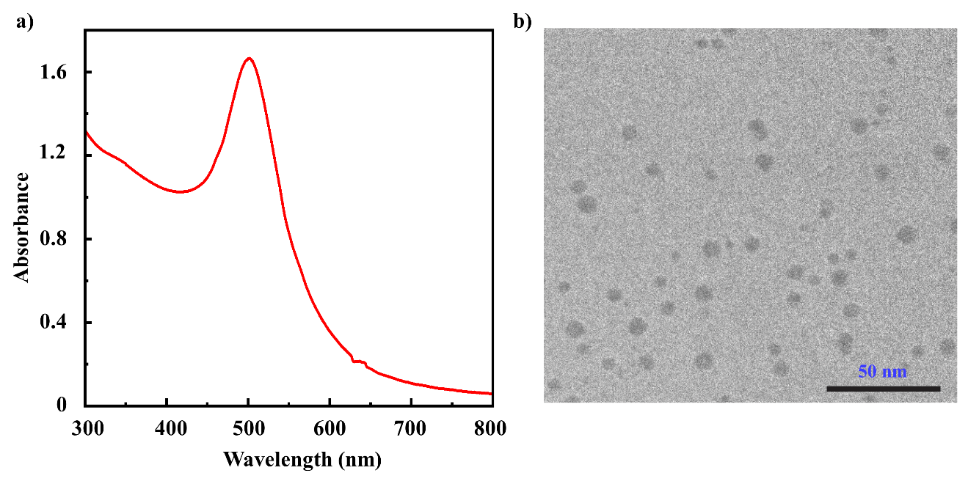

Fig. S1. (a) UV-Vis spectrum of aqueous colloidal Au seed solution, with SPR peak located at 506 nm. (b) TEM image of seed nanoparticles, scale bar 50 nm (no data).

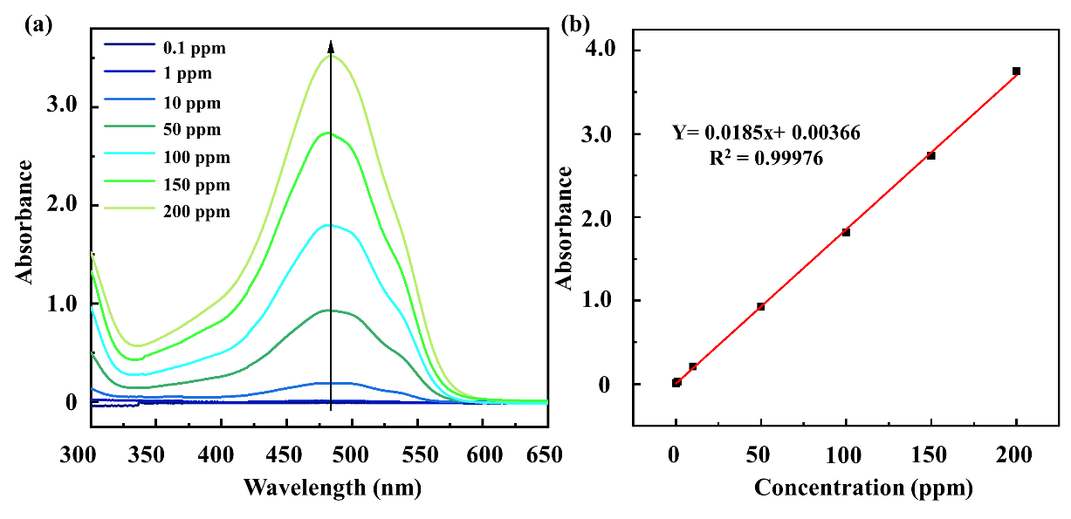

Fig. S2. (a) UV-Vis spectrum of Doxorubicin solutions with different concentrations (b) calibration curve illustrates the absorption as a function of the concentration of the DOX solution within the concentration range of 0.1 to 200 ppm.

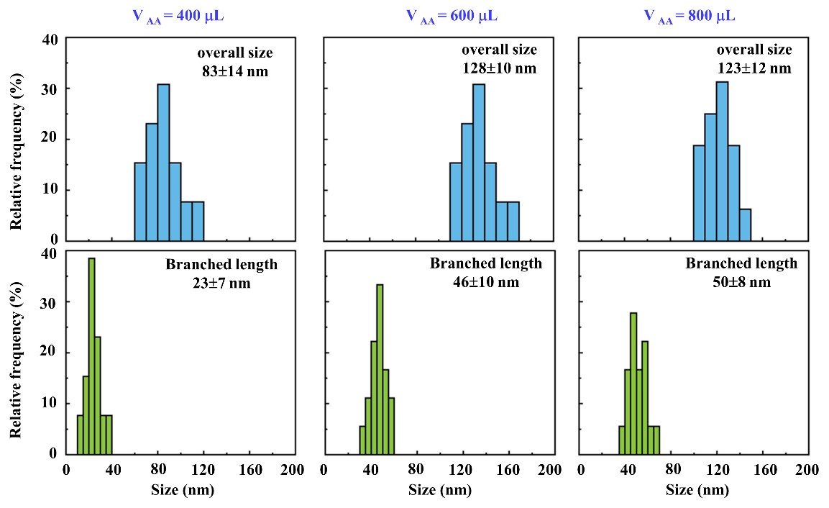

Fig. S3. Histogram of ULGNP size (top) corresponding spike lengths (bottom) synthesized with various ascorbic acid (AA) volumes of 400 μL, 600 μL, and 800 μl, respectively. The data is shown based on the collected SEM images of nearly 50 NPs.

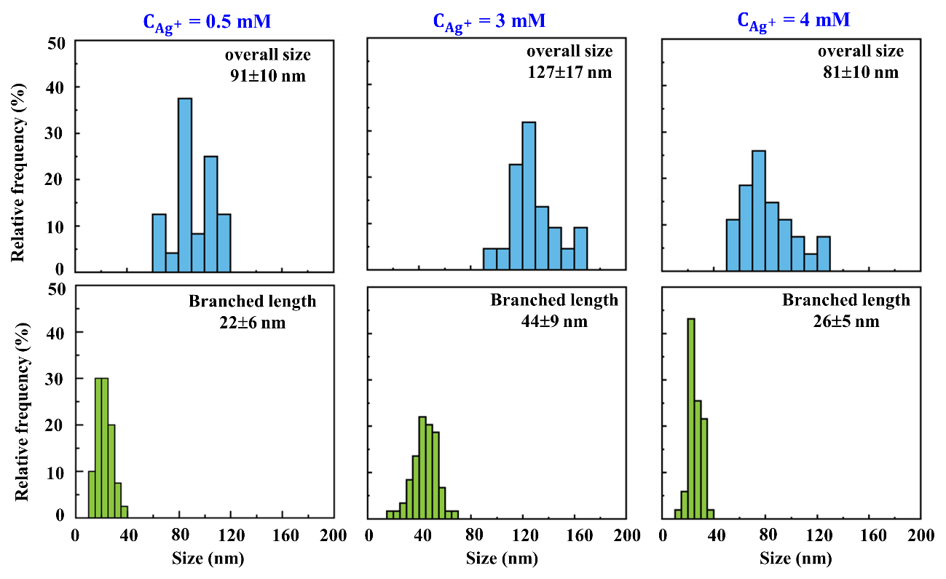

Fig. S4. Histogram of the ULGNPs (top) and the respective ULGNPs spike lengths (bottom) 0.5 mM, 3.0 mM, and 4.0 mM; respectively. The data is shown based on the collected SEM images of nearly 50 NPs.

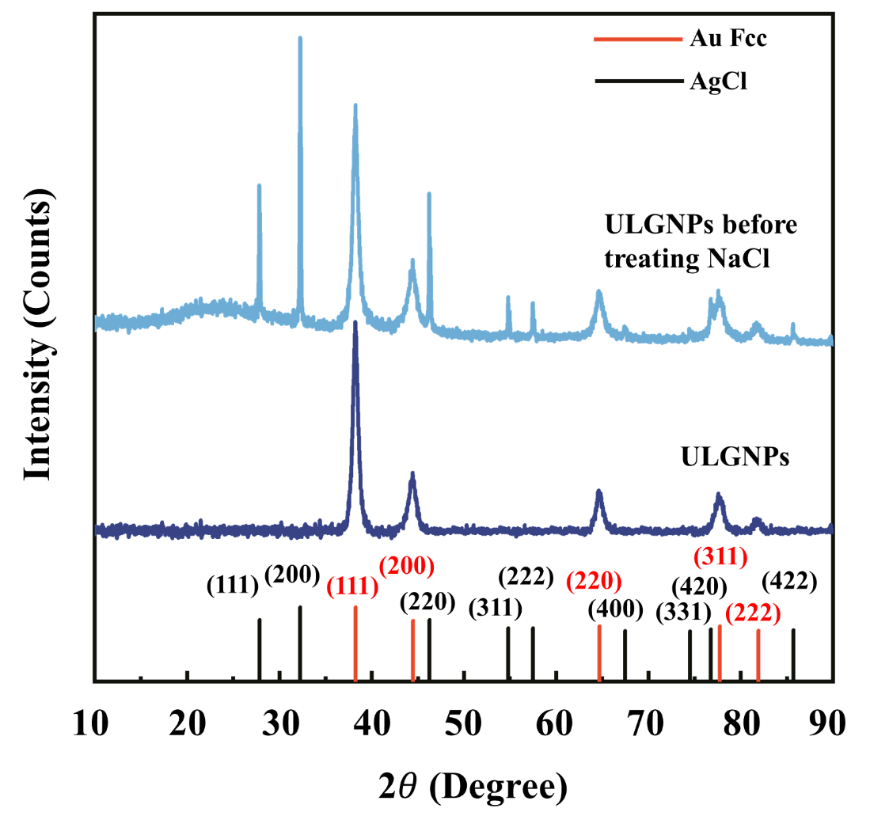

Fig. S5. X-Ray diffraction (XRD) pattern of (a) as-prepared ULGNPs and (b) ULGNPs after purifying with 0.5 M NaCl (Au Fcc JCPDS No. 03-065-8601 and AgCl cubic JCPDS No. 31-1238)
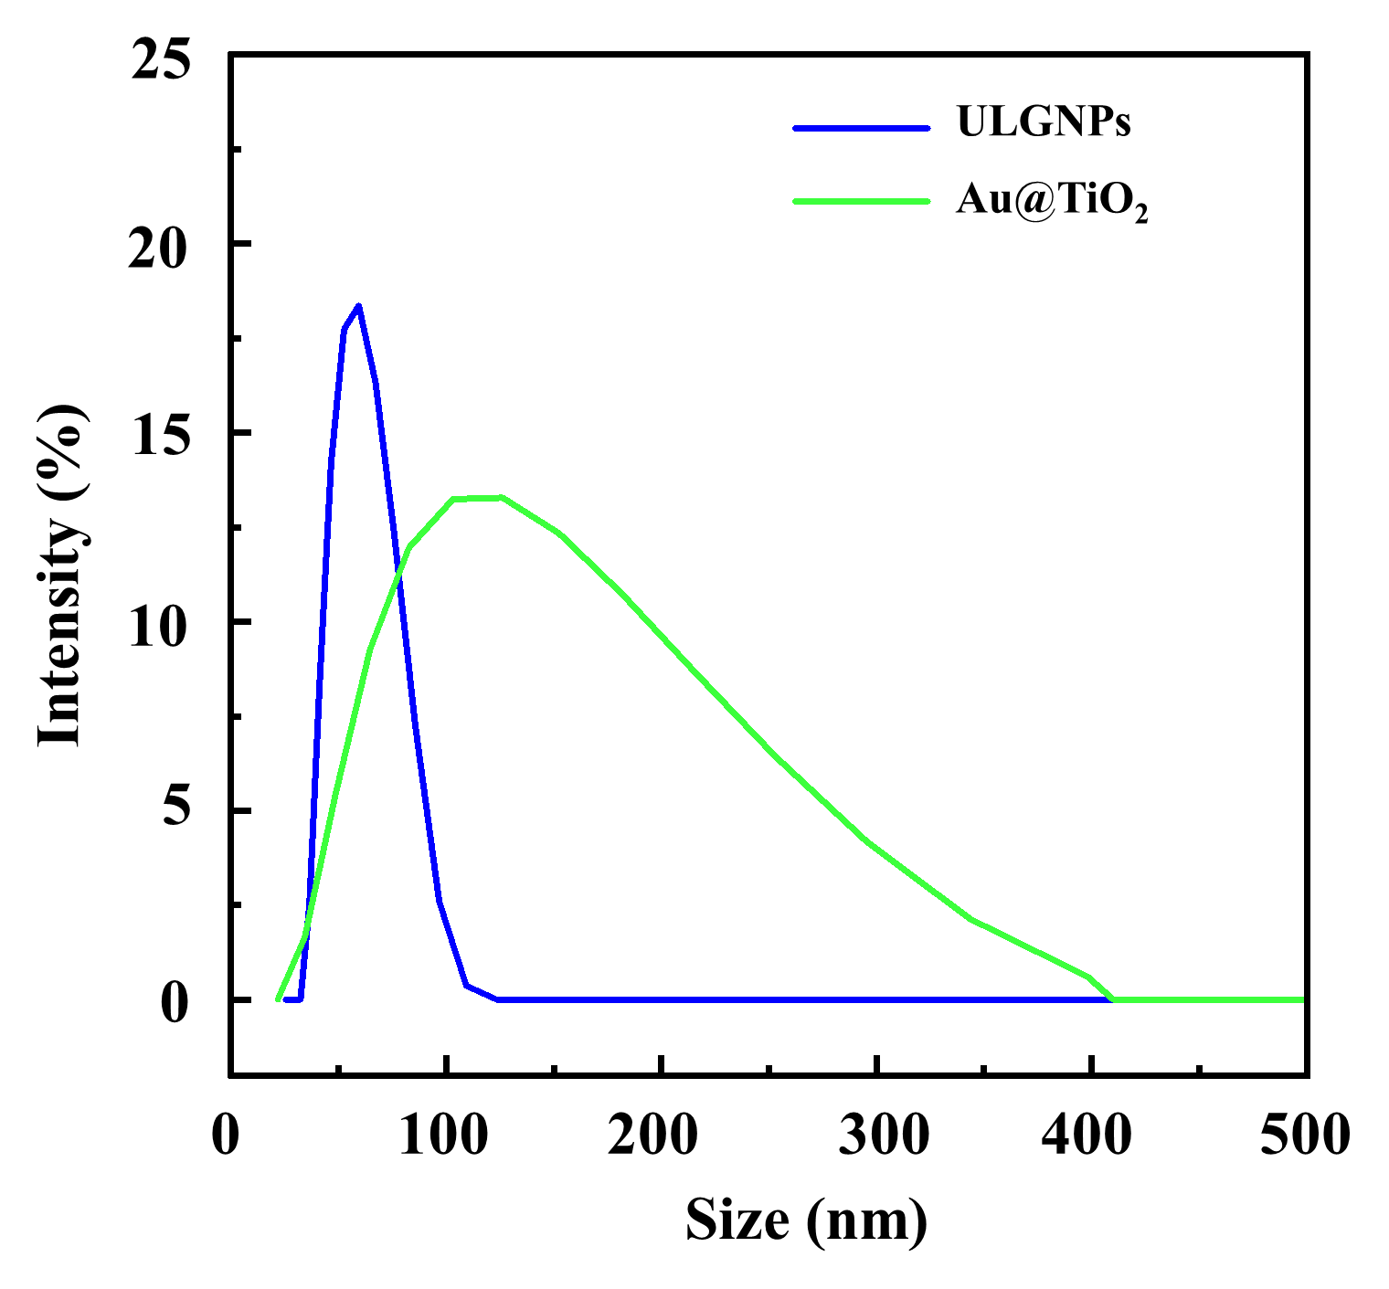

Fig. S6. DLS of the ULGNPs (blue curve) after washing with NaCl and dispersed in DI water and the Au@TiO₂ (green curve) synthesis with TTIP: IPA (8:2) in 24 hours.

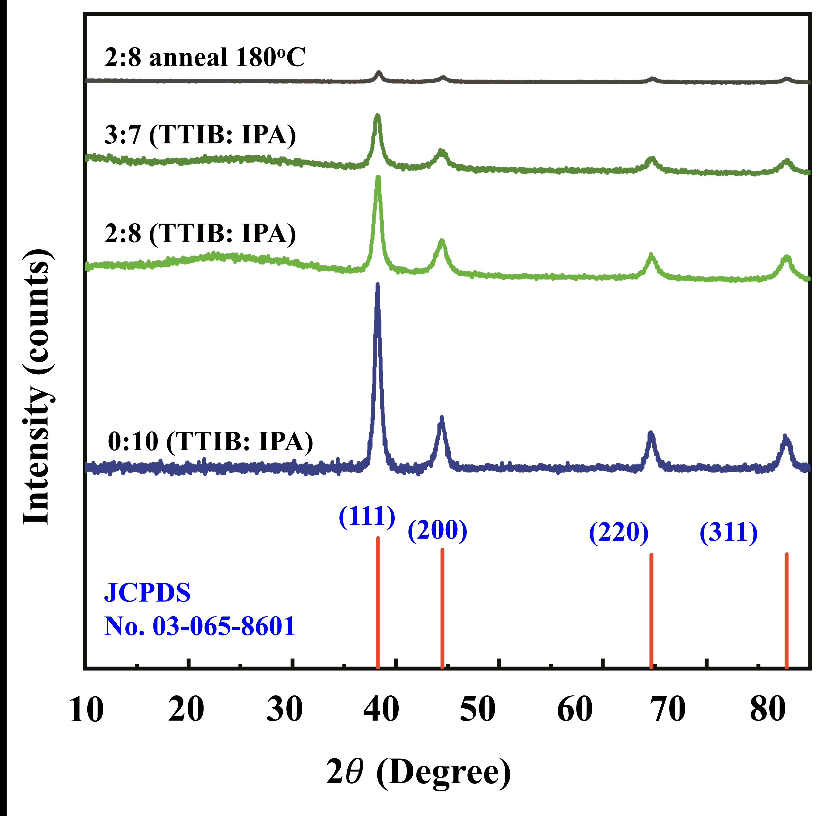

Fig. S7. XRD pattern of compared Au@TiO₂ conducted with the TTIP: IPA ratios of 0:10, 2:8, 3:7 and XRD pattern of Au@TiO₂ with TTIP:IPA ratio (2:8) anneal at 180ºC in 2 hours (Au Fcc JCPDS No. 03-065-8601)

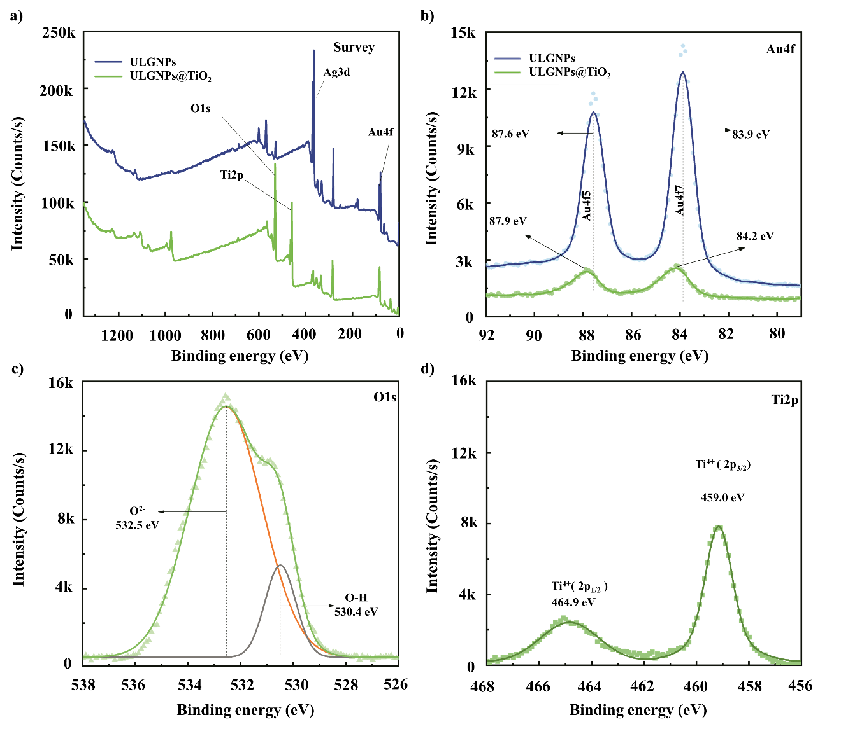

Fig. S8. (a) Survey XPS spectrum for Au@TiO₂-Dox and ULGNPs, High-resolution spectra of Au@TiO₂ in the b) Au_{4f}, (c) O_{1s}, (d) Ti_{2p} binding energy.

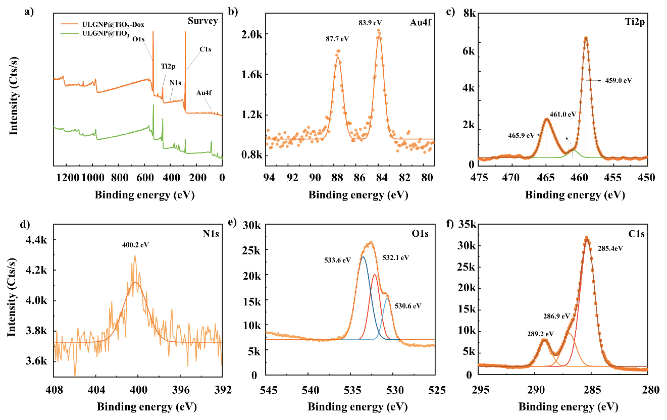

Fig. S9. (a) XPS survey spectra of Au@TiO₂-Dox and Au@TiO₂. High-resolution XPS spectra of Au@TiO₂-Dox in the (b) Au_{4f}, (c) Ti_{2p}, (d) N_{1s}, (f) C_{1s}, and (e) O1s regions

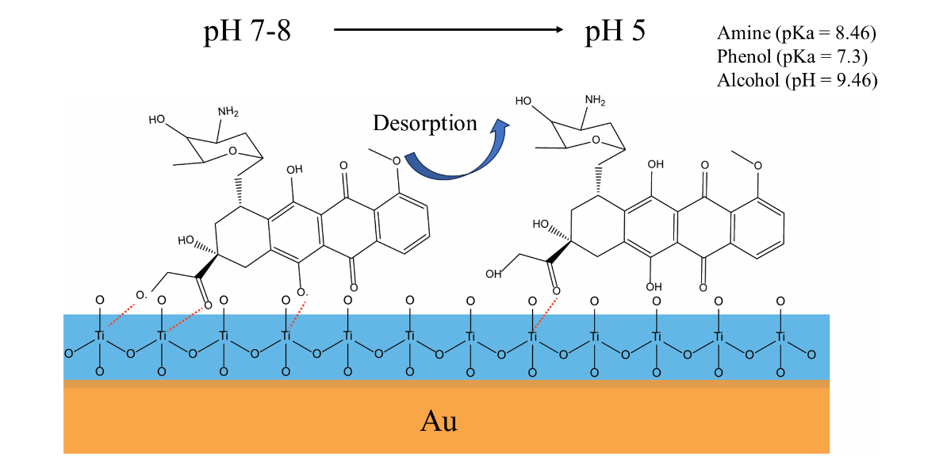

Fig. S10. Scheme illustrates the coordination bonds between Au@TiO₂ and Dox molecules, supporting enhanced Dox loading at pH 8 and controlled release at pH 5.

Fig. S11. SEM images of the obtained ULGNPs at different sizes and the cell uptake per well treated with these ULGNPs

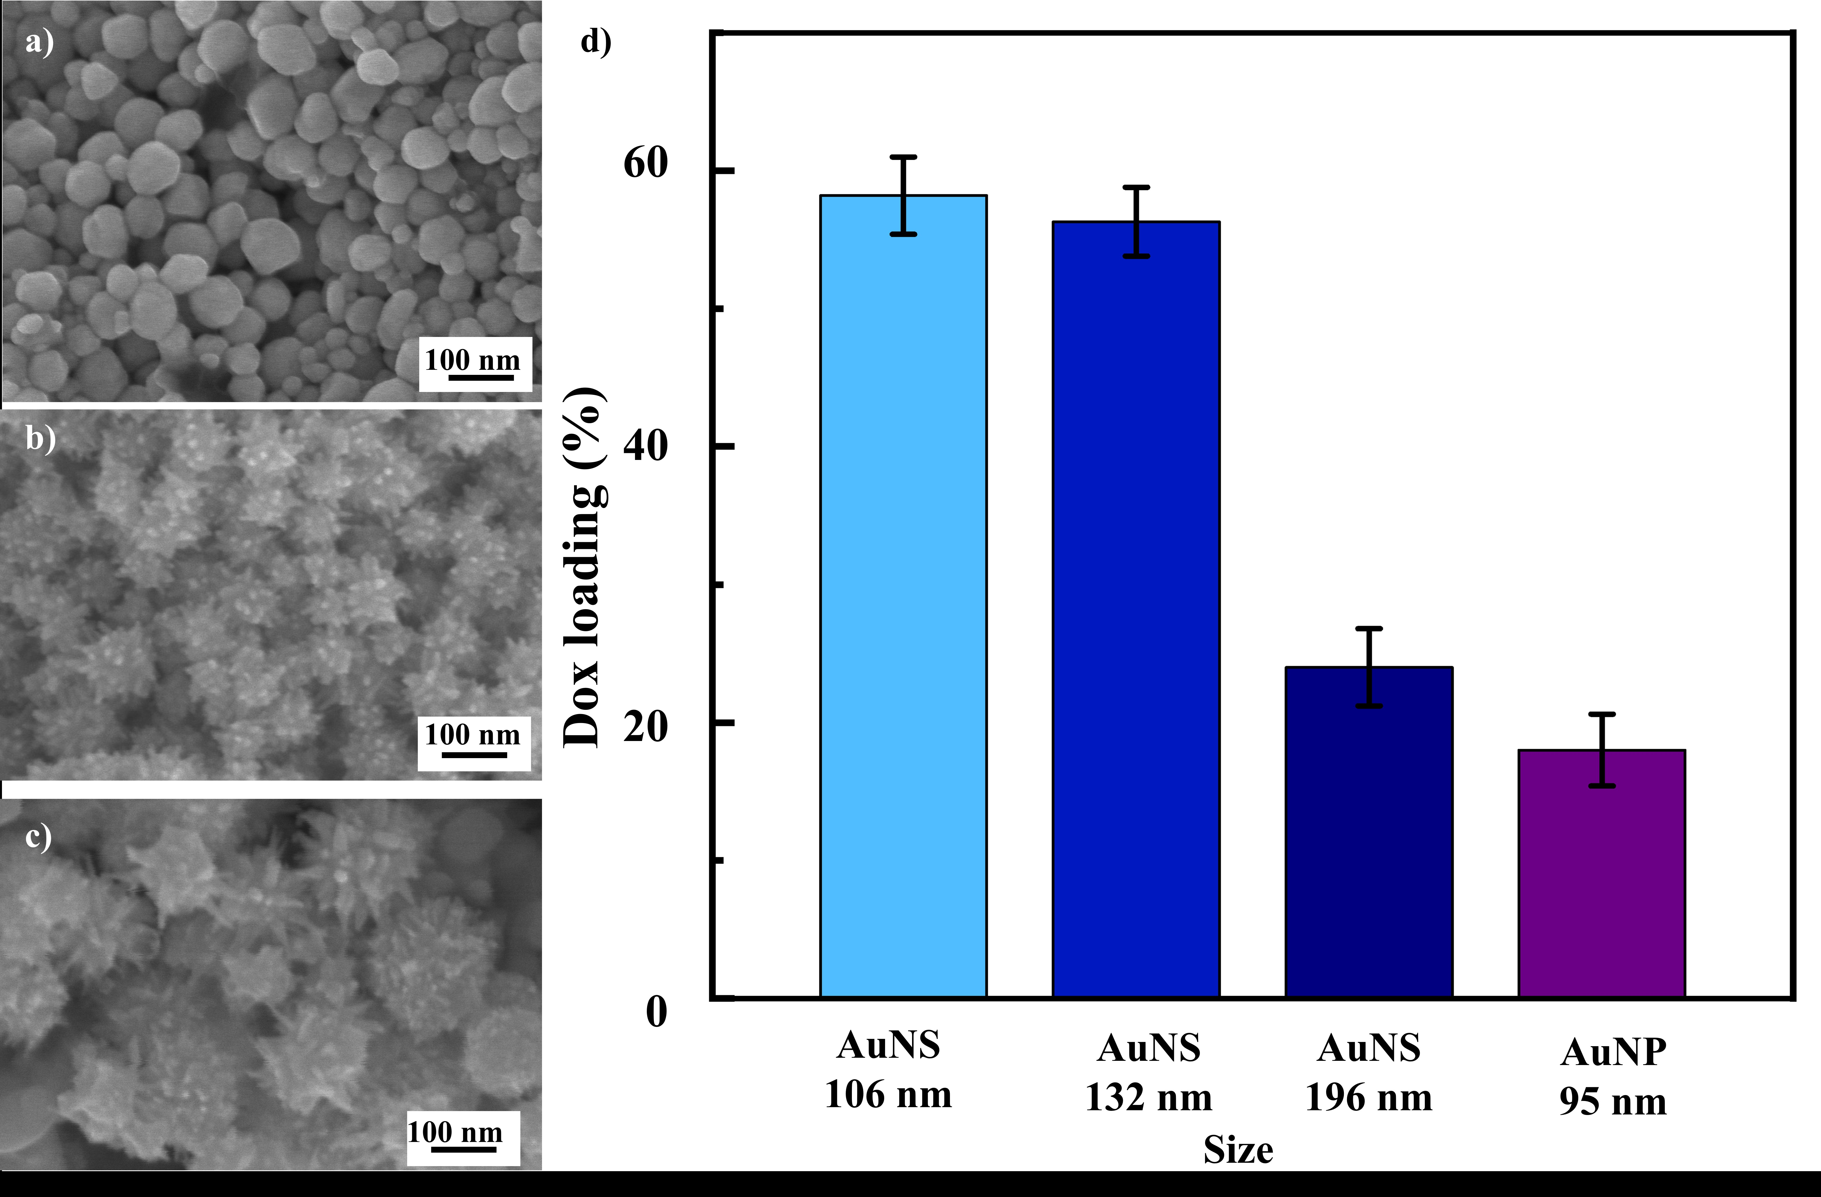

Fig. S12. SEM images of (a) the spherical gold nanoparticles, (b) gold nanostars with an average size of 106 nm, and (c) 196 nm. (d) Loading capacity percentage of the doxorubicin on the AuNSs

Fig. S13. Dox release percentage was investigated with the AuNPs, ULGNPs, and ULGNPs@TiO₂ under pH conditions of 5 and 7, irradiated the samples with the IR laser (808 nm, 0.8 W/cm²) for different times ranging from 1 to 300 mins with the solid line representing samples surveyed at pH 5.0 and the dashed line representing the investigated pH range 7.

Fig. S14. SEM images of the ULGNPs comparison between (a) first and (b) second times rinsing and redispersed in the DI water by the sonication method (scale bars for all, 100 nm).

