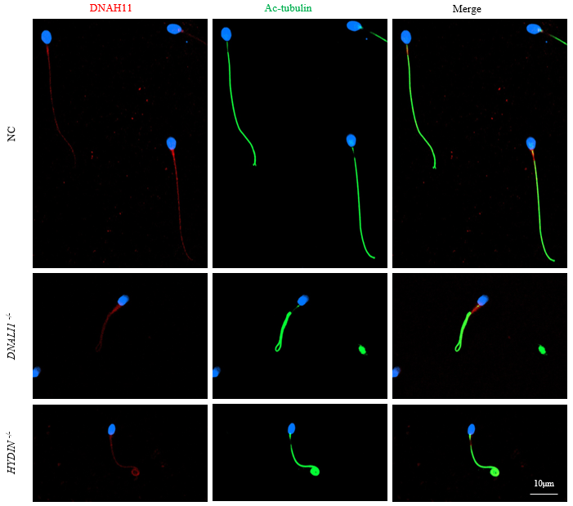

Figure S1. Immunofluorescence staining analysis of DNAH11 in sperm from normal control man, patient with DNALI1 gene pathogenic variants and patient with HYDIN gene pathogenic variants. In the fertile individual, signals of DNAH11 localized along the sperm flagella. Furthermore, the DNAH11 staining was not dramatically reduced and easily found signals in sperm of harboring DNALI1 variants and harboring HYDIN variants. Scale bar: 10μm.

Figure S2. The distribution and expression of proteins related to axoneme in patients and control individual. IF results on the sperm of AY0524, AY0540, AY0435, patient carrying DNAH9 bi-allelic variants and normal subject using anti-DNAH1(red in A) and anti-DNAH6 (red in B). It was demonstrated that DNAH1 and DNAH6 express at full-length flagella in normal sperm. (A) It was found that evidently reduction or absent of DNAH1 in sperm from AY0524, AY0540 carrying DNAH11 bi-allelic variants, and the subject carrying DNAH9 bi-allelic variants, while there were relatively clear signals in sperm from AY0435 carrying DNAH5 bi-allelic variants. (B) By contrast, expressions of DNAH6 were almost absent in sperm obtained from AY0435 harboring DNAH5 variants. However, it was found that anti-DNAH6 normally localized along the sperm flagella in sperm from AY0524, AY0540 carrying DNAH11 bi-allelic variants, and patient carrying DNAH9 bi-allelic variants which the same as in the control sperm. Anti-ac-tubulin (green) marked the sperm flagella, Hoechst (blue) marked the nucleus of spermatozoa. Scale bars: 10μm.

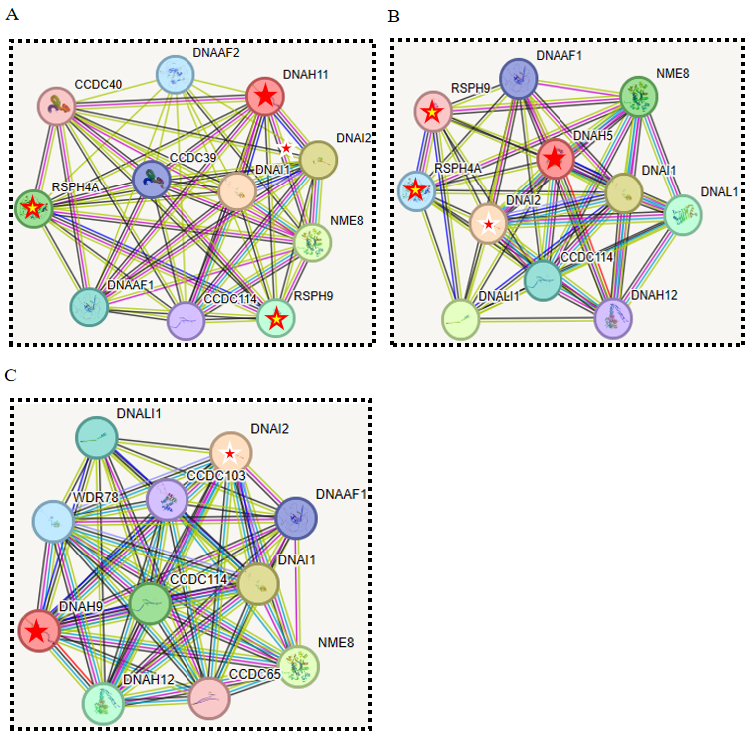
Figure S3. STRING protein-protein interaction analysis of DNAH11, DNAH5 and DNAH9. (A and B) Evidently, it was indicated that DNAH11 and DNAH5 may be highly connected with DNAI2 and RSPH4A. (C) By contrast, DNAH9 could be highly associated with DNAI2, but the correlation with RSPH4A is not clear.

Table S1. Primers Used for Amplification and Verification of DNAH11 and DNAH5 Mutations
Primer Names | Primer Sequences (5'-3') | Tm
AY0524-F | ATGAATCTGCCCGTGTTTATGG | 49℃
AY0524-R | GCCCTTGTGCACTTCTCTCATAC | 49℃
AY0540-F1 | CATGAAGCCTTTCAAAGTGAGC | 52℃
AY0540-R1 | CGGCTTCTTACAGCCAGAAGAT | 52℃
AY0540-F2 | AATACCTCCTGTGCTGGGACTG | 56℃
AY0540-R2 | CAGCCCTTTGTGGAGAACATC | 56℃
XFY03-F1 | AGGTGGGAGACTAGGGTCTG | 58℃
XFY03-R1 | CCTCTTACCTCCTGGGAAGC | 58℃
XFY03-F2 | AAGGTGTTACACACTGCCCG | 60℃
XFY03-R2 | CATCGACAAGTGAATCGAACTC | 60℃
XFY04-F1 | TCTGATGACAAAAAGATTGT | 55℃
XFY04-R1 | ATCGTCTTTTCACACTTCCCA | 55℃
XFY04-F2 | ATGAATCTGCCCGTGTTTATGG | 58℃
XFY04-R2 | GCCCTTGTGCACTTCTCTCATAC | 58℃
AY0435-F1 | TGATACCTGATCTCCCCACTCAT | 61℃
AY0435-R1 | GACGAGTCTCATCCCATTCAA | 61℃
AY0435-F2 | GTTTTCCCACCTGTTGCTCA | 59℃
AY0435-R2 | TCAGTGCGGTGAAAGAGAGA | 59℃

