Supplementary Information
Hydrogeological characterization and extended seasonal hydrogeochemical monitoring of a CO2 controlled-release experimental site: the case of TECNOPUC-Viamão, Rio Grande do Sul state, Southern Brazil

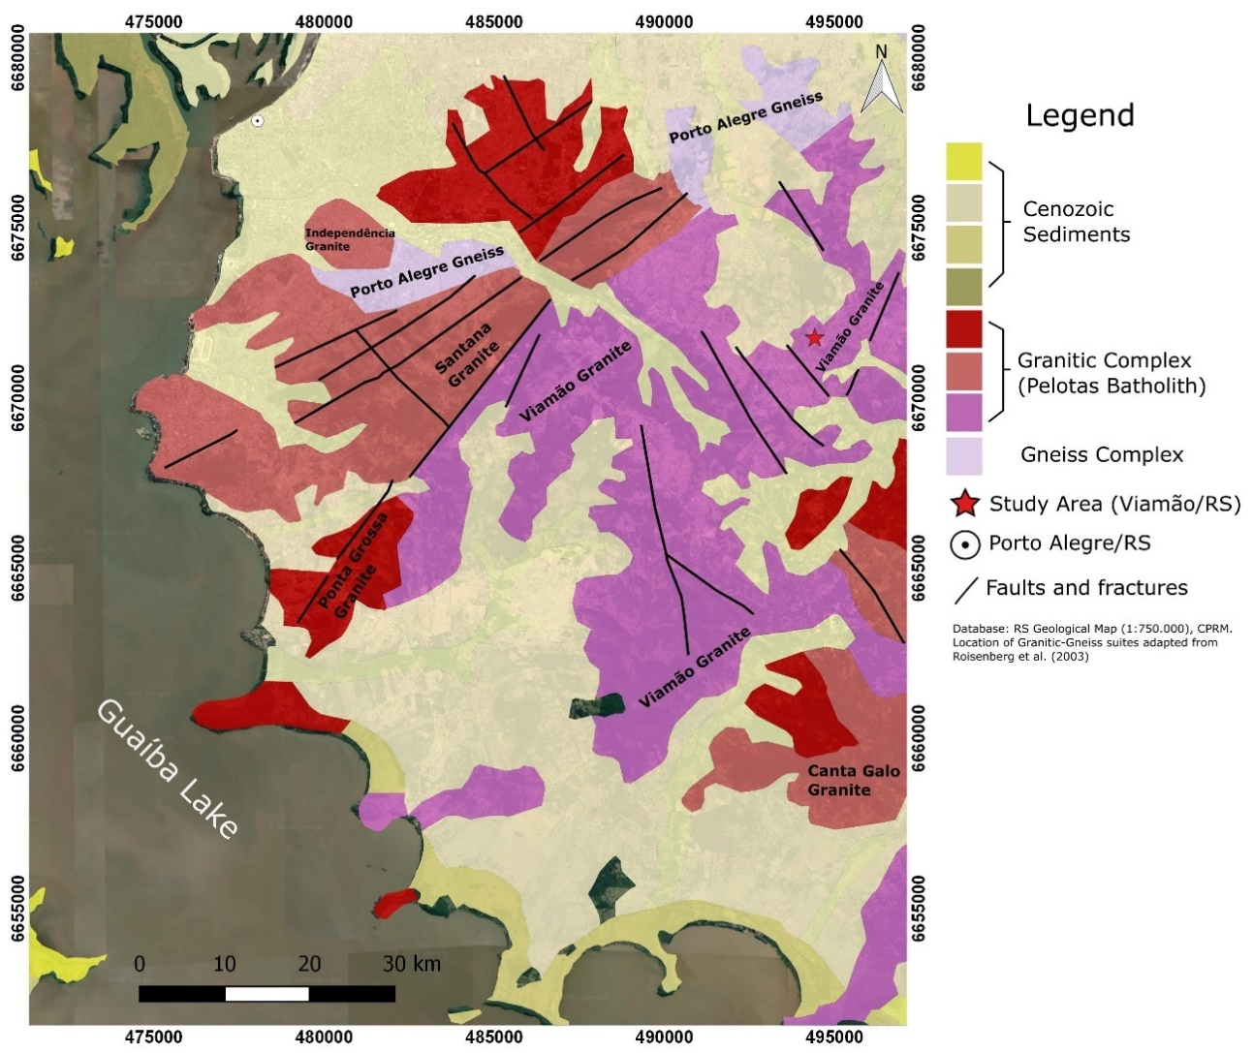
Figure S1. Simplified geological map of the study area and related granitic-gneissic basement suites.

Table S1. Location of geological boreholes and wells in the study area, along with their respective depths and intended purposes.
WELL | UTM COORDINATES (m) |  |  | DEPTH (m) | PURPOSE
WELL | X | Y | Z | DEPTH (m) | PURPOSE
M1A | 494323.53 | 6671949.49 | 106.95 | 1 | SAMPLING
M1B | 494322.95 | 6671950.01 | 106.96 | 2,5 | SAMPLING
M1C | 494323.81 | 6671950.11 | 106.95 | 3,5 | SAMPLING
M2A | 494323.74 | 6671943.91 | 107.07 | 1 | SAMPLING
M2B | 494323.21 | 6671943.24 | 107.10 | 2,5 | SAMPLING
M2C | 494323.93 | 6671943.12 | 107.07 | 3,5 | SAMPLING
M3A | 494309.48 | 6671945.27 | 107.80 | 1 | SAMPLING
M3B | 494308.75 | 6671945.85 | 107.85 | 2,5 | SAMPLING
M3C | 494308.54 | 6671944.86 | 107.91 | 3,5 | SAMPLING
M4A | 494339.99 | 6671944.18 | 106.71 | 1 | SAMPLING
M4B | 494340.64 | 6671944.62 | 106.73 | 2,5 | SAMPLING
M4C | 494340.38 | 6671943.80 | 106.75 | 3,5 | SAMPLING
DPT06 | 494327.80 | 6671963.74 | 106.75 | 8,5 | WATER LEVEL
DPT08 | 494328.48 | 6671928.22 | 107.34 | 9,6 | WATER LEVEL
DPT09 | 494305.40 | 6671962.69 | 107.89 | 3,5 | WATER LEVEL
DPT11 | 494334.40 | 6671953.00 | - | 2,9 | WATER LEVEL
DPT12 | 494354.50 | 6671954.80 | 106.40 | 2,9 | WATER LEVEL
DPT13 | 494341.50 | 6671934.47 | 106.93 | 2,9 | WATER LEVEL

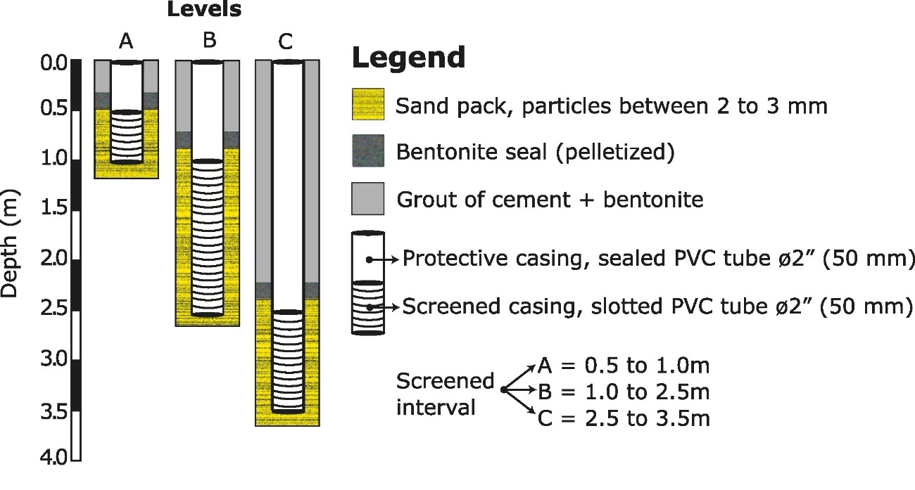
Figure S2. Constructive features of the multi-level monitoring wells used for groundwater sampling.
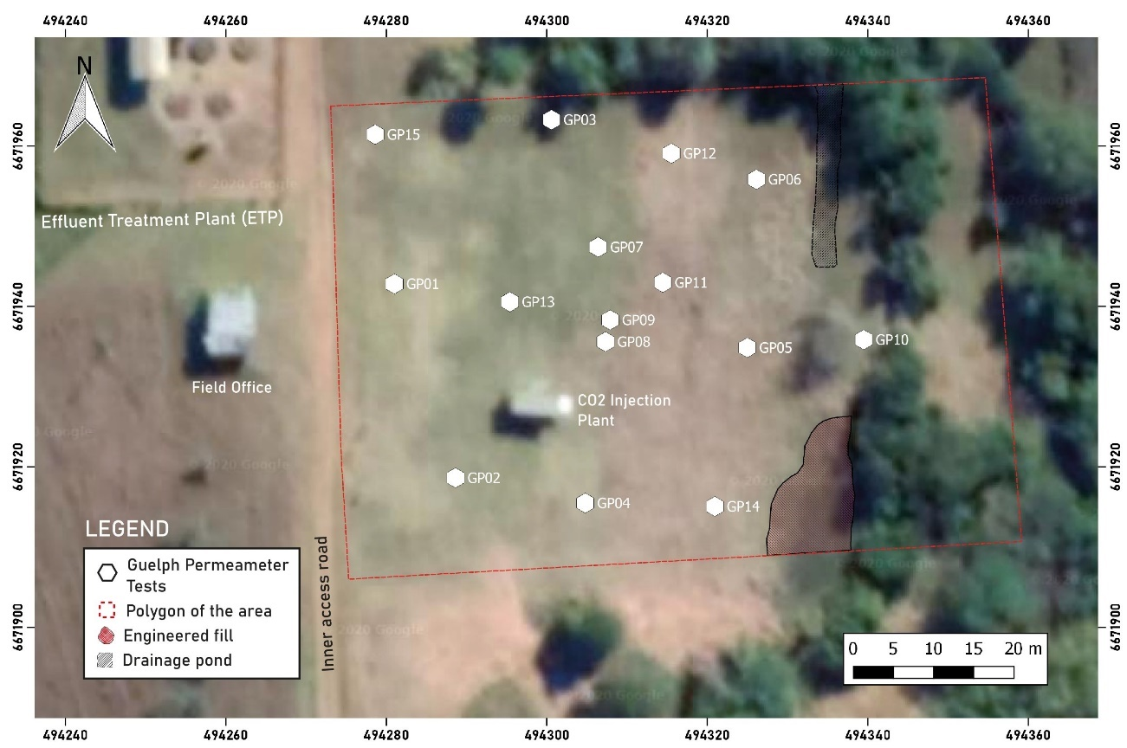
Figure S3. Spatial distribution of the locations where in-situ permeability tests using the Guelph Permeameter were conducted.

Calculation steps to consider isotope fractionation and mass balance
To calculate the theoretical enrichment factor (ε), the following equations were employed, considering the temperatures (T) in ºC measured at the time of sample collection:
$ε^{13}C_{H_{2}{CO}_{3}-{CO}_{2(g)}}= -0.000014T^{2}+0.0049T-1.18$ (1)
$ε^{13}C_{H{CO}_{3}-{CO}_{2(g)}}= 0.00032T^{2}-0.124T+10.87$ (2)
Furthermore, considering the presence of both H2CO3 and HCO3- species in the samples, isotopic mass balance calculations were performed to proportionally account for the contribution of each species to the isotopic fractionation of the CO2 source to the DIC response (Clark, 2015). Initially, the relative fraction of H2CO3 and HCO3- concerning the total DIC was calculated:
$f_{H_{2}{CO}_{3}=}{[H_{2}{CO}_{3} (\frac{mg}{L})]}/{[DIC (\frac{mg}{L})]}$ (3)
$f_{{HCO}_{3}^{-}}= {[{{HCO}_{3}}^{-} (\frac{mg}{L})]}/{[DIC (\frac{mg}{L})]}$ (4)
Since both species are theoretically in equilibrium with the soil CO2, the fractionation of each species can be represented by the following equations:
$δ{}_{}^{13}{C_{H_{2}{CO}_{3}}}= δ_{}^{13}C_{{CO}_{2}}+ ε^{13}C_{H_{2}{CO}_{3}-{CO}_{2(g)}}$ (5)
$δ{}_{}^{13}{C_{{HCO3}_{}^{-}}}= δ_{}^{13}C_{{CO}_{2}}+ ε^{13}C_{H{CO}_{3}-{CO}_{2(g)}}$ (6)
Finally, the isotopic mass balance equations used to determine δ¹³C-DIC are a combination of the above equations to estimate the relative contribution fraction of each component:
$δ{}_{}^{13}{C_{-DIC}}= {(f}_{H_{2}{CO}_{3}} x δ{}_{}^{13}{C_{H_{2}{CO}_{3}}})+(f_{{HCO}_{3}^{-}} x δ{}_{}^{13}{C_{{HCO3}_{}^{-}}})$ (7)
The laboratory analysis effectively provided the δ¹³C-DIC values, enabling the subsequent theoretical δ¹³C-DIC calculation. This calculation respected the observed proportionality of H2CO3 and HCO3- to model the response of the carbon source isotopic ratio (δ¹³C-CO₂). This estimation allowed us to infer the magnitude and identify the carbon reservoir contributing to the carbon present in the DIC.

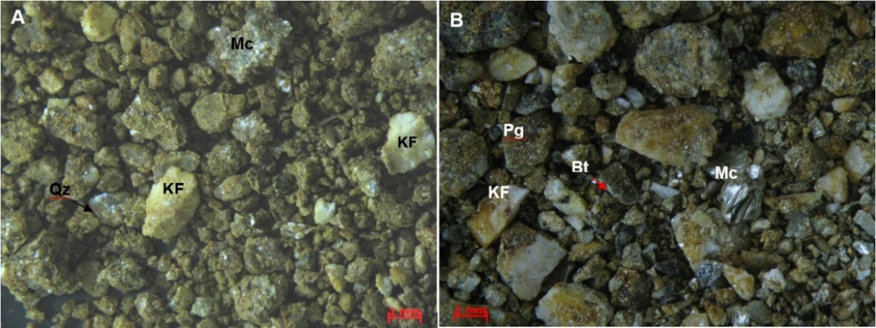
B
A
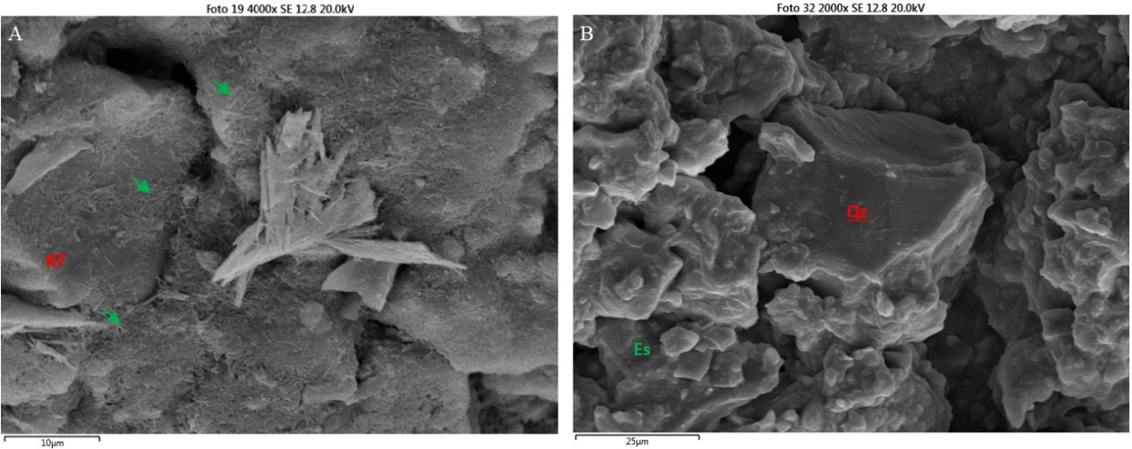
D
C
Figure S4. Representative binocular microscope images of two samples: A) DPT 05 (3.00-4.15m), composed predominantly of Quartz (Qz), Potassium Feldspar (KF), and Muscovite (Mc); and B) DPT 05 (6.00-7.15m), with Potassium Feldspar (KF), Plagioclase (Pg), Biotite (Bt), and Muscovite (Mc). SEM images of samples from boreholes DPT 10 and DPT 06: C) Potassium Feldspar (KF) with iron oxide needles (green arrows), sample DPT 10 (4.5-5.65m); and D) Quartz (Qz) surrounded by Smectite (Es) crystals, sample DPT-06 (0-1.15m).

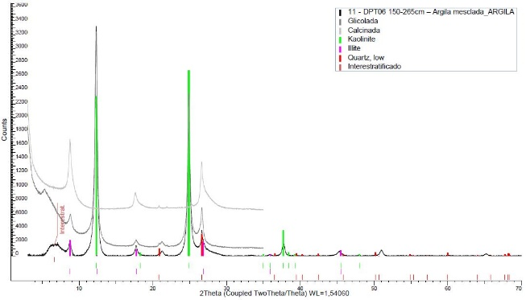
A
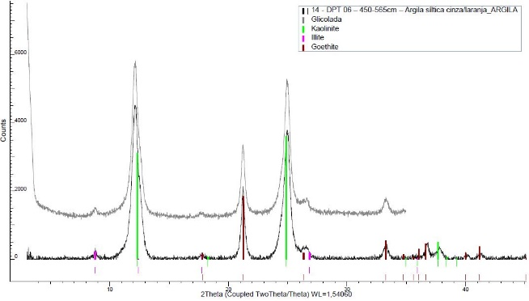
B
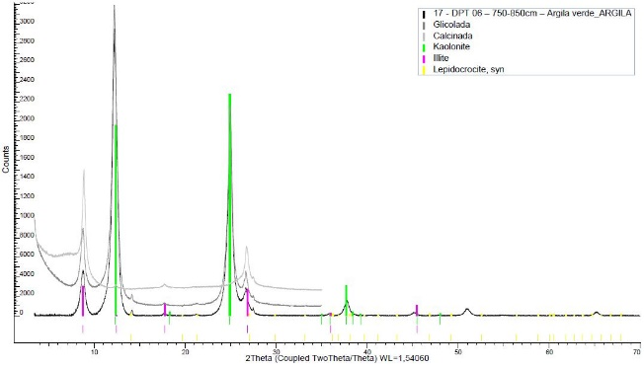
C
Figure S5. XRD diffractograms of some clay fraction samples analyzed: A) sample DPT06 (1.50-2.65m); B) sample DPT06 (4.5-5.65m); and C) sample DPT06 (7.5-8.50m).
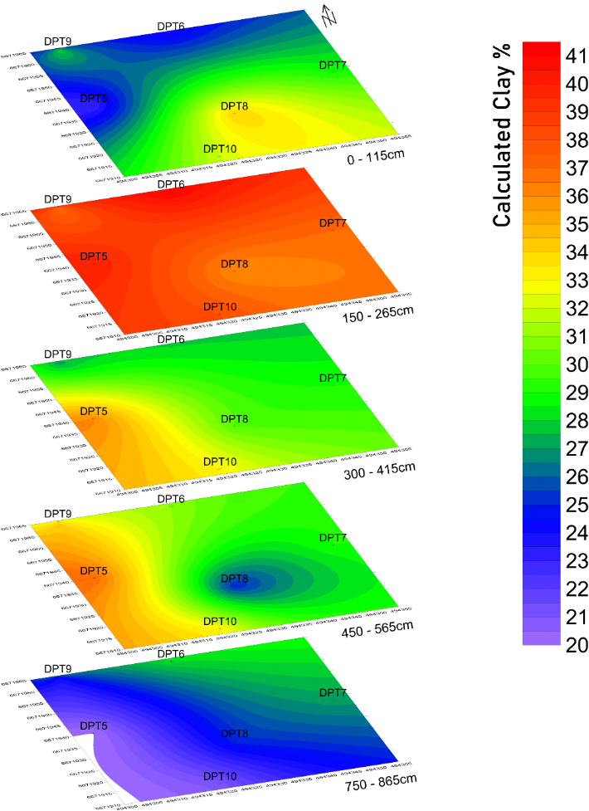
Figure S6. Map of clay percentage with depth, developed based on the granulometric analyses conducted on the sampled sections.
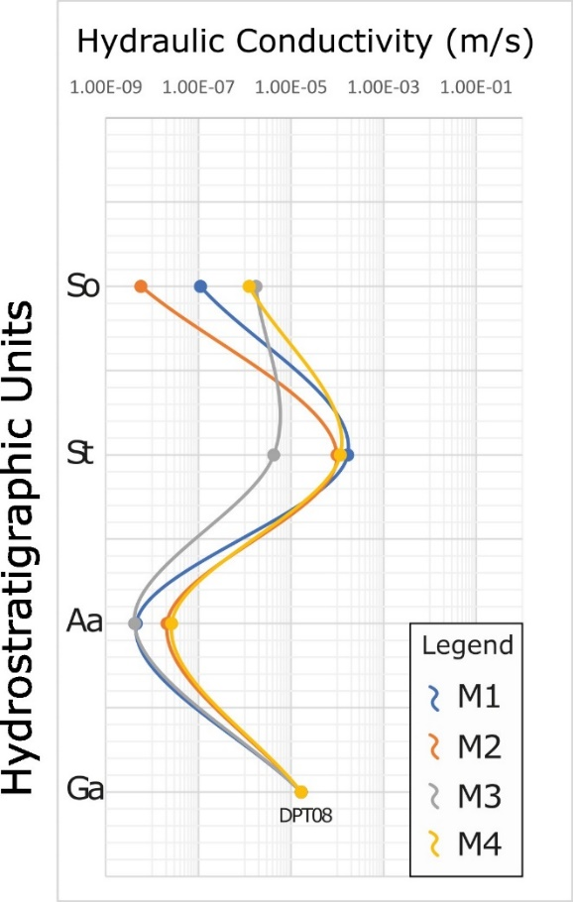
Figure S7. Average hydraulic conductivity values obtained from various wells, each corresponding to its respective hydrostratigraphic unit representation.

