Supplementary Figures
Figure S 1| The IWI framework adopted in this study.
Figure S 2| The descriptions of calculation modules in this study.

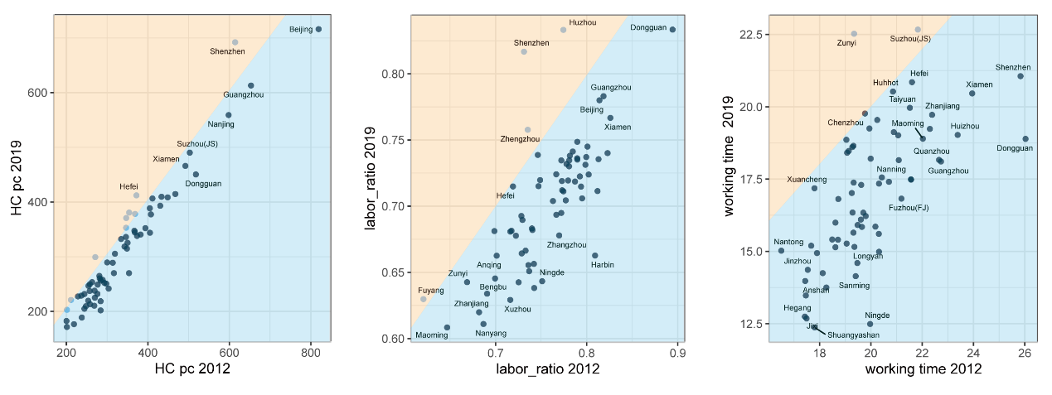
Figure S 3| The change of human capital over 2012-2019. The three scatter plots correspond to the change to HC per capita (thousand), labor ratio (labor population divided by total population) and average working time (years). The yellow area refers to the growing trend over time, while the blue area refers to the declining trend.
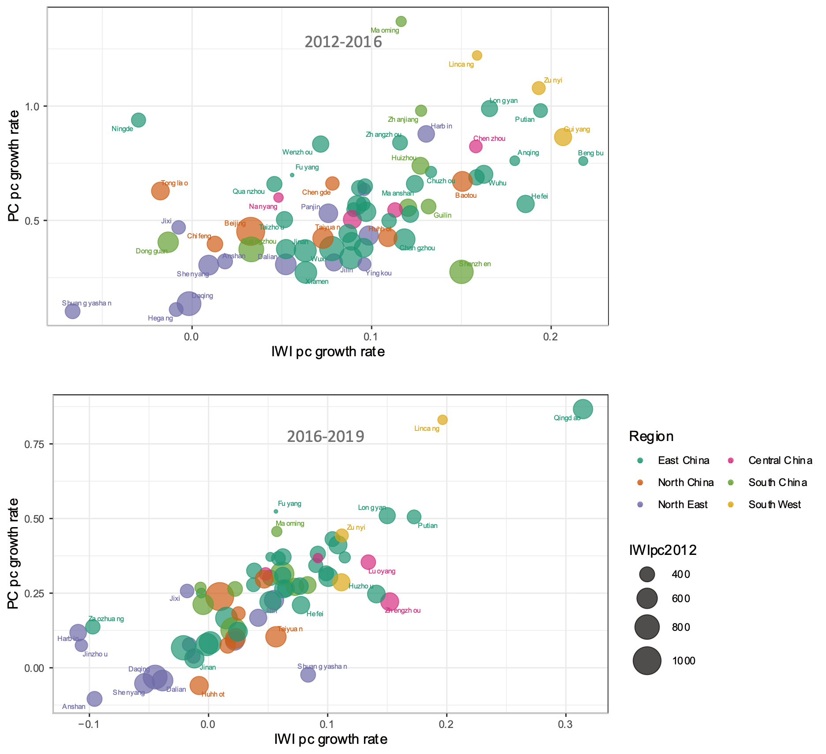
Figure S 4| The relationship between IWI per capita and PC per capita growth over 2012-2019. The scatter plots correspond to the period of 2012-2016 and 2016-2019, respectively.

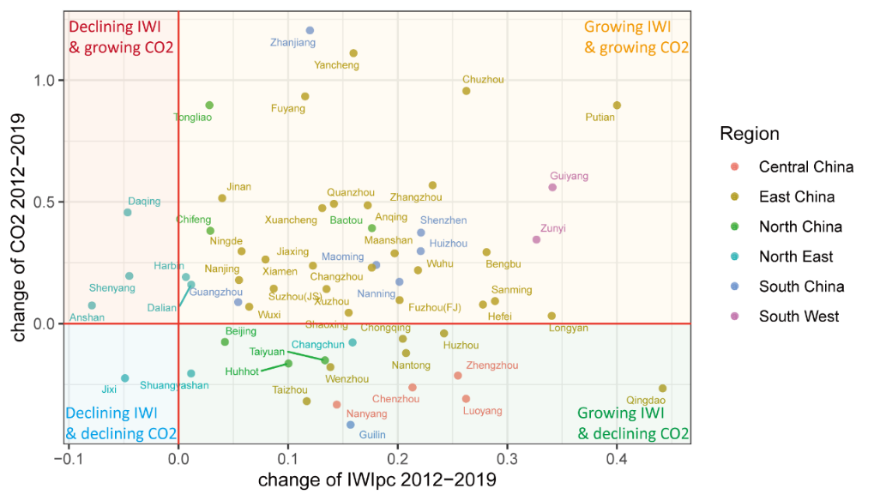
Figure S 5| Comparison between growth rate of IWI per capita and energy-related CO2 emissions over 2012-2019. Four quadrants showed in different colors correspond to the various relationship between IWI per capita and CO2: growing IWI &growing CO2, growing IWI &declining CO2, declining IWI &growing CO2, declining IWI &declining CO2.
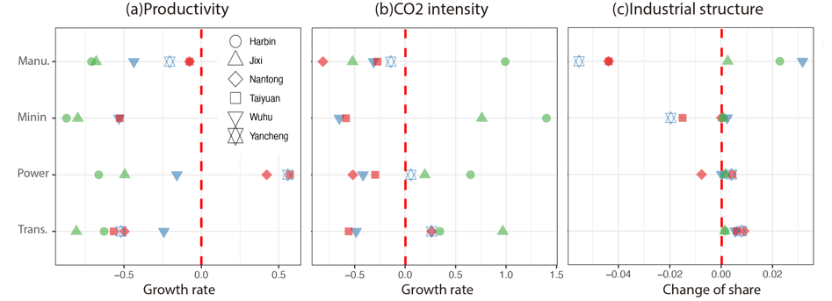
Figure S 6| Change of productivity (industrial output/PC), CO2 intensity and share of each carbon-intensive sector in total PC stock over 2012-2019, with the colors corresponding to the city types. The green refers to the Unsustainable &Peak, blue refers to Sustainable &Not Peak and red refers to Sustainable &Peak.

Supplementary Tables
Table S 1| Descriptions of study area.
Subject | Subgroups | Ratio
Ranking of GDP per capita among 295 Chinese cities | [1,50] | 37%
Ranking of GDP per capita among 295 Chinese cities | [51,100] | 27%
Ranking of GDP per capita among 295 Chinese cities | [101,150] | 13%
Ranking of GDP per capita among 295 Chinese cities | [151,200] | 9%
Ranking of GDP per capita among 295 Chinese cities | [201,250] | 9%
Ranking of GDP per capita among 295 Chinese cities | [251,300] | 4%
GDP composition | Higher ratio in the secondary industry | 28%
GDP composition | Higher ratio in the tertiary industry | 72%
Region | East China | 48%
Region | Northeast China | 19%
Region | North China | 10%
Region | Southwest China | 4%
Region | South China | 12%
Region | Central China | 6%

Table S 2| The supplement of missing data in 2019.
Capital | Indicator | Method
Human Capital | Average working time of 2019 | Linear extrapolation is adopted based on the data of working time between 2010-2015.
Produced Capital | Investment of 2018 and 2019 | The missing investment data of 2018 and 2019 is calculated based on investment data of 2017 and investment growth rate.
Natural Capital | Minerals Reserve | The provincial basic reserves of mineral resources are allocated to city-level, according to the retained or proven reserves, industrial output value and yield. The provincial-level basic reserve data of fossil fuels and minerals are not published since 2017. Then, national basic reserve data is adopted to give evidence for estimating city-level basic reserve in 2019.
Natural Capital | Land use data | Third National Land Survey (2019) is adopted to supplement data.

Table S 3| Key variables and data sources used in the measurement of inclusive wealth.
Capital | Variable | Scale | Data Source
Human Capital | Education attainment | City-level | Tabulation on the 2010 Population Census, 1% Population Sample Survey Data in 2015, Tabulation on the 2020 Population Census
Human Capital | Mortality rate | City-level | Statistical Yearbook of city
Human Capital | Working age population | City-level | Statistical Yearbook of city
Human Capital | Total population | City-level | Statistical Yearbook of city
Human Capital | Average working time | City-level | Tabulation on the 2010 Population Census, 1% Population Sample Survey Data in 2015
Human Capital | Employment Compensation | City-level | China City Statistical Yearbook
Human Capital | Rate of Return on Education | National | China Capital Reports from Central University of Finance and Economics
Produced capital | Investment | City-level | Statistical Yearbook of city
Produced capital | Steady-state Growth | City-level | Statistical Yearbook of city
Produced capital | Correction Factor | Provincial | China Statistical Yearbook
Produced capital | Fixed asset investment price index | Provincial | Data of Gross Domestic Product of China (1952-1995),  China Price Statistical Yearbook
Produced capital | depreciation rate | Provincial | ^{[1-3]}
Natural Capital | Minerals Reserve | City-level | Periodical Plan for Mineral Resources, Statistical Yearbook of city
Natural Capital | Market price of the minerals | National | World Bank, Statista, The Wall Street, Only Gold, Metalary, Macrotrends, Indexmundi, China Land and Resources Statistical Yearbook & US Energy Information Administration.
Natural Capital | Land use data | City-level | Geographic Information Monitoring Cloud Platform (2012,2016), Third National Land Survey (2019)
Natural Capital | Agricultural output | City-level | Statistical Yearbook of city
Natural Capital | Volume of living trees | City-level | Statistical Yearbook of city
Natural Capital | Timber price | provincial | China Forestry Statistical Yearbook
Natural Capital | Hydropower generation | City-level | Statistical Yearbook of city
Natural Capital | Water consumption | City-level | Water resources bulletin

Table S 4| Description of variables used in the IPAT analysis.
Variable | Symbol | Definition measuring method | Unit
Carbon emissions | $$C$$ | Total energy-related emissions in city | Mt
Population size | $$P$$ | Total population in city | Million persons
IWI per capita | $$A$$ | IWI per capita measuring affluence | Yuan per person
Capital productivity | $$L$$ | GDP divided by IWI | none
Emission intensity | $$T$$ | Energy-emissions divided by GDP | t per yuan

Table S 5| Descriptions of drivers in the growth of Inclusive Wealth per capita.
Capital | Driver | Symbol | Definition measuring methods
HC | education improvement (EDU) | $$e^{\left(Edu⋅ρ\right)}$$ | education attainment (Edu), rate of return on education (𝜌)
HC | population structure (LABOR) | $$P/{TP}$$ | working age population (P), total population (TP)
PC | Fixed asset stock (K) | $$\sum_{l}{K_{l}}$$ | Fixed asset stock by sector l ($K_{l}$). There are total l sectors: manufacturing, information, leasing, retailing, transportation, SECH, accommodation, public management, financial, estate, agriculture, mining, power, construction.
PC | population growth (POPU) | $$TP$$ | total population (TP)
NC | Minerals growth (MW) | $$\sum_{i}{{MW}_{i}}$$ | Minerals wealth (MW) calculated according to their reserve and shadow prices. Effects from i types of fossil fuels, metals and non-metallic minerals are considered, including coal mine, oil, natural gas, iron ore, manganese ore, vanadium ore, bauxite, magnesite, phosphate ore, copper, lead and zinc. See detailed calculation methods of each type of minerals capital in literature^{[3]}.
NC | renewable resources growth (RNC) | $$\sum_{m}{{RNC}_{m}}$$ | Renewable natural capital wealth (RNC) calculated according to their amount and shadow prices. Our study includes three types of renewable natural capital: agriculture, forest and water wealth. See detailed calculation methods of each type of renewable capital in literature^{[3]}.
NC | population growth (POPU) | $$TP$$ | total population (TP)

Supplementary Note

Study Area
We select 67 cities as the study area which are representative in China. These 67 cities account for approximately 43% of total gross domestic product (GDP) and 30% of total population in China. In terms of per capita GDP, these cities are distributed at different levels, with the lowest ranking 267th and the highest ranking 1st among the 295 Chinese prefecture-level cities. Also, these cities have different GDP composition, some with higher ratio in secondary industry and others depending on the tertiary industry. To be specific, their ratios of primary industry range between 0-37%, the ratios of secondary industry range between 16-59%, and the ratios of tertiary industry range between 34-84%, reflecting their various industrial structure. In terms of geological location, the study area includes 32 cities (48%) from east China, 13 cities (19%) from northeast China, 7 cities (10%) from north China, 8 cities (12%) from south China, 4 cities (6%) from central China and 3 cities (4%) from south west China, involving 19 provinces. In summary, the 67 cities in this study are characterized with various geographic locations, industrial structures, economic development, etc.

References

1. Xiaofei T. The estimation and expanding application of the cities' fixed capital stock in the provinces in the northeast (in Chinese). Master thesis, Dongbei University of Finance and Economics, 2015.
2. Zhen Z. Empirical analysis about fixed assets investment on the impact of economic growth in Inner Mongolia (in Chinese). Master thesis, Inner Mongolia University of Finance and Economics 2012.
3. Cheng D, Xue Q, Hubacek K, Fan J, Shan Y, Zhou Y, et al. Inclusive wealth index measuring sustainable development potentials for Chinese cities. Global Environmental Change 2022, 72: 102417.

