Suppl. Fig. 2. (a)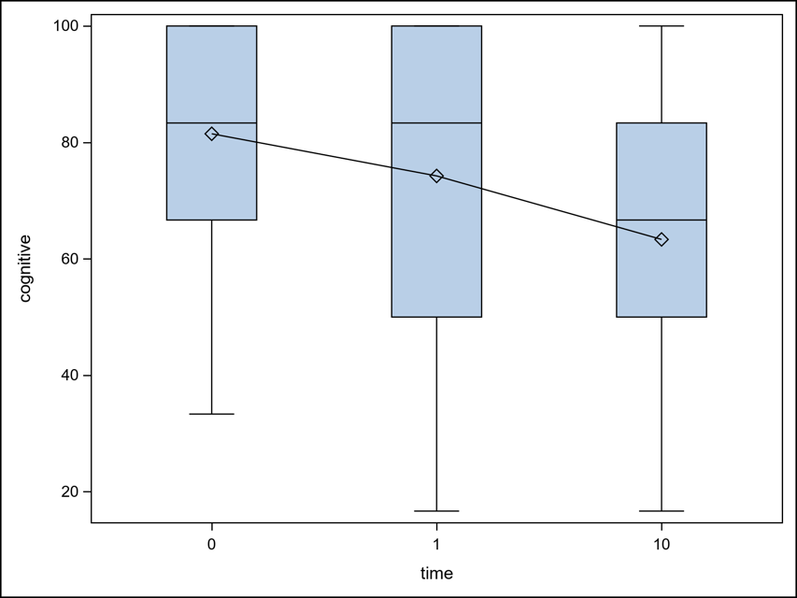

Suppl. Fig. 2. (b) 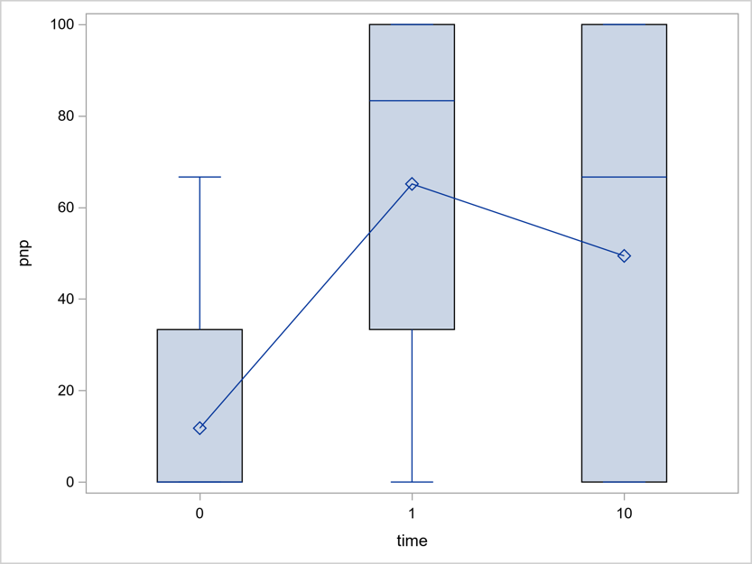

Suppl. Fig. 2. (c) 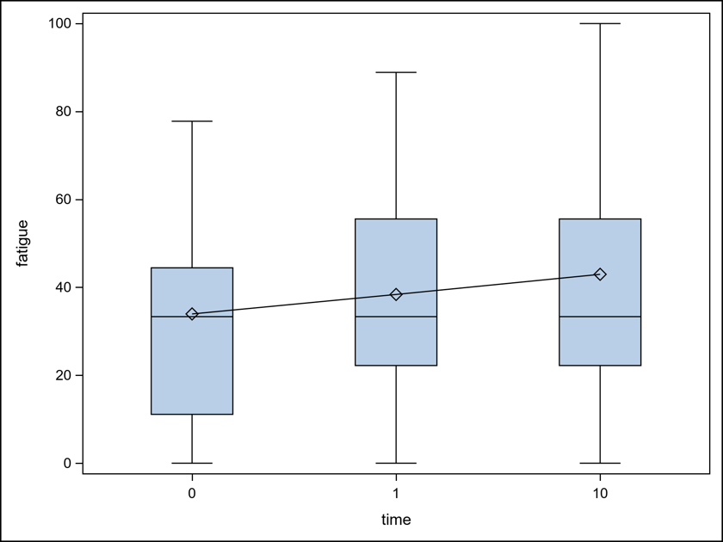

Supplement Figure 2. (a-c). Time Dependant Development of Cognitive Function (a),
PNP (b) and Fatigue (c)

Abbreviations: BMI, Body Mass Index; CTC, Common Terminology Criteria of Adverse Events version 5.0; GOLD, Global Initiative for Chronic Obstructive Lung Disease; NYHA, New York Heart Association; PNP, polyneuropathy; RA, randomly assigned; RCTx, Radiochemotherapy; Tox., Toxicities

