Appendix A: Data processing and industries classification
The OECD STAN database provides non-competitive NIOTs that differentiate between domestically produced and imported inputs. NIOTs covers 66 countries and provides information on the interindustry relationships between 45 industries for the period between 1995-2018. Data on industrial total gross output are expressed in current millions of US dollars. The data used in the OECD Air Emission Accounts includes total emissions of various greenhouse gases, such as carbon emissions (CO₂) from energy use and industrial processes (such as cement production), methane emissions (CH₄) from sources such as solid waste, livestock, and agriculture, as well as nitrous oxide (N₂O), hydrofluorocarbons (HFCs), perfluorocarbons (PFCs), sulphur hexafluoride (SF₆), nitrogen trifluoride (NF₃), sulphur oxides (SO_{x}), nitrogen oxides (NOx), carbon monoxide (CO), non-methane volatile organic compounds (NMVOCs), particulate matter (PM2.5 and PM10), and ammonia (NH₃). The GHG emissions data are expressed in tons of CO₂ equivalent (tCO2e). The described industries and their correspondence to classified International Standard Industrial Classification Revision 4 (ISIC Rev. 4) are reported in Table A.1. As the industry classifications of the NIOT and those from the Air Emissions Account are not homogenous, the data are aggregated into 30 industries to ease the calculation and interpretation of results, as defined in Table A.1. Industry 1 consists of “Agriculture”, industries 2 to 17 belong to “Industrial sector” and industries 18 to 30 belong to “Services”. The elements associated with industry U, are all equal to zero and, therefore, they are not included in the analysis.

Table A.1: Industries classification in NIOT before and after the aggregation process.
Code | Pre-aggregation industries | No | Post-aggregation industries
A01; A02 | Agriculture, hunting, forestry | 1 | A01 ⨁ A02 ⨁ AO3: Agriculture, forestry and fishing
A03 | Fishing and aquaculture | 2 | B05 ⨁ B06 ⨁ B07 ⨁ B08 ⨁ BO9: Mining and quarrying
BO5; BO6 | Mining and quarrying, energy producing products | 3 | C10 ⨁ C11 ⨁ C12: Manufacture of food products, beverages and tobacco products
BO7; BO8 | Mining and quarrying, non-energy producing products | 4 | C13 ⨁ C14 ⨁ C15: Manufacture of textiles, wearing apparel and leather products
BO9 | Mining support service activities | 5 | C16 ⨁ C17 ⨁ C18: Manufacture of wood, paper, printing and reproduction
C10; C11; C12 | Food products, beverages and tobacco | 6 | C19: Manufacture of coke and refined petroleum products
C13; C14; C15 | Textiles, textile products, leather and footwear | 7 | C20: Manufacture of chemicals and chemical products
C16 | Wood and products of wood and cork | 8 | C21: Manufacture of basic pharmaceutical products and pharmaceutical preparations
C17; C18 | Paper products and printing | 9 | C22 ⨁ C23: Manufacture of rubber and plastic products and other non-metallic mineral products
C19 | Coke and refined petroleum products | 10 | C24: Manufacture of basic metals
C20 | Chemical and chemical products | 11 | C25: Manufacture of fabricated metal products, except machinery and equipment
C21 | Pharmaceuticals, medicinal chemical and botanical products | 12 | C26 ⨁ C27 ⨁ C28: Manufacture of computer, electronic and optical products, electrical equipment, machinery and equipment n.e.c
C22 | Rubber and plastics products | 13 | C29 ⨁ C30: Manufacture of motor vehicles, trailers, semi-trailers and of other transport equipment
C23 | Other non-metallic mineral products | 14 | C31 ⨁ C32 ⨁ C33: Manufacture of furniture; jewellery, musical instruments, toys; repair and installation of machinery and equipment
C24 | Basic metals | 15 | D: Electricity, gas, steam and air conditioning supply
C25 | Fabricated metal products | 16 | E: Water supply; sewerage, waste management and remediation activities
C26 | Computer, electronic and optical equipment | 17 | F: Construction
C27 | Electrical equipment | 18 | G: Wholesale and retail trade; repair of motor vehicles and motorcycles
C28 | Machinery and equipment, nec | 19 | H49 ⨁ H50 ⨁ H51 ⨁ H52 ⨁ H53: Transportation and storage
C29 | Motor vehicles, trailers and semi-trailers | 20 | I: Accommodation and food service activities
C30 | Other transport equipment | 21 | J58 ⨁ J59 ⨁ J60 ⨁ J61 ⨁ J62 ⨁ J63: Information and communication
C31; C32; C33 | Manufacturing nec; repair and installation of machinery and equipment | 22 | K: Financial and insurance activities
D | Electricity, gas, steam and air conditioning supply | 23 | L: Real estate activities
E | Water supply; sewerage, waste management and remediation activities | 24 | M: Professional, scientific and technical activities
F | Construction | 25 | N: Administrative and support service activities
G | Wholesale and retail trade; repair of motor vehicles | 26 | O: Public administration and defence; compulsory social security
H49 | Land transport and transport via pipelines | 27 | P: Education
H50 | Water transport | 28 | Q: Human health and social work activities
H51 | Air transport | 29 | R: Arts, entertainment and recreation
H52 | Warehousing and support activities for transportation | 30 | S: Other service activities
H53 | Postal and courier activities
I | Accommodation and food service activities
J58; J59; J60 | Publishing, audiovisual and broadcasting activities
J61 | Telecommunications
J62; J63 | IT and other information services
K | DOM_64T66: Financial and insurance activities
L | Real estate activities
M | Professional, scientific and technical activities
N | Administrative and support services
O | Public administration and defence; compulsory social security
P | Education
Q | Human health and social work activities
R | Arts, entertainment and recreation
S | Other service activities
T | Activities of households as employers; undifferentiated goods- and services-producing activities of households for own use
Note: The symbol ⨁ denotes industry aggregation.

Appendix B: Matrix plot of the GHG emissions interindustry linkages and leakages
Figures B.1 and B.2 provide a visual representation of the matrices of the GHG emissions linkages ($Φ$ and $Ψ$) and leakages ($Γ$ and $Δ$) of the Greek economy, respectively.
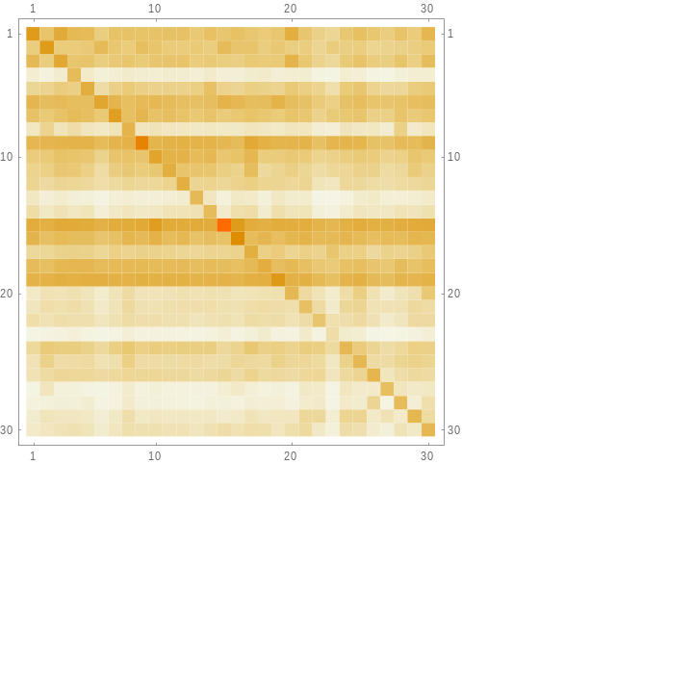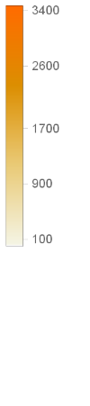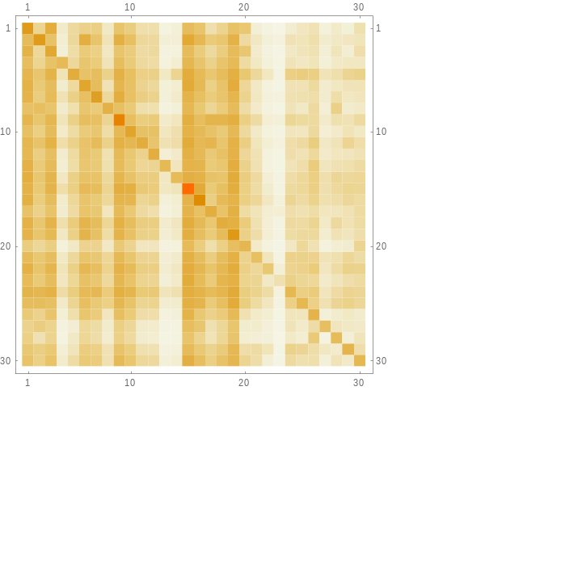
(a) (b)
Figure B.1: The matrix plot of the total (a) backward and (b) forward GHG emissions interindustry linkages (i.e., $Φ≡\hat{q} L$ and $Ψ≡G \hat{q}$, respectively).

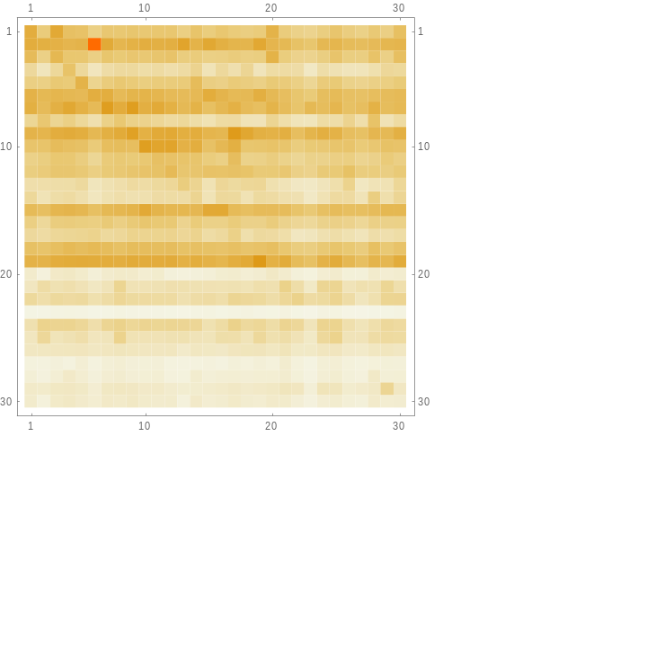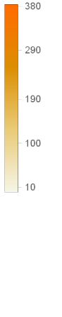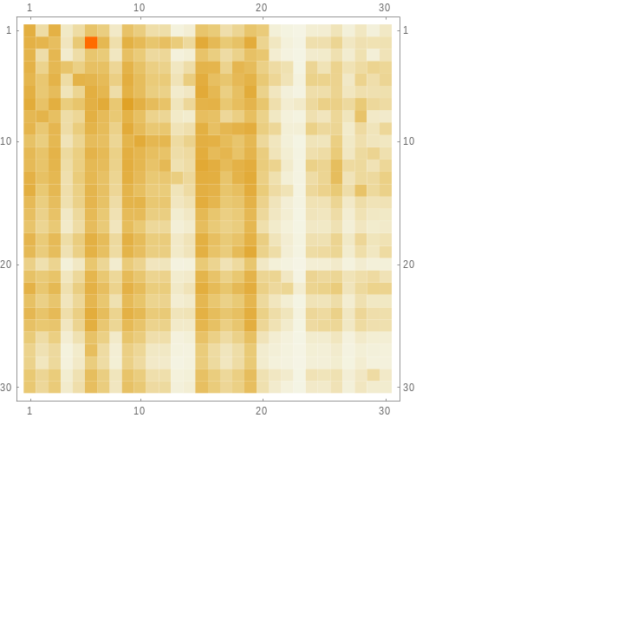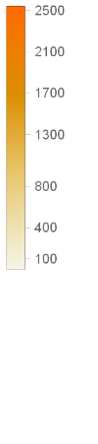
(a) (b)
Figure B.2: The matrix plot of the (a) backward and (b) forward GHG emissions interindustry leakages (i.e., $Γ≡\hat{q} A^{m}L$ and $Δ≡G B^{m}\hat{q}$, respectively).

