Supplementary Information

Wafer-scale lithography of silicone-integrated hole transporters for anti-pixel crosstalk organic light-emitting diodes

Hyukmin Kweon¹†, Seonkwon Kim²†, Borina Ha¹†, Seunghan Lee³, Soyeon Lee¹,
Jiyeon Ha¹, Minsu Kang², Seung Hwan Roh³, Moon Sung Kang^{3,4}*, Jeong Ho Cho²*, Do Hwan Kim^{1,5,6}*
¹Department of Chemical Engineering, Hanyang University, Seoul 04763, Republic of Korea.
²Department of Chemical and Biomolecular Engineering, Yonsei University, Seoul 03722, Republic of Korea.
³Department of Chemical and Biomolecular Engineering, Sogang University, Seoul 04107, Republic of Korea.
⁴Institute of Emergent Materials, Ricci Institute of Basic Science, Sogang University, Seoul 04107, Republic of Korea
⁵Institute of Nano Science and Technology, Hanyang University, Seoul 04763, Republic of Korea.
⁶Clean-Energy Research Institute, Hanyang University, Seoul 04763, Republic of Korea.

†These authors contributed equally to this work.
*Corresponding author. E-mail: kangms@sogang.ac.kr (M.S.K.); jhcho94@yonsei.ac.kr (J.H.C.); dhkim76@hanyang.ac.kr (D.H.K.)

This PDF file includes:

Supplementary Notes 1
Supplementary Figures 1 to 16
Supplementary Tables 1 to 2
Supplementary References 1 to 19

Separate supplementary file for this manuscript: Supplementary Movie 1

Supplementary Note 1 | A role of pixelated HTL to reduce electrical pixel crosstalk in OLEDs
As the pixel per inch (PPI) density increases for achievement of high-resolution micro-OLEDs, the inter-pixel distances significantly shrink, subsequently resulting in the inevitable occurrence of pixel crosstalk. There are two types of pixel crosstalk, optical and electrical pixel crosstalks. The optical pixel crosstalk is caused by a light leakage from neighboring pixels, a phenomenon especially pronounced in color-filter (CF)-based white OLEDs^{1,2}. This is because the light emission coming from the white OLEDs beneath RGB CF layers can travel adjacent pixels, leading to changes in the color gamut and mixing of colors between pixels. The optical pixel crosstalk can be mitigated by introducing a light blocking matrix^{3,4} or by controlling the structure of passivation layer².
On the other hand, electrical pixel crosstalk originates from parasitic currents in electrically coupled pixels via common layers in OLEDs, which could be particularly critical to address in directly-patterned RGB OLEDs. To intrinsically mitigate the electrical crosstalk, pixelation of the common layers can be essential to ensure that the electrical current exclusively flows to the active pixel. While both hole injection layer (HIL) and hole transporting layer (HTL) are commonly used as the shared layers the parasitic currents can flow, the HTL plays a more significant role to decrease the electrical pixel crosstalk than the HIL^{5,6}. This is attributed to the relatively higher conductivity of HTL, wherein its degree of conductivity significantly influences the formation of electrical pathways between interconnected pixels⁷. Additionally, a patterning of electron transporting layer (ETL) could be also a reasonable solution to reduce the electrical pixel crosstalk. However, in a general configuration of active-matrix OLEDs, pixelated ITO electrodes connected with thin-film transistors (TFTs), common ETL, and common cathode layers are typically employed; in this case, the shared ETL can be acting as hole blocking layer and the disconnection of HTL between adjacent pixels sufficiently prevents the parasitic hole flows (Fig. 1a). This implies that micro-pixelation of HTL can serve a primary and straightforward strategy to effectively suppress the electrical pixel crosstalk effect in micro-OLEDs (Fig. 4a, b).

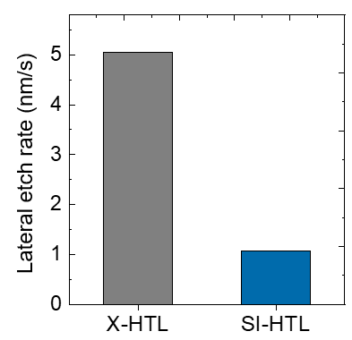

Supplementary Figure 1 | Determination of lateral etch rate. The lateral etch rates of X-HTL and SI-HTL were calculated from the cross-sectional TEM images in Fig. 1d, respectively

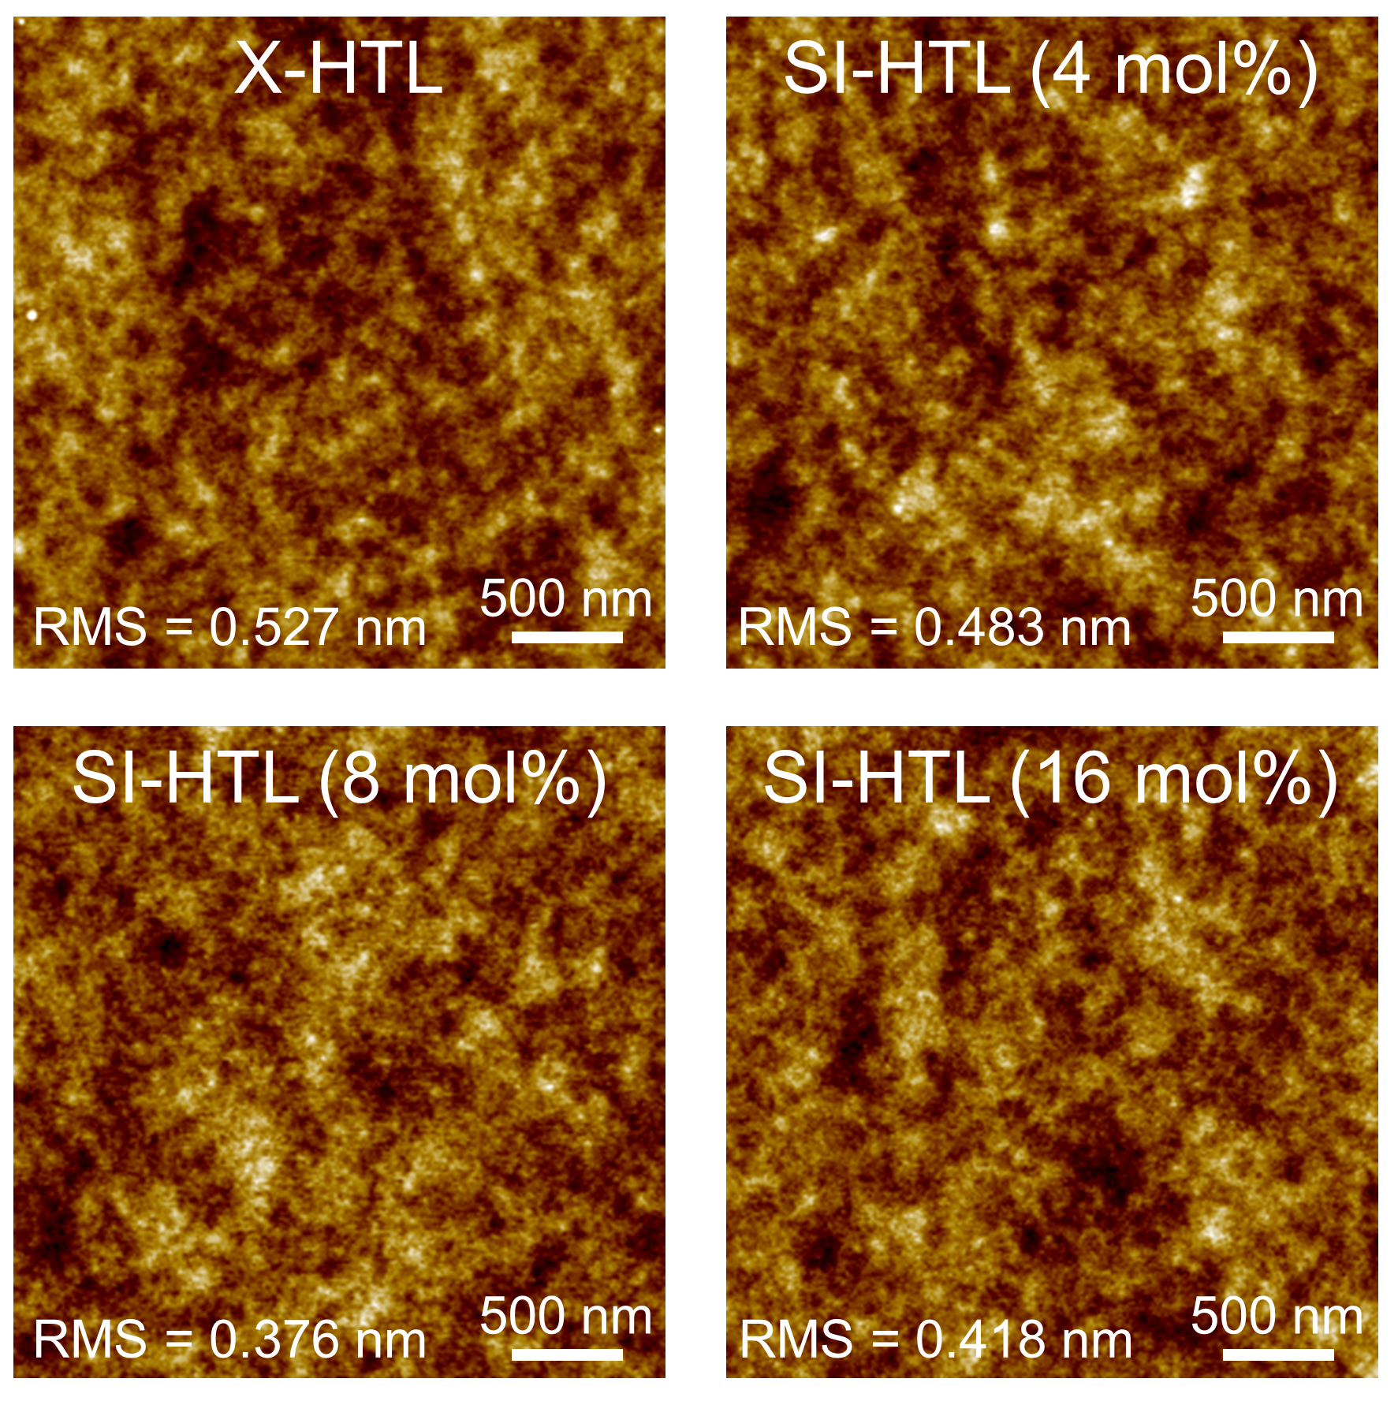

Supplementary Figure 2 | AFM images of the X-HTL and SI-HTL films. Topographic images of the X-HTL and SI-HTL films with 4, 8, 16 mol% of the silicone crosslinker.

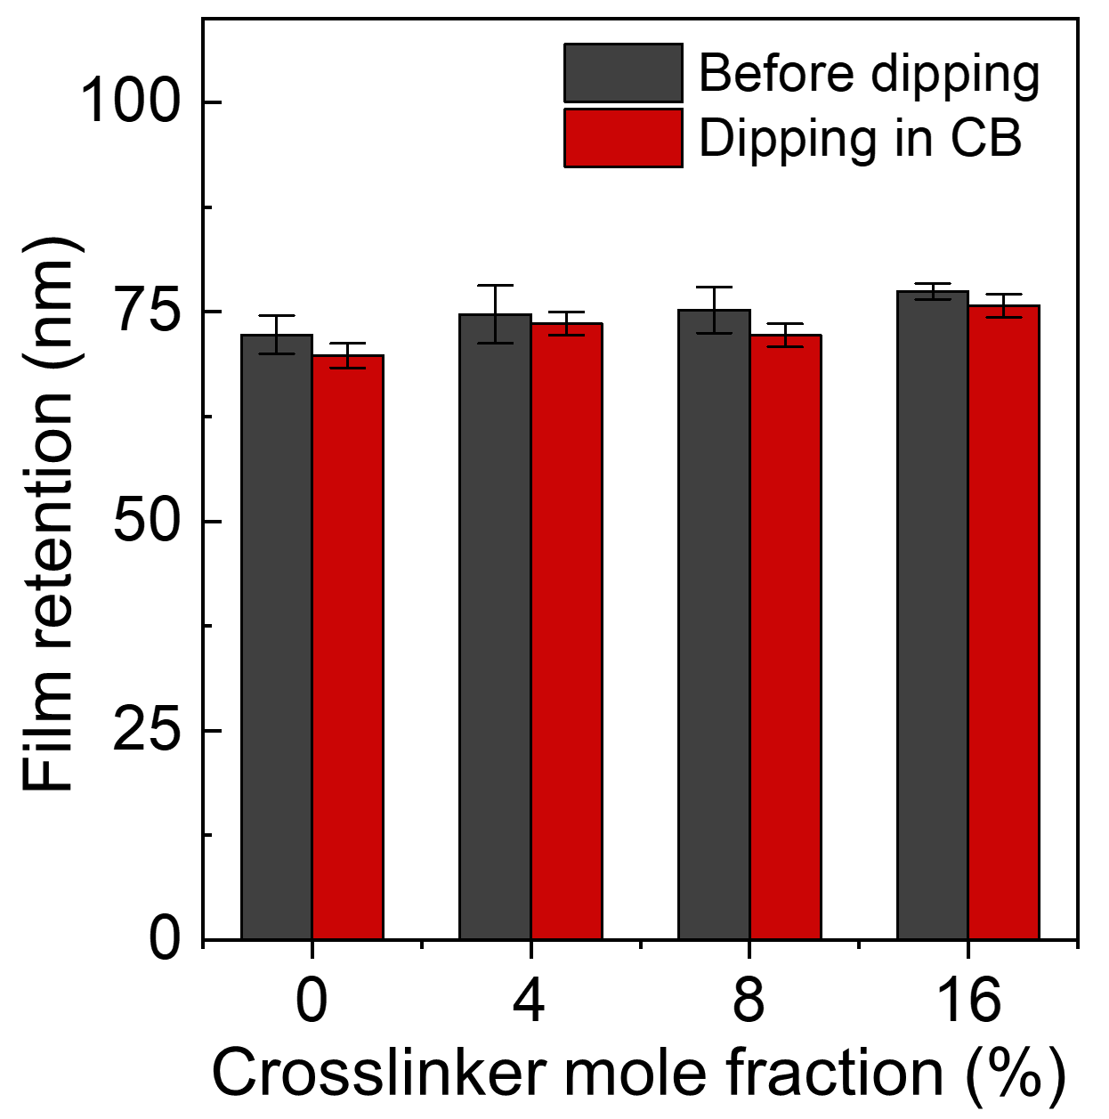

Supplementary Figure 3 | Evaluation of chemical resistance of the X-HTL and SI-HTL films. Film thickness of the X-HTL and SI-HTL films, before and after dipping in mother solvent (CB). Mean values with ± standard variations are indicated in data.

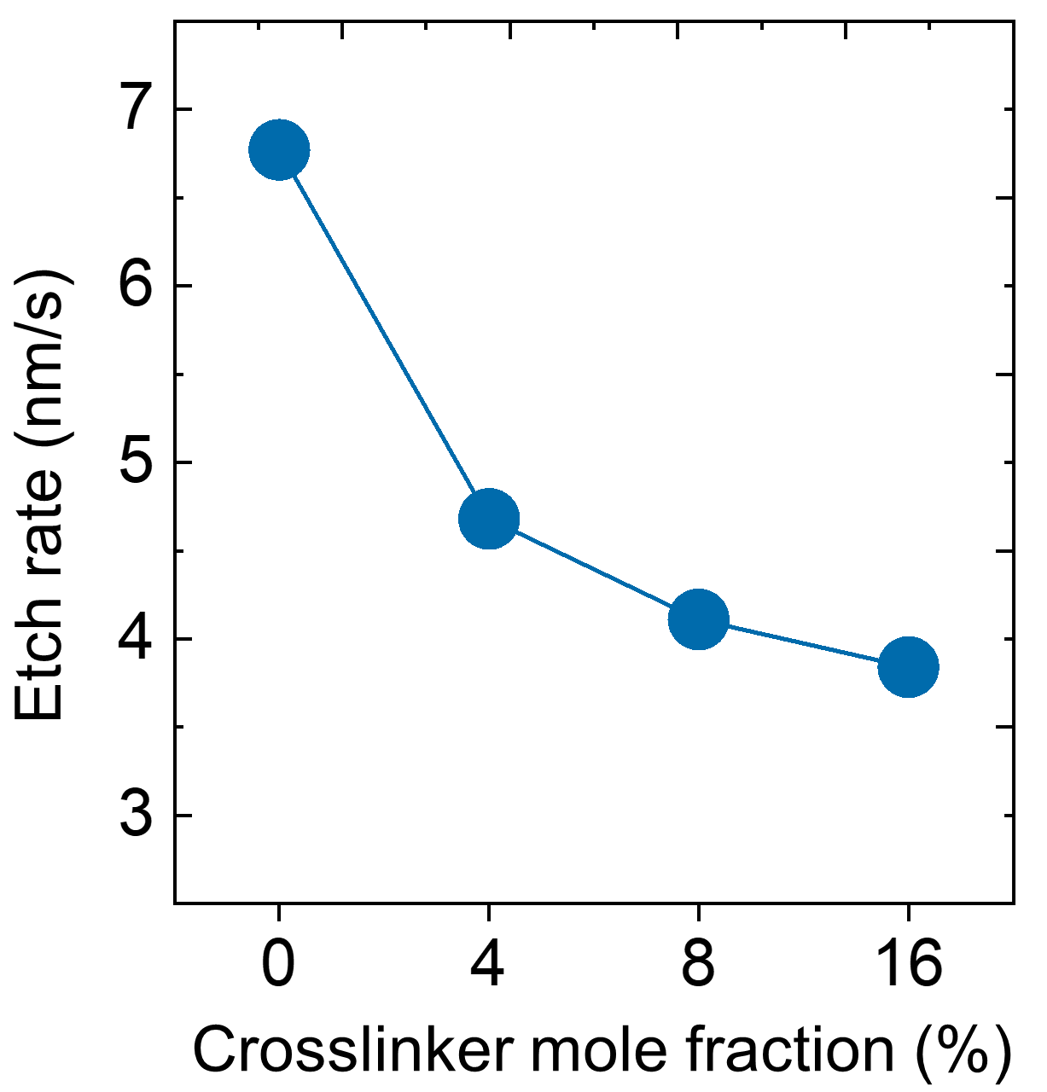

Supplementary Figure 4 | Evaluation of etch rate of the X-HTL and SI-HTL films. Etch rates of the X-HTL and SI-HTL films were determined by the film retention as a function of RIE etching time based on Ar/O₂ exposure.

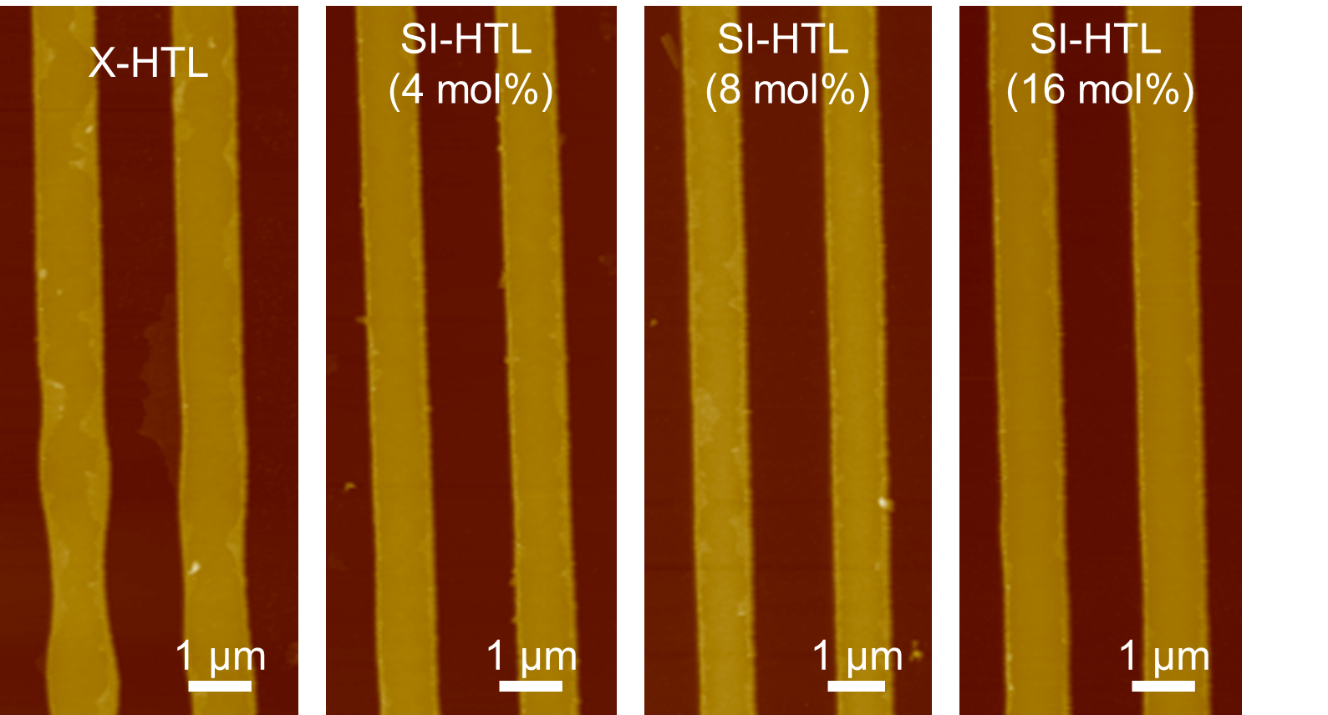

Supplementary Figure 5 | AFM images of micro-patterned X-HTL and SI-HTL films. The pattern and pitch size of the micro-patterns was 1 μm, and all pattern arrays were fabricated by photolithography coupled with RIE process.

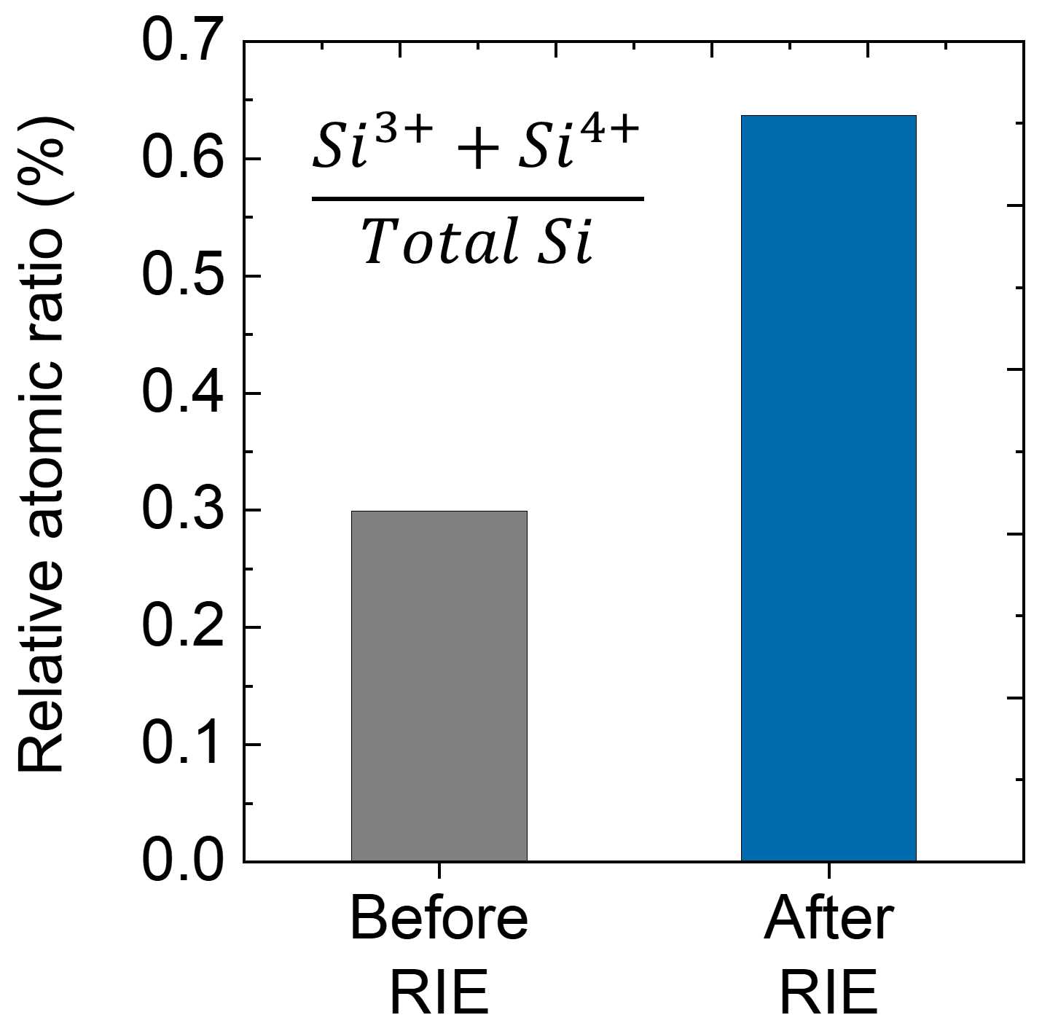

Supplementary Figure 6 | Relative atomic ratio of the SI-HTN before and after RIE. The reactive atomic ratio of high binding energy states (Si³⁺ and Si⁴⁺) in the Si 2p XPS spectra was determined before and after exposure to the RIE gases (Ar/O₂).

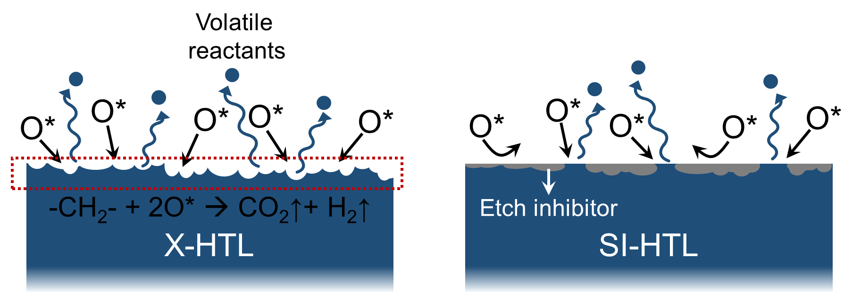

Supplementary Figure 7 | Chemical etching reactions on the surface of X-HTL and SI-HTL films. The CH₂ decomposition, producing volatile reactants, was suppressed in SI-HTL compared to X-HTL due to the formation of etch inhibitors.

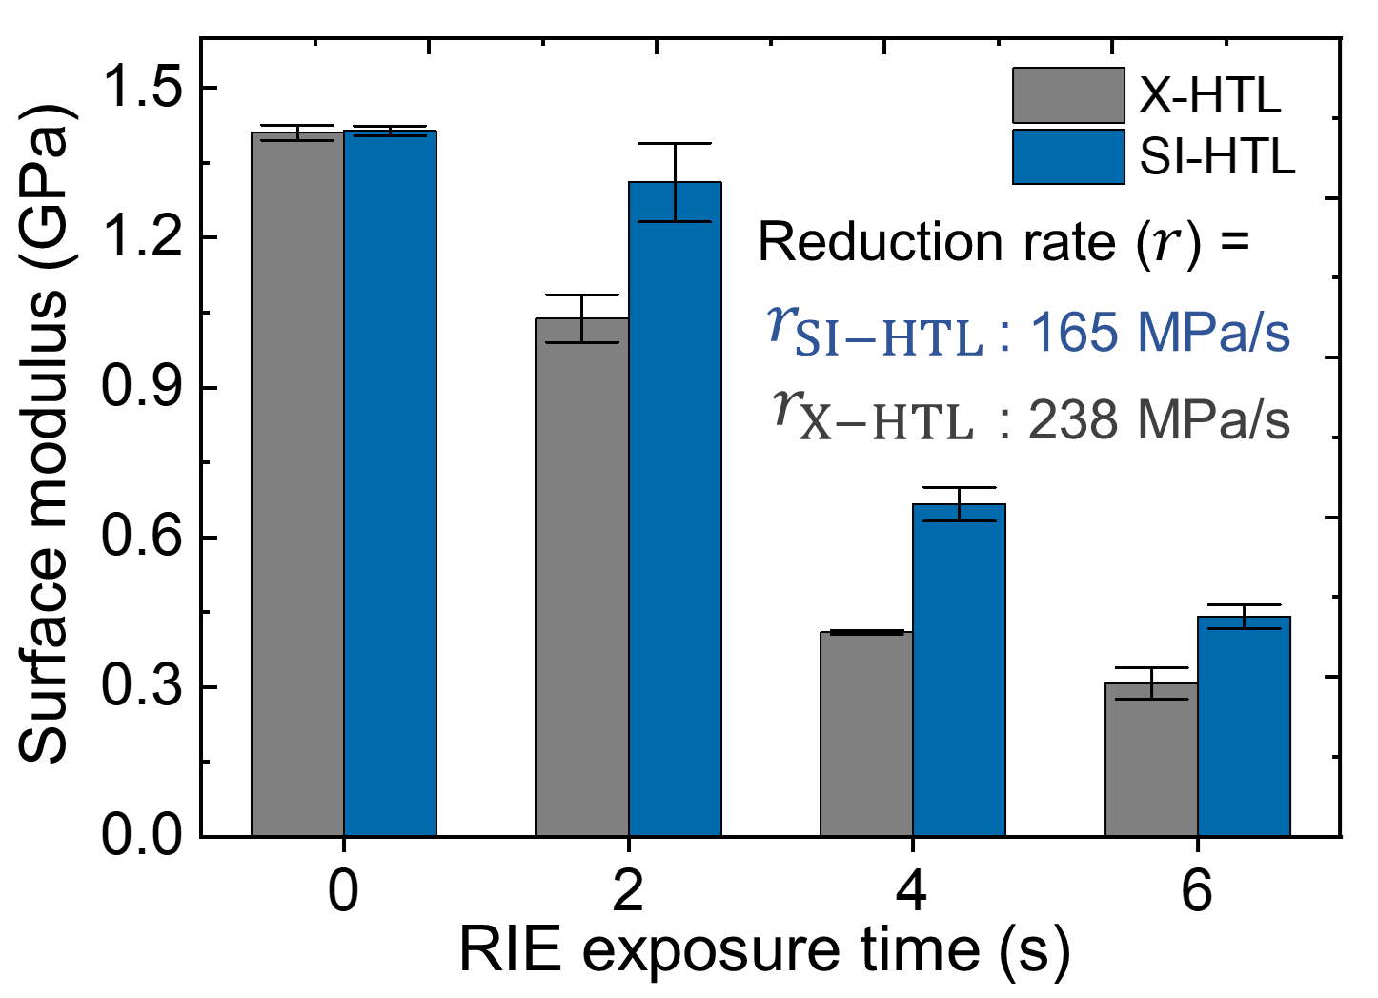

Supplementary Figure 8 | Surface modulus values of the X-HTL and SI-HTL films. The surface modulus of the X-HTL and SI-HTL films were determined as a function of reactive etching times.

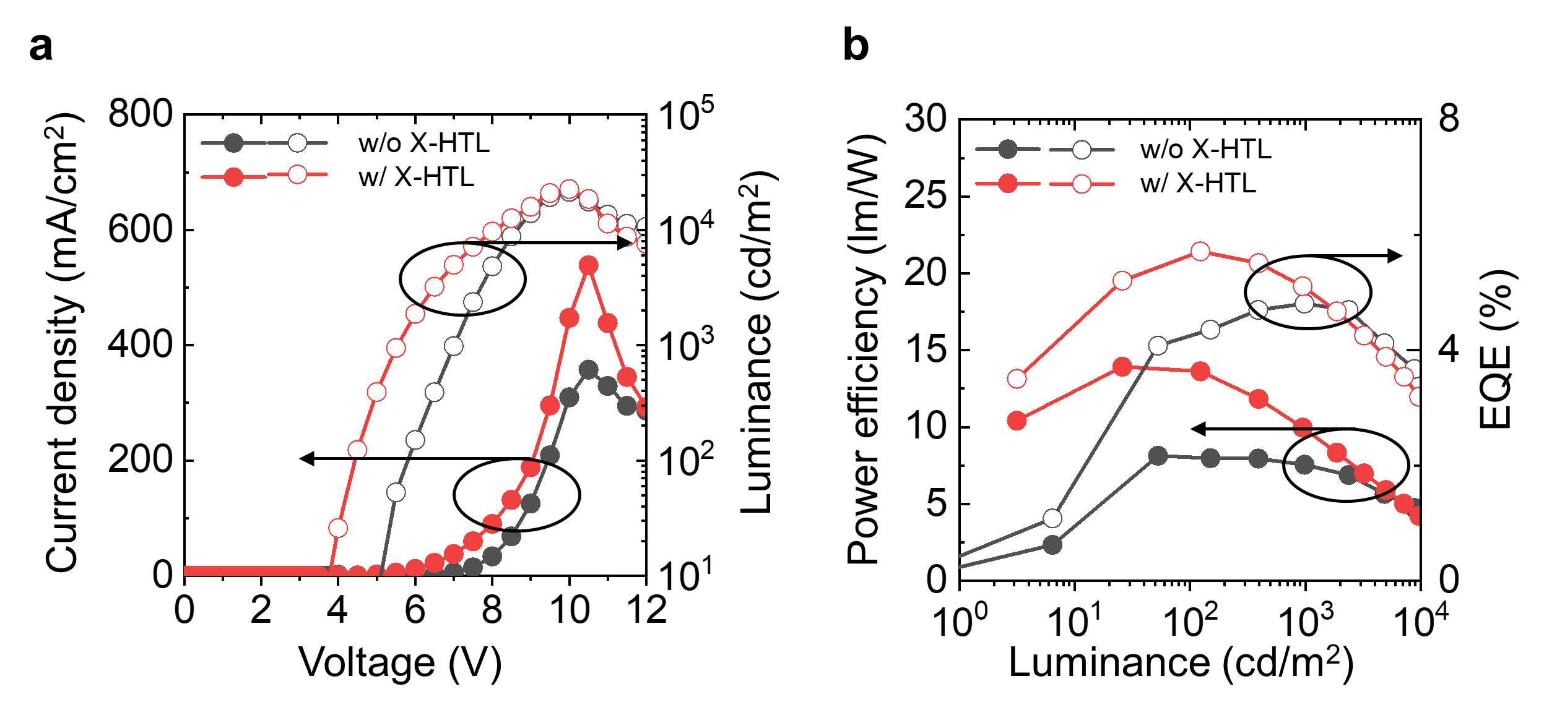

Supplementary Figure 9 | EL performance of OLEDs with X-HTL and withouth X-HTL. J-V-L curves (a), power efficiency and EQE (b) of the OLED devices with and without the X-HTL.

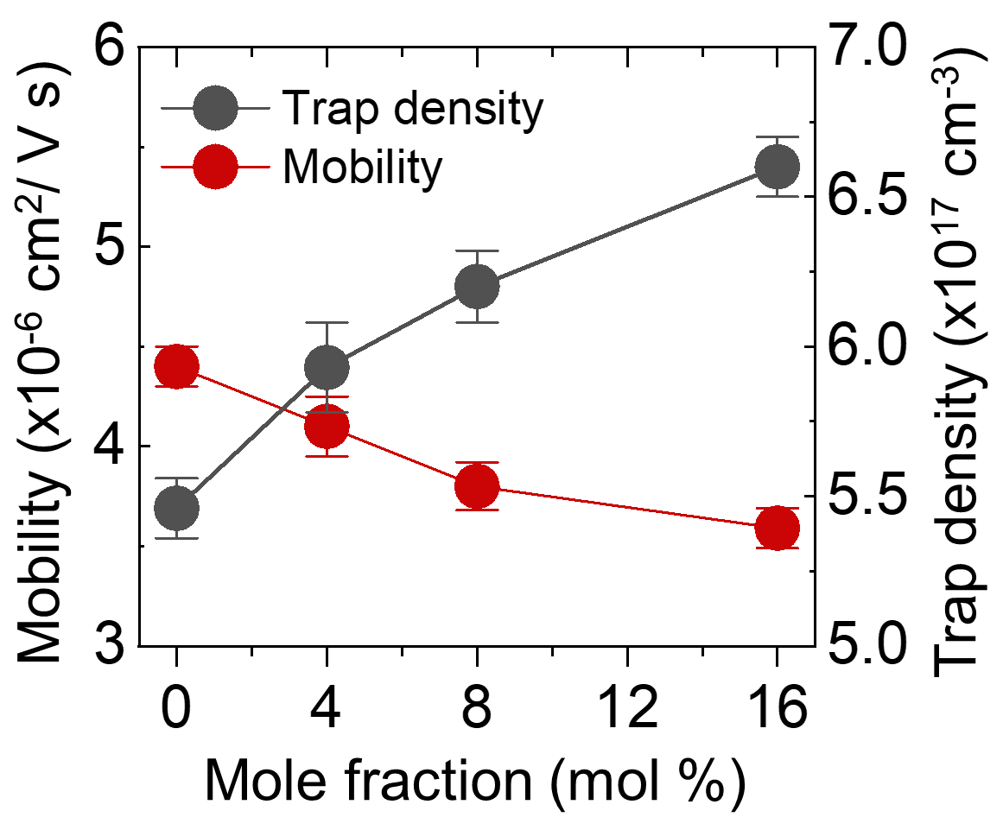

Supplementary Figure 10 | Hole mobility and trap density of X-HTL and SI-HTL depending on a concentration of the silicone crosslinkers. Hole mobility and trap density calculated from the SCLC measurement of hole only devices (HODs).

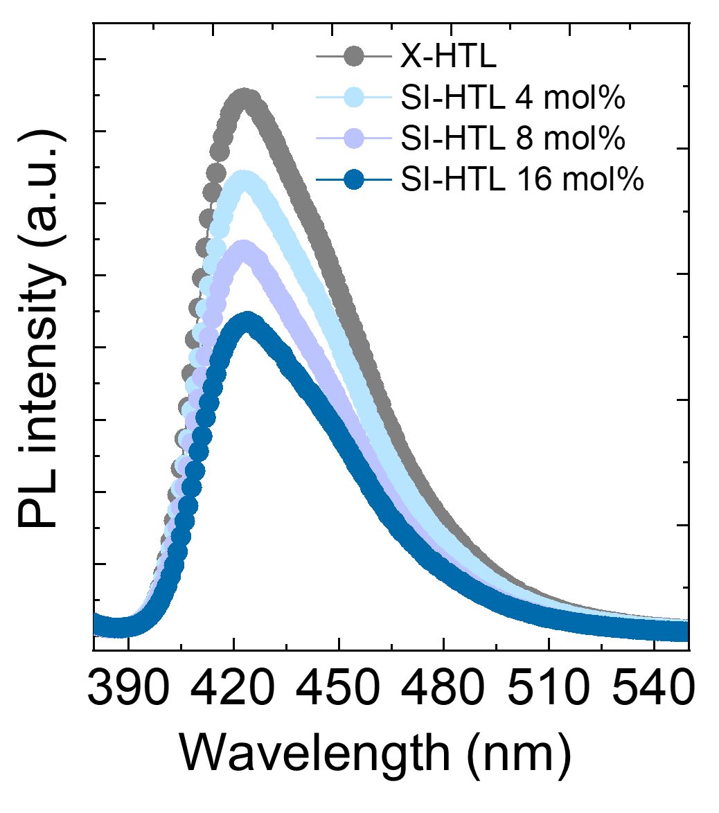

Supplementary Figure 11 | Photoluminescence spectra of X-HTL and SI-HTL with varying the loading amount of the silicone crosslinkers.

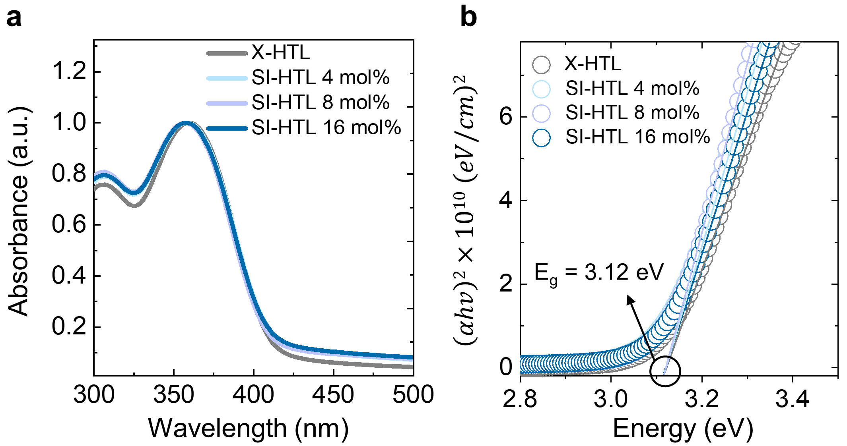

Supplementary Figure 12 | Ultraviolet-visible absorption spectra (a) and tau plots (b). The tau plots were obtained from the absorption spectra and the calculated band gap (E_{g}) was 3.12 eV.

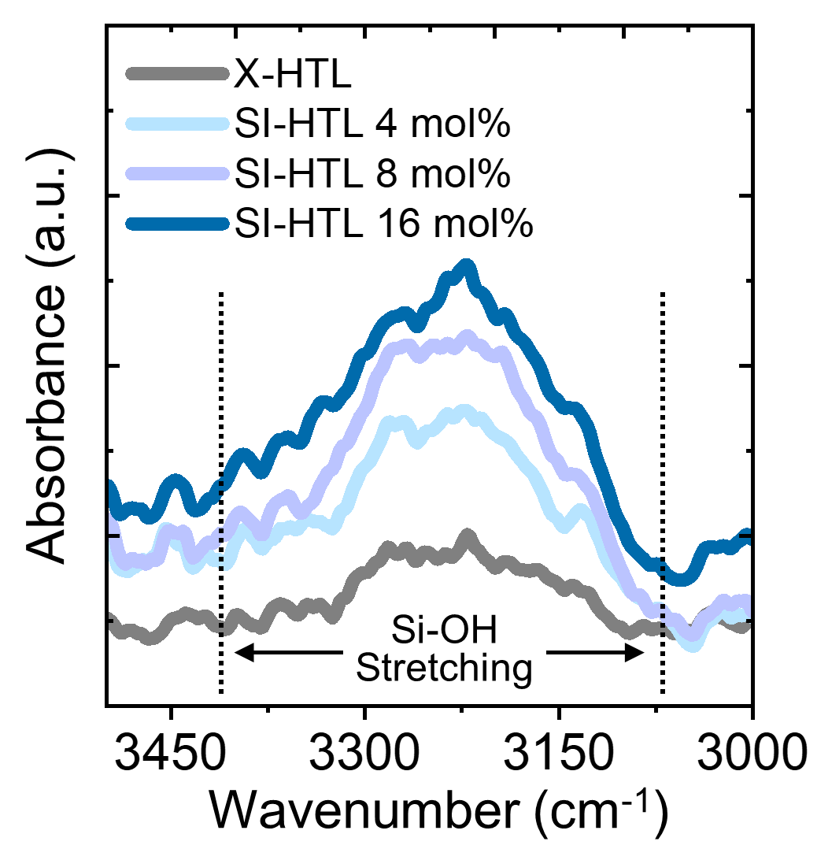
Supplementary Figure 13 | FTIR spectra of SI-HTL (4, 8, 16 mol%) and X-HTL films.

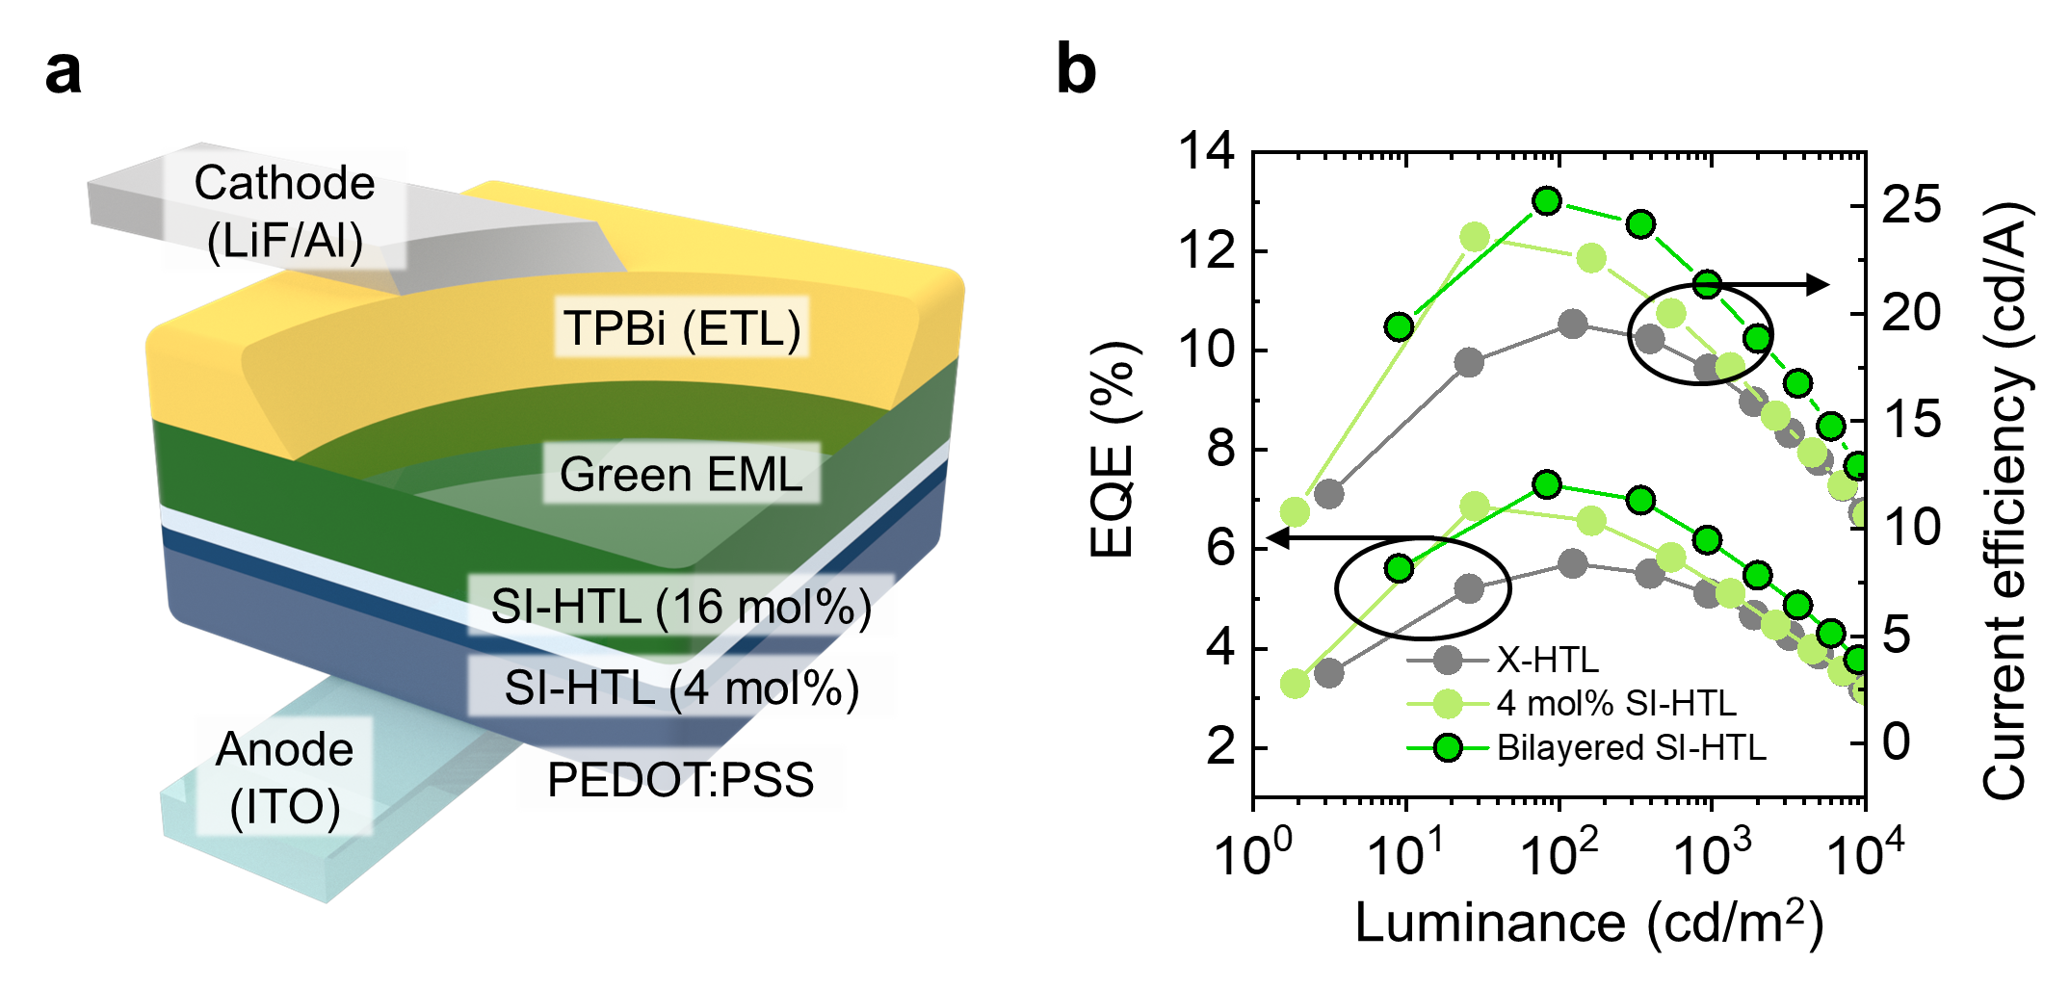

Supplementary Figure 14 | OLEDs integrated with multi-layered SI-HTL (4 mol% and 16 mol%). a, Schematic of the OLED device employing the bilayer (4 mol% and 16 mol %) SI-HTN as the hole transporting layer. b, EQE and current efficiency of OLEDs with X-HTL, 4 mol% SI-HTL, and bilayered SI-HTL, respectively.

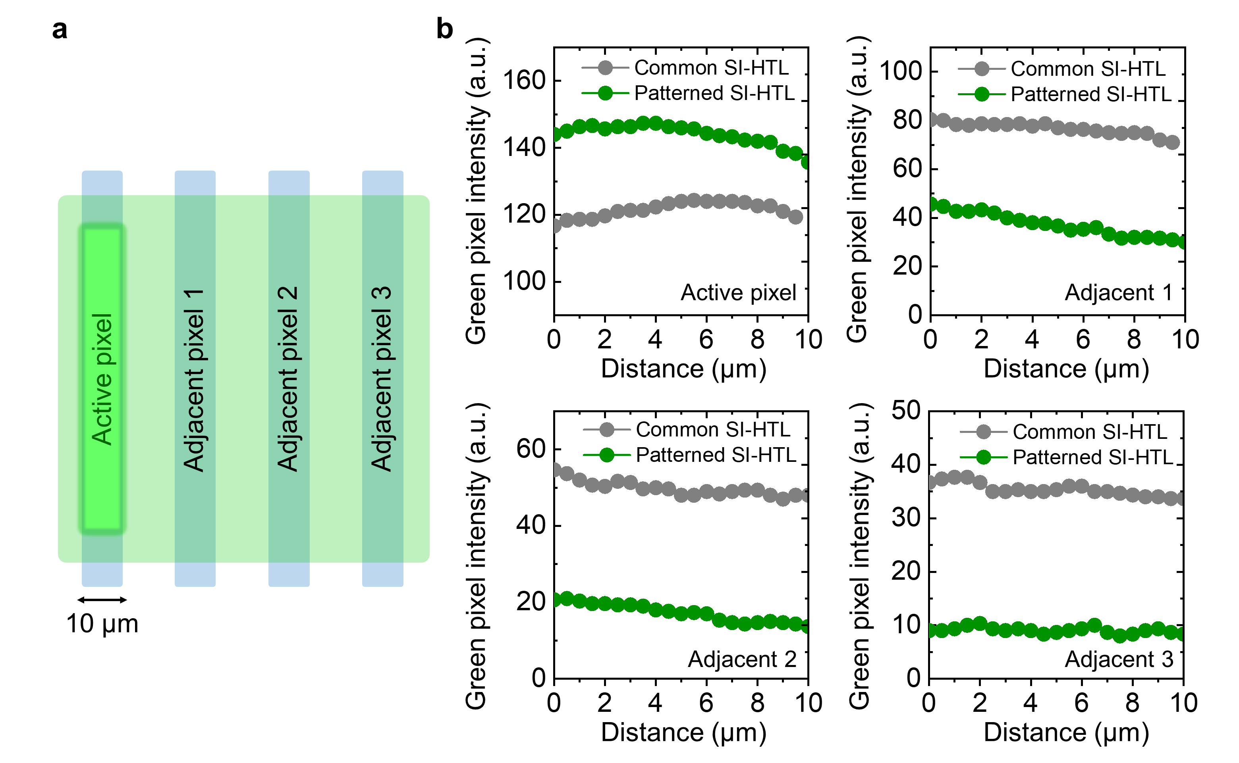

Supplementary Figure 15 | Evaluation of green pixel intensity in OLEDs with common and patterned SI-HTL. a, Schematic of the OLEDs with patterned anode pixels. b, Image analysis results featuring the green pixel intensity of OLED devices with common and patterned SI-HTL.

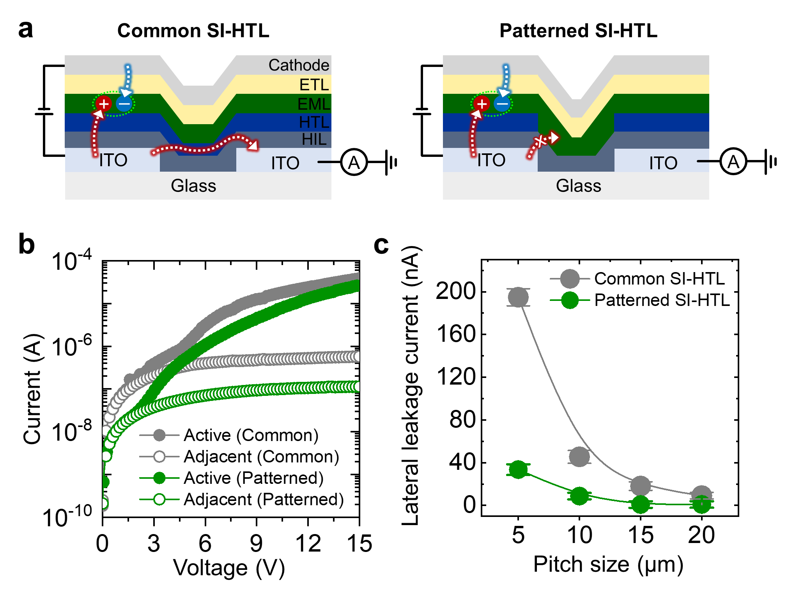

Supplementary Figure 16 | Evaluation of lateral leakage currents in OLEDs with common and patterned SI-HTL. a, Schematic of lateral leakage currents in the OLEDs with patterned and common SI-HTL, respectively. b,c, Voltage-dependent current characteristics and lateral leakage currents of common and micro-patterned SI-HTL-based OLEDs, respectively.

Supplementary Table 1 | Micro-pattering performance of previously reported small-molecule organic semiconductors.

Organic  semiconductor | Patterning  method | Pattern  width | Pattern  pitch | Pattern density  (Patterns/cm²) | Ref
SI-HTL | Photolithography | 1 μm | 1 μm | 16,666,666 | -
Be(bq)₂:Ir(phq)₂(acac) | Transfer printing | 5 μm | 10 μm | 444,444 | 8
C₈-BTBT | Transfer printing | 30 μm | 3 μm | 91,827 | 9
TIPS-PEN | Transfer printing | 10 μm | 5 μm | 444,444 | 10
NPB | Template direct growth | 1 μm | 7 μm | 1,562,500 | 11
NPB | Template direct growth | 9 μm | 1.5 μm | 906,304 | 12
N(Ph-T-CNA-EtHex)₃ | Inkjet printing | 25 μm | 50 μm | 17,777 | 13
SimCP2:Flrpic | Inkjet printing | 80 μm | 40 μm | 2,905 | 14
N/A | FMM | 5.5 μm | 3.5 μm | 1,234,321 | 15
DCJTB, C545T, TBADN | FMM | 25 μm | N/A | 400 | 16
N/A | FMM | N/A | N/A | 12,555,025 | 17
N/A | Photolithography | 2 μm | 1 μm | 11,108,889 | 18
N/A | Photolithography | 10 μm | 10 μm | 250,000 | 19

Supplementary Table 2 | Summary of OLED performances based on X-HTL and SI-HTL (4, 8, 16 mol%, and bilayer) films.

Materials | Luminance  at 8 V  [cd/m²] | Maximum EQE  [%] | Maximum current efficiency  [cd/A]
Without HTL | 4,843 | 4.81 |  | 16.42
X-HTL | 9,670 | 5.71 |  | 19.52
4 mol% SI-HTL | 14,321 | 6.87 |  | 23.57
8 mol% SI-HTL | 10,232 | 6.87 |  | 23.40
16 mol% SI-HTL | 9,535 | 6.58 |  | 22.52
Bilayered SI-HTL  (4 mol % and 16 mol%) | 16,946 | 7.31 |  | 25.25

Supplementary References

- Braga, D. et al. Modeling Electrical and Optical Cross-Talk between Adjacent Pixels in Organic Light-Emitting Diode Displays. SID Symp. Dig. Tech. Pap. 50, 31-34 (2019).
- Sim, S. et al. Color gamut change by optical crosstalk in high-resolution organic light-emitting diode microdisplays. Opt. Express 30, 24155–24165 (2022).
- Yin, Y. et al. Alleviating the crosstalk effect via a fine-moulded light-blocking matrix for colour-converted micro-LED display with a 122% NTSC gamut. Light Adv. Manuf. 3, 445-452 (2022).
- Qi, L., Zhang, X., Li, P., & Lau, K. M. Optical crosstalk reduction in GaN-on-Si micro-LED display. Proceedings of the International Display Workshops 27, 202-204 (2021).
- Diethelm, M. et al. Quantitative analysis of pixel crosstalk in AMOLED displays. J. Inf. Disp. 19, 61-69 (2018).
- Engelhart, J. et al. Hole-Transport Materials — Key Enablers for Future OLED Display Evolution. SID Symp. Dig. Tech. Pap. 53, 877-880 (2022).
- Lee, J.-M. et al. Analysis and simulation of reddish overshoot in active matrix organic light-emitting diode display with varying p-doped hole transport layer concentrations. Org. Electron. 99, 106328 (2021).
- Cha, S. & Kim, C. Transfer-printing phosphorescent OLEDs: Progress towards microdisplay applications. Org. Electron. 122, 106891 (2023).
- Jo, P. S., Vailionis, A., Park, Y. M. & Salleo, A. Scalable fabrication of strongly textured organic semiconductor micropatterns by capillary force lithography. Adv. Mater. 24, 3269–3274 (2012).
- Bae, I. et al. Tailored single crystals of triisopropylsilylethynyl pentacene by selective contact evaporation printing. Adv. Mater. 23, 3398-3402 (2011).
- Zhou, X. et al. Dewetting-assisted patterning of organic semiconductors for micro-OLED arrays with a pixel size of 1 μm. Small Methods 6, 2101509 (2022).
- Zhu, J. et al. Micro organic light-emitting diodes fabricated through area-selective growth. Mater. Chem. Front. 1, 2606-2612 (2017).
- Skhunov, M. et al. Pixelated full-colour small molecule semiconductor devices towards artificial retinas. J. Mater. Chem. C 9, 5858-5867 (2021).
- Bail, R., Hong, J. Y., & Chin, B. D. Inkjet printing of blue phosphorescent light-emitting layer based on bis (3, 5-di (9 H-carbazol-9-yl)) diphenylsilane. RSC Adv. 8, 11191-11197 (2018).
- Jiang, Y., Tam, B. S. T., Dong, S.-C. & Tang, C. W. 2‐inch, 2,000‐ppi Silicon Nitride Mask for Patterning Ultra‐High‐Resolution OLED Displays. SID Symp. Dig. Tech. Pap. 51, 909-912 (2020).
- Kajiyama, Y., Joseph, K., Kajiyama, K., Kudo, S. & Aziz, H. Small feature sizes and high aperture ratio organic light-emitting diodes by using laser-patterned polyimide shadow masks. Appl. Phys. Lett. 104, 053303 (2014).
- Mertens, R. APS manages to produce a 3000 PPI direct-emission OLED using its latest FMM technology. https://www.oled-info.com/aps-progresses-its-oled-microdisplay-project-developes-technologies-produce (2022).
- Malinowski, P. E. et al. Photolithography as Enabler of AMOLED Displays Beyond 1000 ppi. SID Symp. Dig. Tech. Pap. 48, 623-626 (2017).
- Malinowski, P. E. et al. Multicolor 1250 ppi OLED Arrays Patterened by Photolithography. SID Symp. Dig. Tech. Pap. 47, 1009-1012 (2016).

