Supplementary Table.1
Primers used in this study.
Target | Forward sequence | Reverse sequence
Hsd17b7 | ACACCGTACAACGGAGCAGA | TCTGAACGGTGGTCCTGACA
Star | GTCTTCCTGCCTTGCCAGAG | GCTGGGGACAAGAGCATACTG
Plin4 | GCTGCTCCAACCTTCTGAAC | CAGTCCACCCTGGACCATTC
Abcb1b | CTCTTGAAGCCGTAAGAGGCT | AACTCCATCACCACCTCACG
Ltbp1 | GGGCAAACAAGGCCTTTCAA | GGGATTTCCCATGGGGGTTT
Scarb1 | AAAGGGCTCCCAGGATAAGGA | GAGAGAGTCCTCAAGAAGCGG
Akr1c18 | AAGCCAGGGAATGAGCTTTTG | CCAGCCCTGCATCCTTACAC
Ptgfr | ATAATGTGCGTCTCCTGCGT | CTGATTCCACGTTGCCATGC
Rhox8 | AGAACACTTCCAGGTCATGGG | CAGAAGAGACGACTGGGTGAC
Greb1 | GCGAGAGCTCCCATAAAGCA | AGGTGCCAGGATCAAAGAGC
Lhcgr | TAGCCACTGCTGTGCTTTCA | TCGTAATCCCAGCCACTGAG
Cyp19a1 | AACAGAACCTGAGCCTCCCAA | TTAGAACGTAACCCAGCGGT
Inhba | CGTGGAGTTGGAGCTTTGTG | CCCCTTCCCGAGTGTAGAGT
Igfbp7 | GCGAGCAAGGTCCTTCCATA | GTTCTGTCCGCTGAACTCCA
Igf1 | GTTCCCCCAGCTGTTTCCTG | ATTCCATTGCGCAGGCTCTA
ERE | ACCGCAAACTGTATCAGTGG | CCAGCTGCCACAATTAGAAAC

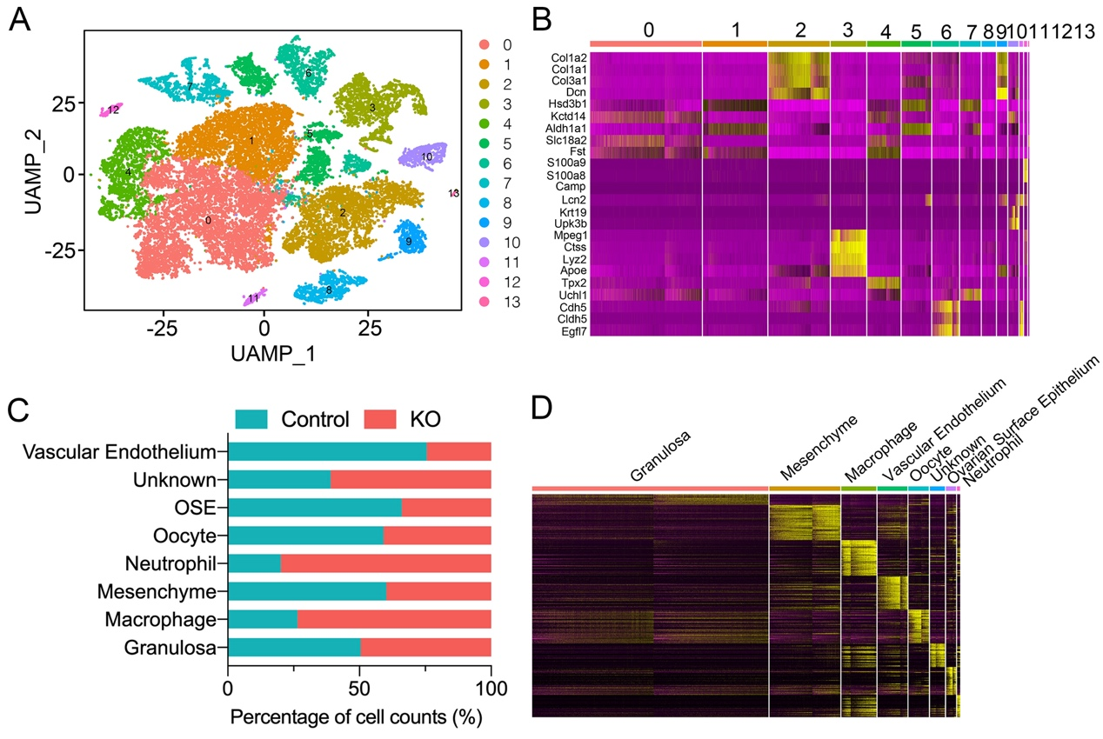

Supplementary Figure S1. ScRNA-seq of ovaries from control and αERKO mice. (A) InDROP libraries were sequenced, demultiplexed, normalized, and analyzed using the Seurat package in ‘R’. The processed samples clustered into 14 clusters. (B) Heatmap of top 5 markers per cluster ordered by logFc values. (C) The percentage of cell counts for each cell type in the control and KO samples. (D) Heatmap of top 10 highly expressed genes per cluster ordered by logFc values.

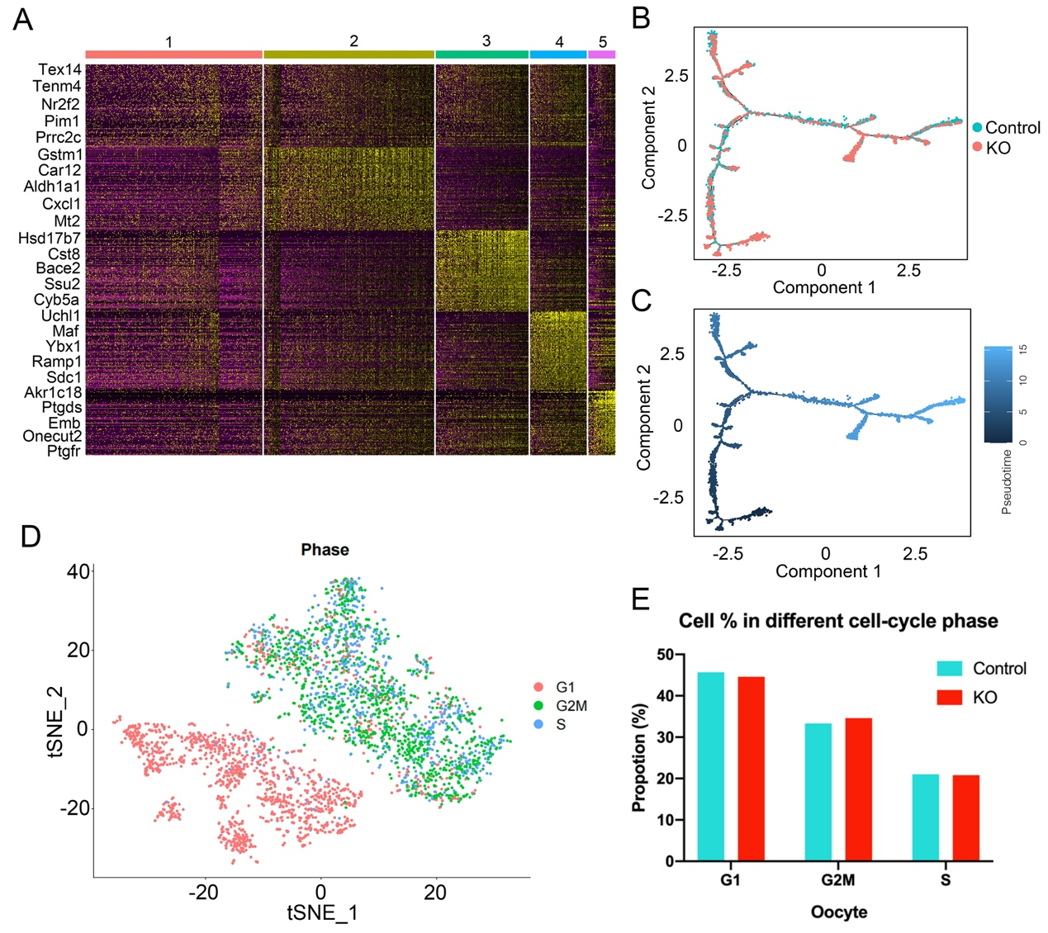

Supplementary Figure S2. Dissecting oocytes subclusters. (A) Heatmap of top 5 highly expressed genes per cluster ordered by logFc values in oocytes subclusters. (B-C) Single-cell pseudotime developmental trajectory of oocytes, which are colored according to two groups (B) and time (C). (D) UMAP plot inferring the cell-cycle phase based on expression of a large set of G2/M- and S-phase genes in oocytes. (E) Percentages of oocytes in different cell-cycle phases from control and KO mice.

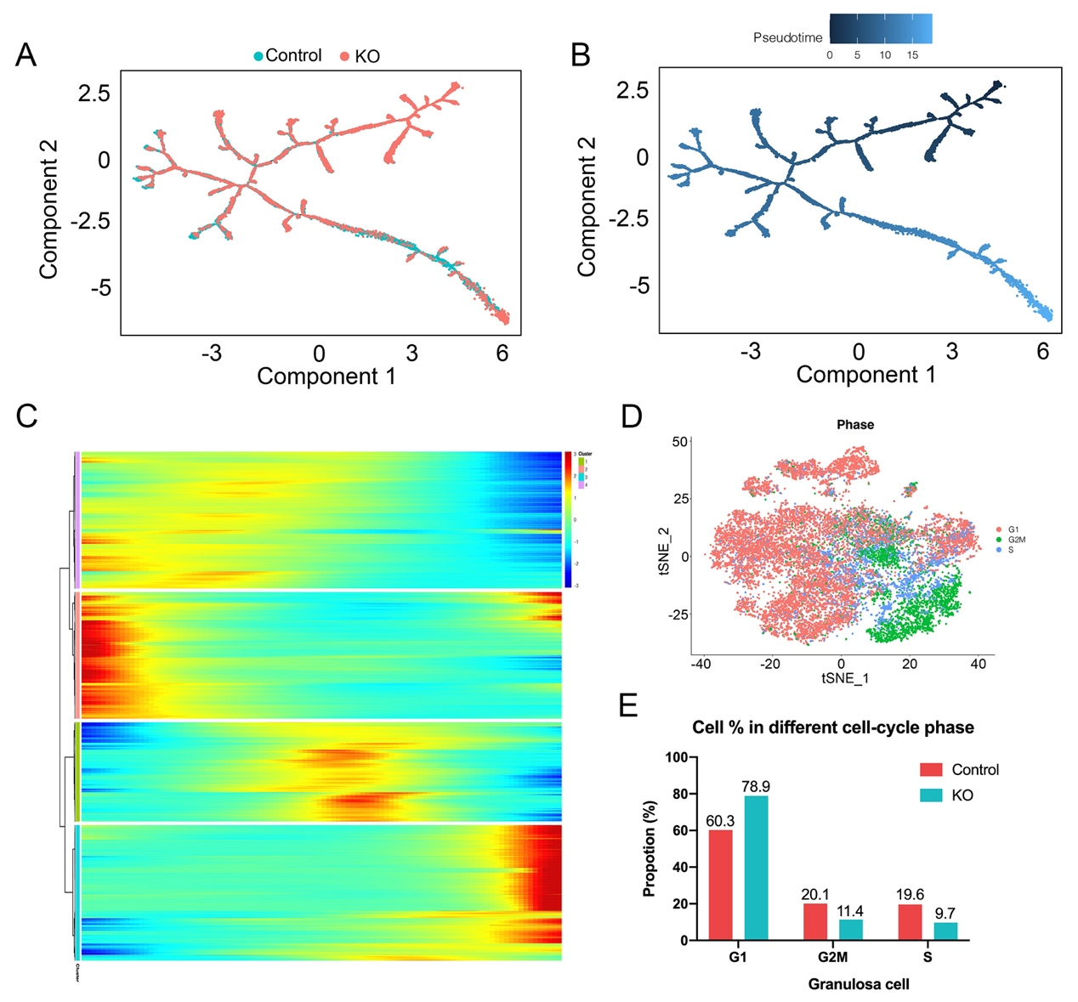Supplementary Figure S3. Dissecting granulosa cells subclusters. (A-B) Single-cell pseudotime developmental trajectory of granulosa cells, which are colored according to two groups (A) and time (B). (C) Monocle analysis on subclustering of granulosa cells. (D) UMAP plot inferring the cell-cycle phase based on expression of a large set of G2/M- and S-phase genes in granulosa cells. (E) Percentages of granulosa cells in different cell-cycle phases from control and KO mice.

