Supplementary materials
Variable | NM (n=22) | DM (n=20) | DCM (n=27) | P value
Age (years) | 60.7±2.4 | 61.3±2.1 | 72.1±1.4 | ＜0.001
Gender (male), n(%) | 8 (36.4) | 10 (50.0) | 10 (37.0) | 0.595
BMI (kg/m²) | 25.3±0.8 | 26.0±1.0 | 25.9±0.7 | 0.790
proBNP (pg/mL) | 61.3±11.4 | 79.3±19.6 | 351.8±89.8 | 0.001
cTnT (ng/mL) | 0.007±0.001 | 0.011±0.002 | 0.023±0.007 | 0.046
IL-37 (pg/mL) | 2.8±0.4 | 2.7±0.3 | 16.8±1.5 | ＜0.001
UA (μmol/L) | 320.8±22.0 | 357.7±30.0 | 325.9±16.3 | 0.482
CRE (mmol/L) | 72.5±4.1 | 89.8±9.3 | 75.9±5.4 | 0.156
ALT (U/L) | 23.2±3.9 | 24.9±3.4 | 17.3±2.2 | 0.187
AST (U/L) | 21.2±1.7 | 20.4±1.3 | 18.3±1.3 | 0.301
HbAlc (%) | 5.5±0.1 | 8.3±0.5 | 7.8±0.3 | ＜0.001
FBG (mmol/L) | 5.4±0.1 | 9.2±1.3 | 7.8±0.6 | 0.005
LDL-C (mmol/L) | 2.6±0.2 | 2.4±0.2 | 2.3±0.2 | 0.515
Total cholesterol (mmol/L) | 4.3±0.2 | 4.5±0.3 | 3.9±0.2 | 0.226
Triglycerides (mmol/L) | 1.6±0.1 | 2.4±0.3 | 1.5±0.1 | 0.012
HDL-C (mmol/L) | 1.3±0.1 | 1.0±0.1 | 1.1±0.1 | 0.102
CRP (mg/L) | 3.3±1.1 | 2.9±0.6 | 5.5±1.8 | 0.339
LAD (mm) | 36.1±0.8 | 38.6±0.9 | 40.2±0.6 | 0.001
LVIDd (mm) | 49.0±1.1 | 47.1±1.0 | 49.2±1.0 | 0.293
LVIDs (mm) | 31.6±0.9 | 31.3±0.7 | 33.7±1.0 | 0.117
IVSd (mm) | 10.1±0.3 | 10.6±0.3 | 11.5±0.3 | 0.003
LVPWd(mm) | 9.2±0.2 | 9.5±0.2 | 10.0±0.2 | 0.017
LVEF (%) | 64.1±1.1 | 62.0±1.1 | 57.7±1.7 | 0.006
E/A ratio | 1.0±0.03 | 0.9±0.03 | 0.7±0.38 | ＜0.001
E/e' ratio | 6.9±0.4 | 6.9±0.2 | 9.8±0.7 | ＜0.001
Table1. The general characteristics of study population
Data presented as mean±SEM or n (%), one way ANOVA followed by Bonferroni post hoc test or chi-square test was used to check for normal distributions of data. BMI, body mass index; BNP, brain natriuretic peptide; cTnT, cardiac troponin T; IL-37, interleukin 37; UA, uric acid; CRE, creatinine; ALT, alanine aminotransferase; AST, aspartate aminotransferase; HbAlc, glycosylated hemoglobin Alc; FBG, fasting blood glucose; LDL-C, low-density lipoprotein cholesterol, HDL-C, high-density lipoprotein cholesterol; CRP, C-reactive protein; LAD, left atrial diameter; LVIDd, left ventricular internal diameter at end-diastole; LVIDs, left ventricular internal diameter at end-systole; IVSd, interventricular septum thickness at end-diastole; LVPWd, left ventricular posterior wall thickness at end-diastole; LVEF, left ventricular ejection fraction; E, passive transmitral LV inflow velocity; A, late transmitral LV inflow during left atrial contraction; e', tissue Doppler imaging velocity of the medial mitral annulus during passive filling.

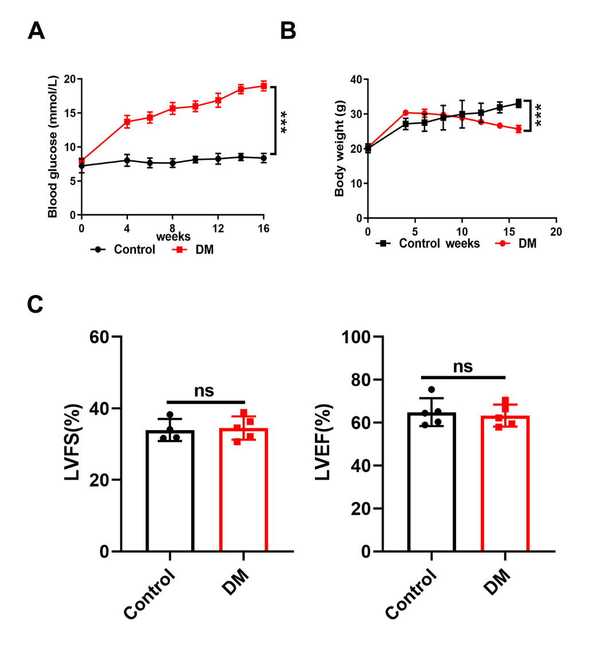
Figure S1
(A) The blood glucose levels in both control and diabetic mice. (B) Body weight changes were measured in both control and diabetic mice. (C and D) Left ventricular fractional shortening (LVFS) and left ventricular ejection fraction (LVEF) in both control and diabetic mice were also evaluated. Values are means ± SEM; *P< 0.05, **P< 0.01, ***P< 0.001. (n = 6 in each group, data were analyzed by one way ANOVA followed by Bonferroni post hoc test or unpaired Student t-test.)

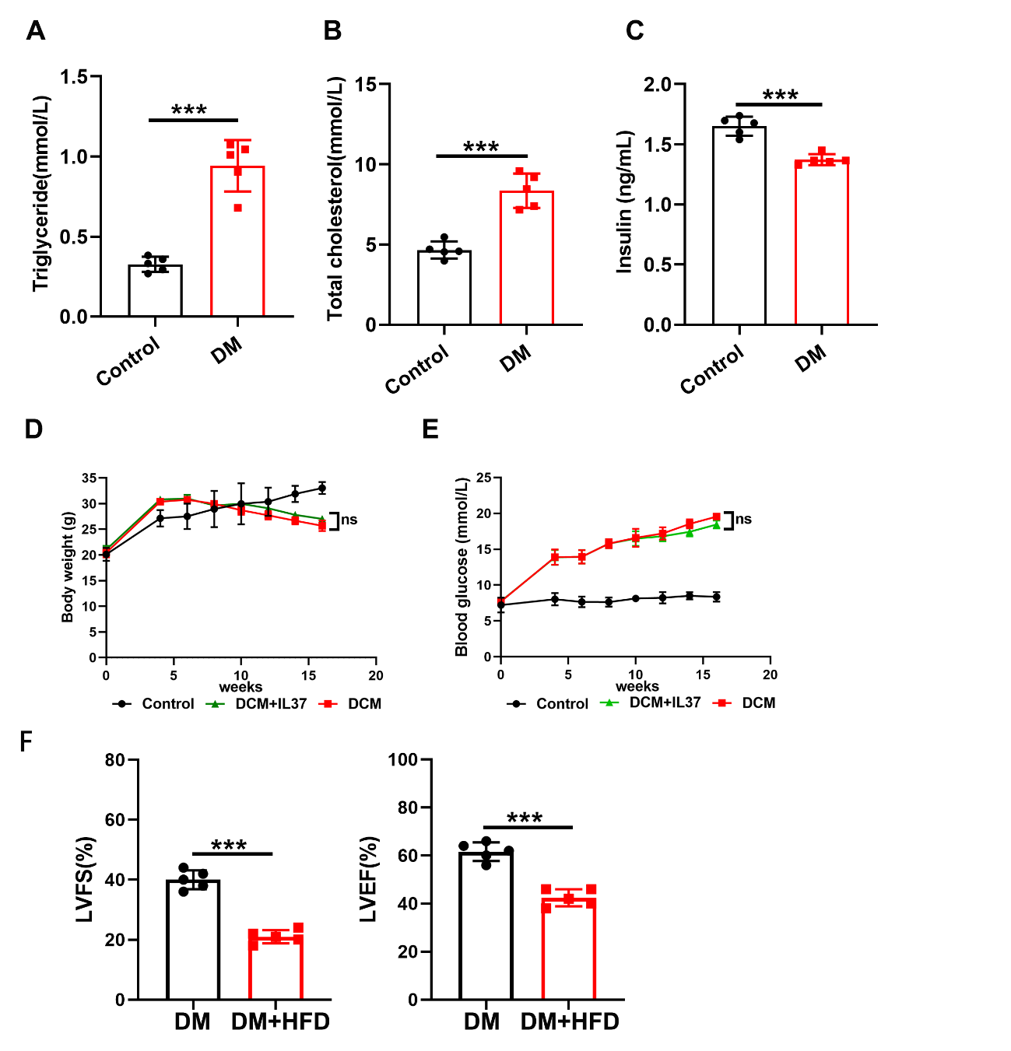
Figure S2 (A-C) The serum levels of triglyceride, cholesterol, and insulin in both control and diabetic mice were measured. (D) The body weight changes were analyzed among the indicated groups. (E) Blood glucose levels were measured in the indicated groups. (F) LVFS and LVEF measurements were obtained. Values are means ± SEM; *P< 0.05, **P< 0.01, ***P< 0.001. (n = 6 in each group, data were analyzed by one way ANOVA followed by Bonferroni post hoc test or unpaired Student t-test.)
Figure S3 (A)The mRNA level of IL37 in different tissues. (B) The expression of IL-37 in WT and IL37-Tg cardiomyocyte. (C and D) The serum levels of cholesterol and insulin in the indicated groups were measured. Values are means ± SEM; *P< 0.05, **P< 0.01, ***P< 0.001. (n = 6 in each group, data were analyzed by one way ANOVA followed by Bonferroni post hoc test or unpaired Student t-test.)
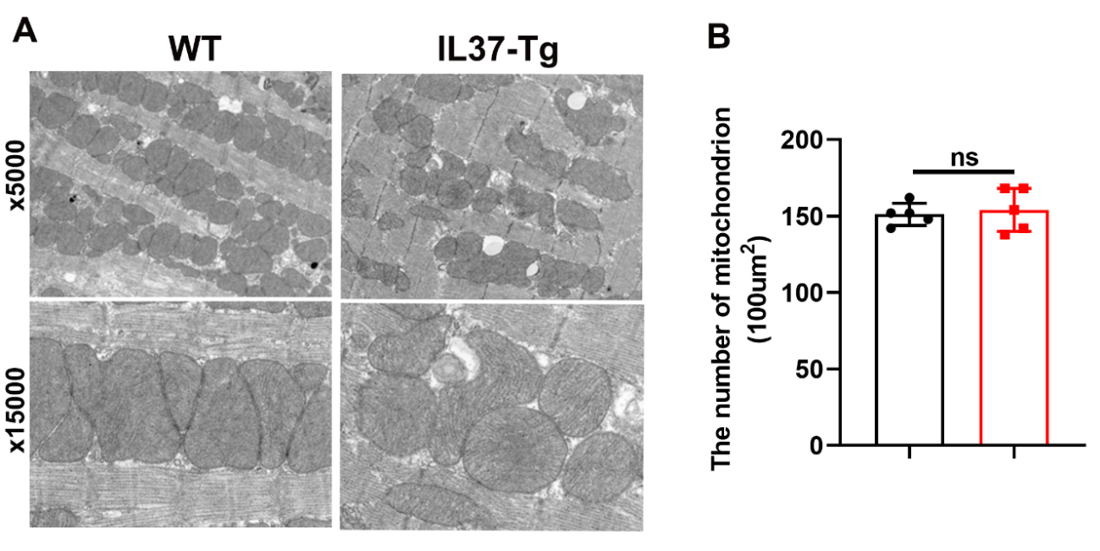
Figure S4 (A)The representative electron microscopy (EM) images of mitochondria in WT and IL-37-Tg mice were presented. (B) Quantification of mitochondrial abundance in panel A was shown. Values are means ± SEM; *P< 0.05, **P< 0.01, ***P< 0.001. (n = 6 in each group, data were analyzed by unpaired Student t-test.)

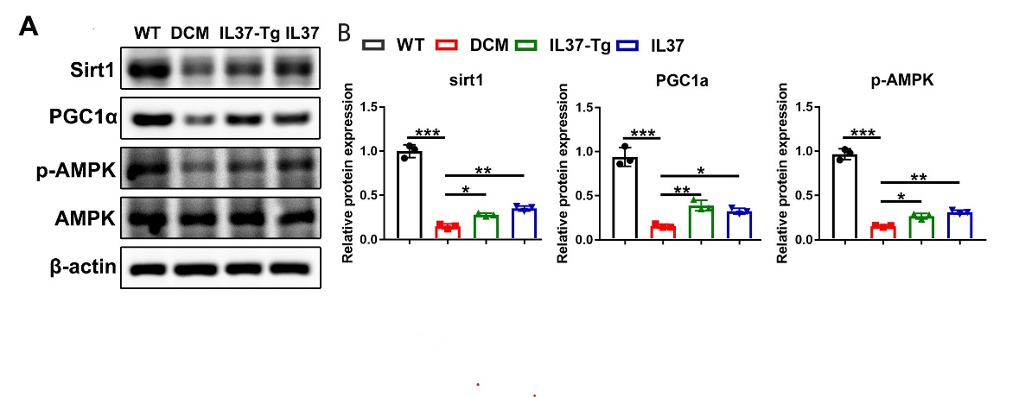
Figure S5 (A) The protein levels of SIRT1, PGC1α, p-AMPK and AMPK were assessed in the myocardium of mice. (B) Quantitative densitometric analysis of SIRT1, PGC1α, p-AMPK and AMPK with β-actin as an internal standard. Values are means ± SEM; *P< 0.05, **P< 0.01, ***P< 0.001. (n = 6 in each group, data were analyzed by one way ANOVA followed by Bonferroni post hoc test.)
Figure S6 (A and B) The efficiency of sirt1 silencing was validated by Western blot and q-PCR analyses. Values are means ± SEM; *P< 0.05, **P< 0.01, ***P< 0.001, (n = 3 in each group at least, data were analyzed by one way ANOVA followed by Bonferroni post hoc test.)
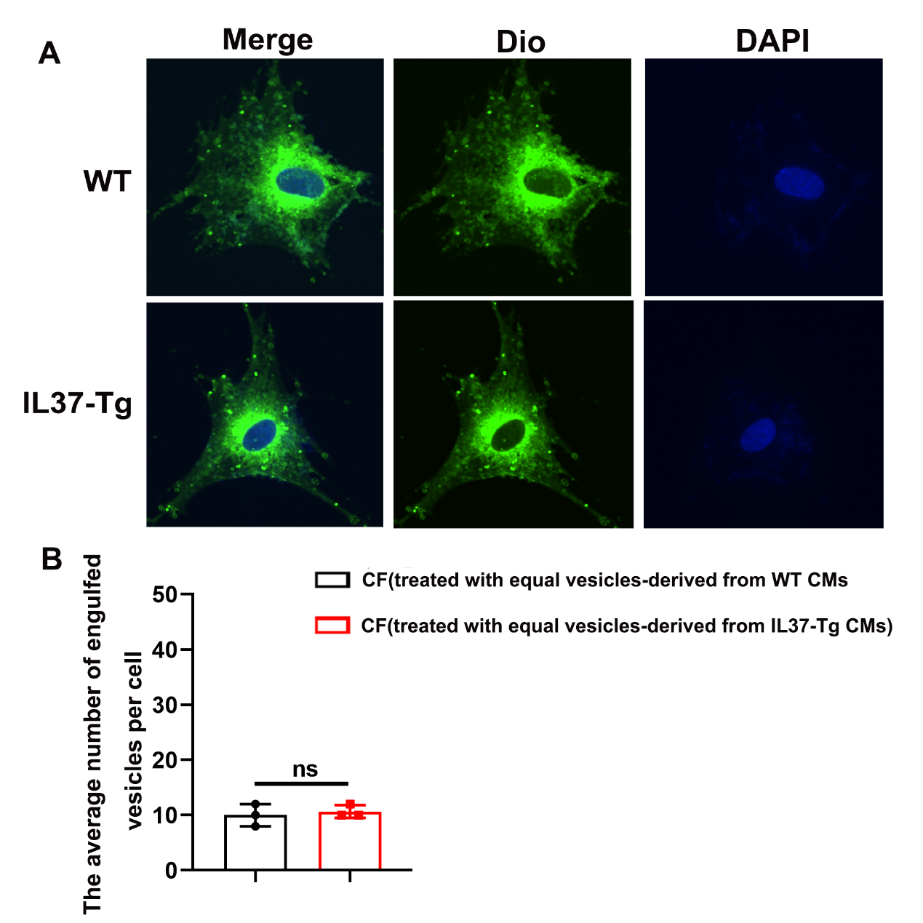
Figure S7 (A) The representative images of engulfment vesicles were presented. (B)The quantification of engulfed vesicles was assessed in both experimental groups. Values are means ± SEM; *P< 0.05, **P< 0.01, ***P< 0.001. (n = 3 in each group at least, data were analyzed by unpaired Student t-test.)
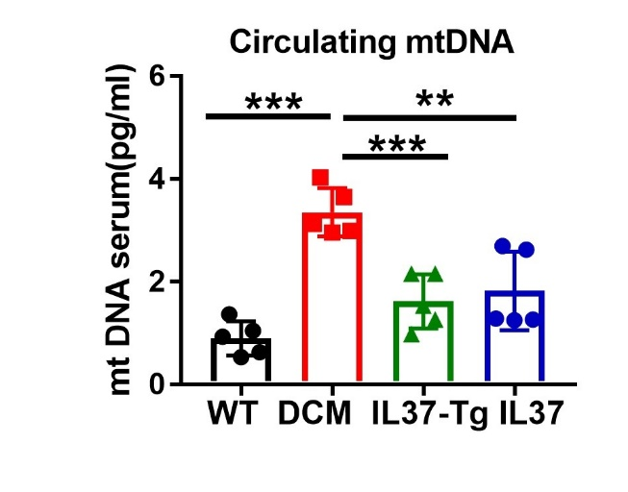
Figure S8 The circulating mtDNA level in serum samples of mice, as measured by RT-PCR. Values are means ± SEM; *P< 0.05, **P< 0.01, ***P< 0.001. (n = 6 in each group, data were analyzed by one way ANOVA followed by Bonferroni post hoc test.)

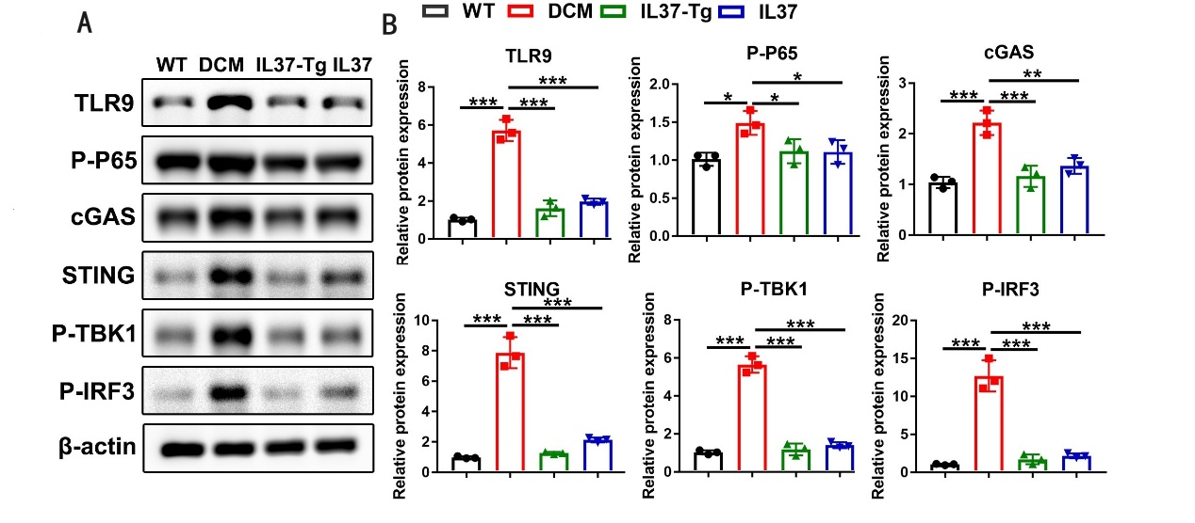
Figure S9 (A) The protein levels of TLR9, p-P65, cGAS, STING and p-TBK1, p-IRF3 were assessed in the myocardium of mice. (B) Quantitative densitometric analysis of TLR9, p-P65, cGAS, STING and p-TBK1, p-IRF3 with β-actin as an internal standard. Values are means ± SEM; *P< 0.05, **P< 0.01, ***P< 0.001vs normal group; #P< 0.05, ## P< 0.01, ### P< 0.001 vs DCM group. (n = 6 in each group, data were analyzed by one way ANOVA followed by Bonferroni post hoc test.)

Table 2. Antibodies used in this study
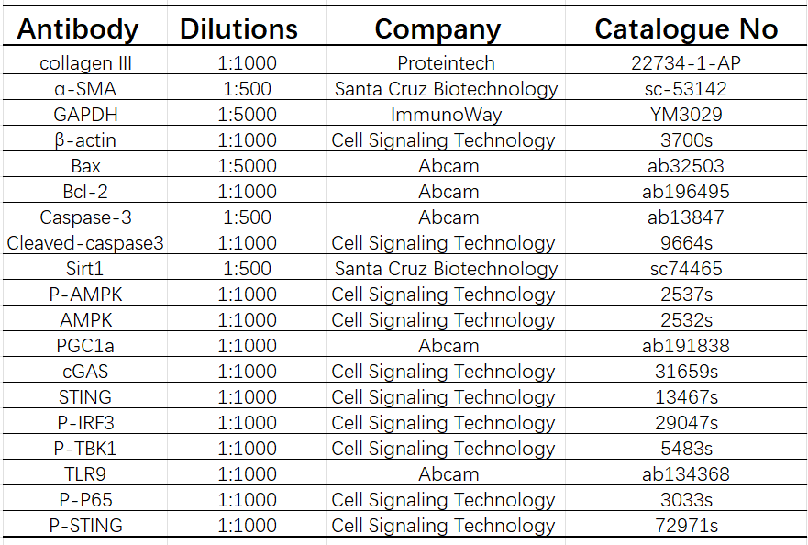
Table 3 PCR primer.
Genes | Forward (5’-3’) | Reverse (3’-5’)
CTGF | TGCGAAGCTGACCTGGAGGAAA | CCGCAGAACTTAGCCCTGTATG
ANP | TACAGTGCGGTGTCCAACACAG | TGCTTCCTCAGTCTGCTCACTC
BNP | TCCTAGCCAGTCTCCAGAGCAA | GGTCCTTCAAGAGCTGTCTCTG
Collagen I | CCTCAGGGTATTGCTGGACAAC | CAGAAGGACCTTGTTTGCCAGG
Collagen III | GACCAAAAGGTGATGCTGGACAG | CAAGACCTCGTGCTCCAGTTAG
ɑ-SMA | TGCTGACAGAGGCACCACTGAA | CAGTTGTACGTCCAGAGGCATAG
TFAM | GAGGCAAAGGATGATTCGGCTC | CGAATCCTATCATCTTTAGCAAGC
NRF1 | GGCAACAGTAGCCACATTGGCT | GTCTGGATGGTCATTTCACCGC
UCP2  mMito  mB2M  hMito  hB2M | TAAAGGTCCGCTTCCAGGCTCA  CGTACACCCTCTAACCTAGAGAAGG  GTGGTGCCAGCAGAGACTTA  CACTTTCCACACAGACATCA  TGTTCCTGCTGGGTAGCTCT | ACGGGCAACATTGGGAGAAGTC  GGTTTTAAGTCTTACGCAATTTCC  GGACAGTGGGTAGGGAACTG TGGTTAGGCTGGTGTTAGGG  CCTCCATGATGCTGCTTACA

