Annexes:
Declaration: signed by both student and primary advisor
Declaration
I, the undersigned declare that this thesis is my original work in partial fulfillment of the requirement for the degree of Master of Public Health. I also declare that it has never been presented in this or any other university and that all resources and materials used in the thesis have been duly acknowledged.
Student Name: Girma Tadesse Birru
Signature: ______ _______________
Place of submission: ACIPH Registration office via email
Date of submission: 29/05/2023
This thesis has been submitted with my approval as a university advisor. Advisor Name: Dr. Semira Abdelmenan and Dr. Ismael Ahmed
Signature: ______ __________________________________________
Date of submission: _29/05/2023___________________________________

Single table, merged database snapshot:
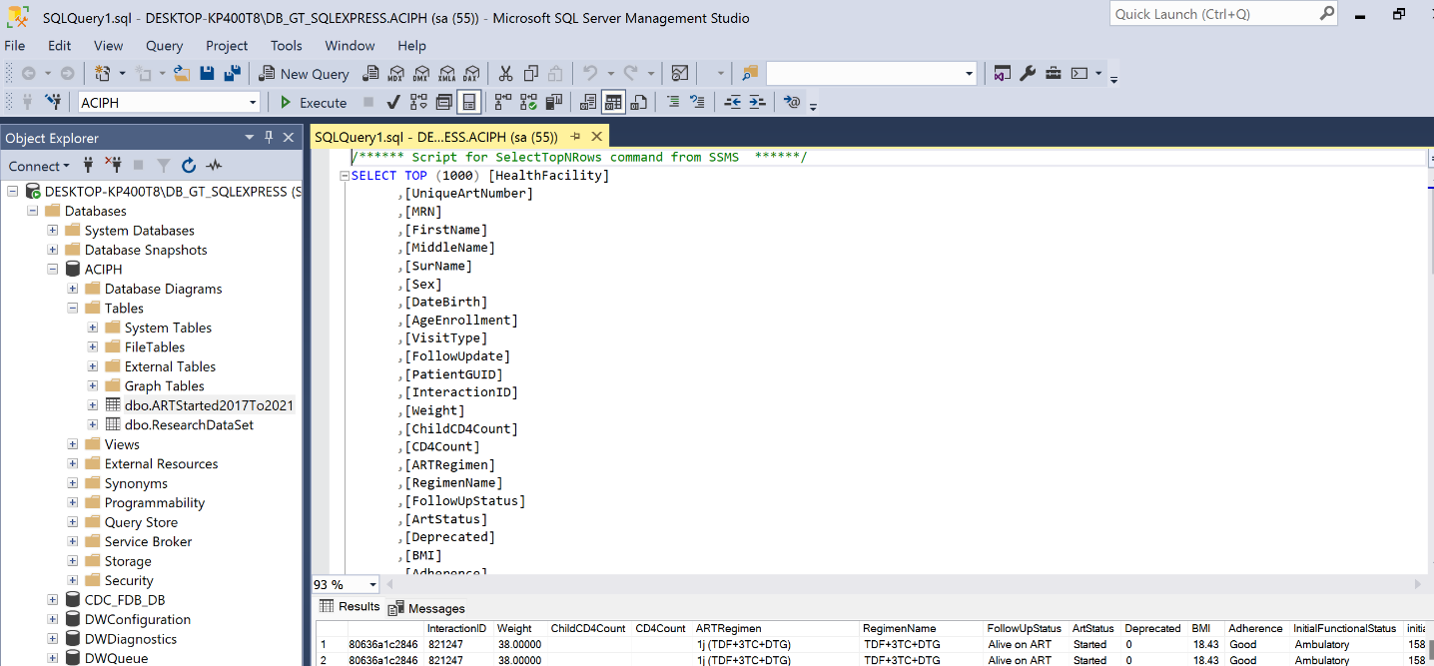
MS excel Dataset snapshot.

