Appendix

Appendix A: Example plots of linear combinations of data
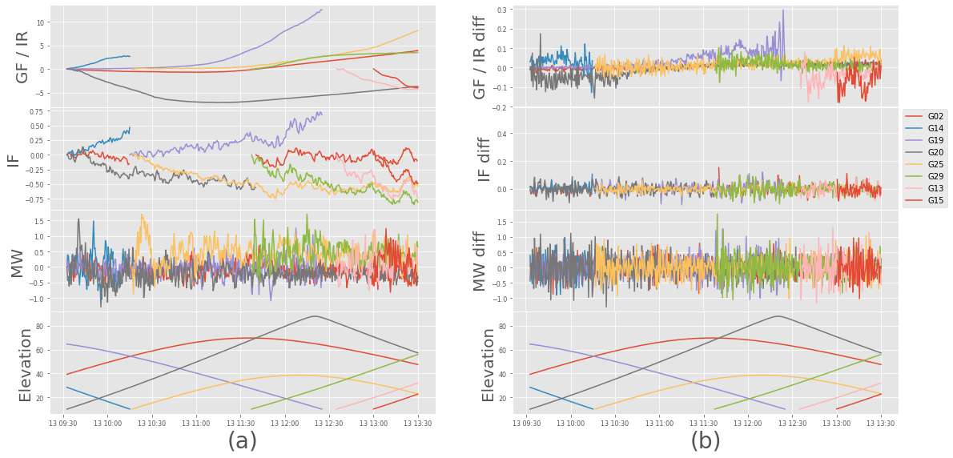
Fig. A-1 Plots of GPS data from the KYBO station RINEX file, showing linear combinations of data (left, top three rows) and their corresponding single differences (right, top three rows). The plots do not show any apparent jumps or cycle slips.
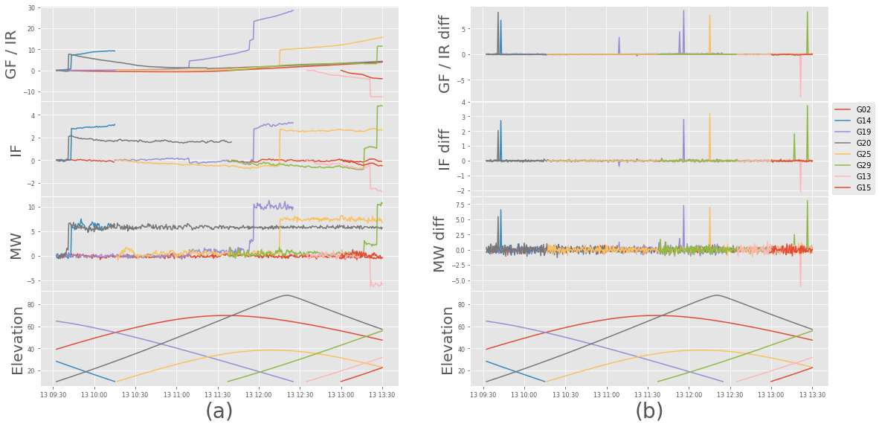
Fig. A-2 Plots of data from KYBO RINEX file, showing the linear combinations (left, top three rows) and the corresponding single differences (right, top three rows) for an instance where ten cycle slip pairs were randomly added to the file.
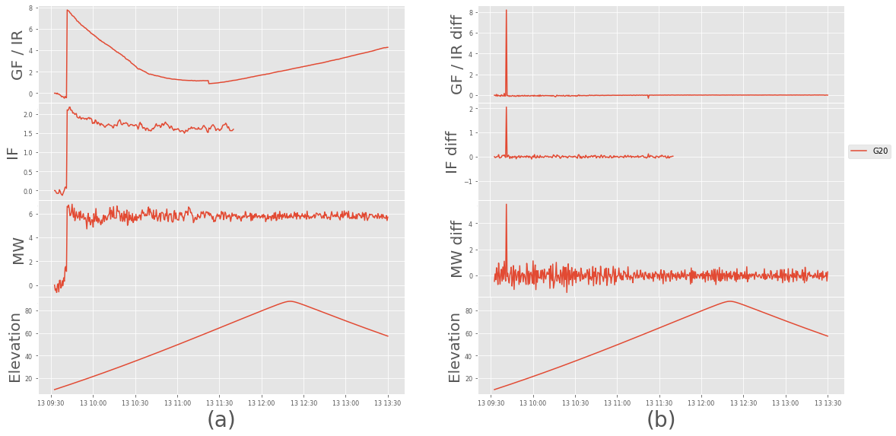
Fig. A-3 A subset of Fig. A-2, in which a (1, 1) cycle slip pair added on satellite G20 at 11:22:30 is not apparent in any of the three linear combinations except for a small barely noticeable jump and spike in the smooth GF / IR plots. This underscores the importance of parameter settings for slip detection. The figure also shows that once the satellite becomes a reference satellite (in the IF case), its IF data are excluded from flagging of its cycle slips which would also propagate into the IF diff data of other satellites. There is a separate logic in the algorithm for flagging cycle slips for reference satellites.

