APPENDIX A

Variables and Measurements for Questionnaire

Variables |  | Measurements | Reference scale
Vending Environment | VE1 | I am satisfied with the working environment. | (Lepold, Tanzer, Bregenzer & Jiménez, 2018) (Raziq & Maulabakhsh, 2015)
 | VE2 | I am satisfied with the working  tools and materials.
 | VE3 | I am satisfied with the current  maintenance of the premises.
 | VE4 | There is sufficient space at your  workplace.
Operating  Hours | OH1 | I am satisfied with the working  hours. | (Lepold, Tanzer, Bregenzer & Jiménez, 2018)
 | OH2 | I am satisfied with the consideration of my wishes in organizing my working hours. | (Lepold, Tanzer, Bregenzer & Jiménez, 2018)
 | OH3 | I am satisfied with the organization of break times.
 | OE4 | I am satisfied with the holidays/vacation times.
Preparation Level of Heir | PH1 | The successor should be equipped with professional qualities and  capabilities. | (Hampel- Milagrosa, Loewe & Reeg, 2015)  (Wang, Lo & Weng, 2019)
 | PH2 | The successor should have crisis  awareness and response capability.
 | PH3 | The successor should have talent  development and utilization capability.
 | PH4 | The successor should have  interpersonal community relationships.
 | PH5 | The successor plans to expand the  hawker business scope.
 | PH6 | The successor generally prefers  challenging work.
Relationship among Family  Members | RM1 | I am satisfied with the help that I receive from my family when  something is troubling me. | (Pritchett et al., 2010)
 | RM2 | I am satisfied with the way my family discusses items of common  interest and shares problem solving with me.

 | RM3 | I find that my family accepts my  wishes to take on new activities or make changes in my life-style.
 | RM4 | I am satisfied with the way my family expresses affection and responds to my feelings such as anger, sorrow, and love.
 | RM5 | I am satisfied with the amount of time my family and I spend together.
Successor willingness | SW1 | The successor wants to control the business in all aspects. | (Wang, Lo & Weng, 2019)
 | SW2 | The successor wants to make the family business more prosperous.
 | SW3 | The successor will input most of their personal time in the business.
 | SW4 | The successor wants to be approved by the eldership.
 | SW5 | The successor will give up a job he/she loves for succession of the family hawker business.
 | SW6 | The successor will enjoy higher flexibility when working in the family business.
Leader’s approval | LA1 | The family business will face greater difficulties in operation after the retirement of the eldership. | (Walsh, Beatty & Shiu, 2009) (Wang, Lo & Weng, 2019)
 | LA2 | The leadership is quite willing to delegate power. | (Walsh, Beatty & Shiu, 2009) (Wang, Lo & Weng, 2019)
 | LA3 | The leadership lost his/her passion for work.
 | LA4 | The leadership intends to retire soon.
 | LA5 | The leadership will not trust anyone other than family members, and will not delegate his/her powers to non-family to handle the affairs of the family business.
Intention of Family  succession in the | FS1 | Family member(s) have defined roles within the business. | (Coffman, 2014)  (Perret, 2016)

food hawking  business in Malaysia | FS2 | Effective communication among  family members exists within the business.
 | FS3 | The successor is ready to step in if unexpectedly required.
 | FS4 | There is an active development plan for the next generation successor.
 | FS5 | The ownership succession plan includes a time frame.
 | FS6 | A successor has been chosen.
 | FS7 | The successor has been made aware of the owner’s decision.

Appendix B

TABLE 4.1 Demographic Information of Respondents

Variables | Category | Frequency | Percentage (%)
Gender | Female | 97 | 46.6
 | Male | 111 | 53.3
Age | 25 years or less | 42 | 20.2
 | 26 to 30 years | 24 | 11.5
 | 31 to 40 years | 62 | 29.8
 | 41 to 45 years | 39 | 18.8
 | Above 45 years | 41 | 19.7
Race | Chinese | 143 | 68.8
 | Indian | 22 | 10.6
 | Malay | 41 | 19.7
 | Others | 2 | 1.0
Education Level | Less than primary | 2 | 1.0
 | Primary | 27 | 13.0
 | Secondary | 146 | 70.2
 | Diploma | 6 | 2.9
 | Bachelor’s degree | 27 | 13.0
Total Monthly Household Income | Below RM2500 | 49 | 23.6
 | RM2500 to  RM6500 | 116 | 55.8
 | RM6500 to  RM10500 | 21 | 10.1
 | RM10500 to  RM14500 | 18 | 8.7
 | RM14500 to RM18500 | 4 | 1.9
State Residing | Kuala Lumpur | 31 | 14.9
 | Penang | 177 | 85.1
Marital Status | Married | 134 | 64.4
 | Single | 69 | 33.2
 | Divorced | 5 | 2.4

TABLE 4.2 Central Tendencies of Constructs Summary

Variables | Items | Mean | Standard Deviation
Vending Environment (VE) | VE 1 | 3.49 | 0.973
Vending Environment (VE) | VE 2 | 3.52 | 0.937
 | VE 3 | 3.39 | 0.910
 | VE 4 | 3.39 | 0.895
Operating Hours  (OH) | OH 1 | 3.56 | 1.048
Operating Hours  (OH) | OH 2 | 3.61 | 1.011
 | OH 3 | 3.47 | 0.997
 | OH 4 | 3.30 | 0.992
Preparation Level of  Heir (PH) | PH 1 | 3.61 | 0.844
Preparation Level of  Heir (PH) | PH 2 | 3.62 | 0.843
 | PH 3 | 3.50 | 0.799
 | PH 4 | 3.72 | 0.895
 | PH 5 | 3.62 | 0.865
 | PH 6 | 3.62 | 0.825
Relationship Among  Family Members (RE) | RE 1 | 4.00 | 0.814
Relationship Among  Family Members (RE) | RE 2 | 4.03 | 0.892
Relationship Among  Family Members (RE) | RE 3 | 3.92 | 0.903
 | RE 4 | 3.95 | 0.872
 | RE 5 | 3.94 | 0.869
Successor  Willingness (SE) | SW 1 | 3.62 | 1.005
Successor  Willingness (SE) | SW 2 | 3.77 | 1.038
 | SW 3 | 3.73 | 1.047
 | SW 4 | 3.61 | 1.015
 | SW 5 | 3.71 | 1.042
 | SW 6 | 3.73 | 0.991
Leader’s Approval  (LA) | LA 1 | 3.47 | 0.873
Leader’s Approval  (LA) | LA 2 | 3.70 | 0.958
 | LA 3 | 3.48 | 0.937
 | LA 4 | 3.56 | 0.961
 | LA 5 | 3.43 | 1.000
Intention of Family Succession in the Food Hawking Business in Malaysia  (DV) | DV 1 | 3.49 | 0.948
 | DV 2 | 3.57 | 0.981
 | DV 3 | 3.56 | 0.936
 | DV 4 | 3.47 | 0.932
 | DV 5 | 3.51 | 0.938
 | DV 6 | 3.48 | 1.116
 | DV 7 | 3.52 | 1.090

Table 4.3 Cronbach’s Alpha Values of Sample Data

Variables | Cronbach’s Alpha Value
Vending Environment (VE) | 0.915
Operating Hours (OH) | 0.921
Preparation Level of Heir (PH) | 0.907
Relationship Among Family Members  (RE) | 0.896
Successor Willingness (SW) | 0.947
Leader’s Approval (LA) | 0.901
Intention of Family Succession in the Food Hawking Business in Malaysia  (DV) | 0.942

TABLE 4.4 Skewness and Kurtosis Summary

Variables | Items | Skewness | Kurtosis
Vending environment (VE) | VE 1 | -.213 | -.456
Vending environment (VE) | VE 2 | -.266 | -.379
 | VE 3 | -.075 | -.520
 | VE 4 | -.046 | -.614
Operating hours (OH) | OH 1 | -.180 | -.956
 | OH 2 | -.206 | -.805
 | OH 3 | -.069 | -.695
 | OH 4 | -.058 | -.608
Preparation level of heir  (OH) | PH 1 | -.328 | -.447
Preparation level of heir  (OH) | PH 2 | -.457 | .350
 | PH 3 | -.345 | .148
 | PH 4 | -.318 | -.601
 | PH 5 | -.218 | -.361
 | PH 6 | -.458 | -.031
Relationship among  Family Members (RE) | RE 1 | -.589 | -.004
Relationship among  Family Members (RE) | RE 2 | -.726 | -.139
 | RE 3 | -.444 | -.625
 | RE 4 | -.480 | -.268
 | RE 5 | -.414 | -.568
Successor willingness  (SW) | SW 1 | -.263 | -.875
Successor willingness  (SW) | SW 2 | -.441 | -.845

 | SW 3 | -.411 | -.900
 | SW 4 | -.248 | -.692
 | SW 5 | -.330 | -.950
 | SW 6 | -.358 | -.758
Leader's approval (LA) | LA 1 | -.006 | -.469
 | LA 2 | -.259 | -.715
 | LA 3 | .088 | -.862
 | LA 4 | -.034 | -.805
 | LA 5 | -.047 | -.724
Intention of Family Succession in the Food Hawking Business in  Malaysia (DV) | DV 1 | -.161 | -.612
 | DV 2 | -.283 | -.547
 | DV 3 | -.365 | -.162
 | DV 4 | -.132 | -.398
 | DV 5 | -.188 | -.553
 | DV 6 | -.193 | -.907
 | DV 7 | -.232 | -.933

TABLE 4.5 Model summary

Model | R Square | F | Sig.
1 | .643 | 72.913 | .000***
***p < 0.001

TABLE 4.6 Multicollinearity Test

Variables | Tolerance | VIF | Condition Index
Vending Environment | .274 | 3.646 | 11.506
Operating Hours | .268 | 3.726 | 14.005
Preparation Level of  Heir | .426 | 2.350 | 18.896
Relationship Among  Family Members | .754 | 1.327 | 21.807
Successor  Willingness | .624 | 1.604 | 24.731

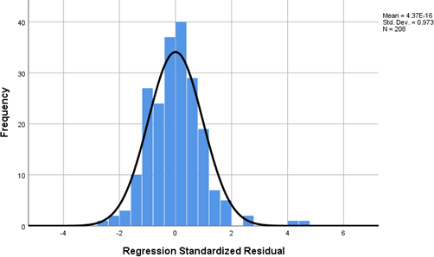

FIGURE 4.8 Histogram for Normality Assumption

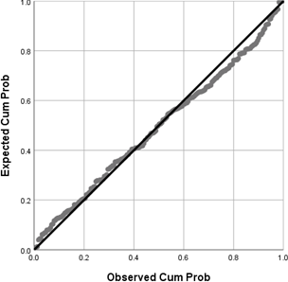

FIGURE 4.9 P-P Plot of Regression Studentised Residual

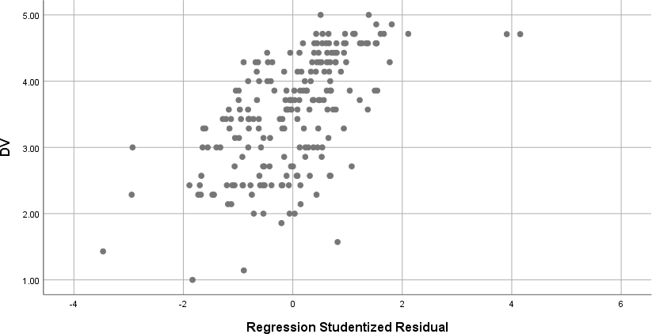

FIGURE 4.10 Scatterplot for Homoscedasticity Assumption

TABLE 4.7 Hypothesis Testing Results

Hypothesis | β | t | Result
Vending  Environment | 0.288*** | 3.586 | Supported
Operating Hours | 0.048 | 0.588 | Not Supported
Preparation Level  of Heir | 0.262*** | 4.066 | Supported
Relationship  Among Family Members | 0.256*** | 5.297 | Supported
Successor  Willingness | 0.145** | 2.720 | Supported
R2 = 0. 643, F = 72.913, Sig. 0.000
***p < 0.001; ** p < 0.01; * p < 0.05; β = Standardized coefficients Beta

TABLE 4.8 Impact of Leader’s Approval on the Relationship between IV Dimensions and The Dependent Variable
Model |  | Model 1 | Model 2 | Model 3
Step | IV dimensions ⭢DV  Moderator: Leader’s Approval |  | Standardised Beta
1 | Vending Environment | 0.288***
 | Operating Hours | 0.048
 | Preparation Level of Heir | 0.262***
 | Relationship Among Family  Members | 0.256***
 | Successor Willingness | 0.145**
2 | Vending Environment |  | 0.246**
 | Operating Hours |  | 0.003
 | Preparation Level of Heir |  | 0.286***
 | Relationship Among Family  Members |  | 0.207***
 | Successor Willingness |  | 0.077
 | Leader’s Approval |  | 0.246***
3 | Vending Environment |  |  | -0.208
 | Operating Hours |  |  | 0.220
 | Preparation Level of Heir |  |  | 0.051
 | Relationship Among Family  Members |  |  | 0.151
 | Successor Willingness |  |  | 0.385
 | Leader’s Approval |  |  | -0.089
 | Vending Environment x  Leader’s Approval |  |  | 0.704
 | Operating Hours x Leader’s  Approval |  |  | -0.286
 | Preparation Level of Heir x  Leader’s Approval |  |  | 0.433
 | Relationship Among Family  Members x Leader’s Approval |  |  | 0.088
 | Successor Willingness x  Leader’s Approval |  |  | -0.461
 | R Square | 0.643 | 0.689 | 0.702
 | Adjusted R Square | 0.635 | 0.680 | 0.685
 | F Value | 72.913*** | 74.273*** | 42.000***
 | F Change | 72.913*** | 29.550*** | 1.706
 | R Square Change | 0.643 | 0.046 | 0.013
***p < 0.001; ** p < 0.01; * p < 0.05. Step 1 refers to regression with IV dimensions. Step 2 refers to regression with IV dimensions and the moderator (Leader’s Approval). Step 3 refers to regression with IV dimensions, moderator and interaction terms.

Appendix C

UCSI UNIVERSITY
Factors Affecting Family Business Succession in the Food Hawking Business in Malaysia

Survey Questionnaire

Dear Respondent,

My name is Jonathan Ng Cho Kin, I am a postgraduate student of Master of Business Administration at UCSI university. The purpose of this survey is to conduct a research to investigate the factors affecting family business succession in the food hawking business in Malaysia. Please answer all questions honestly. There are no right or wrong answers to any of these questions. All responses are collected for the sole purpose of academic research and will be kept strictly confidential.

Thank you for your participation.

Instructions:

- There are EIGHT (8) sections in this questionnaire. Please answer ALL questions in ALL sections.
- Completion of this form should take you no more than 10 minutes.
- The contents of this questionnaire will be kept strictly confidential.

Voluntary Nature of the Study

Participation in this research is entirely voluntary. Even if you decide to participate now, you may change your mind and stop at any time. There is no foreseeable risk of harm or discomfort in answering this questionnaire. This questionnaire survey is anonymous; as such, tracing responses back to any individual participant is not possible. All information collected will be treated confidential for the sole purpose of this study.

I have been informed about the purpose of the study and I readily give my consent to participate in this study.

YES ( ) NO ( )

Note: If yes, please proceed to the first section. If no, you exit the webpage. Thank you for your time and cooperation.

