Supplementary Material S1

Relaxation of the territoriality of the Eurasian otter during low water conditions in a Mediterranean river

José Jiménez¹. Lucía del Río¹. Pablo Ferreras¹. Raquel Godinho^{2.3.4}

¹ Instituto de Investigación en Recursos Cinegéticos (IREC. CSIC-UCLM-JCCM). Ronda de Toledo 12. 13071 Ciudad Real. Spain.
² CIBIO. Centro de Investigação em Biodiversidade e Recursos Genéticos. InBIO Laboratório Associado. Universidade do Porto. Campus de Vairão. 4485-661 Vairão. Portugal.
³ Departamento de Biologia. Faculdade de Ciências. Universidade do Porto. 4169-007 Porto. Portugal.
⁴ BIOPOLIS Program in Genomics. Biodiversity and Land Planning. CIBIO. Campus de Vairão. 4485-661 Vairão. Portugal

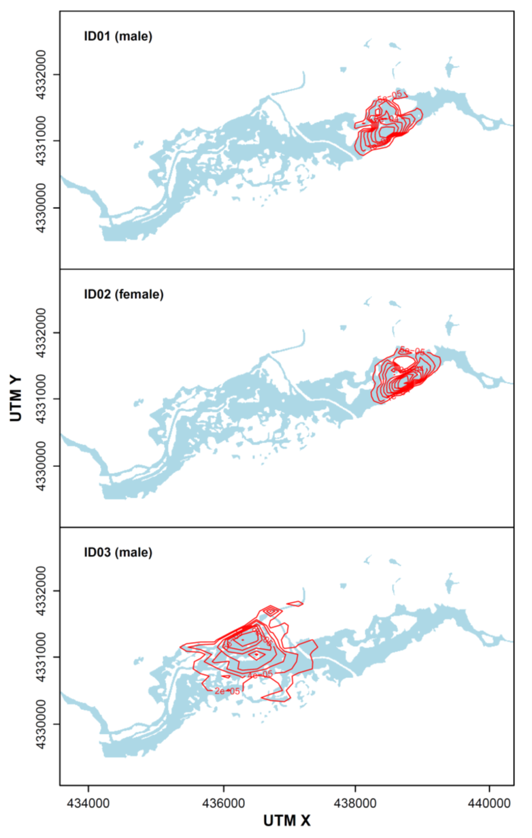

Figure S1. Contour maps for the Bayesian posterior probability distribution of the activity centers (Royle et al.. 2014) for individuals 1-3 using the 2D kernel density estimator with the kde2d function from MASS (Venables and Ripley. 2002) R (R Core Team. 2023) package.

Figure S2. Contour maps for the Bayesian posterior probability distribution of the activity centers (Royle et al.. 2014) for individuals 4-6 using the 2D kernel density estimator with the kde2d function from MASS (Venables and Ripley. 2002) R (R Core Team. 2023) package.

Figure S3. Contour maps for the Bayesian posterior probability distribution of the activity centers (Royle et al.. 2014) for individuals 7-9 using the 2D kernel density estimator with the kde2d function from MASS (Venables and Ripley. 2002) R (R Core Team. 2023) package.

Figure S4. Contour maps for the Bayesian posterior probability distribution of the activity centers (Royle et al.. 2014) for individuals 10-12 using the 2D kernel density estimator with the kde2d function from MASS (Venables and Ripley. 2002) R (R Core Team. 2023) package.

Figure S5. Contour maps for the Bayesian posterior probability distribution of the activity centers (Royle et al.. 2014) for individual 13 using the 2D kernel density estimator with the kde2d function from MASS (Venables and Ripley. 2002) R (R Core Team. 2023) package.

Table S1. Nuclear markers used for individual and sex identification of otters. The multiplex in which markers were amplified and the original reference of each marker are indicated.

Microsatellites | Usage | Multiplex mix | Reference
Lut435 | Individual ID | MIX1 | Dallas & Piertney 1998
Lut453 | Individual ID | MIX2 | Dallas & Piertney 1998
Lut457 | Individual ID | MIX1 | Dallas & Piertney 1998
Lut604 | Individual ID | MIX2 | Dallas & Piertney 1998
Lut615 | Individual ID | MIX2 | Dallas & Piertney 1998
Lut701 | Individual ID | MIX3 | Dallas & Piertney 1998
Lut715 | Individual ID | MIX3 | Dallas & Piertney 1998
Lut717 | Individual ID | MIX1 | Dallas & Piertney 1998
Lut733 | Individual ID | MIX4 | Dallas & Piertney 1998
Lut782 | Individual ID | MIX4 | Dallas & Piertney 1998
Lut818 | Individual ID | MIX3 | Dallas & Piertney 1998
Lut832 | Individual ID | MIX3 | Dallas & Piertney 1998
Lut833 | Individual ID | MIX2 | Dallas & Piertney 1998
OT02 | Individual ID | MIX1 | Huang et al. 2005
OT04 | Individual ID | MIX3 | Huang et al. 2005
OT05 | Individual ID | MIX4 | Huang et al. 2005
OT07 | Individual ID | MIX4 | Huang et al. 2005
OT14 | Individual ID | MIX1 | Huang et al. 2005
OT17 | Individual ID | MIX3 | Huang et al. 2005
OT22 | Individual ID | MIX2 | Huang et al. 2005
LutSRY | Sex ID | MIX1 | Dallas et al. 2000

Table S2. Amplification conditions for the four mutiplex reactions encompassing the 21 markers used in the analysis of otters’ non-invasive samples.

Multiplex | Annealing temperatura/time | Extension time | N cycles (First and second steps of amplification)
MIX1 + MIX2 + MIX3 + MIX4 | 62°-58°/60 sec. | 30 sec. | 20 + 40

Table S3. Amplification rates and genotyping errors (non-amplification of an allele -dropout- and appearance of false alleles) by molecular marker.

Loci | Amplification rate | Dropout rate | False alleles rate
Lut435 | 0.94 | 0.184 | 0
Lut453 | 0.94 | 0.397 | 0
Lut457 | 0.95 | 0.399 | 0
Lut604 | 0.97 | 0.268 | 0
Lut615 | 0.91 | 0.207 | 0
Lut701 | 0.87 | 0.420 | 0.003
Lut715 | 0.89 | 0.491 | 0
Lut717 | 0.86 | 0.590 | 0
Lut733 | 0.93 | 0.532 | 0.023
Lut782 | 0.87 | 0.409 | 0.025
Lut818 | 0.85 | 0.495 | 0
Lut832 | 0.87 | 0.533 | 0
Lut833 | 0.91 | 0 | 0
OT02 | 0.81 | 0 | 0
OT04 | 0.87 | 0.613 | 0
OT05 | 0.91 | 0.429 | 0
OT07 | 0.93 | 0.356 | 0
OT14 | 0.94 | 0.250 | 0.002
OT17 | 0.97 | 0.344 | 0
OT22 | 0.97 | 0.401 | 0.003
Average | 0.91 | 0.346 | 0.003

REFERENCES
Dallas JF, Carss DN, Marshall F, Koepfli KP, Kruuk H, Bacon PJ, Piertney SB (2000). Sex identification of the Eurasian otter Lutra lutra by PCR typing of spraints. Conservation Genetics, 1(2), 181-183.
Dallas JF, Piertney SB (1998). Microsatellite primers for Eurasian otter. Molecular Ecology, 7, 1247-1251.
Huang CC, Hsu YC, Lee LL, Li SH (2005). Isolation and characterization of tetramicrosatellite DNA markers in the Eurasian otter (Lutra lutra). Molecular Ecology, 5, 314-316.
R Core Team. 2023. R: A language and environment for statistical computing. R Found. Stat. Comput.
Royle. J.A.. Chandler. R.B.. Sollmann. R.. Gardner. B.. 2014. Spatial capture-recapture. Elsevier. Academic Press. Waltham. Massachusetts. https://doi.org/10.1016/B978-0-12-405939-9.00026-8
Venables. W.N.. Ripley. B.D.. 2002. Modern Applied Statistics with S. Fourth. ed. Springer. New York. NY.

