Supplemental Information
The Role of Policy and Module Manufacturing Learning in Industrial Decarbonization by Small Modular Reactors
Max Vanatta ^{a*}, William R. Stewart ^{b}, Michael T. Craig ^{a,c}
ª University of Michigan, School for Environment and Sustainability, Ann Arbor, MI, 48105
^{b} Boston Atomics, LLC., Boston, MA, 02108
^{c} University of Michigan, Industrial and Operations Engineering, Ann Arbor, MI, 48105
*corresponding author: mvanatta@umich.edu

SI.1 Per-Facility Deployed Capital Cost
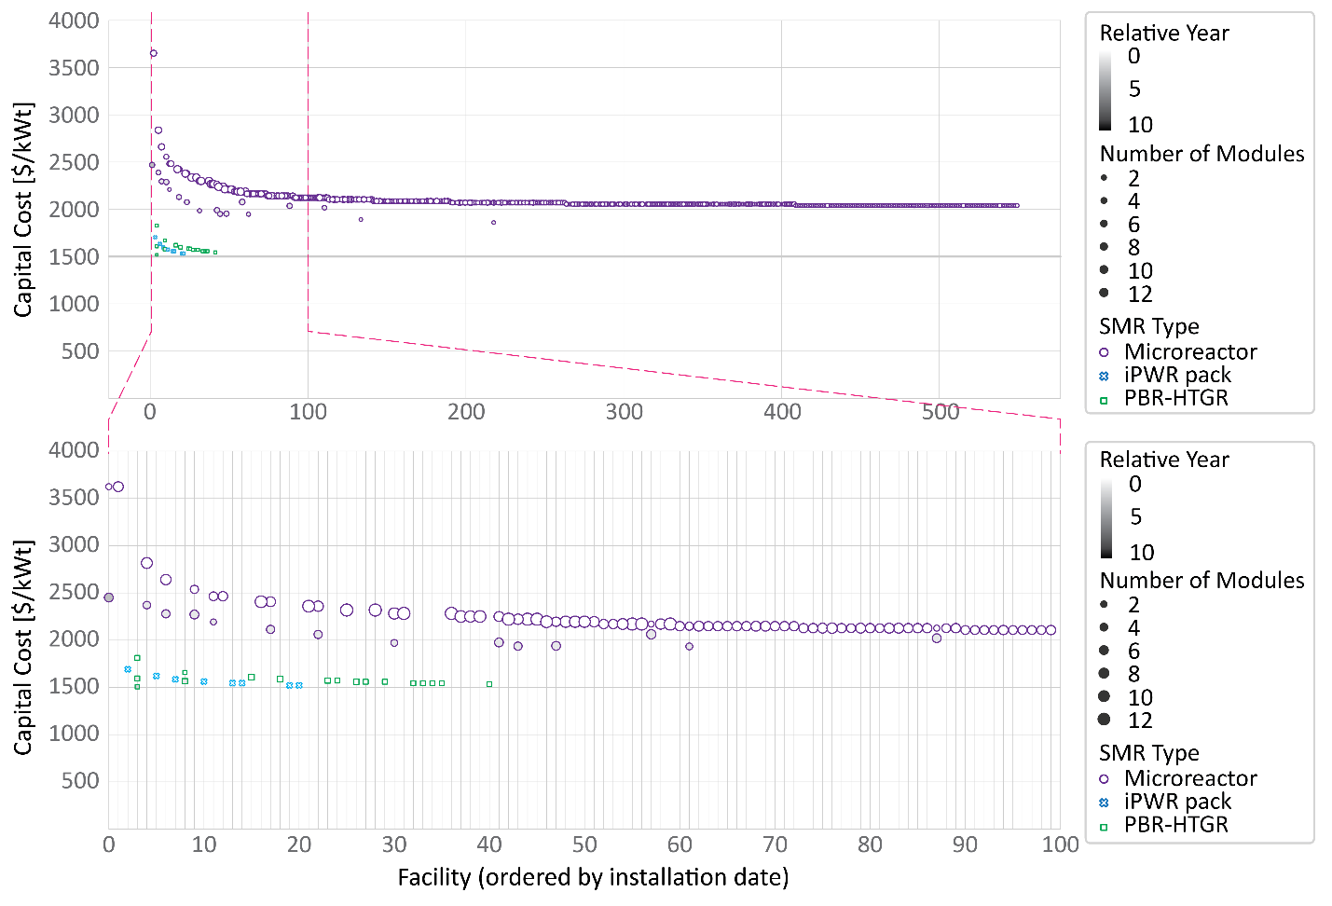
SI Figure 1: Deployment of SMRs under Existing Policy and against $10/MMBtu. Top, Full deployment of all facilities which deploy an SMR in this scenario ordered by the installation. Each column is a unique facility and each marker along that datum is an investment in additional module(s) during a single year period. The y-axis is the capital cost at which the module(s) were deployed. Bottom, Zoomed in subset of first 100 facilities which are installing SMRs and prefer multiple waves of investment. The marker color and shape indicate the SRM design, the fill shade is the year of investment relative to the first module at this facility (e.g., one module built in 2030 and a second in 2035 would have relative years of 0 and 5, respectively), and the size if the marker is the number of modules deployed in the same year.
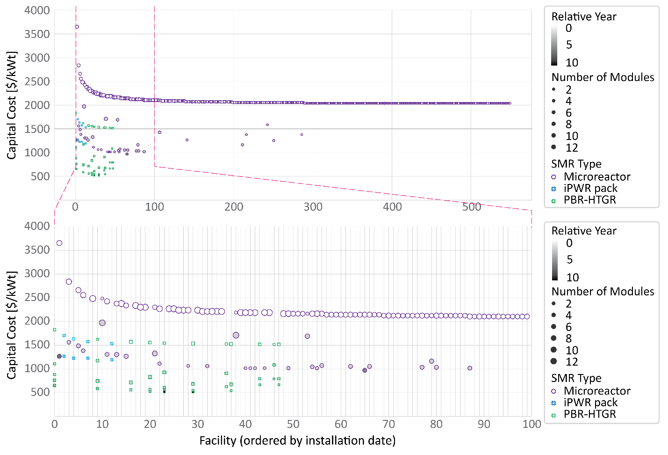
SI Figure 2: Deployment of SMRs with optimal onsite learning rates and against $10/MMBtu. The figure is the same structure as SI Figure 1.

SI.2: Scenario results

SI Table 1: Summary results of total SMR capacity and number of modules deployed in each policy and learning scenario.
Scenario Name |  | Learning Rates |  |  | Natural Gas Prices [$/MMBtu]
 |  |  |  |  | 2 |  | 4 |  | 6 |  | 8 |  | 10
 |  | Factory | Onsite | Total | GW_{t} | Mods | GW_{t} | Mods | GW_{t} | Mods | GW_{t} | Mods | GW_{t} | Mods
Existing Policy |  | 16% | 5% | * | - | - | - | - | 4.5 | 3 | 15.8 | 19 | 51.0 | 1,636
10-B Subsidy | VHTR | 16% | 5% | * | 2.4 | 122 | 2.8 | 138 | 3.2 | 159 | - | - | - | -
10-B Subsidy | Micro | 16% | 5% | * |  |  |  |  |  |  | - | - | - | -
10-B Subsidy | PBR-HTGR | 16% | 5% | * |  |  |  |  |  |  | - | - | - | -
10-B Subsidy | iPWR | 16% | 5% | * |  |  |  |  |  |  | - | - | - | -
CT-USG |  | 16% | 5% | * | 0 | 0 | 4.5 | 3 | - | - | - | - | - | -
CT-RFF |  | 16% | 5% | * | 58.1 | 1748 | 64.2 | 1780 | - | - | - | - | - | -
Full-ITC |  | 16% | 5% | * | - | - | - | - | 9.0 | 6 | - | - | 53.4 | 1,747
No-ITC |  | 16% | 5% | * | - | - | - | - | 0 | 0 | - | - | 28.2 | 89
0:*:-23 |  | 0% | * | -23% | - | - | - | - | 4.5 | 3 | - | - | 21.9 | 72
0:0:0 |  | 0% | 0% | 0% | - | - | - | - | 4.5 | 3 | - | - | 24.9 | 95
16:0:* |  | 16% | 0% | * | - | - | - | - | 4.5 | 3 | - | - | 51.0 | 1,649
0:5:* |  | 0% | 5% | * | - | - | - | - | 4.5 | 3 | - | - | 24.9 | 95
16:*:24 |  | 16% | * | 24% | - | - | - | - | 24.9 | 95 | - | - | 69.6 | 1,956
* calculated learning rate from available learning rates, assumed learning rates, and factory/onsite cost per SMR design.

SI Table 2: Cumulative 2050 deployment of SMRs per-design and scenario.
 |  | Detailed Cumulative Deployments
 |  | HTGR |  | Microreactor |  | PBR-HTGR |  | iPWR
Scenario | Natural Gas [$/MMBtu] | Modules | Cap. [GW_{t}] | Modules | Cap. [GW_{t}] | Modules | Cap. [GW_{t}] | Modules | Cap. [GW_{t}]
Existing Policy | 6 | - | - | - | - | - | - | 3 | 4.5
Existing Policy | 8 | - | - | - | - | 17 | 3.4 | 6 | 9
Existing Policy | 10 | - | - | 1630 | 32.6 | 39 | 7.8 | 8 | 12
$10-B Subsidy  (VHTR) | 2 | 23 | 8.1 | - | - | - | - | - | -
$10-B Subsidy  (VHTR) | 4 | 23 | 8.1 | - | - | - | - | - | -
$10-B Subsidy  (VHTR) | 6 | 23 | 8.1 | - | - | - | - | - | -
$10-B Subsidy  (Micro) | 2 | - | - | 550 | 11.0 | - | - | - | -
$10-B Subsidy  (Micro) | 4 | - | - | 556 | 11.1 | - | - | - | -
$10-B Subsidy  (Micro) | 6 | - | - | 561 | 11.2 | - | - | - | -
$10-B Subsidy  (PBR-HTGR) | 2 | - | - | - | - | 73 | 14.6 | - | -
$10-B Subsidy  (PBR-HTGR) | 4 | - | - | - | - | 75 | 15 | - | -
$10-B Subsidy  (PBR-HTGR) | 6 | - | - | - | - | 125 | 87.6 | - | -
$10-B Subsidy  (iPWR) | 2 | - | - | - | - | - | - | 11 | 16.5
$10-B Subsidy  (iPWR) | 4 | - | - | - | - | - | - | 11 | 16.5
$10-B Subsidy  (iPWR) | 6 | - | - | - | - | - | - | 14 | 21.0
CT-USG | 2 | - | - | - | - | - | - | - | -
CT-USG | 4 | - | - | - | - | - | - | 3 | 4.5
CT-RFF | 2 | 8 | 2.8 | 1691 | 33.82 | 40 | 8 | 9 | 13.5
CT-RFF | 4 | 25 | 8.75 | 1707 | 34.14 | 39 | 7.8 | 9 | 13.5
Full-ITC | 6 | - | - | - | - | - | - | 6 | 9
Full-ITC | 8 | - | - | - | - | 78 | 15.6 | 8 | 12
Full-ITC | 10 | - | - | 1738 | 34.76 | 41 | 8.2 | 8 | 12
No-ITC | 6 | - | - | - | - | - | - | - | -
No-ITC | 8 | - | - | - | - | - | - | 6 | 9
No-ITC | 10 | - | - | - | - | 85 | 17 | 8 | 12
0:*:-23 | 6 | - | - | - | - | - | - | 3 | 4.5
0:*:-23 | 10 | 1 | 0.35 | 28 | 0.56 | 46 | 9.2 | 8 | 12
0:0:0 | 6 | - | - | - | - | - | - | 3 | 4.5
0:0:0 | 10 | - | - | 28 | 0.56 | 70 | 14 | 8 | 12
16:0:* | 6 | - | - | - | - | - | - | 3 | 4.5
16:0:* | 10 | - | - | 1633 | 32.66 | 39 | 7.8 | 8 | 12
0:5:* | 6 | - | - | - | - | - | - | 3 | 4.5
0:5:* | 10 | - | - | 28 | 0.56 | 70 | 14 | 8 | 12
16:*:24 | 6 | - | - | - | - | - | - | 3 | 4.5
16:*:24 | 10 | - | - | 1844 | 36.88 | 104 | 20.8 | 8 | 12

SI Table 3: 2050 capital costs and reductions from FOAK. For each SMR design, the total capital cost per kW_{t} is shown, left column, and the reduction from FOAK costs as a percent, right column. Dashes indicate no deployment and therefore no learning.
 |  | 2050 Learned Capital Costs and Reduction from FOAK
 |  | HTGR |  | Microreactor |  | PBR-HTGR |  | iPWR
Scenario | Natural Gas [$/MMBtu] | [$/kWt] | % red. | [$/kWt] | % red. | [$/kWt] | % red. | [$/kWt] | % red.
Existing Policy | 6 | - | - | - | - | - | - | 1574 | 8%
Existing Policy | 8 | - | - | - | - | 1585 | 13% | 1533 | 10%
Existing Policy | 10 | - | - | 2040 | 44% | 1544 | 16% | 1517 | 11%
$10-B Subsidy  (VHTR) | 2 | 3110 | 11% | - | - | - | - | - | -
$10-B Subsidy  (VHTR) | 4 | 3110 | 11% | - | - | - | - | - | -
$10-B Subsidy  (VHTR) | 6 | 3110 | 11% | - | - | - | - | - | -
$10-B Subsidy  (Micro) | 2 | - | - | 2127 | 42% | - | - | - | -
$10-B Subsidy  (Micro) | 4 | - | - | 2126 | 42% | - | - | - | -
$10-B Subsidy  (Micro) | 6 | - | - | 2125 | 42% | - | - | - | -
$10-B Subsidy  (PBR-HTGR) | 2 | - | - | - | - | 1517 | 17% | - | -
$10-B Subsidy  (PBR-HTGR) | 4 | - | - | - | - | 1516 | 17% | - | -
$10-B Subsidy  (PBR-HTGR) | 6 | - | - | - | - | 1497 | 18% | - | -
$10-B Subsidy  (iPWR) | 2 | - | - | - | - | - | - | 1499 | 12%
$10-B Subsidy  (iPWR) | 4 | - | - | - | - | - | - | 1499 | 12%
$10-B Subsidy  (iPWR) | 6 | - | - | - | - | - | - | 1486 | 13%
CT-USG | 2 | - | - | - | - | - | - | - | -
CT-USG | 4 | - | - | - | - | - | - | 1574 | 8%
CT-RFF | 2 | 3202 | 9% | 1997 | 45% | 1528 | 16% | 1479 | 13%
CT-RFF | 4 | 3091 | 12% | 1995 | 45% | 1522 | 17% | 1476 | 13%
Full-ITC | 6 | - | - | - | - | - | - | 1533 | 10%
Full-ITC | 8 | - | - | - | - | 1514 | 17% | 1517 | 11%
Full-ITC | 10 | - | - | 2040 | 44% | 1541 | 16% | 1517 | 11%
No-ITC | 6 | - | - | - | - | - | - | - | -
No-ITC | 8 | - | - | - | - | - | - | 1533 | 10%
No-ITC | 10 | - | - | - | - | 1512 | 17% | 1517 | 11%
0:*:-23 | 6 | - | - | - | - | - | - | - | -
0:*:-23 | 10 | 3514 | 0% | 3652 | 0% | 1828 | 0% | 1705 | 0%
0:0:0 | 6 | - | - | - | - | - | - | - | -
0:0:0 | 10 | - | - | - | - | 1828 | 0% | 1705 | 0%
16:0:* | 6 | - | - | - | - | - | - | 1574 | 8%
16:0:* | 10 | - | - | 2040 | 44% | 1544 | 16% | 1517 | 11%
0:5:* | 6 | - | - | - | - | - | - | 1574 | 8%
0:5:* | 10 | - | - | 2557 | 30% | 1519 | 17% | 1517 | 11%
16:*:24 | 6 | - | - | - | - | - | - | 1574 | 8%
16:*:24 | 10 | - | - | 1997 | 45% | 1504 | 18% | 1494 | 12%

SI.3 Industrial preference of SMR design
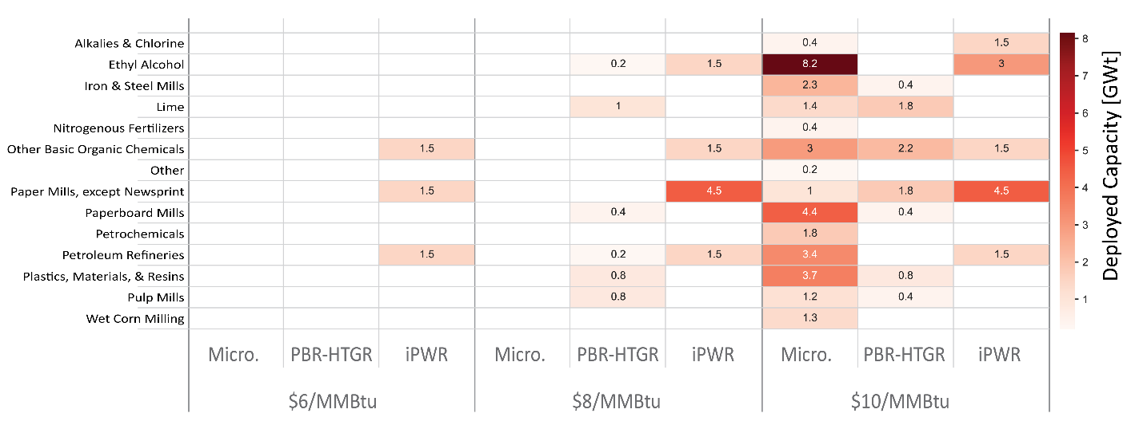
SI Figure 3: Per-Industry 2050 deployed capacity for the Existing Policy Scenario. Rows are the 14 industries included in the study. Columns are SMR design, inner, grouped within the competitive natural gas price.

SI.4 Subsidy Information
To evaluate the impact of a subsidy, we force deployment of at least one SMR module at each facility and each temperature range (unlike in the unsubsidized cases in which there may be a no-build result). In doing so, investments requiring subsidization will yield negative objective values representing their net present value, NPV, over the lifetime of the project. We order the modules for deployment by profitability in the same way as the main results with the exception that the majority, if not all, of the modules are negative profits. As each module is deployed, the subsidy total is reduced by the NPV of that module. Modules are allowed to be installed until either the manufacturing limit is reached, the subsidy is expended, or the model runs out of facilities (the model doesn’t give out new subsidies to facilities which have already used a subsidy).
For this study, we solely allow per-SMR design subsidies as a competitive market will yield solely microreactors. The microreactor will have the smallest NPV loss due solely to the scale in absolute terms (though not if normalized across the energy provided and this normalization generates a highly non-linear program which is outside the scope of our analysis). Therefore, these subsidy results should be seen as a deterministic tool where policymakers have decided a ‘winning’ technology prior to the investments.

SI.5 Full model formulation
SI Table 4:Definitions of model sets, variables, and parameters.
Set | Definition | Indexed by
G | SMR types (iPWR, HTGR, PBR-VHTR, and microreactor) | g
Y | Year of analysis | y
M | Module within maximum module count | m
T | Hourly timestep | t
Variable | Definition | Indexed across:
π | Revenue [$] | -
c_{OP} | Operating costs [$] | -
C_{FAC} | Factory allocated capital costs [$] | -
c_{OS} | Onsite construction costs [$] | -
e | Hourly heat output to processes [MW_{t}] | G,Y,M,T
op | Annual operating status binary | G,Y,M
c | Annual construction status binary | G,Y,M
b | Annual build start binary | G,Y,M
GenC | Generator choice binary | G
r | Reactor core output [MWh_{t}] | G,Y,M,T
un | Annual unbuilt state binary | G,Y,M
ret | Annual retirement state binary | G,Y,M
CC_{OS} | Onsite construction capital costs with build decision learning penalties [$] | G,M
Parameter | Definition | Indexed across
P | Heat price to SMR [$/MWh_{t}] | Y,T
DR | Discount rate coefficient series [%] | Y
VC | Variable costs including O&M and fuel costs [$/MWh_{t}] | G
FC | Fixed costs [$/MW_{t}/yr] | G
CC_{FAC} | Module capital costs [$] | G
CC_{OSbase} | Onsite construction capital costs without learning penalties [$] | G,M
D | Scaling factor to account for length of optimization | -
IR | Interest rate [%/yr] | -
LT | Lifetime [yrs] | -
Cap | Nameplate capacity [MW_{e}] | G
Dem | Facility hourly demand [MW_{th}] | Y,T
η_{TE} | Thermal efficiency [%] | G
Pen | Onsite learning penalty | G,M,N (proxy for M set)
TS | Thermal quality satisfaction binary | G
MSL | Minimum stable load [MW_{t}] | G
CT | Construction duration [yrs] | G
ITC | Investment tax credit [%] | -
B’ | Previous optimization build count | G,M
C’ | Previous optimization construction state count | G,M
Op’ | Previous optimization operation state count | G,M
Cº | Initial construction state binary | G,M
Bº | Initial build state binary | G,M
NG | Natural gas heat supply [MWh_{t}] | T
η_{HT} | Heat transfer efficiency [%] | G

( 1 )
$$maximize: π-(c_{OP}+c_{FAC}+c_{OS})$$
Where π= revenues [$] (Eq 2), c_{OP} = operating costs [$] (Eq 3), c_{Mod} = module capital costs [$] (Eq 4), and c_{OS} = onsite construction costs [$] (Eq 5), which are defined as:

( 2 )
$$π=\sum_{g,y,m,t}{e_{g,m,y,t}}×P_{y,t}×DR_{y}$$
Revenues are derived from selling heat to the industrial facilities and are modified by the annual discount rate from the initial year of system modelling not the optimization window/look ahead.
( 3 )
$$c_{OP}= \sum_{g,y,m}{\left(\left(\sum_{t}{\left(e_{g,m,y,t}×{VC}_{g}\right)+\left({FC}_{g}× Cap_{g}×Op_{g,y,m}×D\right)}\right)×DR_{y}\right) g∊G, y∊Y,m∊M , t∊T}$$
Operating costs are composed of variable costs including fuel and fixed costs.
( 4 )
$$c_{FAC}= \sum_{g,y,m}{\left(CC_{FAC_{g}} ×\left(C_{g,y,m}+Op_{g,y,m}\right)×DR_{y}×D×CRF_{g}×\left(1-ITC\right)\right) g∊G, y∊Y,m∊M }$$
Capital costs are divided into two types, a) module capital costs which are mostly attributed to the manufacturing process in a factory and are updated each iteration of optimization based on previous years of installations.
( 5 )
$$c_{OS}= \sum_{g,y,m}{\left(CC_{OS_{g,m}} ×\left(C_{g,y,m}+Op_{g,y,m}\right)×DR_{y}×D×CRF_{g}×\left(1-ITC\right)\right)} g∊G, y∊Y,m∊M$$
And b) onsite construction costs of the SMR facility. This value is dependent on the other modules being built each year within each optimization as found by:
( 6 )
$$CC_{OS_{g,m}}= \sum_{y}{\left(\sum_{n}^{M}{\left(Pen_{g,m,n}×B_{g,y,n}\right)}×B_{g,y,m}\right)}×C{C_{OS}}_{base} g∊G, y∊Y,m∊M$$
Where each module at a facility is initially defined to have a best possible onsite capital cost if full learning occurred, i.e. sequential annual builds, then any modules built the same year as the previous has a penalty applied to make them equal cost.
( 7 )
$$CRF_{g}=\frac{IR}{1-{\left(1+IR\right)}^{-LT_{g}}} g∊G$$
All capital costs are annualized using a capital recovery factor (CRF) and are found using a 7% interest rate ¹.
( 8 )
$$B_{g,y,m}+B_{g,m}^{'}≤GenC_{g } g∊G, y∊Y,m∊M$$
We only allow selected SMR types to be built.
( 9 )
$$\sum_{g}{GenC_{g}}=1 g∊G$$
And only one SMR type is allowed to be installed at a given facility.
( 10 )
$$\sum_{m}{\left(e_{g,y,m,t}\right)}+NG_{y,t}=Dem_{y,t} g∊G, y∊Y,m∊M , t∊T$$
We allow thermal demand to be met by either SMR heat, natural gas, or a combination of the two, but it must be met at all points.
( 11 )
$$e_{g,y,m,t}=r_{g,y,m,t}×η_{HT} g∊G, y∊Y,m∊M , t∊T$$
Additionally, the heat provided by the SMR to the industrial process is reduced by a heat transfer loss from the core to the working fluid.
( 12 )
$$r_{g,y,m,t}≤Cap_{g}×Op_{g,y,m} g∊G, y∊Y,m∊M , t∊T$$
The energy output from the reactor core cannot exceed the nameplate capacity of the SMR and cannot be positive when the SMR is not operating.
( 13 )
$$Op_{g,y,m}≤TS_{g} g∊G, y∊Y,m∊M$$
Further, we only allow SMRs which can provide the required temperatures for the industrial process to operate.
( 14 )
$$0≤r_{g,y,m,t}-MSL_{g}×Op_{g,y,m} g∊G, y∊Y,m∊M , t∊T$$
While we do not include other operational limitations such as ramping due to the insensitivity to flexibility found in Vanatta et al. ², we limit the lower bound of reactor output to the minimum stable load (MSL).
( 15 )
$$\sum_{y}{\left(C_{g,y,m}\right)+C_{g,m}^{'}}=CT_{g}×\left(\sum_{v}{\left(B_{g,y,m}\right)}+B_{g,m}^{'}\right) g∊G, y∊Y,m∊M$$
We constrain the construction times, including that of previous optimization windows, to be equal the construction time (CT) of the SMRs if they are built.
( 16 )
$$Un_{g,y,m}{+ B}_{g,y,m}+C_{g,y,m}+Op_{g,y,m}+Ret_{g,y,m}=1 g∊G, y∊Y,m∊M$$
SMRs can only exist in one state (unbuilt, build start, construction, operation, and retirement) during any given year.
( 17 )

$$y=1, Ret_{g,y,m}≥Ret_{g,m}^{'}$$
$$y>1, Ret_{g,y,m}≥Ret_{g,y-1,m}$$
$$g∊G,m∊M , t∊T$$
If an SMR module retires, it cannot return to any other state, though other modules at a facility might be built to replace this one later.
( 18 )
$$y=1, {Un}_{g,y,m}≥{Un}_{g,m}^{'}$$
$$y>1, {Un}_{g,y,m}≥{Un}_{g,y-1,m}$$
$$g∊G,m∊M , t∊T$$
Each module starts as unbuilt and once it leaves this state, cannot return to being unbuilt.
( 19 )
$$\sum_{y}{\left(Op_{g,y,m}\right)}+Op_{g,m}^{'}≤ LT_{g} g∊G, y∊Y,m∊M$$
Once an SMR enters into the operating state, the sum of these years must be less than the total planned lifetime of the SMR, including the operating years from previous optimization windows.
( 20 )
$$\sum_{y}{\left(B_{g,y,m}\right)}+B_{g,m}^{'}≤ \sum_{y}{\left(B_{g,y,m-1}\right)}+B_{g,m-1}^{'} g∊G, y∊Y,m>1$$
We force the modules to be deployed in the order of their index within the optimization (e.g., the model couldn’t build module 2 without building modules 0 and 1 first).
( 21 )
$$Op_{g,y,m}≤ \sum_{y}{\left(B_{g,y,m}\right)}+B_{g,m}^{'} g∊G, y∊Y,m∊M$$
Only modules which have been built in the current or previous iterations may operate.
( 22 )
$$C_{g,y,m}≤C_{g,m}^{o}+B_{g,m}^{o} g∊G, y=1,m∊M$$
The construction state may not be preceded by anything but a build state or a construction state in the initial year of the optimization.
( 23 )
$$C_{g,y,m}+{Op}_{g,y,m}≤C_{g,y-1,m} g∊G, y>1 ,m∊M$$
The state following a construction state year must be either a construction year or an operating year.
( 24 )
$$B_{g,y,m}+C_{g,y,m}+{Un}_{g,y,m}≤ B_{g,y-1,m}+C_{g,y-1,m}+{Un}_{g,y-1,m} g∊G, y>1,m∊M$$
Once a module passes the unbuilt, build, and construction states, it cannot return to this. Therefore, it must enter into the operating or retirement states.

SI.6 Analytical Verification
To verify the MINLP function, we ran multiple test analyses comparing the model output and a hand generated excel spreadsheet. The two methods both provided the same qualitative result in the deployment pathways. The objective value of the excel model was 2% different than the MILNP objective. With this analytical verification, we also find that if the learning for module costs is known prior to the optimization, the objective will be more profitable, but this foresight is not possible in the MINLP. Please see attached excel spreadsheet for analytical verification.

SI.7 Learning Rates
Each SMR design is a different capacity and has a different allocation of capital cost to factory versus onsite. Therefore, in the scenarios in which we rely on historical trends for overall NPP learning, we must generate the factory and onsite learning rates. To do so, we fix the factory learning rate and use the ratio of factory to onsite capital cost to calculate the onsite learning resulting in the desired overall learning.
SI Table 5: Factory and onsite learning rates for each SMR design per the scenarios.
 | HTGR |  | Microreactor |  | PBR-HTGR |  | iPWR
 | Factory | Onsite | Factory | Onsite | Factory | Onsite | Factory | Onsite
Cost Portion | 20.9 | 79.1 | 52.5 | 47.5 | 29.0 | 71.0 | 26.0 | 74.0
Existing Policy | 16 | 5 | 16 | 5 | 16 | 5 | 16 | 5
0:*:-23 | 0 | -29.1 | 0 | -48.4 | 0 | -32.3 | 0 | -31
0:0:0 | 0 | 0 | 0 | 0 | 0 | 0 | 0 | 0
16:0:* | 16 | 0 | 16 | 0 | 16 | 0 | 16 | 0
0:5:* | 0 | 5 | 0 | 5 | 0 | 5 | 0 | 5
16:*:24 | 16 | 26.1 | 16 | 32.8 | 16 | 27.3 | 16 | 26.8

SI.8 Supply Chain Limits
To estimate the annual supply chain limits of SMR manufacturing, we use a derivative of historical deployment of conventional NPPs. We use the IAEA historical NPP data³ to find the annual number and capacity of NPPs installed per company. The largest installer of reactors for both peak capacity and reactors was Westinghouse (14.7 GW_{e}, 16 reactors) followed by Kraftwerk Union (12.5 GW_{e}, 9 reactors), and Framatome (10.7 GW_{e}, 9 reactors). If applied to SMRs, these capacities would correlate to approximately a hundred 100 MW_{e} modules per company in a single peak year. Due to the nascent state of the SMR designs, early deployment will likely be slower than this peak rate. We estimate SMR limits by multiplying the reference NPP count value by a typical SMR pack size per design (e.g., iPWRs are often discussed as being deployed in multiples of 6) (SI Table 5). The resulting annual SMR module limits are described as ‘peak’ in SI Table 5 and in many cases still result in significant initial manufacturing potential at median and 25th percentile companies. Some years, large producers would install multiple reactors followed by years of low rates. Therefore, we applied a 3-year rolling average to the data to smooth the trends. These manufacturing limits are labeled as ‘Rolling’ in SI Table 5.
These assumed manufacturing limits are uncertain, but they are reasonable when compared to existing limits on key SMR components. One of the limiting components of SMR manufacturing is the pressure vessel which must be cast in specialized foundries. In an analysis from the World Nuclear Association of production limits, global capacity for vessels is estimated at approximately 50 reactor pressure vessels per year⁴. Foundries providing these vessels are likely to increase their capacity as the demand increases and in turn enabling it as indicated by deals between SMR manufacturers including NuScale and X-energy with Doosan^{5–7}. Given the uncertainty, we evaluate a range of manufacturing limits as a sensitivity (see Sensitivity section).

SI Table 6: SMR module manufacturing limit parameters. These values are derived from historical IAEA data and the estimated pack sizes of SMRs. Bolded is the accepted initial limit used in the Existing Policy scenario.
 | NPP Ref. Value | iPWR | HTGR | Microreactor | PBR-HTGR
Pack Size | - | 6 | 4 | 12 | 4
Module [MWe] | - | 77 | 164 | 6.7 | 80
Max. Peak [GWe] | 14.7 | 191 | 89 | 2196 | 183
Median Peak [GWe] | 1.1 | 15 | 7 | 173 | 14
25th pct. Peak [GWe] | 0.5 | 7 | 3 | 85 | 7
Rolling Max. [GWe] | 9.4 | 122 | 57 | 1407 | 117
Rolling Median [GWe] | 0.5 | 7 | 3 | 84 | 7
Rolling 25th pct. [GWe] | 0.2 | 2 | 1 | 30 | 2
Max. Peak [count] | 16 | 96 | 64 | 192 | 64
Median Peak [count] | 2 | 12 | 8 | 24 | 8
25th pct. Peak [count] | 1 | 6 | 4 | 12 | 4
Rolling Max. [count] | 9.5 | 58 | 38 | 116 | 38
Rolling Median [count] | 0.67 | 4 | 2 | 8 | 2
Rolling 25th pct. [count] | 0.67 | 4 | 2 | 8 | 2

1. The White House Office of Management and Budget. Guidelines and discount rates for benefit-cost analysis of federal programs. Circular No. A-94 Revised. (1992).
2. Vanatta, M., Patel, D., Allen, T., Cooper, D. & Craig, M. T. Technoeconomic analysis of small modular reactors decarbonizing industrial process heat. Joule 7, 713–737 (2023).
3. Nuclear Power Reactors in the World, REFERENCE DATA SERIES No. 2, 2023 Edition. https://www-pub.iaea.org/MTCD/Publications/PDF/RDS-2-43_web.pdf (2023).
4. Heavy Manufacturing of Power Plants. https://world-nuclear.org/information-library/nuclear-fuel-cycle/nuclear-power-reactors/heavy-manufacturing-of-power-plants.aspx (2021).
5. NuScale Power Places First Long Lead Material Production Order with Doosan Enerbility. https://www.nuscalepower.com/en/news/press-releases/2023/nuscale-power-places-first-long-lead-material-production-order-with-doosan-enerbility (2023).
6. NuScale Power Signs Agreement with Doosan Enerbility and Export-Import Bank of Korea, Highlighting Global Supply Chain Development Opportunities. NuScale Power (2023).
7. X-energy Announces Strategic Investment from DL E&C and Doosan Enerbility to Advance the Deployment of the Xe-100 Generation IV Advanced Small Modular Reactor. X-energy https://x-energy.com/media/news-releases/x-energy-announces-strategic-investment-from-dl-ec-and-doosan-enerbility-to-advance-the-deployment-of-the-xe-100-generation-iv-advanced-small-modular-reactor (2023).

