Supplementary Figures
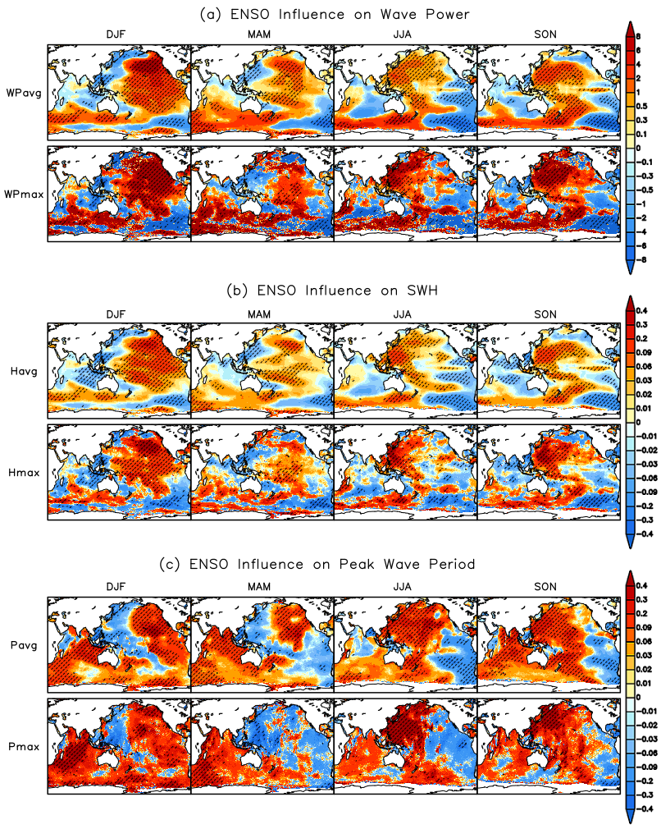
Figure S1.The seasonal ENSO influence on the mean and extreme WP (WPavg and WPmax), SWH (Havg and Hmax), and PWP (Pavg and Pmax) in the Indo–Pacific Ocean over the period 1979–2019. Hatching represents statistically significant regions at the 5% level. The unit of WP, SWH and PWP are given as kilowatts per meter (kW/m), meter (m) and seconds (s).
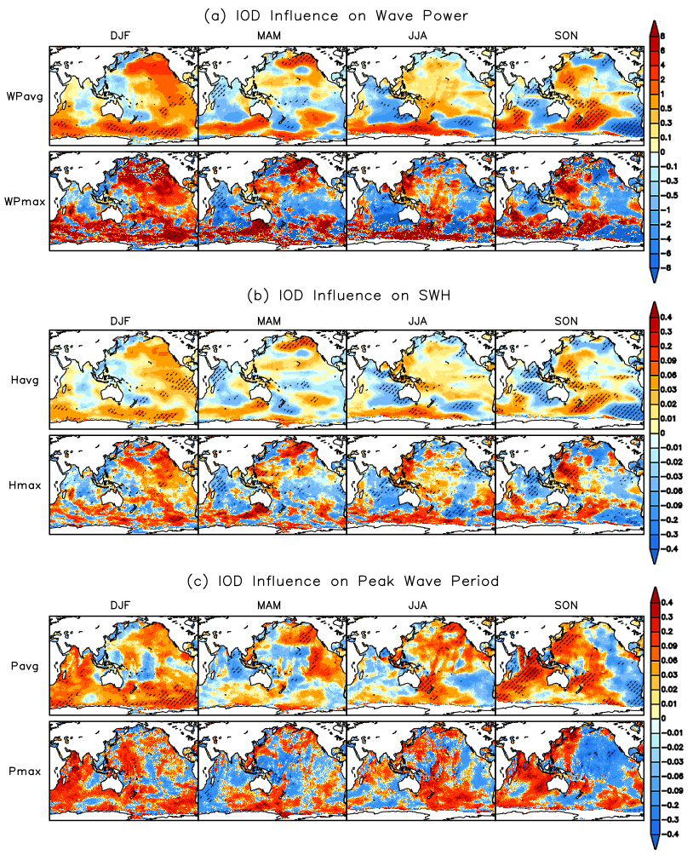
Figure S2. As in Fig. S1, but for the seasonal IOD influence.

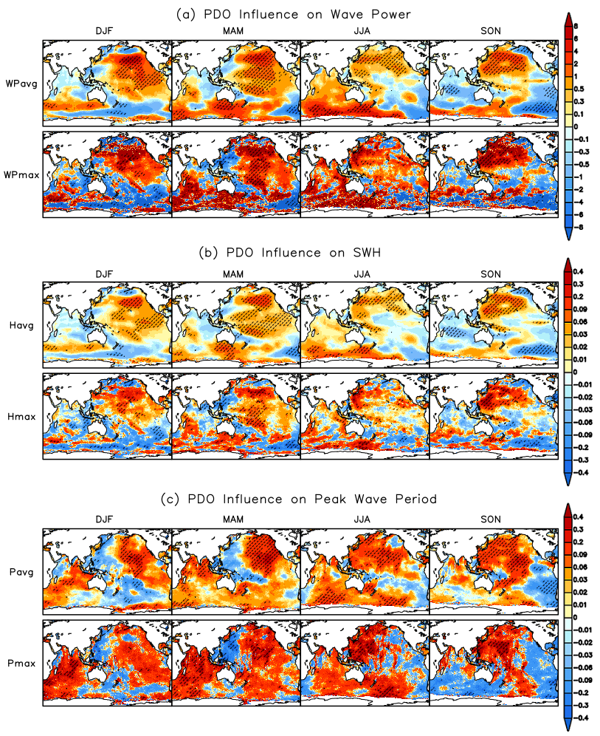
Figure S3. As in Fig. S1, but for the seasonal PDO influence.

