SUPPLEMENTARY FIGURE
Figure S1
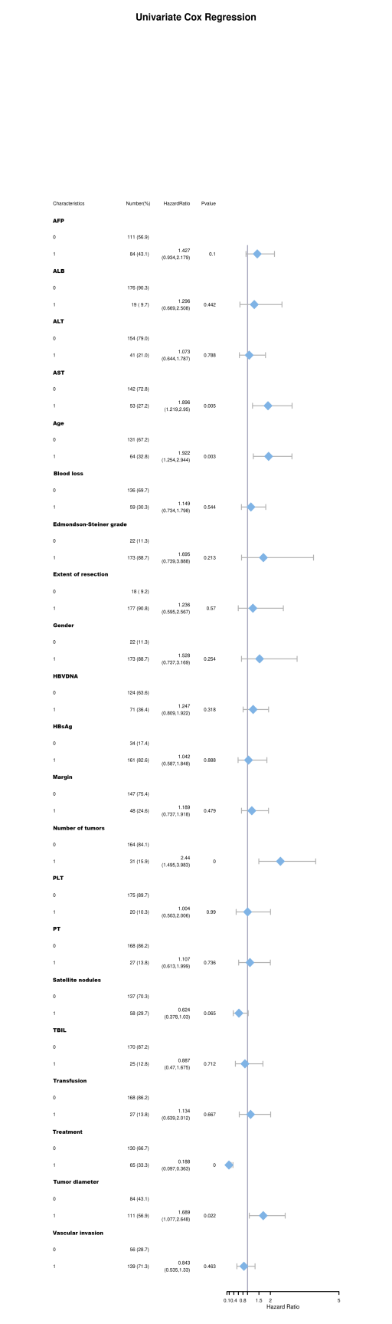
Figure S1 Univariate Cox regression analysis and HR forest plot for patients with HCC and HRRFs who underwent radical resection after PSM to improve the RFS.
RFS, recurrence-free survival; HCC, hepatocellular carcinoma; HRRFs, high-risk recurrent factors; PSM, propensity score matching; HR, hazard ratio; HBsAg, hepatitis B surface antigen; HBV-DNA, hepatitis B virus-deoxyribonucleic acid; PLT, platelet; PT, prothrombin time; ALT, alanine aminotransferase; AST, aspartate aminotransferase; ALB, serum albumin; TBIL, total serum bilirubin; AFP, alpha-fetoprotein.

Figure S2
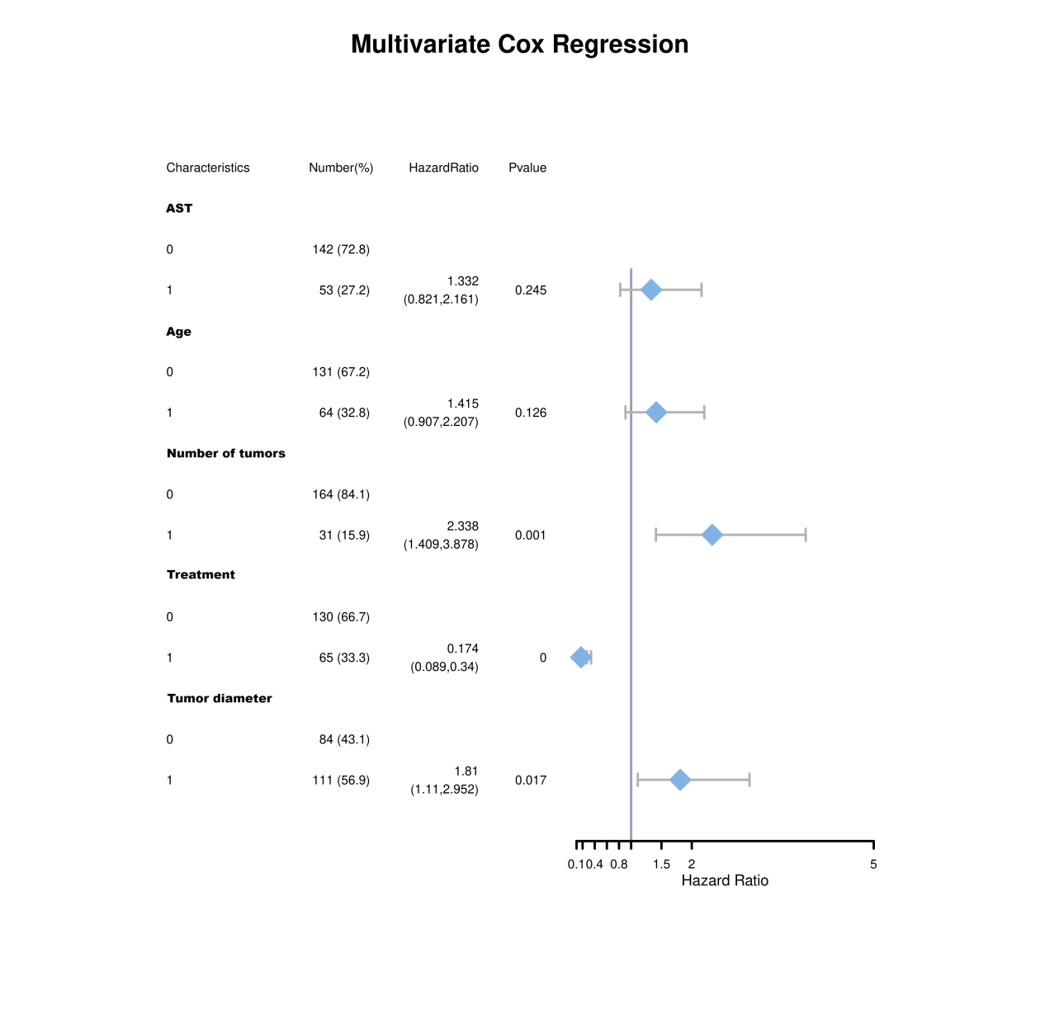
Figure S2 Multivariate Cox regression analysis and HR forest plot for patients with HCC and HRRFs who underwent radical resection after PSM to improve the RFS.
RFS, recurrence-free survival; HCC, hepatocellular carcinoma; HRRFs, high-risk recurrent factors; PSM, propensity score matching; HR, hazard ratio; AST, aspartate aminotransaminase.

Figure S3
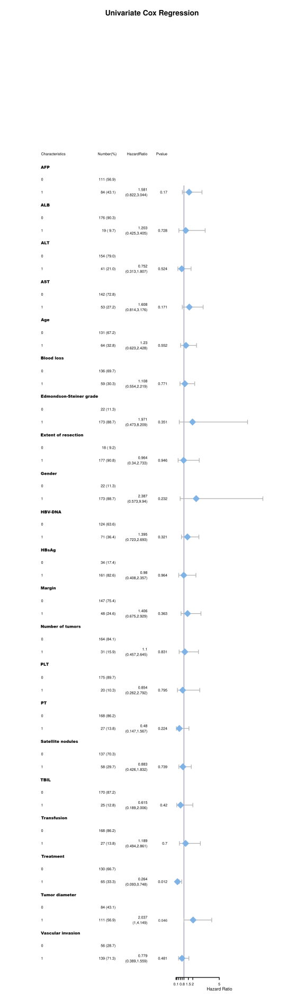
Figure S3 Univariate Cox regression and HR forest plot for patients with HCC and HRRFs who underwent radical resection after PSM to improve the OS.
OS, overall survival; HCC, hepatocellular carcinoma; HRRFs, high-risk recurrent factors; PSM, propensity score matching; HR, hazard ratio; HBsAg, hepatitis B surface antigen; HBV-DNA, hepatitis B virus-deoxyribonucleic acid; PLT, platelet; PT, prothrombin time; ALT, alanine aminotransferase; AST, aspartate aminotransferase; ALB, serum albumin; TBIL, total serum bilirubin; AFP, alpha-fetoprotein.

Figure S4
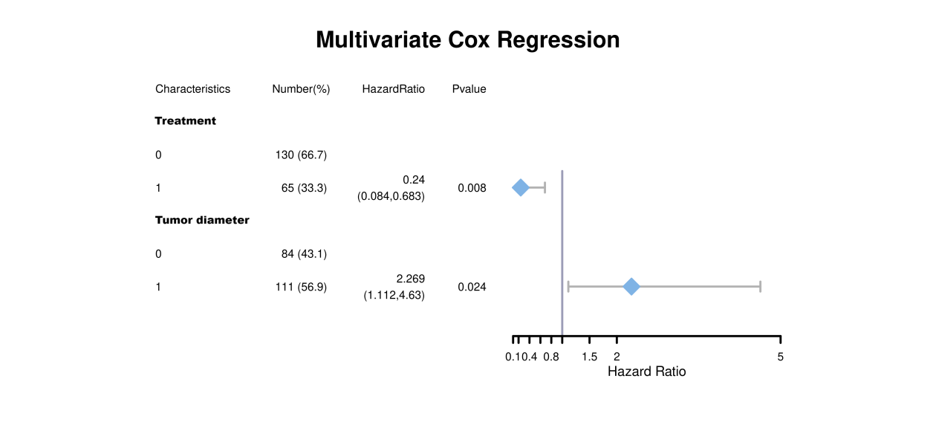
Figure S4 Multivariate Cox regression analysis and HR forest plot for patients with HCC and HRRFs who underwent radical resection after PSM to improve the OS.
OS, overall survival; HCC, hepatocellular carcinoma; HRRFs, high-risk recurrent factors; PSM, propensity score matching; HR, hazard ratio.

