Supporting information
Ice-assisted soft-landing deposition for van der Waals integration
Xinyu Sun^{145#}, BinBin Jin^{2#*}, Yihan Lu¹⁴, Ding Zhao^{134*}, Min Qiu^{134*}
1 Key Laboratory of 3D Micro/Nano Fabrication and Characterization of Zhejiang Province, School of Engineering, Westlake University, 18 Shilongshan Road, Hangzhou 310024, Zhejiang Province, China.
2 School of Information and Electrical Engineering, Hangzhou City University, Hangzhou 310015, China.
3 Westlake Institute for Optoelectronics, Fuyang, Hangzhou 311421, China.
4 Institute of Advanced Technology, Westlake Institute for Advanced Study, 18 Shilongshan Road, Hangzhou 310024, Zhejiang Province, China.
5 College of Optical Science and Engineering, Zhejiang University, Hangzhou 310027, China.

Email:
jinbinbin@westlake.edu.cn;
zhaoding@ westlake.edu.cn;
qiu_lab@westlake.edu.cn

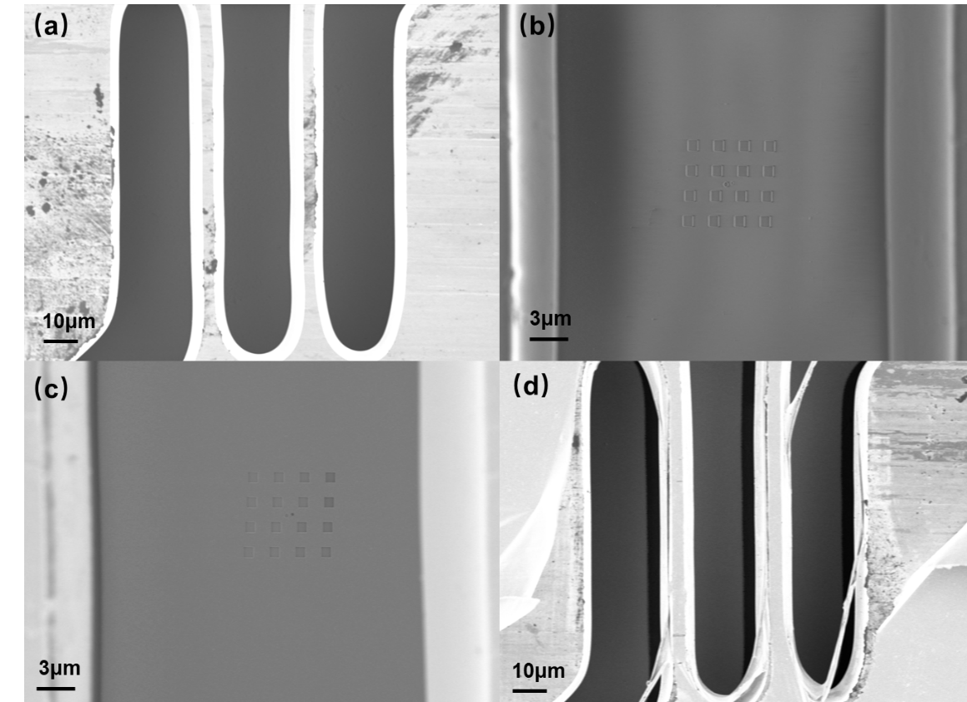
Fig. S1 In situ cryogenic SEM images of Ice-assisted vdW-contact process. (a) The sample, together with a shadow mask cooled down to 130K. (b) 90 nm thick water ice films were deposited onto the sample. 1 μm squares formed in the ice by a 1 keV, 80 pA electron beam. (c) 40 nm thick Au films were deposited onto the sample. (d) Device after ice sublimated and Au electrode laminated on the sample.
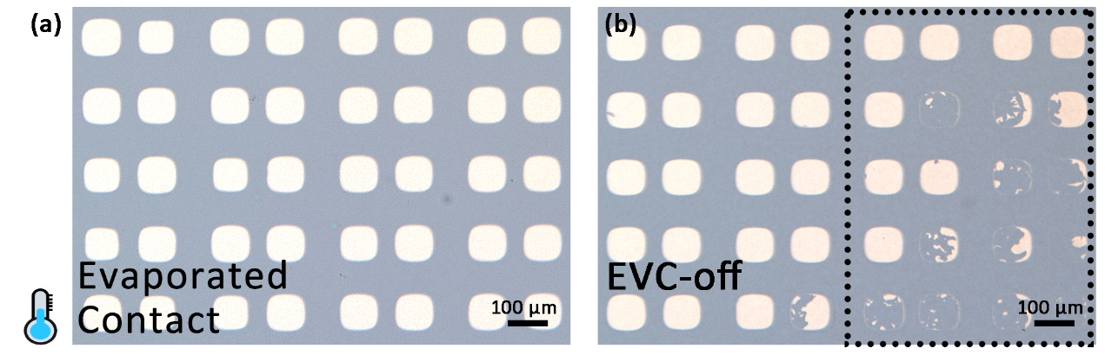
Fig. S2 Optical images of metal deposition process under cryogenic condition on MAPbI₃ thin films (a) and after electrodes peeled off evaporated deposition (b). The peeling-off yield of the cryogenic deposited contacts was much lower compared to the vdW-contacts electrodes, suggesting a much stronger chemical bonding with underlying perovskite.

Fig. S3 X-ray photoelectron spectroscopy (XPS) spectra of Au 4f after electrodes peeled off from MAPbI₃ thin films with (a) ice-assisted vdW contact Au electrodes and (b) evaporated contact Au electrodes fabricated under cryogenic condition. In the case where the evaporated contact Au film peeled off, the residual Au was still detected by X-ray photoelectron spectroscopy (XPS), while for vdW contacts no Au signal was detected. (c-d) Photoluminescence (PL) mapping images and (e, f) PL spectra of MAPbI₃ after peeling off electrodes. The blank spectra were obtained in the area where the MAPbI₃ was not exposed during Au deposition.

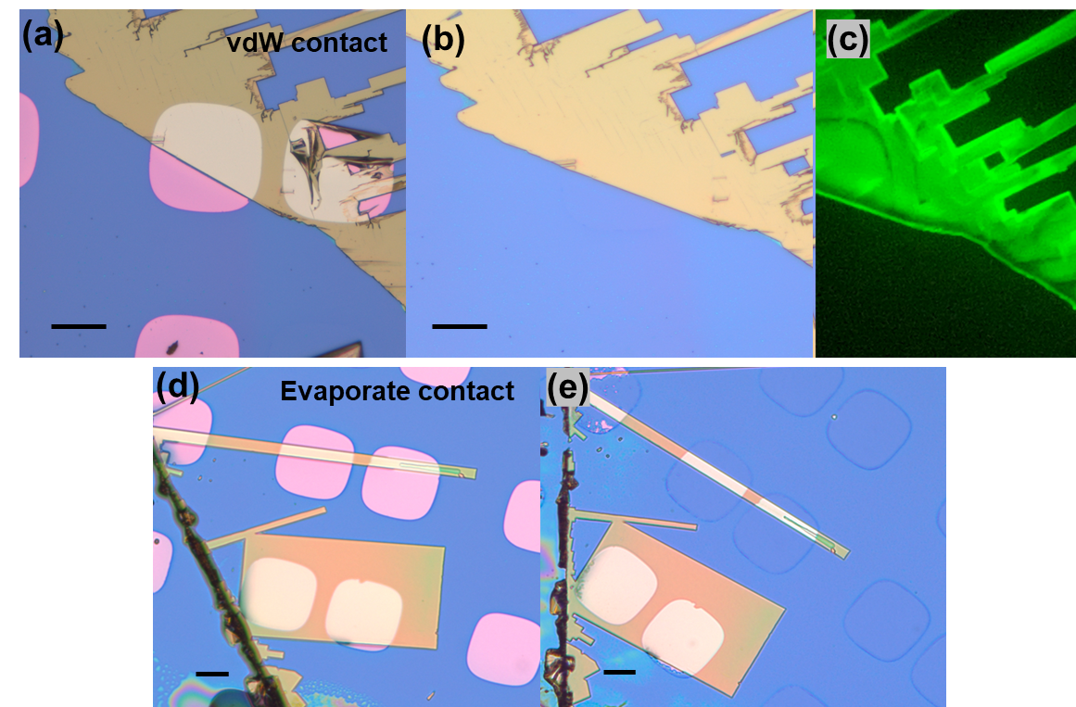
Fig. S4 (a-b) Optical images of ice-assisted vdW contact Au nanoplates on single-crystal MAPbBr₃ and after electrodes peeled off. (c) Photoluminescence (PL) mapping of MAPbBr₃ after peeling off electrodes. The PL intensity is essentially unchanged after removing the electrodes. (d-e) Optical images of conventional evaporated Au nanoplates on single-crystal MAPbBr₃ and after electrodes peeled off. The segment of the Au film on the MAPbBr₃ substrate could not be peeled off, even though the surrounding area was successfully removed, suggesting the underlying perovskite is seriously damaged by the metal deposition process. This provides evidence that strong bonding is easily established between the “soft lattice” perovskites and the deposited contacts. Scale bar: 25 μm.

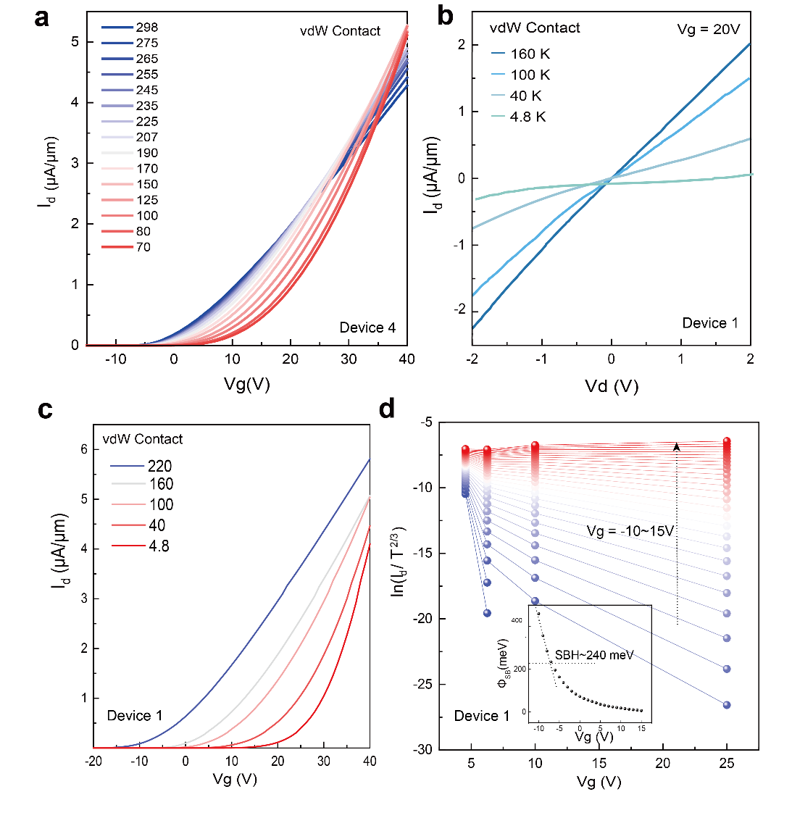
Fig. S5 (a) Temperature-dependent transfer curves of Ag vdW-contact FET (Device 4) with temperature ranging from 298 K to 70 K. (b) Temperature-dependent output curves (Id–Vd) of the vdW-contacted Au FET (Device 1) under the temperature ranging from 160 K to 4.8 K. Nonlinear Id–Vd output curves obtained below 40 K, suggesting the formation of Schottky contact with MoS₂ and a relatively large SBH. (c) Temperature-dependent transfer curves of the FET with vdW contact Au electrodes (Device1) with temperature ranging from 220 K to 4.8 K. (d) Gate-dependent ln (I_{d}/T^{3/2}) versus 1000/T plots for the vdW-contacted Au electrode (Device1). Insets: Barrier heights as a function of Vg, where the SBH is extracted at a flat band voltage.

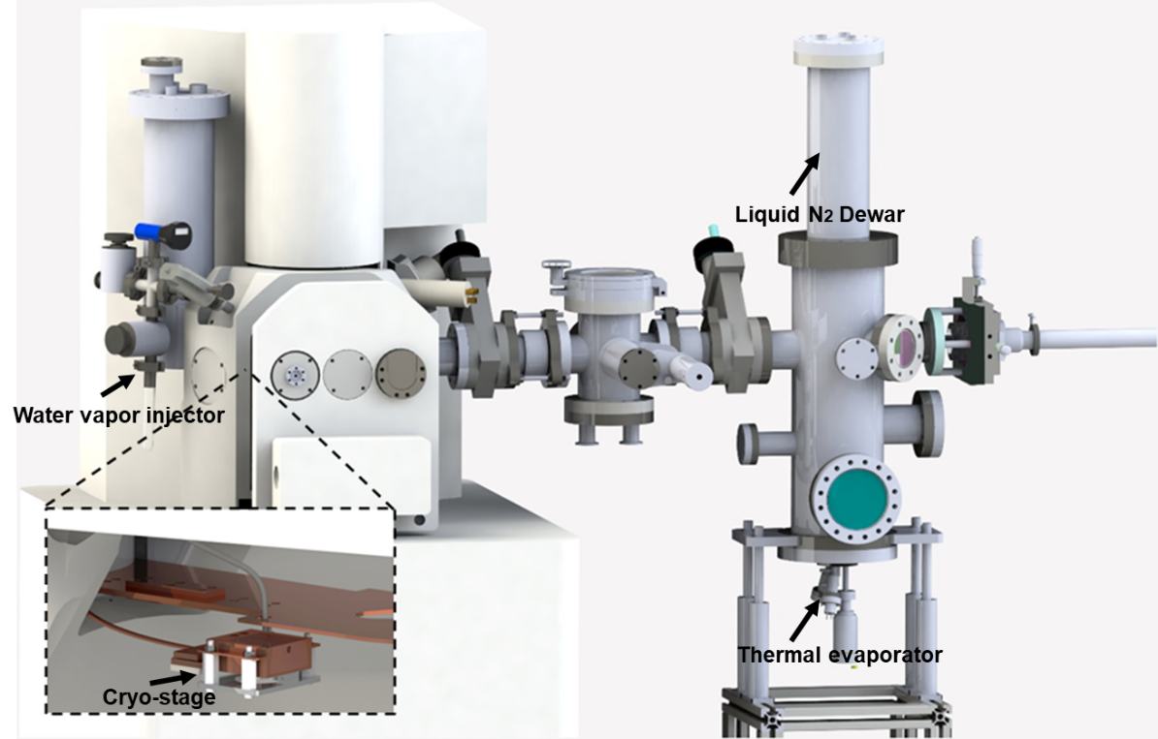
Fig. S6 Illustration of our dedicated system for ice-assisted vdW integration. The system included a water vapor injector, a cryogenic stage, and a thermal evaporator system with a liquid N₂ dewar for cooling.

