Supplementary Information
Supplementary Methods: Literature Search
The following keyword searches were performed in October-November 2018. For Web of Science, the syntax was (TS=((microb* OR bacteri*) AND (temporal OR succession OR time OR dynamics) AND V4 AND miseq)) AND LANGUAGE:(English) AND DOCUMENT TYPES:(Article); Timespan: Last 5 years. Indexes: SCI-EXPANDED, SSCI, A&HCI, CPCI-S, CPCI-SSH, BKCI-S, BKCI-SSH, ESCI, CCR-EXPANDED, IC. For Google Scholar, the search syntax was "V4", Miseq, accession, temporal, OR time, OR succession, OR disturbance, OR stress, OR dynamics -v3. Results were filtered to include only publications since 2015. Search results were initially checked for temporal sampling intervals, the region of the 16S rRNA gene sequenced and the availability of raw sequence data prior to further inspection.
Table 1 is presented separately as an excel file.
Table S2. Slope estimates for models comparing immediate changes in dispersion following disturbance, calculated on Bray-Curtis values and null model outputs.
 | Slope | Estimate | Q2.5 | Q97.5
Bray- curtis values | Aquatic | 0.638 | -0.978 | 2.242
Bray- curtis values | Mammalian | 0.783 | -2.709 | 4.246
Bray- curtis values | Soil | 0.772 | -2.519 | 4.081
null model outputs | Aquatic | 0.141 | -0.042 | 0.319
null model outputs | Mammalian | 0.027 | -0.399 | 0.451
null model outputs | Soil | 0.087 | -0.322 | 0.502

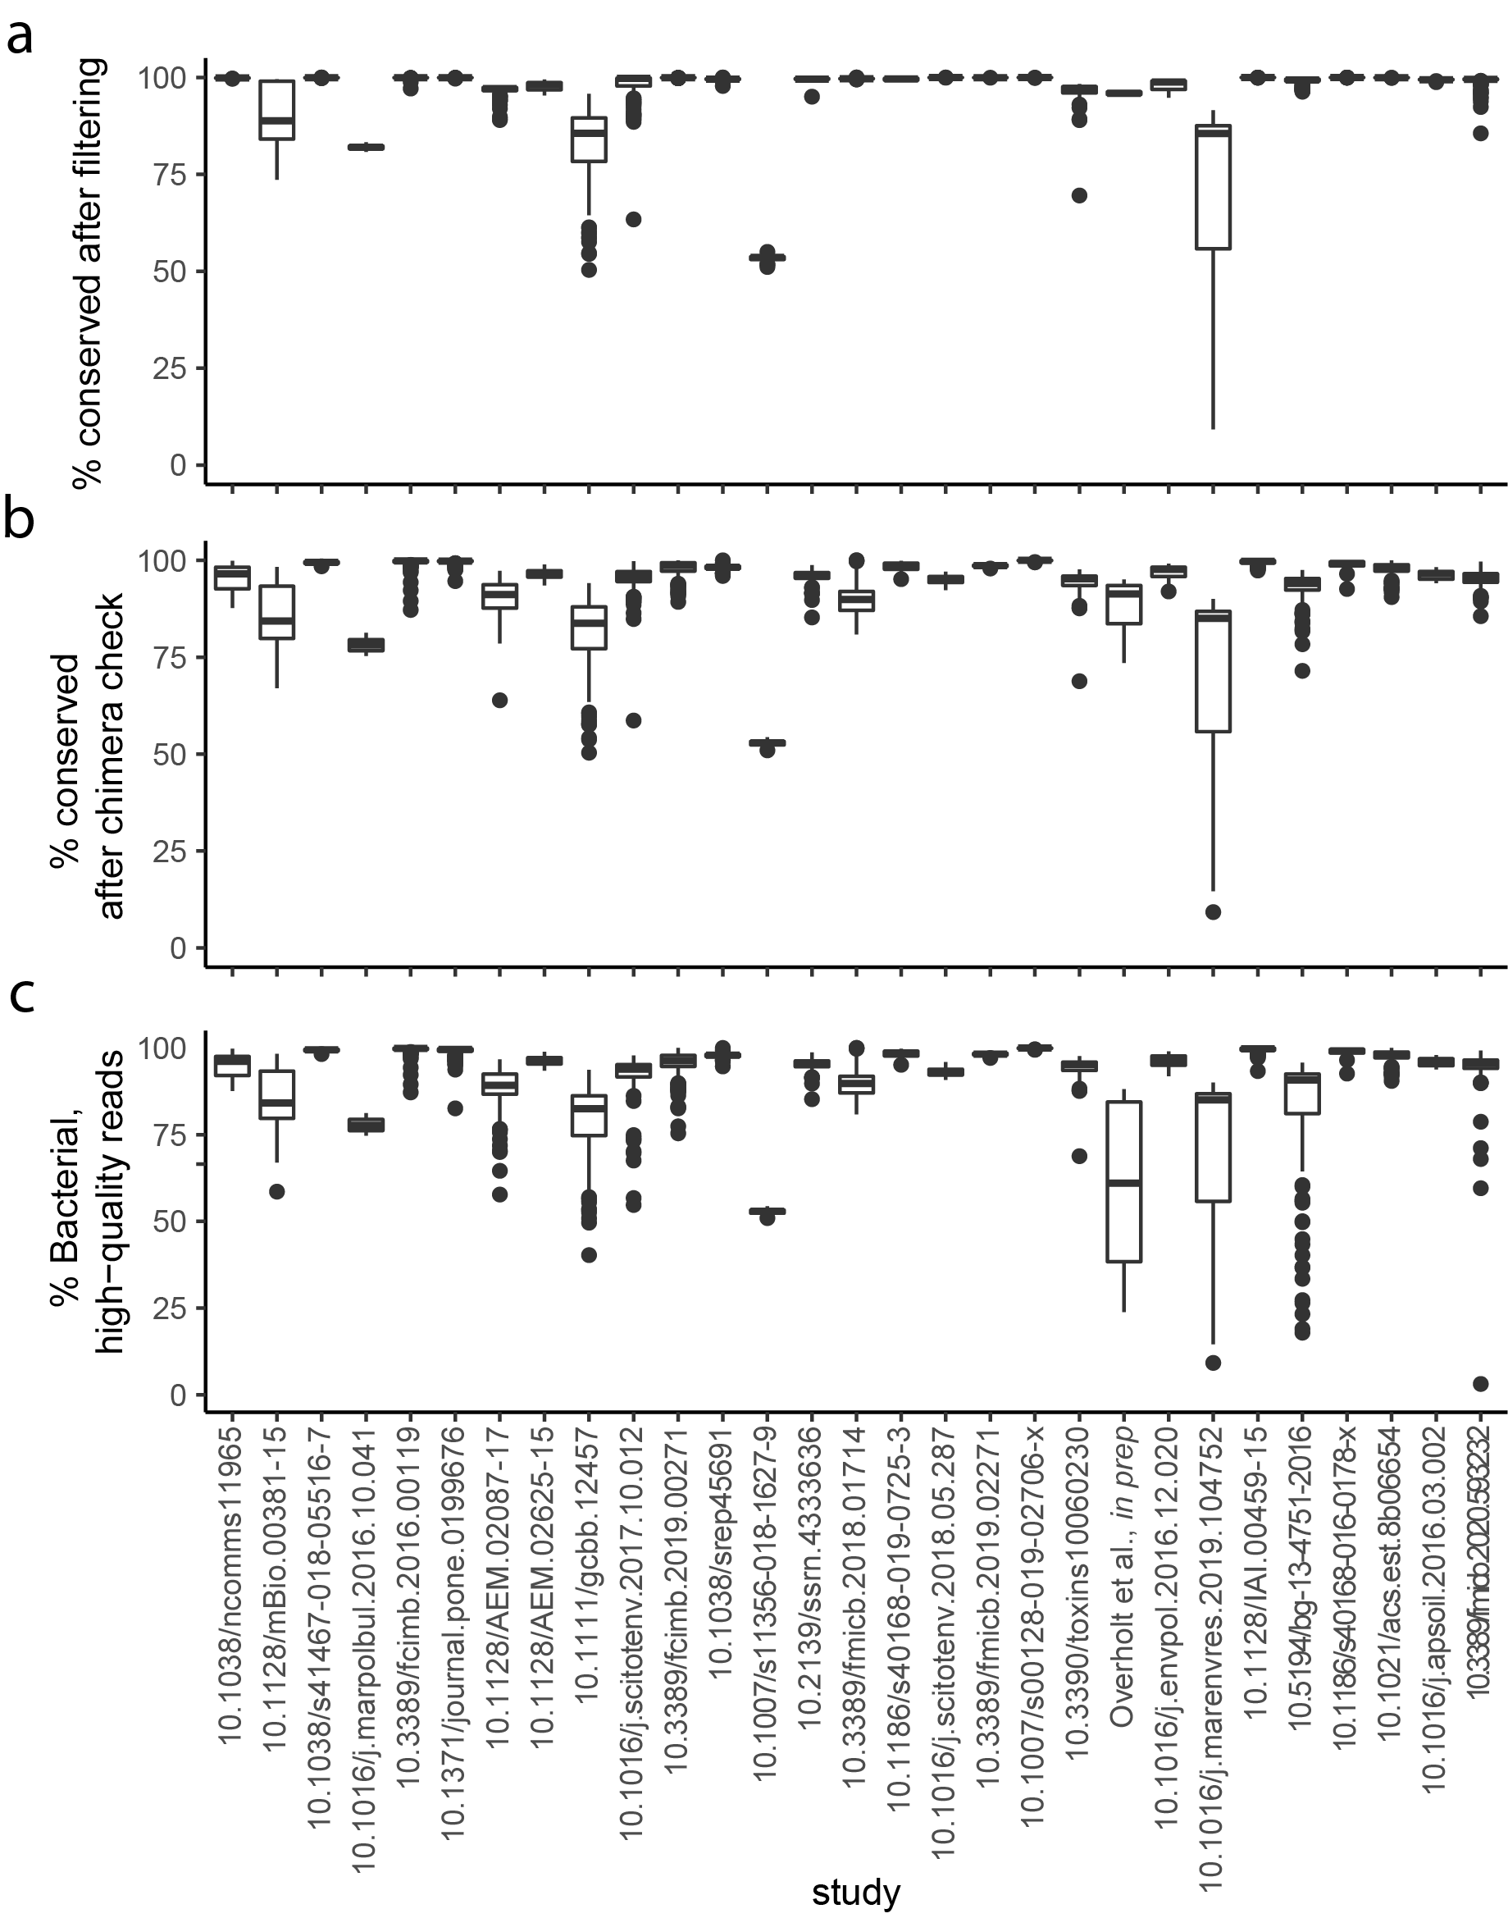
Figure S1. Proportion of reads preserved after quality filtering (a), chimera checking (b), and selection of bacterial reads (c). All data is presented as a proportion of the number of reads originally recovered from public databases, and presented per study. Studies are labeled with their corresponding DOIs, and additional per-study information is found in Table S1.
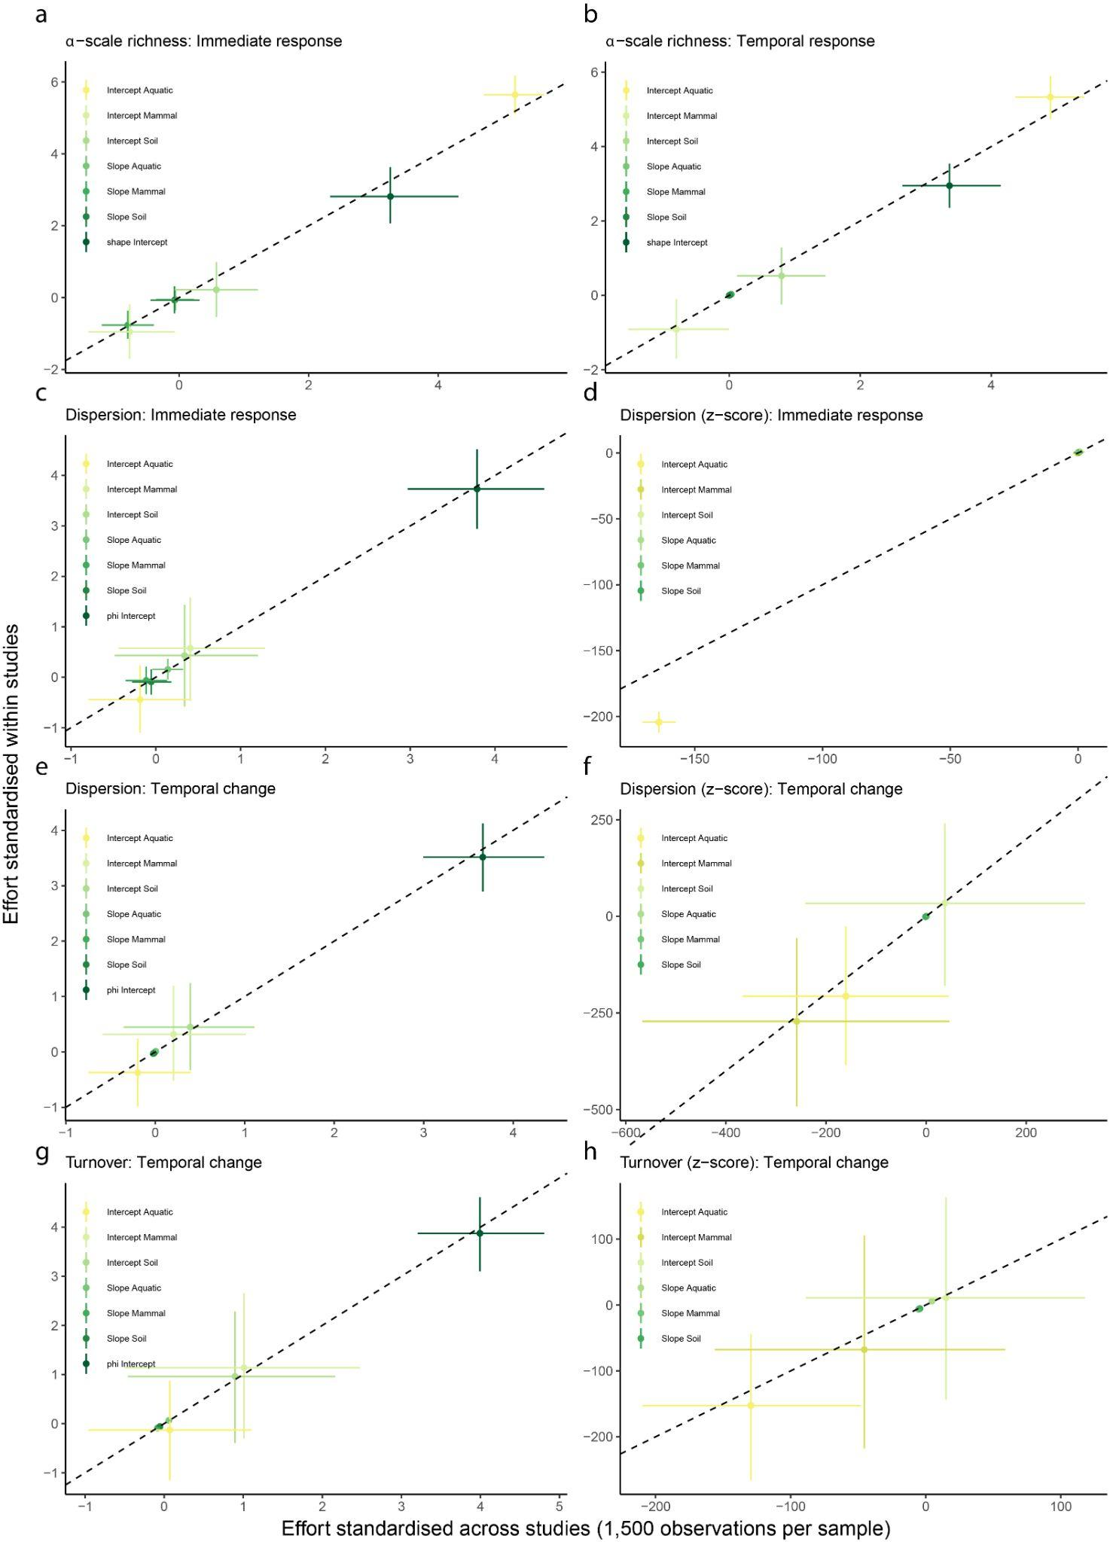
Figure S2: Models fit to data standardized across studies and to data standardized within studies yield very similar parameter estimates. Each panel shows the fixed effect estimates for models fit to (a) richness before-after disturbance, (b) richness change through time following disturbance, (c) dispersion before-after disturbance, (d) dispersion (z-score) before-after disturbance, (e) dispersion change through time following disturbance, (f) dispersion (z-score) change through time following disturbance, (g) turnover change through time following disturbance, and (h) turnover (z-score) change through time following disturbance. Rarefaction performed within time series selected the deepest possible observation depth for each time series or 1500 reads per sample and only mildly increased coverage from 0.96±0.05 to 0.98±0.04. Importantly, sampling depth and sample richness were not correlated.

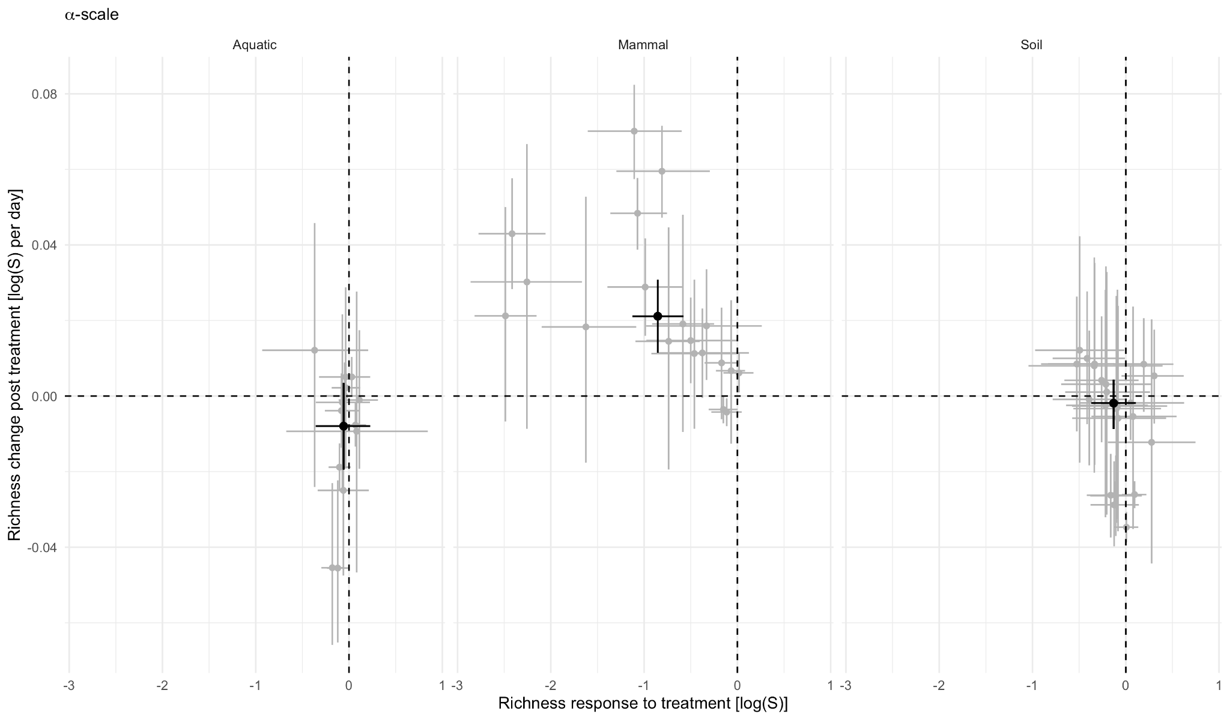
Figure S3. The immediate effect of a disturbance on richness was only related to the rate of recovery of richness in mammals. Each point is a time series, faceted by environment. Immediate richness responses were estimated as the effect of disturbance on log-scale community richness (Figure 3a). Richness response to treatment was calculated as the slope estimates of richnessover time. Error bars show the 95% CI for both metrics. Large circles indicate the mean response per environment.
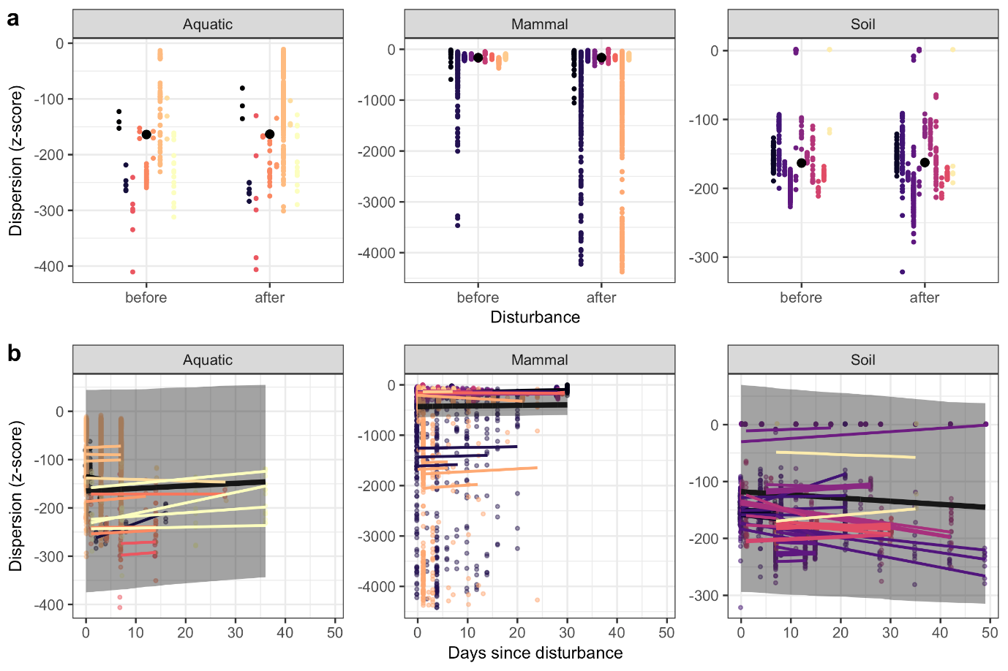
Figure S4. The effect of disturbance on microbiome dispersion, immediately (<4 days) after disturbance (a), and over 50 days of recovery (b). Dispersion was calculated as the pairwise Bray-Curtis distance between replicates for each time point within each time series, and each circle is a Z-score of a pairwise comparison, colored by study. In a, solid black circles indicate the mean across time series per environment with a 95% CI indicated by error bars. In b, regression lines for each time series are colored by study, and the solid black line shows the mean response across time series per environment. The 95% CI of the overall response in each environment is displayed as a grey shaded area, and environments for which overall trends deviate from zero are indicated with an asterisk (*) on the bottom right corner.

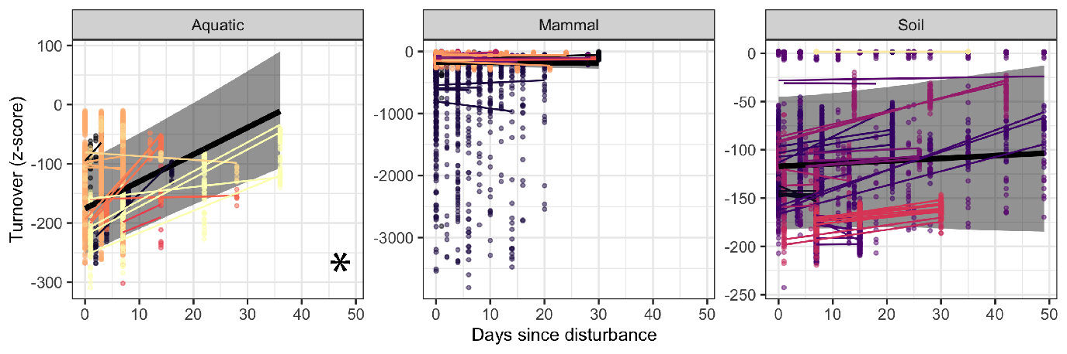
Figure S5. The effect of disturbance on turnover. For each time series, recovery was calculated as the pairwise distance between post-disturbance samples and pre-disturbance controls. Each point is a Z-score of a pairwise comparison, colored by study. Regression lines for each time series are colored by study, and a solid black line indicates the mean response across time series per environment. The 95% CI is displayed as a grey shaded area, and environments for which overall trends deviate from zero are indicated with an asterisk (*) on the bottom right corner.

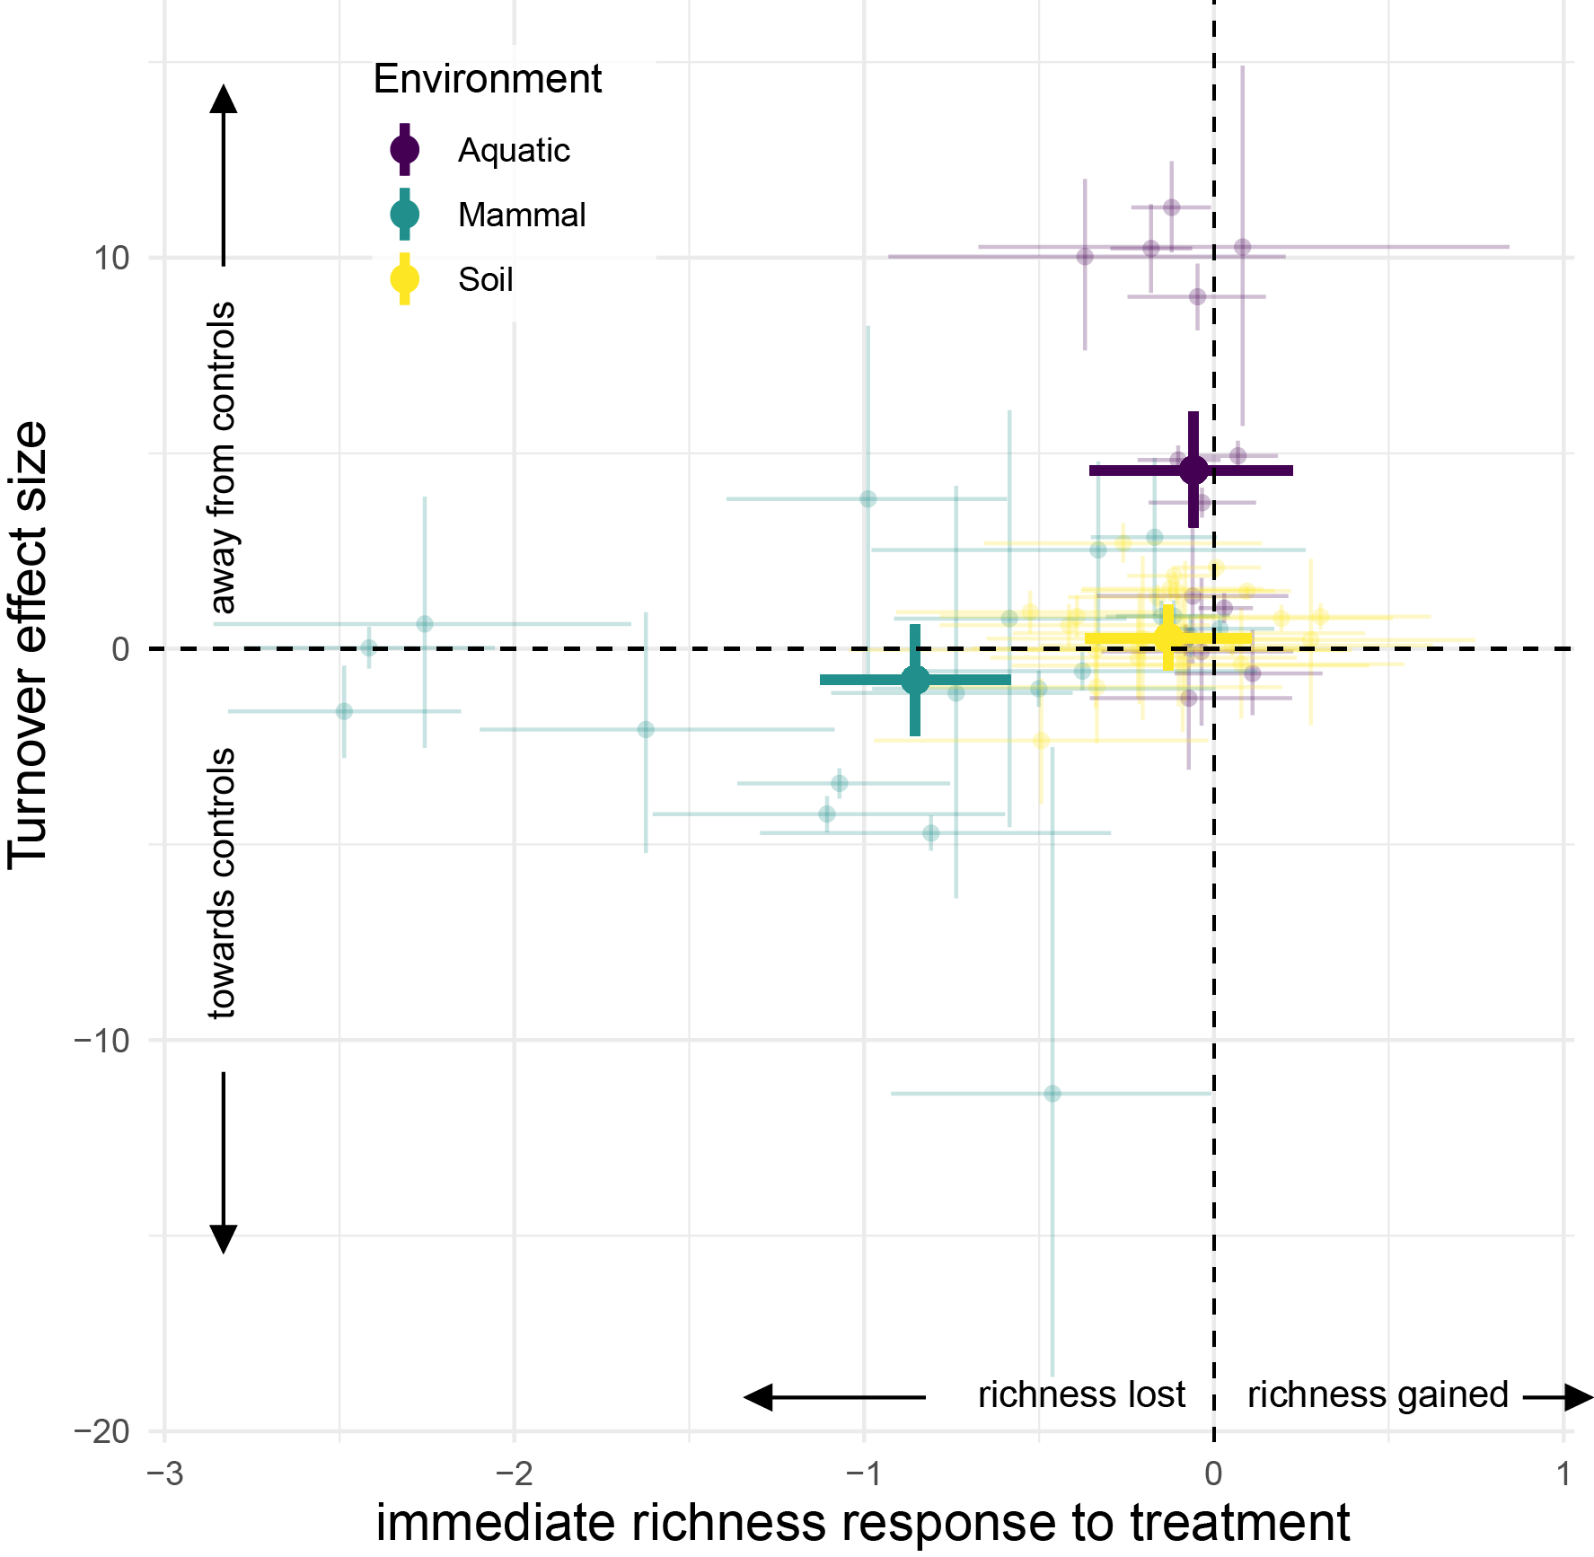
Figure S6. Relationships between the immediate effect of a disturbance on richness and a microbiome’s long-term recovery of composition vary among environments. Each point is a time series, colored by its environment. Immediate richness responses were calculated as the before-after effect of disturbance on log-transformed community richness (Figure 3a). Turnover rates were calculated as the slope estimates of logit-transformed turnover Z-scores over time. Error bars show the 95% CI for both metrics. Large points indicate the mean responses per environment.

