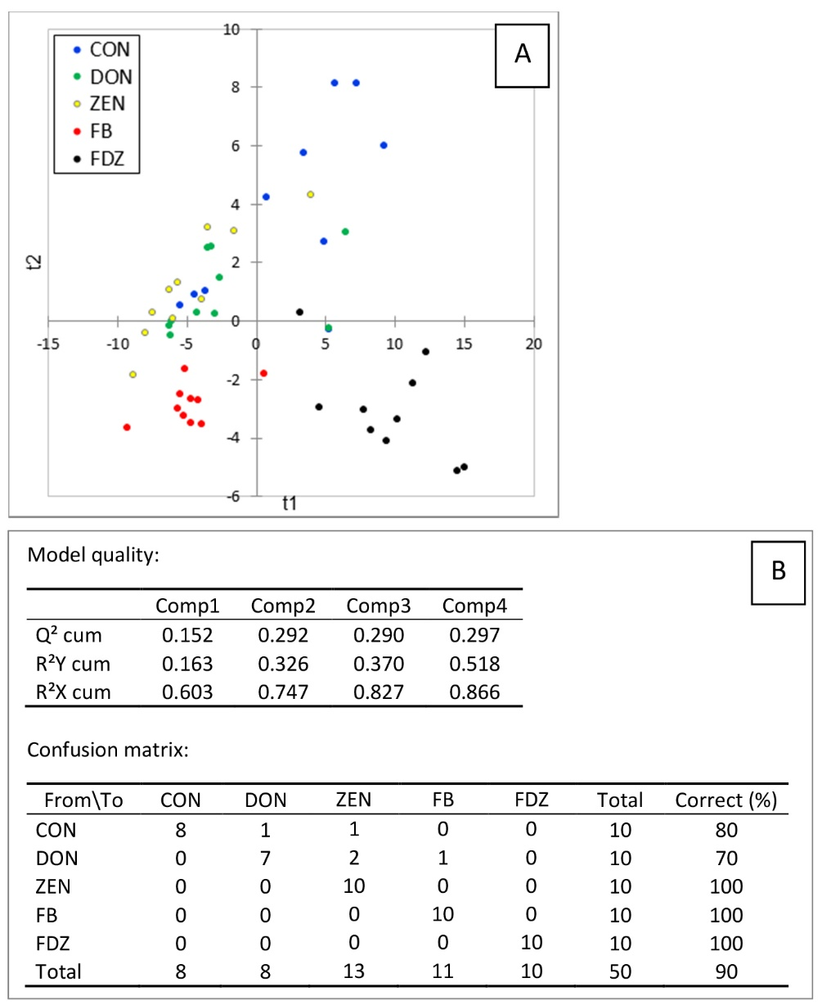
Figure S1

Fig. S1 Partial least squares-discriminant analysis (PLS-DA) of sphingolipids measured in the liver of chickens exposed to the mycotoxins-free diet (CON, n =10) and chickens fed the fumonisins diet (FB, n = 10), the deoxynivalenol diet (DON, n = 10), the zearalenone diet (ZEN, n = 10), or the fumonisins, deoxynivalenol, and zearalenone mixture diet (FDZ, n = 10). (A) Discrimination on the factor axes extracted from the original explanatory variables. (B) Model quality and confusion matrix for the training sample (variable groups).

Figure S2
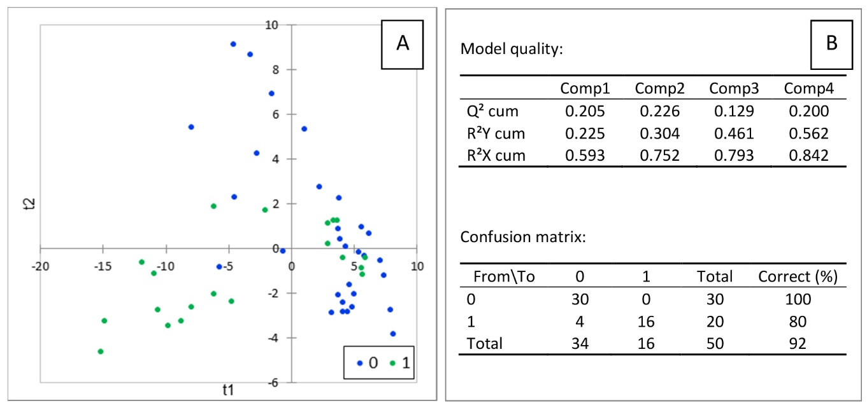

Fig. S2 Partial least squares-discriminant analysis (PLS-DA) of sphingolipids measured in the liver of chickens exposed to zearalenone and fed the DON or FDZ diets (1, n = 20) and chickens not exposed to zearalenone and fed the CON, ZEN, or FB diets (0, n = 30). (A) Discrimination on the factor axes extracted from the original explanatory variables. (B) Model quality and confusion matrix for the training sample (variable groups).

Figure S3
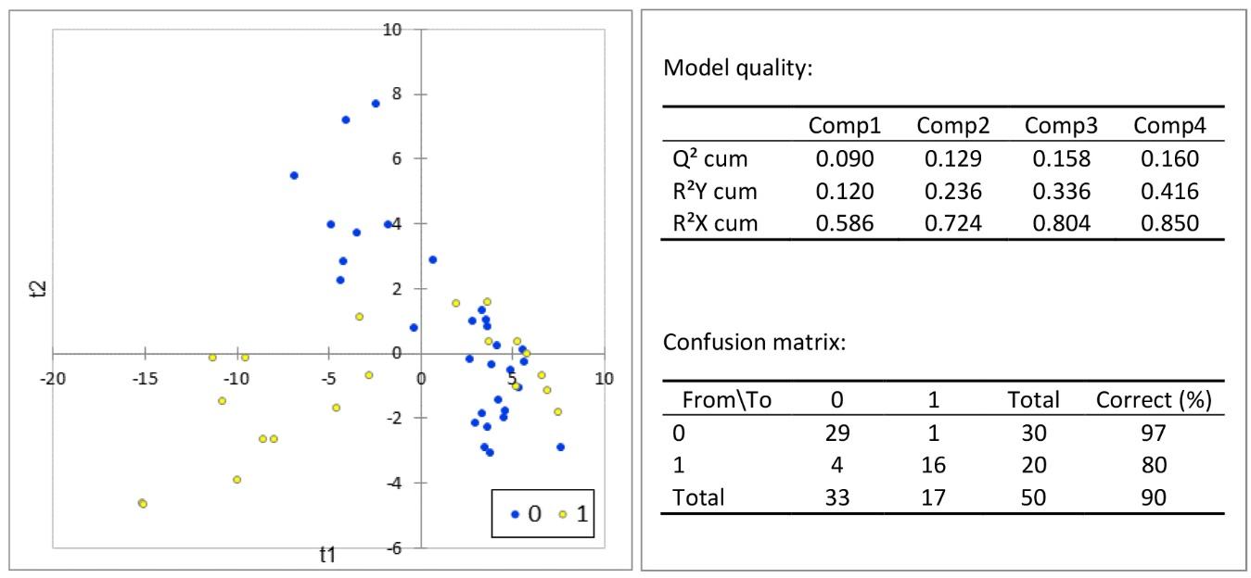

Fig. S3 Partial least squares-discriminant analysis (PLS-DA) of sphingolipids measured in the liver of chickens exposed to zearalenone and fed the ZEN or FDZ diets (1, n = 20) and chickens not exposed to zearalenone and fed the CON, DON, or FB diets (0, n = 30). (A) Discrimination on the factor axes extracted from the original explanatory variables. (B) Model quality and confusion matrix for the training sample (variable groups).

Figure S4
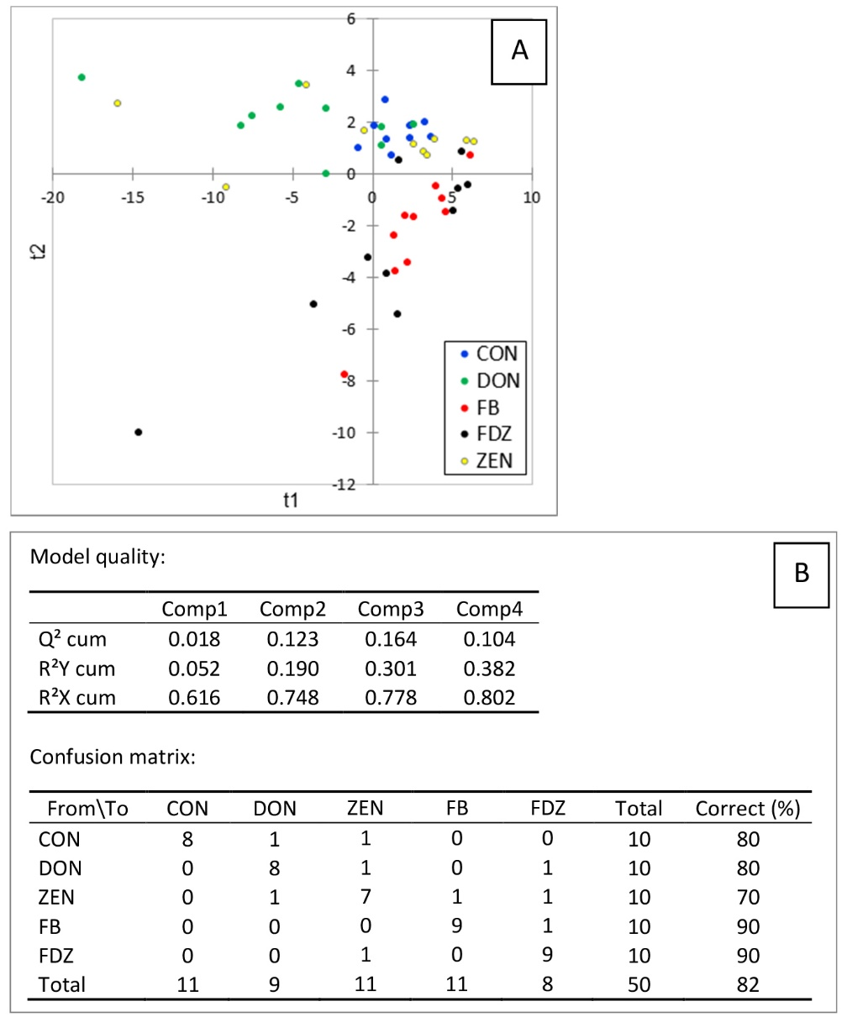

Fig. S4 Partial least squares -discriminant analysis (PLS-DA) of sphingolipids measured in the liver of ducks exposed to the mycotoxins-free diet (CON, n = 10) and ducks fed the fumonisins diet (FB, n = 10), the deoxynivalenol diet (DON, n = 10), the zearalenone diet (ZEN, n = 10), or the fumonisins, deoxynivalenol, and zearalenone mixture diet (FDZ, n = 10). (A) Discrimination on the factor axes extracted from the original explanatory variables. (B) Model quality and confusion matrix for the training sample (variable groups).

Figure S5
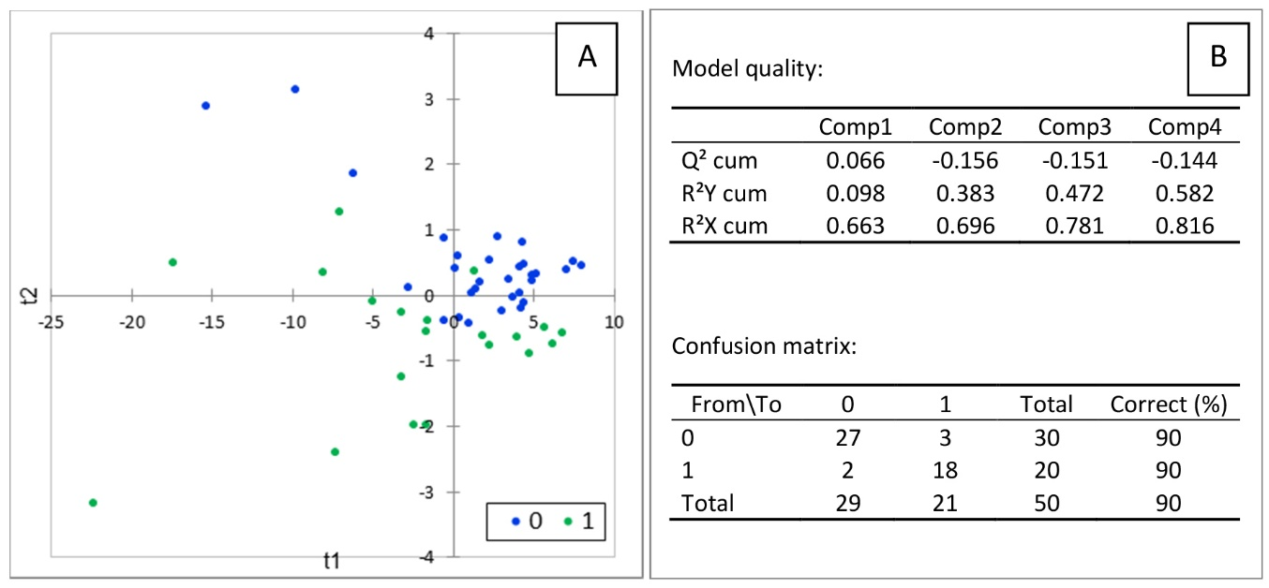

Fig. S5 Partial least squares-discriminant analysis (PLS-DA) of sphingolipids measured in the liver of ducks exposed to zearalenone and fed the DON or FDZ diets (1, n = 20) and ducks not exposed to zearalenone fed the CON, ZEN, or FB diets (0, n = 30). (A) Discrimination on the factor axes extracted from the original explanatory variables. (B) Model quality and confusion matrix for the training sample (variable groups).

Figure S6
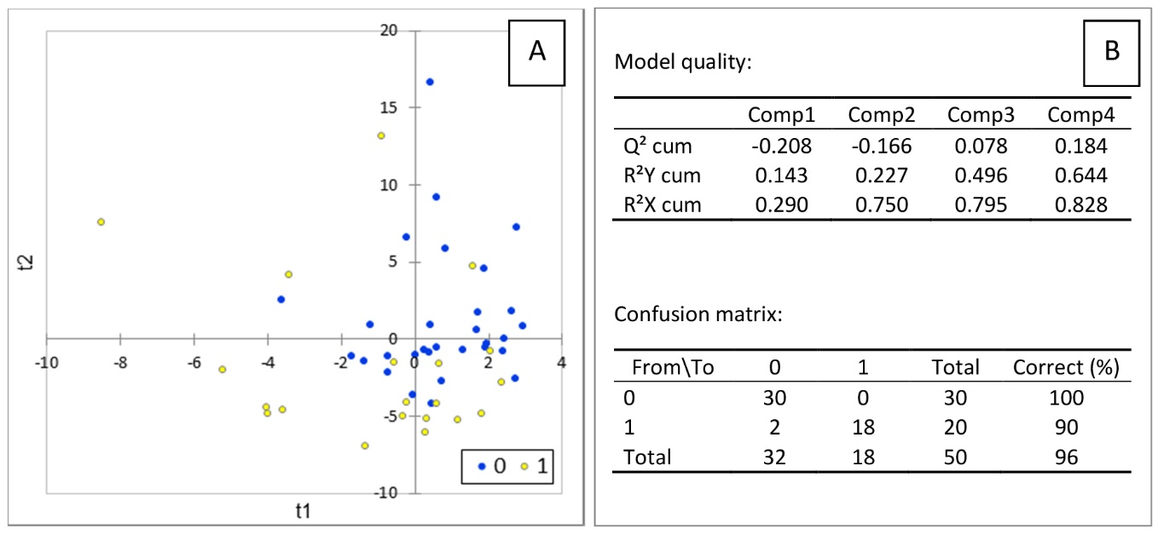

Fig. S6 Partial least squares-discriminant analysis (PLS-DA) of sphingolipids measured in the liver of ducks exposed to zearalenone and fed the ZEN or FDZ diets (1, n = 20) and ducks not exposed to zearalenone and fed the CON, DON, or FB diets (0, n = 30). (A) Discrimination on the factor axes extracted from the original explanatory variables. (B) Model quality and confusion matrix for the training sample (variable groups).

