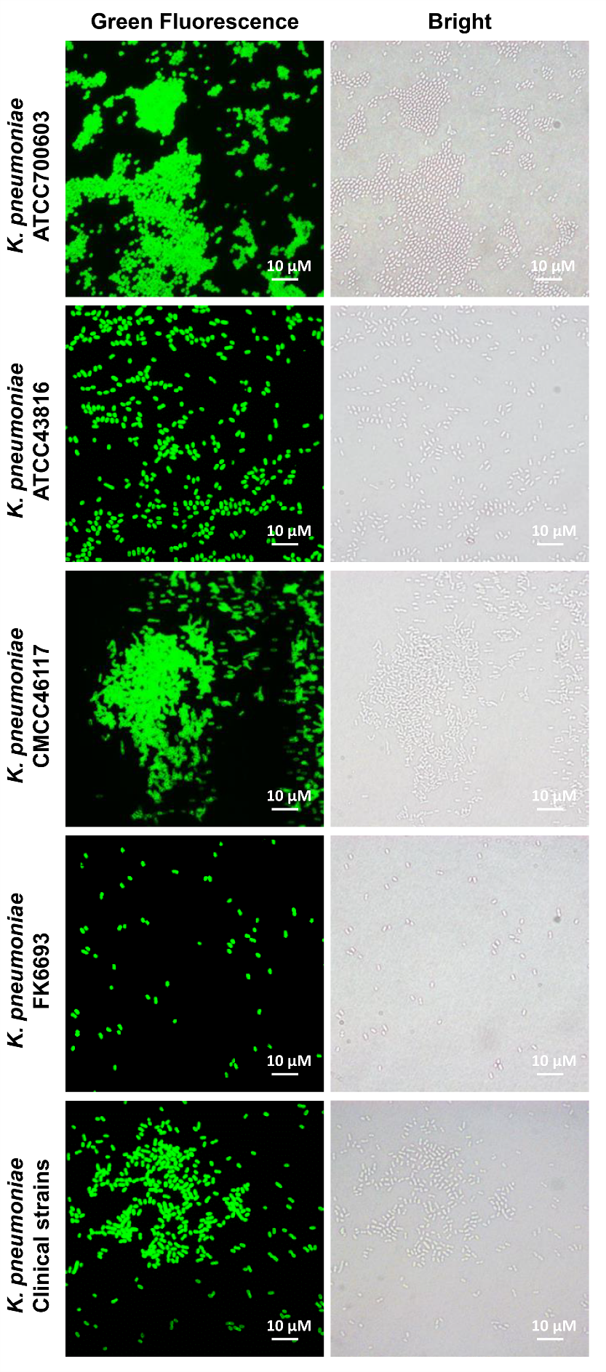
Extended Data Fig. 1| Fluorescence microscopy images of K. pneumoniae cells after treatment of gRBP_{P545} at 37 °C for 30 min. The observed green cells demonstrate that gRBP_{P545} was bonded to all five tested K. pneumoniae strains. (Scale bars represent 10 μm).

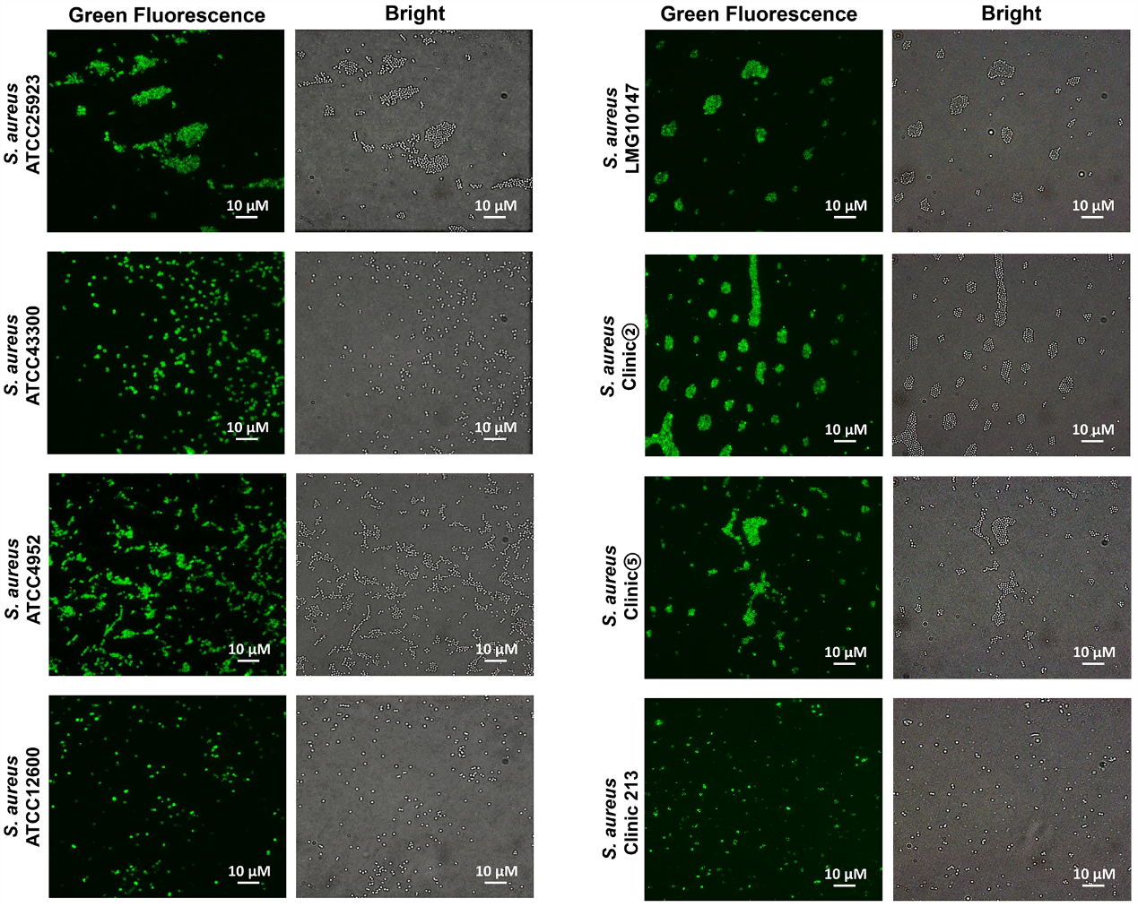
Extended Data Fig. 2| Fluorescence microscopy images of S. aureus cells after treatment of gCBD_{SA97} at 37 °C for 30 min. The observed green cells demonstrate that gCBD_{SA97} was bonded to all eight tested S. aureus strains. (Scale bars represent 10 μm).

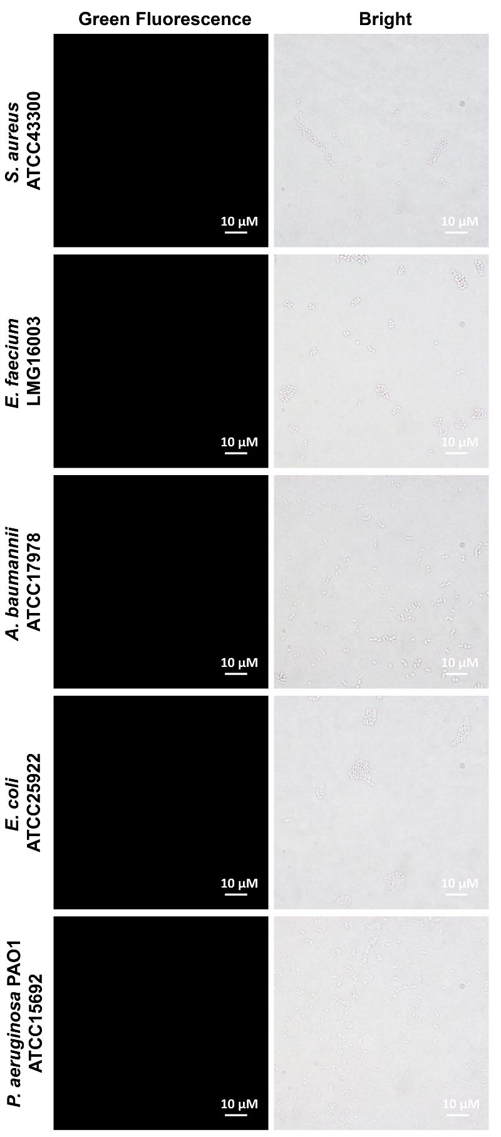
Extended Data Fig. 3| Fluorescence microscopy images of S. aureus, E. faecium, A. baumannii, E. coli, P. aeruginosa PAO1 after treatment of gRBP_{P545} at 37 °C for 30 min. No green cells were observed, demonstrating gRBP_{P545} was specifically bonded to K. pneumoniae strains. (Scale bars represent 10 μm).

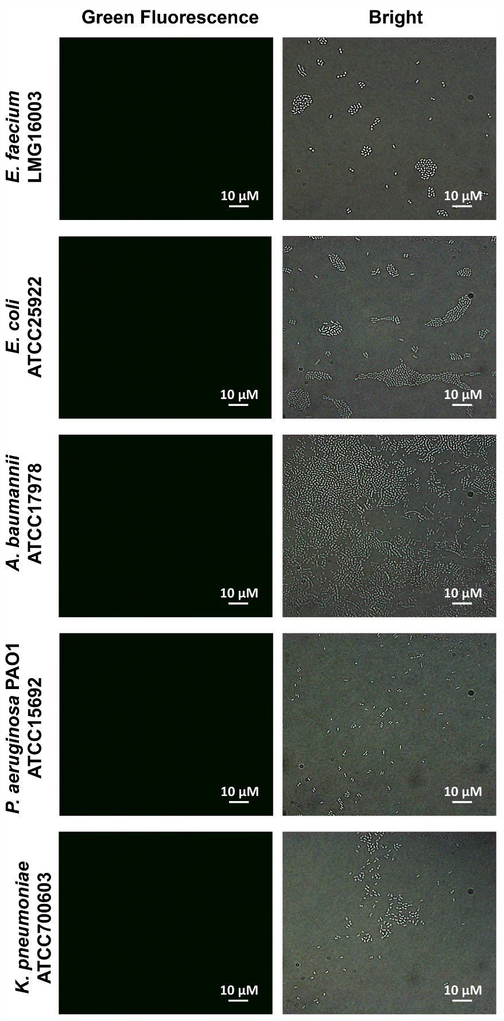
Extended Data Fig. 4| Fluorescence microscopy images of E. faecium, K. pneumoniae, A. baumannii, E. coli, P. aeruginosa PAO1 after treatment of gCBD_{SA97} at 37 °C for 30 min. No green cells were observed, demonstrating gCBD_{SA97} was specifically bonded to S. aureus strains. (Scale bars represent 10 μm).

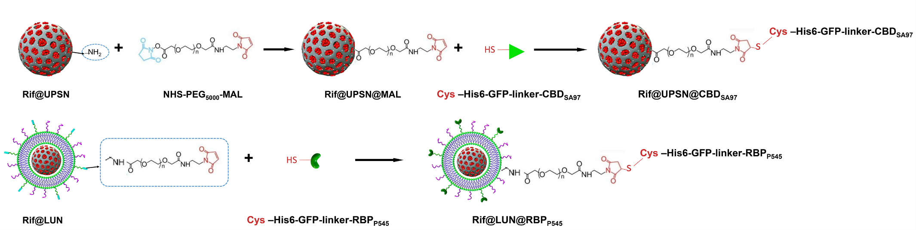
Extended Data Fig. 5| Schematic illustration depicting the gCBD_{SA97} (Cys-His6-GFP-linker-CBD_{SA97}) conjugates to Rif@UPSN and gRBP_{P545} (Cys-His6-GFP-linker-RBP_{P545}) conjugates to Rif@LUN. gCBD_{SA97} conjugates to maleimide-activated Rif@-UPSN via the designed free cysteine residue at the N-terminus of this protein, and gRBP_{P545} conjugates to maleimide-activated Rif@LUN via the designed free cysteine residue at the N-terminus of this protein.

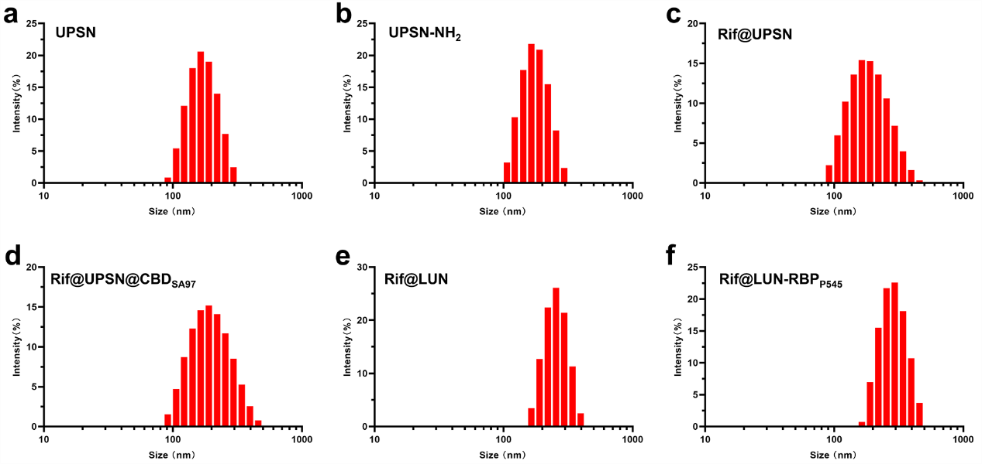
Extended Data Fig. 6| Hydrodynamic size distribution of the nanoparticles measured by dynamic light scattering. a, The hydrodynamic diameters of UPSN. b, The hydrodynamic diameters of UPSN-NH₂. c, The hydrodynamic diameters of Rif@UPSN. d, The hydrodynamic diameters of Rif@UPSN@CBD_{SA97}. e, The hydrodynamic diameters of Rif@LUN. f, The hydrodynamic diameters of Rif@LUN-RBP_{P545}.

Extended Data Fig. 7| Survival rate (n=10) of mice after intratracheal inoculation of K. pneumoniae at a dose of 8×10⁹ c.f.u. per mouse. Groups of mice received free rifampicin at a dose range of 1.25 to 40 mg/kg intravenously 12 post the bacterial inoculation.

Extended Data Fig. 8| Survival rate (n=10) of mice after intratracheal inoculation of S. aureus at a dose of 10×10⁹ c.f.u. per mouse. Groups of mice received free rifampicin at a dose range of 0.033 to 8.1 mg/kg intravenously 12 post the bacterial inoculation.

