Supplementary Information
Table S1 Scalar recovery, limits of detection (LOD) and limits of quantification (LOQ) of TCEP, TPHP and PCB18
OPEs | Scalar recovery (%) | LOD* (ug g⁻¹) | LOQ* (ug g⁻¹)
TCEP | 95.2 | 0.0028 | 0.0094
TPHP | 98.8 | 0.0019 | 0.0063
PCB18 | 101.4 | 0.0016 | 0.0083
*The LOD and LOQ were determined for the instrument.

Table S2 Genes chosen and their primers used in qPCR
gene | Gene ID | Primer sequence (5’-3’)
18S | 4333919 | GCCGTCCTCTCTCTGTATGC  GGGGACAGTGTGGCTGAC
OsCHL | 4337069 | TACTCAAGAACACCTAATCCTG GACATCACCTCGCAATCC
OsTIL | 4329967 | GGTGGTTCAAGTCGCTCTTC GCTATACATCGTCGTCCTCTG
OsVDE | 4335625 | TCACCAGAACAGCCATACAG CAGCACCTCCATATCCATCC
OsZEP1 | 4335984 | TTGAGGAGATATGAGAAGGAGAG CAAGTATGGTCTATAAGTGGTAGC
OsZEP2 | 107278150 | ATCCAGCAGAGCACCAAC TTCCGCAATCGTAATCAGC
OsUN | 4325583 | GCACAGAAGGTTCCCAGATG CAAGTCCGCAGTATCCACAG
OspsaA | 3131406 | ATACCGCCATACAATTACAAC GCCTACTGCTACTAACTCGA
OspsaB | 3131407 | TTGTGATATTTCTGCTTGG CATTGATAAGTTGTGAAGAG
OspsbB | 3131410 | CTATGGTGGCGAACTTAATGGAG AGAAGAGCAAAGCAAAGGTAGC
OsDHAR | 4337622 | ATGGGCGTGGAGGTGTGCGTCAAGG  CCTTGCTCTTCAAGAACGTTGTGAAGC
OsGR | 4331719 | TCTCAGAGGGACTTCTCTACT  AGGCAGTGGTACTCACATGGT
OsAPX | 4329643 | TGGTCTGATGACCTCCTCTGA  CATGAGCCATGACAACTAGA
OsMDHAR | 4330469 | AGATTCGACAGGGAAGGTGA  CACGGATGCCAATACCAAC
OsSOD | 4332082 | TGGCTTCCACATCCACTCCT  CAACAACTGCCCTTCCCAATA
OsCAT | 4342124 | GATGCTCTCTCAGATCCTCGTA  CAGTTTCACAACTTGCGTCAC
OsPOD | 4344279 | TAATGCTGCTGGTGGCTG  TGACGCTCTTGATGGTGG

Table S3 The template protein and sequences’ identities, confidence, and coverage of lipocalins
Target Protein | Template | Confidence (%) | Coverage (%)
OsCHL | 3CQR | 100 | 45
OsTIL | 1QWD | 100 | 81
OsVDE | 3CQR | 99.9 | 36
OsZEP1 | 6PVH | 100 | 53
OsZEP2 | 3FMW | 100 | 91
OsUN | 3CQR | 99.8 | 31
OspsaA | 1JB0 | 100 | 99
OspsaB | 1JB0 | 100 | 100
OspsbB | 2XAT | 100 | 96

Figure captions
Figure S1. The chromatogram of TCEP, TPHP and PCB18.
Figure S2. The standard curve of TCEP, TPHP and PCB18.
Figure S3. Ramachandran plots of Lipocalins.

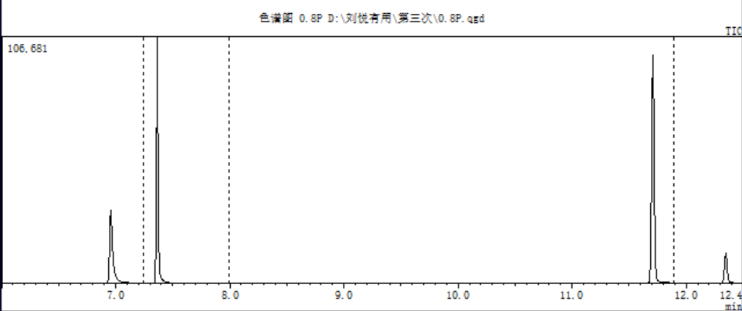
A
TCEP
PCB
TPHP

Figure S1.

Figure S2.

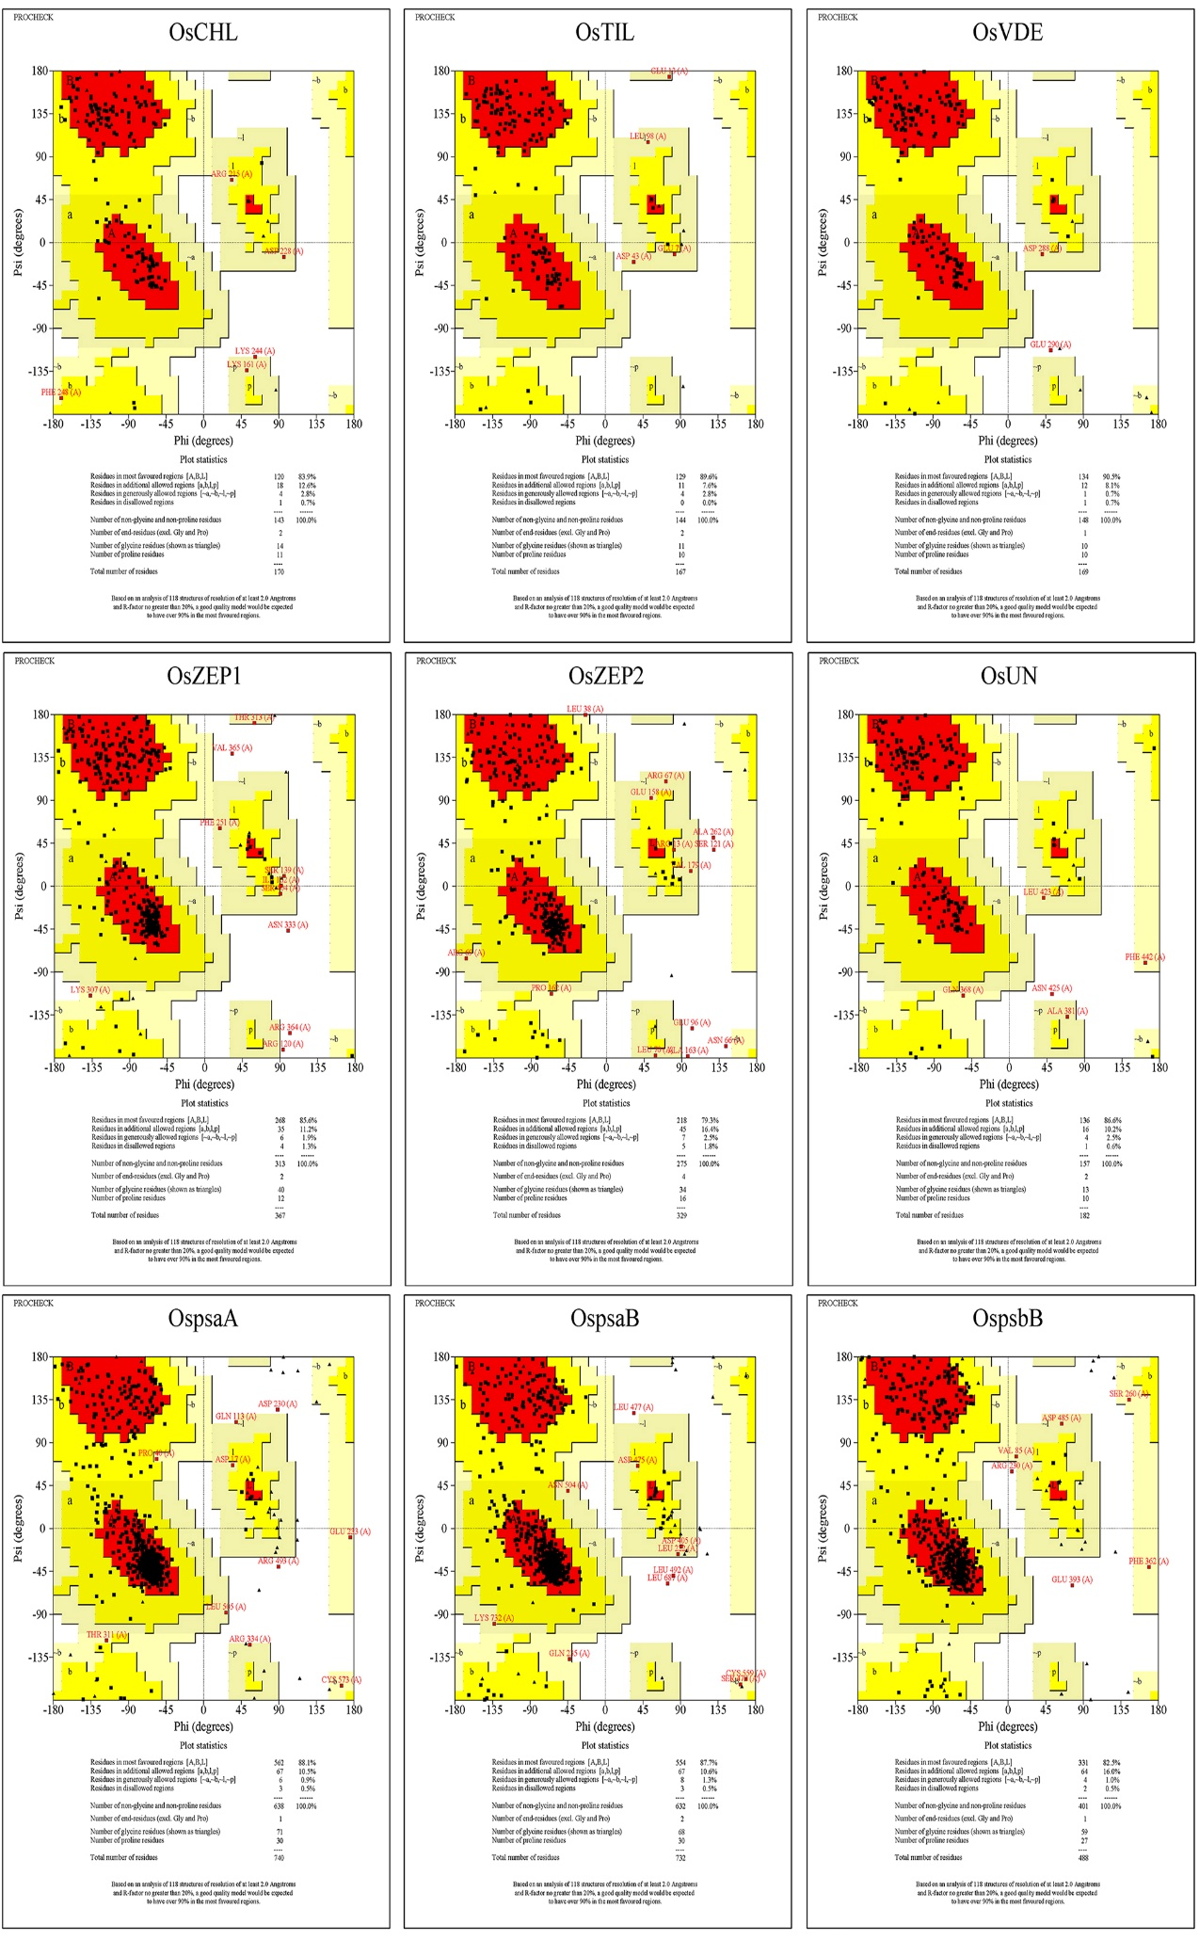Figure S3.

