Appendix S1: The procedure followed in the generation of 431 wall configurations

In this study, a set of formulas has been developed for the horizontal displacement estimation of free embedded cantilever walls using 431 finite element (FE) wall configurations in which the height (H), flexural rigidity (EI), embedment length of the wall (d), soil modulus (E₁, E₂, E₃, E₄), internal (φ₁, φ₂, φ₃, φ₄,) and interface friction angle (δ₁=0.66φ₁, δ₂=0.66φ₂, δ₃=0.66φ₃, δ₄=0.66φ₄), the unit weight of the soil (γ_{1,} γ_{2,} γ_{3,} γ₄) and the surcharge load (L) are considered. The formulas address the nominal wall heights, namely, 1, 2, 3, 4, 5, 6, 7 and 8 m. Initially, the goal was to derive a single formula in which all wall heights between 1-8 m could be represented. Such single formula has been derived but the accuracy of the formula was not satisfying. Instead of this, separate formulas were derived for each wall height. The formulas were derived using One Factor At a Time method (OFAT). In this method, 8 baseline configurations are set. As an example, the baseline configuration for the wall height-H=1 m is given in the Table Row 1 (Table S1). In Table Row 2-4, new configurations are generated by changing the “d” parameter of the baseline configuration. Later, the same procedure is applied to other parameters, such as unit weight of soil (γ_{1,} γ_{2,} γ_{3,} γ₄), soil modulus (E₁, E₂, E₃, E₄), internal (φ₁, φ₂, φ₃, φ₄,), flexural rigidity (EI), line load (L) (Table 1S). Finally, the same procedure is applied to 8 wall heights.
The number of assigned values for a given parameter was at least three. The minimum and maximum values for a certain parameter were specific to wall height. For example, the minimum soil modulus for the wall heights 1 m, 2 m and 3 m was 10 000 kPa, whereas this value was greater than 25 000 kPa for some higher walls (Table 1S). This meant, higher walls required a higher soil modulus value for stability. The same procedure was followed in the selection of the internal friction angles.
The flexural rigidity (EI) values included the rigidity range of sheet pile walls, concrete pile walls and continuous concrete walls.
The embedment depth (d) and the nominal wall height (H) were established as equal to one another. Some other combinations have been generated by setting lower and higher values for the embedment depth (d). By trials, the minimum embedment depth for a certain wall height was determined. The embedment depths, in which the wall was stable, were included. The upper boundary values were selected in a way that the further increase in embedment depth had no significant influence in wall displacement.

Table S1. The details of 431 finite element wall configurations

No | H (m) | d (m) | γ_{1,} γ_{2,} γ₃, γ₄(^{ο}) | E_{1,} E_{2,} E_{3,} E₄ (10³kPa) | L (kPa) | φ_{1 ,} φ_{2,} φ_{3,} φ₄ (^{ο}) | EI (10³KN.m²) | Notes
1 | 1 | 1 | 20-20-20-20 | 50-50-50-50 | 0 | 35-35-35-35 | 2500 | Baseline config. for H=1 m
2-4 | 1 | 0.7, 0.75, 1.25 | 20-20-20-20 | 50-50-50-50 | 0 | 35-35-35-35 | 2500 | d is changed.
5-20 | 1 | 1 | 20-20-20-22, 20-20-20-24, 20-20-20-18, 20-20-20-16, 20-20-11.2-11.2, 20-20-10.2-10.2, 20-20, 9.2-9.2, 20-20-18-20, 20-20-16-20, 20-20-14-20, 18-20-20-20, 16-20-20-20,14-20-20-20 | 50-50-50-50 | 0 | 35-35-35-35 | 2500 | γ_{1,} γ₂ γ_{3,} γ₄ are changed.
21-34 | 1 | 1 | 20-20-20-20 | 25-25-25-25, 10-10-10-10, 100-100-100-100, 250-250-250-250, 50-50-50-100, 50-50-50-250, 25-25-25-50, 10-10-10-50, 20-50-50-50, 30-50-50-50, 40-50-50-50, 50-20-50-50, 50-30-50-50, 50-40-50-50 | 0 | 35-35-35-35 | 2500 | E₁, E_{2,} E_{3,} E₄ are changed.
35-52 | 1 | 1 | 20-20-20-20 | 50-50-50-50 | 0 | 35-35-40-35, 35-35-42-35, 35-35-30-35, 35-35-35-25, 30-30-30-30, 30-30-30-40, 30-30-30-42, 30-30-30-25, 28-28-28-30, 25-25-25-33, 25-25-25-36, 25-25-25-42, 28-35-35-35, 32-35-35-35, 38-35-35-35, 35-28-35-35, 35-32-35-35, 35-38-35-35 | 2500 | φ_{1,} φ₂ φ_{3,} φ₄ are changed.
53-55 | 1 | 1 | 20-20-20-20 | 50-50-50-50 | 5, 10, 15 | 35-35-35-35 | 2500 | L is changed.
56-59 | 1 | 1 | 20-20-20-20 | 50-50-50-50 | 0 | 35-35-35-35 | 2.5, 39.1, 312.5, 8437.5 | EI is changed.
No | H (m) | d (m) | γ_{1,} γ_{2,} γ₃, γ₄(^{ο}) | E_{1,} E_{2,} E_{3,} E₄ (10³kPa) | L (kPa) | φ_{1 ,} φ_{2,} φ_{3,} φ₄ (^{ο}) | EI (10³KN.m²) | Notes
60 | 2 | 2 | 20-20-20-20 | 50-50-50-50 | 0 | 35-35-35-35 | 2500 | Baseline config. for H=2 m
61-63 | 2 | 1.2, 1.4, 2, 2.25 | 20-20-20-20 | 50-50-50-50 | 0 | 35-35-35-35 | 2500 | d is changed.
64-79 | 2 | 2 | 20-20-20-22, 20-20-20-24, 20-20-20-18, 20-20-20-16, 20-20-11.2-11.2, 20-20-10.2-10.2, 20-20, 9.2-9.2, 20-20-18-20, 20-20-16-20, 20-20-14-20, 18-20-20-20, 16-20-20-20,14-20-20-20 | 50-50-50-50 | 0 | 35-35-35-35 | 2500 | γ_{1,} γ₂ γ_{3,} γ₄ are changed.
80-93 | 2 | 2 | 20-20-20-20 | 25-25-25-25, 10-10-10-10, 100-100-100-100, 250-250-250-250, 50-50-50-100, 50-50-50-250, 25-25-25-50, 10-10-10-50, 20-50-50-50, 30-50-50-50, 40-50-50-50, 50-20-50-50, 50-30-50-50, 50-40-50-50 | 0 | 35-35-35-35 | 2500 | E₁, E_{2,} E_{3,} E₄ are changed.
94-111 | 2 | 2 | 20-20-20-20 | 50-50-50-50 | 0 | 35-35-40-35, 35-35-42-35, 35-35-30-35, 35-35-35-25, 30-30-30-30, 30-30-30-40, 30-30-30-42, 30-30-30-25, 28-28-28-30, 25-25-25-33, 25-25-25-36, 25-25-25-42, 28-35-35-35, 32-35-35-35, 38-35-35-35, 35-28-35-35, 35-32-35-35, 35-38-35-35 | 2500 | φ_{1,} φ₂ φ_{3,} φ₄ are changed.
112-114 | 2 | 2 | 20-20-20-20 | 50-50-50-50 | 5, 10, 15 | 35-35-35-35 | 2500 | L is changed.
115-118 | 2 | 2 | 20-20-20-20 | 50-50-50-50 | 0 | 35-35-35-35 | 160, 39.1, 312.5, 8437.5 | EI is changed.
No | H (m) | d (m) | γ_{1,} γ_{2,} γ₃, γ₄(^{ο}) | E_{1,} E_{2,} E_{3,} E₄ (10³kPa) | L (kPa) | φ_{1 ,} φ_{2,} φ_{3,} φ₄ (^{ο}) | EI (10³KN.m²) | Notes
119 | 3 | 3 | 20-20-20-20 | 50-50-50-50 | 0 | 35-35-35-35 | 2500 | Baseline config. for H=3 m
120-123 | 3 | 2, 2.5, 3, 3.5, 4 | 20-20-20-20 | 50-50-50-50 | 0 | 35-35-35-35 | 2500 | d is changed.
124-139 | 3 | 3 | 20-20-20-22, 20-20-20-24, 20-20-20-18, 20-20-20-16, 20-20-11.2-11.2, 20-20-10.2-10.2, 20-20, 9.2-9.2, 20-20-18-20, 20-20-16-20, 20-20-14-20, 18-20-20-20, 16-20-20-20,14-20-20-20 | 50-50-50-50 | 0 | 35-35-35-35 | 2500 | γ_{1,} γ₂ γ_{3,} γ₄ are changed.
140-153 | 3 | 3 | 20-20-20-20 | 25-25-25-25, 10-10-10-10, 100-100-100-100, 250-250-250-250, 50-50-50-100, 50-50-50-250, 25-25-25-50, 10-10-10-50, 20-50-50-50, 30-50-50-50, 40-50-50-50, 50-20-50-50, 50-30-50-50, 50-40-50-50 | 0 | 35-35-35-35 | 2500 | E₁, E_{2,} E_{3,} E₄ are changed.
154-166 | 3 | 3 | 20-20-20-20 | 50-50-50-50 | 0 | 35-35-35-40, 35-35-35-42, 35-35-35-30, 35-35-35-25, 30-30-30-40, 30-30-30-25, 28-35-35-35, 32-35-35-35, 38-35-35-35, 35-28-35-35, 35-38-35-35 | 2500 | φ_{1,} φ₂ φ_{3,} φ₄ are changed.
167-169 | 3 | 3 | 20-20-20-20 | 50-50-50-50 | 5, 10, 15 | 35-35-35-35 | 2500 | L is changed.
170-173 | 3 | 3 | 20-20-20-20 | 50-50-50-50 | 0 | 35-35-35-35 | 312.5, 8437.5, 540, 1280 | EI is changed.
No | H (m) | d (m) | γ_{1,} γ_{2,} γ₃, γ₄(^{ο}) | E_{1,} E_{2,} E_{3,} E₄ (10³kPa) | L (kPa) | φ_{1 ,} φ_{2,} φ_{3,} φ₄ (^{ο}) | EI (10³KN.m²) | Notes
174 | 4 | 4 | 20-20-20-20 | 50-50-50-50 | 0 | 35-35-35-35 | 2500 | Baseline config. for H=4 m
175-178 | 4 | 3, 2.5, 2.75, 5 | 20-20-20-20 | 50-50-50-50 | 0 | 35-35-35-35 | 2500 | d is changed.
179-195 | 4 | 4 | 20-20-20-22, 20-20-20-24, 20-20-20-18, 20-20-20-16, 20-20-11.2-11.2, 20-20-10.2-10.2, 20-20-9.2-9.2, 20-20-9.2-9.2, 20-20-18-20, 20-20-16-20, 20-20-14-20, 18-20-20-20, 16-20-20-20, 14-20-20-20, 20-14-20-20, 20-16-20-20, 20-18-20-20 | 50-50-50-50 | 0 | 35-35-35-35 | 2500 | γ_{1,} γ₂ γ_{3,} γ₄ are changed.
196-208 | 4 | 4 | 20-20-20-20 | 25-25-25-25, 100-100-100-100, 250-250-250-250, 150-150-150-150, 50-50-50-50, 75-75-75-50, 25-25-25-50, 20-50-50-50, 30-50-50-50, 40-50-50-50, 50-20-50-50, 50-30-50-50, 50-40-50-50 | 0 | 35-35-35-35 | 2500 | E₁, E_{2,} E_{3,} E₄ are changed.
209-221 | 4 | 4 | 20-20-20-20 | 50-50-50-50 | 0 | 35-35-35-40, 35-35-35-42, 35-35-35-30, 35-35-35-25, 30-30-30-35, 30-30-30-40, 30-30-30-30, 28-35-35-35, 32-35-35-35, 38-35-35-35, 35-28-35-35, 35-32-35-35, 35-38-35-35 | 2500 | φ_{1,} φ₂ φ_{3,} φ₄ are changed.
222-224 | 4 | 4 | 20-20-20-20 | 50-50-50-50 | 5, 10, 15 | 35-35-35-35 | 2500 | L is changed.
225-227 | 4 | 4 | 20-20-20-20 | 50-50-50-50 | 0 | 35-35-35-35 | 540, 8437.5, 1054.7 | EI is changed.
No | H (m) | d (m) | γ_{1,} γ_{2,} γ₃, γ₄(^{ο}) | E_{1,} E_{2,} E_{3,} E₄ (10³kPa) | L (kPa) | φ_{1 ,} φ_{2,} φ_{3,} φ₄ (^{ο}) | EI (10³KN.m²) | Notes
228 | 5 | 5 | 20-20-20-20 | 50-50-50-50 | 0 | 35-35-35-35 | 2500 | Baseline config. for H=5 m
229-231 | 5 | 3, 3.5, 4 | 20-20-20-20 | 50-50-50-50 | 0 | 35-35-35-35 | 2500 | d is changed.
232-247 | 5 | 5 | 20-20-20-22, 20-20-20-24, 20-20-20-18, 20-20-20-16, 20-20-11.2-11.2, 20-20-10.2-10.2, 20-20-9.2-9.2, 20-20-9.2-9.2, 20-20-18-20, 20-20-16-20, 20-20-14-20, 18-20-20-20, 16-20-20-20, 14-20-20-20, 20-14-20-20, 20-16-20-20, 20-18-20-20 | 50-50-50-50 | 0 | 35-35-35-35 | 2500 | γ_{1,} γ₂ γ_{3,} γ₄ are changed.
248-260 | 5 | 5 | 20-20-20-20 | 25-25-25-25, 100-100-100-100, 250-250-250-250, 150-150-150-150, 50-50-50-50, 75-75-75-50, 25-25-25-50, 20-50-50-50, 30-50-50-50, 40-50-50-50, 50-20-50-50, 50-30-50-50, 50-40-50-50 | 0 | 35-35-35-35 | 2500 | E₁, E_{2,} E_{3,} E₄ are changed.
261-273 | 5 | 5 | 20-20-20-20 | 50-50-50-50 | 0 | 35-35-35-40, 35-35-35-42, 35-35-35-30, 35-35-35-25, 30-30-30-35, 30-30-30-40, 30-30-30-30, 28-35-35-35, 32-35-35-35, 38-35-35-35, 35-28-35-35, 35-32-35-35, 35-38-35-35 | 2500 | φ_{1,} φ₂ φ_{3,} φ₄ are changed.
274-276 | 5 | 5 | 20-20-20-20 | 50-50-50-50 | 5, 10, 15 | 35-35-35-35 | 2500 | L is changed.
277-279 | 5 | 5 | 20-20-20-20 | 50-50-50-50 | 0 | 35-35-35-35 | 1280, 4882, 8437 | EI is changed.
No | H (m) | d (m) | γ_{1,} γ_{2,} γ₃, γ₄(^{ο}) | E_{1,} E_{2,} E_{3,} E₄ (10³kPa) | L (kPa) | φ_{1 ,} φ_{2,} φ_{3,} φ₄ (^{ο}) | EI (10³KN.m²) | Notes
280 | 6 | 6 | 20-20-20-20 | 50-50-50-50 | 0 | 35-35-35-35 | 2500 | Baseline config. for H=6 m
281-282 | 6 | 4, 5 | 20-20-20-20 | 50-50-50-50 | 0 | 35-35-35-35 | 2500 | d is changed.
283-298 | 6 | 6 | 20-20-20-22, 20-20-20-24, 20-20-20-18, 20-20-20-16, 20-20-11.2-11.2, 20-20-10.2-10.2, 20-20-9.2-9.2, 20-20-9.2-9.2, 20-20-18-20, 20-20-16-20, 20-20-14-20, 18-20-20-20, 16-20-20-20, 14-20-20-20, 20-14-20-20, 20-16-20-20, 20-18-20-20 | 50-50-50-50 | 0 | 35-35-35-35 | 2500 | γ_{1,} γ₂ γ_{3,} γ₄ are changed.
299-311 | 6 | 6 | 20-20-20-20 | 25-25-25-25, 100-100-100-100, 250-250-250-250, 150-150-150-150, 50-50-50-50, 75-75-75-50, 25-25-25-50, 20-50-50-50, 30-50-50-50, 40-50-50-50, 50-20-50-50, 50-30-50-50, 50-40-50-50 | 0 | 35-35-35-35 | 2500 | E₁, E_{2,} E_{3,} E₄ are changed.
312-324 | 6 | 6 | 20-20-20-20 | 50-50-50-50 | 0 | 35-35-35-40, 35-35-35-42, 35-35-35-30, 35-35-35-25, 30-30-30-35, 30-30-30-40, 30-30-30-30, 28-35-35-35, 32-35-35-35, 38-35-35-35, 35-28-35-35, 35-32-35-35, 35-38-35-35 | 2500 | φ_{1,} φ₂ φ_{3,} φ₄ are changed.
325-327 | 6 | 6 | 20-20-20-20 | 50-50-50-50 | 5, 10, 15 | 35-35-35-35 | 2500 | L is changed.
328-329 | 6 | 6 | 20-20-20-20 | 50-50-50-50 | 0 | 35-35-35-35 | 1280, 2500, 20000 | EI is changed.
No | H (m) | d (m) | γ_{1,} γ_{2,} γ₃, γ₄(^{ο}) | E_{1,} E_{2,} E_{3,} E₄ (10³kPa) | L (kPa) | φ_{1 ,} φ_{2,} φ_{3,} φ₄ (^{ο}) | EI (10³KN.m²) | Notes
330 | 7 | 7 | 20-20-20-20 | 50-50-50-50 | 0 | 35-35-35-35 | 2500 | Baseline config. for H=7 m
331-332 | 7 | 5, 6 | 20-20-20-20 | 50-50-50-50 | 0 | 35-35-35-35 | 2500 | d is changed.
333-348 | 7 | 7 | 20-20-20-22, 20-20-20-24, 20-20-20-18, 20-20-20-16, 20-20-11.2-11.2, 20-20-10.2-10.2, 20-20-9.2-9.2, 20-20-9.2-9.2, 20-20-18-20, 20-20-16-20, 20-20-14-20, 18-20-20-20, 16-20-20-20, 14-20-20-20, 20-14-20-20, 20-16-20-20, 20-18-20-20 | 50-50-50-50 | 0 | 35-35-35-35 | 2500 | γ_{1,} γ₂ γ_{3,} γ₄ are changed.
349-361 | 7 | 7 | 20-20-20-20 | 25-25-25-25, 100-100-100-100, 250-250-250-250, 150-150-150-150, 50-50-50-50, 75-75-75-50, 25-25-25-50, 20-50-50-50, 30-50-50-50, 40-50-50-50, 50-20-50-50, 50-30-50-50, 50-40-50-50 | 0 | 35-35-35-35 | 2500 | E₁, E_{2,} E_{3,} E₄ are changed.
362-375 | 7 | 7 | 20-20-20-20 | 50-50-50-50 | 0 | 35-35-35-40, 35-35-35-42, 35-35-35-30, 35-35-35-25, 30-30-30-35, 30-30-30-40, 30-30-30-30, 28-35-35-35, 32-35-35-35, 38-35-35-35, 35-28-35-35, 35-32-35-35, 35-38-35-35, 32-32-32-32 | 2500 | φ_{1,} φ₂ φ_{3,} φ₄ are changed.
376-378 | 7 | 7 | 20-20-20-20 | 50-50-50-50 | 5, 8, 12 | 35-35-35-35 | 2500 | L is changed.
379-380 | 7 | 7 | 20-20-20-20 | 50-50-50-50 | 0 | 35-35-35-35 | 8437, 20000 | EI is changed.
No | H (m) | d (m) | γ_{1,} γ_{2,} γ₃, γ₄(^{ο}) | E_{1,} E_{2,} E_{3,} E₄ (10³kPa) | L (kPa) | φ_{1 ,} φ_{2,} φ_{3,} φ₄ (^{ο}) | EI (10³KN.m²) | Notes
381 | 8 | 8 | 20-20-20-20 | 50-50-50-50 | 0 | 35-35-35-35 | 2500 | Baseline config. for H=8 m
382-383 | 8 | 5, 6 | 20-20-20-20 | 50-50-50-50 | 0 | 35-35-35-35 | 2500 | d is changed.
384-399 | 8 | 8 | 20-20-20-22, 20-20-20-24, 20-20-20-18, 20-20-20-16, 20-20-11.2-11.2, 20-20-10.2-10.2, 20-20-9.2-9.2, 20-20-9.2-9.2, 20-20-18-20, 20-20-16-20, 20-20-14-20, 18-20-20-20, 16-20-20-20, 14-20-20-20, 20-14-20-20, 20-16-20-20, 20-18-20-20 | 50-50-50-50 | 0 | 35-35-35-35 | 2500 | γ_{1,} γ₂ γ_{3,} γ₄ are changed.
400-412 | 8 | 8 | 20-20-20-20 | 25-25-25-25, 100-100-100-100, 250-250-250-250, 150-150-150-150, 50-50-50-50, 75-75-75-50, 25-25-25-50, 20-50-50-50, 30-50-50-50, 40-50-50-50, 50-20-50-50, 50-30-50-50, 50-40-50-50 | 0 | 35-35-35-35 | 2500 | E₁, E_{2,} E_{3,} E₄ are changed.
413-426 | 8 | 8 | 20-20-20-20 | 50-50-50-50 | 0 | 35-35-35-40, 35-35-35-42, 35-35-35-30, 35-35-35-25, 30-30-30-35, 30-30-30-40, 30-30-30-30, 28-35-35-35, 32-35-35-35, 38-35-35-35, 35-28-35-35, 35-32-35-35, 35-38-35-35, 28-28-28-28 | 2500 | φ_{1,} φ₂ φ_{3,} φ₄ are changed.
427-429 | 8 | 8 | 20-20-20-20 | 50-50-50-50 | 5, 8, 12 | 35-35-35-35 | 2500 | L is changed.
430-431 | 8 | 8 | 20-20-20-20 | 50-50-50-50 | 0 | 35-35-35-35 | 8437, 20000 | EI is changed.

Appendix S2: The mesh and geometry of model walls in MIDAS GTS NX.

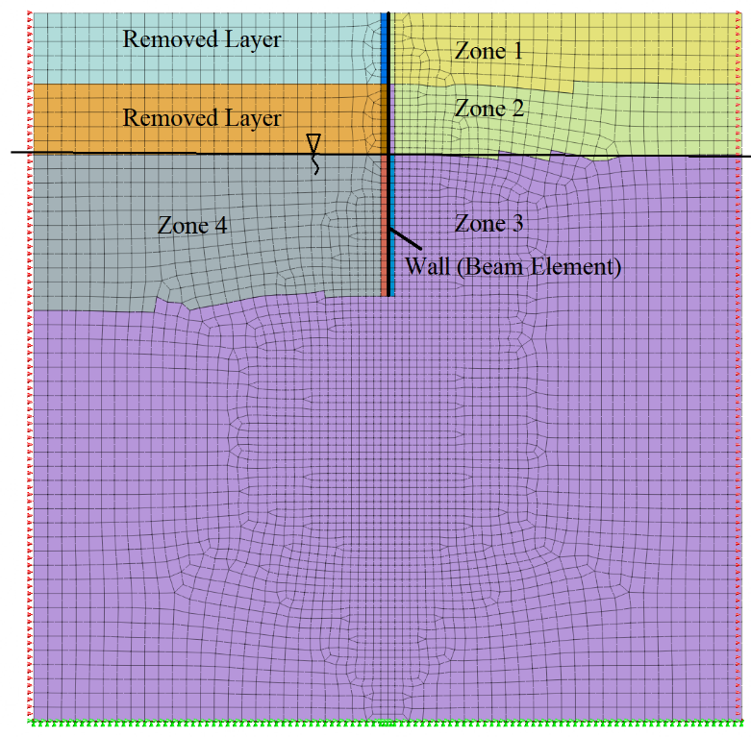
Figure 1S. The FE mesh of the wall model H=1 m, min. mesh-edge size = 50 mm, max. mesh-edge size = 100 mm

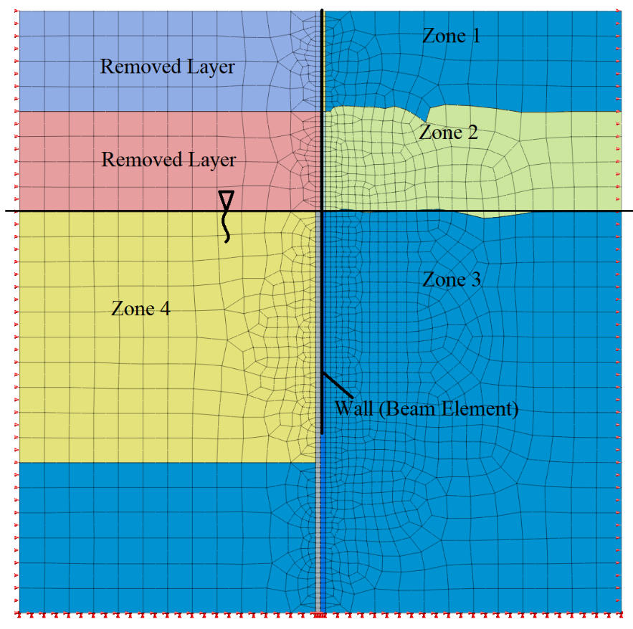
Figure 2S. The FE mesh of the wall model H=2 m, min. mesh-edge size = 50 mm, max. mesh-edge size = 250 mm
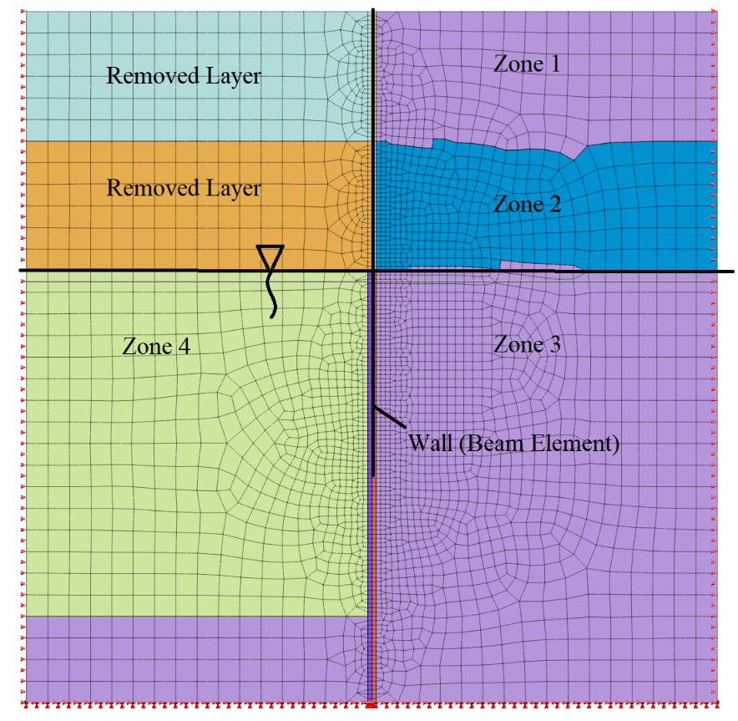
Figure 3S. The FE mesh of the wall model H=3 m, min. mesh-edge size = 50 mm, max. mesh-edge size = 250 mm

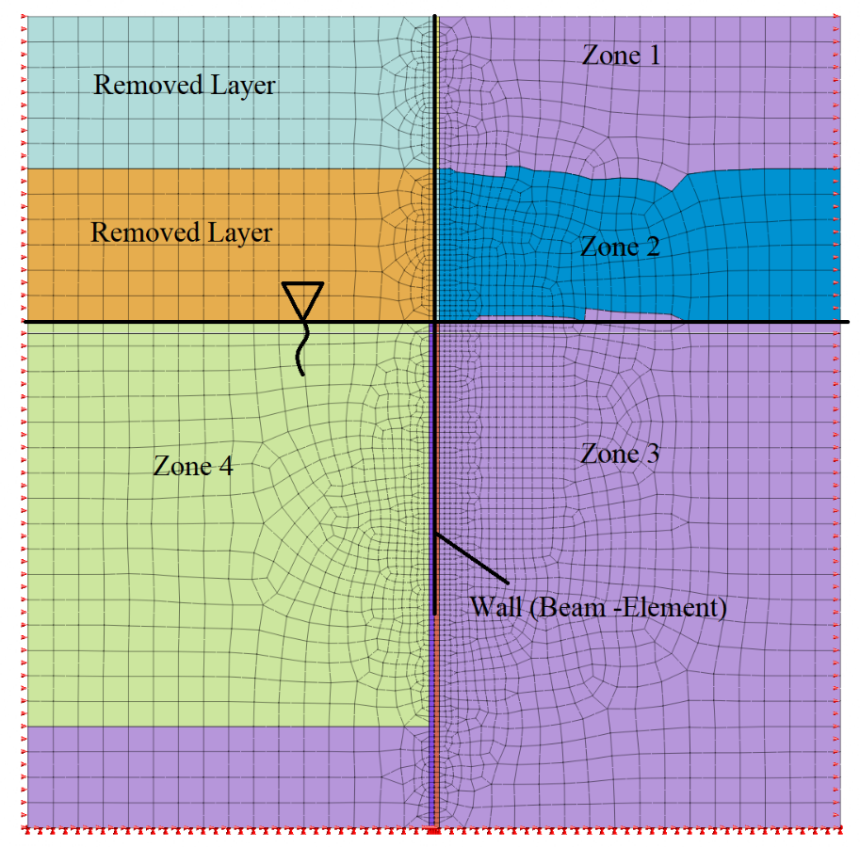
Figure 4S. The FE mesh of the wall model H=4 m, min. mesh-edge size = 50 mm, max. mesh-edge size = 250 mm
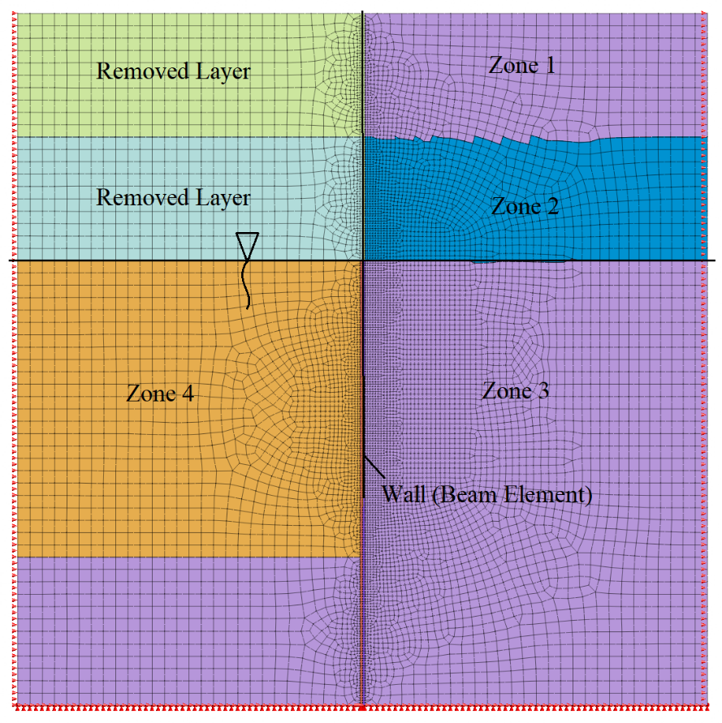
Figure 5S. The FE mesh of the wall model H=5 m, min. mesh-edge size = 50 mm, max. mesh-edge size = 250 mm
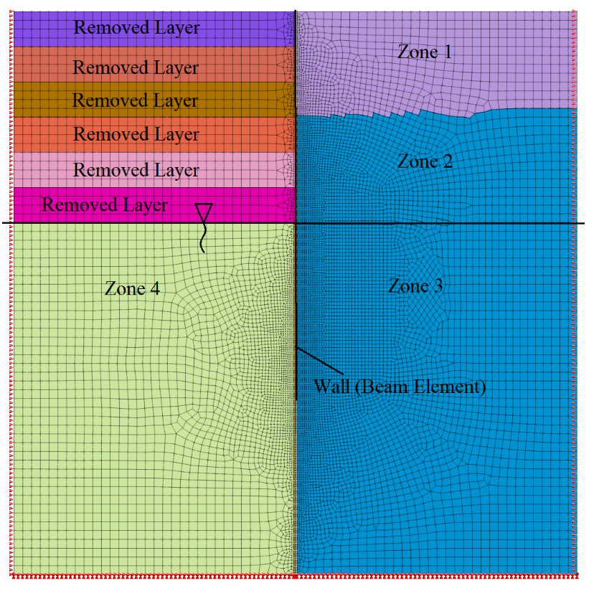
Figure 6S. The FE mesh of the wall model H=6 m, min. mesh-edge size = 50 mm, max. mesh-edge size = 250 mm

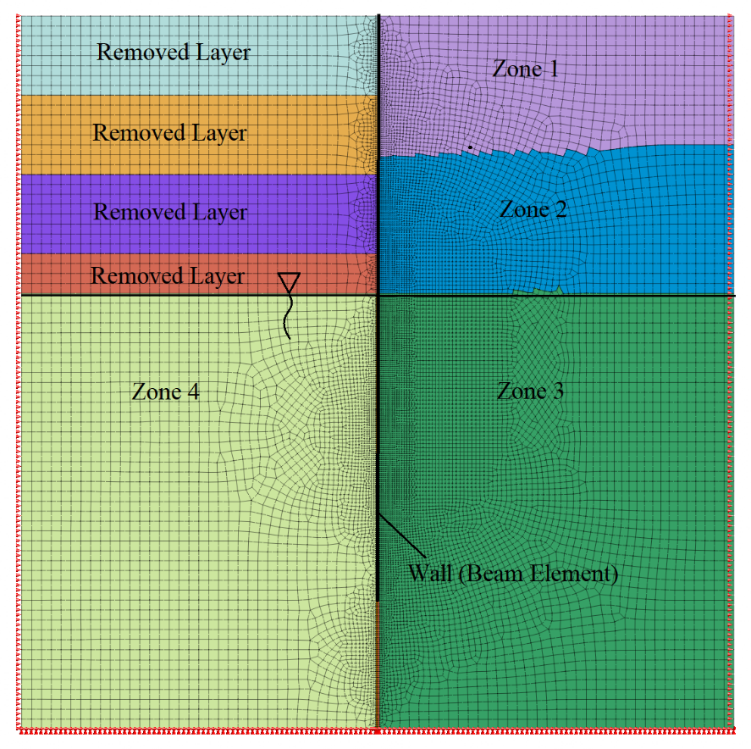
Figure 7S. The FE mesh of the wall model H=7 m, min. mesh-edge size = 50 mm, max. mesh-edge size = 250 mm
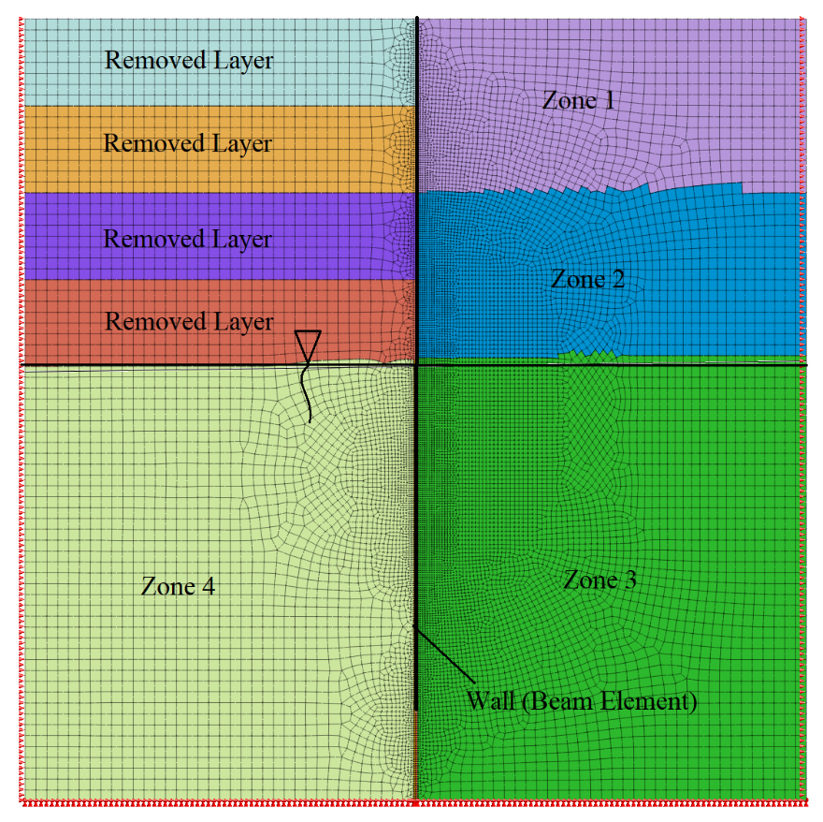
Figure 8S. The FE mesh of the wall model H=8 m, min. mesh-edge size = 50 mm, max. mesh-edge size = 250 mm

Appendix S3: Mesh Convergence Optimization
The mesh size of a finite element model is important to obtain results closer to the true solution. Generally, as the mesh element size decreases, the convergence performance increases. The decrease in mesh element size results with an increase in the total number of elements. The total number of elements determines the number of equations that a computer has to solve. In other words, the computer capacity is the limiting factor for the maximum number of elements. In practice, to reduce the maximum number of equations, a finer mesh size is adopted within the area of interest, where the expected displacements are larger. In turn, the mesh size is set to coarse in the vicinity of the boundaries, where there are smaller displacements. In this study, the area of interest is the vicinity of the beam wall, where the maximum displacement develops. The mesh size of the interface layers surrounding the beam wall is configured preferably smaller to obtain accurate results. The 3 m high wall was meshed with different sizes in order to determine the mesh size, which yields considerably accurate results and is at the same time computer-capacity friendly (Fig 10S). A coarse mesh with an interface element size = 0.25 m and the largest element size = 0.25 m, a medium mesh with an interface element size = 0.05 m and the largest element size = 0.2 m, a medium fine mesh with an interface element size = 0.025 m and the largest element size = 0.125 m, a fine mesh with interface element size = 0.0125 m and the largest element size = 0.125 m were created. The wall-top displacements calculated from different mesh sizes are given in Fig. 11s. The wall-top displacements appeared to be the same for medium, medium-fine, and fine mesh. However, the displacement in the coarse mesh is considerably greater than others. In this study, medium mesh size was adopted for all wall heights. In other words, for all wall heights, the element sizes of the interface elements and the largest element were 0.05 m and 0.25 m, respectively.
The 8 m high wall has the largest mesh with 18 m by 18 m side dimensions and 15 000 elements ( Fig. 8S).

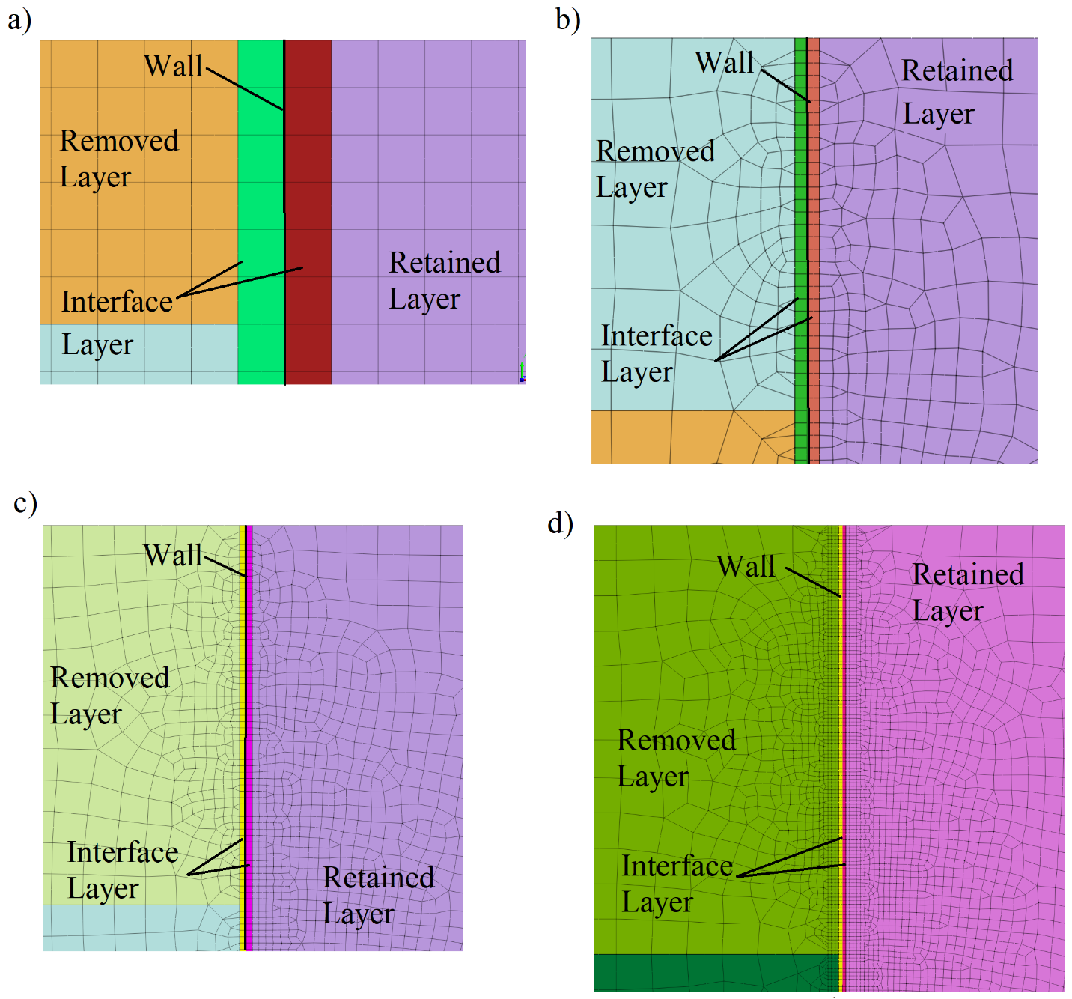

Figure 9s. Meshes at various refinements: a) coarse mesh, Interface element size = 0.25 m, largest element size = 0.25 m, b) medium mesh, Interface element size = 0.05 m, largest element size = 0.25 m (used in the formula derivation), c) medium fine mesh, Interface element size = 0.025 m, largest element size = 0.125 m, d) fine mesh, Interface element size = 0.0125 m, largest element size = 0.125 m

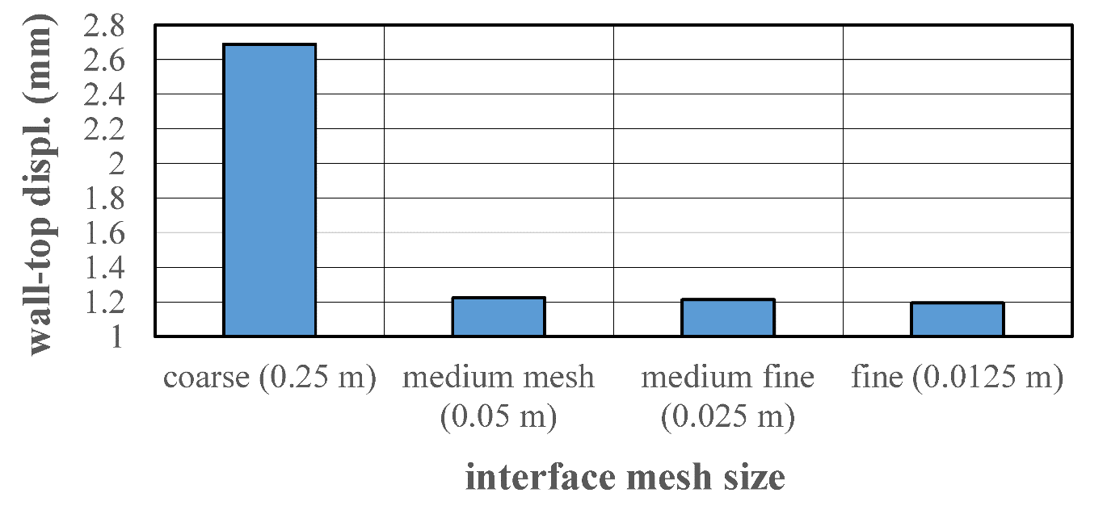

Fig.10S. Wall-top displacements with different mesh refinements
Appendix S4: The derivation details of the formulas

The equation proposed for the horizontal wall-top and wall-bottom displacement is given as follows:
$${disp}_{wall-top} or {disp}_{wall-bottom}=a_{H}.{\left(d\right)}^{b_{H}}.{\left(γ_{1}\right)}^{c_{H}}.{{\left(γ_{2}\right)}^{d_{H}}.{\left(γ_{3}\right)}^{e_{H}}.{\left(γ_{4}\right)}^{f_{H}}\left(\frac{E_{1}}{50000}\right)}^{g_{H}}.{\left(\frac{E_{2}}{50000}\right)}^{h_{H}}.{\left(\frac{E_{3}}{50000}\right)}^{i_{H}}.$$
${{\left(\frac{E_{4}}{50000}\right)}^{j_{H}}.{\left(\frac{5+L}{5}\right)}^{k_{H}}.\left(\frac{ϕ_{1}}{35}\right)}^{l_{H}}.{\left(\frac{ϕ_{2}}{35}\right)}^{m_{H}}.{\left(\frac{ϕ_{3}}{35}\right)}^{n_{H}}.{\left(\frac{ϕ_{4}}{35}\right)}^{o_{H}}.{\left(\frac{EI}{2500000}\right)}^{p_{H}}$ Eq. (1S)

The formula in the exponential form includes γ₁, γ₂, γ₃, γ₄, E₁, E₂, E₃, E₄, φ₁, φ₂, φ₃, φ₄ and EI parameters. These parameters are linked to the equation with the fitting coefficients a_{H}, b_{H}, c_{H}, d_{H}, e_{H,} f_{H}, g_{H} h_{H}, i_{H,} j_{H}, k_{H}, l_{H,} m_{H}, n_{H}, o_{H} and p_{H}. The main goal is to find out these coefficients by regression analyses. In addition to the fitting coefficients, there are numbers such as 50000, 35 and 2500000 as denominators below the parameters, E₁, E₂, E₃, E₄, φ₁, φ₂, φ₃, φ₄ and EI. These numbers enable the values inside of the parenthesis such as in ${\left(\frac{E_{1}}{50000}\right)}^{g_{H}}$ to be in the order of magnitude of “1”. During the regression analysis, it is preferable to start with values in the order of magnitude of “1”. Such a normalization is extremely significant for the terms with different order of magnitudes (e.g. E₁ = 50000 kPa and φ = 35º, 50000/35= 1428 >>>1).
The fitting coefficients a_{H}, b_{H}, c_{H}, d_{H}, e_{H,} f_{H}, g_{H} h_{H}, i_{H,} j_{H}, k_{H}, l_{H,} m_{H}, n_{H}, o_{H} and p_{H} are calculated using the “Solver add-on” provided in MS Excel. As the first step, a set of input parameters (γ₁, γ₂, γ₃, γ₄, E₁, E₂, E₃, E₄, φ₁, φ₂, φ₃, φ₄ and EI) is entered in columns 2–15 (Table S2). The first disp_{wall-top} value obtained from Midas GTS NX for the given set of parameters is entered in column 16. The next step is changing one or two values of the input parameter set and obtaining another disp_{wall-top} value for this set using Midas GTS NX. Subsequently, the second set of input parameters and the corresponding disp_{wall-top} value are entered in the consecutive row. This procedure is repeated 431 times in total. The next step is to enter the disp_{wall-top} formula (Eq. 1S) in column 10. In this case, the column 16 becomes dependent on columns 2–15 and 19–34. This procedure is repeated 431 times in total. As a start, it is required that cells 19–34 have an initial value such as “1” so that a real number appears in column 17 where the formula is entered. In the end, a dataset is obtained which is composed of 431 FE-based and 431 formula-based disp_{wall-top} values (not iterated and corrected yet). The next step is to enter the square of the difference between these two disp_{wall-top} values (the difference of columns 16–17) into column 18. This value is our “error.” Finally, sum of the errors are added up at the bottom row of column 18 and this becomes the global error value. Now, the target is to minimize the global error value by changing the fitting coefficients given in columns 19–34. Thanks to the “Solver add-on” in MS Excel, these coefficients are automatically determined by iterations.
Table S2. The Preview of the Excel spreadsheet for formula derivation
1 | 2 | 3 | 4 | 5 | 6 | 7 | 8 | 9 | 10 | 11 | 12 | 13 | 14 | 15 | 16 | 17 | 18
No | γ₁ (kN/m³) | γ₂ (kN/m³) | γ₃ (kN/m³) | γ₄ (kN/m³) | E₁ (10³.kPa) | E₂ (10³.kPa) | E₃ (10³.kPa) | E₄ (10³.kPa) | L (kN/m) | φ₁ (^{ο}) | φ₂ (^{ο}) | φ₃ (^{ο}) | φ₄ (^{ο}) | EI (10⁶.kN.m²) | disp_{wall-top} Midas GTS NX | disp_{wall-top} Formula | square of difference between 16 and 17
1 | 20 | 20 | 20 | 20 | 50 | 50 | 50 | 50 | 5 | 35 | 35 | 35 | 35 | 2.5 | x.xx | ? | ?
… | … | … | … | … | … | … | … | … | … | … | … | … | … | … | … | … | …
431 | … | … | … | … | … | … | … | … | … | … | … | … | … | … | … | … | …
 |  |  |  |  |  |  |  |  |  |  |  |  |  |  |  | sum of 18---> | …
19 | 20 | 21 | 22 | 23 | 24 | 25 | 26 | 27 | 28 | 29 | 30 | 31 | 32 | 33 | 34
a_{H} | b_{H} | c_{H} | d_{H} | e_{H} | f_{H} | g_{H} | h_{H} | i_{H} | j_{H} | k_{H} | l_{H} | m_{H} | n_{H} | o_{H} | p_{H}
? | ? | ? | ? | ? | ? | ? | ? | ? | ? | ? | ? | ? | ? | ? | ?

Appendix S5: The horizontal earth pressure distribution and the displacement of a typical 3 m-high wall

The horizontal earth pressure distribution obtained from one of the FE model configurations (H=3 m, d=2.0 m, γ₁=γ₂=γ₃=γ₄=20 kN/m³, φ₁=φ₂=φ₃=φ₄=35º, L=0, E₁=E₂=E₃=E₄=50000 kPa, EI=2.5x10⁶ kN.m², 1 m-thick reinforced concrete wall) has been compared with those of the distributions offered by formulas in the literature (Fig. 11s). In addition, the wall displacement obtained from the FE model is illustrated with a red line in Fig. 11s. The displacement plot of the wall is fairly linear, which indicates a rigid behavior. The maximum displacement of the 3 m-high wall is about 0.012 m. At the depth of 1.6 m, the wall only rotates with no horizontal displacement. This depth can be taken as the point of rotation. In the retained soil, down to the depth of point of rotation, the horizontal earth pressure distribution (σ_{x}) obtained from the FE model is linear. The σ_{x} values using the active earth pressure coefficients offered by Coulomb`s approach (Poncelet, 1840)) and Hamderi, 2021are also plotted in Fig 11s. Both formulas offer exactly the same pressure distribution with FE-model down to the depth of point of rotation (Fig.11s). However, the distribution offered by the FE model suddenly changes below the point of rotation, where the active pressure is more or less replaced with the passive pressure. In the resisting wall side, the FE model offers a parabola-like horizontal passive pressure distribution above the depth of point of rotation (Fig. 11s). Hamderi, 2021 offered a formula for calculating the weighted average of the passive earth pressure, in which the rotation of the wall, soil modulus included along with other conventional parameters. The passive horizontal earth pressure calculated by Hamderi’s and Coulomb-passive formula are also plotted in Fig. 11s. The Coulomb-passive pressure formula considers the ultimate state; therefore, it deviates a lot from the FE results. Because of this, in practice, Coulomb results are divided by a certain safety factor. The distribution offered by Hamderi, 2021 is more accurate due to the fact that it allows the input of actual wall rotation.

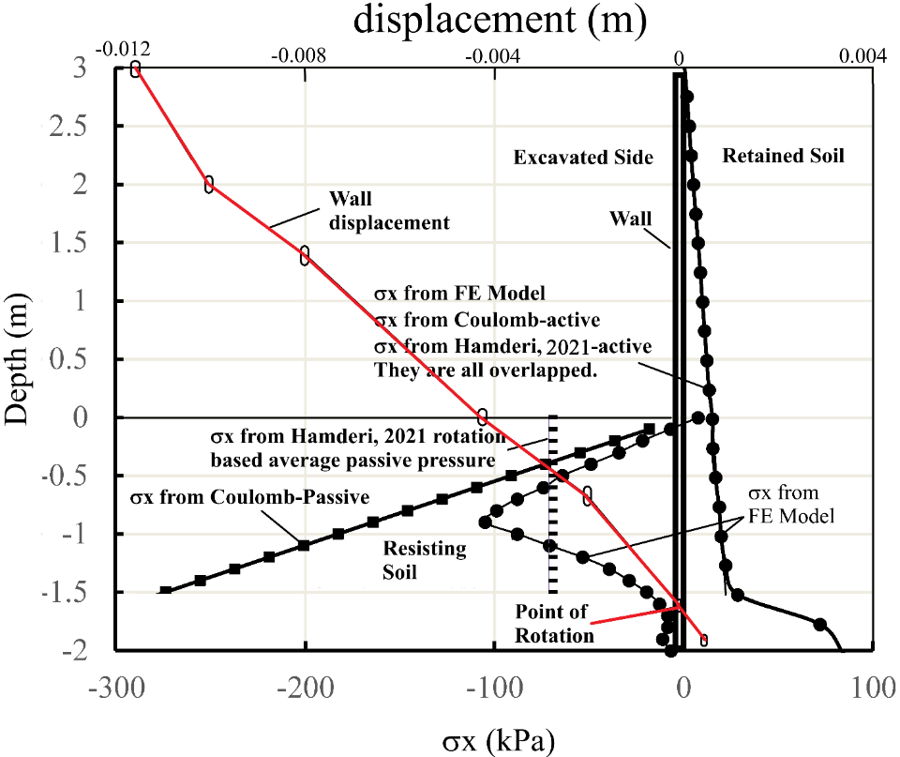

Fig 11s. The horizontal earth pressure distributions from different sources: FE-Model, Coulomb-active, Coulomb-passive, Hamderi, 2021 active and passive earth pressures

The horizontal active pressure coefficient, k_{ax-ult} offered by Hamderi, 2021 is as follows:

$k_{ax-ult}=a_{1}-b_{1}.{\left(\frac{\left(ϕ+20\right)}{36}\right)}^{c_{1}}.{\left(\frac{\left(δ+0.1\right)}{30}\right)}^{d_{1}}.{\left(\frac{\left(β+15\right)}{5}\right)}^{e_{1}}$ Eq.(2S)
where φ, δ, β are friction angle of soil, wall friction angle, slope angle, respectively, a₁, b₁, c₁, d₁, e₁ are fitting coefficients (Table S3) and φ≥20º, δ≥15º, β≤φ/2.

Table S3. Fitting coefficients of k_{ax-ult} formula (Eq.2S)
a₁ | b₁ | c₁ | d₁ | e₁
2.686955 | 2.338920 | 0.194972 | 0.041700 | -0.026646

The horizontal average passive pressure coefficient, $k_{px-avg}$ offered by Hamderi, 2021 is as follows:

$k_{px-avg}=\sum_{n=0}^{n=5}{\left[{a_{4n}.\left({b_{4n}.\left(\frac{E_{1\%Strain}}{50000[kPa]}\right)}^{c_{4n}}.{\left(\frac{\left(ϕ+20\right)}{36}\right)}^{d_{4n}}{\left(\frac{\left(δ+0.1\right)}{30}\right)}^{e_{4n}}.{\left(\frac{\left(β+15\right)}{15}\right)}^{f_{4n}}.\left(θ_{p}+0.0001\right)\right)}^{n}\right]}$ (3S)
where E_{1%strain}, θp are the soil modulus at 1% strain and wall rotation in radians x 1000, respectively, a_{4n}, b_{4n}, c_{4n}, d_{4n}, e_{2n}, f_{4n} are fitting coefficients (Table S4) and φ≥20º, δ≥15º, β≤φ/2.

Table S4. Fitting coefficients of k_{px-avg} formula (Eq.3S)
n | a₄ | b₄ | c₄ | d₄ | e₄ | f₄
0 | 0.6705 | 0.0000 | 0.0000 | 0.0000 | 0.0000 | 0.0000
1 | 44.6176 | 0.0664 | 0.9228 | 0.2888 | 0.0406 | 0.2456
2 | -189.3166 | 0.1596 | 0.8914 | -1.8668 | 0.1214 | -0.1128
3 | 45.8769 | 0.4577 | 0.8605 | -2.6712 | 0.2287 | -0.2310
4 | -113.8981 | -0.3215 | 0.8349 | -2.9180 | 0.2616 | -0.2772
5 | 8.4099 | 0.0539 | 0.5568 | 0.3958 | -1.3184 | -0.2440

For Coulomb’s active and passive approaches, Poncelet (1840) obtained an expression for coefficient of active lateral earth pressure including the wall friction, wall inclination and slope angle. After the wall inclination angle is set to zero and then the resulting expression is multiplied by cos δ to obtain the horizontal component, the expression simplifies to the following format:

$k_{aC-hor}=\frac{\cos^{2}ϕ}{{\left[1+{\left(\frac{sin\left(ϕ+δ\right)sin⁡(ϕ-β)}{\cos\left(δ\right)cos⁡(β)}\right)}^{1/2}\right]}^{2}}$ Eq.(4S)

The expression for the passive case is as follows:

$k_{pC-hor}=\frac{\cos^{2}ϕ}{{\left[1+{\left(\frac{sin\left(ϕ+δ\right)sin⁡(ϕ+β)}{\cos\left(δ\right)cos⁡(β)}\right)}^{1/2}\right]}^{2}}$ Eq.(5S)

The k values from the different formulas are multiplied by the unit weight of soil and various soil depths in order to find the horizontal pressure acting on the wall. However, $k_{px-avg}$ formula represents the average passive pressure in the mid-depth of the parabola-like shape, therefore, the calculation is only performed at the mid-depth.

References:
Hamderi, M. 2021. “Finite Element–Based Coefficient of Lateral Earth Pressure for Cohesionless Soil” Int. J. Geomechanics. 21 (5). https://doi.org/10.1061/(ASCE)GM.1943-5622.0002000.
Poncelet, J. V. 1840. Mémoire sur la stabilité des revêtements et de leurs fondations. Note additionelle sur les relations analytiques qui lient entre elles la poussée et la butée de la terre. Mémorial de l’offi cier du génie, 13

