Supplementary information for
Deterministic quasi-continuous tuning of phase-change material integrated on a high-volume 300-mm silicon photonics platform
Rui Chen^{1,†,*}, Virat Tara^{1,†}, Minho Choi¹, Jayita Duta¹, Justin Sim¹, Julian Ye², Zhuoran Fang¹, Jiajiu Zheng¹, Arka Majumdar^{1,2,}*
¹Department of Electrical and Computer Engineering, University of Washington, Seattle, WA 98195, USA
²Department of Physics, University of Washington, Seattle, WA 98195, USA
†These authors contributed equally: Rui Chen and Virat Tara.
*Email: charey@uw.edu and arka@uw.edu

This supplementary information includes:
S1. In-house fabrication workflow diagram
S2. Q-factor of rings before and after oxide window and metallization
S3. Current-Voltage (IV) plot for the micro-ring resonator and Mach-Zehnder interferometer
S4. Endurance test of the MZI for 500 switching events
S5. Numerical simulations for quasi-continuous tunable asymmetric directional couplers
S6. Quasi-continuously tuning with larger spectral shift
S7. Derivation of spectral shifting feature of MZIs on different arms

Section S1. In-house fabrication workflow diagram
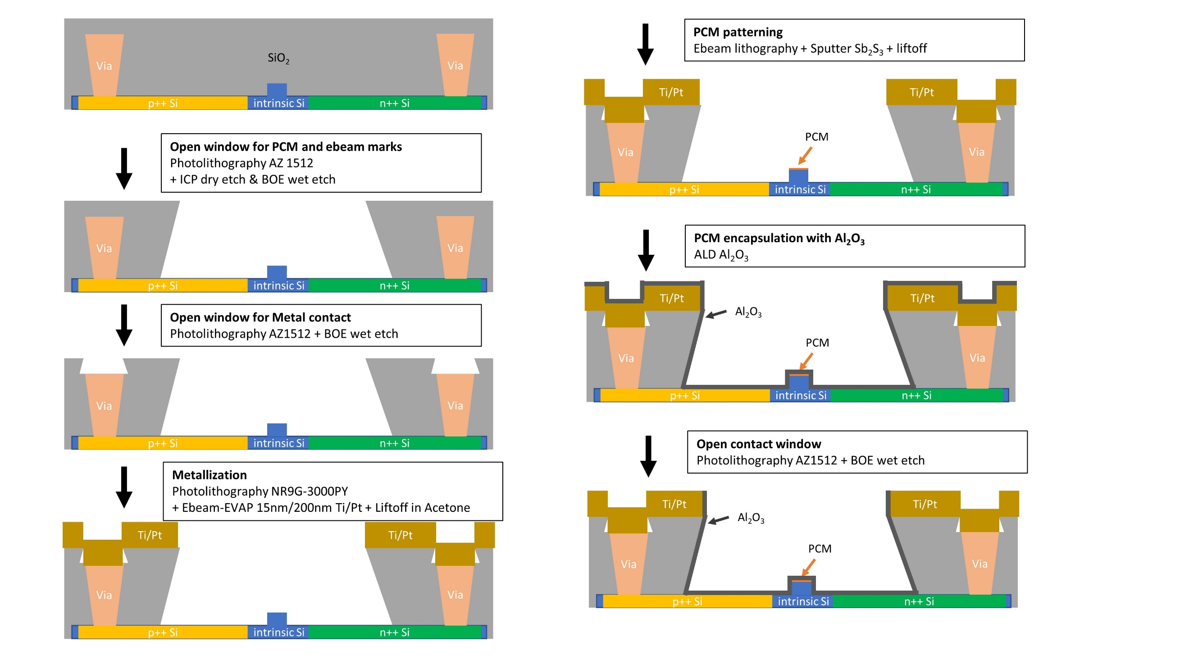
Fig. S1: In-house fabrication workflow diagram. The detailed fabrication procedure is described in the Methods section of the main text.

Section S2. Q-factor of rings before and after oxide window and metallization
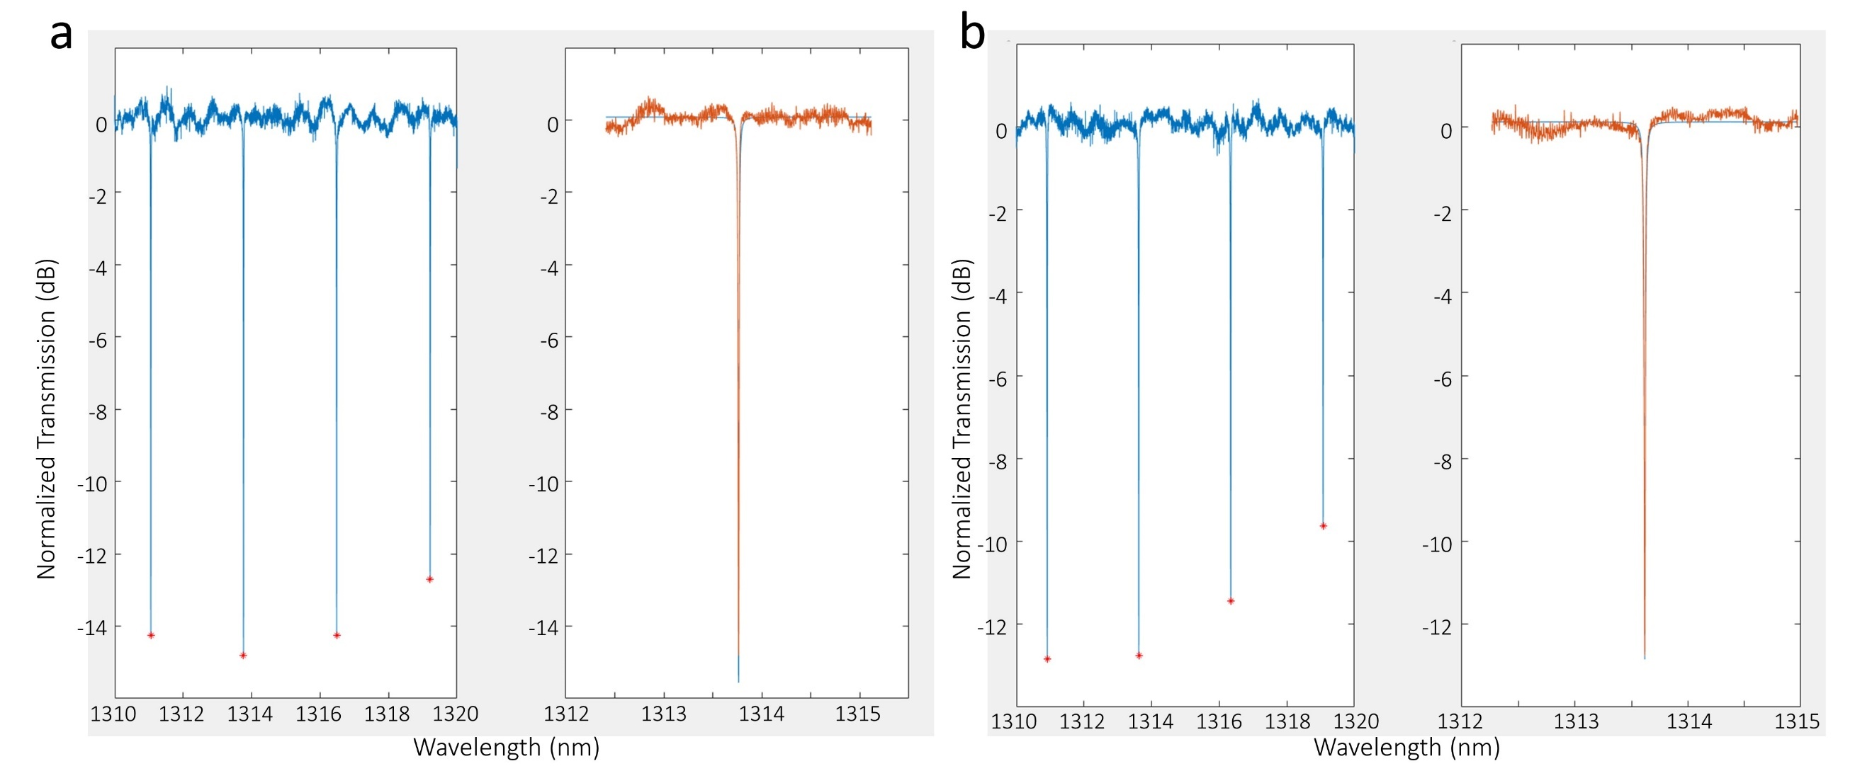
Fig. S2: Measured optical transmission spectra for a micro-ring resonator with 20-μm-long oxide window. (a) The responce of a micro-ring resonator before any in-house process. Fitting to a Lorentz shape gives a Q-factor of 127k in the zoomed in plot. (b) The responce of a micro-ring resonator after opening oxide windows, metallization and 20-nm-thick Sb₂S₃ deposition. Fitting to a Lorentz shape gives a Q-factor of 101k in the zoomed in plot, indicating very small extra loss due to the in-house fabrication process of ~0.02 dB, estimated using the formula in ref¹.

Section S3. Measured current-voltage (I-V) plot for the micro-ring resonator and Mach-Zehnder interferometer
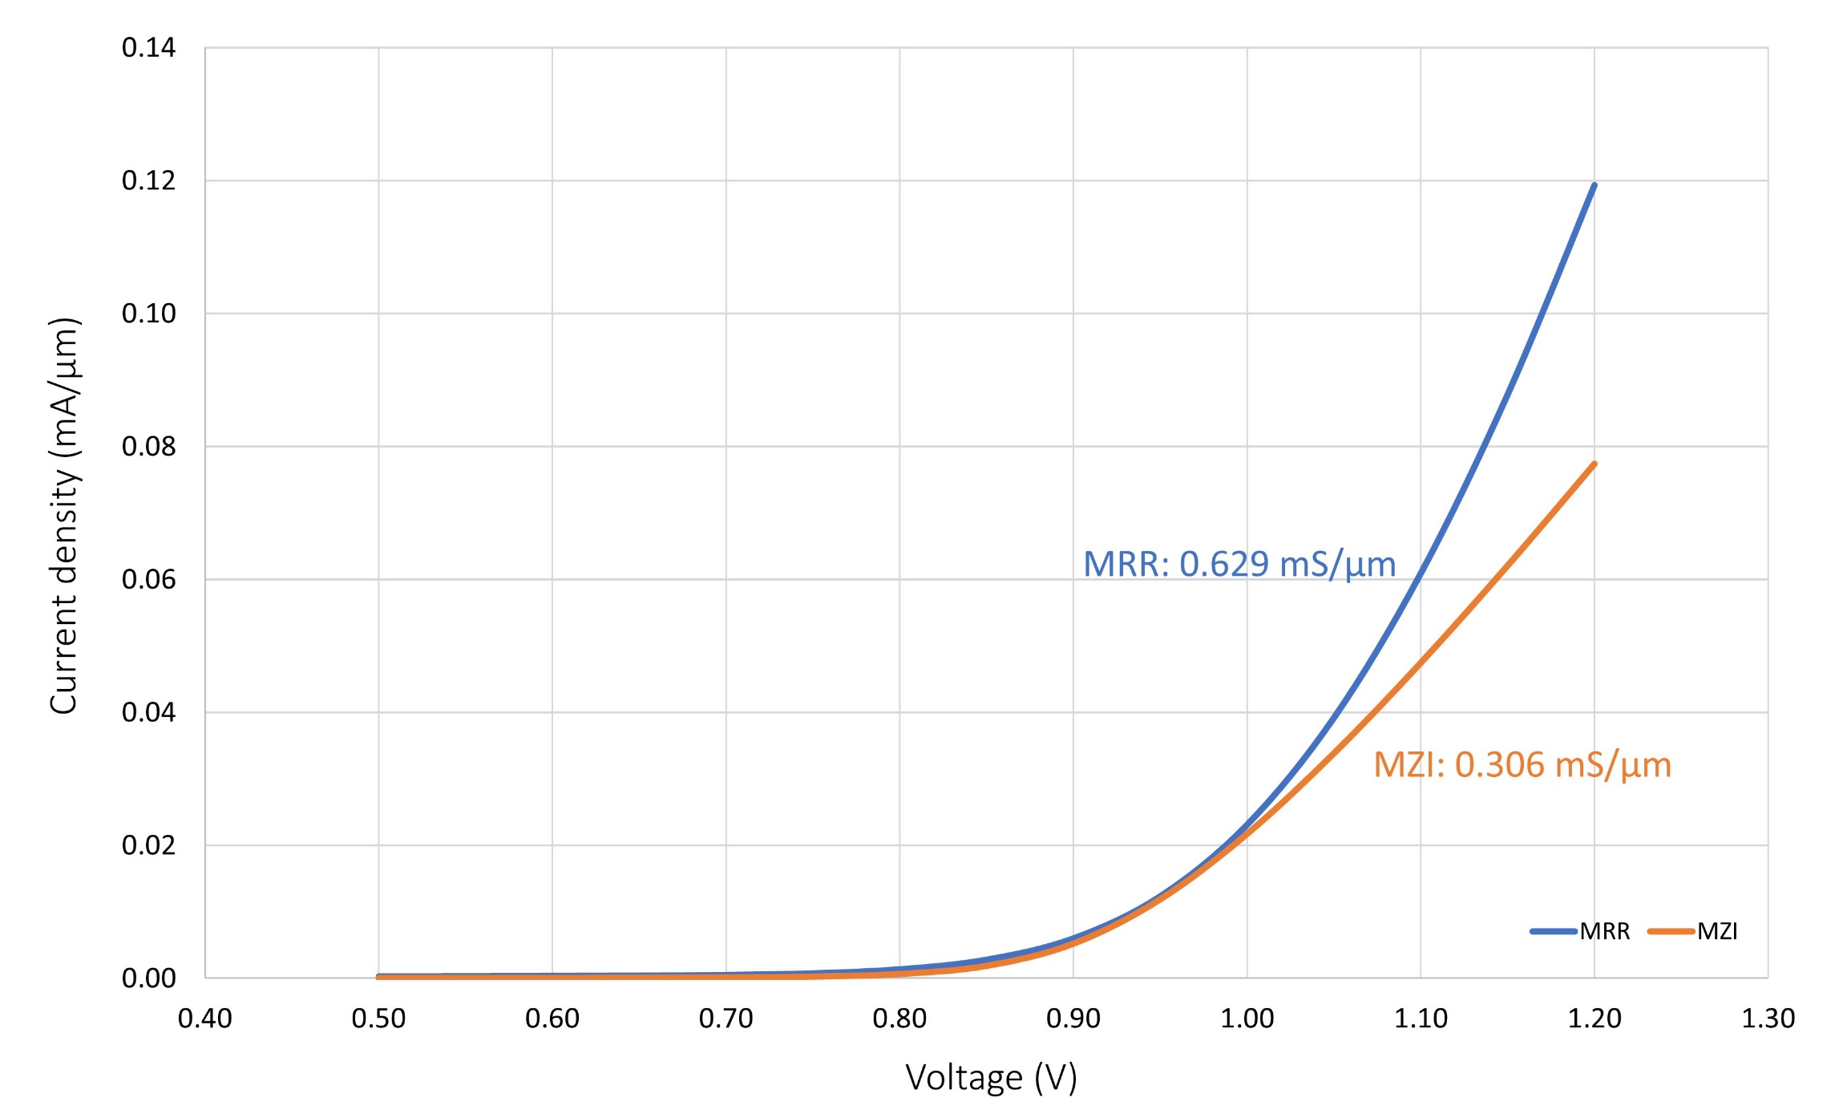
Fig. S3: Measured I-V curve of the micro-ring resonator and Mach-Zehnder interferometer. The current is normalized with respect to the PIN junction length. The unit length conductivity for the MRR and the MZI is 0.629 mS/μm and 0.306 mS/μm, respectively. The MRR shows a higher unit length conductivity, which leads to the lower phase-transition voltages. This is attributed to the longer metal wire in the MZI and could be improved in the future fabrication by making the metal wire wider.

Section S4. Endurance test of the MZI for 500 switching events

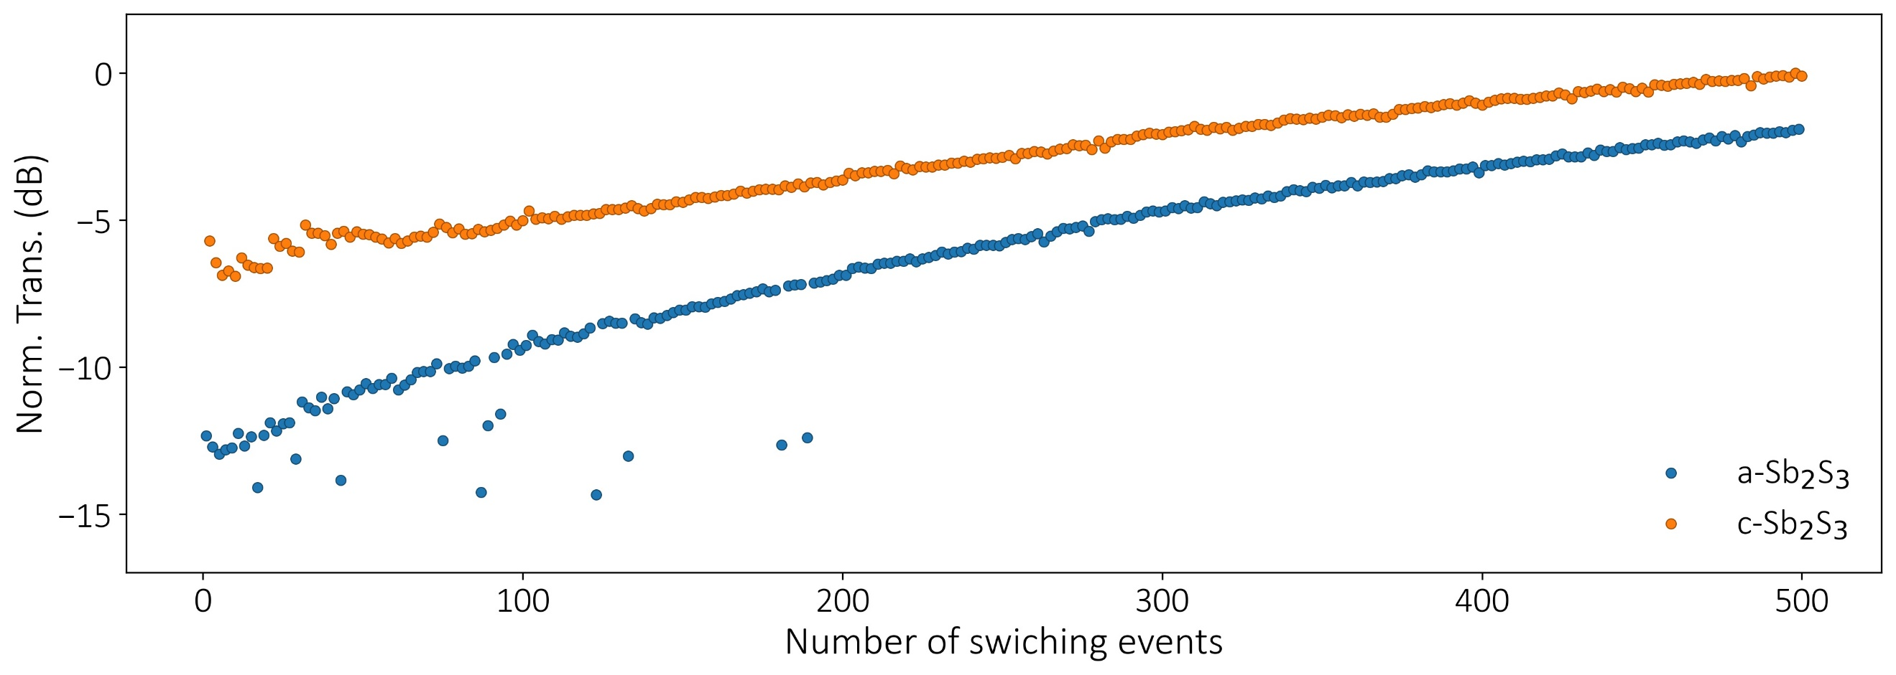
Fig. S4: Endurance test of an unbalanced MZI. We alternatively sent in amorphization and crystallization pulses for 500 switching events and the contrast still remains. There is a DC shift in the transmission level, which could be attributed to partial material damage and could be resolved later by optimizing the electrical pulse condition. See Fig. 2 for another test using suitable electrical pulses for an asymmetric directional coupler.

Section S5. Numerical simulations for quasi-continuous tunable asymmetric directional couplers
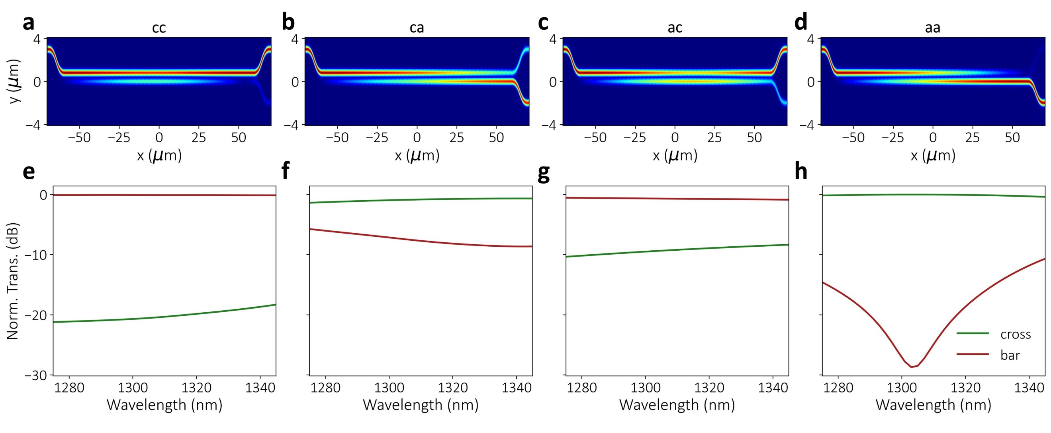
Fig. S5: Simulated electric field distribution and transmission spectra for quasi-continuously tunable beam splitters with 2 Sb₂S₃ segments. (a)-(d) The field distribution and (e)-(h) the transmission spectra. The optical characteristics are programmable depending on the phases of two Sb₂S₃ segments indicated in the titles of the sub-figures. We note here the optical splitting ratios are different from the experimental results and it can be attributed to fabrication imperfections such as variations of Sb₂S₃ deposition thickness, waveguide width and waveguide gap.

Section S6. Quasi-continuously tuning with a larger spectral shift
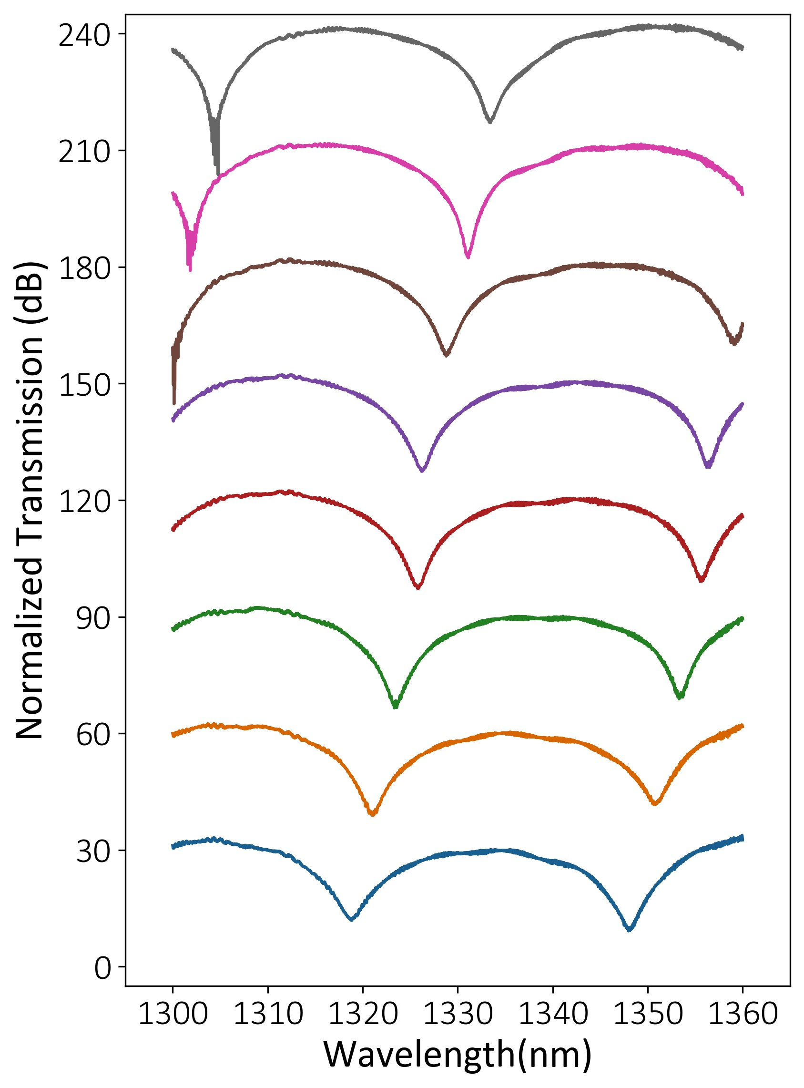
Fig. S6: Another quasi-continuous tuning measurement results with 3 unequal-length Sb₂S₃ segments showing larger spectral shift of 0.14π/step.

Section S7. Derivation of spectral shifting feature of MZIs on different arms
In Section S6, we reported a blue shift in the spectra when crystallizing the Sb₂S₃ (the effective refractive index or the phase increases), which is counterintuitive for the micro-ring resonator community. This supplementary note will provide an explanation of this observation. Firstly, this can be intuitively understood that the spectral shift direction is determined by the relative phase shift between two arms. Therefore, increasing the phase on two arms would lead to an opposite spectral shift behavior. To show this in a more rigorous way, we briefly derive the spectral shifting of an unbalanced MZI taking an scattering (S)-matrix approach and show that the spectral shift direction depends on the arm that is modulated.
Without losing generality, we assume that the light inputs from the upper port and an initial phase difference of $Δϕ_{0}$ between the lower arm $ϕ_{l, 0}$ and upper arm $ϕ_{u, 0}$, therefore $Δϕ_{0}=ϕ_{l, 0}-ϕ_{u, 0}=\frac{2πn_{eff}}{λ}ΔL$, where $λ$ is the free space wavelength, $n_{eff}$ is the effective refractive index of the waveguide mode, and $ΔL$ is the initial length difference between two arms. The S-matrix of such an unbalanced MZI is expressed as²:
$S_{MZI}=\frac{\sqrt{2}}{2}\left[\begin{matrix}1 & i \\ i & 1\end{matrix}\right]⋅\left[\begin{matrix}1 & 0 \\ 0 & e^{iΔϕ}\end{matrix}\right]⋅\frac{\sqrt{2}}{2}\left[\begin{matrix}1 & i \\ i & 1\end{matrix}\right]=\frac{1}{2}\left[\begin{matrix}1-e^{iΔϕ} & i\left(1+e^{iΔϕ}\right) \\ i\left(1+e^{iΔϕ}\right) & -1+e^{iΔϕ}\end{matrix}\right]$. (Eq. S1)
Therefore, the output field is expressed as
$\left[\begin{matrix}E_{u} \\ E_{l}\end{matrix}\right]=S_{MZI}⋅\left[\begin{matrix}1 \\ 0\end{matrix}\right]=\frac{1}{2}\left[\begin{matrix}\left(1-e^{iΔϕ}\right) \\ i\left(1+e^{iΔϕ}\right)\end{matrix}\right]=ie^{\frac{iΔϕ}{2}}\left[\begin{matrix}-sin\left(\frac{Δϕ}{2}\right) \\ \cos\left(\frac{Δϕ}{2}\right)\end{matrix}\right]$, (Eq. S2)
where $E_{u}$ and $E_{l}$ represents the output field from the upper and lower output port, respectively. $Δϕ=Δϕ_{0}+Δϕ^{'}=\frac{2πn_{eff}}{λ}ΔL+\frac{2π{Δn}_{eff}}{λ}L_{SbS}$, where $Δϕ'$ is the phase shift on the lower arm, ${Δn}_{eff}$Is the effective index change due to Sb₂S₃ and $L_{SbS}$ is the length of Sb₂S₃. Equation S2 shows that if $Δn_{eff}>0$, then $λ$ needs to increase to maintain the same output field, indicating a red spectral shift in the output spectra.
In conclusion, the output spectra of an unbalanced MZI shift to the red (blue) side if increasing the phase on the lower (upper) arm when inputing light from the upper input port. More generally, if the modulated arm sits on the same side as the input ports, such as both on the upper side, a blue shift would occur when increasing the phase, whereas opposite sides produce a red shift. The blue spectra shift after crystallization in our experiment agrees with this analysis and.

References
1. Zheng, J. et al. GST-on-silicon hybrid nanophotonic integrated circuits: a non-volatile quasi-continuously reprogrammable platform. Optical Materials Express 8, 1551 (2018).
2. Osgood, R. & Meng, X. Principles of Photonic Integrated Circuits: Materials, Device Physics, Guided Wave Design. (Springer International Publishing, 2021). doi:10.1007/978-3-030-65193-0.

