Supplementary Material

Supplementary Figures

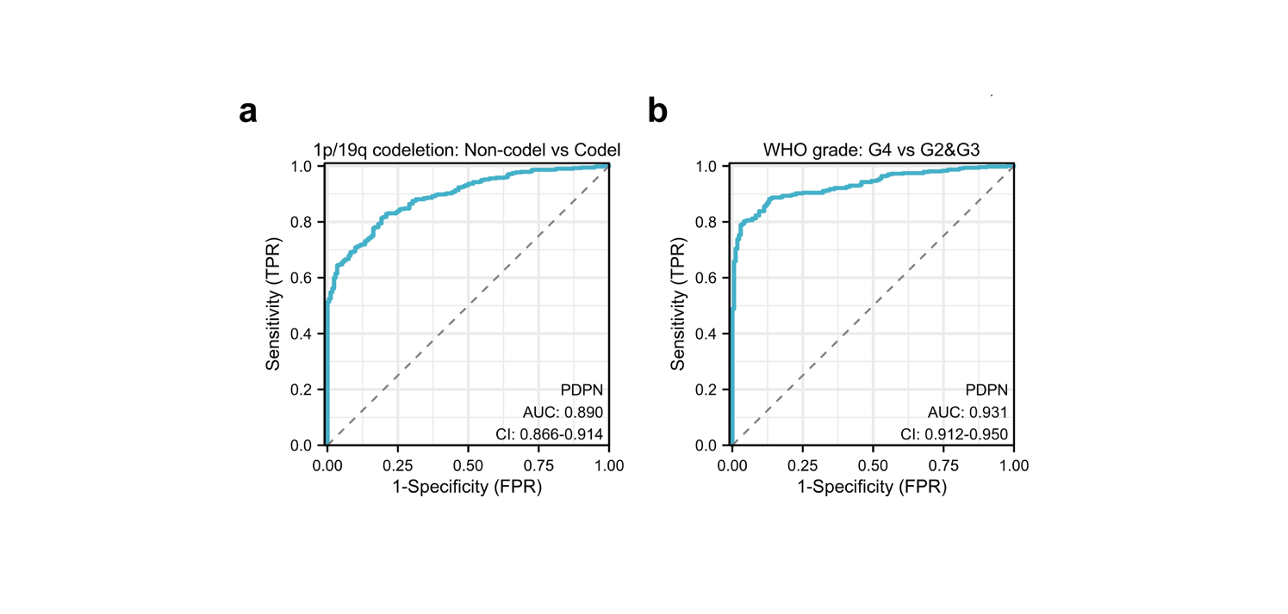

Supplementary Fig1. Predicting values of PDPN expression in gliomas. (a) ROC curve for predicting 1p/19q codeletion in the TCGA cohort. (b) ROC curve for predicting WHO grade in the TCGA cohort.

Supplementary Fig2. The association between PDPN levels and immune profiles in gliomas. (a) Estimated fraction of 22 tumor-infiltrating immune cells with Cibersortx algorithm in the TCGA IDH-wildtype cohort. (b) Estimated fraction of 22 tumor-infiltrating immune cells with Cibersortx algorithm in the TCGA IDH-mutant cohort. (c) Correlation between PDPN and the fraction of plasma cells, CD8+ T cells, Tregs, macrophages M2, and neutrophils in the TCGA IDH-mutant and IDH-wildtype glioma cohorts respectively. (d) mRNA expression of six vital immune checkpoints (CTLA4, CD274, CD276, LAG3, PDCD1, TIGHT) in the TCGA IDH-mutant and IDH-wildtype glioma cohorts respectively. * p < 0.05, ** p < 0.01, *** p < 0.001, **** p < 0.0001.

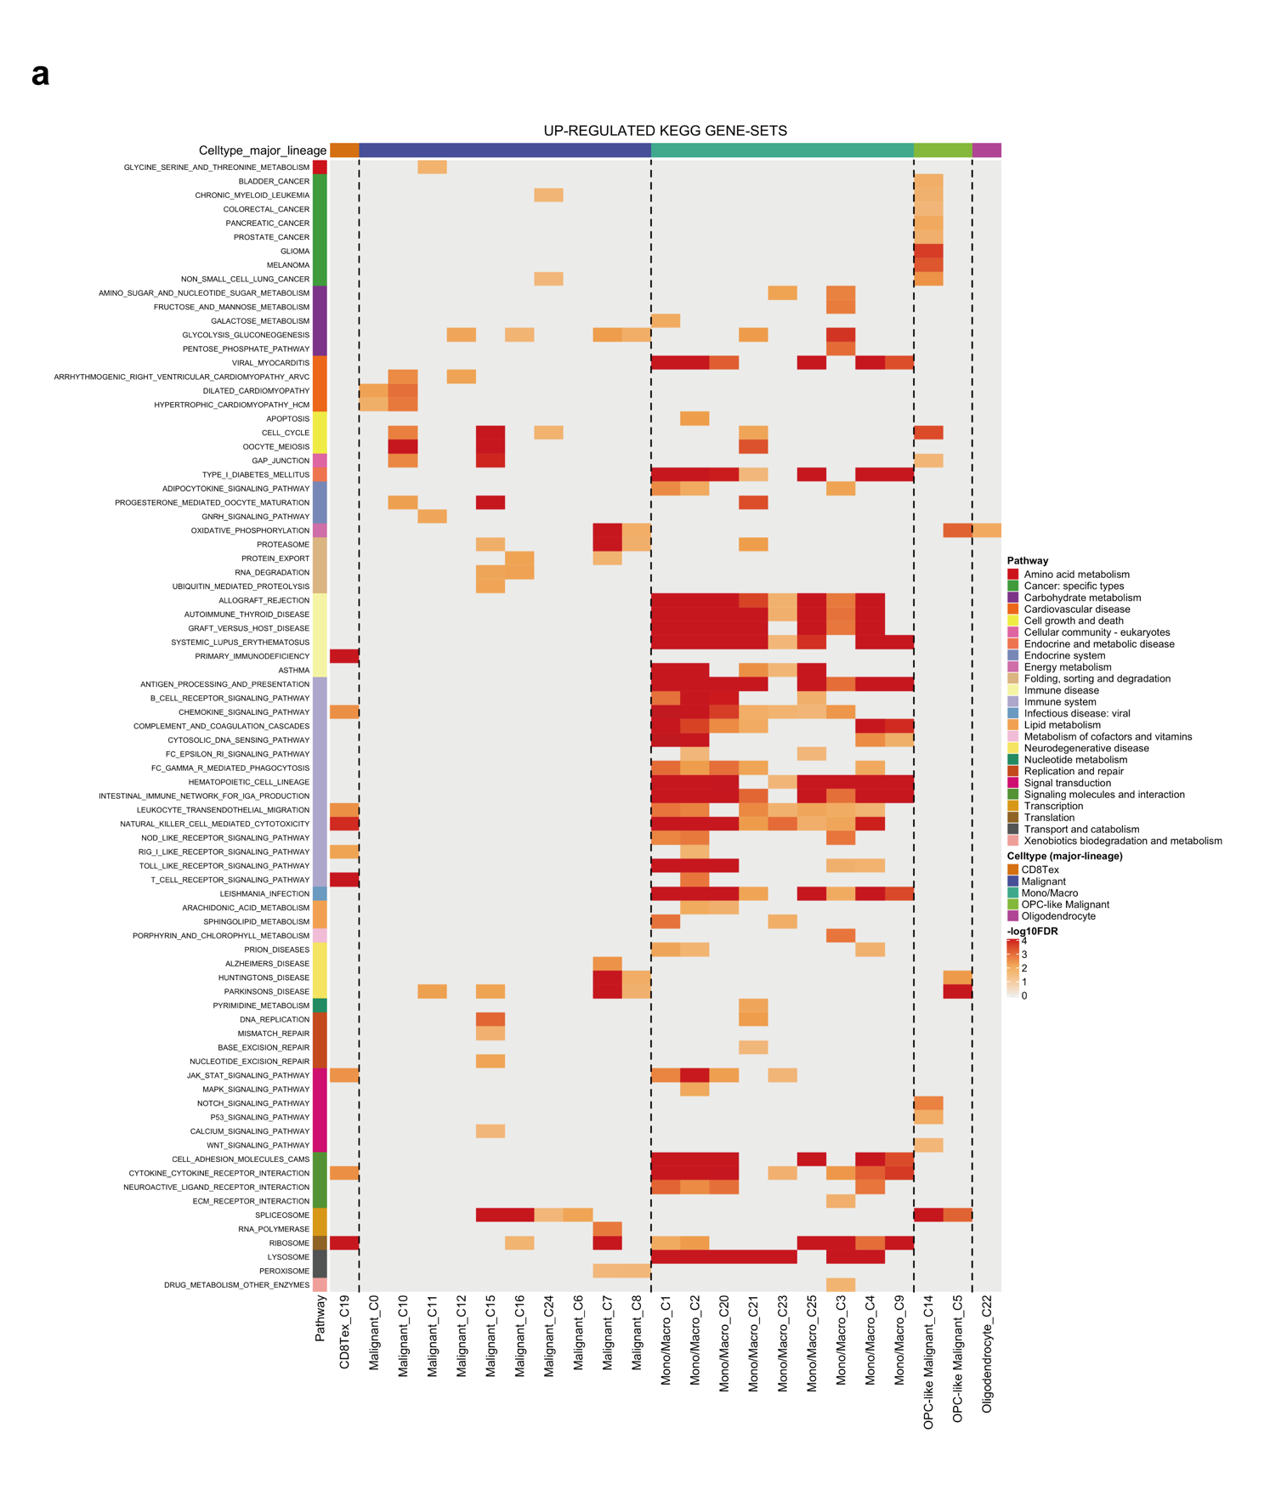

Supplementary Fig3. Molecular pathways associated with PDPN in each cell cluster using KEGG analysis. (a) KEGG functional enrichment analysis of upregulated molecular pathways in each cell cluster.

Supplementary Table
Supplementary Table 1. The Hazard ratios of PDPN and clinicopathological indicators in univariate Cox regression and multivariate Cox regression.
Characteristics | Univariate analysis |  |  | Multivariate analysis
Characteristics | Hazard ratio (95% CI) | P value |  | Hazard ratio (95% CI) | P value
WHO grade
G2 | Reference |  |  | Reference
G3 | 2.967 (1.986 - 4.433) | < 0.001 |  | 1.906 (1.206 - 3.014) | 0.006
G4 | 18.600 (12.448 - 27.794) | < 0.001 |  | 6.142 (1.957 - 19.281) | 0.002
IDH status
WT | Reference |  |  | Reference
Mut | 0.116 (0.089 - 0.151) | < 0.001 |  | 0.606 (0.347 - 1.060) | 0.079
PDPN
Low | Reference |  |  | Reference
High | 5.974 (4.471 - 7.984) | < 0.001 |  | 1.513 (0.918 - 2.494) | 0.104
Age
<= 60 | Reference |  |  | Reference
> 60 | 4.696 (3.620 - 6.093) | < 0.001 |  | 4.245 (2.568 - 7.016) | < 0.001
Primary therapy outcome
CR | Reference |  |  | Reference
PR | 1.279 (0.443 - 3.690) | 0.649 |  | 1.242 (0.369 - 4.181) | 0.727
PD | 7.643 (3.667 - 15.929) | < 0.001 |  | 6.140 (2.842 - 13.265) | < 0.001
SD | 3.361 (1.557 - 7.258) | 0.002 |  | 2.367 (1.048 - 5.349) | 0.038
1p/19q codeletion
Non-codel | Reference |  |  | Reference
Codel | 0.225 (0.147 - 0.346) | < 0.001 |  | 0.741 (0.417 - 1.318) | 0.308
Gender
Female | Reference |  |  | Reference
Male | 1.250 (0.979 - 1.595) | 0.073 |  | 1.762 (1.127 - 2.756) | 0.013

