Supplementary Materials for

Sustained SREBP-1 Activation Mediates Cardiac Lipotoxicity to Statins Therapy in Diabetic Mice
Tong-sheng Huang ^{1,2 #}, Teng Wu^{1,2 #}, Xin-lu Fu^{1,2}, Hong-lin Ren^{1,2}, Xiao-dan He^{3,4}, Ding-hao Zheng^{3,4}, Jing Tan ^{1,2}, Cong-hui Shen^{1,2}, Shi-jie Xiong^{1,2}, Jiang Qian^{1,2}, Yan Zou^{1,2}, Hui-ting Zheng^{1,2}, Yuan-jun Ji^{1,2}, Meng-ying Liu ^{1,2}, Yan-di Wu^{1,2}, Xing-hui Li ^{1,2}, Hui Li¹, Li Yan^{3,4}, Meng Ren^{3,4} *, Wei-bin Cai^{1,2} *
¹ Guangdong Engineering & Technology Research Center for Disease-Model Animals, Laboratory Animal Center, Zhongshan School of Medicine, Sun Yat-sen University, Guangzhou 510080, Guangdong, China.
² Department of Biochemistry, Zhongshan School of Medicine, Sun Yat-sen University, Guangzhou 510080, Guangdong, China.
³ Department of Endocrinology, Sun Yat-sen Memorial Hospital, Sun Yat-sen University, Guangzhou, China.
⁴ Guangdong Provincial Key Laboratory of Malignant Tumor Epigenetics and Gene Regulation, Guangdong-Hong Kong Joint Laboratory for RNA Medicine, Sun Yat-sen Memorial Hospital, Sun Yat-sen University, Guangzhou, China.
# These authors contributed equally: Tong-sheng Huang, Teng Wu.
* These authors contributed equally to this work and are joint corresponding authors.
*Correspondence to: Professor. Wei-bin Cai, Sun Yat-sen University, Guangzhou 510080, PR China (email: caiwb@mail.sysu.edu.cn).
Meng Ren, Department of Endocrinology, Sun Yat-sen Memorial Hospital, Sun Yat-sen University, Guangzhou, China (email: renmeng80@139.com).

This PDF file includes:
Supplementary Table 1 to 4;
Supplementary Figure 1 to 9.
Supplementary Tables

Supplementary Table 1. Clinical information for collected human heart samples. Abbreviations: LV, left ventricle. RV, right ventricle. Data were expressed as means ± SEM.
Category | Normal (n=10) | T2DM (n=12) | P value
Age, years | 46.1±6.14 | 42.67±4.86 | 0.662
Gender, Male % | 60% | 66.7% | -
Heart weight, g | 298.00±18.90 | 362.50±26.80 | 0.073
LV thickness, cm | 1.12±0.04 | 1.21±0.34 | 0.121
RV thickness, cm | 0.27±0.02 | 0.28±0.02 | 0.568

Supplementary Table 2. Echocardiographic parameters of db/db mice. (See Fig. 3B) Abbreviations: LV, Left Ventricular; LVAW, left ventricular anterior wall; LVPW, LV posterior wall thickness. Results are presented as the means ± SEM.
Groups | Db/m | Db/db | Db+Ato5 | Db+Ato10 | Db+Rosu20
N | 6 | 6 | 6 | 6 | 6
Diameter;s (mm) | 1.65±0.27 | 1.91±0.14 | 2.21±0.18* | 2.18±0.13 | 2.03±0.19
Diameter;d (mm) | 3.13±0.22 | 3.37±0.23 | 3.53±0.09 | 3.23±0.11 | 3.28±0.17
Volume;s (μL) | 9.91±4.02 | 12.15±2.00 | 17.40±3.64* | 16.40±2.66* | 14.33±2.54
Volume;d (μL) | 40.45±7.14 | 48.27±6.70* | 52.13±3.25 | 42.51±3.60 | 44.53±5.54
Stroke Volume (μL) | 30.54±4.05 | 36.11±4.79* | 34.73±1.81 | 26.11±2.94 | 30.20±3.39
Ejection Fraction (%) | 78.64±5.33 | 75.28±1.07 | 67.77±14.89 | 61.42±5.06**# | 69.09±4.15
Fractional Shortening (%) | 48.24±5.53 | 43.22±0.81 | 37.65±3.68 | 32.66±3.40**# | 38.63±3.88
Cardiac Output (mL/min) | 15.14±1.19 | 14.66±2.11 | 15.77±1.53 | 9.74±1.11*# | 13.73±1.56
LV Mass (mg) | 142.63±10.56 | 129.96±10.94 | 110.99±11.77* | 103.18±8.34*# | 106.10±10.25*
LV Mass Cor (mg) | 114.10±8.45 | 103.97±8.75 | 88.79±9.41* | 82.54±6.67* | 84.88±8.20*
LVAW; s (mm) | 1.80±0.10 | 1.56±0.10 | 1.37±0.17** | 1.22±0.04***# | 1.43±0.08*
LVAW;d (mm) | 1.24±0.05 | 1.03±0.09* | 0.83±0.09*** | 0.93±0.05 | 0.94±0.10
LVPW; s (mm) | 1.63±0.16 | 1.44±0.13 | 1.24±0.22 | 1.21±0.18 | 1.25±0.11
LVPW;d (mm) | 1.12±0.08 | 1.05±0.17 | 0.94±0.17 | 0.92±0.12 | 0.91±0.08
***P<0.001, **P<0.01, *P<0.05 vs. respective Db/m group; #P<0.05 vs. respective Db group.

Supplementary Table 3. Clinical characteristics of outcomes between statins users and non-statins users in diabetes. Abbreviations: BMI, body mass index; TG, Triglyceride; TC, Total Cholesterol; LDL-C, Low-density Lipoprotein Cholesterol; HDL-C, High-density Lipoproteins Cholesterol; OGTT, oral glucose tolerance Test; HbA1c, Hemoglobin A1C; ALT, alanine transaminase; AST, aspartate transaminase; Scr, Serum creatinine; eGFR, estimated glomerular filtration rate; CK; Creatine kinase; LDH; lactatedehydrogenase; CK-MB, Creatine kinase-MB; NT-proBNP, N-terminal pro-B-type natriuretic peptide; hs-cTnT, High-Sensitivity Cardiac Troponin; LVEF, Left Ventricular Ejection Fractions; FS, Fractional Shortening; LAD, Left Atrium Diameter; IVSD, Inter-Ventricular Septum Dimension; LVDD, Left Ventricular End-diastolic Diameter; AoD, Ascending Aorta Diameters; LVPWD, Left Ventricular Posterior Wall Dimension. Results are presented as the means ± SEM.
Characteristics | Diabetes-cohort |  | P value
Characteristics | Non-statin user | statin user | P value
n | 291 | 108
Age (years) | 54.09±0.65 | 54.96±1.09 | 0.487
Sex (male %) | 59.45 | 60.18
BMI (kg/m²) | 24.68±0.22 | 25.18±0.38 | 0.249
Statin administration (Year) | 0 | 4.34
Lipid profile
TG (mmol/L) | 2.05±0.13 | 1.98±0.15 | 0.751
TC (mmol/L) | 5.60±0.08 | 5.06±0.14 | 0.001**
LDL-C (mmol/L) | 3.70±0.09 | 3.19±0.10 | 0.001**
HDL-C(mmol/L) | 1.19±0.02 | 1.13±0.03 | 0.217
Diabetes indicator
OGTT-2h (mmol/L) | 16.72±0.29 | 17.97±0.42 | 0.023*
HbA1c (%) | 9.68±0.16 | 10.41±0.25 | 0.015
Fasting C-peptide levels (µg/L) | 341.90±20.50 | 415.49±20.88 | 0.045*
Fasting insulin level (µIU/mL) | 10.58±0.94 | 11.40±1.16 | 0.636
Liver enzymes
ALT (IU/L) | 26.40±1.07 | 25.24±1.48 | 0.559
AST (IU/L) | 25.19±0.74 | 22.28±0.78 | 0.026*
Kidney function
Scr (μmol/L) | 86.05±3.35 | 83.30±2.45 | 0.628
eGFR (ml/min·per 1.73 m²) | 85.92±2.89 | 75.79±4.07 | 0.061
Assessment of Cardiac Function
CK (U/L) | 94.14±4.78 | 129.59±6.02 | <0.001****
LDH (U/L) | 190.98±2.96 | 192.98±3.32 | 0.653
CK-MB (U/L) | 12.60±0.41 | 13.73±0.84 | 0.210
NT-pro BNP (pg/mL) | 89.21±16.37 | 140.36±65.93 | 0.413
hs-cTnT (pg/ml) | 7.69±0.36 | 9.80±0.77 | 0.012*
LVEF | 67.15±0.32 | 68.04±0.59 | 0.158
FS (%) | 37.64±0.36 | 37.93±0.79 | 0.708
LAD (mm) | 34.39±1.23 | 33.91±0.40 | 0.809
IVSD (mm) | 9.55±0.10 | 9.66±0.15 | 0.545
LVDD (mm) | 46.37±0.36 | 46.76±0.38 | 0.533
AoD (mm) | 20.48±0.11 | 20.52±0.17 | 0.853
LVPWD (mm) | 9.39±0.18 | 9.26±0.13 | 0.665
****P<0.0001, *P<0.05 vs. respective non-statin user group.

Supplementary Table 4. Antibody Information.
Antibodies | Manufacture and item NO. | Application
Alexa Fluor ™ 488 WGA | Thermo Fisher Scientific (W11261) | IF
COL1A1 | Cell signaling technology (72026S) | IHC
SCAP | Cell signaling technology (8242S) | IF
CD68 | Cell signaling technology (97778S) | IHC
4-HNE | Abcam (ab46545) | IHC
IL-1β | Cell signaling technology(12242S) | WB, IHC
SREBP2 | Novus Biologicals (NB100-74543) | WB
SREBP1 | Novus Biologicals (NB100-2215) | WB, IHC，IF
FAS | Cell signaling technology (3180S) | WB, IHC
SCD1 | Cell signaling technology (2794S) | WB, IHC
ACC1 | Proteintech (21923-1-AP) | WB
ACC2 | Santa cruz biotechnology (sc-390344) | WB
ATGL (30A4) | Cell signaling technology (2439S) | WB
CD36 | Sigma aldrich (HPA002018) | WB, IHC
CPT1B | Proteintech (22170-1-AP) | WB
RAGE | Proteintech (16346-1-AP) | IHC
Phospho-Akt (Ser473) | Cell signaling technology (4060S) | WB
Phospho-p70 S6 Kinase (Thr389) | Cell signaling technology (9205S) | WB
p70(S6K) | Proteintech (14485-1-AP) | WB
SCAP Antibody | Affinity Biosciences (DF13713) | IF
SCAP Antibody | Abcam (ab153933) | WB
SCAP (9D5) | Santa cruz biotechnology (sc-13553) | WB
INSIG-1 | Santa cruz biotechnology (sc-390504) | WB
GOLGIN-97 | Invitrogen(A21270) | IF
PDI | Proteintech (66422-1-Ig) | IF
Troponin T | Thermo Fisher Scientific (MA5-12960) | IF
HSP90 | Proteintech (13171-1-AP) | WB

Supplementary Figure and Figure legends
Supplementary Figure 1. Pathological characteristics of long-term statin administration in the heart of db/m mice. (A) HE staining of heart from each group of db/m mice. (B) Representative Masson’s trichrome staining. (C) Representative FITC-conjugated WGA staining. Original magnification × 400, scale bar = 50 μm.

Supplemental Figure 2. Long-term statin administration worsens cardiac dysfunction in STZ -induced diabetic mice and KK-ay diabetic mice. (A) Masson’s trichrome staining of heart in statin treated STZ-induced diabetic mice. (B) Masson’s trichrome staining of heart in statin treated KK-ay diabetic mice. (C) Quantification of fibrosis area in the heart. n = 4 in each group. (D) Detection of BNP in serum in statin treated STZ-induced diabetic mice. Data are expressed as means ± SEM. n = 8 in each group. One-way ANOVA with Tukey post hoc test was used for the analysis of statistical significance.
Supplemental Figure 3. Long-term statins administration accelerates cardiac fibrosis and inflammation in db/db mice. (A) Immunofluorescence staining of macrophages marker protein CD68 (green) and cardiomyocyte marker Troponin T(pink) in the myocardium. White arrows indicated CD68-positive cells. (B) Immunohistochemistry staining of IL-1beta in the myocardium from each group of db/db mice. Black arrows indicated IL-1beta positive expression in the myocardium. (C-D) Representative Masson’s trichrome staining and Sirius Red staining images in the myocardium. Black arrows indicated collagen deposition of heart sections. (E) Immunofluorescence staining of protein COL1A1 (green) and cardiomyocyte marker Troponin T(pink) in the myocardium. White arrows indicated Type I Collagen deposition of heart sections. (F) The number of CD68-positive macrophage. (G-I) Semiquantification analysis of fibrotic areas in heart sections. Data are expressed as means ± SEM. n = 6 in each group. One-way ANOVA with Tukey post hoc test was used for the analysis of statistical significance.
Supplemental Figure 4. Metabolic measurements feature in db/db mice. (A) Carbon dioxide production. (B) Oxygen consumption. (C) Energy expenditure. (D) Energy balance. (E) Food consumed. (F) Water consumed. (G) Wheel running. Data are expressed as means ± SEM. n = 4 in each group. One-way ANOVA with Tukey post hoc test was used for the analysis of statistical significance.
Supplemental figure 5. The stimulation of SREBP-1 expression by statins accompanied by lipid deposition in the myocardium. (A) Immunofluorescence staining of protein SREBP1 (yellow), Nile red (red) and cardiomyocyte marker Troponin T (green) in the myocardium. White arrows indicated lipids in the myocardium, red arrows indicated SREBP1 nuclear translocation accompanied by lipid deposition in the myocardium.
Supplemental Figure 6. Genotyping and features of the srebp1 deficient mouse. (A) PCR analysis with mice tail tip DNA showing genotypes of srebp1 heterozygous and wild-type mice. The wild-type allele is represented by a band at 300 bp in PCR2 gel, whereas the disrupted allele shows 1 band at 300 bp in the PCR1 gel and 1 band at 300 bp in the PCR2 gel. (B) Immunohistochemistry staining of heart shows the expression of srebp1 was decreased in STZ-induced srebp1 deficient diabetic mouse. Original magnification × 200 or × 400, scale bar = 100 or 50 μm. (C) Western blot analysis srebp1 and related lipid metabolism gene of heart in wild-type and srebp1 deficient mice.
Supplemental Figure 7. Long-term statin administration leads to muscle and kidney glycogen deposition. (A) PAS staining of kidney from each group of db/db mice. Black arrows indicated glycogen deposition in renal tubular epithelial cells. Original magnification × 1000, scale bar 20 μm. (B) PAS staining of muscle from each group of db/db mice. Black arrows indicated glycogen deposition in myocyte. Original magnification × 400, scale bar 50 μm. (C-D) Representative immunoblot images and quantification of RAGE in the heart tissues. HSP90 was used as an internal control. n = 6 in each group. Data are expressed as means ± SEM. One-way ANOVA with Tukey post hoc test was used for the analysis of statistical significance.
Supplemental Figure 8. Long-term statins administration up-regulation of SREBP via AKT/mTOR Pathway. (A) Representative immunoblot images of p-AKT, p-p70s6k, and p70s6k in the heart tissues. HSP90 was used as an internal control. (B-C) Quantification of p-AKT, p-p70s6k, and p70s6k protein expression in the myocardium according to immunoblot. n = 6 in each group. Data are expressed as means ± SEM. One-way ANOVA with Tukey post hoc test was used for the analysis of statistical significance.
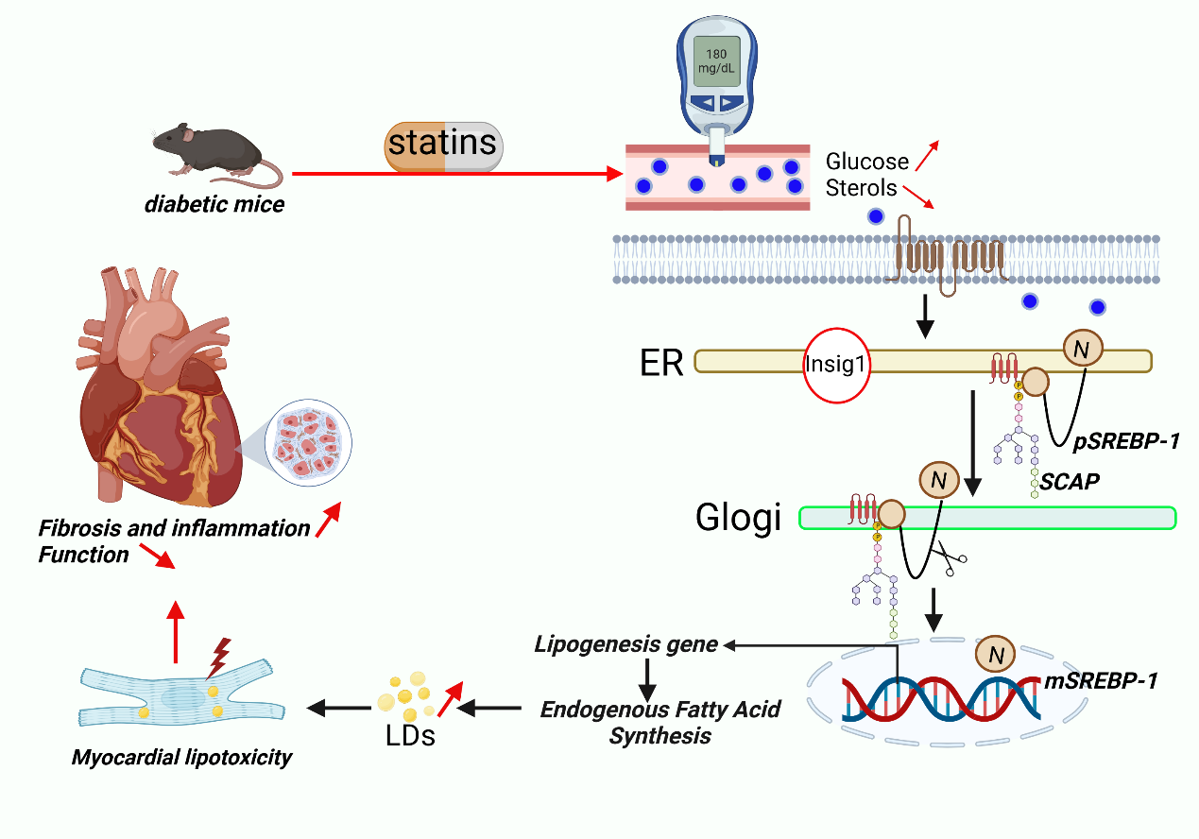
Supplemental Figure 9. Schematic diagram illustrating sustained SREBP-1 activation mediates cardiac lipotoxicity to statins therapy in diabetic mice. Long-term statins administration increased cardiac endogenous fatty acid synthesis via enhancing intracellular accumulation of glucose promotes SCAP N-glycosylation leading to SREBP-1 activation, which promoted cardiac lipotoxicity to accelerate cardiac dysfunction in diabetic mice. Graphics were created with Biorender.com.

