Extended Data
Extended Data Table 1: Greater bilbies are culturally important to many Indigenous Australians and go by many names. Listed below are some of the names given to the Greater bilby by mobs across Australia, modified from the report produced as part of the Ninu Festival at Kiwirrkurra in 2016¹. This is by no means a comprehensive list but rather represents the many Indigenous communities of which this species has cultural importance and value, including giving a separate name to the bilby tail in some languages.

Language group (and area) | Bilby and related names
Pintupi (Great Sandy Desert) | Ninu, Natari, Taaalku, Kuninka
Pintupi (Great Sandy Desert) | Patiri ~ bandicoot’s tail
Warlpiri (Tanami desert) | Walpajirri
Warlpiri, eastern | Pingki-tawutawu
Manjilyjarra, Martu wangka | Mankarr
Martu dialect | Kulkawalu
Martu at Birriliburu | Muntalngaku *
Ngaanyatjarra (Warburton region) | Marrura, Ninu
Warlmanpa (NNW Tennant Creek) | Warrikirti
Anmatyerr (Ti Tree region) | Angkay
Pitjantjatjara (South Australia) | Ninu
Yankunytjarra | Tjalku
Walmajarri | Nyalku/Nyarlku/Nyarlgoo/Kurrmili
Walmajarri (Ngurrara) | Mirtuluju
Ullaroi/Yuwaalayaay (NW NSW) | Bilba
Kimberley language names | Nyarlku/ Nyarlgu, Nyarlgoo, Nyarlku, Nalgo, Nalgo,-midi, Jitarru/Jidardu,, Kurmili, , Kurrmili, Mirtulurtu, Birndirdiri, Yawuri, Gurmin
To be determined | Yinpu
To be determined | Nirlyari
To be determined | Jawinji
To be determined | Jirrartu
Kimberley language | Birndirdiri
Bilby and bilby tail names from other Central Australian languages
Alyawarr  (Sandover) | Ahert
Arrernte  (Alice Springs region)  Western, Central, Western C. Strehlow | Ahert, Kere Aherte  Kere angkaye  Ngkaye, Kere ngkaye  Inkaia Albitja
Arrernte (Alice Springs region) | Alpirte, Alpitye
Kayteye (Barrow Creek region) | Artnangke
Kayteye (Barrow Creek region) | Alpite
Jingulu & Mudburra (Elliott region) | Yarningki
Kuwarri (Elliott region) | Yalbawurrini
Alekerange area | Jawinji, Walpajirri, Nini, Ngarlaparaji, Pingki-tawu-tawu (all the same animal)
Nyungar/ Nyoongar (SW WA) | Dalgayt/ Dalgyte/Dalgite/Dol-goitch
Antikirinya (Port Augusta) | Malku (Bilby or possibly Bilby-tail)
Ooldea | Milbu (Bilby tail)

Extended Data Table 2 Ninu reference genome and transcriptome statistics.
Statistic | Value
Genome
Assembly Size | 3.66 Gb
Coverage | 39x
Assigned to chromosomes | 3.50 Gb (95.6%)
No. Chromosomes | 9 nuclear, plus mtDNA
No. Scaffolds | 609 (10 with scaffolding)
No. Contigs | 5,028 (4,429 with scaffolding)
Scaffold N50 | 343.85 Mb
Contig N50 | 1.23 Mb
Gaps | 0.34%
Repeat Content* | 47.4487%
BUSCO V5 | C:93.5% [S:88.6%, D:4.9%], F:1.1%, M:5.4%, n:9226
No. Protein-coding Genes | 38,756
BUSCO V5 (proteins) | C:96.0% [S:52.4%, D:43.6%], F:0.8%, M:3.2%, n:9226
Global Transcriptome
No. Transcripts | 303,420
No. Genes | 39,106
Average Transcript Length | 6,833 bp
Transcript N50 | 13.4 kb
BUSCO V5 | C:86.1% [S:8.4%, D:77.7%], F:3.0%, M:10.9%, n:9226
Testis Transcriptome
No. Transcripts | 82,964
No. Genes | 37,034
Average Transcript Length | 2363 bp
Transcript N50 | 3.93 kb
BUSCO V5 | C:75.5% [S:25.9%, D: 49.6%], F:4.0%, M:20.5%, n:9226
*Excluding low complexity and simple repeats

Extended Data Table 3: Estimates of observed (H_{O}) and expected (H_{E}) heterozygosity and population-level inbreeding (F_{IS}) from genotyped scat samples (Kiwirrkurra) compared to wild and translocated Ninu populations across Australia. Data from these latter populations are from the larger DArTseq dataset subset to the 35 autosomal SNPs included in the MassARRAY SNP panel.
Population | Sample | Type | N | H_{O} | H_{E} | F_{IS}
Pilbara | Tissue | Wild | 4.7 | 0.291 | 0.428 | 0.229
Pilbara | Scat | Wild | 6.7 | 0.289 | 0.419 | 0.275
Kimberley | Tissue | Wild | 2.9 | 0.371 | 0.387 | -0.058
Kimberley | Scat | Wild | 4.4 | 0.253 | 0.286 | 0.080
Kiwirrkurra (2021) | Scat | Wild | 11.9 | 0.342 | 0.311 | -0.086
Kiwirrkurra (2022) | Scat | Wild | 16.5 | 0.360 | 0.357 | -0.027
Combined 2021-2022 | Scat | Wild | 23.6 | 0.338 | 0.337 | -0.011
Arid Recovery | Tissue | Translocated | 15.5 | 0.390 | 0.396 | 0.040
Currawinya | Tissue | Translocated | 33.7 | 0.429 | 0.436 | 0.015
Mallee Cliffs | Tissue | Translocated | 48.8 | 0.393 | 0.461 | 0.144
Mt Gibson founder | Tissue | Translocated | 15.7 | 0.429 | 0.403 | -0.056
Mt Gibson | Tissue | Translocated | 23.3 | 0.406 | 0.449 | 0.090
Mt Gibson | Scat | Translocated | 6.7 | 0.388 | 0.396 | 0.023
Pilliga | Tissue | Translocated | 36.0 | 0.409 | 0.446 | 0.085
Scotia | Tissue | Translocated | 7.3 | 0.330 | 0.340 | 0.019
Thistle Island | Tissue | Translocated | 28.9 | 0.430 | 0.445 | 0.048
Venus Bay | Tissue | Translocated | 5.0 | 0.326 | 0.304 | -0.073
Yooka1 | Tissue | Translocated | 15.6 | 0.310 | 0.261 | -0.147
Yooka2 | Tissue | Translocated | 3.0 | 0.295 | 0.329 | 0.040
ZAA | Tissue | Zoo | 43.2 | 0.443 | 0.450 | 0.009

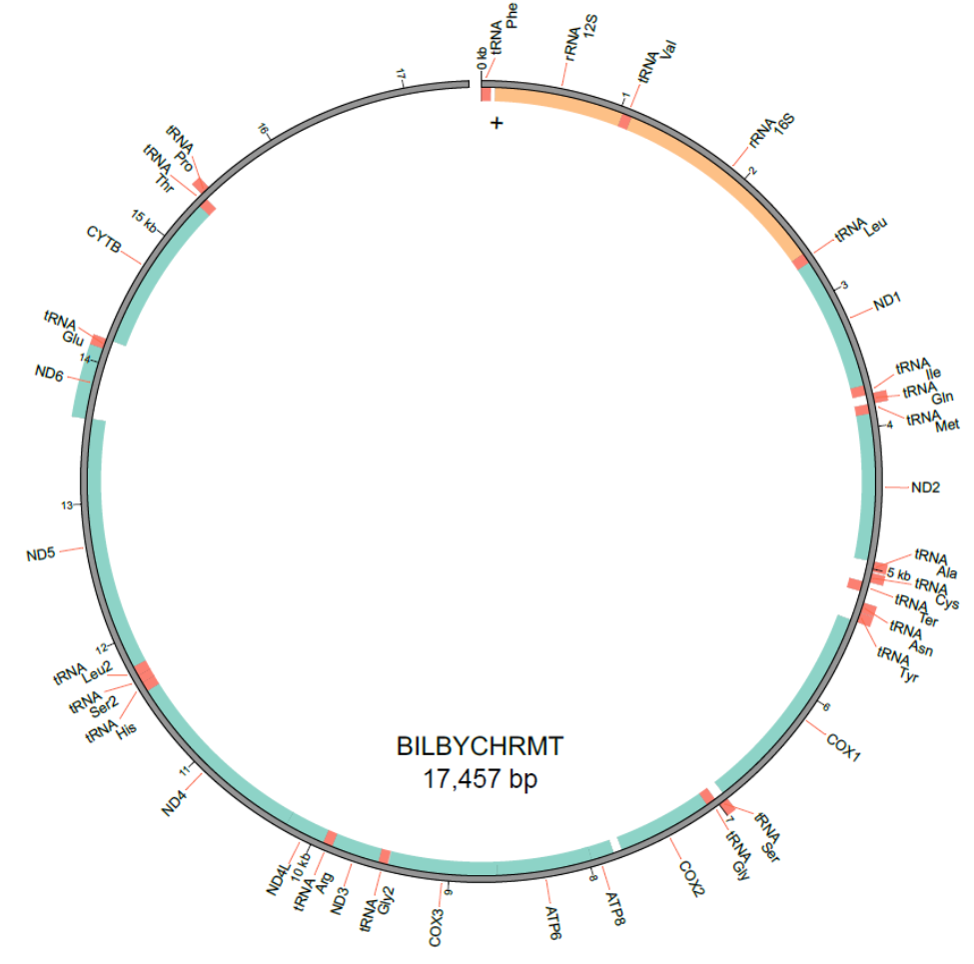

Extended Data Figure 1: Mitochondrial genome for the Ninu.

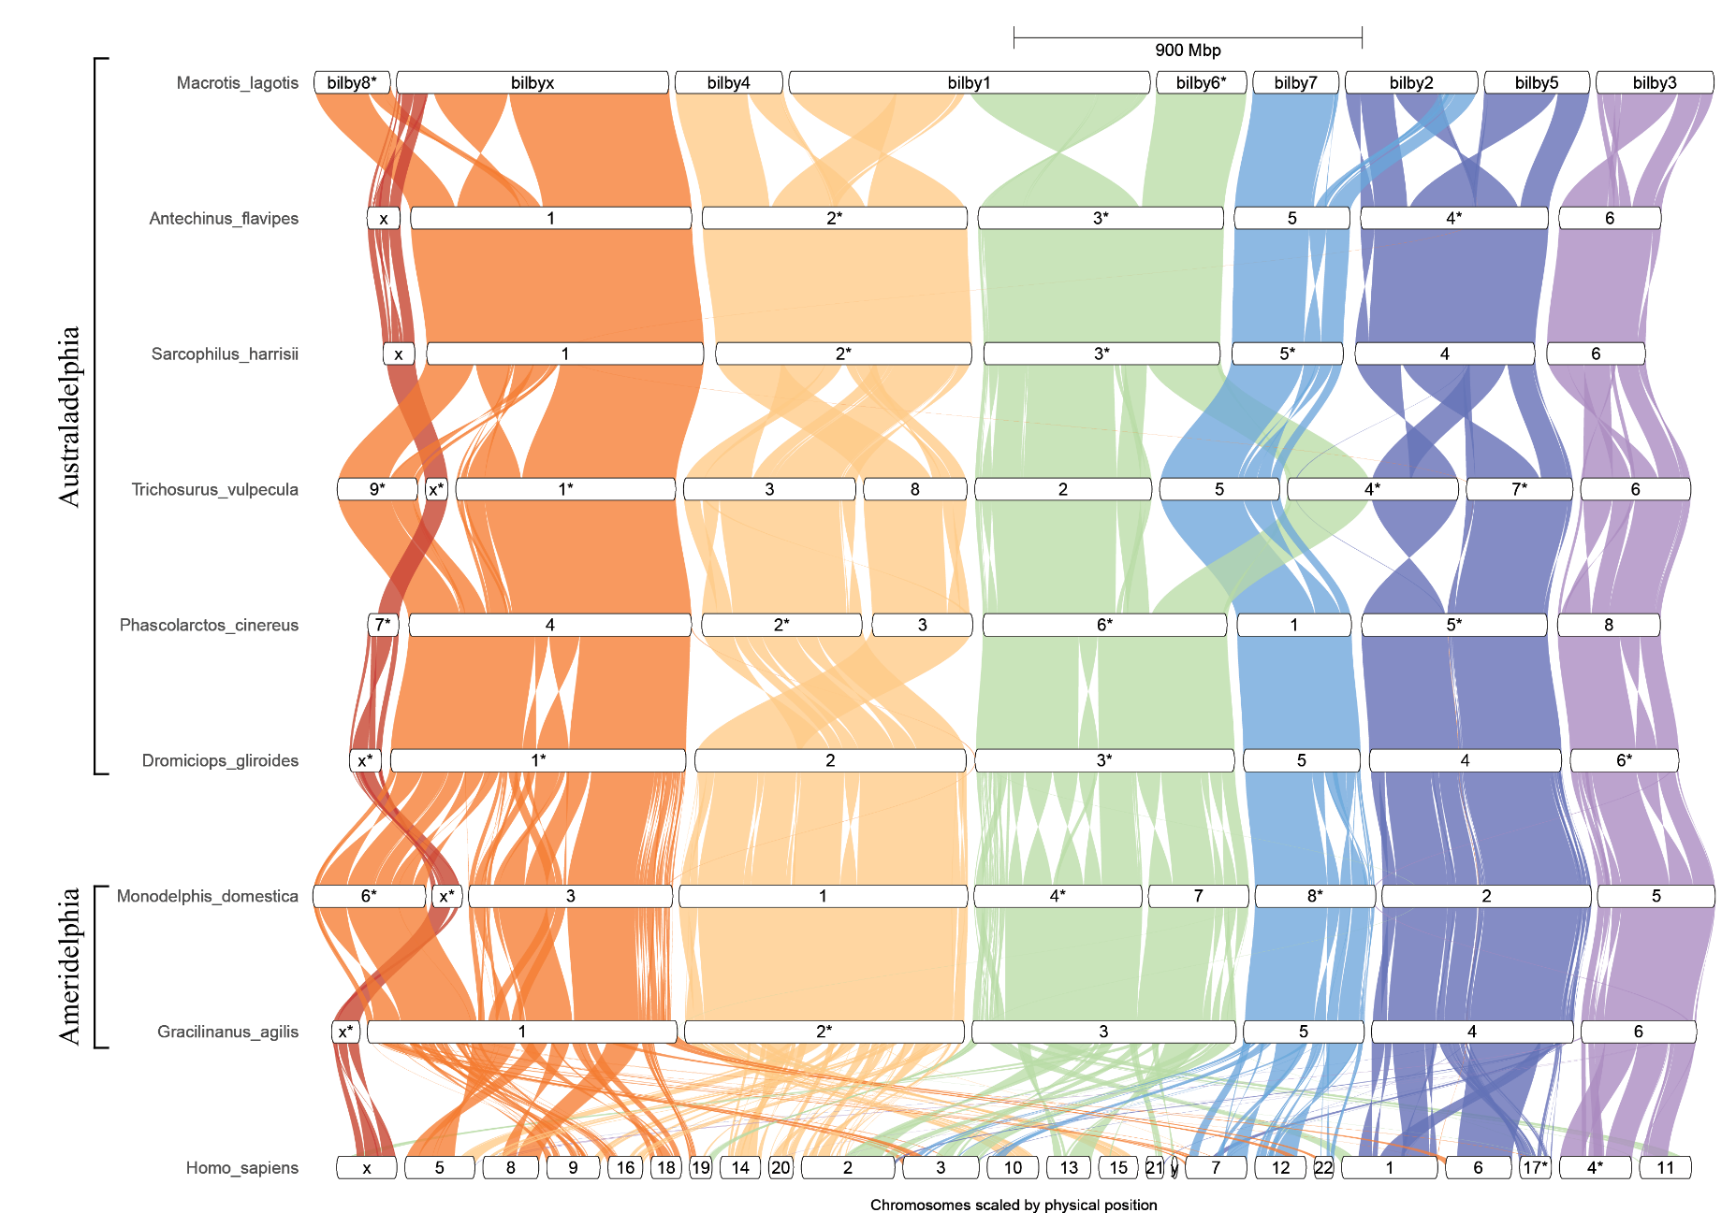

Extended Data Figure 2. Genespace synteny plots of the Australadelphia and Ameridelphia marsupials and Homo sapiens. Coloured blocks represent chromosome scaffolds for each species. Chromosomes are ordered to maximise visual synteny relative to neighbouring genomes, with the Ninu chromosomes defining the starting order and orientation. Each chromosome is labelled with the species and chromosome number (or X), with an “*” suffix when reversed to minimise inversions.

