Supplementary Information

Tuning the oxidation activity of alcohols via hydrogen-bond interactions
Xiao Feng^{1,2}, Piaoping Yang³, Yinwei Wang^{1,2}, Jieqi Cao^{1,2}, Jin Gao¹*, Song Shi¹*, Dionisios G. Vlachos³
¹ State Key Laboratory of Catalysis, Dalian Institute of Chemical Physics, Chinese Academy of Sciences, Dalian 116023, People’s Republic of China.
² University of Chinese Academy of Sciences, Beijing 100049, People’s Republic of China.
³ Department of Chemical and Biomolecular Engineering and Catalysis Center for Energy Innovation (CCEI), University of Delaware, Newark, DE 19716, USA.
Email: shisong@dicp.ac.cn

Contents
Methods. 4
Supplementary Figure 1. Lattice spacing measurement with Digital Micrograph. 6
Supplementary Figure 2. XPS spectra of Au 4f and Pd 3d on different catalysts. 7
Supplementary Figure 3. XRD patterns and partial regions of XRD patterns. 8
Supplementary Figure 4. XPS spectra of Au 4f in different states. 9
Supplementary Figure 5. FT-IR spectra of the polymers 10
Supplementary Figure 6. Thermogravimetric analysis of polymers with different ratios and types of groups. 11
Supplementary Figure 7. Activity of Encap-ET, Encap-C=O, Encap-S=O and Encap-N-O in the oxidation reactions with diverse substrates of substituents. 12
Supplementary Figure 8. Linear relationship between 1/Δδ and 1/C of benzyl alcohol and acetophenone(Ar-C=O) in CDCl₃. 13
Supplementary Figure 9. Linear relationship between 1/Δδ and 1/C of benzyl alcohol and benzyl sulfoxide(Ar-S=O) in CDCl₃. 14
Supplementary Figure 10. Linear relationship between 1/Δδ and 1/C of benzyl alcohol and Nitrogen dimethylbenzylamine-nitrogen oxide(Ar-N-O) in CDCl₃. 15
Supplementary Table 1. Chemical shifts of active H in benzyl alcohol with different concentration ratios of Ar-C=O and benzyl alcohol 16
Supplementary Table 2. Chemical shifts of active H in benzyl alcohol with different concentration ratios of Ar-S=O and benzyl alcohol 17
Supplementary Table 3. Chemical shifts of active H in benzyl alcohol with different concentration ratios of Ar-N-O and benzyl alcohol 18
Supplementary Table 4. Correlations between oxygen-containing monomers and benzyl alcohol. 19
Supplementary Figure 11. Optimized configuration and relative hydrogen bond energies (∆G_{H-NO}, ∆G_{H-CO}, ∆G_{H-SO}) for the hydrogen bond donor (benzyl alcohol) and acceptor. 20
Supplementary Table 5. Hydrogen bond energy and length for the hydrogen bond donor (benzyl alcohol)-acceptor with varying number of aromatic rings using DFT calculations. 20
Supplementary Figure 12. Optimized configuration and relative hydrogen bond energy gap (∆G_{H-NO}-∆G_{H-CO}, ∆G_{H-NO}-∆G_{H-SO}) for the hydrogen bond donor (benzyl alcohol)- acceptor with varying number of aromatic rings. 21
Supplementary Figure 13. IGC plots of different POFs. 22
Supplementary Figure 14. Linear relationship between ∆G₁ from ¹H-NMR tests and ∆G₂ from IGC tests (∆G^{Sp}_{methanol}). 23
Supplementary Figure 15. Methanol adsorption isotherms on different polymers. 24
Supplementary Figure 16. TOF of aromatic alcohol catalytic oxidation vs. hydrogen bonding energies with varying number of aromatic rings obtained from DFT calculations.. 25
Supplementary Figure 17. Hammett plots for different catalysts.. 26
Supplementary Fig 18. ¹H-NMR of PhCD₂OD and PhCH₂OH. 27
Supplementary Figure 19. TOF values of Encap-C=O and Encap-N-O with different oxygen pressures. 28
Supplementary Table 6. Surface free energy for different materials. 29
Supplementary Table 7. Parameters of different materials in the packed columns. 29
Supplementary Table 8. Physicochemical properties and contents of Au and Pd of different samples. 29
Supplementary Note 30
References 31

Methods
Catalyst Preparation
Synthesis of AuPd alloy nanoparticles
AuPd alloy nanoparticles were synthesized by the sol-immobilization method. HAuCl₄ and PdCl₂ aqueous solutions at a certain concentration and ratio (Au: Pd (mol/mol)=2:3) were mixed, followed by adding a certain amount of polyvinyl alcohol (PVA) (PVA/(Au+Pd) (wt/wt)=1.2). Under vigorous stirring, the freshly prepared solution of NaBH₄ (0.1 M, NaBH₄/(Au+Pd) (mol/mol)=5) was added and a dark brown sol formed.

Synthesis of the inner layer support POF-N
Typically, the monomer (triphenylamine, 0.02 mol), cross-linker (FDA, 0.06 mol), and catalyst (FeCl₃, 0.06 mol) were dissolved in 1,2-dichloroethane (DCE, 20 mL) and heated at 45 ºC for 5 h, and then heated at 80 ºC for 19 h. After washing the resulting solid product with methanol several times, until the filtrate liquor was nearly colorless, the product was Soxhlet extracted in methanol for 24 h followed by drying in a vacuum oven at 60 ºC for 24 h.

Synthesis of the kernel AuPd/POF-N
The kernel AuPd/POF-N was prepared by adding a certain amount of support POF-N to the prepared dark brown sol with AuPd alloy nanoparticles, after vigorous stirring for 3 h, and then centrifugated. Upon drying at 80 ºC for 12 h, the kernel AuPd/POF-N was obtained.

Synthesis of the encapsulated Encap-ET (Encap-S=O, Encap-C=O, Encap-N-O)
To ensure the same amount of AuPd alloy on different catalysts, and facilitate the subsequent comparison of catalytic performance, we encapsulated the same mass of the outer polymer layer and inner polymer. Typically, the monomer (triphenylamine 0.36 g, ethylbenzene 0.36 g, the molar ratio=3:7) and cross-linker (FDA, 1.12 g) were first dissolved in 1,2-dichloroethane (DCE, 20 mL) to obtain 1.0 g polymer (POF-ET). Afterward, the kernel AuPd/POF-N (1.00 g), and the catalyst (FeCl₃, 2.4 g) were added in order, heated at 45 ºC for 5 h and 80 ºC for 19 h. After washing the obtained solid product with methanol several times, until the filtrate liquor was nearly colorless, the product was Soxhlet extracted in methanol for 24 h followed by drying in a vacuum oven at 60 ºC for 24 h. Then the encapsulated catalyst Encap-ET (POF-ET/AuPd/POF-N) was obtained. The catalyst Encap-S=O, Encap-C=O, and Encap-N-O catalysts were prepared through the same method.

Synthesis of the outer layer POF-ET, POF-C=O, POF-S=O and POF-N-O
Typically, the monomer (a certain amount of triphenylamine and ethylbenzene), cross-linker (FDA, 0.06 mol), and catalyst (FeCl₃, 0.06 mol)were dissolved in 1,2-dichloroethane (DCE, 20 mL) and heated at 45 ºC for 5 h and then at 80 ºC for 19 h. After washing the resulting solid product with methanol several times, until the filtrate liquor was nearly colorless, the product was Soxhlet extracted in methanol for 24 h followed by drying in a vacuum oven at 60 ºC for 24 h. Similarly, the POF-C=O, POF-S=O and POF-N-O were prepared through the same method using the monomer acetophenone, methyl phenyl sulfoxide, and nitrogen dimethylbenzylamine-nitrogen oxide, respectively.

Characterization
X-ray photoelectron spectroscopy (XPS) was performed on the Thermofisher ESCALAB 250Xi spectrometer using AlKα radiation. The binding energies were calibrated using the C1s level (284.6 eV) as the internal standard reference. ¹³C cross-polarization magic-angle spinning nuclear magnetic resonance (¹³C CP/MAS NMR) spectra were collected on Bruker AVANCE III HD 600 MHz Wide Bore Solid State spectrometer. The amounts of Au and Pd were measured on ICP-OES 7300DV. HR-TEM images were collected on a JEM-2100, and the HAADF-STEM images and the elemental mapping of C, N, O, Au, and Pd were performed with an FEI Talos F 200X microscope operated at 200 kV. IGC measurement was performed on an Agilent 6890N GC equipped with a flame ionization detector.

Reaction procedures and product analysis
Catalytic reactions were performed on a 60 mL of autoclave reactor with a Teflon insert. A typical procedure is as follows: in a 60 mL reaction kettle containing a PTFE lining, benzyl alcohol (108.1 mg, 1 mmol), catalyst (100 mg), and solvent acetonitrile (10 mL) were added in sequence, sealed, and pressurized with oxygen to 1.0 MPa. With the magnetic stirring turned on, the reaction was carried out under the program-controlled temperature. After a certain time of reaction, the heating and stirring were stopped in time, and the mixture was cooled to room temperature in an ice bath. When the reaction was complete, the reaction mixture was diluted to 25 mL for analysis. The products were identified by Agilent 6890N GC/5973 MS detector and quantitated by Agilent 7890N GC equipped with an HP-INNOWAX (30.0 m × 0.320 mm) and flame ionization detector with p-dichlorobenzene as an internal standard. The adsorption capability of the polymers was measured on an Intelligent Gravimetric Analyzer (IGA-100, Hiden Analytical Company, the United Kingdom).
DFT calculations
All the calculations were carried out using Gaussian 09 software package.¹ B3LYP/6–31++G(d,p) was used with basis set superposition error (BSSE) correction.^{2,3} The interaction energy for hydrogen-bonded complex is calculated using:⁴
E(H-bond) = E(AB) + E(BSSE) – E(A) – E(B)
where E(AB), E(BSSE), E(A), and E(B) are the total energy of hydrogen-bonded complex, the correction for the basis set superposition error (BSSE), the energy of component A, and the energy of component B, respectively.⁵

Supplementary Figure 1. Lattice spacing measurement with Digital Micrograph.

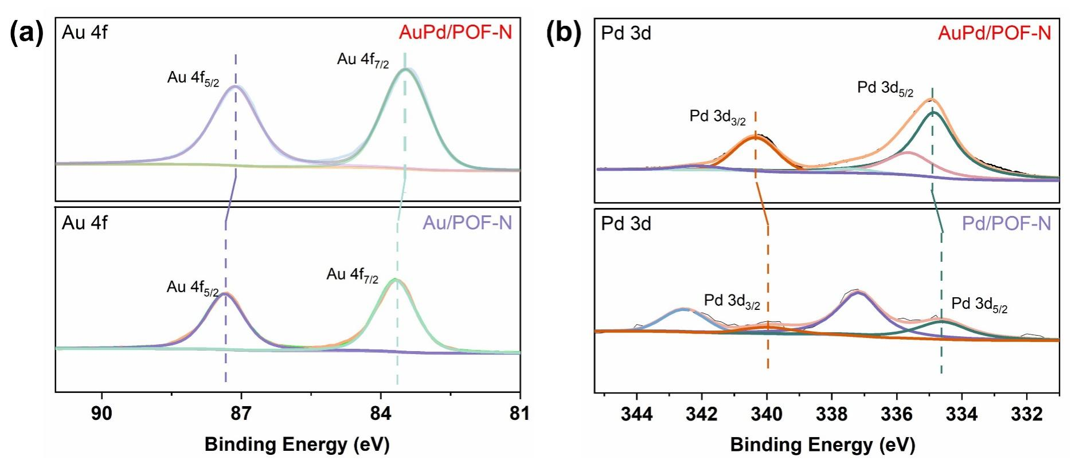
Supplementary Figure 2. XPS spectra of Au 4f and Pd 3d on different catalysts.

(A) Au 4f on catalysts AuPd/POF-N and Au/POF-N; (B) Pd 3d on catalysts AuPd/POF-N and Pd/POF-N.

The Au 4f and Pd 3d signals of AuPd/POF-N peaks at 87.1 eV and 83.4 eV corresponding to the Au(0) show a negative shift compared with the signal at 87.4 eV and 84.1 eV on Au/POF-N (Fig. S2). While a positive shift was displayed on the Pd3d signals in AuPd/POF-N (340.2 eV and 334.8 eV) compared with the signals on Pd/POF-N (339.9 eV and 334.6 eV). It suggests charge transfer between Au and Pd on the AuPd/POF-N, indicating successful formation of AuPd alloys.

Supplementary Figure 3. XRD patterns and partial regions of XRD patterns.
(a) POF-N, (b) Au/POF-N, (c) Pd/POF-N, (d) AuPd/POF-N, (e) Encap-ET, (f) Encap-S=O, (g) Encap-C=O, (h) Encap-N-O.

The diffraction peak of the kernel AuPd/POF-N was between the two mono-metals (38° for Au and 40° for Pd), demonstrating that Au and Pd on the kernel form a AuPd alloy. Furthermore, the diffraction peaks of all encapsulated catalysts Encap-X are also located in this range, indicating the consistency of AuPd alloy during encapsulation.

Supplementary Figure 4. XPS spectra of Au 4f in different states.
- Supported AuPd/POF-N, (ii) encapsulated Encap-C=O, and (iii) in-situ argon ion sputtering on Encap-C=O.

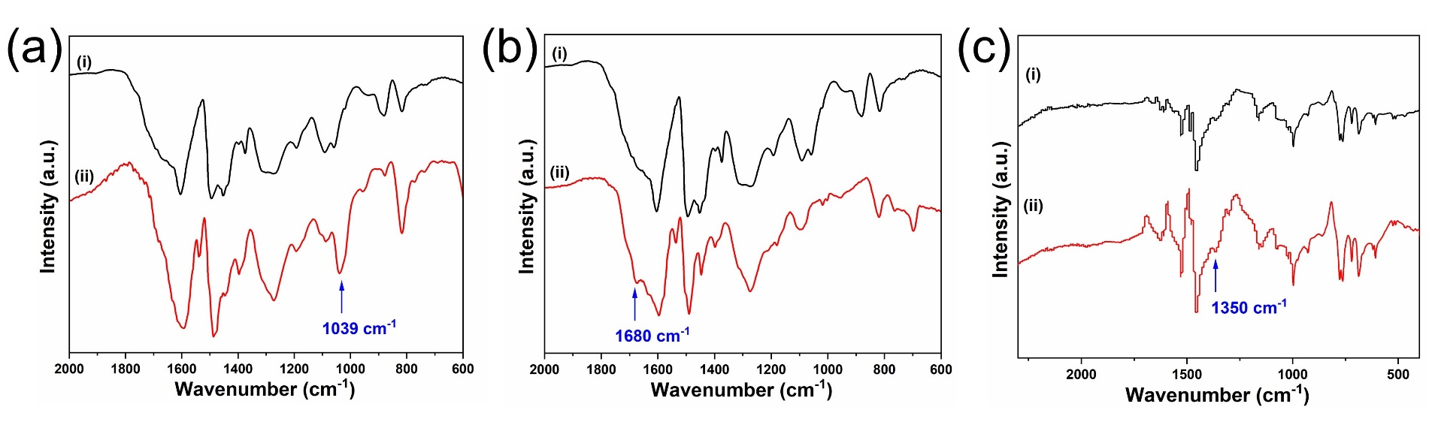

Supplementary Figure 5. FT-IR spectra of the polymer POF-S=O, POF-C=O and POF-N-O.
(a) i.POF-ET and ii.POF-S=O; (b) i.POF-ET and ii.POF-C=O; (c) i.POF-N-(CH₃)₂ and ii.POF-N(O)-(CH₃)₂.

Therein, 3032 cm⁻¹ corresponds to aromatic ring unsaturated hydrocarbon telescopic vibration υ (=C-H), 1583 cm⁻¹ and 1489 cm⁻¹ are attributed to conjugate double bond telescopic vibration υ (C=C) on the benzene ring, and 1039cm⁻¹, 1680 cm⁻¹ and 1350 cm⁻¹ are from the sulfoxide group, carbonyl group, and nitrogen oxide functional groups, respectively.⁶⁻⁸

Supplementary Figure 6. Thermogravimetric analysis of polymers with different ratios and types of groups.

Supplementary Figure 7. Activity of Encap-ET, Encap-C=O, Encap-S=O and Encap-N-O in the oxidation with diverse substrates of substituents.

a.4-CF₃, b.4-Cl, c.4-CH₃, d.4-OCH₃.
Notes: a. Reaction conditions: 120 ºC, 1.0 MPa O₂, 10 mL CH₃CN, 1.0 mmol of substrates; b. TOF values were calculated according to the total metal loading; c. Metal loading is 0.25 wt%.

Supplementary Figure 8. Linear relationship between 1/Δδ and 1/C of benzyl alcohol and acetophenone (Ar-C=O) in CDCl₃.

Supplementary Figure 9. Linear relationship between 1/Δδ and 1/C of benzyl alcohol and benzyl sulfoxide (Ar-S=O) in CDCl₃.

Supplementary Figure 10. Linear relationship between 1/Δδ and 1/C of benzyl alcohol and nitrogen dimethylbenzylamine-nitrogen oxide (Ar-N-O) in CDCl₃.

Supplementary Table 1. Chemical shifts of active H in benzyl alcohol with different concentration ratios of Ar-C=O and benzyl alcohol.

ratio | Δδ (ppm) | δ (ppm)
0 | - | 1.6614
0.2 | 0.0130 | 1.6744
0.6 | 0.0378 | 1.6992
0.8 | 0.0510 | 1.7124
1.0 | 0.0636 | 1.7250
1.2 | 0.0747 | 1.7361
1.2_{repeat} | 0.0670 | 1.7236
1.4 | 0.0761 | 1.7327
1.4_{repeat} | 0.0869 | 1.7483

Supplementary Table 2. Chemical shifts of active H in benzyl alcohol with different concentration ratios of Ar-S=O and benzyl alcohol.

ratio | Δδ (ppm) | δ (ppm)
0 | - | 1.6965
0.2 | 0.0511 | 1.7476
0.6 | 0.1494 | 1.8459
0.8 | 0.184 | 1.8805
1.0 | 0.2255 | 1.9220
1.4 | 0.2975 | 1.9940
1.6 | 0.3648 | 2.0613
1.8 | 0.4021 | 2.0986
2.0 | 0.4432 | 2.1397

Supplementary Table 3. Chemical shifts of active H in benzyl alcohol with different concentration ratios of Ar-N-O and benzyl alcohol.

ratio | Δδ (ppm) | δ (ppm)
0 | - | 1.6566
0.2 | 1.9351 | 3.5934
0.4 | 3.4184 | 5.0767
0.6 | 4.5238 | 6.1821
0.8 | 5.3449 | 7.0032
1.0 | 6.217 | 7.8753
1.2 | 6.8069 | 8.4652
1.4 | 7.3278 | 8.9861
1.6 | 7.7718 | 9.4301

Supplementary Table 4. Correlations between oxygen-containing monomers and benzyl alcohol.
Samples | Slope | Intercept | Correlation coefficient | -∆G (kcal/mol)
Ar-ET | - | - | - | -
Ar-C=O | 0.7280 | 1.0738 | 0.9987 | 0.23
Ar-S=O | 0.1835 | 0.4664 | 0.9994 | 0.55
Ar-N-O | 0.0043 | 0.0734 | 0.9999 | 1.68

Supplementary Figure 11. Optimized configuration and relative hydrogen bond energies (∆G_{H-NO}, ∆G_{H-CO}, ∆G_{H-SO}) for the hydrogen bond donor (benzyl alcohol) and acceptor.
Varying number of aromatic rings using DFT calculations. X=C, S, or N, representing Ar-C=O, Ar-S=O, or Ar-N-O.

Supplementary Table 5. Hydrogen bond energy and length for the hydrogen bond donor (benzyl alcohol)-acceptor with varying number of aromatic rings using DFT calculations.
Number of aromatic rings | C=O |  |  | S=O |  | N-O
Number of aromatic rings | ∆G_{H-CO} (kcal/mol) |  | Length-_{H-CO} (Å) | ∆G_{H-SO}  (kcal/mol) | Length-_{H-SO} (Å) | ∆G_{H-NO}  (kcal/mol) | Length-_{H-NO} (Å)
1 | 3.09 | 2.14 |  | 3.91 | 1.99 | 4.54 | 1.95
2 | 6.27 | 1.89 |  | 6.82 | 1.88 | 7.74 | 1.84
4 | 7.97 | 1.76 |  | 8.57 | 1.75 | 9.54 | 1.68
5 | 8.71 | 1.74 |  | 9.45 | 1.71 | 10.4 | 1.64

Supplementary Figure 12. Optimized configuration and relative hydrogen bond energy gap (∆G_{H-NO}-∆G_{H-CO}, ∆G_{H-NO}-∆G_{H-SO}) for the hydrogen bond donor (benzyl alcohol)-acceptor with varying number of aromatic rings.

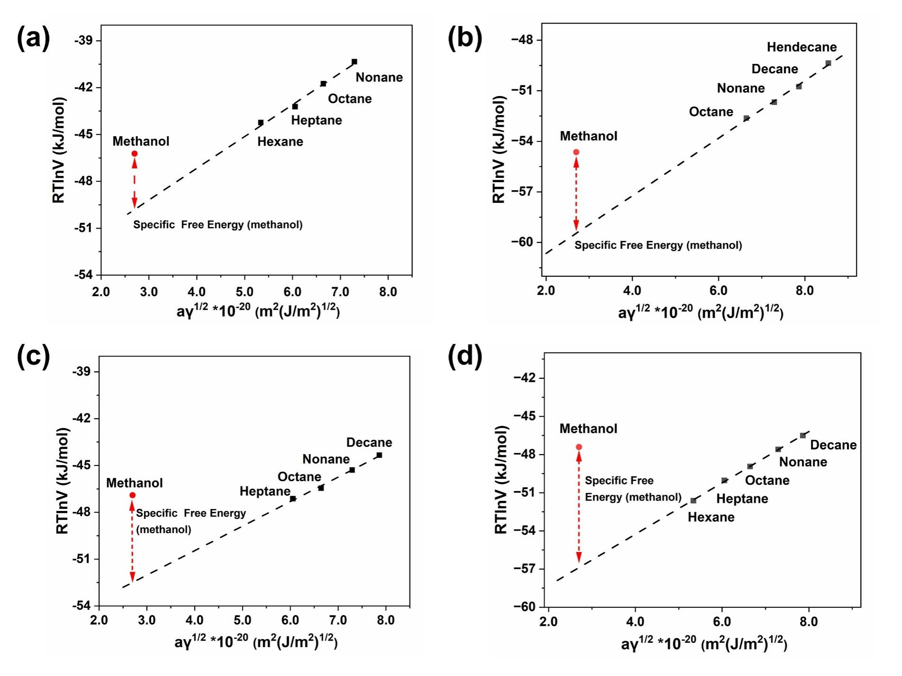
Supplementary Figure 13. IGC plots of different POFs. (a) POF-ET, (b) POF-C=O, (c) POF-S=O, (d) POF-N-O. Detailed parameters are in Supplementary Table 6 and 7.

Supplementary Figure 14. Linear relationship between ∆G₁ from ¹H-NMR tests and ∆G₂ from IGC tests (∆G^{Sp}_{methanol} ).
∆G₂ represents the difference of ∆G^{Sp}_{methanol} between POFs modified with different hydrogen bond acceptors vs. POF-ET.

Supplementary Figure 15. Methanol adsorption isotherms on different polymers at 25 °C.
POF-ET (black), POF-C=O (red), POF-S=O (blue) and POF-N-O (green).
Uptake normalized by dividing molar uptake by S_{BET}.

Supplementary Figure 16. TOF of aromatic alcohol catalytic oxidation vs. hydrogen bonding energies with varying number of aromatic rings obtained from DFT calculations.
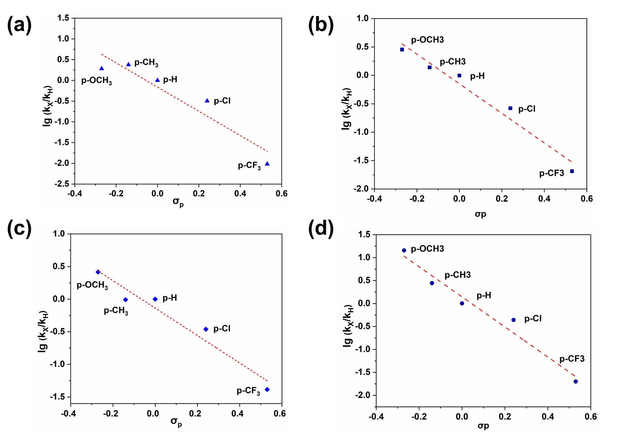
Supplementary Figure 17. Hammett plots for different catalysts.
(a) Encap-ET, (b) Encap-C=O, (c) Encap-S=O, and (d) Encap-N-O.

Supplementary Figure 18. ¹H-NMR of (i) PhCD₂OD and (ii) PhCH₂OH.

Equations of kinetic isotope effect (KIE) experiment on Encap-ET, Encap-S=O, Encap-C=O and Encap-N-O:
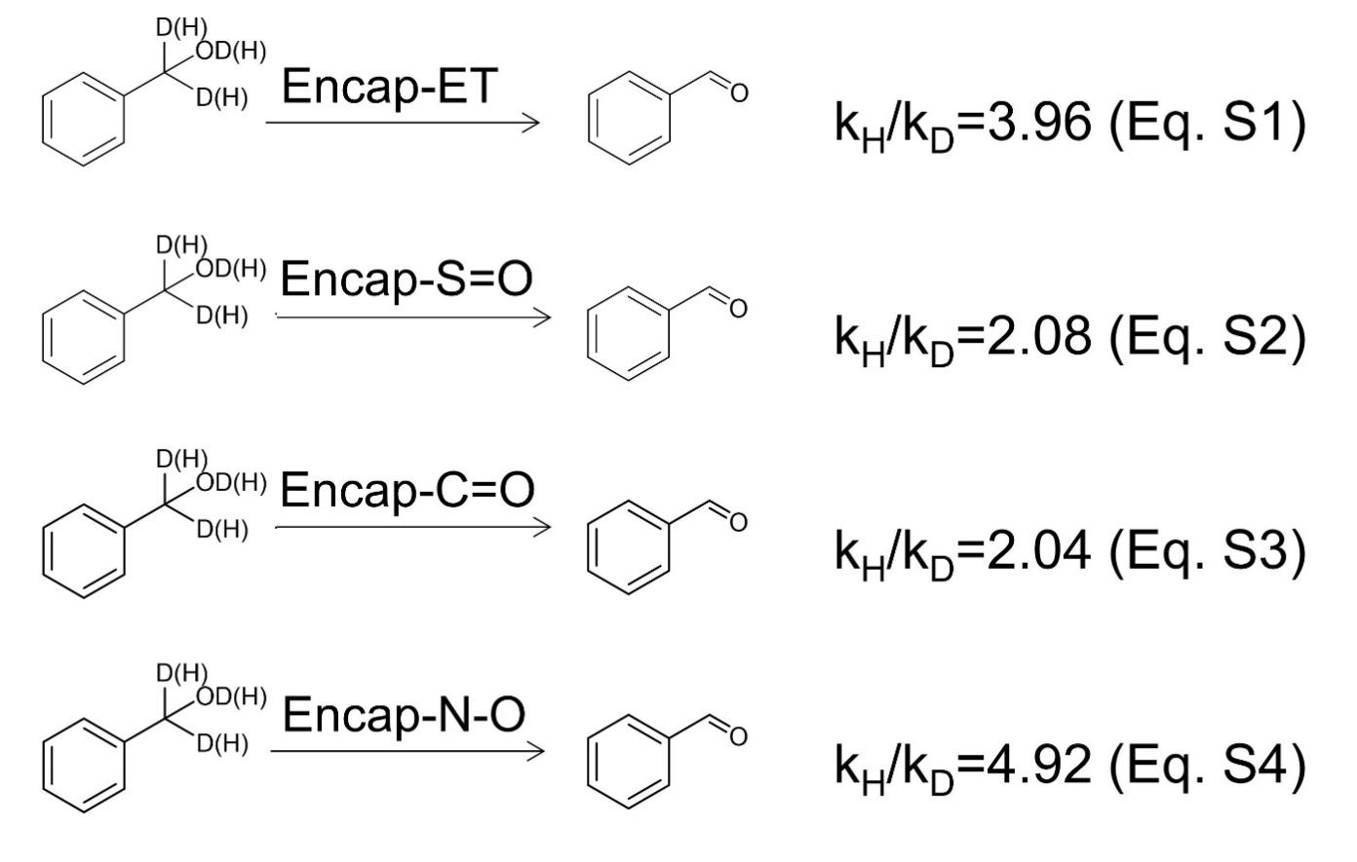

Supplementary Figure 19. TOF values of Encap-C=O and Encap-N-O with different oxygen pressures.

Supplementary Table 6. Surface free energy for different materials.

Samples | Slope (J*m/  (m²* mol*J^{1/2})) | Intercept (J/mol) | Correlation coefficient | -∆G^{Sp}_{methanol} (kcal/mol)
POF-ET | 2.03*10²³ | -55235 | 0.9872 | 0.84
POF-C=O | 1.74*10²³ | -63980 | 0.9844 | 1.10
POF-S=O | 1.57*10²³ | -56736 | 0.9964 | 1.33
POF-N-O | 2.01*10²³ | -62335 | 0.9992 | 2.26

Supplementary Table 7. Parameters of different materials in the packed columns.

Samples | Retention Time (min) |  |  |  |  |  |  |  | P₁  (KPa) | P₂ (KPa)
POF-ET | Hexane | Heptane | Octane |  | Nonane |  | CH₃OH |  | P₁  (KPa) | P₂ (KPa)
POF-ET | 0.082 | 0.095 | 0.122 |  | 0.161 |  | 0.074 |  | 41.6 | 27.4
POF-C=O | Octane | Nonane | Decane |  | Hendecane |  | CH₃OH |  | P₁  (KPa) | P₂ (KPa)
POF-C=O | 0.837 | 0.897 | 0.945 |  | 1.016 |  | 0.797 |  | 57.6 | 2.21
POF-S=O | Heptane | Octane | Nonane |  | Decane |  | CH₃OH |  | P₁  (KPa) | P₂ (KPa)
POF-S=O | 0.075 | 0.079 | 0.088 |  | 0.098 |  | 0.083 |  | 43.2 | 27.2
POF-N-O | Hexane | Heptane | Octane | Nonane |  | Decane |  | CH₃OH | P₁  (KPa) | P₂ (KPa)
POF-N-O | 0.078 | 0.082 | 0.086 |  | 0.093 | 0.101 |  | 0.097 | 46.3 | 22.1

Supplementary Table 8. Physicochemical properties and contents of Au and Pd of different samples.

Samples | S_{BET} (m²/g) | V (cc/g) | Au (wt%) | Pd (wt%)
Encap-ET | 374 | 0.42 | 0.11 | 0.073
Encap-C=O | 156 | 0.16 | 0.11 | 0.068
Encap-S=O | 346 | 0.42 | 0.11 | 0.066
Encap-N-O | 405 | 0.31 | 0.12 | 0.055

Note: The contents of Au and Pd were obtained by ICP-OES.

Supplementary Note

IGC measurement

Material column filling:
The catalyst sample was packed into a glass column (70 mm x 2 mm i.d.) with tapping until the powder bed had no cracks or voids. The ends of the column were plugged with glass wool.

Tests:
IGC data were collected on a converted Agilent 6890N GC.
The powder-packed column was connected to the inlet and detector of the Gas Chromatography. Then remove the adsorbed water under He flow at 250 ºC for 2 h. The probe molecules were brought into the column with a He flow of ~70 mL/min. The retention times of the probes were recorded by a flame ionization detector (FID). The pre-column and post-column pressure were measured with two pressure gauges. Methanol was selected as the polar probe to determine the specific surface energy (-∆G^{Sp}).
According to the following formulas:⁹⁻¹²

$$\text{∆}{\text{G}}_{\text{ads} }\text{=} \text{∆}{\text{G}}_{\text{ads}}^{\text{D}}\text{+∆}{\text{G}}_{\text{ads}}^{\text{SP}}$$
Eq. S5
$$\text{RTln}{\text{V}}_{\text{N}}\text{ = 2}{\text{N}}_{\text{A}}\text{a}\sqrt{{\text{γ}}_{\text{S}}^{\text{D}}{\text{γ}}_{\text{L}}^{\text{D}} }\text{+ C}$$
Eq. S6
$$\text{∆}{\text{G}}_{\text{ads}}^{\text{SP}} \text{=} \text{RTln}\frac{V_{N}}{V_{N}^{ref}}$$
Eq. S7
N_{A} is the Avogadro number, a is the surface area occupied by the probe molecule, V_{N} is the net retention volume of the adsorbate, and γ^{D}_{S} and γ^{D}_{L} are the dispersed components of the solid and liquid surface energies, respectively.

The specific free energy (-∆G^{Sp}) resulting from polar interactions can be calculated from the deviation of RTlnV_{N} (the calculated value of methanol) from the gradient plot (plot of RTlnV_{N}^{ref} versus a(γ^{D}_{L})^{1/2} for the non-polar probe molecules).
Specific parameters and surface energy are shown in Table S6 and Table S7.

References
1. Frisch, M. et al. Gaussian 09, Revision (B.01). Gaussian Inc., Wallingford CT, (2010).
2. Becke, A. D. Density-functional exchange-energy approximation with correct asymptotic behavior. Phys Rev A Gen Phys 38, 3098-3100, (1988).
3. Grimme, S. Accurate description of van der Waals complexes by density functional theory including empirical corrections. J. Comput. Chem. 25, 1463-1473, (2004).
4. Gordon, M. S. & Jensen, J. H. Understanding the hydrogen bond using quantum chemistry. Acc. Chem. Res. 29, 536-543, (1996).
5. Boys, S. F. & Bernardi, F. The calculation of small molecular interactions by the differences of separate total energies. Some procedures with reduced errors. Mol. Phys. 19, 553-566, (1970).
6. Issidorides, C. H. & Haddadin, M. J. Benzofurazan oxide. II. Reactions with enolate anions. The Journal of Organic Chemistry 31, 4067-4068, (1966).
7. Kuwahara, Y., Kango, H. & Yamashita, H. Catalytic Transfer Hydrogenation of Biomass-Derived Levulinic Acid and Its Esters to γ-Valerolactone over Sulfonic Acid-Functionalized UiO-66. ACS Sustainable Chemistry & Engineering 5, 1141-1152, (2016).
8. Oh, K. I., Rajesh, K., Stanton, J. F. & Baiz, C. R. Quantifying Hydrogen-Bond Populations in Dimethyl Sulfoxide/Water Mixtures. Angew. Chem. Int. Ed. Engl. 56, 11375-11379, (2017).
9. Xie, D. et al. Effect of the Lignin Structure on the Physicochemical Properties of Lignin-Grafted-Poly(ε-caprolactone) and Its Application for Water/Oil Separation. ACS Sustainable Chemistry & Engineering 10, 16882-16895, (2022).
10. Ojah, N. et al. Surface modification of core-shell silk/PVA nanofibers by oxygen dielectric barrier discharge plasma: Studies of physico-chemical properties and drug release behavior. Appl. Surf. Sci. 475, 219-229, (2019).
11. Dierks, M. et al. Impact of Hydrophobic Organohybrid Silicas on the Stability of Ni2P Catalyst Phase in the Hydrodeoxygenation of Biophenols. ChemCatChem 10, 2219-2231, (2018).
12. Manayil, J. C. et al. Octyl Co-grafted PrSO3H/SBA-15: Tunable Hydrophobic Solid Acid Catalysts for Acetic Acid Esterification. ChemCatChem 9, 2231-2238, (2017).

