Table 5. Correspondent BoAM list of the armored FLDS considering the DfA2 method.
Nb. | FLDS armored parts Image | Armored part name | Ballistic protected material | Dimensions  (mm) | Estimat.  mass (kg) | Attach. type
1 |  | Side impact bar cover | Aramid fiber 9 layers | 863 x 226 x 4 | 1,42 | Glued
2/3 |  | Inner upper and lower cover - ASM | Aramid fiber 9 layers | 955 x 757x 4 | 3,37 | Glued
4 |  | Door lock cover | High Strength Steel (HSS) | 344 x 210 x 2 | 1,19 | Screwed
5 |  | Door front cover | High Strength Steel (HSS) | 207 x 205 x 2 | 1,19 | Glued
6 | 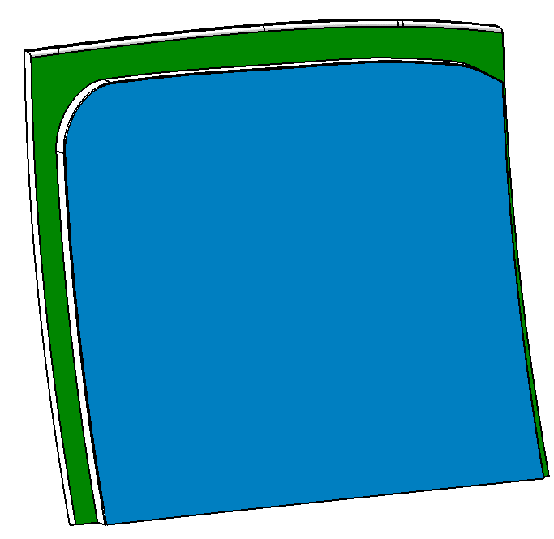 | Moveable armored glass | Glass layers + Polymers | 720 x 520 x 18 | 15,09 | Screwed
7 | 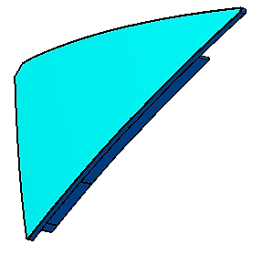 | Fixed armored glass | Glass layers + Polymers | 190 x 400 x 18 | 1,25 | Glued
8 |  | Lower rear cover | High Strength Steel (HSS) | 395 x 310 x 2 | 1,46 | Glued
9 |  | Upper frame cover | High Strength Steel (HSS) | 905 x 475 x 2 | 1,22 | Glued
10 |  | Rear door lock cover | High Strength Steel (HSS) | 63 x 210 x 2 | 1,78 | Glued
11 |  | Inner front panel cover | High Strength Steel (HSS) | 127 x 572 x 2 | 8,82 | Glued
12 |  | Fixed glass channel cover | High Strength Steel (HSS) | 49 x 367 x 2 | 2,57 | Glued

