Appendix 1
Description of the DfA2 method steps

After the customer order, armoring firms formalize an agreement contract with the new vehicle's owner and generate a service order on the shop floor to implement the armoring operation of the latest passenger car (steps 1 to 4). The firm describes in this contract the detailed description of bullet-resistant components and the level of protection the vehicle will receive. It also includes the armoring services warranties, and the ballistic protection certifications of each opaque and transparent part assumed from AASP to the vehicle's owner. After the contract is signed, the armoring process begins.

Next, the armoring firms identify the necessary armor parts (step 5) based on the vehicle type and model. In cases when the companies receive a vehicle that has never been protected before or the protective parts for the vehicle model are not available in specific dimensions, or even it has different processes that do not allow the use of the same available ballistic supplier parts, the DfA2 flow runs with a new ballistic protection development (step 6).

In the sequence, to allow the installation of the ballistic protect parts, the operator has first to disassemble the entire passenger compartment finish components, such as the headliner, door trim panels, cover trim pillars, and sunvisors (step 7), following the OEM disassembly sequence guidelines accurately and the DfX principles; the operators measure (or scan) each body structure area of the passenger compartment together with 3D parts assembly, respecting tolerances, clearances, and automotive moveable and fixed parts interface analysis (step 8), such as the roof, doors, and glasses. Under the ADC, these measurements intend to refine the project of the ballistic protection parts that fit with the vehicle components when installed. The collected environment measurement and vehicle layout information enables the firms and its ballistic stakeholders (suppliers) to design, produce, test, and deliver the ballistic components according to the vehicle model dimensions, also considering the 3D armoring parts using DfX methods and armoring requirements to protect and safeguard each of these areas previously cited (steps 9 and 10).

After acquiring the ballistic parts from suppliers (step 11), the operators inspect all of them in detail before being installed in the automobile, as well as the vehicle (step 12): checking if the engine, warning lamps, lighting, electronic systems, and all safety equipment are working correctly and simultaneously verifying any damage, scratches, dents or risks all around the vehicle. Next, the operators dismantle the vehicle's interior entirely after covering the interface surfaces with protective adhesive tapes, exposing only its internal frames and sheet metal panels (step 13). All the vehicle's interior finishing parts are removed, packaged, identified with the service order number, and stored in the warehouses. This traceability procedure ensures that the specific component returns for reassembly at the exact vehicle (step 14). To fit the armored glasses in the vehicle body, thicker than the original, door trim panels and frames are modified (step 15).

In steps 16, 17, and 18, the protective parts are installed in the passenger compartment. Fixed and movable armored glasses replace the original parts. In the regions of greater area per square centimeter, the aramid plates are glued. Note that to completely seal the aramid plates in humid regions, such as doors, as they are hygroscopic. Water absorption significantly reduces ballistic efficiency. In areas with smaller spaces, stainless steel plates are attached by screws of the same material, as they maintain their ballistic protection properties in reduced surfaces such as columns, roof, and door frames and mainly in serviceability regions, such as roof antenna, electronic modules in the quarter panels and taillights (SUVs).

In step 19, the installation of accessories, siren, and communicator are complementary to the armoring operations. In step 20, the automotive parts follow the automaker manufacturing processes together with DfX principles; in step 21, the assembly of new specific automotive parts focused on replaced components to similar, but reinforced, parts due to the increase of weight of ballistic parts mass in the vehicle, also following the ADC and DfX methods.

After the static and dynamic tests (step 22), the vehicle is reinspected (step 24), and after performing static and dynamic tests (step 23), the CAV is delivered to the customer (step 25). If the test fails, e.g., excessive wind noising, squeaks, and rattles, or any malfunctions detected, the firm identifies the nonconformity root causes, disassembles the parts affected, fixes them, and performs the tests again. The checkout inspection is a final quality audit that armoring firms guarantee that service is completed and the vehicle can be delivered to the customer.

Appendix 2
NIJ III-A ballistic level ammunitions: dimensions and specifications

9 mm Luger:
- Caliber: 9 mm;
- Nominal bullet mass: 124 grain or 8,0 g;
- Required bullet velocity: 426 ± 15 m/s (1400 ± 50 ft/s);
- Cartridge type: pistol/revolver;
- Bullet type: FMJ (Full Metal Jacket *);

* FMJ: a bullet made of lead wholly covered, except for the base, with copper alloy (US DoD, 1985).
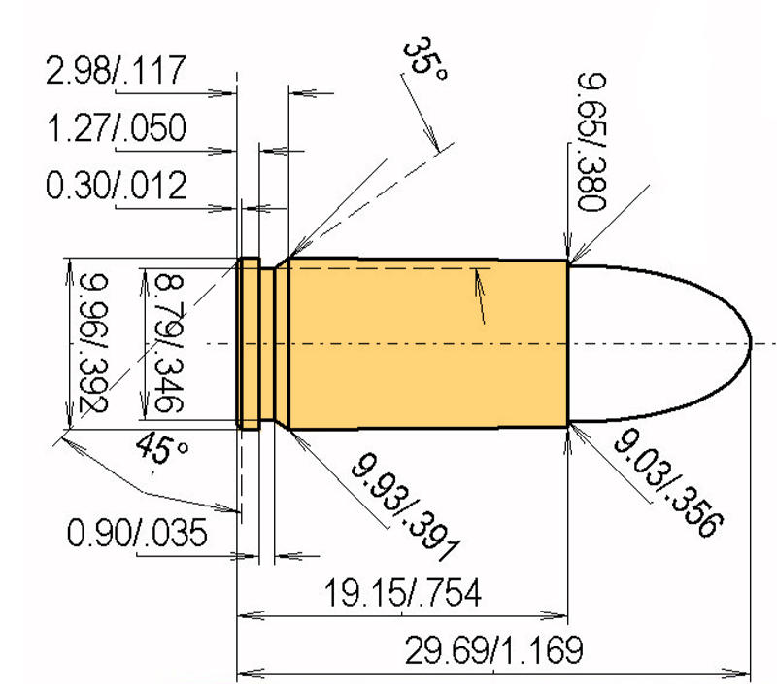

0,44 Magnum
- Caliber: 0,44 Magnum;
- Nominal bullet mass: 240 grain or 15, 6 g;
- Required bullet velocity: 426 ± 15 m/s or 1400 ± 50 ft/s;
- Cartridge Type: Pistol/Revolver;
- Bullet type: Lead SWC (Semi Wadcutter) Gas Checked (**);

** SWC: a bullet shape characterized by a flat nose and a tapered section leading to a cylindrical bullet body with a sharp break where the taper meets the body (US DoD, 1985).
