SUPPLEMENTAL DATA FILE.

High-performance methylated DNA markers for the detection of cervical lesions at risk of malignant progression in low- and middle-income countries:
A retrospective study
Mary Jo Fackler, Madison Pleas, Youran Li, Anushri Soni, Deyin Xing, Leslie Cope, Syed Ali, Quang Van Le, Chu Van Nguyen, Han Thi Pham, Long Minh Duong, Eunice Vanden Berg, Reubina Wadee, Pamela Michelow, Wenlong Carl Chen, Maureen Joffe, Christina S. Fjeldbo, Heidi Lyng, Saraswati Sukumar

Contents.
Additional files
Supplemental Figures
- Figure S1: Marker discovery workflow.
- Figure S2: Validation of TCGA-CESC 5-marker panel using external databases.
- Figure S3: Association between methylation of the five CpG markers and gene expression.
- Figure S4: Contribution of individual markers of the 5-marker panel to detect cervical neoplasia.
- Figure S5: The 5-marker panel is highly methylated in cervical smears from patients with HSIL and SCC.
- Figure S6: Association between DNA methylation and age in study samples and TCGA benign/normal
Supplemental Tables:
- Table S1: TCGA-CESC: Descriptive statistics for the 5-marker panel.
- Table S2: TCGA-CESC Cervical marker ID, gene name, location, and function.
- Table S3: Descriptive statistics for QM-MSP detected methylation of individual markers in the 5-marker panel.
- Table S4: Detailed description of samples used in this study
- Table S5: United States patient characteristics submitted as an Excel File
- Table S6: Vietnam patient characteristics submitted as an Excel File
- Table S7: HPV status of patients in dataset GSE68339. Submitted as an Excel File

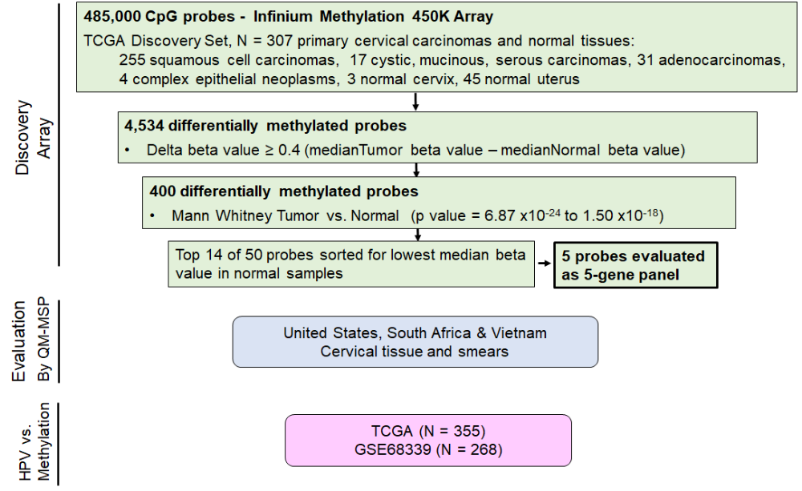
SUPPLEMENTAL FIGURES
Figure S1. Marker discovery workflow. Array data from cervical tumor and normal cervical and uterine samples from TCGA (CESC and UCEC, respectively) were analyzed. Among 485,000 total Cytosine-phosphate-Guanidine (CpG) probes, 4534 probes were differentially methylated in cervical cancer. These were found to be highly methylated in cancer but not in normal. In a stepwise manner, shown in the figure, five that displayed the lowest beta methylation at the highest frequency (80%) in normal were selected for further evaluation by Quantitative Multiplex Methylation Specific PCR (QM-MSP) in samples from United States, South Africa and Vietnam. Tissue samples were used for initial screening of the markers. Cervical smear samples were used to validate the markers. Methylation in Human Papilloma Virus (HPV)-positive and HPV-negative tumors was evaluated in TCGA and GSE68339 databases. S1 and S2 Tables contain specific probe Identification (ID) information, location, tumor/normal ratio of methylation and functional characteristics of CpG sites in regions represented in the 5-gene panel.

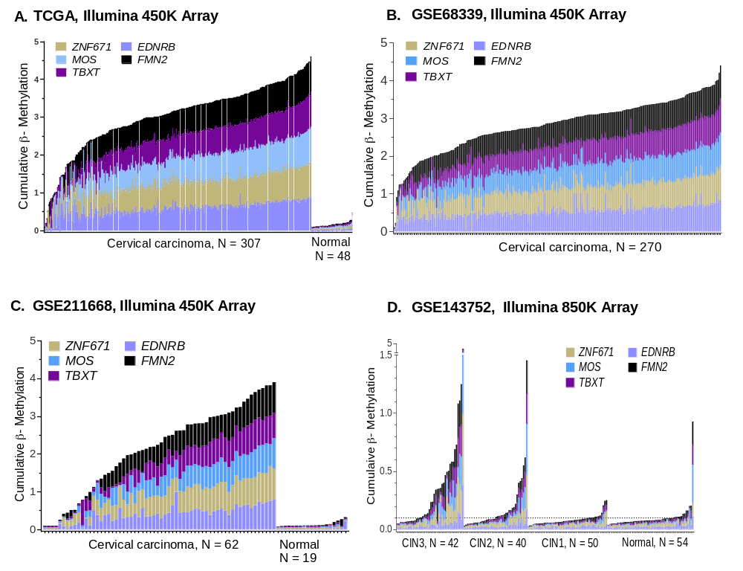
Figure S2. Validation of the 5-marker panel using external databases. Histograms indicate cumulative β-methylation (Y-axis) for the 5-marker panel in each sample (X-axis). The height of each colored segment represents the intensity of the beta methylation signal in each of the 5 markers. A. TCGA cervical cancer 450K Illumina array platform was used for marker discovery. B. GSE68339, C. GSE211668 and D. GSE143752 data were analyzed to validate TCGA data presented in A. S1 Figure contains additional details of the marker selection process.
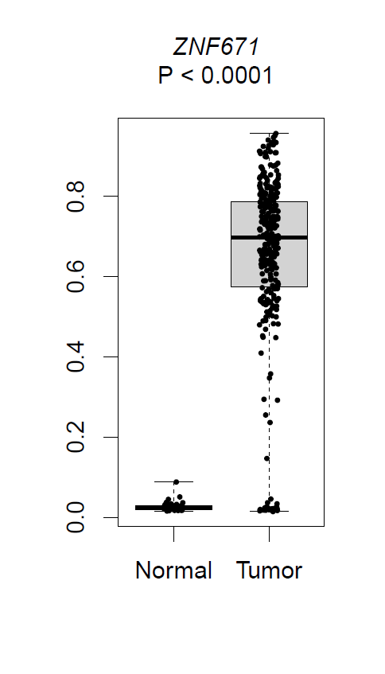
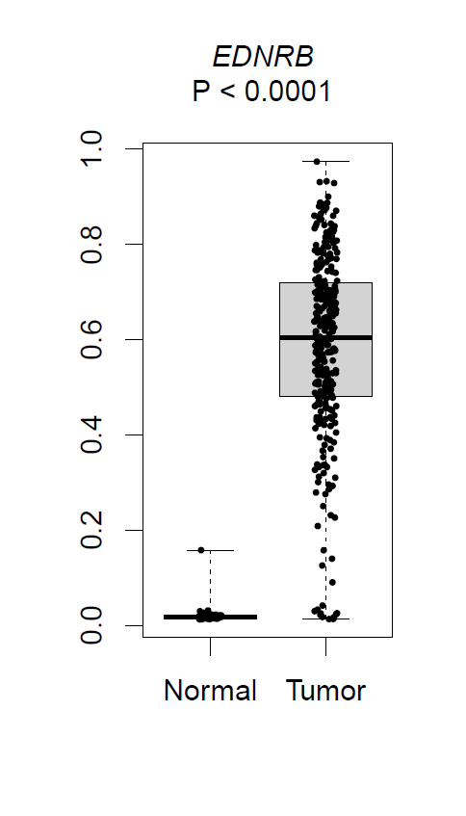
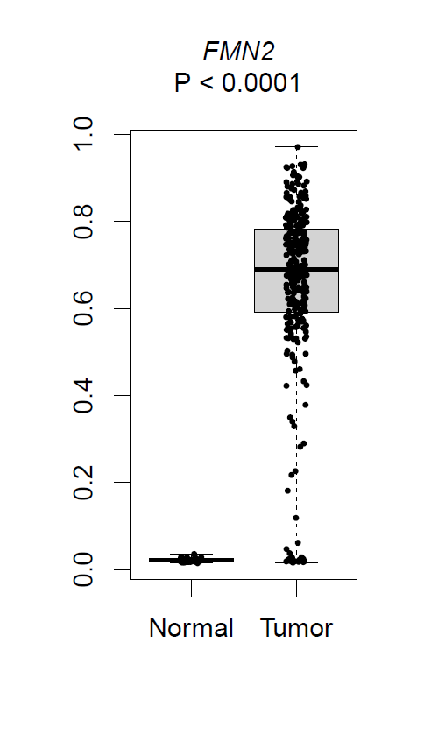
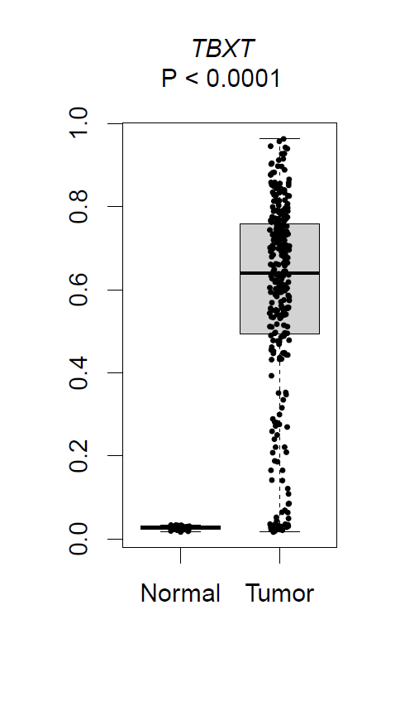
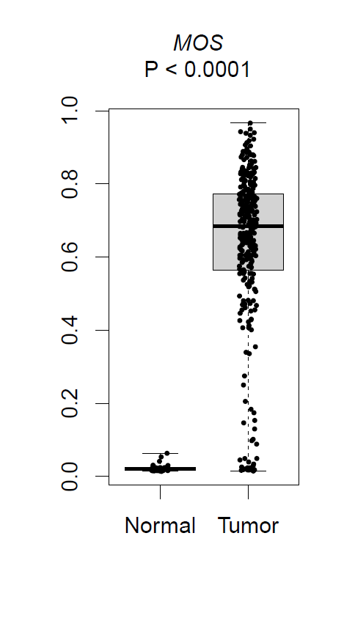
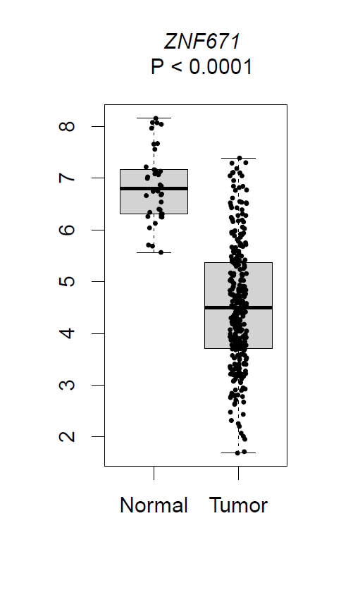
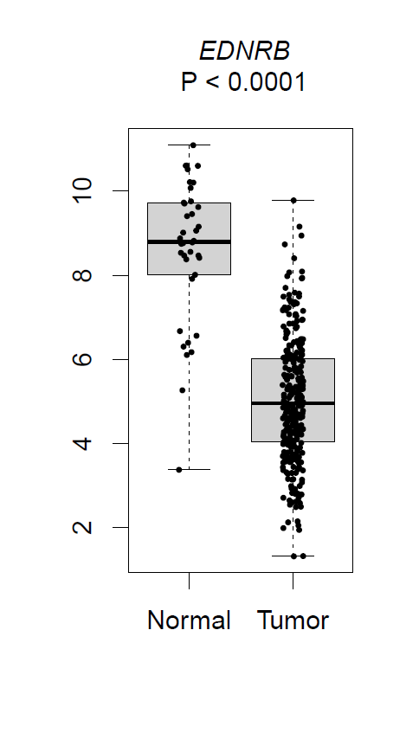
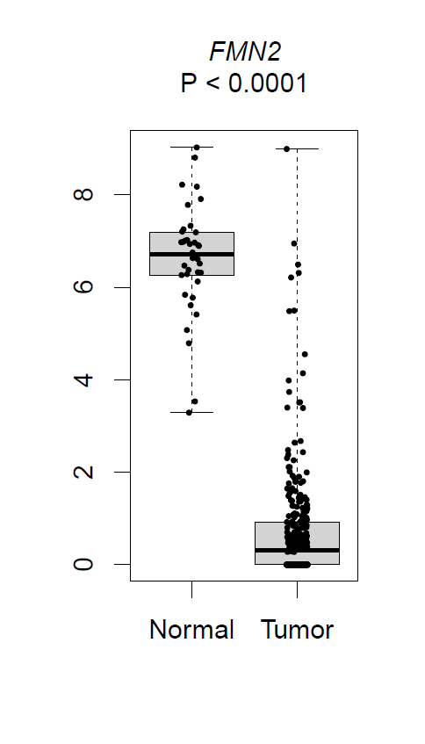
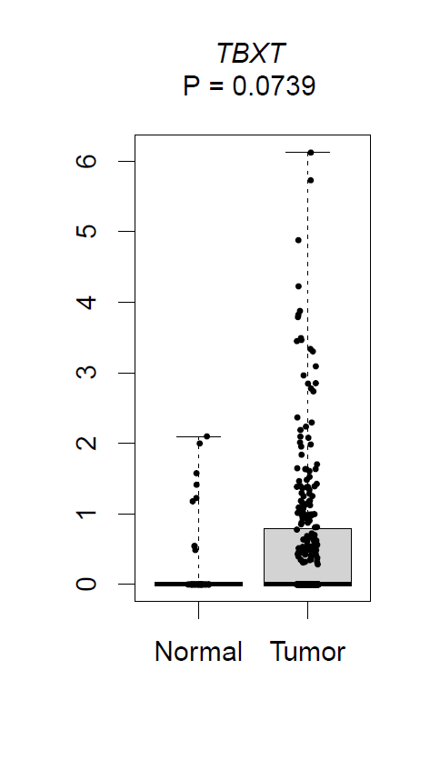
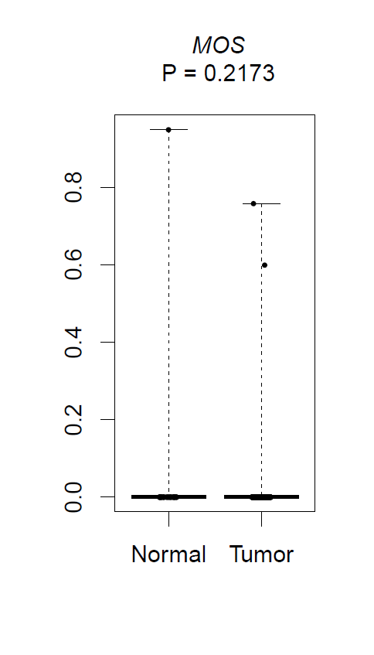
Figure S3. Association between methylation of the five CpG markers and gene expression. The Cancer Genome Atlas (TCGA) cervical cancer 450K array data and RNA sequencing data were plotted for each of the markers in normal (N = 48, 45 uteri, 3 cervix) and tumor (N = 307). The data are presented as box and whiskers plots with Mann-Whitney statistics. A. Significantly higher methylation was observed in tumor compared to normal (P < 0.0001) for all five markers. B. Analysis of RNA sequencing data for the same markers showed low expression levels for ZNF671, EDNRB and FMN2 in tumors compared to normal. For two markers, TBXT and MOS, such a correlation between high methylation and low expression was not observed. Expression was low in both normal and tumor samples.
A. Methylation
B. Expression

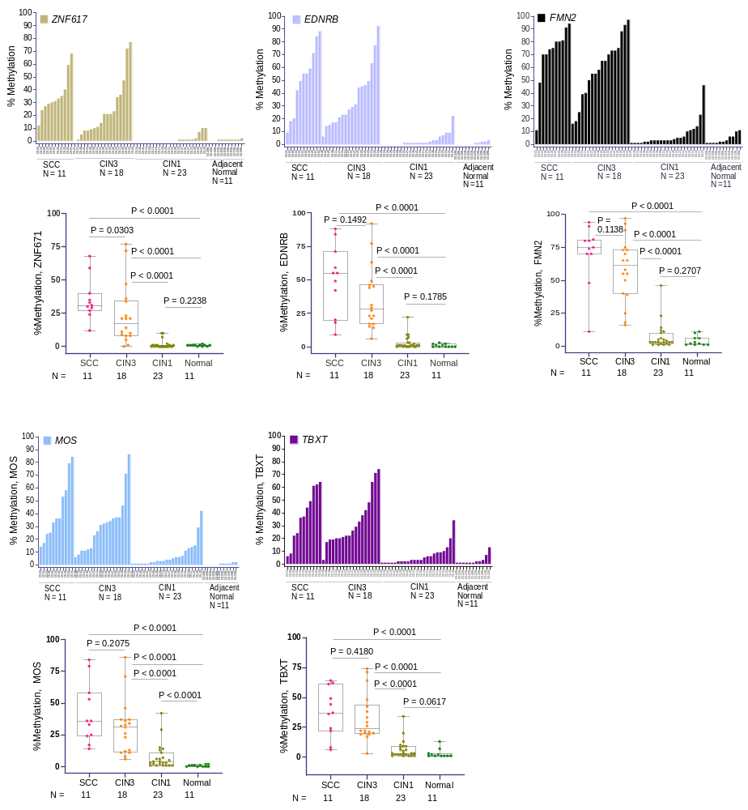
Figure S4. Contribution of individual markers of the 5-marker panel to detect cervical neoplasia. Quantitative Multiplex Methylation Specific PCR (QM-MSP) data of macrodissected cervical formalin fixed paraffin embedded (FFPE) tissue (United States samples, N = 63) shown in main Figure 3A, was evaluated to assess the performance of each marker in progressive stages of neoplasia. Histogram plots show the magnitude of methylation (Y-axis) in each sample (X-axis). Below each histogram the corresponding box and whiskers plot indicates significantly higher methylation in SCC and CIN3 compared to CIN1 and normal cervix (P < 0.0001, Mann Whitney).
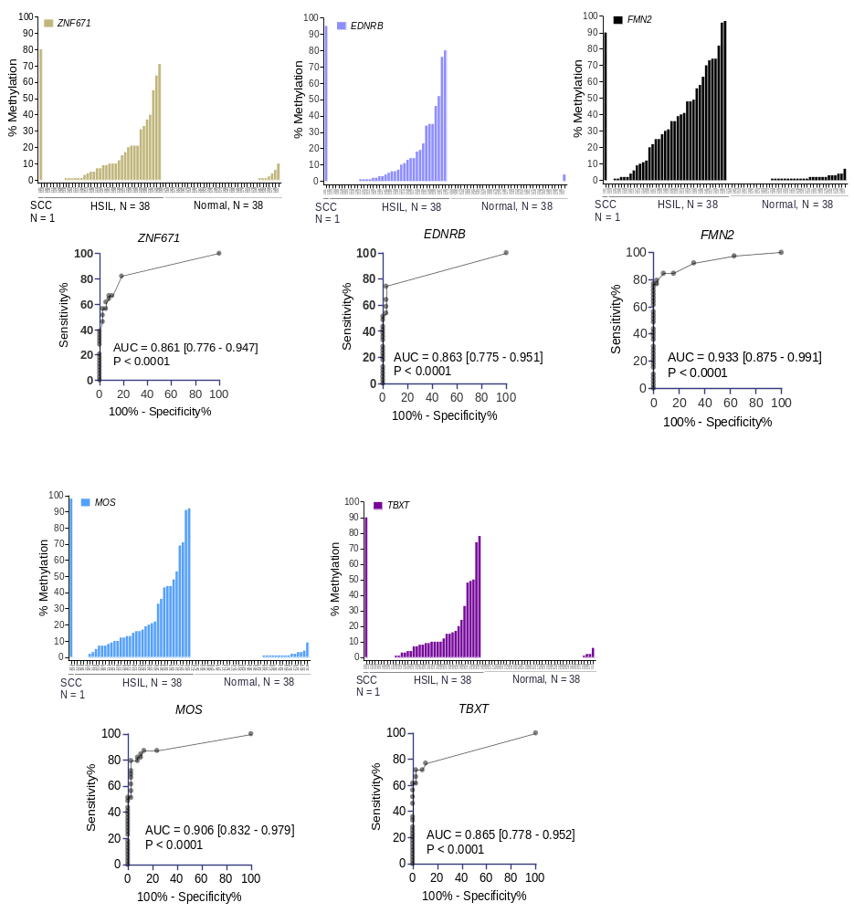
Figure S5. The 5-marker panel is highly methylated in cervical smears from patients with high grade squamous intraepithelial lesion (HSIL) and squamous cell carcinoma (SCC). Histogram analysis shows the magnitude of methylation in individual markers of the 5-marker panel obtained by Quantitative Multiplex Methylation Specific PCR (QM-MSP) in cervical smear samples from the United States (N = 77). Magnitude of single marker and cumulative methylation is shown by the bar height (percent methylation; Y-axis) for each sample (X-axis). Receiver Operating Characteristic (ROC) area under the curve (AUC) analyses shown below each histogram indicate the discriminatory ability of the marker (HSIL and SCC vs. normal), which ranged from 0.861 to 0.933, P < 0.0001.
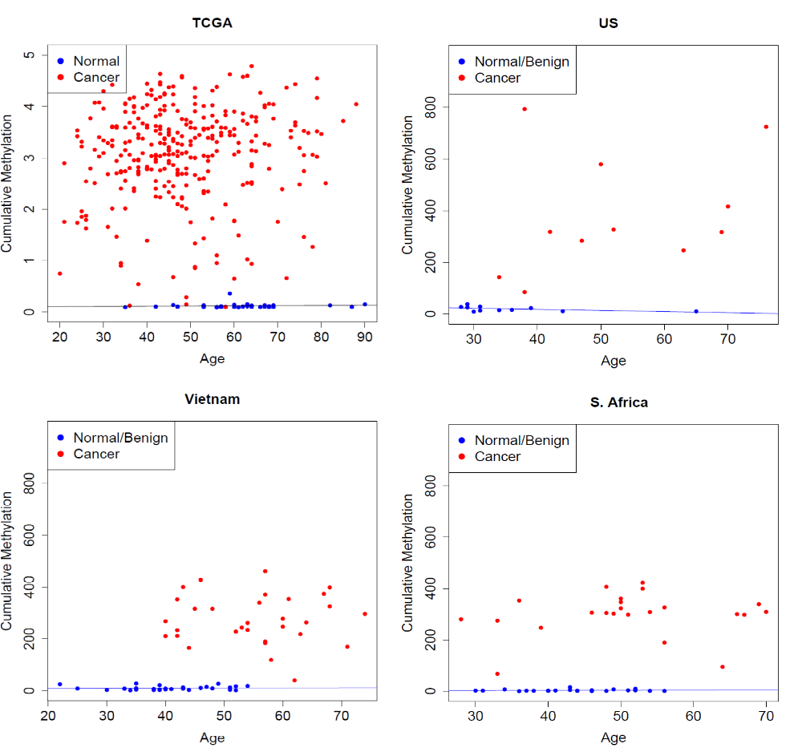

Normal/Benign | Intercept | Age Coefficient | Pearson Correlation | P-value
U.S. Cervix | 35.27 | -0.428 | -0.493 | 0.123
S. Africa Cervix | 1.48 | 0.046 | 0.096 | 0.662
Vietnam Cervix | 7.15 | 0.051 | 0.053 | 0.781
TCGA Uterus | 0.095 | 0.00037 | 0.092 | 0.604
Figure S6. Association between DNA methylation and age in normal/benign tissue. Linear regression analysis of the effect of age on DNA methylation levels in our 5-marker panel is shown. Results are shown as plots for A. normal uterine tissue from TCGA and normal/benign cervical samples from our sites in the B. U.S, C., Vietnam and D. South Africa and E. data Table. Age Coefficient is the change in DNA methylation level associated with a one-year increase in age. For example, in Vietnam, the average healthy 20-year-old has a CM level of 8.17 units in cervical tissue versus a healthy 70-year-old who has a CM level of 10.72 units, reflecting a change of 2.53 units over 50 years.

SUPPLEMENTAL TABLES
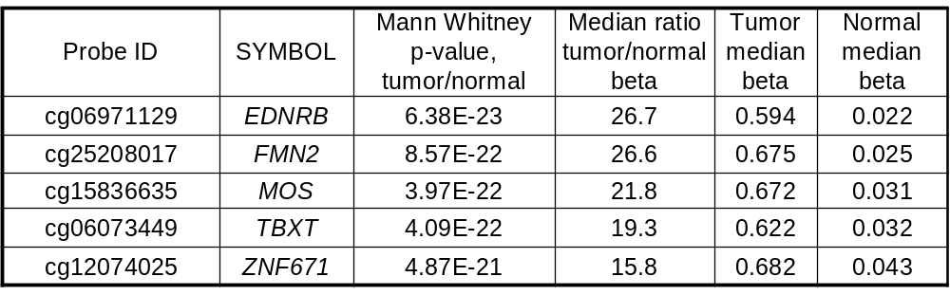
Table S1. Descriptive statistics for 5-marker panel comparing beta methylation in cervical tumor to normal/benign tissues in TCGA database.

Table S2. TCGA Cervical Database Marker ID, Gene name, Location and Function
Gene Symbol | Probe ID  Cervical Cancer Discovery Set | Probe ID QM-MSP | Gene Name | Probe location Discovery Set * | Probe location QM-MSP * | Gene Function
EDNRB | cg06971129 | cg02147695 | Endothelin receptor type B | Ch13:7849306 1st Exon,  CpG Island | Ch13:78493657; TSS 1500 bp, South Shore | G-protein coupled receptor that activates the phosphatidyl-inositol-calcium signaling cascade. Aberrantly expressed and differentially methylated in cancer [1]
TBXT | cg06073449 | cg11338643 | T-box transcription factor T; brachyury | Ch6:166582310TSS 200 bp, CpG Island | Ch6:166580983; Gene body,  CpG Island | Embryonic nuclear DNA-binding transcription factor, apparent role in promoting tumorigenesis, progression via activation of EMT [2]
MOS | cg15836635 | cg22411207 | MOS proto-oncogene, serine/threonine kinase | Ch8:57025662; 1st Exon, CpG Island | Ch8:57026301; 1st Exon,  CpG Island | Protein kinase, activates MAPK signaling, aneuploidy/polyploidy in cancer cells [3]; regulates the actin cytoskeleton, essential for meiotic metaphase I and release from metaphase II [4,5]
ZNF671 | cg12074025 |  | Zinc finger protein 671 | Ch19:58238850; 1st Exon,  CpG Island |  | DNA-binding protein, transcription factor [6,7]
FMN2 | cg25208017 |  | Formin 2 | Ch1:240255486; 1st Exon,  CpG Island |  | Actin binding protein, regulates actin networks and cell polarity [8]; cyclin-dependent kinase inhibitor p21 [9]; essential for meiotic metaphase I [10]
* Genome Reference Consortium Human Build 37 (GRCh37); Abbreviations: TSS, transcriptional start site; Ch, chromosome; CpG Island, methylated cytosine phosphate guanidium DNA dinucleotide region.

Table S2. The Cancer Genome Atlas (TCGA) cervical marker probe identification (ID), gene name, location and function. Provided is the CpG probe location in the TCGA databases which was used for discovery of the 5-marker panel. Also provided is the genomic location used for developing Quantitative Multiplex Methylation Specific PCR (QM-MSP) primers and probes; the known gene functions are described.
References for Table S2.
- Ma X, Liu J, Wang H, Jiang Y, Wan Y, Xia Y, et al. Identification of crucial aberrantly methylated and differentially expressed genes related to cervical cancer using an integrated bioinformatics analysis. Biosci Rep 2020;40
- Chen M, Wu Y, Zhang H, Li S, Zhou J, Shen J. The Roles of Embryonic Transcription Factor BRACHYURY in Tumorigenesis and Progression. Front Oncol 2020;10:961
- Vitale I, Senovilla L, Jemaa M, Michaud M, Galluzzi L, Kepp O, et al. Multipolar mitosis of tetraploid cells: inhibition by p53 and dependency on Mos. EMBO J 2010;29:1272-84
- Erenpreisa J, Cragg MS. MOS, aneuploidy and the ploidy cycle of cancer cells. Oncogene 2010;29:5447-51
- Acevedo N, Smith GD. Oocyte-specific gene signaling and its regulation of mammalian reproductive potential. Front Biosci 2005;10:2335-45
- Wang Y, Chen FR, Wei CC, Sun LL, Liu CY, Yang LB, et al. Zinc finger protein 671 has a cancer-inhibiting function in colorectal carcinoma via the deactivation of Notch signaling. Toxicol Appl Pharmacol 2023;458:116326
- Zhan W, Li Y, Liu X, Zheng C, Fu Y. ZNF671 Inhibits the Proliferation and Metastasis of NSCLC via the Wnt/beta-Catenin Pathway. Cancer Manag Res 2020;12:599-610
- Kundu T, Siva Das S, Sewatkar LK, Kumar DS, Nagar D, Ghose A. Antagonistic Activities of Fmn2 and ADF Regulate Axonal F-Actin Patch Dynamics and the Initiation of Collateral Branching. J Neurosci 2022;42:7355-69
- Yamada K, Ono M, Perkins ND, Rocha S, Lamond AI. Identification and functional characterization of FMN2, a regulator of the cyclin-dependent kinase inhibitor p21. Mol Cell 2013;49:922-33
- Tsuiko O, Noukas M, Zilina O, Hensen K, Tapanainen JS, Magi R, et al. Copy number variation analysis detects novel candidate genes involved in follicular growth and oocyte maturation in a cohort of premature ovarian failure cases. Hum Reprod 2016;31:1913-25
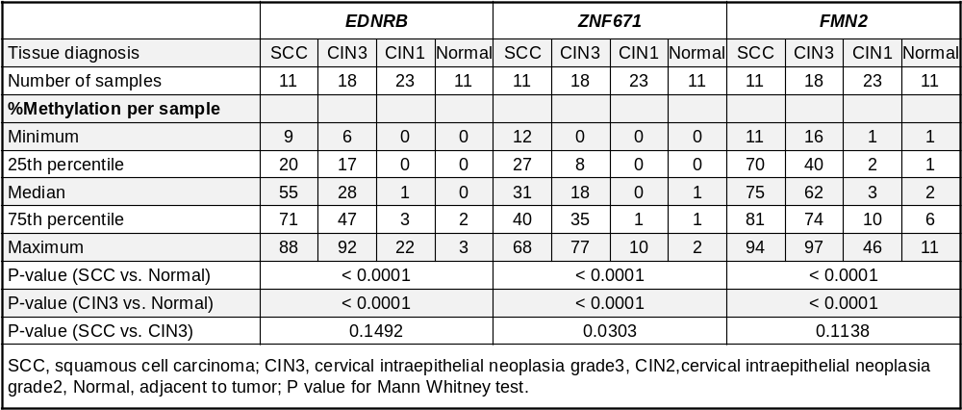
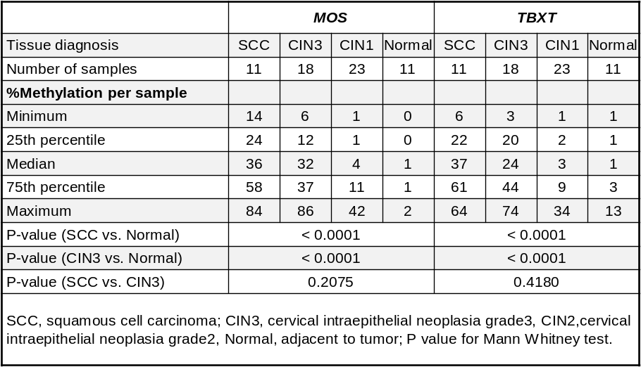
Table S3. Descriptive statistics for QM-MSP methylation of individual markers in the 5-marker panel. Tissue sections from the United States (N = 63) were macrodissected and methylation was quantified using Quantitative Multiplex Methylation Specific PCR (QM-MSP) for EDNRB, ZNF671, FMN2, MOS and TBXT. Data was analyzed using Mann Whitney statistic for the indicated comparisons. S4 Figure shows accompanying data. %M, percent methylation.

SAMPLES USED IN THIS STUDY
Set 1 FFPE tissue | United States - Macrodissected | Vietnam | South Africa
SCC | 11 | 31 | 23
CIN2/3 | 18 | 31 | 23
LSIL (CIN1) | 23 | 28 | 0
Benign | 0 | 30 | 23
Benign adjacent to tumor | 11 | 0 | 0
Total | 63 | 120 | 69
Set 2 Cervical Smear | United States | Vietnam | South Africa
SCC | 1 | 25 | 50
HSIL | 38 | 23 | 0
LSIL | 0 | 21 | 0
Normal | 38 | 48 | 0
Total | 77 | 117 | 50
Paired subsets | PAIRED (United States) | PAIRED (Vietnam) | PAIRED (South African)
SCC smear + tissue | 0 | 25 | 0
HSIL smear + tissue | 0 | 23 | 0
LSIL smear + tissue | 0 | 21 | 0
Benign smear + tissue | 0 | 23 | 0
Total | 0 | 92 | 0
Table S4. Detailed description of samples used in this study. Quantitative Multiplex-Methylation Specific PCR (QM-MSP) was performed on archival formalin fixed paraffin embedded (FFPE)-tissue and cervical smear samples. Paired smear/tissue samples were available from Vietnam, which is a subset of the Vietnam samples shown in Set 1 and Set 2. This information supports Figure 1, and patient characteristics are provided in Tables S6 and S7. SCC- Squamous cell carcinoma; CIN2/3- Cervical intraepithelial neoplasia 2/3; CIN1- Cervical intraepithelial neoplasia 1; HSIL- High grade intraepithelial lesion, LSIL-low grade intraepithelial lesion; CIN2- Cervical intraepithelial neoplasia 2.
Table S5: United States Patient Characteristics submitted as an Excel File

Table S6: Vietnam Patient Characteristics submitted as an Excel File

Table S7: HPV status of patients in dataset GSE68339 submitted as an Excel File

