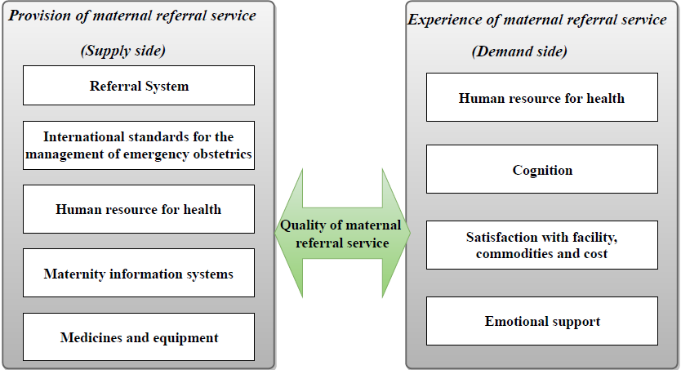
S 1. Framework for assessing the quality of maternal referrals
Source: Adapted from Hulton, Matthews & Stones, 2000

