Isolation of Streptomyces inhibiting multiple-phytopathogenic fungi and characterization of lucensomycin biosynthetic gene cluster

Heung-Soon Park, Seung-Hoon Kang, Si-Sun Choi, and Eung-Soo Kim*
Department of Biological Sciences and Bioengineering, Inha University, Incheon 22212, Republic of Korea
*Corresponding authors: E-mail: eungsoo@inha.ac.kr; Phone: +82-32-860-8318; Fax: +82-32-865-4046

Key words: Actinomycetes, Antifungal activity, Phytopathogenic fungicide, Polyene macrolide, Genome mining
Supplementary Fig. S1. Screening to isolate the strains showing both antifungal activities against C. albicans and F. oxysporum and a typical polyene spectrum assayed by 2-dimensional HPLC analysis. (A) antifungal assay against C. albicans and F. oxysporum (B) HPLC analysis
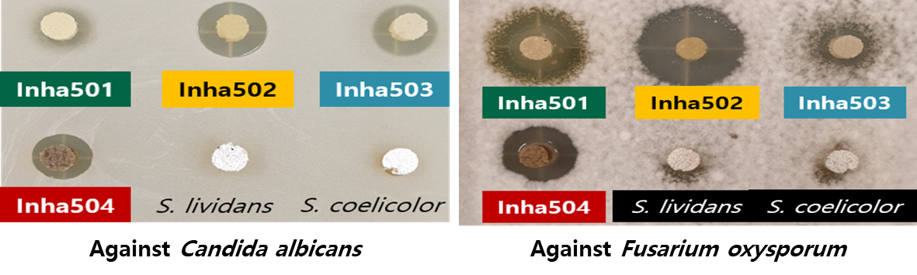
A.

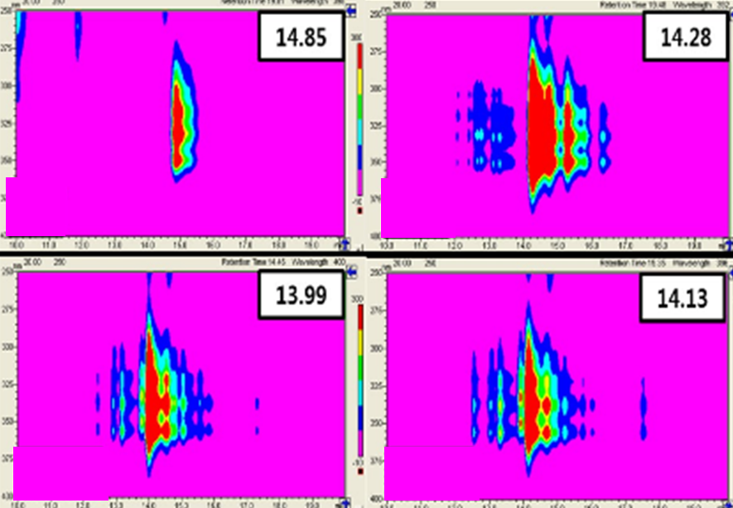
B.

Supplementary Fig. S2. In vivo pot test of S. collinus Inha504 against F. oxysporum
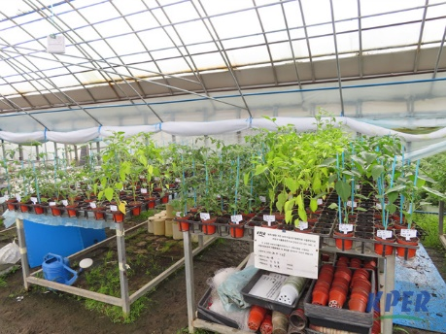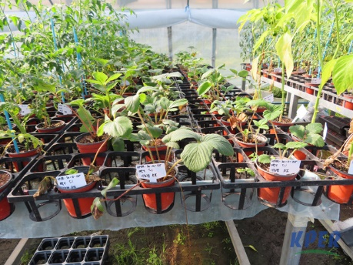
< Panoramic view of the test area>
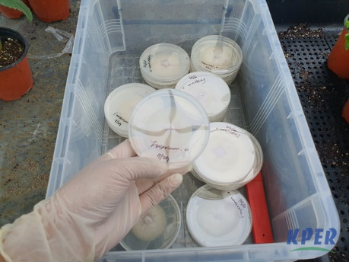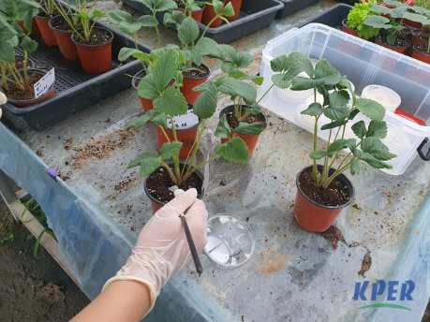
< Pathogen inoculation>
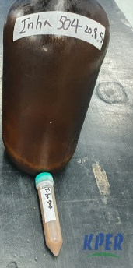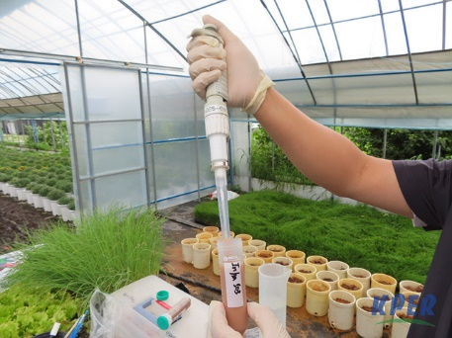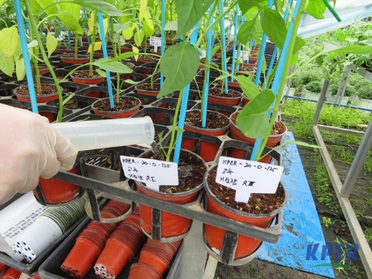
< Culture broth treatment>

Supplementary Fig. S3. Comparison of LCM BGCs in S. collinus Inha504 (LCM)and S. cyanogenus S136 (lcm) & Comparison of PKS domains in those BGCs
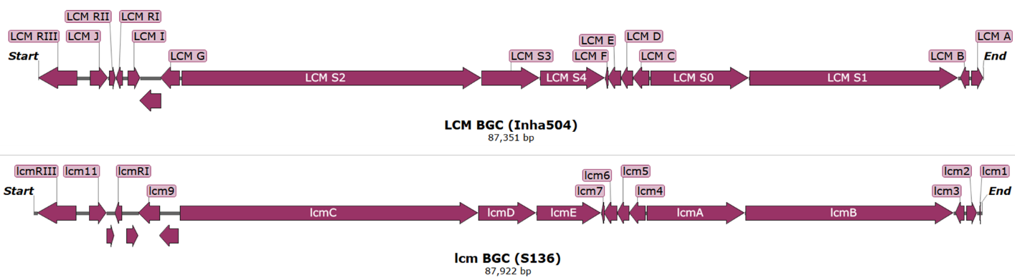
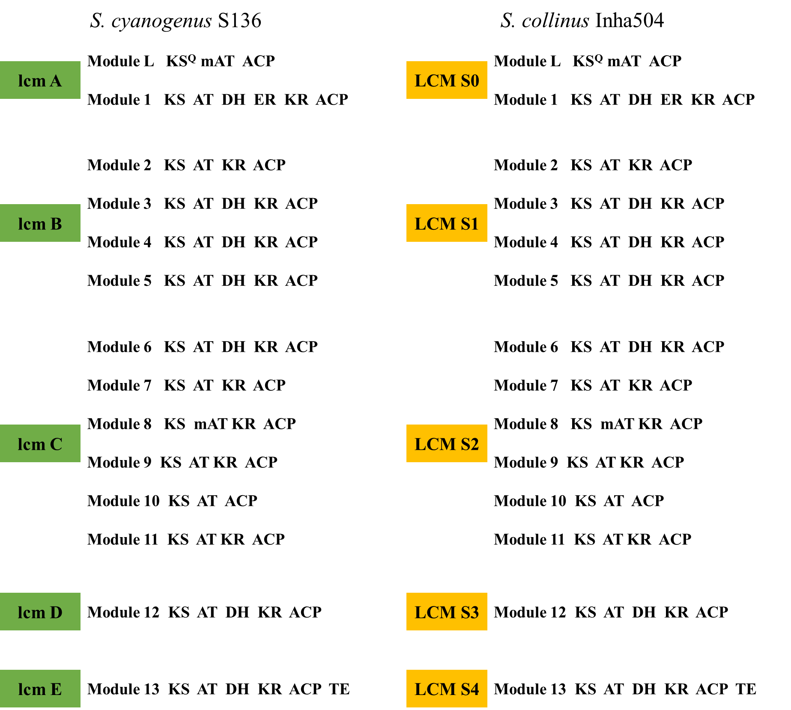

Supplementary Fig. S4. High Resolution Mass Spectrometry (HRMS) in negative ion mode to measure the molecular weight of LCM.
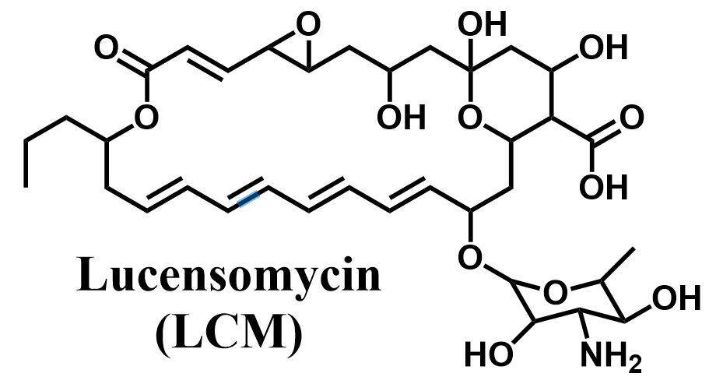
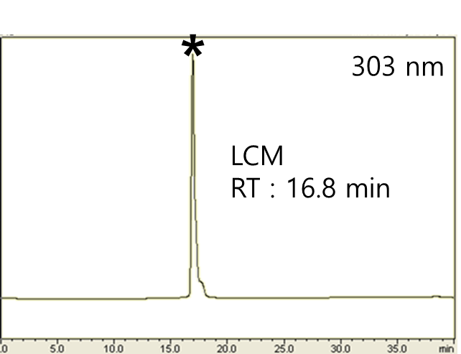
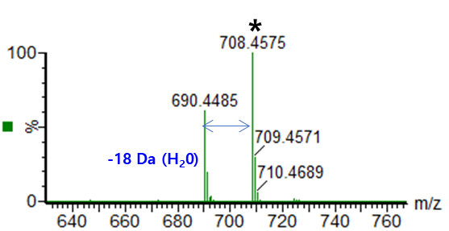

Supplementary Fig. S5. Confirmation of LCM BGC by gene knockout. (Check primer pair; F (5’- GTGAGATCGGCGTGCTGGAA-3’) and R (5’- TTCCGGCTCGTATGTTGTGT-3’)
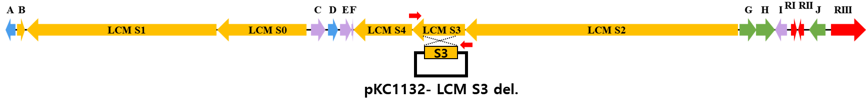
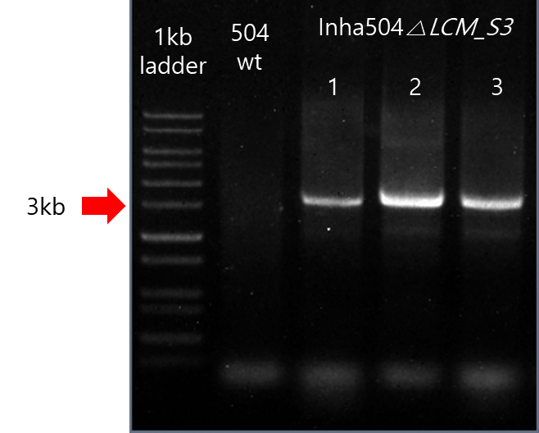

Supplementary Fig. S6. Comparison of HPLC Analysis Results of the wild-type S. collinus Inha504 (upper line) and LCM S3 disrupted S. collinus Inha504 mutant (Inha504 △LCM, lower line) at 303 nm. The asterisked peak is confirmed to be the LCM and the small peak in front of LCM peak is believed to the derivative or degradation product of LCM.
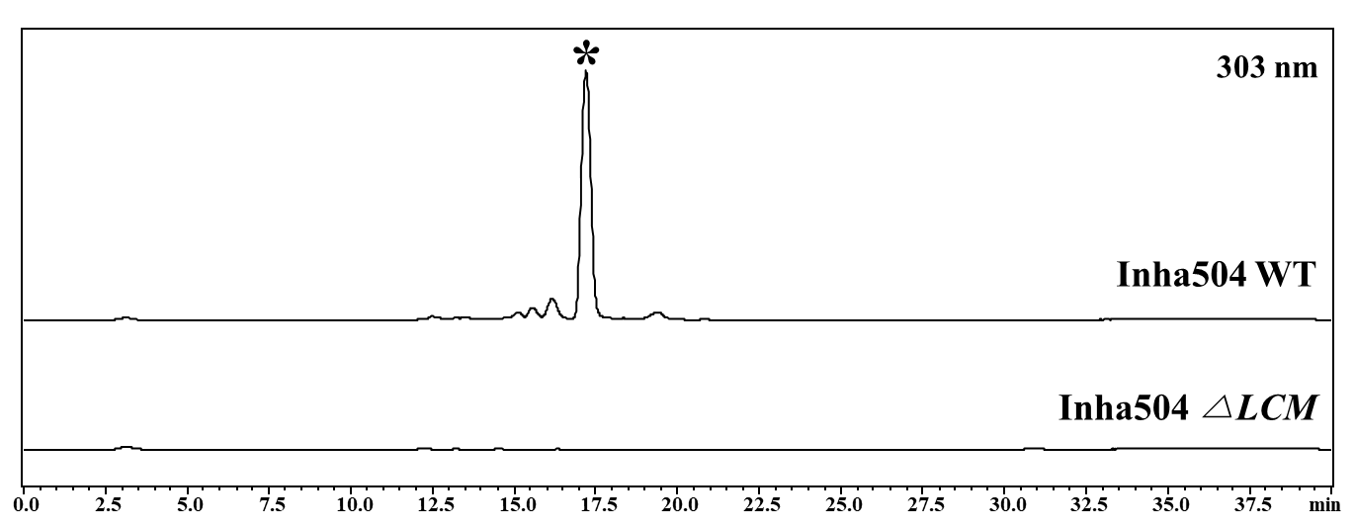

Supplementary Fig. S7. In vitro antifungal activity of LCM using the RPMI-1640. The minimum inhibitory concentration (MIC) values were determined by measuring the minimum concentration that changed color to yellow.
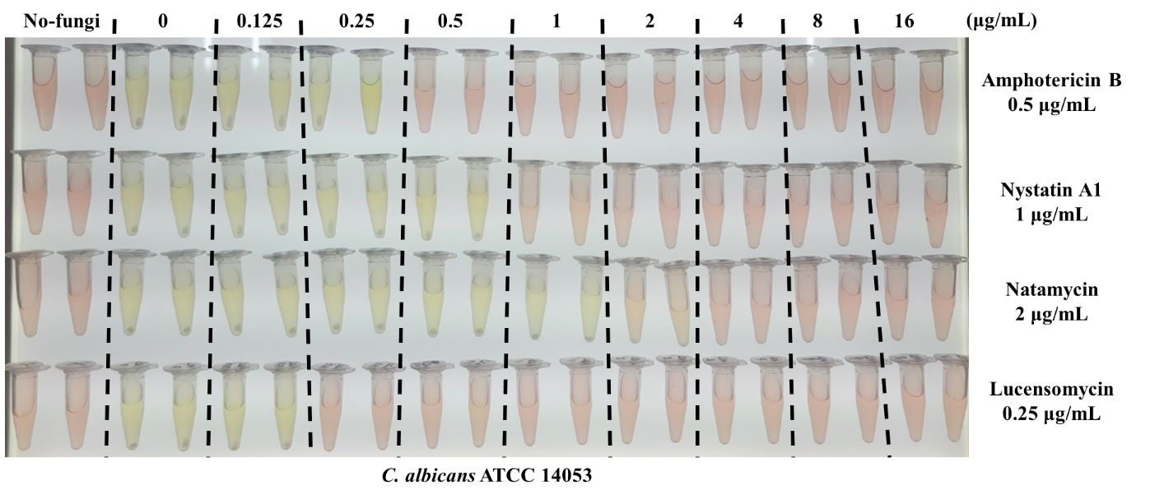

Supplementary Fig. S8. In vitro hemolytic toxicity of polyene macrolides.
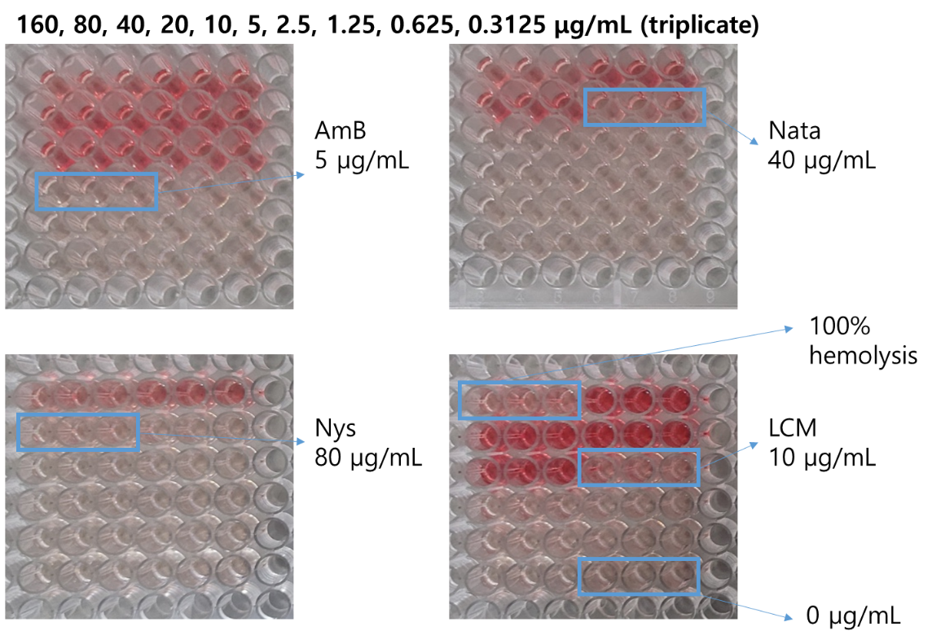
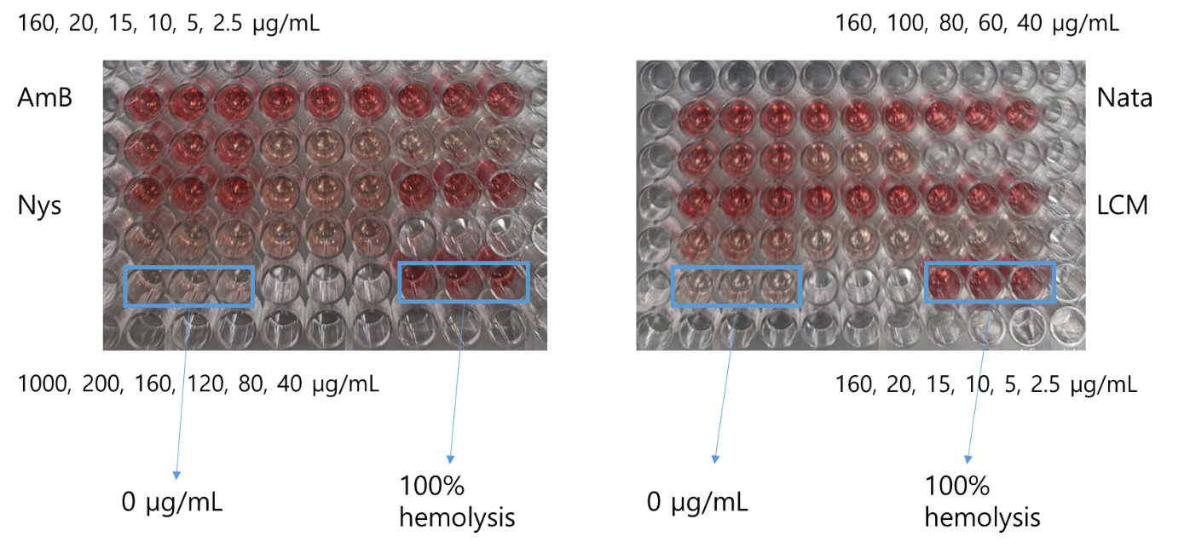

Supplementary Table 1 Whole-genome sequencing of S. collinus Inha504
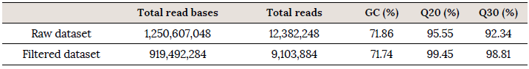
. Total Number of Bases: The Total number of bases sequenced.
. Number of Reads: The Total number of reads. In illumina paired-end data, read1 and read2 are added.
. GC(%) : GC content
. Q20(%): Ratio of bases that have phred quality score over 20.
. Q30(%): Ratio of bases that have phred quality score over 30.

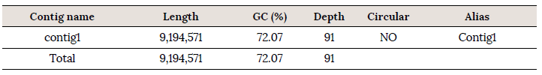
. Length(bp): The number of bases in each contig
. GC%: GC content
. Depth: The number of reads that overlap each contig
. Circular: 5’ end and 3’ end are connected.
. Alias: The alias is named based on the BLASTN(v2.7.1+) result.
The following two conditions are used to create an alias:
a. Query cover 80% or more
b. Similarity between genome size
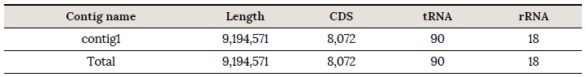
. Length(bp): The number of bases in each contig
. CDS : Coding sequences
. tRNA : Transfer RNA, tRNA has triplet nucleotide sequence complementary to the triplet nucleotide coding
sequences of messenger RNA. Circular: 5’ end and 3’ end are connected.
. rRNA : Ribosomal RNA, a molecular component of ribosome

