Supplementary Information:

Anti-Ebola virus mAb 3A6 with unprecedented potency protects highly viremic animals from fatal outcome and physically lifts its glycoprotein target from the virion membrane

Zhe Li Salie¹, Zunlong Ke^{2,3}, Peter J. Halfmann⁴, Lisa Evans DeWald⁵, Sara McArdle⁶, Ariadna Grinyó⁷, Edgar Davidson⁷, Sharon L. Schendel¹, Chitra Hariharan¹, Michael J. Norris¹, Xiaoying Yu¹, Chakravarthy Chennareddy⁸, Xiaoli Xiong^{2,$}, Megan Heinrich⁹, Michael R. Holbrook⁵, Benjamin Doranz⁷, Ian Crozier¹⁰, Kathryn M. Hastie¹, Yoshihiro Kawaoka^{4,11,12,13}, Luis M. Branco⁹, Jens H. Kuhn^{5,}*, John A. G. Briggs^{2,3,}*, Gabriella Worwa^{5,}*, Carl W. Davis^{8,}*, Rafi Ahmed^{8,}*, Erica Ollmann Saphire^{1,14,}*,#

¹Center for Infectious Disease and Vaccine Discovery, La Jolla Institute for Immunology, La Jolla, CA, USA
²Division of Structural Studies, Medical Research Council Laboratory of Molecular Biology, Cambridge, UK
³Department of Cell and Virus Structure, Max Planck Institute of Biochemistry, Martinsried, Germany
⁴Influenza Research Institute, Department of Pathobiological Sciences, School of Veterinary Medicine, University of Wisconsin—Madison, Madison, WI, USA
⁵Integrated Research Facility at Fort Detrick, National Institute of Allergy and Infectious Diseases, National Institutes of Health, Fort Detrick, Frederick, MD, USA
⁶Microscopy Core, La Jolla Institute for Immunology, La Jolla, La Jolla, CA, USA
⁷Integral Molecular, Philadelphia, PA, USA
⁸Department of Microbiology and Immunology and Emory Vaccine Center, Atlanta, GA, USA
⁹Zalgen Labs LLC, Frederick, MD, USA
¹⁰Clinical Monitoring Research Program Directorate, Frederick National Laboratory for Cancer Research, Frederick, MD, USA
¹¹Division of Virology, Institute of Medical Science, University of Tokyo, Tokyo, Japan
¹²The Research Center for Global Viral Diseases, National Center for Global Health and Medicine Research Institute, Tokyo, Japan
¹³Pandemic Preparedness, Infection and Advanced Research Center (UTOPIA), University of Tokyo, Tokyo, Japan
¹⁴Department of Medicine, University of California San Diego, La Jolla, CA, USA
$Current address: Guangzhou Regenerative Medicine and Health—Guangdong Laboratory, Guangzhou Institutes of Biomedicine and Health, Chinese Academy of Sciences, Science Park, Guangzhou, Guangdong Province, China
*Corresponding authors:
Jens H. Kuhn, Integrated Research Facility at Fort Detrick, National Institute of Allergy and Infectious Diseases, National Institutes of Health, B-8200 Research Plaza, Fort Detrick, Frederick, MD 21702, USA. Phone: +1-301-631-7245; Email: kuhnjens@mail.nih.gov
John A. G. Briggs, Department of Cell and Virus Structure, Max Planck Institute of Biochemistry, Am Klopferspitz 18, 82152 Martinsried, Germany. Phone: +49-89-8578-2592; Email: briggs@biochem.mpg.de
Gabriella Worwa, Integrated Research Facility at Fort Detrick, National Institute of Allergy and Infectious Diseases, National Institutes of Health, B-8200 Research Plaza, Fort Detrick, Frederick, MD 21702, USA. Phone: +1-240-236-9277; Email: gabriella.worwa@nih.gov
Carl W. Davis, Emory Vaccine Center and Department of Microbiology and Immunology, 954 Gatewood Road, Emory University, Atlanta, GA 30329, USA. Phone: +1-404-727-404-727-9029; Email: cwdavi2@emory.edu
Rafi Ahmed Emory Vaccine Center and Department of Microbiology and Immunology, 954 Gatewood Road, Emory University, Atlanta, GA 30329, USA. Phone: +1-404-727-4700; Email: rahmed@emory.edu
Erica Ollmann Saphire, Center for Infectious Disease and Vaccine Discovery, La Jolla Institute for Immunology, 9420 Athena Circle, La Jolla, CA 92037, USA. Phone: +1-858-752-6791; Email: erica@lji.org

# Lead Contact: Erica Ollmann Saphire; erica@lji.org

Table of Contents
SUPPLEMENTARY TABLES 3
Supplementary Table 1. Crystallographic statistics 3
Supplementary Table 2. Alanine scanning analysis for 3A6 binding to EBOV GP_{1,2ΔMLD} 4
Supplementary Table 3. Neutralization of P636S-bearing EbolaΔVP30-eGFP virions by multiple mAbs 5
Supplementary Table 4. Cryogenic electron tomography data acquisition and processing parameters 6
SUPPLEMENTARY FIGURES 7
Supplementary Figure 1. Crystal structures of unbound human mAb 3A6 Fab and mAb 3A6 Fab bound to the Ebola virus glycoprotein stalk–MPER 7
Supplementary Figure 2. Residues D632 and P636 of the Ebola virus glycoprotein MPER are key for mAb 3A6 binding 8
Supplementary Figure 3. mAb 3A6 lifts Ebola virus glycoprotein relative to the membrane surface 9
Supplementary Figure 4. Low-dose mAb 3A6 monotherapy is highly efficacious in domesticated guinea pigs and rhesus monkeys exposed to Ebola virus 10
Supplementary Figure 5. Low-dose mAb 3A6 monotherapy is highly efficacious in domesticated guinea pigs and rhesus monkeys exposed to Ebola virus 11
REFERENCES 12

SUPPLEMENTARY TABLES

Supplementary Table 1. Crystallographic statistics
 | 3A6 Fab | 3A6 Fab-stalk–MPER
Data collection
Beamline | APS 231D-B | SSRL 12-2
Space group | P41 | P1 21 1
Unit cell (a, b, c) (Å) | 53.66, 65.67, 125.56 | 52.29, 66.42, 67.98
(α, β, γ) (°) | 98.7, 91.4, 96.0 | 90, 104.2, 90
Resolution range (last shell) (Å) | 43.51–2.50 (2.59–2.50) | 65.89–1.27 (1.32–1.27)
Multiplicity | 1.7 (1.7) | 2.0 (1.8)
Completeness (spherical) (%) | - | 93.92 (60.80)
Completeness (ellipsoidal) (%) | 78.1 (10.1) | -
R_{meas} (%) |  | 0.025 (0.36)
R_{pim} (%) |  | 0.018 (0.25)
CC_{1/2} (%) | 0.987 (0.53) | 0.999 (0.88)
Average I/σ(I) | 2.7 (1.6) | 11.0 (2.29)
Refinement
R_{work}/R_{free} | 0.192/0.249 | 0.167/0.179
Number of atoms
Macromolecules | 13179 | 3431
Solvent | 215 | 639
Root-mean-square deviations
Bond lengths (Å) | 0.014 | 0.008
Bond angles (°) | 1.67 | 1.02
Average B (A2) | 39.44 | 19.54
Macromolecules | 39.55 | 17.02
Solvent | 32.9 | 33.09
Ramachandran plot
Outliers (%) | 0 | 0
Allowed (%) | 2.54 | 1.38
Favored (%) | 97.46 | 98.16
Protein Databank (PDB) ID | 7RPT | 7RPU
APS, advanced photon source; MPER, membrane proximal external region; SSRT, Stanford synchrotron radiation lightsource.

Supplementary Table 2. Alanine scanning analysis for 3A6 binding to EBOV GP_{1,2ΔMLD}

GP_{1,2ΔMLD} variant | Mean | Range
I627A | 94 | 16
H628A | 34 | 10
D629A | 70 | 6
F630A | 71 | 7
V631A | 173 | 11
D632A | 10 | 1
K633A | 84 | 11
T634A | 86 | 13
L635A | 103 | 1
P636A | 14 | 5
D637A | 105 | 5
Q638A | 73 | 5
G639A | 58 | 4

Mean 3A6 reactivities with the indicated GP_{1,2ΔMLD} variants are expressed as percentage of binding relative to wild-type EBOV GP_{1,2ΔMLD} with ranges (half of the maximum minus minimum values). Values shaded in green indicate critical residues. Binding represents the average of two replicate values.

Supplementary Table 3. Neutralization of P636S-bearing EbolaΔVP30-eGFP virions by multiple mAbs

mAb | Short name | Antigenic site | # Virus plaques (mean)
- |  |  | 168/162 (165)
9.6.3 A06 | 3A6 | GP₂ MPER | 124/138 (131)
2.10.1 E06 | 1E6 | GP₂ MPER | 126/124 (125)
9.6.3 D06 | 3D6 | GP₁ glycan cap | 97/109 (103)
2.1.1 D05 | 1D5 | GP₁ core | 0/0 (0)
5.1.7 D03 | 7D3 | GP₁ core | 10/9 (9.5)
9.6.1 A09 | 1A0 | GP₁ core | 7/7 (7)
9.20.1 A02 | 1A2* | GP₁ core | 0/0 (0)
5.6.1 A02 | 1A2* | GP₂ fusion loop | 0/0 (0)
9.6.3 A04 | 3A4 | GP₂ fusion loop | 0/0 (0)
5.24.12 C11 | 12C11 | GP_{1,2} trimer base | 0/0 (0)
5.24.2 C06 | 2C6 | GP_{1,2} trimer base | 0/0 (0)
9.20.1 C03 | 1C3 | GP RBS | 0/0 (0)
5.24.2 A12 | 2A12 | GP RBS | 0/0 (0)
5.1.10 B3 | 10B3 | GP₁ core | 55/72 (63.5)
5.1.13 G03 | 13G3 | GP₂ fusion loop | 20/16 (18)
2.1.1 D07 | 1D7 | GP₁-GP₂ interface | 50/61 (55.5)
2.1.7 G07 | 7G7 | GP₁-GP₂ interface | 32/31 (31.5)
5.24.2 C05 | 2C5 | GP_{1,2} trimer base | 66/68 (67)
9.20.1 D09 | 1D9 | GP_{1,2} trimer base | 59/49 (54)
5.24.2 D11 | 2D11 | GP_{1,2} trimer base | 18/20 (19)

GP_{1,2} P636S-bearing “biologically-contained” EbolaΔVP30-eGFP was tested against a panel of mAbs identified by Davis, et al. ¹ in a plaque reduction neutralization assay. Listed are mAbs having potent (orange highlight), partial (grey), and no (green) neutralization activity against this virus. Anti-EBOV GP_{1,2} stalk–MPER-specific mAbs 9.6.3.A06 and 2.10.1 E06 are highlighted in purple. The number of plaques observed after 10 µg/mL of mAb treatment in two independent experiments is listed with the mean values in parentheses. MPER, membrane proximal external region, RBS, receptor binding site. *same short name for two distinct mAbs.

Supplementary Table 4. Cryogenic electron tomography data acquisition and processing parameters
Sample | VLP-GP_{1,2}–3A6 Fab | VLP-GP_{1,2}–KZ52 Fab | VLP-GP_{1,2}–3A6-KZ52 Fab
Microscope | FEI Titan Krios | FEI Titan Krios | FEI Titan Krios
Voltage (keV) | 300 | 300 | 300
Energy filter (eV) | 20 | 20 | 20
Detector | Gatan K3 | Gatan K3 | Gatan K3
Recording Mode | Counting | Counting | Counting
Pixel size (Å) | 1.386 | 1.386 | 1.386
Defocus range (μm) | -2 to -4.5 | -2 to -4.5 | -2 to -4.5
Acquisition scheme | -60/60°, 3° | -60/60°, 3° | -60/60°, 3°
Total Dose (electrons/Å²) | ≈120 | ≈120 | ≈120
Frame number | 10 | 10 | 10
Tomograms | 26 | 18 | 42
Subtomograms | 9,602 | 13,520 | 40,072
Symmetry | C3 | C3 | C3
Resolution at 0.143 FSC (Å) | 17.7 | 8.7 | 7.4
FSC, Fourier shell correlation.

SUPPLEMENTARY FIGURES

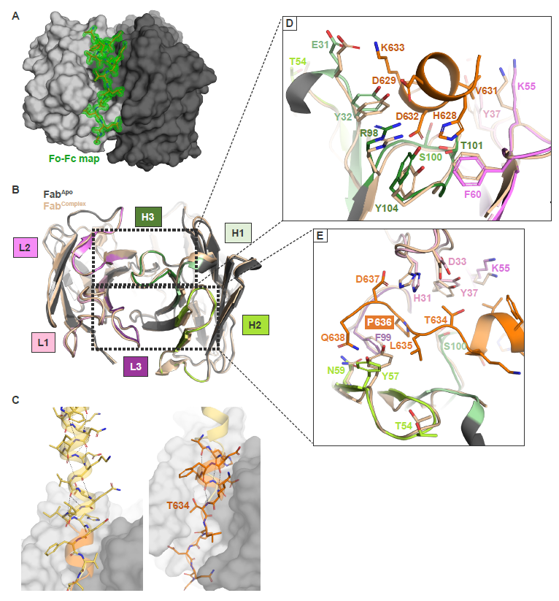

Supplementary Figure 1. Crystal structures of unbound human mAb 3A6 Fab and mAb 3A6 Fab bound to the Ebola virus glycoprotein stalk–MPER
(A) Fo–Fc density from a simulated annealing composite omit map (green mesh; 1.3 Å) calculated for the 3A6 Fab stalk–MPER complex structure with the EBOV stalk–MPER peptide deleted from the model. (B) Crystal structure of the 3A6–peptide complex (colored by CDRs as in Figure 1C) superposed onto the 3A6 Fab structure (tan), RMSD: 0.461 Å. (C) The 3A6 Fab-stalk–MPER structure (stalk–MPER peptide highlighted in orange, Fab in greys) docked onto the stalk region of the EBOV trimeric GP₂ ectodomain (yellow, PDB ID: 5JQ7) using the overlapping portion of the 3A6 epitope as a guide. The peptide representing GP₂ residues I627–G639 in the crystal structure extends the current observation of the stalk–MPER and shows that the ɑ-helical structure continues until residue T634 and unravels thereafter. (D and E) Shifts and rotations of residue side chains in the CDRs enables 3A6 Fab site binding. P636, associated with escape from 3A6 after change P636S, is boxed in red. CDR, complementarity determining region; EBOV, Ebola virus; GP_{2,} glycoprotein subunit 2; ID, identification number; MPER, membrane proximal external region; PDB, Protein Data Bank; RMSD, root-mean-square deviation.
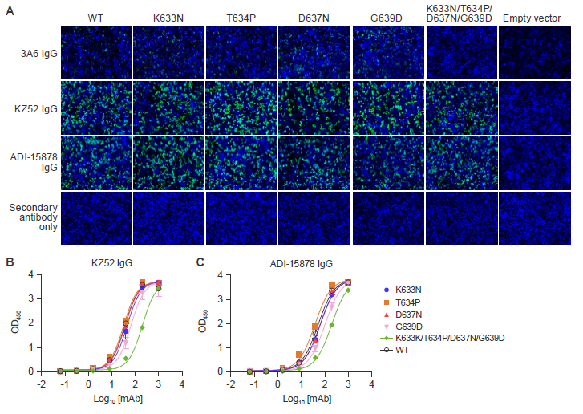

Supplementary Figure 2. Residues D632 and P636 of the Ebola virus glycoprotein MPER are key for mAb 3A6 binding
(A) Representative widefield fluorescent microscopy images used for quantification for Figure 2A. Scale bar, 100 µm. (B, C) ELISA measurement of conformational IgG mAbs KZ52 (B) and ADI-15878 (C) binding to EBOV GP_{1,2ΔTM/ΔMLD} wild-type or variants thereof containing the same amino acid residue changes as in Figure 2A. Error bars represent means ± standard deviation of triplicates. GP_{2,} glycoprotein subunit 2; EBOV, Ebola virus; ELISA, enzyme-linked immunosorbent assay; GP_{2,} glycoprotein subunit 2; WT, wildtype.

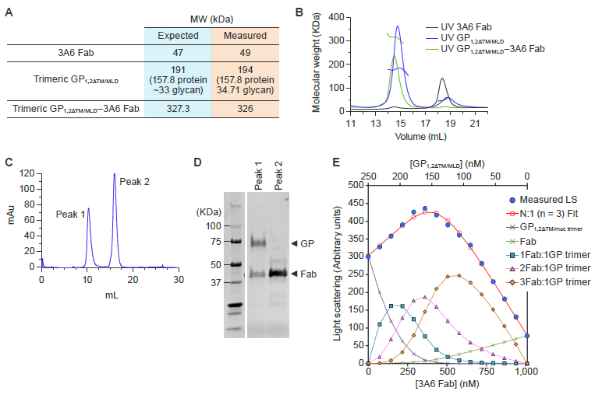

Supplementary Figure 3. mAb 3A6 lifts Ebola virus glycoprotein relative to the membrane surface
(A–B) SEC-MALS analysis of trimeric EBOV GP_{1,2ΔTM/ΔMLD} and 3A6 Fabs separately and as a preformed complex purified from the SEC run shown in (C). The measured molecular weights demonstrate an approximate 1 to 3 stoichiometry for 3A6 binding to the glycoprotein trimer. (C) Trimeric GP_{1,2ΔTM/ΔMLD} was mixed with an excess amount of 3A6 Fabs and the resulting product was run over a S600 Increase column (SEC). (D) Non-reducing SDS-PAGE analysis of SEC peak fractions shows that peak 1 corresponds to the trimeric GP_{1,2ΔTM/ΔMLD}–3A6 Fab complex, and peak 2 represents excess unbound Fab. (E) CG-MALS analysis of trimeric GP_{1,2ΔTM/ΔMLD}–3A6 Fab. Light scattering intensity is shown as a function of composition, with blue circles indicating the measured light scattering intensity for each gradient plateau and red circles indicating the fit to a model of up to three 3A6 Fabs bound to one GP₂ trimer with equal affinity. The resulting fitted model calculates that three 3A6 Fabs bind to GP_{1,2} with equal affinity of K_{D} = 52·15 (±1·3) nM. CG-MALS, composition gradient multi-angle light scattering; EBOV, Ebola virus; GP₂, glycoprotein subunit 2; SDS–PAGE, sodium dodecyl sulphate–polyacrylamide gel electrophoresis. SEC-MALS, size-exclusion chromatography coupled to multi-angle light scattering.
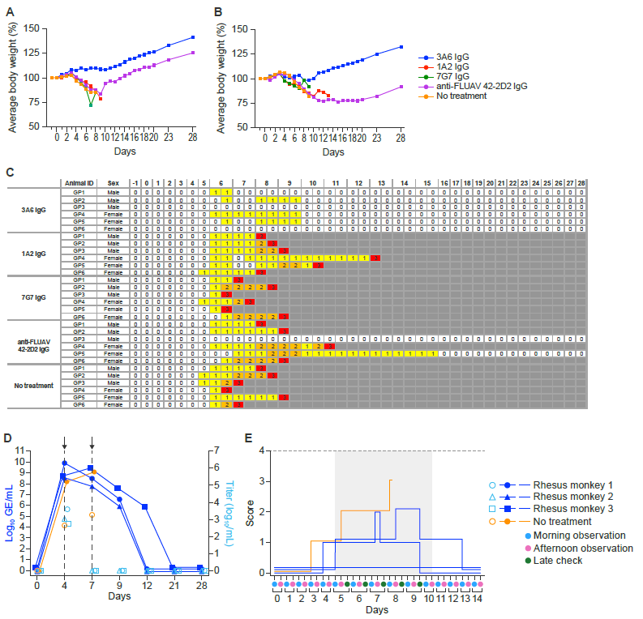

Supplementary Figure 4. Low-dose mAb 3A6 monotherapy is highly efficacious in domesticated guinea pigs and rhesus monkeys exposed to Ebola virus
Body weights of (A) male and (B) female domesticated guinea pigs and (C) their clinical scoring over the course of the experiment shown in Figure 5A. (D) Viremia as determined by RT-qPCR and (E) clinical scoring of rhesus monkeys over the course of the experiment shown in Figure 5B (critical period is highlighted in grey). FLUAV, influenza A virus; GE, genome equivalents.

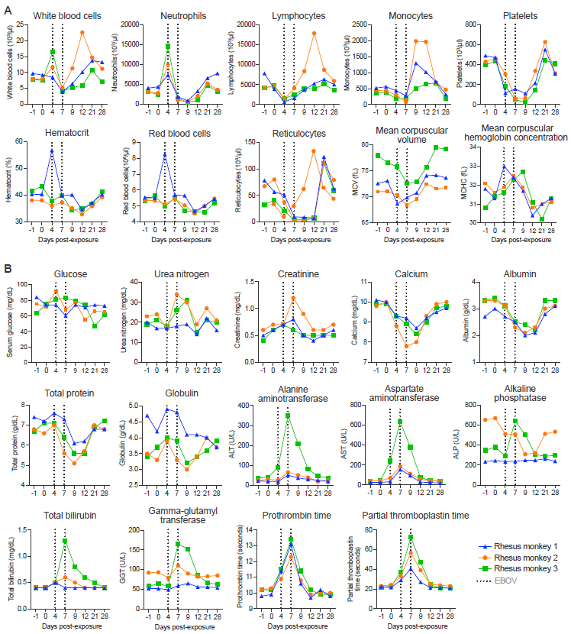

Supplementary Figure 5. Low-dose mAb 3A6 monotherapy is highly efficacious in domesticated guinea pigs and rhesus monkeys exposed to Ebola virus
(A) Hematology and (B) blood chemistry for three rhesus monkeys over the course of the experiment shown in Figure 5B. The animals were infected with EBOV on Day 0. Black dotted lines indicate delivery of antibody treatments on Days 4 and 7 post-exposure.

REFERENCES

1. Davis, C.W., et al. Longitudinal analysis of the human B cell response to Ebola virus infection. Cell 177, 1566-1582 e1517 (2019).

